Janet Thorndycraft 2316471

5. Assessment Five Transcription Exercise
Transcription Exercise
Being able to transcribe the documents you find either in the archive or their digitised counterparts is a key skill for historians of all periods.
In consultation with your tutors, select an archival or digitised source (or set of sources) to transcribe and evaluate. Chosen sources must include HANDWRITTEN elements. The transcription should include:
- An opening statement explaining the transcription techniques, methodology and/or approach used to complete the exercise
- A short explanation of the historical context in which the document(s) originated
- An image of the chosen document(s)
- A full transcription of the document(s)
- A closing statement summarising some key points identified in the transcription process, and any wider historical insights that can be derived from them.
I have chosen to transcribe the prologue from A Knights Tale by Geoffrey Chaucer (circa. 1342/43 – 1400). Firstly, I downloaded the first two pages of the prologue from The Huntington Library, then bought a copy of Chaucer’s Canterbury Tales in Middle English to read and downloaded a copy of the alphabet in Middle English. Letter by letter I transcribed the first 68 lines using the techniques in the seminar on Moodle to fill in the missing letters. It was important for me to transcribe the document first before moving on to answering the questions, to allow me time to fully immerse myself in the language. Some letters are particularly hard to read, especially the m, n and w. It helped to see if the same figure was elsewhere in the manuscript to make sense of the context, and it is relatively easy to see the distinct words as they do not all flow together. As it is written in rhyming couplets the final word held similarities to the one directly before or after it. The approach is to read and research as much as possible on the Canterbury Tales and use Harold Lasswell’s (1902-1972) Model of Communication Lasswell, The Structure and Function of Communication in Society, published in 1948 to concentrate attention.
Contrary to popular belief, ‘by the time that Chaucer wrote the Canterbury Tales there were plenty of books in England.’ The book was written circ. 1387-1400, although none of the original ‘boke’, as Chaucer would call them, exists. According to Michael Hicks, ‘His education was appropriate for a gentleman and courtier. He understood and shared their values, for instance the knightly ideal,’ It is believed that his personal experiences as a courtier and diplomat for the King were the inspiration behind the Canterbury Tales. In 1359 Chaucer was seized in Reims as part of the King’s army in France, King Edward donated towards his ransom, later, Chaucer was to serve in 1360 negotiating peace between Calais and England. In 1366 Chaucer married Philippa Roet, lady-in-waiting in the Queen’s household, whose sister later became the third wife of John of Gaunt, Chaucers’ patron. Under the auspices of King Edward III, he was given increasingly financially rewarding and essential work at court, this undoubtedly placed him in a good position to observe people in all walks of life. The Canterbury Tales is believed to be incomplete as Chaucer intended to have each of the 30 pilgrims tell more than one story on the way to and from Canterbury. However, Chaucer only completed 24 tales before he died, leaving scribes to attempt to form the book into a finished article. Historically it is believed that many of the population would have been illiterate and so unable to read books but:
all of Chaucer’s pilgrims are or at least could have been literate. The Guildsmen, the Man of Law, the Knight, Squire, Franklin, the Shipman, Merchant, the Manciple, the Prioress, her attendants, and the other religious on their way to Canterbury—all of these people hold positions that demand that they work with written record, if only so they can manage accounts or use their prayerbooks
At the time that Chaucer wrote the Canterbury Tales there were many books in England, from Margery Kempe to Dante and the anonymous author of Beowulf to Omar Khayyam, with many able to read them. Medieval literacy levels have been debated, but the generally accepted estimates are that if only ‘10% of the male population was functionally literate—with a population of two million or so in the late 1300s, England had 200,000 readers.’

The Tabard Inn existed and was owned by Chaucers friend Harry Bailey, his character becomes the Host. The other characters are fictional and likely to have been made up as an amalgamation of other people Chaucer saw around him in the course of his work for the King and John of Gaunt. The main theme of Canterbury Tales is rebirth, set in springtime, symbolizing new life, the pilgrims are on a journey seeking spiritual rejuvenation. The tales would have been contentious as they criticised the clergy highlighting the hypocrisy and abuse of power attributed to medieval clerics. Ian Mortimer writes of the works of Chaucer that into them ‘he breathes his skill, his love of people, his generosity of spirit and his lively interest in the ideas and stories of the world.’ Chaucer wrote his characters as flawed individuals, morally corrupt. The Pilgrims are exaggerated, fused examples of English society in the 14th century broken into three distinct classes, the clergy, the nobility and the peasantry. The Knight is a character of high regard among his fellow travellers, depicted as the heroic soldier, successful in battle across different lands, in the tale he was always triumphant, when Chaucer writes about a knight taking part in battles in ‘Lithuania, Prussia, Russia, Portugal and Turkey, most of his audience will be familiar with the names of these places, and know how far they are from England, even if they have never seen a map.’ His pride has created in him an appearance of the heroic soldier, like the romantic hero of the tale he tells his fellow pilgrims.

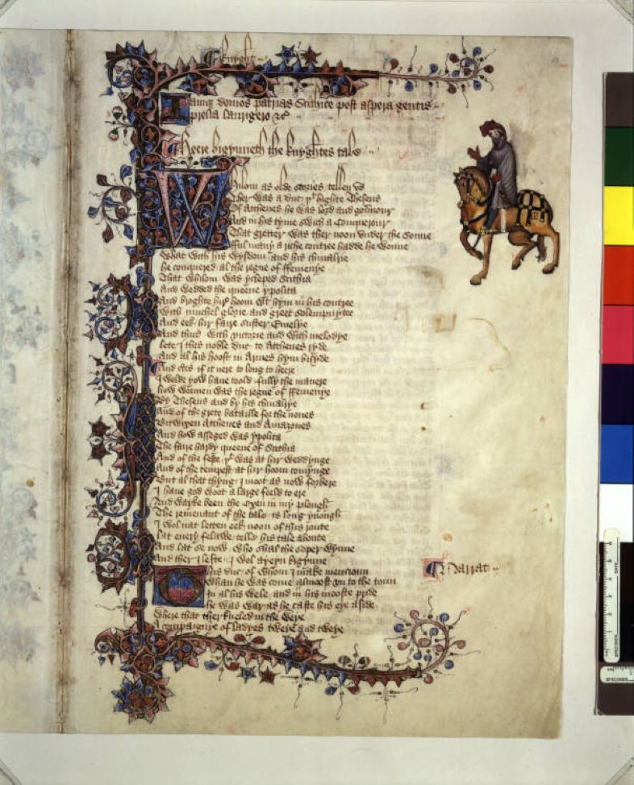
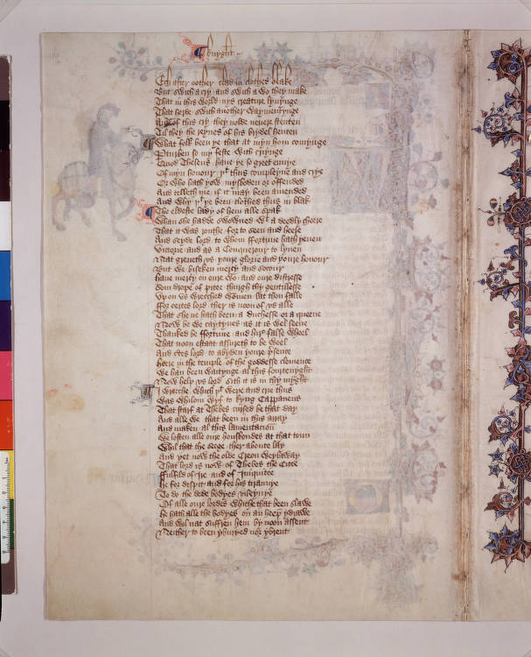
lamque domos patrias Scithice post aspera gentis prelia laurigero &c
Heere bigynneth the knyghtes tale
Whilom as olde stories tellen us
Ther was a duc t[ha]t highte Theseus
Of Atthenes he was lord and govenour
And in his tyme swich a conquerour
That gretter was the noon under the sonne
fful many a riche contree hadde he wonne
What with his wisdom and his chivalrie
He conquered al the regne of ffemenye
That Whilom was ycleped scithia
And wedded the queene ypolita
And broghte hir hoom w[i]t[h] hym in his contree
With muchel glorie and greet solempnytee
And eek hir faire suster Emelye
And thus with victorie and with melodye
Lete I this noble duk to Atthenes ryde
And al his hoost in armes hym bisyde
And c[er]tes if it nere to long to here
I would yow have toold fully the manere
How wonnen was the regne of ffemenye
By Theseus and by his chivalry
And for the grete bataille for the nones
Betwixen Atthenes and Amazones
And how asseged was ypolita
The faire hardy queene of Scithia
And of the feste t[ha]t was at hir weddynge
And of the tempest at hir hoom comynge
But al that thing I moot as now forbere
I have God woot a large feeld to ere
And wayke been the oxen in my plough
The remenant of the tale is long ynough
I wol nat letten eek noon of this route
Lat every felawe telle his tale aboute
And lat se now who shal the soper wynne
And ther I lefte I wol ayeyn bigynne
This duc of whom I make mencioun
Whan he was come almost unto the toun
In al his wele and in his mooste pride
He was war as he caste his eye aside
Where that ther kneled in the weye
A campaignye of ladyes tweye and tweye
Ech after oother clad in clothes blake
But swich a crey and swich a wo they make
That in this world nys creature lyvynge
That herde swich another waymentynge
And of this cry they nolde nevere stenten
Til they the reigns of his brydel henten
‘What folk been ye that at myn hom comynge
P[er]turben so my feste with criynge’
Quod Theseus ‘hav ye so greet envye
Of myn honour t[ha]t thus compleyne and crye
Or who hath yow mysboden or offended
And telleth me if it may been amended
And why t[ha]t ye been clothed thus in blak’
The eldest lady of hem alle spak
Whan she hadde swowned w[i]t[h] a deedly cheere
That it was routhe for to seen and here
And seyde ‘Lord to whom ffortune hath yeven
Victorie and as a conquerour to lyven
Nat greveth us youre glorie and youre honour
But we biseken mercy and socour
Have mercy on oure wo and oure distresse
Som drope of pitee thurgh thy gentilesse
Upon us wrecched women lat thou falle
ffor certes lord ther is noon of us alle
That she ne hath been a duchesse or a queene
Now be we caytyves as it is wel seene
Thanked be ffortune and hir false wheel
That noon estaat assureth to be weel

This work comes from the Ellesmere Manuscript, believed to have been created circa 1400-1410 and is a striking, ornately decorated manuscript of Geoffrey Chaucer’s Canterbury Tales. It includes illumination paintings of twenty-two of the pilgrims, who relate their tales to brighten their journey. The manuscript is an example of splendid workmanship by the scribe, written on good quality vellum, using goose quill pens and iron and oak gall inks to hand copy texts, the writing is neat and upright, with elegant flourishes, and the leaves are decorated with beautiful border illumination. It has 22 images of pilgrims in its borders, the character painted in the prologue has been proposed as Chaucer himself, but this is doubtful. To keep the narrative flowing Chaucer mostly uses the rhyming couplet in the Canterbury Tales, (described as aa, bb, cc, dd), the endings to each pair of lines rhyming. At this time the language written was Middle English, ‘The late fourteenth century was the age of Langland, of Gower and of Chaucer, that it was also the period which witnessed the decisive shift towards English as England’s vernacular,’ in the example are abbreviations which would only slightly quicken the writing process, sadly, none of the copies of the Canterbury Tales come from Chaucer’s own lifetime. There are no punctuation marks but the use of large blue or red letters at the beginning of a line appear to indicate the start of new sentences. The writing style is Anglicana, cursive script, a more rounded script and quicker to write for the scribe. The earliest printed copies of Canterbury Tales are believed to have been made by William Caxton around 1477.
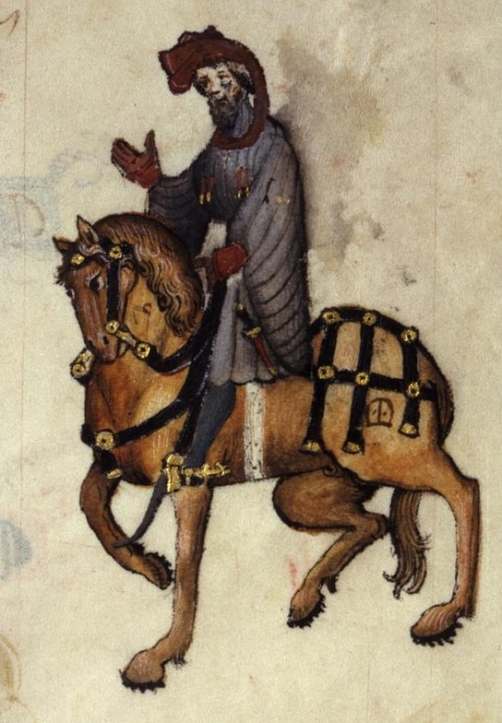
Illuminated manuscripts are both secular and non-secular, which is the case with the Canterbury Tales. It is not possible to know exactly who the scribe was but the name Adam Pinkhurst is suggested, however, whoever it was had access to Chaucers draft materials, possibly had worked with him before and had a strong idea of his intentions for the tales. With the Ellesmere manuscript the scribe appears to have faithfully transcribed the material with the occasional shorthand, it is generally accepted that he was responsible for placing the tales in the order in which we read them today. The earliest creators of illuminated manuscripts were scribes in the monasteries, hand-written on animal skin with highly ornate borders, historiated initials, (the first capital letter greatly ornamental), illustrations and possibly drolleries, (pictures in the margins). The illustrations in the book were practical as well as attractive serving to distinguish the start of a significant piece of the text, painted initials and miniatures allowed readers to follow the flow of the book with a single manuscript taking many years to complete. It was an expensive and slow process requiring the use of gold and silver leaf and costly paints made from a wide variety of elements, insects, chemicals, minerals and plants. Here in the The Knights Tale, the first page shows the incredibly ornate border, initial and figure. While the scribe has embellished the manuscript with bold colours, it is not as heavily painted with gold as a religious text might be, also, the figures are interpretive rather than realistic. Gold has been used to highlight the horses’ bridle accessories, the scrolls, leaves and flowers of the borders are brilliant. The second page shows the image coming through, evidence of the thinness of the animal skin and depth of colours used. This piece of work was valued, time and care spent on its presentation, nonetheless, 700 years later Geoffrey Chaucer would not have expected to see the manuscript still in existence. The Canterbury Tales are still relevant and significant today as a snapshot of 14th Century England and of the cares and issues that continue to affect people today. Chaucer had ‘ideals, a conventional one in the Knight and an unusual one in the Parson, and his other characters are satirised and their motives exposed,’ Hicks goes on to say that Chaucer ‘may once have accepted uncritically the standards of the time, but he had developed an independent judgement, profundity of thought, and a critical incisiveness all his own.’ He was the first poet to be buried in Westminster Abbey, it isn’t likely that it was due to his writings, more as recognition for all that he had done for the King in his lifetime.

Bibliography

Academia.Edu <https://www.academia.edu/34560281/What_picture_of_14th_century_English_society> [Accessed 31 December 2023]
Chaucer, G. The Canterbury Tales (Feathers Classics, 2018)
Early English Books Online <https://proquest.libguides.com/eebopqp> [Accessed 1 January 2024]
Gillespie, A. and Chianelli, J. Manuscripts of the Canterbury Tales (The Open Access Companion to the Canterbury Tales, 2017), pp. 1-10
Given-Wilson, C., Chronicles: The Writing of History in Medieval England (Hambledon and London, 2004)
Harvard University <https://chaucer.fas.harvard.edu/pages/text-and-translations> [Accessed 20 December 2023]
Hector, L.C. ‘English Handwriting in the Conquest’, The Handwriting of English Documents (Edward Arnold), pp. 51-59.
Hicks, M., Who’s Who in Late Medieval England (1272-1485) (Shepheard-Walwyn Publishers Ltd, 1991)
Middle English Alphabet <https://www.thehistoryofenglish.com/middle-english> [Accessed 20 December 2023]
Mortimer, I. The Time Traveller’s Guide to Medieval England (Penguin Random House UK, 2008)
The Chaucer Heritage Trust <The Life of Geoffrey Chaucer – The Chaucer Heritage Trust> [Accessed 30 December 2023]
The Huntington Library, Art Museum and Botanical Garden <https://hdl.huntington.org/digital/collection> [Accessed 20 December 2023]
The University of Alabama <The Making of Manuscripts: Materials & Illuminations - Libraries (uab.edu)> [Accessed 30 December 2023]

l Alexandra Gillespie and Julianna Chianelli, Manuscripts of the Canterbury Tales (The Open Access Companion to the Canterbury Tales, 2017), p. 2.
Michael Hicks, Who’s Who in Late Medieval England (1272-1485) (Shepheard-Walwyn Publishers Ltd, 1991), p. 166.
Alexandra Gillespie and Julianna Chianelli, Manuscripts of the Canterbury Tales (The Open Access Companion to the Canterbury Tales, 2017), p. 3.
Ibid, p.2.
Ian Mortimer, The Time Traveller’s Guide to Medieval England (Penguin Random House UK, 2008), p. 284.
Ibid. p. 71.
Chris Given-Wilson, Chronicles: The Writing of History in Medieval England (Hambledon and London, 2004), p. 140.
Michael Hicks, Who’s Who in Late Medieval England (1272-1485) (Shepheard-Walwyn Publishers Ltd, 1991), p. 167.
Ibid, p. 167.

