
Submission Date:
CertHE Computing Skills for Workplace



ACCA4022:
Computer Architecture and Operating Systems

Nafeesa Khan Begum
—
2223214
—
Lecturer Name: Md Shantanu Islam

Contents:

Introduction 4
Key functions of general Operating Systems 5
Task Management: 5
Application/Program Management: 6
File/Directory Management: 6
Device Management: 7
Security Management: 7
Use of Windows OS CLI commands 8
Example 1: 8
Example 2: 9
Example 3: 9
Example 4: 10
Example 5: 10
Example 6: 11
Example 7: 12
Example 8: 12
Example 9: 13
Example 10: 13
Use of Linux OS CLI commands 14
Example 1: 14
Example 2: 14
Example 3: 15
Example 4: 15
Example 5: 15
Example 6: 16
Example 7: 16
Example 8: 16
Example 9: 17
Example 10: 17
Use of Windows OS scripts 18
Example 1: 18
Example 2: 19
Use of Linux OS scripts 20
Example 1: 20
Example 2: 21
Conclusion 22
References 23
Appendices 24

Introduction

Throughout this report the key functions of general Operating Systems (OS) will be looked at. Some of these operating systems introduces commands for Command Line Interface (CLI) for Windows and Linux operating systems. As well as that this report will explore the aspects of Windows and Linux scripting and explains why scripts can be used to automate tasks, work more efficiently and help manage systems. The report illustrates how crucial operating systems are in the modern computing environment, through these topics.

Key functions of general Operating Systems

Windows Operating System (OS) is a system software that manages resources of a computer system, hardware and software, and serves as a platform to run applications. It is responsible for various required tasks and is constantly evolving [1]. Below are in-depth examples of some of these operations.

Task Management:

Windows Operation System runs tasks for user’s computer to work, and these tasks can all be seen on ‘Task Manager’. Each task that is run on windows is known as ‘running a process’. One of the ways to open Task Manager on a computer is by pressing Ctrl+Alt+Delete and then click "Task Manager" [2]. As shown in Figure 1 below, the Task Manager displayed 6 applications running a process and for the background process 68 applications where running.

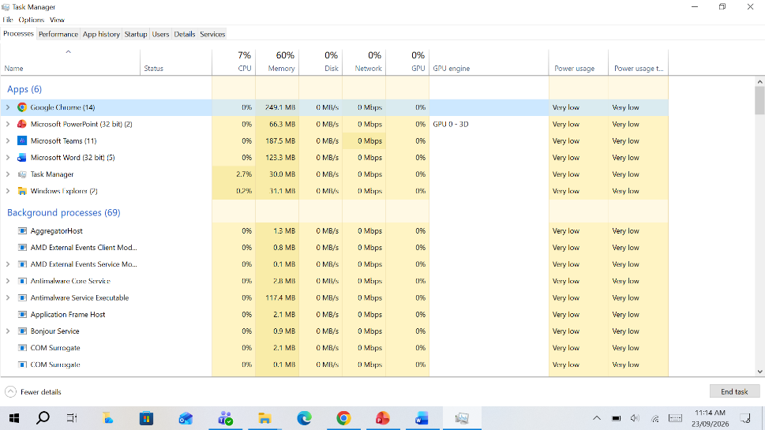
Figure 1: Task Manager

Application/Program Management:

Application/Program management is a system in Windows which shows users all the application on their device also known as ‘Add or Remove Programs’. As well as overseeing all the applications on your device users can also manage their settings, uninstall programs, and assign default apps for specific tasks [3]. As shown in Figure 2 is gives the option to search all the installed applications on the computer.

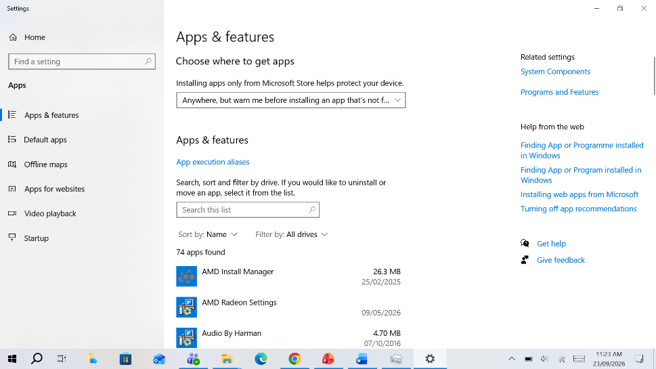
Figure 2: Application/Program Management

File/Directory Management:

In Windows, File Explorer acts like a digital filing cabinet were users can browse files and folders with ease [4]. Please refer to figure 3 to view an example of Windows, File Explorer. So as stated above this is a file manager in which users can access, save, edit, delete, rename, hide and organise all documents.

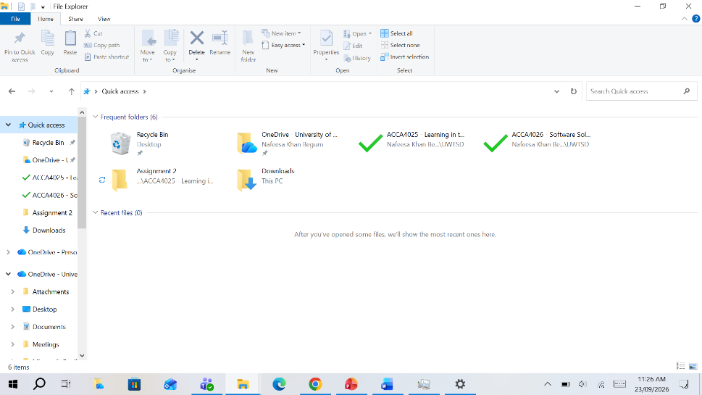
Figure 3: File/Directory Management

Device Management:

The Windows Device Manager allows users to view and manage the hardware installed on their computer [5]. Each hardwire is categorises and you must click the arrow to show each exact hardware as displayed in Figure 4. With this you can install, update or remove device drivers.

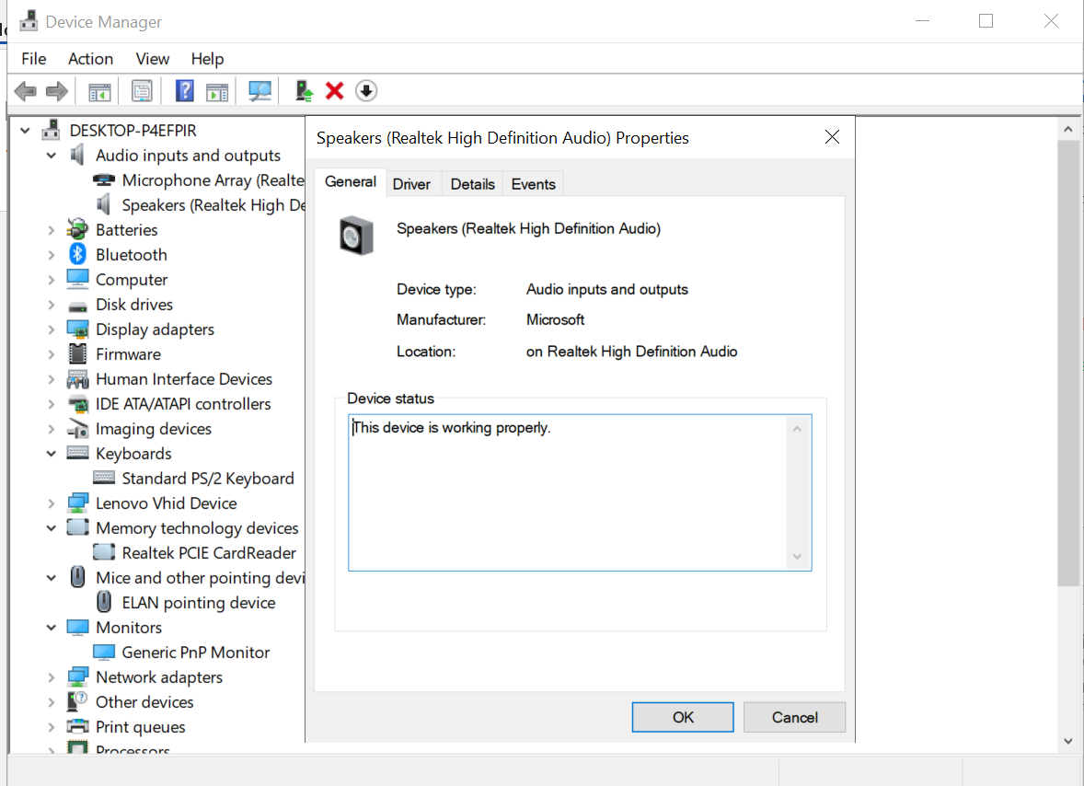
Figure 4: Device management

Security Management:

Security management in windows helps protect from viruses and has anti-virus software in place. So, this operating system recognises viruses by having a list of popular viruses and/or similarities of a virus and blocks it from access the hard drive. Furthermore, account protection is put in place with passwords and pins which thus doesn’t allow others to get in. Finally, there are firewall put up to protect against viruses through the internet/network connection and can set rules on who can access or send out. [6]
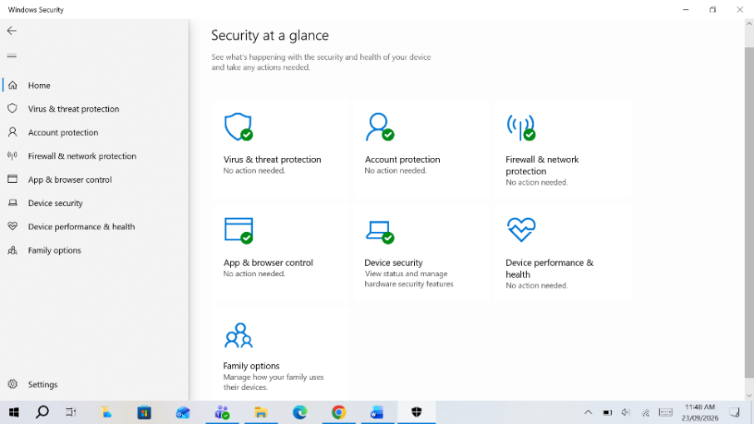
Figure 5: Security Management

Use of Windows OS CLI commands

A command-line interface (CLI) is one of the earliest ways people interacted with computers. Rather than clicking icons or using menus, users type commands to tell the computer what to do. A common example of a CLI is the Windows Command Prompt. In Command Prompt, all instructions are entered as text instead of using a mouse. Just before the cursor, the system displays the current directory path, showing where you are located within the computer's file system [7]. Please see examples given below.

Example 1:

The command I used in this example is ‘DIR’. DIR is short for directories. As seen in Figure 6 doing this command shows I have 13 folders.

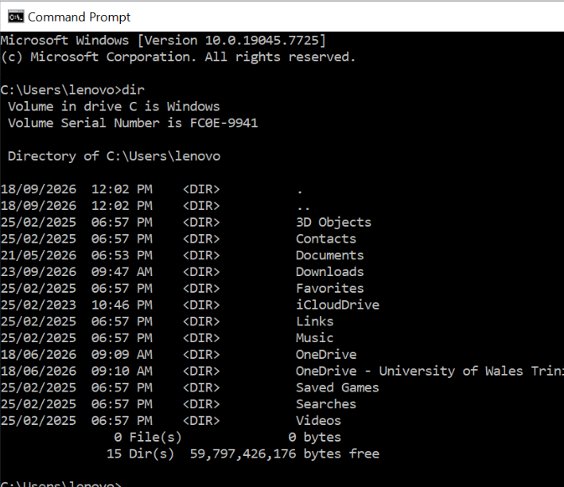
Figure 6: Command DIR

Example 2:

The CD (Change Directory) command is used to change your current location within the computer's file system. To move to a different directory, type ‘cd’ followed by the new location you want to access. If you want to move back one directory level, you can use the command ‘cd ..’. This is all shown in Figure 7 below.

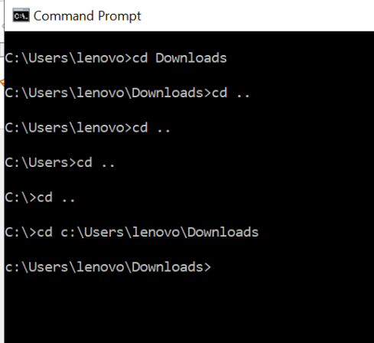
Figure 7: Change Directories.

Example 3:

The MKDIR (Make Directory) command is used to create folders in Command Prompt. Type ‘mkdir’ followed by the folder name, leaving a space between the command and folder name as shown in Figure 8. Multiple folders can be created by separating names with spaces. Two folders cannot have the same name in one location. Use quotation marks when folder names contain spaces.

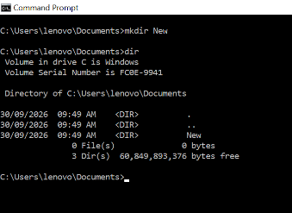
Figure 8: Make new folder.

Example 4:

The ‘rename’ command is used to change a folder's name. Enter the current folder name, then type the new name. This updates the folder name without changing its contents. Refer to Figure 9 for an example.

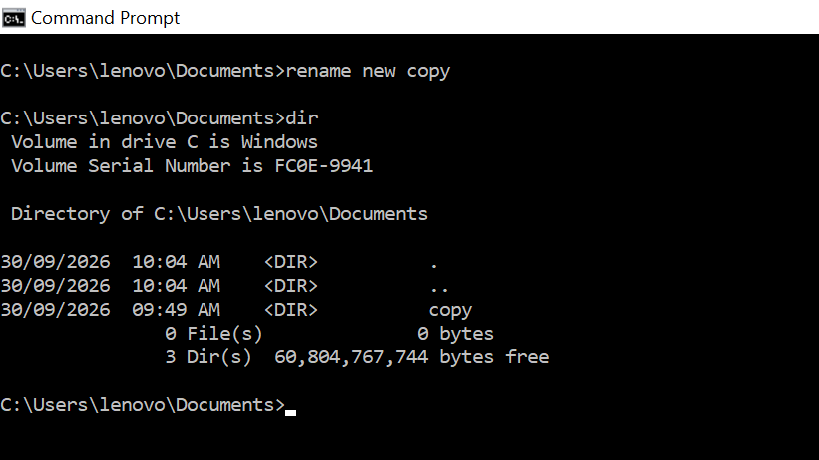
Figure 9: change name of folder

Example 5:

The RMDIR (Remove Directory) command is used to delete a folder. Type ‘rmdir’ followed by the folder name to remove it. Refer to Figure 10 for an example.

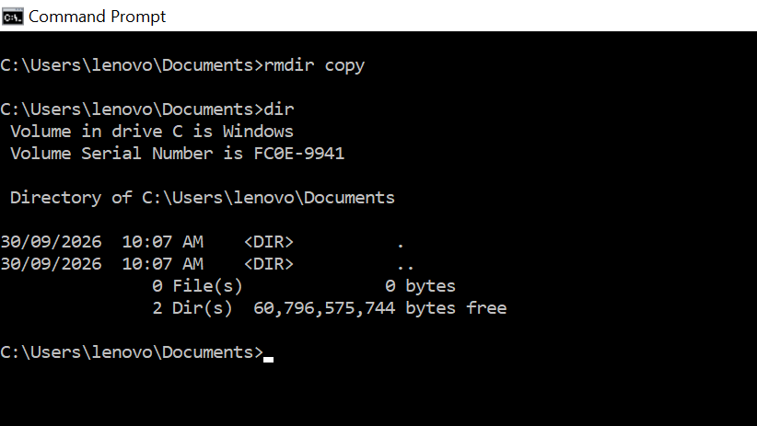
Figure 10: Remove directory.

Example 6:

The ‘ipconfig’ command displays your network configuration, including your IP address and internet settings. It is a commonly used command for checking network information. Refer to Figure 11 for an example of IP configuration.

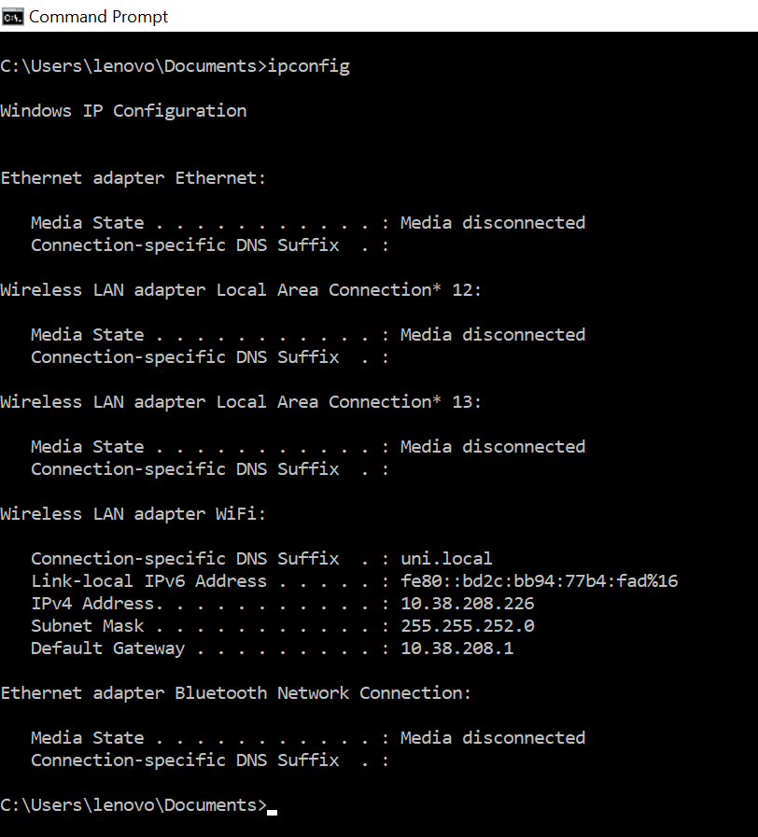
Figure 11: IP Configuration

Example 7:

The ‘netstat’ command displays network statistics and shows all active connections on your computer. It helps users monitor network activity and can be a useful tool for beginners learning cybersecurity.

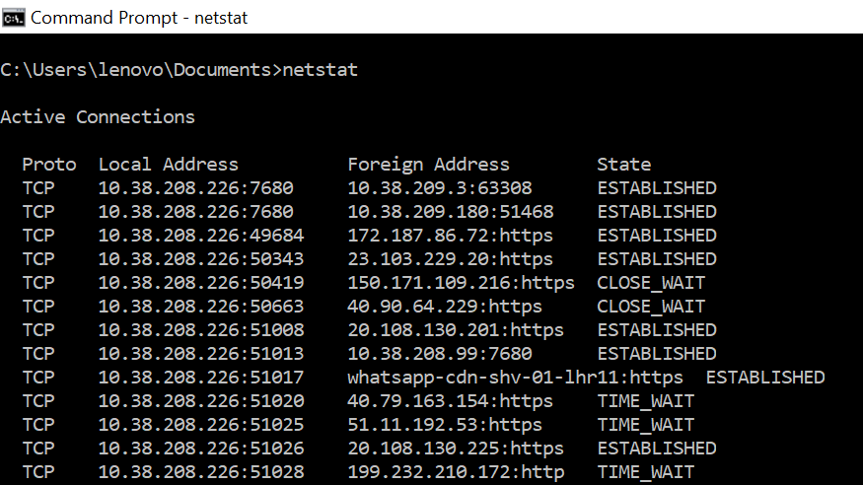
Figure 12: Network Statistics

Example 8:

The ‘ping’ command checks whether your computer has an internet connection. If a reliable website responds to the ping request, your internet connection is working.

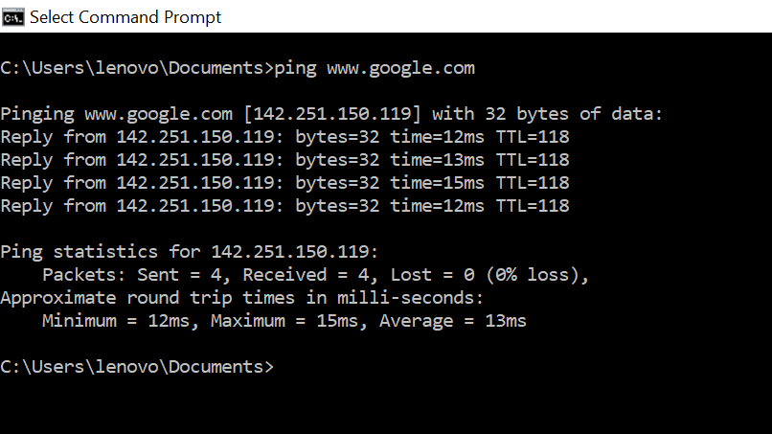
Figure 13: Checking Internet Connection.

Example 9:

The ‘tasklist’ command displays all running processes on your computer. It provides information similar to Task Manager by showing the tasks currently being performed by the system.

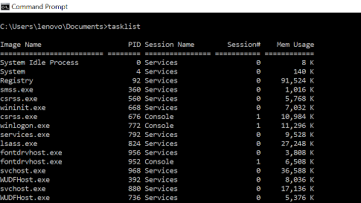
Figure 14: Task List.

Example 10:

The ‘systeminfo’ command displays detailed information about your computer, including the operating system, hardware specifications, and system configuration. Please refer to figure 15 for an example.

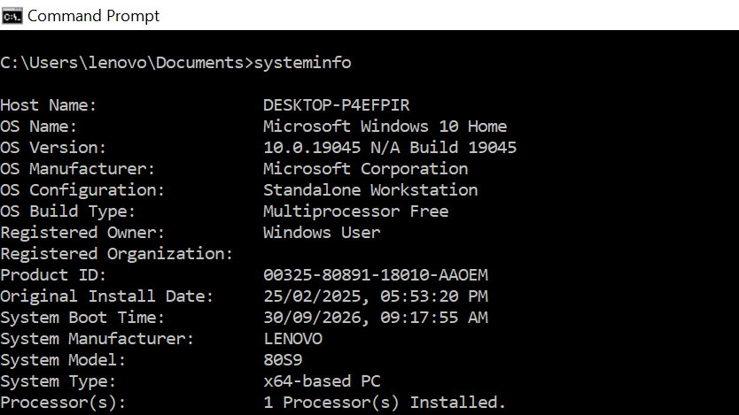
Figure 15: System Information.

Use of Linux OS CLI commands

Linux uses a command-line interface (CLI), where users type commands to interact with the computer. It can be used to manage files, run programs, and change system settings. Linux commands are case-sensitive and are usually written in lowercase. Every Linux system has a special user called root, who has complete access to and control over the system [8].

Example 1:

The ‘whoami’ command displays the username currently logged into the computer. It is a reliable way to identify the active user. The ‘date’ command displays the current system date and time. Both examples are used below in figure 16.

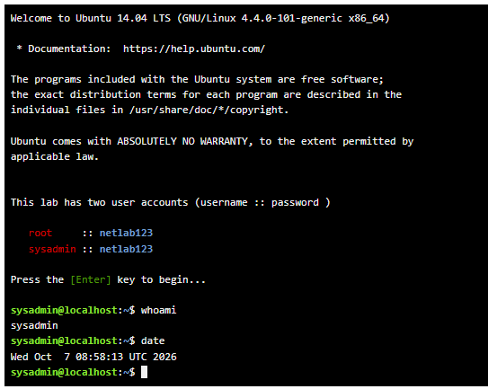
Figure 16: ‘date’ & ‘whoami’ Commands

Example 2:

The SU (Switch User) command allows you to change to another user account. After typing ‘su’, enter the username as shown in figure 17. When entering the password, the characters are hidden to protect your security.

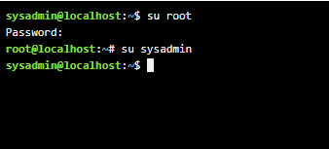
Figure 17: Switch Users

Example 3:

The LS command lists files and folders in the current directory. ‘ls -l’ shows detailed information, while ‘ls -a’ includes hidden files. Colours help identify items: blue for folders, white for files, and bright green for applications as shown in figure 18.

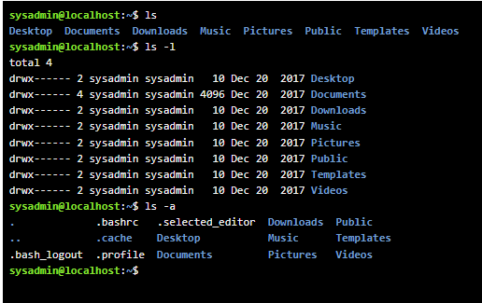
Figure 18: LS – list

Example 4:

The CD (Change Directory) command is used to move between folders. Folder names are case-sensitive, so uppercase and lowercase letters must be entered exactly as they appear. Please refer to figure 19 as an example.

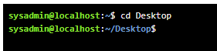
Figure 19: CD – Change directory

Example 5:

The ‘mkdir’ command creates a new folder, while ‘touch’ creates a new file as shown in figure 20. When using touch, specify a filename and extension, such as .txt, .doc, .mp3, or .pdf.

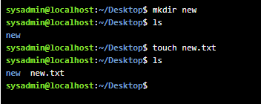
Figure 20: Make new files and folders

Example 6:

The ‘mv’ command is used to rename a file or folder. Enter the current name followed by the new name. The output shows that the file or folder has been successfully renamed as displayed in figure 21.

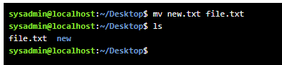
Figure 21: Change folder name.

Example 7:

The ‘rmdir’ command deletes only empty folders. ‘rm -r’ removes a folder and all its contents, while ‘rm’ deletes a specified file. Please refer to figure 22 for an example.

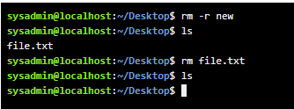
Figure 22: Delete folders.

Example 8:

The ‘echo’ command writes text into a file using the ‘>’ symbol. The ‘cat’ command displays the contents of a file. Please refer to figure 23 for an example of both commands.

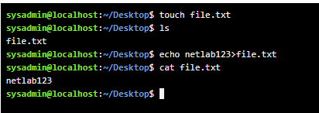
Figure 23: Read and write in a file.

Example 9:

The PWD (Present Working Directory) command displays the full path of your current location in the file system. As shown in figure 24 it shows the complete directory address you are currently working in.

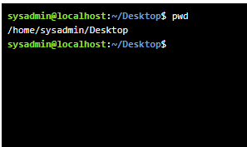
Figure 24: Present Working Directory.

Example 10:

The ‘ifconfig’ command displays network configuration details, including your IP address and network settings. Figure 25 displays an example of how the command shows information about active network interfaces and their configurations.

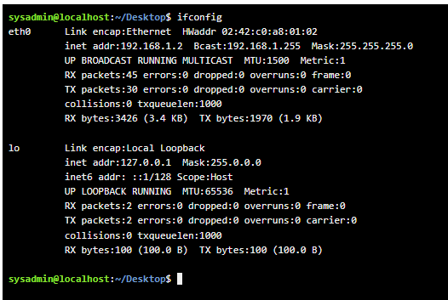
Figure 25: IP Configaration

Use of Windows OS scripts

Windows uses Batch scripting to automate tasks by running a series of commands. Scripts can be created in Notepad++ and saved with the ‘.bat’ file extension, there are several commands that can be used in a Batch file some of which include the ‘SET’ command which is used to create a variable. ‘ECHO’ displays text or values on the screen, the ‘=’ symbol is used to give a value to a variable, ‘/p’ lets the user enter a value and ‘/a’ lets the computer perform calculations. Furthermore, the ‘%’ command is placed before and after a variable name to use its value. The ‘PAUSE’ command makes the program wait until a key is pressed. Finally, the ‘@echo off’ hides the commands being run, making the output easier to read. [9] There are many more command, please see below some examples that have been applied.

Example 1:
In Figure 26 below batch scripting is used to create an application, which in this case is a simple calculator. The commands mentioned above have been applied according. Please note if the ‘PAUSE’ command is not included, the Command Prompt window will close automatically when the program finishes running. After saving the file, locate where it was saved using File Explorer, then double-click the batch file to run the application as shows in Figure 27.

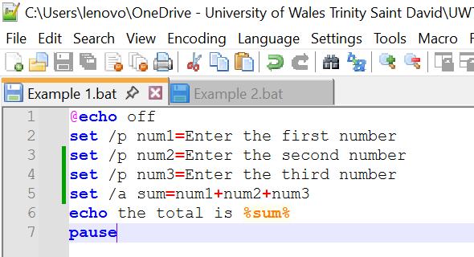
Figure 26: Script of basic calculator.

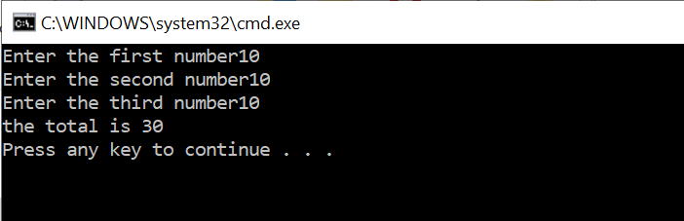
Figure 27: Output of basic calculator

Example 2:
Another example of batch scripting that was done was to find out individuals Age and if they are eligible to vote. In Figure 28 the ‘IF’ command is used to check whether a condition is true. If the condition is true, the program follows one set of instructions. If the condition is false, the ‘ELSE’ command tells the program what to do instead. Please refer to Figure 29 for examples of both.

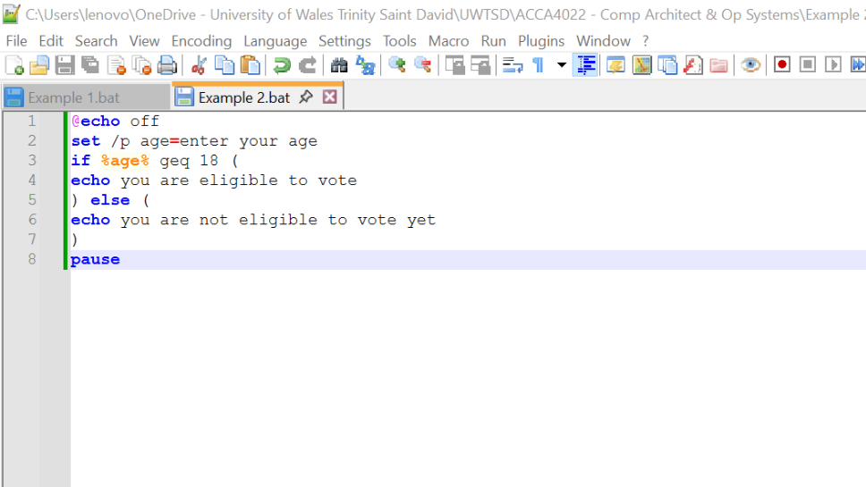
Figure 28: Script of eligibility to Vote depending on age.

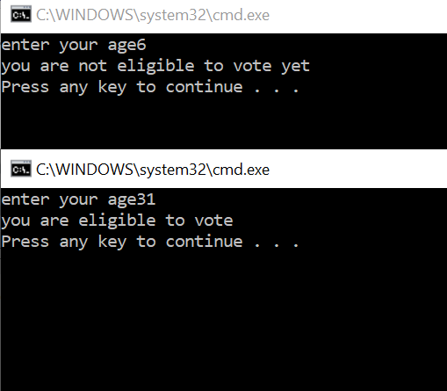
Figure 29: Output of both responses you will receive if you are eligible to vote or not.

Use of Linux OS scripts

BASH scripting is used to automate tasks in Linux. Scripts can be created and edited using Nano. The ‘echo’ command displays text on the screen, the ‘read’ command accepts user input, and the ‘=$(( ))’ command is used for calculations. BASH scripting is commonly used for file management, system administration, and task automation [10]. Some examples are given below.

Example 1:
The ‘chmod +x’ command allows a file to be run like a program. Figure 30 shows it was used on a calculator script that adds three numbers together. Figure 31 displays the calculated sum after the user enters the values.

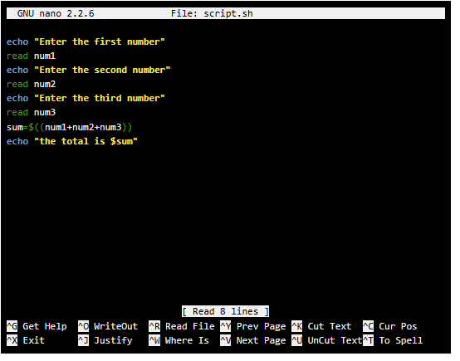
Figure 30: Nano software adding 3 numbers.

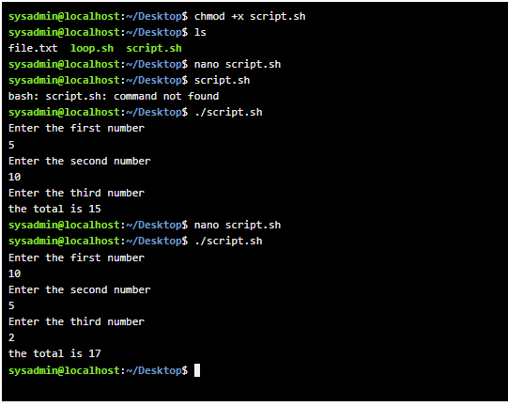
Figure 31: Output of file into application.

Example 2:

In this example, a loop repeats a task using three values: ‘i = 1’ is the starting number, ‘i <= count’ is the stopping point, and ‘i++’ adds 1 each time. ‘i--’ subtracts 1 each time. Please refer to figure 32 for visuals. Figure 33 shows the output of the loop running repeatedly until the end value is reached.

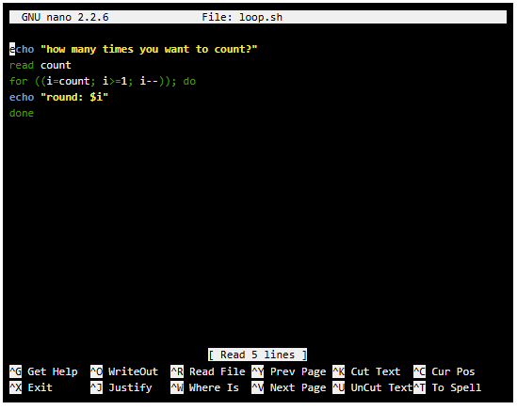
Figure 32: Nano software creating a loop.
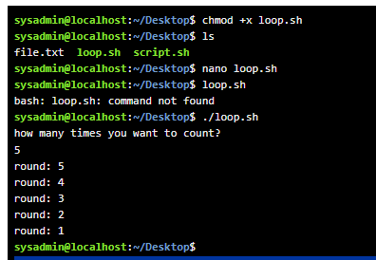
Figure 33: Output of loop.

Conclusion

Operating systems help manage files, applications, hardware devices, and security. Windows and Linux command-line tools provide an efficient way to control and manage a computer. Scripting helps automate repetitive tasks, saving time and improving productivity. Understanding these features is important for effective computer use and system administration.

References

[1] | B. Wójtowicz and N. Wójcik, “The evolution of Microsoft Windows operating systems after 2001,” Journal of Computer Sciences Institute, vol. 32, p. 186–193, Sept. 2024.
[2] | C. Hoffman, “Windows Task Manager: The Complete Guide,” 28 03 2019. [Online]. Available: https://www.howtogeek.com/405806/windows-task-manager-the-complete-guide/. [Accessed 10 2026].
[3] | bitaylor-creates, “Understand and explore Windows Settings,” Microsoft Support, [Online]. Available: https://support.microsoft.com/en-us/accessibility/windows/understand-and-explore-windows-settings. [Accessed 14 10 2026].
[4] | A. Rathbone, Windows 11 for dummies, 1st ed., Hoboken, N.J: John Wiley, 2022.
[5] | markdefalco, “Device Manager,” Microsoft, 29 Jan 2019. [Online]. Available: https://learn.microsoft.com/en-us/shows/inside/device-manager. [Accessed 15 10 2026].
[6] | Microsoft, “Windows Security,” Microsoft Learn, 27 05 2026. [Online]. Available: https://learn.microsoft.com/en-us/windows/security/operating-system-security/system-security/windows-defender-security-center/windows-defender-security-center. [Accessed 18 10 2026].
[7] | GeeksforGeeks, “Difference between CLI and GUI,” 22 Sep. 2025. [Online]. Available: https://www.geeksforgeeks.org/operating-systems/difference-between-cli-and-gui/. [Accessed 18 10 2026].
[8] | Luxembourg Public eXchange Point (LXP), “Basic Linux Commands,” LXP Documentation, [Online]. Available: https://docs.lxp.lu/first-steps/basic_linux/. [Accessed 18 10 2026].
[9] | A. Paul, “Windows Batch Scripting,” SlideShare, 10 Jul 2021. [Online]. Available: https://www.slideshare.net/slideshow/windows-batch-scripting/249925499. [Accessed 18 10 2026].
[10] | L. Reynolds, “Bash Scripting Tutorial: A Beginner's Guide,” LinuxConfig.org, 22 Sept 2025. [Online]. Available: https://linuxconfig.org/bash-scripting-tutorial. [Accessed 18 10 2026].

Appendices

Online Course Name: ‘Data Analytics Essentials’ offered by Networking Academy through the Cisco Networking Academy program.


Figure 34: Certificate of completion

