
Skills for the Workplace
Module Assignment Submission
Student Name: | Ismatara Begum
Student Number: | 1811532
Module No: | BMSK4003
Module Title: | Digital Skills and Research Methods

Statement of Confirmation of Authenticity
By the act of making this submission, the student declares that this is the work of the student named above. The work has not, in whole or in part, been knowingly presented elsewhere for assessment, or where assessment has been built on a previous assessment, this has been identified. Where materials have been used from other sources it has been properly acknowledged. If this statement is untrue, the student acknowledges that an assessment offence has been committed.
Attention is drawn to the plagiarism and unfair practice policies of both the University and of ILM.
Permission for ILM to use this script
ILM uses learners’ submissions – on an anonymous basis – for assessment standardisation. By submitting, both the centre and the learner agree that ILM may use this script on condition that identifying information is removed. However, if you are unwilling to allow ILM use this script, please refuse by ticking the box: □

Contents
Introduction 3
What has been the impact of 21st Century Technologies on the modern workplace? 3
An Overview of the 21st Century Workplace 3
An in-depth look at technologies used in own workplace 7
An exploration of the use of social media in the workplace generally 10
Comparison and evaluation of my social media accounts 14
An in-depth look at the use of social media in own workplace 16
Conclusion 16
References 17

Introduction
The aim of this report is to provide an overview of how modern technology and social media have impacted the modern workplace and personal lives. It will give an analysis of how technologies have transformed the workplace as well as creating a new set of work-based risks for employers to understand and manage. The report will also assess different kinds of social media as to their uses and effectiveness in the workplace and will also provide a risk assessment in order to understand the main advantages and disadvantages. To support my findings, I will research and use credible sources after putting them through the CRAAP Test. This test is a methodology that helps interrogate source materials. It does this by asking whether a source is Current, Relevant, Accurate, Authentic and Purposeful.

What has been the impact of 21st Century Technologies on the modern workplace?

An Overview of the 21st Century Workplace
Over the last 200 years there have been many transformations in the world of work. Previously the industrial revolution brought about a number of changes to how people lived and worked. In terms of social economic health and political context the changes brought on by industrial revolution had a permanent and irreversible impact on society. In the last forty years multiple breakthroughs in information and communication technology have had a further profound impact on how people live and work. In particular, changes in technology have made some lines of work obsolete whilst completely transforming how other services are delivered. Changes in technology have had a decisive impact on everything from the work patterns of employees to the tools they use to deliver their work and even has had an impact on the location on where work is conventionally carried out.
Technological advancement
In order to understand the true impact of technology in the modern workplace it is first important to gain appreciation of the technological advancements in the past forty years or so. The biggest change in technology in recent decades has been the movement from manual labour to automation. It goes without saying that there are a handful of professions that are manual in nature such as building work or arts and crafts related activities. However, a large number of professions in the professional services space as well as professions in the engineering space are now heavily reliant upon automation in order to deliver goods and services. An example of this change in the most extreme form can be seen in the area of financial services. At stock market exchanges such a high level of mathematical automation is now used that billions of transactions now happen at the touch of a button. These transactions are based on algorithms initially written by computer scientists. However now computers are writing far more sophisticated algorithms and have taken away a sense of control and human accountability. As a result, on the rare occasion stock markets have suffered so called flash crashes where billions of dollars are wiped off the values of the companies within a matter of seconds.

Methods of communication
One of the biggest changes that modern technology has caused within the workplace is the way in which employers and employees communicate with each other. Historically methods of communication within the workplace and to the workplace was highly fixed and inflexible. For example, the typical worker would travel into an office at a fixed location and stay at that location until the work was done for the day. If workers needed to communicate with other individuals in the organisation this would typically be done via telephone. If an employer was away from the office on sick leave and was unable to use the telephone then they would have to physically write a letter and send through the post. The following examples show how technology has transformed the above working pattern in many workplaces across the world.
- The introduction of the internet
Since the early nineties one of the most ubiquitous technological changes in the workplace has been the introduction of the internet by Sir Tim Berners-Lee. The worldwide web has enabled companies and individuals to communicate electronically and effectively which waved the need for paper-based communication. In todays world electronic mail is the primary method employers use to convey instructions and messages to each other.
Thomas W. Malone from the MIT School of Management says “with new technologies like email, instant messaging, and the internet, it’s now becoming economically feasible-for the first time in human history-to give huge numbers of people the information they need to make more choices for themselves.” This simple observation highlights the biggest impact that the internet has had on the modern workplace and it is at once both an advantage for a company as well as potentially causing its downfall. Having put this source through the CRAAP test, Malone’s views can be considered current and relevant because he is someone who specialises in the debate around technology. He can be considered an authoritative source as MIT is almost universally regarded as one of the world’s leading centres for technology with a purpose and therefore most likely they would provide accurate and authentic views.
The choice now given to consumers means that companies can use the internet to provide highly tailored goods and services. As a result, companies need to understand what their key target audience is thinking about. This also means by default that if a company is not utilising the internet in order to understand and communicate with its customers then it will suffer negatively. This trend highlights another major impact of modern technology in the 21st century workplace, in that there are now many companies who only trade online. They are able to do this by customising their communication and utilising customer data in an effective way. An example of this is Lastminute.com. Lastminute.com essentially does all the leg work on behalf of a customer in terms of the end to end process of searching and booking a holiday. This has had a massive impact on traditional high street travel agents who have had to develop an online presence or simply fail as a business. This example also encapsulates one of the main disadvantages of the internet and its use in the modern business in that it has removed a sense of personal human touch. Sometimes people prefer to talk face to face rather than going through loads of drop-down boxes. It can be said that the situation is becoming even more impersonal as introduction of artificial intelligence has led to the spread of chat boxes in the form of online help chats.

- Mobile technology
Historically due to limits of technology people would spend their work time in a specific location. However, transformations in mobile technology have transformed the very definitions of what a workplace can be. This change began initially when mobile phones became a mass market product and a tool of everyday life. Through the combination of mobiles and internet people have been able to move from one location to another whilst at all times being able to complete work tasks. Marc Wilkinson a technology expert from global technology company DXE has written about the impact of mobile technology in the modern workplace. He has highlighted the main need for companies to be flexible and agile when delivering services. He highlights that many businesses wish to use mobile technology in order to increase collaboration and connectivity between employees. He also highlighted that businesses have found that mobile technology has enabled them to deliver work in a more strategic way and boost specialisation. But Wilkinson also points out one of the main dangers of mobile technology which is concerned with the idea of allowing people to work from anywhere, in isolation. He cautions that in some cases work needs to be delivered in a shared space. And that the idea that people should be allowed working from anywhere is effectively wrong and can be detrimental for the business and the individual. He also touched upon how mobile technology has helped move the balance of power in an enterprise from the employer to the worker. And this has happened in the form of Bring your own device (BYOD) which can benefit work and personal life balance. It is important to note that on the one hand DXE being a global technology provider can provide a highly authoritative view of the impact of technology in the modern workplace. But by the same token their accuracy in regards to technology trends might be overstated as for sales reasons they have a natural inclination to promote some technology over others. And therefore, what they say is to be treated cautiously in some regards.

- Web Conferencing
Despite the ability of the internet and mobile phones to increase speed and location efficiency, for a long time one of the most difficult elements of the workplace to replicate using technology has been face to face direct communication. This has been because up until the last ten years data transfer protocols have been limited. As a result, watching a video in so called real time on the internet has been challenging. However, in the last fifteen years there have been great expansions in data transfer speeds and the quality of the data. As a result, videoconferencing has become a fully-fledged modern business tool. In many businesses there is no longer a need for team members to physically attend team-based exercises. Through video conferencing facilities individuals are now able to fully participate in team meetings from any location in the world. Skype is one of the biggest web conferencing tools in the world. It has sub-division called ‘Skype for Business’ which is an enhanced version of the tool suitable for large and complex organisations. It has been shown that videoconferencing has a better ability to reduce levels of depression. A study discovered that when comparing video-chat, emails, social networks and instant messaging, communication via video particular among older adults indicated that they had lower risks of depression. These findings have been published in the American journal of Geriatric Psychiatry, 2018 (Teo et al, 2018). I agree with this research as it seems to confirm what many technologists believe about video conferencing, which is that the visual human interaction can boost communication and collaboration and removes the danger of isolationism. This is a current and relevant research from a highly authoritative Journal that was undertaken for scientific and mental health purposes. Despite this it should be noted that Get Safe Online, the advice service for safer online browsing has highlighted risks of video conferencing that companies can face. One of these risks is the ability for anybody to access the login details just by viewing the invitation. This means that within the organisation sometimes a sense of familiarity can trump security and this is something businesses need to be aware of.

- Storage
During the era when paper was at the heart of workplace output, one of the main considerations that businesses had to attend to was storage. Files and records would traditionally take up vast amount of floor space within businesses. There would be entire department dedicated to records management. It goes without saying that some sectors such as Law enforcement are mandated to continue to this hardcopy approach to records management due to security and evidential reasons. However outside of these spaces across most sectors changes in technology have led to most information being stored electronically which benefits the environment. These electronic records were initially kept within the confines of the business premises itself. However, advances on technologies and securities now mean that much of a company’s electronic information is stored externally on the premises of storage specialist companies. This new approach is called storing information in the Cloud. It has a number of data and security implications. There are many Cloud-based software and storage tools which are popular with businesses and individuals such as Google drive, Dropbox and One-drive.

When understanding the advantages and disadvantages of Cloud storage one of the main areas that needs to be considered is the impact of data. The advent of Cloud storage has led to a break in the logical relationship of data ownership. Previously a company would store its own data within its parameters. Cloud storage has meant that a company hands over all of its data to a third party. This approach has led to a number of security risks that needs to be addressed when a company moves to the cloud. For example, many public sector authorities stipulate that their data should either be held in a private cloud environment or that their data should be kept behind a cage in a data centre. In recent years a further consideration has arisen in the form of the European Union’s General Data Protection Regulations (GDPR). The GDPR is a set of rules that has the aim of giving consumers greater protection in regards to their personal data. Insight which is a global technology provider has published information on how the GDPR has impacted on Cloud services. Insights first point is concerned with sovereignty. It says that the new rules mandate that the data of EU Citizens must either be stored in the EU or subject to EU privacy laws. This creates a challenge for many organisations who store their data with large US companies on US soil. An interesting find of a recent GDPR case is that the Internet Giant Google is fined £44m over ads by the French Data Regulator CNIL, for a breach of the EU’s data protection rules.

- DATA, Information, Knowledge, Understanding and Wisdom
Professor Ackoff was a professor of organisational change. He postulated that everything that we store in our minds can be divided into 5 categories. The first category is Data and this is interpreted as purely symbolic. The second category is information. This is when data is processed so as to answer questions like who, what and why. The third category is knowledge. This puts together the data and information in an attempt to answer how questions. The fourth category is understanding and this category is pre-occupied with the appreciation of why. The fifth category is wisdom and this category is based on an evaluation of what we understand. Later on, it will be shown how Ackoff’s model is used in my personal workplace.

An in-depth look at technologies used in own workplace
Wifi
In my workplace the introduction of Wifi across the building has had a positive effect on the business particularly in the area of collaboration. Previously employees were largely stuck at their desks due to connectivity restrictions. With Wifi enabled staff can take their laptops into meeting rooms and use it more efficiently e.g for project work. When on a business meeting with stakeholders at their offices, there are high security risks connecting to outside networks as confidential online files can get hacked. This limits what online files can be accessed while at a business meeting which can be a dis-advantage as you won’t always have the information to hand when needed. Also, one of the main dis-advantage of Wifi is that when the system is down people are unable to access the network and do their work or access files which inevitably causes delays.
Mobility-Laptops
Due to safety and security reasons my organisation does not have a long history of allowing employees to work from laptops. This has meant that even as recently as 3 years ago staff have been restricted to fix locations. As many other government departments had rolled out laptops to their employees several years ago, there was much disquiet in my department about work/life balance. The initiative to give senior staff laptops was initially triggered by the same financial concerns that other government departments faced. As a result, over the past 3 years there has been a phased rolled out of laptops to senior staff. As inferred, one of the drawbacks of the policies has been that junior staff have not been issued with laptops on the basis that they are not regarded from an organisational prospective as being operationally critical. However, this is misguided as from a survey I gathered, many Junior staff undertake core administrative duties that could be enhanced if they were able to do these remotely. Also, most believed that this would increase their technological skills and experiences in order for progression.

The civil service department I work in has several technologies in place. As there are an extensive list of modern technological tools that are used, I will concentrate on evaluating the key ones below:
The department has put in a strategy to implement cloud storage in the coming two to three years. After researching views of different employees, I have gathered that most believe that the main advantage to the organisation will be cost efficiency and better use of infrastructure. At the moment many pieces of software are operated on the organisation’s infrastructure. In the future software will be run on the infrastructure on the organisation that produces the software. This means that the department will benefit from technological economies of scale and will suffer far fewer technical glitches. The main disadvantage of this approach is that the department may lose an element of control. Because the specific supplier provides a cloud service for many of its customers, it has a standardised approach to service level agreements. In some cases, having a standardised approach is not sufficient when delivering public services. In order to have a more bespoke service level the department may have to pay a higher price for the delivery of that service and so lose some of the financial benefits of going to the cloud in the first place.

Technological tools | Purpose | Advantages | Disadvantages
Oracle | To pay suppliers | Payment made instantly as electronic system so highly effective.  Highly secure as protected by a number of firewalls. | Technical issues could prevent payments from being processed on time  Security risks as with all online bank transactions
SAP | Used for employee salaries and travel expenses | Secure and easy to use  Example of enterprise resource planning tools (ERP)  ERP tools main benefit is to amalgamate and track and trace transactions effectively. | When there is a system error you will not be able to access information like salaries, invoices and purchase orders etc at the required time.
Electronic Folder | We use electronic folder to store customer information and records. | Highly secure and prevents us going into the filing rooms to search through huge quantity of customer records to find the specific customer information that we may require which is time consuming.  Effectiveness of storing customer information in an electronic folder is that we can easily filter and search for the right piece of information within a short time. | Downside again is if the system is down you can’t access the records in time which will cause delays
Box | To store files.  Mainly used as a collaborative tool so different people in the organisation can access and work on the same file from different places at the same time if needed. | Work is done efficiently and people do not have to email versions back and forth to one another.  Box has a built-in version control mechanism so that it records when a change is made to a document, what the change is and who has made the change. It is not possible to tamper with this control mechanism. And this allows for a record of changes to be kept and tracked in the event of any issues or disputes.  Collaborative | No internet, no access  Ownership permission required to access which can delay efficiency if the owner absent

Website
The department has a public facing website. From an internal perspective the content management system (CMS) that manages this website is very important. This is because providing a public service means the website needs to be constantly updated with the latest information. The website also has a feedback mechanism where by members of the public can send comments and complaints back to the department. This is beneficial for the department’s continuous improvement. In recent times the department has turned to advertising jobs on social media platforms such as Facebook and LinkedIn. This is so that more people can be aware of the vacancies available as a lot of people use social media on their smartphones. One of the known dis-advantages of the public facing website is the comment section. In recent years the phenomenon of trolling has occurred. This is where individuals publish abusive comments purely for the sake of wanting to be abusive or defame another person or an organisation. This happens a lot on social media sites, in particular on Facebook.
Microsoft Office
Microsoft Office is a software package that has been at the heart of the technological transformation in the workplace. It includes essential tools like word-processing and database management in order to help people process day to day activities. My job requires significant data handling and as mentioned earlier I am able to process this using Ackoff’s theory. I initially have to obtain bulk data on an excel spreadsheet. The data in itself is meaningless. I then have to use filtering tools in order to give the data some meanings. This meaning allows me to understand questions such as who and what. By analysing the information, I am able to gain appreciation of why the information appears in a certain way. This also helps when I use Microsoft excel spreadsheets to download the enormous amounts of figures and dates of several quarters to analyse and compare to find any anomalies and discrepancies. Spreadsheets are very effective tools in quickly and accurately re-calculating figures or spotting any anomalies. From using this regularly I have picked up on many errors and mis-declarations that have prevented loss of money from the treasury and brought in more yield. This is for me one of the biggest benefits of modern technology in the workplace.

An exploration of the use of social media in the workplace generally
The online Cambridge university dictionary defines social media as “Websites and computer programs that allow people to communicate and share information on the internet using a computer and mobile number”. Social media has been one of the most transformational media channels in the past twenty years. Social media can be noted both for the speed in which its grown and the almost invasive way it has penetrated our personal and work life. In fact, before the advent of google many people think social media was nothing to think of. In the late 20th century we were able to see the early signs of social media in tools such as msn messenger. Since then advances in internet speed and mobile technologies have led to a range of applications being published. Today the most popular social media tools are Facebook, Instagram, Pinterest, Snapchat, Twitter, LinkedIn and WhatsApp. Each tool tries to promote a unique selling point.

Tools | Purpose | Advantages | Disadvantages
Facebook | Social networking, sharing photos and experiences, marketing, promoting, selling items, sharing news globally | Communicating with family, friends and sometimes strangers. Sharing photos or tagging each other to places you are in e.g. restaurants, theatres, holidays and other general day-outs. Advertising help or job or items for selling. You can write and share blogs. Sharing news so you could keep up to date with current affairs or be aware of what is happening around you. Some jobs are advertised on Facebook and you could see and apply. | Thieves and robbers could become aware of your whereabouts e.g. how far you are from home and attempt a house robbery. Criminals might track you down or children for kidnapping etc. People could steal your photos. Your ex’s might be able to stalk you. Employers may check your Facebook to determine if to hire you or not. No full privacy.
LinkedIn | Primarily a business and employability network, advertising services, promoting jobs and business-related news | Provides a direct access to jobs and recruiters. Promotes your skills and experiences and employability. Provides an analytical, insights on things like salary expectations. It is a professional tool. | Your employer may find out you are applying for other jobs or advertising your services. Your personal information will be online e.g. which company you may work for so your work address which always poses a safety/security risk. LinkedIn has a series of tools that require user authorisation in order for the tools to be more effective so user needs to be aware of how their data will be used before accepting these requests.
Twitter | Primarily a messaging system to share personal views and news within a limited character. Many politicians and celebrities use Twitter over other social networks in order to give an instant response or reaction to something | Instant communication. The limited nature of twitter messages can help to convey a sense of impact and succinct information. This has shown to be particularly useful when reporting fast moving news developments. | The nature of Twitter inherently encourages superficiality due to the limited information shared in a tweet.
Instagram | Primarily a photo sharing tool both personal photos to share experiences or one’s photos.  Also to advertise and promote items to sell online. This social network is most popular with the younger generation. | You can sell clothes, products and services online. You can write short blogs on Instagram with photos. | People could steal your photos. And Instagram has been known to encourage catfishing which is something when people steal other people’s photos for the purpose of creating a false identity.
Snapchat | An instant messaging tool. Youngsters like to share their life experiences captured in photos and keep each other up to date of where they are and what they are doing which sometimes can pose a safety risk. | Messages and photos disappear after a limited time so it is a bit more secure if only family and friends on it. | However too many scammers and predators use snapchat to groom or scam vulnerable youngsters who add strangers easily. Snapchatting can be addictive and waste of time when you start posing every little bit for the day on it as well as gaining security risks.
WhatsApp | This is also an instant messaging service but only connected to mobile phones. You can share photos and videos on it as well as voice recording. | It is free and fast to use. You can create group chats and communicate in groups whether with family members, friends, work group or student groups and share information and ideas together more efficiently. | Requires wifi access/internet.

Screenshots and analysis of my Social media accounts
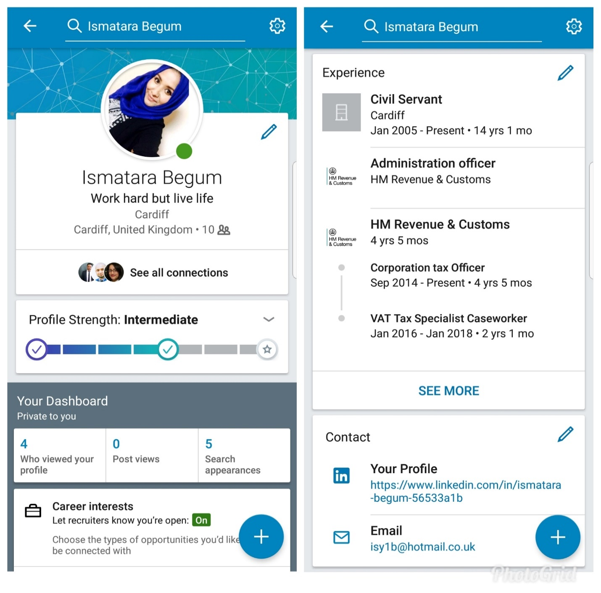

Facebook:
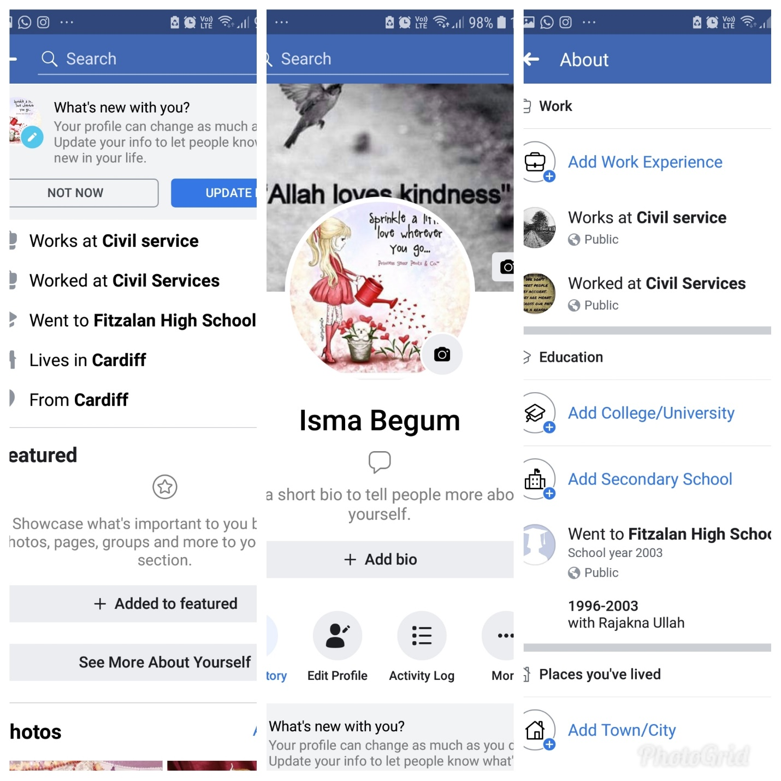

Comparison and evaluation of my social media accounts
Profile details | LinkedIn Profile | Facebook Profile
Layout | Simple layout, easy to navigate through | Quite simple layout too as not too active and engrossed in Social networking
Profile Photos | I put up a smiley unfiltered photo as I believe this photo makes me look like my positive and happy self and I wanted to show my bubbly personality through my photo | Contrary to LinkedIn I withhold from putting a profile photo of myself for safety reasons as any people can view your public photo and some scammers steal people’s photos and impersonate when doing any criminal activities online. I also did not want my photo to attract unnecessary friends request from strangers.
Background Photos | I preferred to keep it plain but with a positive quote | Just a background which makes it obvious I believe in Allah (God) and again a positive quote about kindness
Personal Information | Age, experiences and work details on it which I guess can pose a safety risk if someone wants to target or stalk you. (They may google HMRC Cardiff address and easily find out full address of work location) | Name shortened as don’t want anyone who searches to find me on it know it’s me as photos hidden and Isma more common name than Ismatara
Work details | As mentioned above | As stated civil service where there is broad departments no one would easily know which department I work for
Branding | My quote says ‘Work hard but live life’ which is my personal branding as I believe it is important to be hardworking but also have fun and enjoy personal life to have a positive mindset and contentment. | No interest to attract people to my Facebook except communicate with family and friends and keep up to date with things so no attention paid to have a personal branding as not on Facebook for advertising or marketing purposes but for personal use only
Employability Chance | Good chance as work experiences and some skills noted for potential recruiters to see or others to see and recommend for suitable jobs. | No controversial comments or photos on my Facebook to put employers off from recruiting me. However, nothing on it as such to promote employability either
Activity | Not active enough. Need to be more active on LinkedIn now to find a more suitable flexible job for work/life balance. Also need to invest time in uploading skills and connecting with professional people that have experience in similar fields. | Not too active, don’t post much which is a good thing. Less posting more chance of privacy and less chance of people knowing where you are or your business. Less risk overall.
Safety/ security measures in place | It is a public account. I didn’t mention addresses etc. Only connect with familiar faces. | Privacy settings enabled so only people on my friends list can view my photos and uploads

I think a LinkedIn profile is far more useful in terms of employability than Facebook because on Facebook people post their personal photos and comments or are tagged in photos which sometimes give the assumption the person may be immature or irresponsible. Therefore, recruiters would be put off from hiring the person after viewing their profile. Whereas LinkedIn is more professionally driven highlighting your skills and qualities and there appears to be a greater onus on maintaining professional standards. This view on mine is supported by a survey undertaking by Jobvite which is a recruiting platform. This Survey results state that LinkedIn was used by 79 percent of respondents for hiring purposes in comparison to 26 percent for Facebook. This difference is because as confirmed earlier people lower their inhibitions when posting on Facebook whereas LinkedIn is highly tailored for recruiting purposes and people avoid saying impertinent things on this platform. In contrast Facebook was according to responders used for branding purposes and referring friends.
Jobvite Survey results showing percentage of which social media was used for hiring purposes in 2014

An in-depth look at the use of social media in own workplace
The use of social media in my department is that it is used concurrently with more formal channels. For example, jobs are regularly posted in LinkedIn. However, for government transparency reasons all jobs are posted on the civil service jobs website which is a good thing as it promotes a standardised approach. Personally, I believe it is more effective for employability when it is advertised on the civil service jobs website because this process requires the disclosing of more personal information which allows the candidate to sell themselves more as well as keeping their information secure whereas with any social media the information is at more chance of being hacked. Some civil service jobs are highly secure so it is inappropriate to be processed outside government databases. In my workplace rapid communication with the public is very important. As a result, our department quickly embraced Twitter in order to disseminate important information. The approach to Twitter has been very successful and the department has a high number of followers on site. There is a Facebook page, but this is predominantly used for information and branding purposes but it isn’t operationally critical, whereas Twitter has become very important for our department e.g. public policy changes that are forthcoming are instantly shared on Twitter.

Conclusion
In conclusion we can say with certainty modern technology and social media have completely transformed the world of work and our personal lives. Technology has improved to such a degree that speed, accuracy and connectivity are almost taken for granted. These benefits have greatly increased efficiency in the workplace and have led to entire businesses being created online. Despite these benefits there are still a number of risks that companies are trying to manage. These risks predominantly revolve around data and access information. Data is the currency of the information age and so governments are trying to understand how best to regulate and manage it. Data is also at the heart of social media. Social media is based upon consumers disclosing information about themselves and their personal habits. Social media firms are sometimes accused of encouraging their members to disclose information too easily as these firms need this information to order to sell their products. However, this approach completely overlooks the privacy and safety concerns of consumers. In the professional realm, some tools such as LinkedIn are highly advantageous for career progression and professional networking. However, other tools such as Facebook have benefits at an organisational level such as branding and corporate communication. However, they are not as beneficial in the day to day activities of an employee and in fact can lead to unprofessional situations if the employee misuses them. So, the conclusion is that although modern technology and social media have many benefits in the workplace, they can also be detrimental in some regards whether in personal life or work life.

References
Thomas W Malone, (2014), Change: 19 Key Essays on How the Internet is changing our lives: (OpenMind Book 2014 Publications)
(Insight direct UK, article published online on 22nd May 2018) No formal author attributed to article.
Marc, Wilkinson “The real impact of mobile technologies on a digital workplace” Article: Insights
Professor Russell L. Ackoff, (2003) Systems thinking.org website
www.bbc.co.uk ‘Google hit with £44m GDPR fine over ads’ (Author Chris Fox, 21st January 2019)
Maund Andrew, Shriek Michaela, Tinkler Paul K, (2017), Certificate in Higher Education: Skills for the Workplace Student Yearbook (Sage publications)
Morgan, Peter (2017), The Business Student’s Guide to Study and Employability (Sage Publications)

