Ayesha Masood 2220784
MSc Public Health and Social care in practice
Community Care and Management of Longer-term Conditions
LCHS7003
Component 1
Information Booklet for Long- term Condition Management
Raheela Shaikh

Table of Contents
- Introduction
- Definition and Overview of Type 2 Diabetes Mellitus
- Prevalence and Burden of Type 2 Diabetes Mellitus
- Causes and Risk Factors
- Physical Impact of Type 2 Diabetes Mellitus
- Psychological Impact of Type 2 Diabetes Mellitus
- Social Impact on Individuals and Families
- Treatment and Management in the NHS
- Person-Centred Care and Self-Management
- Models of Long-Term Condition Management
10.1 Chronic Care Model (International Model)
10.2 House of Care Model (UK Model)
- National and Local Health Policy and NHS Strategy
- End-of-Life Care Considerations
- Conclusion
- Reference List

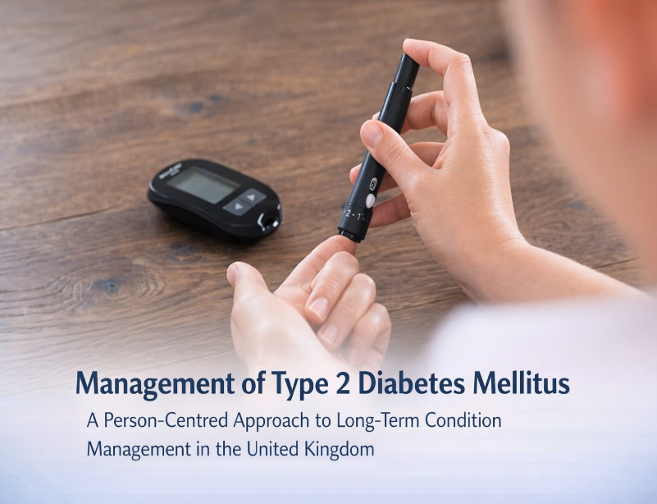

Linjawi (2026), My Health Explained

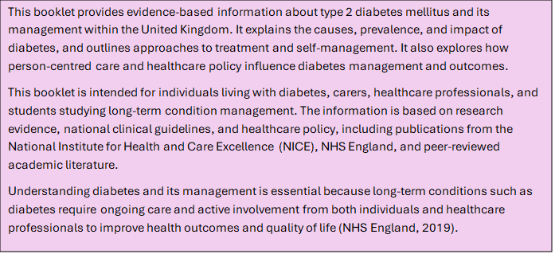

- Table of Contents
- What is Type 2 Diabetes Mellitus
- Prevalence and Burden of Diabetes
- Causes and Risk Factors
- Physical Impact of Type 2 Diabetes
- Psychological Impact
- Social Impact
- Treatment and Management in the NHS
- Self-Management and Person-Centred Care
- Models of Long-Term Condition Management
- 10.Health Policy and NHS Strategy
- 11.Recommendations for Improving Care
- 12.End-of-Life Care Considerations
- 13.Conclusion
- 14.Reference List

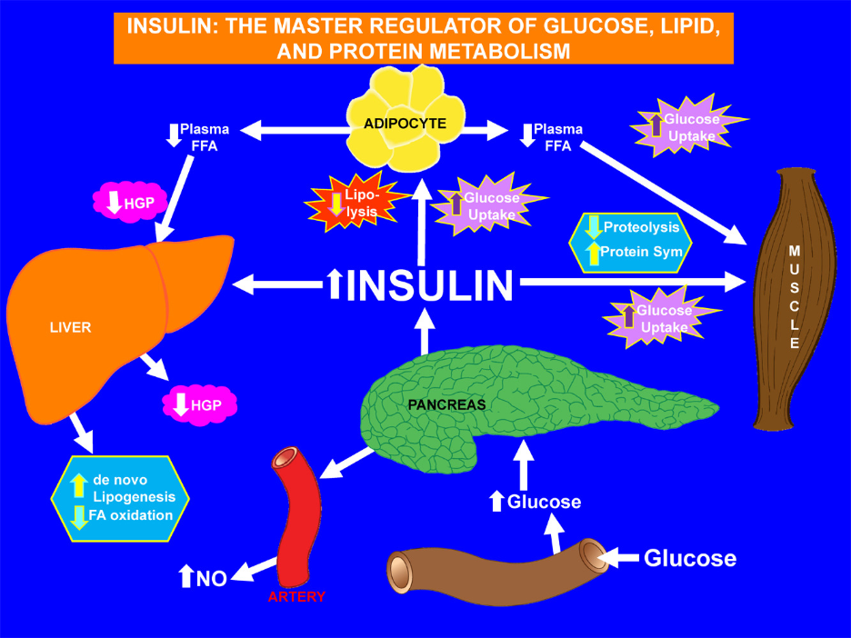Norton et al. (2022), Metabolism Journal
What is Type 2 Diabetes Mellitus
Type 2 Diabetes Mellitus is a chronic metabolic disorder characterised by persistently elevated blood glucose levels due to reduced insulin effectiveness and insufficient insulin production (American Diabetes Association, 2023). Insulin is a hormone produced by the pancreas that plays an essential role in regulating blood glucose by enabling glucose to move from the bloodstream into body cells, where it is used to produce energy. When insulin does not function effectively, glucose accumulates in the bloodstream, resulting in hyperglycaemia.
Unlike Type 1 diabetes, which develops due to autoimmune destruction of insulin-producing pancreatic cells, Type 2 Diabetes Mellitus typically develops gradually and is strongly associated with lifestyle factors, genetic predisposition, and environmental influences (International Diabetes Federation, 2023). A key feature of the condition is insulin resistance, where body tissues respond less effectively to insulin. In response, the pancreas initially produces higher amounts of insulin to compensate. However, over time, the pancreas becomes unable to maintain sufficient insulin production, leading to chronically elevated blood glucose levels (DeFronzo et al., 2015).
Type 2 Diabetes Mellitus is classified as a long-term condition because it cannot currently be cured, although it can be effectively managed through lifestyle modification, pharmacological treatment, and regular monitoring (NICE, 2023). If the condition is poorly controlled, it may lead to severe complications affecting vital organs, including the cardiovascular system, kidneys, eyes, and nervous system. These complications can significantly reduce both life expectancy and overall quality of life (Forouhi and Wareham, 2014).
Early diagnosis and appropriate management are essential in reducing the risk of long-term complications. Healthcare professionals play a crucial role in supporting individuals by providing education, treatment, and ongoing clinical monitoring to promote effective management and improve health outcomes.

Prevalence and Burden of Diabetes
Diabetes is recognised as a major global public health issue, with prevalence increasing significantly worldwide. According to the World Health Organization (2023), approximately 422 million adults are currently living with diabetes globally, with Type 2 Diabetes Mellitus accounting for around 90–95% of all cases. This increase is associated with rising levels of obesity, reduced physical activity, and ageing populations.
In the United Kingdom, diabetes affects approximately 4.3 million people, and this figure is expected to rise further in the coming years (Diabetes UK, 2023). In addition, a considerable number of individuals remain undiagnosed, which increases the likelihood of developing serious complications due to delayed diagnosis and treatment. Diabetes also places a substantial financial burden on healthcare systems, accounting for approximately 10% of total NHS expenditure (Hex et al., 2012).
Long-term conditions such as diabetes represent a major proportion of healthcare demand, accounting for around 70% of NHS spending and approximately 50% of all general practitioner consultations (NHS England, 2019). Furthermore, diabetes is associated with increased risk of severe health complications, including cardiovascular disease, stroke, and kidney failure, which contribute to higher rates of mortality among affected individuals (Emerging Risk Factors Collaboration, 2010).
The increasing prevalence and associated burden of diabetes highlight the importance of prevention, early identification, and effective long-term management strategies. Addressing these factors is essential in reducing the impact of diabetes on individuals, healthcare systems, and wider society.

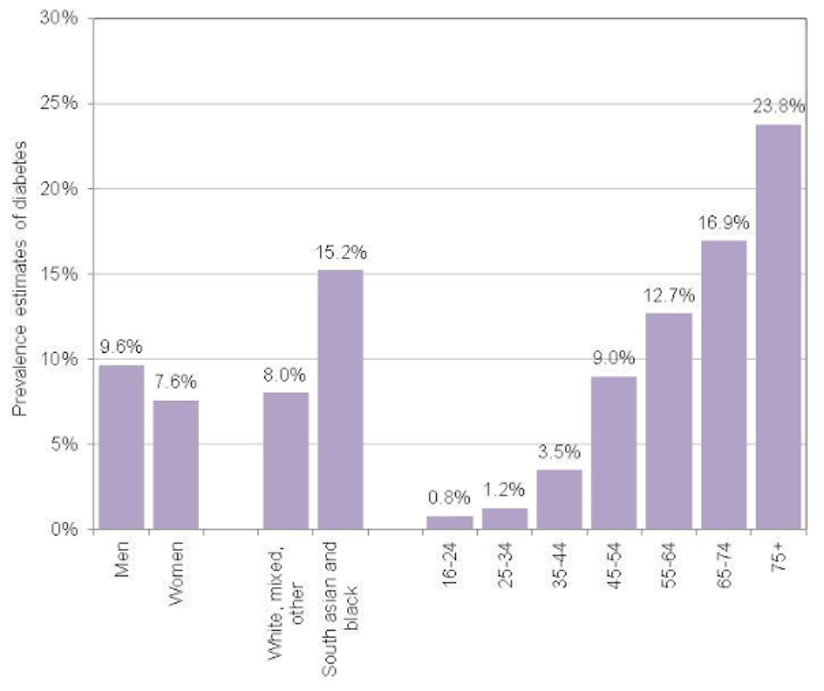

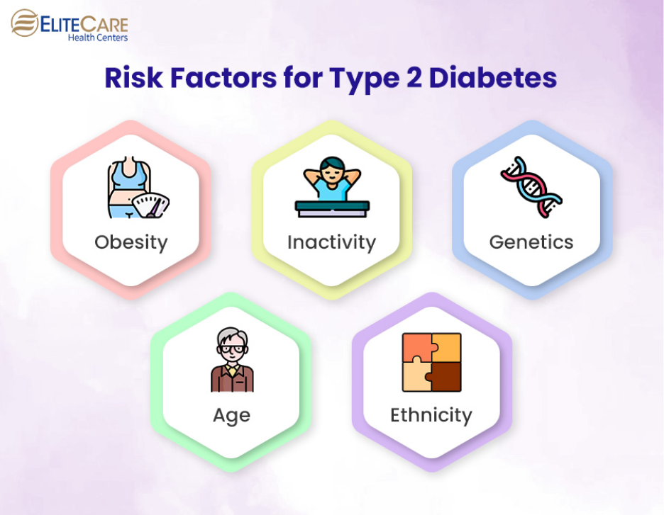
EliteCare Health Centers (2023)
Causes and Risk Factors
Type 2 Diabetes Mellitus develops because of a complex interaction between genetic, environmental, and behavioural influences that affect the body’s ability to regulate blood glucose levels effectively. These risk factors are broadly classified into modifiable factors, which can be altered through lifestyle and behavioural changes, and non-modifiable factors, which cannot be changed but help identify individuals who may be at greater risk of developing the condition (NICE, 2023). Understanding these risk factors is essential for prevention, early identification, and effective long-term management.
Modifiable risk factors play a key role in the development of Type 2 Diabetes Mellitus. Obesity is widely recognised as one of the most significant contributors to the condition. Excess body fat, particularly around the abdominal area, increases insulin resistance, which reduces the ability of cells to respond effectively to insulin. This results in impaired glucose uptake and increased blood glucose levels (Forouhi et al., 2018). In addition, obesity contributes to metabolic dysfunction and chronic inflammation, both of which further increase the risk of diabetes.
Physical inactivity is another important modifiable risk factor. Individuals who engage in limited physical activity are more likely to develop insulin resistance and experience weight gain, which increases their risk of developing diabetes. Regular physical activity improves insulin sensitivity, enhances glucose metabolism, and supports weight control. Therefore, maintaining an active lifestyle plays a crucial role in reducing the risk of developing Type 2 Diabetes Mellitus (World Health Organization, 2023).
Dietary habits also significantly influence the development of diabetes. Diets high in processed foods, refined carbohydrates, sugars, and saturated fats contribute to weight gain and impaired insulin function (Ley et al., 2014). Frequent consumption of high-calorie foods and sugary beverages can increase blood glucose levels and contribute to obesity, which further increases diabetes risk. In contrast, balanced diets that include whole grains, fruits, vegetables, and lean proteins can improve metabolic health and reduce the likelihood of developing the condition.
Smoking is another behavioural risk factor associated with an increased risk of Type 2 Diabetes Mellitus. Smoking negatively affects insulin sensitivity and contributes to inflammation, which can impair glucose metabolism. Furthermore, smoking increases the risk of cardiovascular disease, which is already a major complication associated with diabetes (Forouhi and Wareham, 2014). Smoking cessation is therefore an important aspect of both prevention and management.
Non-modifiable risk factors also play a significant role in determining an individual’s risk of developing Type 2 Diabetes Mellitus. Age is a key factor, as the risk increases significantly with advancing age, particularly after the age of 45. Age-related physiological changes, including reduced insulin sensitivity and changes in body composition, contribute to this increased risk (NICE, 2023). However, Type 2 Diabetes Mellitus is increasingly being diagnosed in younger individuals due to rising levels of obesity and sedentary lifestyles.
Genetic predisposition and family history are also important risk factors. Individuals who have close family members with diabetes are more likely to develop the condition due to inherited genetic factors that affect insulin production and glucose regulation (DeFronzo et al., 2015). Although genetic risk cannot be altered, early identification allows individuals to adopt preventive strategies and reduce their risk.
Ethnicity is another significant non-modifiable risk factor. Certain ethnic groups, including South Asian, African, and Caribbean populations, have a higher risk of developing Type 2 Diabetes Mellitus compared with the general population (Diabetes UK, 2023). This increased risk is influenced by genetic susceptibility, lifestyle patterns, and socioeconomic factors.
Socioeconomic factors also contribute to diabetes risk. Individuals living in lower socioeconomic conditions may experience barriers to accessing healthcare services, healthy food, and opportunities for physical activity. These barriers increase their risk of developing diabetes and experiencing poorer health outcomes (Walker et al., 2014).
Understanding both modifiable and non-modifiable risk factors is essential in supporting prevention and early intervention. Healthcare professionals play a key role in identifying individuals at risk and promoting lifestyle changes that reduce the likelihood of developing Type 2 Diabetes Mellitus. Early intervention and preventive strategies can significantly reduce the burden of the condition and improve long-term health outcomes.

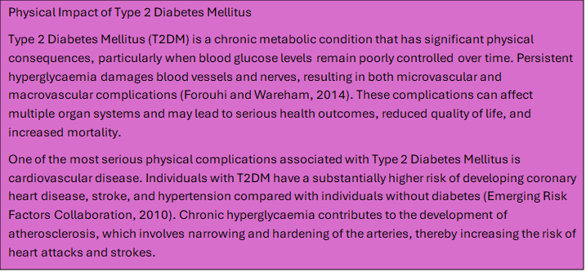

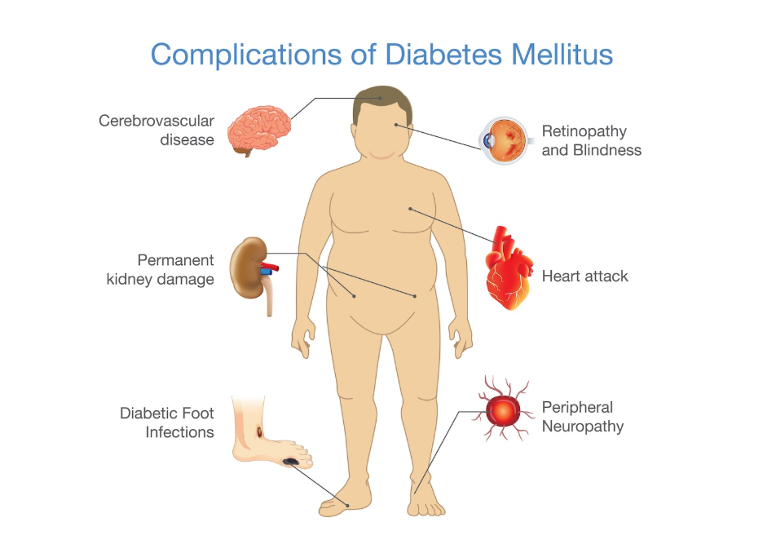
Linjawi (2026), My Health Explained
Psychological Impact of Type 2 Diabetes
Living with type 2 diabetes can have significant psychological effects. The daily demands of managing a chronic condition, including monitoring blood glucose levels, taking medication, and making lifestyle changes, can create emotional stress and psychological burden (Grady and Gough, 2014).
Many individuals with diabetes experience diabetes-related distress, which refers to emotional stress associated with managing the condition and fear of complications (Fisher et al., 2010). This distress may affect motivation, self-care behaviours, and treatment adherence. Individuals may feel overwhelmed by the continuous responsibility of managing their condition.
Depression is also more common among individuals with diabetes compared with the general population. Research suggests that individuals with diabetes are twice as likely to experience depression (Anderson et al., 2001). Depression can negatively affect self-management behaviours, including medication adherence, diet, and physical activity, leading to poorer glycaemic control and increased risk of complications.
Anxiety is another psychological impact associated with diabetes. Individuals may experience anxiety related to fear of complications, hypoglycaemia, or disease progression (NICE, 2023). Fear of complications such as blindness or amputation can significantly affect emotional wellbeing and quality of life.
Psychological wellbeing is an essential component of diabetes management. Healthcare professionals should provide emotional support and assess psychological needs as part of holistic, person-centred care (Health Foundation, 2016). Addressing psychological health can improve self-management and overall health outcomes.
Sermo (2023), sermo.com

Social Impact on Individuals and Families
Type 2 diabetes can have wide-ranging social implications for individuals and their families. Managing diabetes requires significant lifestyle adjustments, which may affect daily routines, employment, social relationships, and financial wellbeing (Bury et al., 2005).
Individuals living with diabetes may face challenges maintaining employment, particularly if complications develop. Fatigue, frequent medical appointments, and complications may affect work productivity and attendance (Diabetes UK, 2023). Some individuals may experience financial difficulties related to managing their condition.
Diabetes can also affect social interactions and lifestyle choices. Dietary restrictions, medication schedules, and the need for regular monitoring may affect participation in social activities and eating habits. Individuals may feel socially isolated or experience reduced quality of life due to these lifestyle changes.
Family members and carers often play a key role in supporting individuals with diabetes. They may assist with medication management, lifestyle changes, and emotional support. However, caregiving responsibilities may also create emotional and physical burden for carers (Gallant, 2003).
Social determinants of health, such as income, education, and access to healthcare, also influence diabetes management and outcomes. Individuals from disadvantaged backgrounds may experience barriers to accessing healthcare services, healthy food, and opportunities for physical activity (Walker et al., 2014).
Healthcare professionals must consider social factors when supporting individuals with diabetes and adopt a comprehensive approach to care that addresses physical, psychological, and social needs.
Imperial Health (2023), imperialhealth.com

Treatment and Management of Type 2 Diabetes Mellitus in the NHS
The management of Type 2 Diabetes Mellitus aims to control blood glucose levels, prevent complications, and improve quality of life. Treatment involves a combination of lifestyle interventions, medication, and regular monitoring (NICE, 2023).
Lifestyle modification is the first-line approach in managing T2DM. This includes adopting a healthy diet, increasing physical activity, and achieving a healthy body weight. Weight reduction improves insulin sensitivity and glycaemic control, reducing the risk of complications (Lean et al., 2018).
Medication is often required when lifestyle changes alone are insufficient. Metformin is typically the first-line medication prescribed for individuals with T2DM, as it improves insulin sensitivity and reduces glucose production in the liver (NICE, 2023). Additional medications, such as sulfonylureas, SGLT2 inhibitors, and GLP-1 receptor agonists, may be prescribed depending on individual needs.
Insulin therapy may be required in advanced stages of T2DM when the pancreas is unable to produce sufficient insulin. Insulin helps regulate blood glucose levels and prevent complications.
Regular monitoring is essential in managing T2DM. HbA1c tests measure average blood glucose levels over the previous two to three months and are used to assess glycaemic control (American Diabetes Association, 2023). Regular screening for complications, including eye examinations, kidney function tests, and foot assessments, is also important.
The NHS provides structured diabetes care through multidisciplinary teams, including doctors, nurses, dietitians, and diabetes specialists, to support individuals in managing their condition effectively (NHS England, 2019).
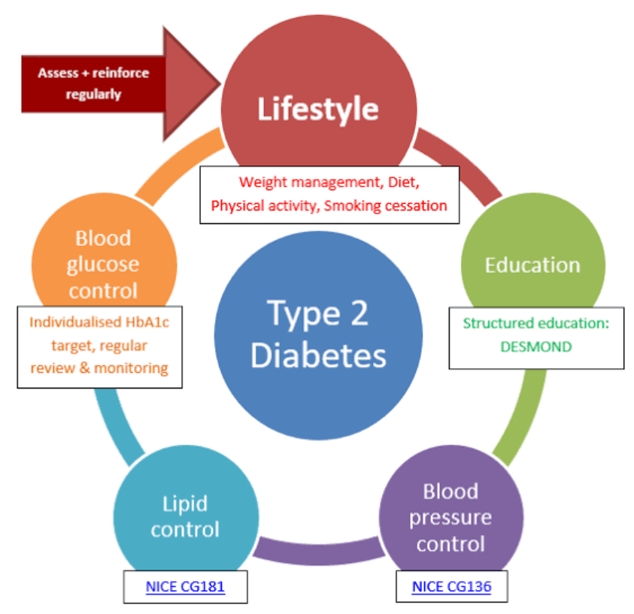
NICE (2015), nice.org.uk

Self-Management and Person-Centred Care in Type 2 Diabetes Mellitus
Person-centred care is a fundamental approach in the management of long-term conditions such as Type 2 Diabetes Mellitus (T2DM). It involves recognising individuals as active partners in their care and ensuring that healthcare decisions are based on their individual needs, preferences, and values rather than focusing solely on the disease (Health Foundation, 2016). Person-centred care promotes collaboration between healthcare professionals and individuals, supporting shared decision-making and improving health outcomes.
Type 2 Diabetes Mellitus requires continuous management, and individuals are responsible for managing their condition daily. This includes monitoring blood glucose levels, adhering to medication, maintaining a healthy diet, and engaging in regular physical activity. Therefore, person-centred care plays a crucial role in empowering individuals to develop the knowledge, skills, and confidence necessary to manage their condition effectively (Grady and Gough, 2014).
One of the key principles of person-centred care is shared decision-making. Shared decision-making involves healthcare professionals working collaboratively with individuals to develop personalised care plans. This ensures that treatment decisions reflect the individual’s preferences, lifestyle, and personal circumstances (Coulter et al., 2015). For example, healthcare professionals may discuss treatment options with individuals and consider their ability to adhere to medication, dietary changes, and lifestyle modifications.
Person-centred care also involves recognising the psychological and emotional impact of T2DM. Individuals living with diabetes may experience emotional distress, anxiety, or depression, which can affect their ability to manage their condition effectively (Fisher et al., 2010). Healthcare professionals should assess psychological wellbeing and provide appropriate emotional support, education, and counselling where necessary. Addressing psychological needs improves treatment adherence and overall wellbeing.
Education is another essential component of person-centred care. Structured education programmes, such as DESMOND, provide individuals with the knowledge and skills needed to manage their condition effectively (Davies et al., 2008). Education helps individuals understand the importance of lifestyle changes, medication adherence, and monitoring blood glucose levels. Individuals who participate in structured education programmes demonstrate improved glycaemic control and increased confidence in managing their condition.
Person-centred care also promotes self-management, which refers to the ability of individuals to manage the physical, psychological, and social aspects of their condition. Self-management includes monitoring blood glucose levels, making healthy lifestyle choices, and recognising symptoms that require medical attention (Bodenheimer et al., 2002). Supporting self-management improves health outcomes and reduces the risk of complications.
The NHS promotes person-centred care through multidisciplinary care teams that include doctors, nurses, dietitians, and diabetes specialists. These healthcare professionals work together to provide coordinated care and support individuals in managing their condition (NHS England, 2019). Care planning conversations allow individuals to discuss their goals, concerns, and treatment preferences, ensuring that care is tailored to their individual needs.
Person-centred care also recognises the importance of involving family members and carers in diabetes management. Family support can improve treatment adherence and emotional wellbeing. Healthcare professionals should provide education and support to family members to help them assist individuals in managing their condition effectively (Gallant, 2003).
Research demonstrates that person-centred care improves clinical outcomes, treatment adherence, and patient satisfaction (Coulter et al., 2015). It also improves quality of life by supporting individuals to manage their condition confidently and independently.
Overall, person-centred care is essential in the management of Type 2 Diabetes Mellitus. It empowers individuals, improves health outcomes, and supports holistic care that addresses physical, psychological, and social needs.

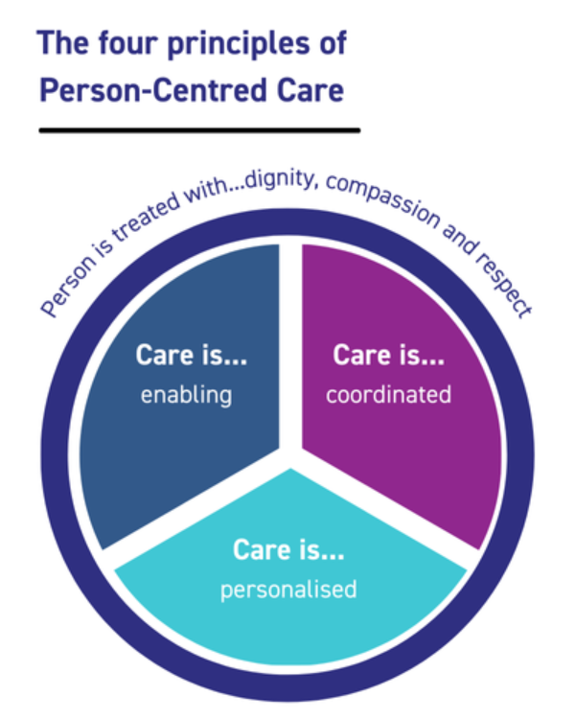
NHS England, england.nhs.uk

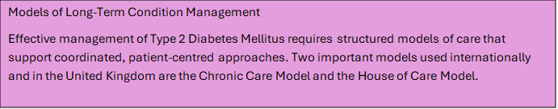
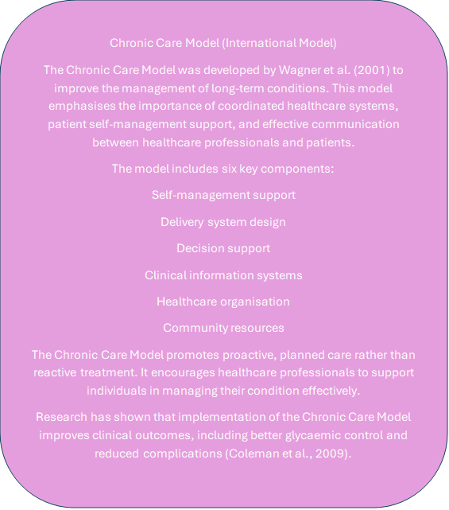

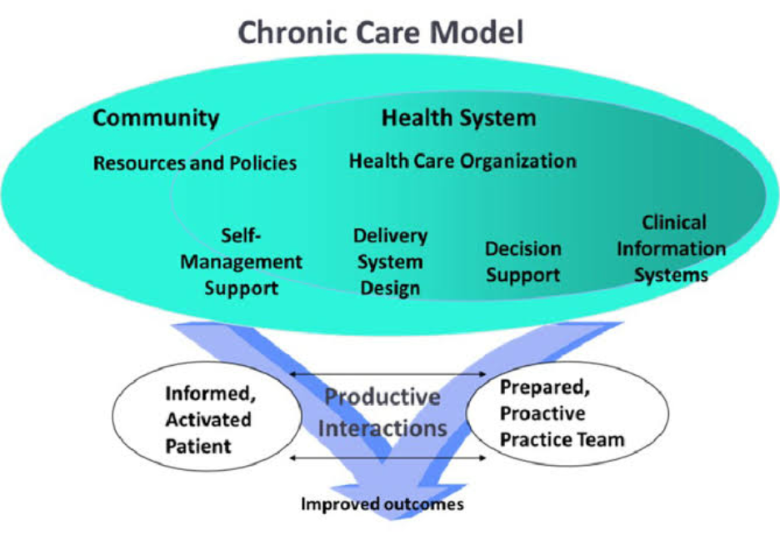
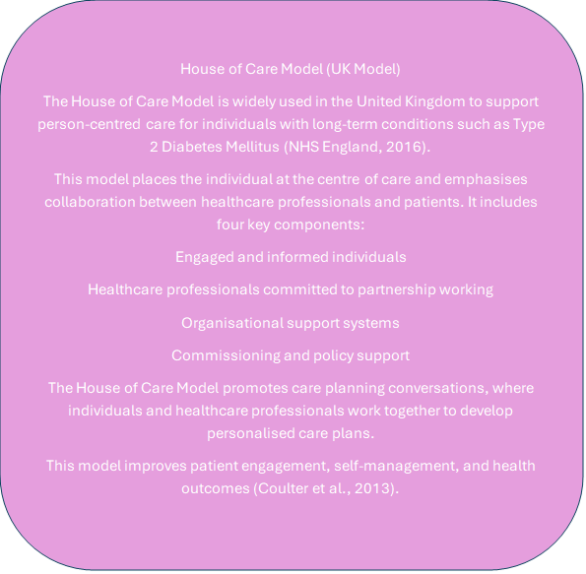

National and International Health Policy and NHS Strategy
Healthcare policies play an essential role in improving the management of Type 2 Diabetes Mellitus. In the United Kingdom, the NHS Long Term Plan prioritises prevention, early diagnosis, and person-centred care for individuals with long-term conditions (NHS England, 2019).
The National Institute for Health and Care Excellence (NICE) provides clinical guidelines for the management of T2DM, ensuring that individuals receive evidence-based treatment and care (NICE, 2023). These guidelines support healthcare professionals in making informed decisions regarding medication, monitoring, and patient education.
International organisations such as the World Health Organization (WHO) also promote strategies to prevent and manage diabetes, emphasising the importance of lifestyle interventions, early diagnosis, and integrated healthcare systems (WHO, 2023).
Healthcare policies support the development of multidisciplinary care teams, structured education programmes, and improved access to healthcare services. These initiatives improve diabetes management and reduce complications.
Recommendations for Improving the Management of Type 2 Diabetes Mellitus
Improving the management of Type 2 Diabetes Mellitus (T2DM) requires a comprehensive approach that integrates clinical care, education, policy support, and person-centred practice. Evidence suggests that structured, individualised care improves health outcomes and reduces the risk of complications (NICE, 2023).
One key recommendation is the provision of structured education programmes. Education enables individuals to understand their condition, develop self-management skills, and make informed lifestyle decisions. Structured programmes such as DESMOND have been shown to improve glycaemic control and promote positive behavioural changes (Davies et al., 2008).
Another important recommendation is strengthening person-centred care approaches. Healthcare professionals should involve individuals in decision-making and care planning. Shared decision-making improves treatment adherence, patient satisfaction, and overall health outcomes (Coulter et al., 2015). Individuals should be supported to set realistic goals and actively participate in managing their condition.
Psychological support should also be integrated into diabetes care. Screening for depression, anxiety, and diabetes-related distress can help identify individuals who require emotional support (Fisher et al., 2010). Providing psychological support improves emotional wellbeing and promotes effective self-management.
Improving access to multidisciplinary care is also essential. Multidisciplinary teams, including doctors, nurses, dietitians, and diabetes specialists, provide comprehensive care that addresses physical, psychological, and social needs (NHS England, 2019). Coordinated care improves clinical outcomes and reduces complications.
Public health strategies should also focus on prevention by promoting healthy lifestyles, physical activity, and weight management. Preventive interventions reduce the risk of developing Type 2 Diabetes Mellitus and improve population health (World Health Organization, 2023).
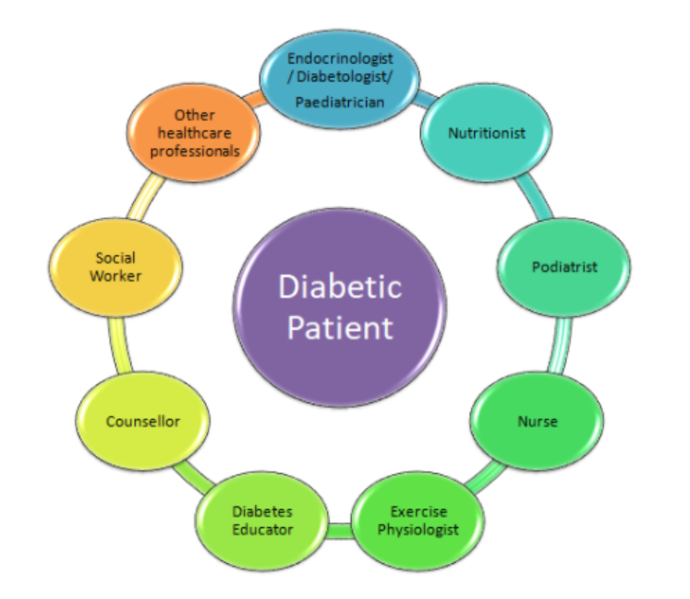
Diabetes UK, diabetes.org.uk

End-of-Life Care Considerations in Type 2 Diabetes Mellitus


End-of-life care is a vital component of managing long-term conditions such as Type 2 Diabetes Mellitus (T2DM), particularly for individuals with advanced disease, multiple complications, or significant comorbidities. As individuals approach the later stages of life, the primary focus of care may shift from intensive disease control to maintaining comfort, dignity, and quality of life (Sinclair et al., 2012). This approach reflects the principles of person-centred care, which emphasise respecting individual preferences, values, and goals.
In the earlier stages of T2DM, treatment typically focuses on strict glycaemic control to prevent complications. However, in advanced stages or at the end of life, aggressive glycaemic control may no longer be appropriate, particularly if it increases the risk of hypoglycaemia or treatment burden (National Institute for Health and Care Excellence, 2023). Hypoglycaemia can be particularly harmful in older adults and may lead to falls, confusion, and reduced quality of life. Therefore, treatment plans should be reviewed regularly and adjusted according to the individual’s clinical condition and personal wishes.
Person-centred care is essential in end-of-life management. Healthcare professionals should engage in open and sensitive communication with individuals and their families to discuss care preferences and future treatment decisions. Advance care planning allows individuals to express their wishes regarding medical treatment, including preferences related to medication, hospital admission, and supportive care (NHS England, 2019). This ensures that care is aligned with the individual’s values and promotes dignity and respect.
Multidisciplinary care teams play a crucial role in providing end-of-life care for individuals with T2DM. These teams may include doctors, nurses, diabetes specialists, and palliative care professionals. Their role is to provide holistic care that addresses physical symptoms, emotional wellbeing, and social needs. Palliative care focuses on managing symptoms such as pain, fatigue, and discomfort while supporting emotional and psychological wellbeing (Sinclair et al., 2012).
Family members and carers also play a key role during end-of-life care. They provide emotional support and assist with daily care needs. Healthcare professionals should involve family members in care planning and provide them with appropriate support and information.
End-of-life care in T2DM highlights the importance of person-centred, compassionate care that prioritises quality of life. Healthcare professionals must ensure that individuals receive appropriate support, symptom management, and respectful care during this stage of life.

Conclusion
Type 2 Diabetes Mellitus is a complex and progressive long-term condition that requires ongoing management and support. The increasing prevalence of T2DM presents significant challenges for individuals, families, and healthcare systems. This booklet has explored the definition, causes, prevalence, and impact of T2DM, highlighting its physical, psychological, and social consequences.
The physical complications of T2DM, including cardiovascular disease, neuropathy, nephropathy, and retinopathy, can significantly affect health and quality of life if the condition is poorly managed (Forouhi and Wareham, 2014). In addition to physical complications, T2DM can have profound psychological effects, including anxiety, depression, and emotional distress, which may affect self-management behaviours and overall wellbeing (Anderson et al., 2001). Social factors, including family support, employment, and access to healthcare services, also influence diabetes management and outcomes.
Effective management of T2DM requires a comprehensive approach that includes lifestyle modification, medication, regular monitoring, and structured healthcare support. The NHS provides multidisciplinary care and evidence-based treatment to support individuals in managing their condition (NHS England, 2019). Self-management and person-centred care are essential components of effective diabetes management, as they empower individuals to take an active role in their care and improve health outcomes (Grady and Gough, 2014).
Healthcare models such as the Chronic Care Model and the House of Care Model provide structured approaches to improving long-term condition management. These models promote coordinated care, patient engagement, and partnership between healthcare professionals and individuals, improving clinical outcomes and quality of life (Wagner et al., 2001; NHS England, 2016).
In conclusion, effective management of Type 2 Diabetes Mellitus requires a holistic, person-centred approach that addresses physical, psychological, and social needs. Supporting individuals through education, healthcare services, and person-centred care can improve quality of life and reduce the risk of complications.

Reference List
American Diabetes Association (2023) ‘Standards of care in diabetes—2023’, Diabetes Care, 46(Supplement 1), pp. S1–S291.
Anderson, R.J., Freedland, K.E., Clouse, R.E. and Lustman, P.J. (2001) ‘The prevalence of comorbid depression in adults with diabetes’, Diabetes Care, 24(6), pp. 1069–1078.
Bodenheimer, T., Lorig, K., Holman, H. and Grumbach, K. (2002) ‘Patient self-management of chronic disease in primary care’, JAMA, 288(19), pp. 2469–2475.
Bury, M., Newbould,

J. and Taylor, D. (2005) A rapid review of the current state of knowledge regarding lay-led self-management of chronic illness. London: National Institute for Health Research.
Carey, I.M., Critchley, J.A., DeWilde, S., Harris, T., Hosking, F.J. and Cook, D.G. (2018) ‘Risk of complications in type 2 diabetes’, Diabetes Care, 41(6), pp. 1182–1191.
Cheung, N., Mitchell, P. and Wong, T.Y. (2010) ‘Diabetic retinopathy’, Lancet, 376(9735), pp. 124–136.
Coleman, K., Austin, B.T., Brach, C. and Wagner, E.H. (2009) ‘Evidence on the Chronic Care Model in the new millennium’, Health Affairs, 28(1), pp. 75–85.
Coulter, A., Roberts, S. and Dixon, A. (2013) Delivering better services for people with long-term conditions. London: King’s Fund.
Coulter, A., Entwistle, V.A., Eccles, A., Ryan, S., Shepperd, S. and Perera, R. (2015) ‘Personalised care planning for adults with chronic conditions’, Cochrane Database of Systematic Reviews, Issue 3.
Davies, M.J., Heller, S., Skinner, T.C., Campbell, M.J., Carey, M.E., Cradock, S. and Khunti, K. (2008) ‘Effectiveness of the DESMOND structured education programme’, BMJ, 336(7642), pp. 491–495.
DeFronzo, R.A., Ferrannini, E., Groop, L., Henry, R.R., Herman, W.H., Holst, J.J. and Weiss, R. (2015) ‘Type 2 diabetes mellitus’, Nature Reviews Disease Primers, 1(1), pp. 1–22.
Department of Health (2012) Long-term conditions compendium of information. London: Department of Health.
Diabetes UK (2023) Diabetes prevalence statistics. London: Diabetes UK.
Eaton, S., Roberts, S. and Turner, B. (2015) ‘Delivering person-centred care in long-term conditions’, Future Hospital Journal, 2(3), pp. 208–211.
Emerging Risk Factors Collaboration (2010) ‘Diabetes mellitus, fasting glucose, and risk of cause-specific death’, Lancet, 375(9733), pp. 2215–2222.
Fisher, L., Glasgow, R.E. and Strycker, L.A. (2010) ‘The relationship between diabetes distress and clinical depression’, Diabetes Care, 33(5), pp. 1034–1036.
Forouhi, N.G. and Wareham, N.J. (2014) ‘Epidemiology of diabetes’, Medicine, 42(12), pp. 698–702.
Gallant, M.P. (2003) ‘The influence of social support on chronic illness self-management’, Health Education and Behaviour, 30(2), pp. 170–195.
Grady, P.A. and Gough, L.L. (2014) ‘Self-management: A comprehensive approach to management of chronic conditions’, American Journal of Public Health, 104(8), pp. e25–e31.
Health Foundation (2016) Person-centred care made simple. London: Health Foundation.
Hex, N., Bartlett, C., Wright, D., Taylor, M. and Varley, D. (2012) ‘Estimating the current and future costs of type 1 and type 2 diabetes’, Diabetic Medicine, 29(7), pp. 855–862.
Hibbard, J.H. and Greene, J. (2013) ‘What the evidence shows about patient activation’, Health Affairs, 32(2), pp. 207–214.
Holman, R.R., Paul, S.K., Bethel, M.A., Matthews, D.R. and Neil, H.A.W. (2008) ‘10-year follow-up of intensive glucose control’, New England Journal of Medicine, 359(15), pp. 1577–1589.
International Diabetes Federation (2023) IDF Diabetes Atlas. Brussels: International Diabetes Federation.
Lean, M.E.J., Leslie, W.S., Barnes, A.C., Brosnahan, N., Thom, G., McCombie, L. and Taylor, R. (2018) ‘Primary care-led weight management for remission of type 2 diabetes’, Lancet, 391(10120), pp. 541–551.
National Institute for Health and Care Excellence (2015) Diabetes in adults' quality standard QS6. London: NICE.
National Institute for Health and Care Excellence (2023) Type 2 diabetes in adults: management NG28. London: NICE.
NHS England (2016) House of Care framework. London: NHS England.
NHS England (2019) The NHS Long Term Plan. London: NHS England.
Powers, M.A., Bardsley, J., Cypress, M., Duker, P., Funnell, M.M., Fischl, A.H. and Vivian, E. (2015) ‘Diabetes self-management education and support’, Diabetes Care, 38(7), pp. 1372–1382.
Sinclair, A., Dunning, T. and Rodriguez-Mañas, L. (2012) ‘Diabetes in older people’, Lancet, 379(9821), pp. 219–229.
Tesfaye, S., Boulton, A.J.M., Dyck, P.J., Freeman, R., Horowitz, M., Kempler, P. and Valensi, P. (2011) ‘Diabetic neuropathy’, Diabetes Care, 34(10), pp. 2285–2293.
Walker, R.J., Smalls, B.L., Campbell, J.A., Egede, L.E. (2014) ‘Social determinants of health in adults with type 2 diabetes’, Current Diabetes Reports, 14(1), p. 473.
Wagner, E.H., Austin, B.T., Davis, C., Hindmarsh, M., Schaefer, J. and Bonomi, A. (2001) ‘Improving chronic illness care’, Health Affairs, 20(6), pp. 64–78.
World Health Organization (2023) Global report on diabetes. Geneva: World Health Organization.

