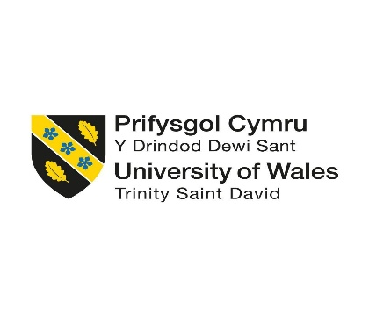

Master of Business Administration (MBA)
Module Title: Human Capital Management
Module Code: LCMB7023
Assessment Component: Individual Report
Assignment Title: The Influence of National and International Labour Markets on HRM and IHRM Strategies
Student Name: Roshan Lal
Student ID: 2430265
Group: 3

Executive Summary
This report is a critical investigation into the ways national and international labor market systems are reshaping technology, demography, and geopolitical change which, in turn, determine the effectiveness of Human Resource Management (HRM) and International Human Resource Management (IHRM) strategies. Exposing four main threads, these include the following: (1) Technology such as AI, automation, and digital platforms rewrites the work construct and the need to reskill; (2) Ageing populations, migration, and conflict transform the global mobility landscape; (3) Persistent skill shortages in mission-critical sectors-technology, healthcare, and hospitality-necessitate strategic workforce planning and re-envisioning learning; and (4) A reflective analysis would reveal the relevance of digital fluency, cross-cultural competence, and lifelong learning for future HR leaders. Lastly, it argues that human-centred and technologically adaptive HR strategies are vital for sustainable competitiveness by balancing efficiency, ethics, and inclusion in a workforce increasingly globalised and AI-driven.

Table of Contents
Executive Summary 1
Introduction 2
2. Technological Advancements and Labour-Market Transformation 3
2.1 Global Trends in Labour-Market Digitalisation 3
2.2 Implications for HRM and IHRM Strategies 4
2.3 Comparative Evidence and Case Studies 4
2.4 Theoretical Integration and Practical Recommendations 5
3. Demographic and Geopolitical Influences 7
3.1 Demographic pressures: ageing, Gen Z and gender gaps 7
3.2 Migration and cultural diversity 8
3.3 Geopolitics, supply chains and remote outsourcing 9
3.4 Implications and Comparative Policy Logics 9
4. Skills Gaps and Talent-Shortage Management 10
4.1 Understanding the Global Skills Crisis 10
4.2 Strategic HR Responses 11
4.3 Theoretical and Practical Integration 12
5. Reflective Self-Analysis 12
5.1 Description and Feelings 12
5.2 Evaluation 13
5.3 Analysis 13
5.4 Action Plan 14
6. Conclusion 14
Reference 16

Introduction
The international and national labor markets are changing with time due to technological advancements, demographic changes, and geopolitical modulations. Global employment outlook has been decreased by the new 53 million jobs created in 2025 as compared to an old forecast of 60 million in 2025, as employment growth by ILO shows slackened due to conflicts and trade disruptions (2025). OECD-wide, employment as of early 2025 is even at 72.1 percent, but the increment in jobs will slow down due to uncertainties surrounding the economic outlook (OECD, 2025). At the same time, Future of Jobs Report 2025 explains how digitalization and artificial intelligence (AI) have redefined how work will be performed such that the skills that their workers will need by 2030 will include among others highly demanded creativity, adaptability, and analytic thinking (World Economic Forum [WEF], 2025). A good example of this concern is AI impacting HR practice-in fact, 43% of organizations apply AI tools in recruitment, analytics, and workforce planning (Society for Human Resource Management, [SHRM], 2025; Nawaz et al., 2024). Actually, HRM and IHRM go hand in hand toward taking into consideration people policies compatible with such technological, demographic, and geopolitical environments in order to remain competitive as well as inclusive (CIPD 2025).

Figure 1: Report structure (Author created)

2. Technological Advancements and Labour-Market Transformation

2.1 Global Trends in Labour-Market Digitalisation
Technological change, especially AI, robots, and digital platforms, is rapidly transforming the global labor markets. According to ILO (2024), automation and digitalization are reshaping industries, and by 2030, more than 18% of jobs across the globe are at high risk of being automated. OECD (2023) reports that about 27% of tasks in the OECD economies are susceptible to automation, while the professions related to AI have grown by 34% since 2020 due to increased demand for data and machine learning skills. WEF (2025) affirms that 75% of companies will adopt AI and big data technologies in the next five years while predicting that core skills of 39% of the workforce will change by 2030. The evidence highlights the twin challenge of technological opportunity and risk of displacement that exists in developed and emerging labor markets alike.

2.2 Implications for HRM and IHRM Strategies
In terms of human resource management, digitization entails completely reengineering people strategies. AI is in use in recruiting (automated screening, chatbots, psychometric analytics), performance management (AI-based dashboards), learning and development (tailored micro-learning platforms), etc. However, the question of algorithmic bias and ethical governance is brought in by automation. The OECD (2023) urges HR stakeholders to create transparent AI systems that will protect against discriminatory outcomes through data lineage, fairness audits, and explainability of algorithms.

HR analytics, the umbrella through which evidence-based HRM is achieved, has also moved from descriptive metrics to predictive analytics, whereby HR is equipped to pronounce turnover levels, engagement, and skills gaps. Resource-Based-View (Barney, 1991) accords to this capability as data driven, that is, rare and hard to copy; thus, it can enhance competitive advantage. Here, strategic HRM puts that digitization aligns HR with the organization strategy by talent segmentation, agile resourcing, and hybrid team management.
Digitalization, in fact, multiplies the already-existing complexity of cross-border management in international human resource management. Global companies need to deal with the different laws on data privacy (for example, GDPR in the EU, Digital Personal Data Protection Act in India) as well as the availability of digital skills across markets. Emerging countries have been warned by the ILO (2024) against widening digital divides, with 43% of their workforce having basic ICT skills, whereas those of OECD member countries stand out at 88%. Reskilling initiatives and location-independent learning platforms will thus form part of IHRM strategies for equity and competitiveness.

2.3 Comparative Evidence and Case Studies
In developed economies, automation has increased productivity while deepening demand for high-skilled work. Productivity growth in AI-intensive industries is 4.3% year on year (PwC, 2024) as compared with 0.9% in other industries. On the other hand, the digital gig economy in India-a USD 250 billion market by 2025-is an example of how technology is leveraged in emerging economies to create inclusive employment (NITI Aayog, 2023). However, platform-based work continues to expose workers to precarious employment, sub-par pay, and various forms of exploitation. This calls for the implementation of ethical IHRM policies to promote decent work and sustainable livelihoods for all. Many corporate cases attest to alternative measures. AI at Unilever's Flex Experiences platform has facilitated matching over 65,000 employees to internal projects, enhancing mobility and skill development (Unilever, 2024). IBM SkillsBuild is upskilling employees globally in AI and Cybersecurity, while Siemens My Learning World incorporates digital twins to accelerate reskilling in the industry (Siemens, 2024). Proven joint ventures between automation and human-centered development have put these organizations in a better position vis-a-vis their competitors in adaptive capacity and retention.

2.4 Theoretical Integration and Practical Recommendations
Technological disruption validates many HR paradigms. Human Capital Theory (Becker, 1993) emphasizes that investments in personnel skills yield returns in productivity over the long haul. The AMO framework (Appelbaum et al., 2000): Ability, Motivation, Opportunity says that in digital contexts, high performance is achieved when employees possess digital literacy (Ability); an incentive to innovate (Motivation); and autonomy towards the choice of projects (Opportunity). Respective operationalization would be put in the hands of HR leaders as:
- Establish ethics boards for AI monitoring and algorithmic accountabilities.
- Implement skills-based HR models linking pay and career paths to demonstrable competencies.
- Facilitate the development of internal talent marketplaces that can dynamically redeploy workers.
- Cultivate workplace cultures of continuous learning through micro-learning and mentoring from a global perspective.
Such interventions position HRM within the Resource-Based View (RBV) by turning intangible employee capabilities into sustainable competitive advantage across borders..
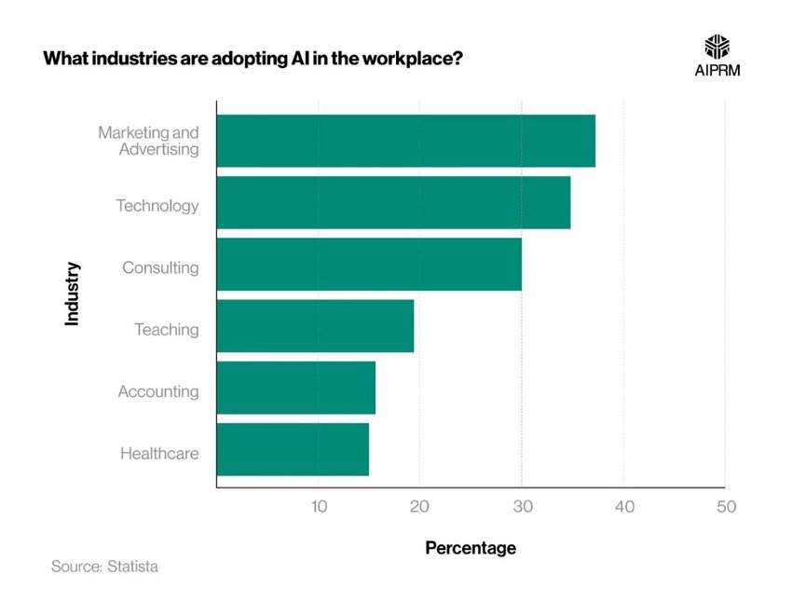
Figure 2: Median AI-Maturity by Industry, 2021 vs 2024

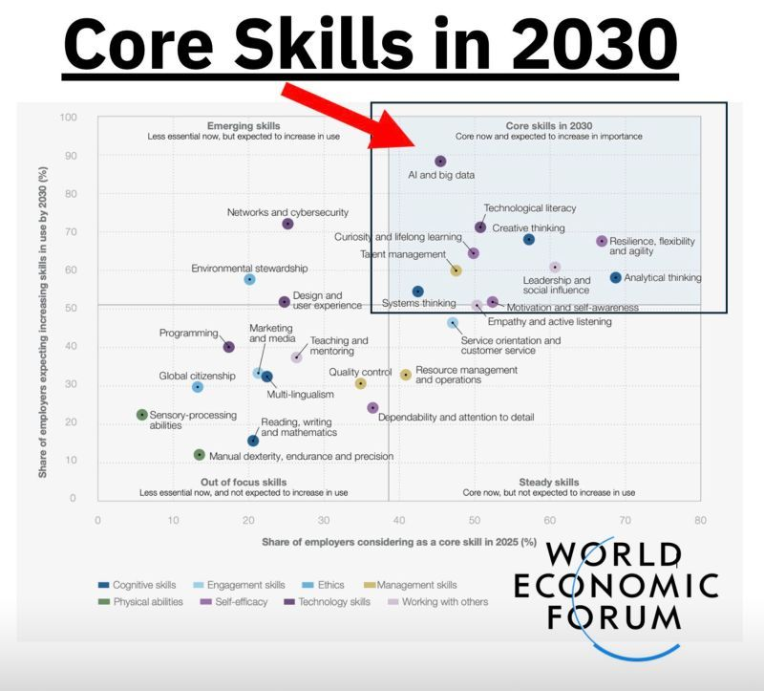
Figure 3: Top 10 Fastest-growing Skills by 2030

3. Demographic and Geopolitical Influences

3.1 Demographic pressures: ageing, Gen Z and gender gaps
Demographic trends observed with labour supply tightening, rising dependency ratios, and increased demand for replacement skills have been observed in advanced economies. The UN estimates that in rapid growth of older cohorts (80+), there will be about ~265 million born by mid-2035, significantly outnumbering infants. This will, in turn, alter the very structures underpinning work and pensions–work incentives (United Nations, 2025). OECD further indicated the fact that only about 22% of persons with ages 50-69 continued working in the year 2023 and continued to receive pensions-an insight into the untapped capacity of older workers (OECD, 2025). At the other hand, Generation Z is now emerging as a tipping talent block. They are perceived to be very hybrid-work oriented and fast-changing with much emphasis on skill development as GenAI populates (Deloitte, 2025). Persistent gender participation gaps continue to impede progress; global labor force participation for females sits at 48.7% in 2023 compared to 73.0% of males (ILO, 2024). In the absence of targeted childcare and flexible work and pay equity measures, HR could expect to see increasingly segregated careers and leadership pipelines stunted by mid-career drop-off.
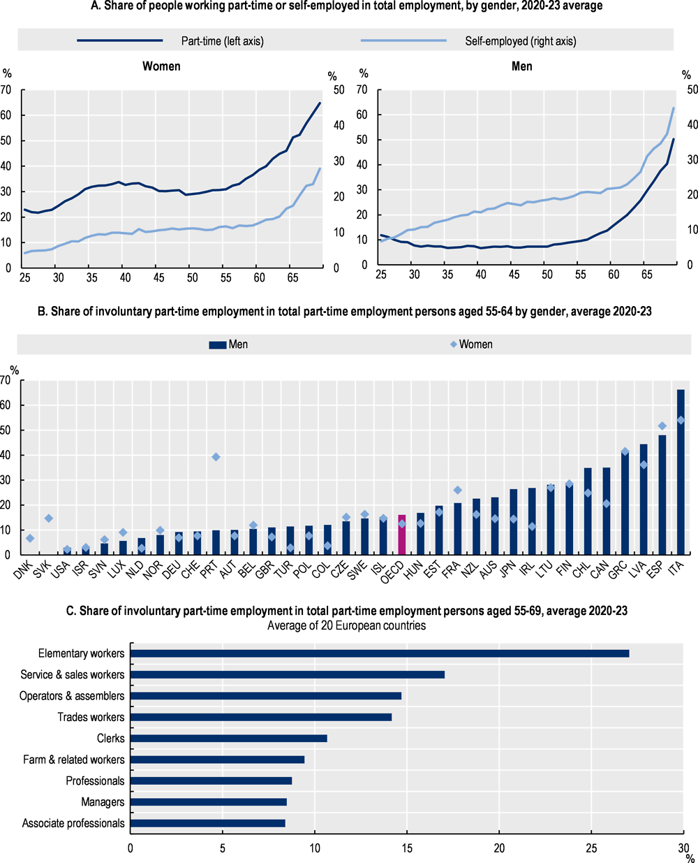
Figure 4. Gendered Patterns of Part-Time and Self-Employment in Europe (2020–2023)
The OECD chart shows women’s higher prevalence of part-time and self-employment, rising involuntary part-time work among older workers, and occupational clustering in lower-skill roles—highlighting age and gender inequalities shaping European labour-market participation (OECD, 2025)

3.2 Migration and cultural diversity
Cross-border migration has remained a principal adjustment valve for labour markets. The World Migration Report 2024 tells the long-term story of international migration growth and important remittance flows that relate labour supply to global demand (IOM, 2024a; 2024b). After Brexit, the UK is an example of structural change: EU inflows fell, that is, since 2021, and more EU citizens left than arrived, while 3.6 million non-EU arrivals (2021–2024) reshaped sectoral staffing (Economics Observatory, 2025). This increases compliance complexity along HR lines regarding rights to work and sponsorship in this mix and increases the need for cross-cultural capability across teams. Hofstede's dimensions (e.g., power distance, uncertainty avoidance) are of value but may lead to stereotyping when applied uncritically. A more rigorous lens of Institutional Theory helps HR map the formal rules (immigration, data privacy, labour law) and informal norms (professional credentialing, unionisation) that jointly determine talent mobility and onboarding frictions.

3.3 Geopolitics, supply chains and remote outsourcing
Demographic trends observed with labour supply tightening, rising dependency ratios, and increased demand for replacement skills have been observed in advanced economies. The UN estimates that in rapid growth of older cohorts (80+), there will be about ~265 million born by mid-2035, significantly outnumbering infants. This will, in turn, alter the very structures underpinning work and pensions–work incentives (United Nations, 2025). OECD further indicated the fact that only about 22% of persons with ages 50-69 continued working in the year 2023 and continued to receive pensions-an insight into the untapped capacity of older workers (OECD, 2025). At the other hand, Generation Z is now emerging as a tipping talent block. They are perceived to be very hybrid-work oriented and fast-changing with much emphasis on skill development as GenAI populates (Deloitte, 2025). Persistent gender participation gaps continue to impede progress; global labor force participation for females sits at 48.7% in 2023 compared to 73.0% of males (ILO, 2024). In the absence of targeted childcare and flexible work and pay equity measures, HR could expect to see increasingly segregated careers and leadership pipelines stunted by mid-career drop-off (OII, 2025).

3.4 Implications and Comparative Policy Logics
The comparison of models elucidates the trade-offs. The EU social-market model (co-determination, active labour-market policies, childcare support) buffers the shocks and sustains female participation but offers inertia for rapid reallocation; while the US liberal-market model does so much faster, through price signals and flexible hiring, but exposes individuals to volatility and less coverage. For globally distributed employers, a PESTLE analysis should inform the design of their global talent management:
- Political/Legal: immigration regimes (e.g., UK points-based system), sanctions, data sovereignty.
- Economic: ageing-driven shortages vs. Gen Z expectations; wage–inflation pass-through from freight shocks.
- Socio-cultural: for gender and migrants; evidence-based use of Hofstede within DEI training.
- Technological: secure remote infrastructures enabling multi-jurisdiction teams.
Put operationally, HR should combine inclusive policies (childcare, flexible/hybrid, returnships) with cross-cultural leadership and skills recognition for refugees, and compliance-by-design for mobility and vendor ecosystems.

4. Skills Gaps and Talent-Shortage Management

4.1 Understanding the Global Skills Crisis
The existence of long-lasting skill shortages has become the propensity minimal across areas such as technology, health care, and hospitality. As stated by the World Economic Forum in 2025, over 44% of global workers' skills will be disrupted by 2030, and six out of ten employers have difficulty hiring for critical roles, data analysis, AI, cybersecurity, and green transition technologies, among others. The LinkedIn 2024 Workforce Report lists software engineering, nursing, and hotel operations as among some of the hardest positions to fill in both OECD and emerging economies. The reasons themselves are many: rapid digitalisation has overtaken the education systems; sizeable STEM gender gaps remain (with women constituting only 29% of AI specialists globally); and the brain drain from developing to advanced economies has aggravated talent asymmetries (ILO, 2024).
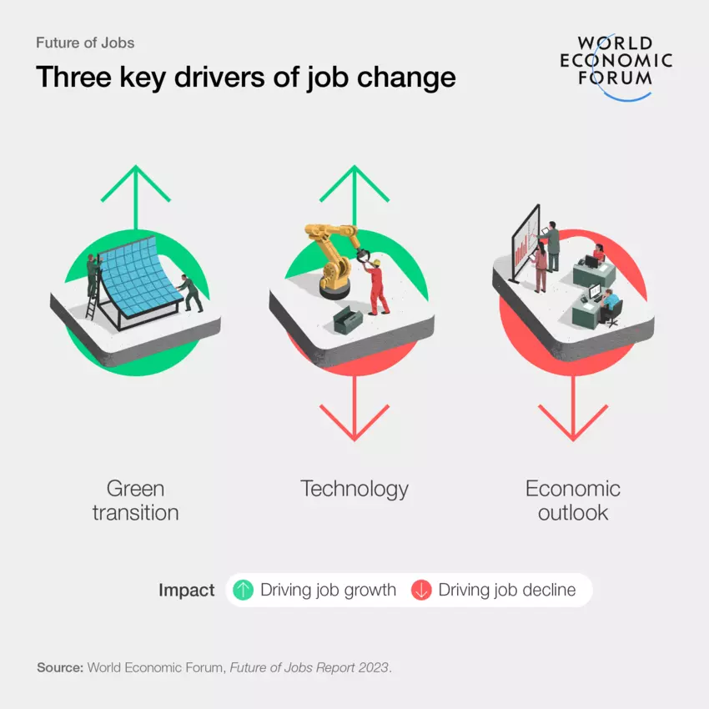
Figure 5: Three Key Drivers of Job Change (World Economic Forum, 2023)
This infographic illustrates the main global forces shaping employment trends: the green transition generating new job growth, technological advancement both creating and displacing roles, and the economic outlook acting as a primary driver of job decline.

4.2 Strategic HR Responses
Indeed, integrated, evidence-based strategic workforce planning (SWP) is needed to address the shortages. Together with predictive analytics, labour-market intelligence will assist HR professionals in identifying emerging skills gaps and designing reskilling pathways. Learning & Development 4.0 (L&D 4.0) accelerates requalification through adaptive AI learning platforms and micro-credentials, reducing training by 30% (McKinsey, 2024). The UK NHS Skills Academy on the model applies modular e-learning and simulation-based learning to facilitate countering clinical capacity shortages, while Accor Hospitality's "Heartist" programme targets training for employees on digital guest engagement and sustainability to achieve a 15% retention improvement (Accor, 2024).
One more important leaver is internal mobility. The Talent Management Cycle (Lewis & Heckman, 2006) underlines continuous development and succession planning so the firms may redeploy employees to adjacent roles instead of relying solely on external hiring. Global talent pipelines for multinational corporations, developed by working remotely through cross-border teams, internships, and through global mobility rotations, bring increased diversity in sourcing skills and build resilience.

4.3 Theoretical and Practical Integration
Ulrich's HR Business Partner Model applies to align the strategic, operational, and transformational functions of HR. HRBPs partner with business leaders for demand forecasting, CoEs design and develop digital upskilling frameworks, and shared service teams deliver high-volume learning solutions. Intertwined with AI-powered workforce planning, this model shifts HR from administration support to competitive capability. A sustainable talent strategy must balance technology-led solutions with inclusivity and human development. While automation helps mitigate shortages, it is only human-centred learning ecosystems—from predictive analytics to social partnerships to lifelong learning cultures—that can close structural skills gaps.

5. Reflective Self-Analysis
This reflection uses Gibbs' 1988 Reflective Cycle to critically analyze my preparedness for working internationally with technology. Instead of superficially detailing the experiences, it assesses behaviors, biases, and skills that may or may not fit the demands of global HR practice.

5.1 Description and Feelings
Throughout my master's course in Human Capital Management, I had been part of virtual teams consisting of colleagues from the UK, Kenya, and India. In the course of the collaboration, we used Microsoft Teams, Trello, and Zoom to develop presentations and research papers. In the beginning, I underestimated the cultural and time-zone complexities entailed in virtual teamwork. Time-frame coordination on tasks was frustrating at times; sometimes, culturally induced communication norms, such as indirect feedback or different conceptions of what is considered punctual, slowed down the whole process. However, with such tensions also came an opportunity for awareness of cross-cultural negotiation and emotional self-regulation; thus, discomfort serves to propel one forward.

5.2 Evaluation
I show clear evidence of strengths in digital collaboration and intercultural awareness. I have always been the one to convene meetings, summarise decisions made, and ensure that all voices were heard in equitable fashion, representing further evidence of my building of inclusive leadership. My adaptability and curiosity reflect characteristics expected of global managers (Deardorff, 2020). My weakness, however, is a limitation in technology applications, which so far have been more conventional, confined to email automation, spreadsheet applications, and video conferencing—with very limited exposure to newer AI-enabled HR system applications such as predictive analytics, virtual onboarding, or generative-AI content design. This kind of conservative attitude toward technology therefore raises the issue of a developmental gap for me. Sooner or later, though, it will be undermined if I continue to shun constructive conflict in team situations, which I see as a weakness in assertive leadership, even though it is concise and analytical in one direction of written communications.

5.3 Analysis
Applying Kolb's (1984) model of experiential learning, my professional learning develops through a cycle: concrete experience (virtual teamwork); reflective observation (defining cultural barriers); abstract conceptualization (putting together ideas with intercultural competence theories); and active experimentation (finding solutions to culture issues). Still, the aforementioned process might just land itself in a well-deserved descriptive limbo if backed by neither evidence nor theory. Viewed through the lens of transformational leadership theory (Bass & Riggio, 2006), my address to the issues is characterized by high inspirational motivation and individualised consideration; on the downside, it appears to lack sufficient intellectual stimulation when dealing with innovation projects. For leadership in technology-intensive settings, the elements of compassion and analytical ability must come together with relevant data-backed decision-making.

5.4 Action Plan
To strengthen employability and leadership impact, I will:
- Complete AI and HR analytics certificates via LinkedIn Learning and Coursera to boost my digital acumen;
- Develop cross-cultural mentoring skills by joining CIPD Global and the HR Analytics Europe Network, where I can sharpen my intercultural agility;
- Engage in remote consulting or capstone projects to simulate global HR transformation scenarios;
- Establish a reflective logbook documenting performance feedback and evidence of behavioural change to hold myself accountable.
Real global competence goes beyond technology skills; it has to do with an ethical awareness of technology's impact on equity, privacy, and employee dignity. I hope to transform into an HR leader who, while strategically analytical, is still grounded in empathy, one who can shepherd AI-enhanced multicultural work ecosystems.

6. Conclusion
The report indicated that the HRM and IHRM landscape has been collectively affected by technological stagnation, demographic shifts, and geopolitical turbulence. Accordingly, organizations can move beyond transactional HR practices and embrace the realms of strategic analytics, inclusive leadership, and the learning sustenance of workforce agility. At a larger paraqaph, this nexus between human capital and digital systems describes leaders who must equally weigh algorithmic efficiency and ethical insight. My reflection has put into perspective that professional excellence is now dependent upon lifelong learning, intercultural fluency, and adaptive resilience. Consequently, to maintain employability under these conditions, HR will have to heed unique administrative functions and metamorphose into a strategic, evidence-based, and person-centred discipline.

Reference
Accor (2024) Heartist Digital Training Programme: Building Hospitality Skills for the Future. Paris: Accor Group.
Appelbaum, E., Bailey, T., Berg, P. and Kalleberg, A. (2000) Manufacturing Advantage: Why High-Performance Work Systems Pay Off. Ithaca, NY: Cornell University Press.
Barney, J.B. (1991) ‘Firm resources and sustained competitive advantage’, Journal of Management, 17 (1), pp. 99–120.
Bass, B.M. and Riggio, R.E. (2006) Transformational Leadership. 2nd edn. Mahwah, NJ: Lawrence Erlbaum Associates.
Becker, G.S. (1993) Human Capital: A Theoretical and Empirical Analysis with Special Reference to Education. 3rd edn. Chicago: University of Chicago Press.
Briscoe, D.R., Schuler, R.S. and Tarique, I. (2022) International Human Resource Management: Policies and Practices for Multinational Enterprises. 6th edn. London: Routledge.
Deardorff, D.K. (2020) Manual for Developing Intercultural Competence: The Theory and Practice of Intercultural Competence Development. Paris: UNESCO Publishing.
Deloitte (2025) 2025 Gen Z and Millennial Survey. Available at: https://www.deloitte.com/global/en/issues/work/genz-millennial-survey.html (Accessed: 2 November 2025).
Economics Observatory (2025) ‘How might the UK’s new approach to migration affect the economy?’ Economics Observatory. Available at: https://www.economicsobservatory.com/how-might-the-uks-new-approach-to-migration-affect-the-economy (Accessed: 2 November 2025).
Gibbs, G. (1988) Learning by Doing: A Guide to Teaching and Learning Methods. Oxford: Oxford Polytechnic.
International Labour Organization (ILO) (2024) World Employment and Social Outlook 2024: The Future of Work in Transition. Geneva: ILO. Available at: https://www.ilo.org/global/research/global-reports/weso/2024 (Accessed: 2 November 2025).
International Labour Organization (ILO) (2024) ‘Persistent gender gaps in labour force participation’, ILO Statistical Brief, 29 October. Available at: https://www.ilo.org/sites/default/files/2024-10/GEDI-STAT%20brief_formatted_28.10.24_final.pdf (Accessed: 2 November 2025).
International Monetary Fund (IMF) (2024) ‘Red Sea Attacks Disrupt Global Trade’, IMF Blog, 7 March. Available at: https://www.imf.org/en/Blogs/Articles/2024/03/07/Red-Sea-Attacks-Disrupt-Global-Trade (Accessed: 2 November 2025).
International Organization for Migration (IOM) (2024a) World Migration Report 2024. Geneva: IOM. Available at: https://publications.iom.int/books/world-migration-report-2024 (Accessed: 2 November 2025).
International Organization for Migration (IOM) (2025) ‘Key Global Migration Figures, 2019–2025.’ Available at: https://www.migrationdataportal.org/resource/key-global-migration-figures (Accessed: 2 November 2025).
Kolb, D.A. (1984) Experiential Learning: Experience as the Source of Learning and Development. Englewood Cliffs, NJ: Prentice-Hall.
Lewis, R.E. and Heckman, R.J. (2006) ‘Talent management: A critical review’, Human Resource Management Review, 16 (2), pp. 139–154.
LinkedIn (2024) Workforce Report 2024: Global Hiring Trends. California: LinkedIn Economic Graph.
McKinsey & Company (2024) The Economic Potential of Generative AI: Workforce Implications. Available at: https://www.mckinsey.com (Accessed: 2 November 2025).
NITI Aayog (2023) India’s Bo oming Gig and Platform Economy Report. New Delhi: Government of India. Available at: https://www.niti.gov.in (Accessed: 2 November 2025).
Organisation for Economic Co-operation and Development (OECD) (2023) AI and Employment: Implications for Skills and Labour Markets. Paris: OECD. Available at: https://www.oecd.org/employment (Accessed: 2 November 2025).
Organisation for Economic Co-operation and Development (OECD) (2025) Employment Outlook 2025: Navigating the Golden Age of Longevity. Paris: OECD Publishing. Available at: https://www.oecd.org/en/publications/2025/07/oecd-employment-outlook-2025_5345f034/full-report/component-7.html (Accessed: 2 November 2025).
Oxford Internet Institute (OII) (2025) ‘Online Labour Index.’ Available at: https://ilabour.oii.ox.ac.uk/category/oli/ (Accessed: 2 November 2025).
PwC (2024) AI and Productivity Report 2024. London: PricewaterhouseCoopers. Available at: https://www.pwc.com (Accessed: 2 November 2025).
Reuters (2024) ‘Maersk says impact from Red Sea attacks continues to intensify’, Reuters, 5 September. Available at: https://www.reuters.com/world/middle-east/maersk-says-impact-red-sea-situation-continues-intensify-2024-09-05/ (Accessed: 2 November 2025).
Siemens (2024) My Learning World: Empowering Continuous Learning. Munich: Siemens AG.
Ulrich, D. (1997) Human Resource Champions: The Next Agenda for Adding Value and Delivering Results. Boston, MA: Harvard Business School Press.
United Nations (2025) ‘Ageing.’ Available at: https://www.un.org/en/global-issues/ageing (Accessed: 2 November 2025).
Unilever (2024) Future of Work and Flex Experiences Platform. London: Unilever.
World Economic Forum (WEF) (2025) The Future of Jobs Report 2025. Geneva: World Economic Forum. Available at: https://www.weforum.org/reports/the-future-of-jobs-report-2025 (Accessed: 2 November 2025).

