
Analyze the impacts of social-economic force on employees’ performance management and monitoring in different work modes: Hospitality HR’s perspective
MODULE: Personnel Resourcing and Development BMIH5005
Lecturer: Jemma Smith

Marinela Covasneanu
Student number 1920078
Word count: 2198


Executive Summary

This paper includes a project proposal prepared by HR Manager for a hotel General Manager, which highlights the impacts of socio-economic force on employees’ performance management and how is being monitored in different work modes.

Contents
Executive Summary 1
Introduction 2
Social factors: 2
Economic factors: 2
Main body 3
Hospitality industry HR trends 3
Leadership Development 3
Finding and hiring top talents 4
Job security and secure future 5
Diversity, equity, and inclusion 5
Embracing technology 6
Retention= Employee Experience+ Employee Engagement 7
Physical environment: 7
Employee wellbeing 7
Learning, upskilling and development. 7
Adapting the work modes 8
Feedback and benefits 8
The emerge of different work modes in hospitality industry over the last five years. 8
Employee performance management and monitoring. 9
Conclusion 12
References: 13
Appendices: 17

Introduction

The conducted research proposal that the HR Manager is presenting to the General Manager is based on Marriott International INC. hotels. The Marriott chain has a portfolio of nearly 8300 properties under thirty leading brands extended over 138 countries and territories (News centre, 2024). This report will summarise the current issues, based on the impacts of socio-economic factors and identify what are the effects on employee monitoring and management. After an elaborate Pestle analysis (MBA Skool, 2024) there were determined some of the external factors that impacts Marriott International company such as:

Social factors:
- Significant competition from more than 1400 similar companies
- Demographics and skill level of the population
- Culture changing (gender roles, social convention, age)
- Attitude (health, environmental consciousness)
- Skills level of workforce in the hospitality industry
- Education level in company

Economic factors:
- Inflation rates
- Saving rates
- Foreign exchange rates
- Labour costs and productivity
- Unemployment rate
All these factors impact the company function and simultaneously makes changes in the employee monitoring and management. It is critically for every leader to be aware and to understand these risk factors and find the solution to maintain performance and the wellbeing of their employees (Khosrow, 2019). The success of a company depends on its human capital, and the skilled ones are the primary source of positive results (White et al., 2020). Fostering positive relationships between company and its people, along with the stakeholders, creates a path to increase employee engagement and productivity (Rahman & Taniya, 2017). Both social and economic factors guide people behaviour (Posadzy, 2017). Also, the company strategies to overcome the impact of these threats. Different work modes and management processes are implemented to successfully monitor and adapt to the present changing environment. The last couple of years were hard for all hospitality businesses. Also, for Marriott Hotel was a challenging period. But its commitment to diversity and inclusion, embracing the modern technology, fostering flexible work environment and schedule, made Marriott’s motto recognised: “Take care of your employees, they’ll take care of your customers, and the customers will keep on coming again and again” (Marriott & Brown, 2015).

Main body

Hospitality industry HR trends

Leadership Development
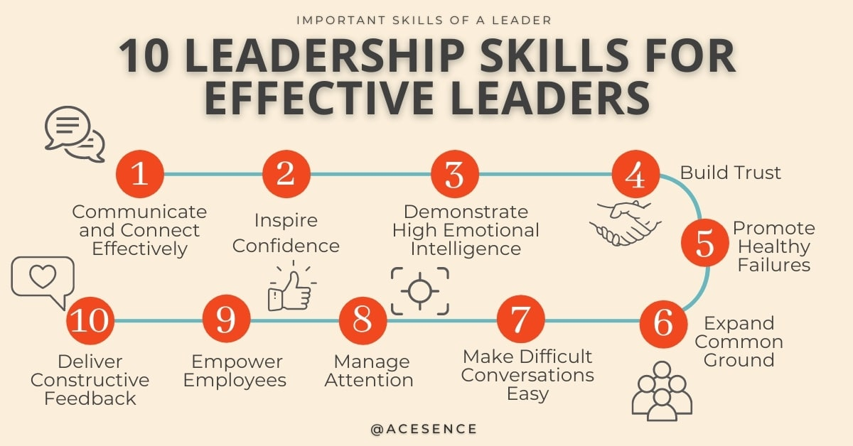
(Acesence,2024)
In times of crises, social economic impact and in such a competitive market, leadership development plans are essential to the business progression (AIHR, 2024). According to Forbes, 60% of HR leaders think that by increasing management team’s effectiveness will improve employee loyalty, productivity, and satisfaction (Forbes, 2024). As an example of not having an excellent leader is that Marriot employees would renounce their pay raise in order to see their manager fired (Forbes, 2024). The leaders must be an example to stimulate and increase the employee’s confidence and to show them the right way of applying the company values.

Finding and hiring top talents
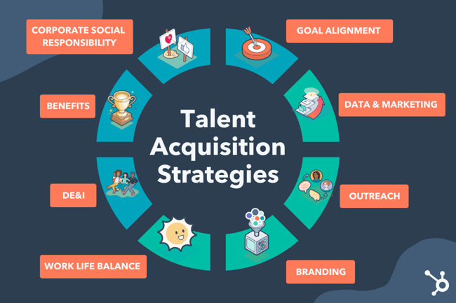
(Team dash, 2024)
As stated in a research paper from HR Datahub 56% of businesses are showing loyalty to ESG (Environmental, Social and Governance) to attract exceptional talents assets for their companies (HR Datahub, 2024). Marriott has specific recruitment principles in accordance with ESG to make sure they find the right candidates, for the right jobs, with the right skills. These are: get it right from the first time, not just money matter, create a caring workplace, promote from within and brand employment (HR Digest, 2024). Also, it implemented new people brand “Be” that is focused on three pillars: begin, belong, become with the goal to attract, hire, and retain great talents (Marriott, 2024).

Job security and secure future


(Lone star college, 2024)
Making job security the principal factor in the company is critical for the employee. Gives him stability in life. When people are secure for their job and future they can focus more on the work and produce higher quality results (Herrity, 2023). Creating a sense of security when hiring and training, makes the candidates to feel human first and then employees (Morgan, 2014). Also, it lifts some of the stress and anxiety that is affecting their productivity. Gallup discovered that 37% of insecure employees are more likely to be disengaged in workplace. Marriott created for a plus of security “Employee Stock Purchase Plan” making their staff to feel engaged and have the sense of ownership throughout the business (Elouadi, 2021).

Diversity, equity, and inclusion
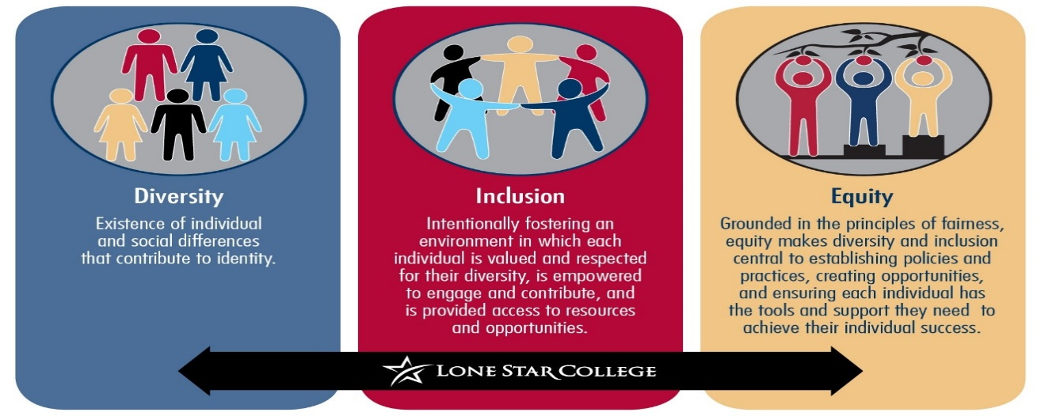
(Lone star college, 2024)
That is a form of retention and creates a company culture and together they have a long-term effect on the business performance. By using data, the HR team can reshape culture to reveille the basic issues and raise awareness of bias in the workplace (Gonçalves, 2023). According to AIHR 80% of employees expect from their leaders to take a public stand against discrimination (AIHR, 2024). Marriott intention was always to be global and to become a place where everyone to feel welcome. Its goal “To Serve 360” aims to achieve gender parity by the end of 2024 and to expand the representation of people of colour to 25% by the end of 2025 (Marriot, 2023).

Embracing technology
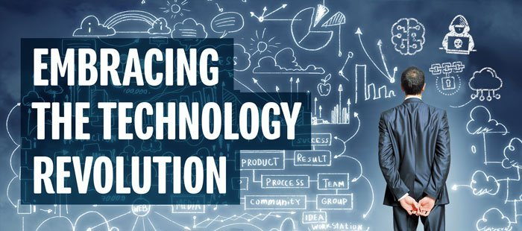
(Austbrokers, 2024)
Modern technology innovations are changing the hospitality industry. Now is becoming an essential and more straightforward way to manage data, workflow, measure, report and understand employee performance. Marcus Buckingham says that leaders can construct a real-time system via cloud that helps management team to give moment coaching and correcting, to improve employee productivity and to monitor any distinct behaviour to be able to avoid any cultural or workwise misunderstandings (Buckingham, 2022). Also, it is a useful tool for employee self-service, learning, development, and an accessible way to gather feedback from the workforce and customers to find the perfect way of improvement (Hughes, 2023).

Retention= Employee Experience+ Employee Engagement
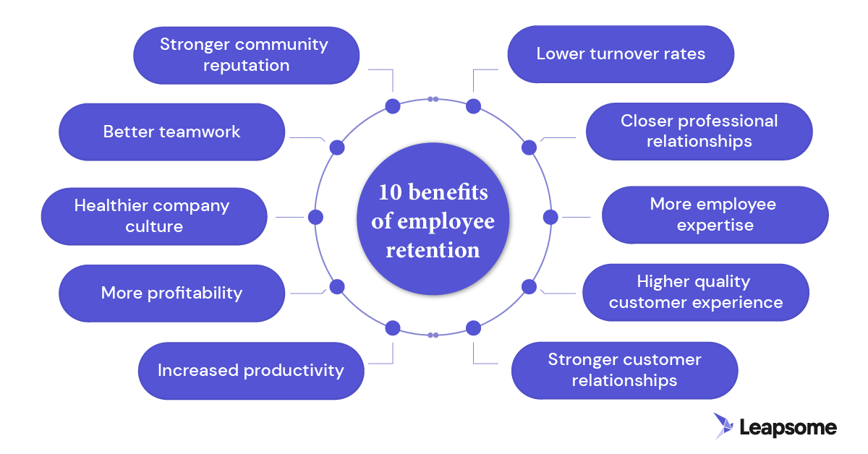
Evaluating employee’s experience involves:

Physical environment:
It incorporates the workplace, amenities, technology, tools, and tactics to help the employees in their jobs. The focus is on creating a safe, comfortable, and functional environment (White et al., 2020). Marriott was recognised as a Platinum winner of the 2015 “Best Employers for Healthy Lifestyle” for creating a safe, enjoyable and with all the necessary conditions for a healthy work environment for their associates (Marriott & Brown, 2015)

Employee wellbeing
According to WorkHuman the employees who are constantly recognised have better rates of retention and morale (WorkHuman, 2024). Ways to achieve a faultless employee life cycle (Appendix 1) is by collecting data through one-to-one talks regularly, monthly surveys and feedback from the workforce and customers (Rahman & Taniya, 2017). Marriott have been recognised for prioritising its workers’ wellbeing. 88% of their properties are allowing walking and fitness breaks and more than half have designated private prayer, relaxation rooms or rest space. Also, it provides programs foe teambuilding, financial planning, emotional health, career development and more (Marriott, 2024).

Learning, upskilling and development.
Can be achieved by offering access to grow using professional development, training, mentorship, and support (Appendix 2). Marriott learning and development starts with a new hire orientation program to ensure the candidates have the essential needed skills. Followed by 15-minute training every day for them to master their jobs. Gateways program is designed to teach them IT, HR, finance, and sales skills. Also, Marriott has an immense variety of virtual learning resources (Marriot & Brown, 2015).

Adapting the work modes
Hybrid, office, home, or flexi work are adaptive ways for offering flexibility and relive stress for their employees to boost productivity and lay a foundation for employee wellbeing.

Feedback and benefits
Listen to your employees is crucial. They are the principal source of information. Giving feedback make them feel valued and empowered and it can be a boost in their productivity. Through benefits they can see the appreciation for their work, the care from the company for their health and wellbeing and increase employee retention.

The emerge of different work modes in hospitality industry over the last five years.

Due the mixture of factors from socio-economic, population demographics, impact of Covid to the perception of industry has been created a staff crisis. Workforce is essential key part in the industry. When Covid 19 hit a great part of hospitality businesses were forced into a considerable staff reduction (Mejia, 2019). With the things slowly come back to the right path these forced changes caused a development of new work models. Flexible work arrangements like employee sharing (Meng et al, 2024) where more employers ca share human workforce across the organisations. Also, office, home, or hybrid work (combines office environment and working from home) modes are implemented for a better flexibility and achieving a work-life balance (Vasilieva & Gromova, 2021).
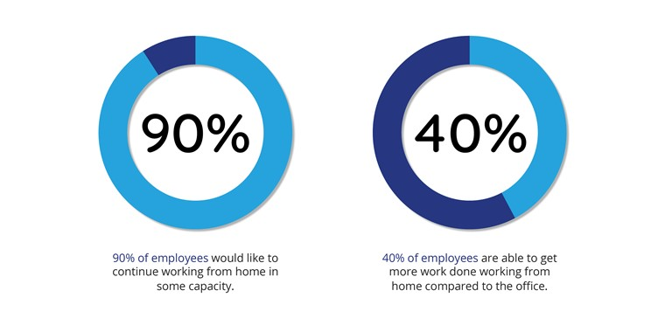
Oak Engage, (2021)
As well, hospitality adapted new concepts like take out only for restaurants and innovative technology like contactless payments, AI, and self-service. This adaptation is beneficial but can lead to fewer jobs, higher level skill people demand or combined duties (Vassou et al., 2017).

Employee performance management and monitoring.
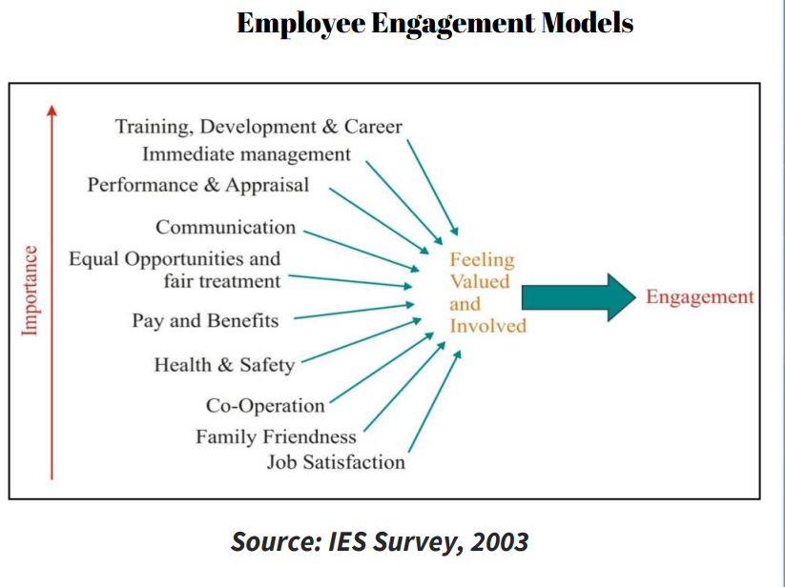
Employees need to be aware what is expected from them and to be given the support, resources, motivation they need to succeed. Also, make them accountable for their action. Involving them in their work is the key factor in improving theirs and organisational performance. According to Gallup Institute, worldwide just 15% of employees are described as fully engaged (Gallup, 2018). Having effective strategies that helps to create a perfect work culture reduces staff turnover, builds a better work, and impacts the company profits (Dewett, 2022). Engagement improvement is the essential way to overcome the challenges in this uncertainty period.
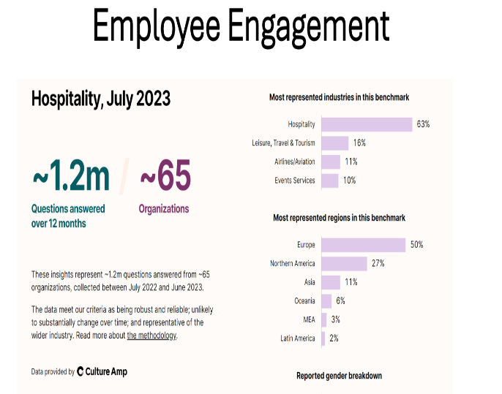

Hospitality industry has the highest employee engagement percentage according to a survey performed over one year period in sixty-five organisations (Culture Amp, 2024)

Marriot company is using AON Hewitt engagement model as a framework to identify the elements that influence the employee engagement and provides actionable insights (Appendix 3). Conducting thousands of interviews and group discussions they reach this “say, stay and strive” definition. This way they discovered what engaged workers think and do in order to create the future strategies for the new candidates (Hinzmann et al., 2019).
There are several factors to take in consideration when menage and monitor the employee engagement and performance. Age for example as generational difference cannot be controlled in the selection processes. It has been researched that younger people have lower level of cognitive functions than native born adults (Hausdorf & Robie, 2018). So therefore, the majority of engaged employees are situated in between age of 24 and 54, part of Generation X and Millennials, (Appendix 4 and 5) and it has been predicted through surveys and research that will be continued to be also in the future.
In addition, another crucial factor that can influence employee life cycle and experience and therefore their engagement is health and wellbeing. UK Government attests that being unemployed is not the desirable condition for our health and wellbeing and that is better to have a “good work” instead (Gov.UK, 2019). Employment quality protects against social exclusion, poor mental health, increase risk of mortality, long term illness and loss of identity.
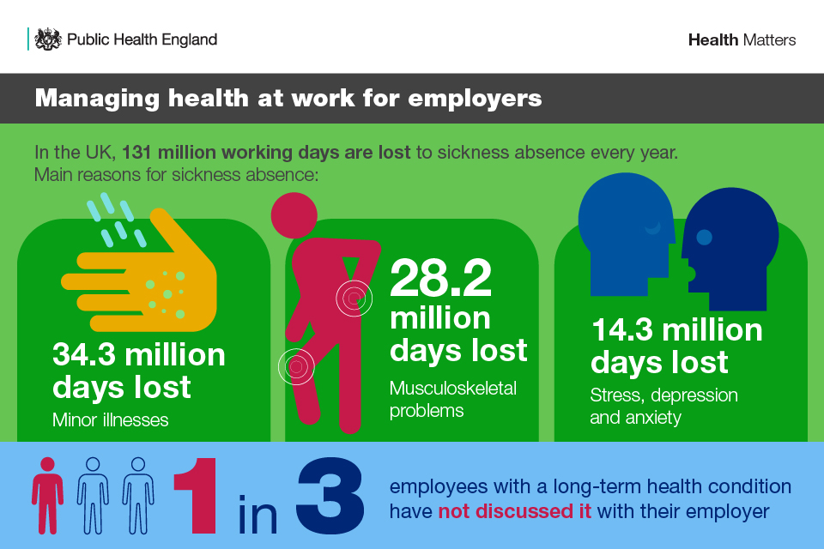
An unhealthy workforce leads to loss of productivity due the increase of long-term sickness or incapacity of perform certain tasks.
Additionally, looking from the economic perspective, due the increase sickness absence (Appendix 6) and unemployment the amount lost annually is approximately £100 billion. Around 12,8 million employees have long term condition and 5,3 million with non-disabling health conditions. Studies shows that not always having a health problem affects the employment as 61% of people with certain condition are already in a job, but with limited day to day activities and tools and environment suitable for their affections (Sabariego, et al. 2018).
Marriott leader team knows that success depends on employee health and productivity. Their understanding about good health is to meet the needs of their employees and their families. Marriott provides medical, prescription drugs, vision, and dental coverage to 150000 associates and 80% of benefits to eligible dependents that are enrolled in its medical plans. Marriot has implemented a series of mental health and wellbeing programs to equip leaders with knowledge to be able to identify struggles in their teams, to raise and address any similar concerns. They share their authentic stories and experience through social media platforms to show what a suitable place is Marriott and to stimulate the looking candidates to apply for a job. (Marriott, 2024)

Conclusion

It is a fact that social and economic factors have a high-level impact on the workforce. It is essential that every leader to be aware of those factors, understand and find solutions to maintain performance, engagement, and motivation in this new world. Companies need to develop leaders who can reduce the fear of no stability, security in work or any concerns of their employees through a future vision and a sense of belonging. The workplace relationships need to be based on trust, engagement, and loyalty. The leaders must stand up, pay attention and lead by example. Find the faulty factors, formulate a plan, and take measures. Treat your employees like individuals regardless of age, gender, sexual orientation, race, or religion. Make them feel authentic selves in work. A happy employee is a an engaged and have an excellence performance driving the productivity to its superior limits.

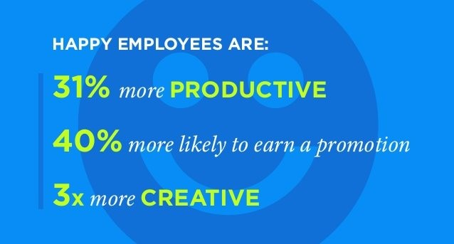

References:
Acesence, (2024), Agile leadership blog, 10 Leadership Skills Every Effective Leader Needs, Available at: https://blog.acesence.com/10-important-leadership-skills-for-effective-leaders/, Accessed 23.05.2024.
AIHR, (2024), Build a better workplace, Available at: https://www.aihr.com/?utm_source=bing&utm_medium=search&utm_campaign=global&utm_content=brand&hsa_ad=&hsa_mt=e&hsa_tgt=kwd-82808186370473, Accessed 23.05.2024.
Austbrokers, (2024), Countrywide, Available at: https://abcountrywide.com/page-not-found/?avia_forced_reroute=1, Accessed 23.05.2024.
Buckingham, M. (2022) Designing Work That People Love, Harvard business review. Boston: Harvard Business Review, pp. 66-.
Culture Amp, (2024), Hospitality January 2024, Available at: https://www.cultureamp.com/science/insights/hospitality, Accessed 25.05.2024.
Elouadi, S. (ed.) (2021) Employee share ownership and impacts on organizational value and behaviour. Hershey, Pennsylvania: Business Science Reference. Available at: https://doi.org/10.4018/978-1-7998-8557-3., Accessed 22.05.2024.
Deloitte (2019). Future of work: An introduction. Deloitte Development LLC.
Dewett, T. (2022) Sustainable Employee Engagement. Carpenteria, CA: linkedin.com.
‘Disengaged Employees Result in Lower Productivity, Gallup Report Says’ (2018) Professional safety, 63(2), pp. 17–17.
Elena Vasilieva and Alla Gromova (2021), Organization of Work in Remote Mode and Hybrid Format, 17(4), pp. 954–963. Available at: https://doi.org/10.25559/SITITO.17.202104.954-963. Accessed 24.05.2024.
Forbes, (2024), Key HR Statistics and Trends In 2024, Available at: https://www.marriott.com/culture-and-values/core-values.mi, Accessed 21.05.2024.
Gonçalves, S. (ed.) (2023) Developing diversity, equity, and inclusion policies for promoting employee sustainability and well-being: Sonia Gonçalves [and three others], editors. 1st ed. Hershey, Pennsylvania: Business Science Reference.
GOV.UK, (2019), Health matters: health and work, Available at: https://www.gov.uk/government/publications/health-matters-health-and-work/health-matters-health-and-work, Accessed 25.05.2024.
Hausdorf, P.A. and Robie, C. (2018) ‘Understanding subgroup differences with general mental ability tests in employment selection: Exploring socio‐cultural factors across inter‐generational groups. International journal of selection and assessment, 26(2–4), pp. 176–190. Available at: https://doi.org/10.1111/ijsa.12226. Accessed 25.05.2024.
Hughes, C. (2023) Valuing people and technology in the workplace: ethical implications and imperatives for success. 1st ed. Hershey, Pennsylvania: Business Science Reference.
Institute for Employment Studies, (2003), Survey, Available at: https://www.employment-studies.co.uk/system/files/resources/files/408.pdf, Accessed 25.05.2024.
Jennifer Herrity, (2023), The Importance of Job Security in the Workplace (With Tips), Indeed, Available at: https://www.indeed.com/career-advice/career-development/job-security, Accessed 26.05.2024.
Lone star college, (2024), Pictures, Available at: https://www.lonestar.edu/college-departments/culture-engagement/index.htm, Accessed 23.02.2024.
Marriott, (2023), Associates, Diversity, equity, and inclusion, Available at: https://www.marriott.com/diversity/associates-diversity.mi, Accessed 22.05.2024.
Marriott International, (2024), Marriott International Launches New People Brand “Be” to Grow and Empower Global Workforce, Available at: https://news.marriott.com/news/2023/04/04/marriott-international-launches-new-people-brand-be-to-grow-and-empower-global-workforce, Accessed 22.05.2024.
Marriott, J.W. and Brown, K.A. (2015) The spirit to serve: Marriott’s way. Place of publication not identified: Snowball Publishing.
Mba Skool, (2024), Marriott PESTLE Analysis, Available at: https://www.mbaskool.com/pestle-analysis/companies/17988-marriott.html#social, Accessed 21.05.2024.
Mejia, C. (2019) ‘Influencing green technology use behaviour in the hospitality industry and the role of the “green champion”’, Journal of hospitality marketing & management, 28(5), pp. 538–557. Available at: https://doi.org/10.1080/19368623.2019.1539935. Accessed 24.05.2024.
(Monroe)Meng, L. et al. (2024) ‘Employee‐sharing and consumers’ brand attitudes during COVID‐19: A CSR perspective’, Journal of consumer behaviour, 23(2), pp. 608–619. Available at: https://doi.org/10.1002/cb.2216. Accessed 24.05.2024.
Morgan, J. (2014) The future of work: attract new talent, build better leaders, and create a competitive organization. First edition. Hoboken, New Jersey: Wiley.
Oak Engage, (2021), The Evolution of Work Modes Throughout 2021. Available at: https://www.oak.com/blog/the-evolution-of-work-modes-throughout-2021/, Accessed 24.05.2024.
Pearlman, K. (2023) ‘Workhuman Specializes in Social Recognition: SaaS: Software Focuses on Recognizing, Rewarding Employees’, San Diego business journal, 44(14), pp. 13-.
Posadzy, K. (2017) Social and Economic Factors in Decision Making under Uncertainty: Five Essays in Behavioural Economics. Available at: https://doi.org/10.3384/diss.diva-143035. Accessed 21.05.2024.
Rahman, M. S., & Taniya, R. K. (2017). Effect of employee relationship management (ERM) on employee performance: A study on private commercial banks in Bangladesh. Human Resource Management Research, 7(2), 90-96. Doi: https://doi.org/10.5923/j.hrmr.20170702.03, Accessed 21.05.2024.
Roxana Hinzmann, Martina Rašticová and Jakub Šácha (2019) ‘Factors of Employee Engagement at the Workplace. Do Years of Service Count?’ Acta Universitatis Agriculturae et Silviculturae Mendelianae Brunensis, 67(6), pp. 1525–1533. Available at: https://doi.org/10.11118/actaun201967061525. Accessed 25.05.2024.
Sabariego, C. et al. (2018) ‘Effectiveness of Integration and Re-Integration into Work Strategies for Persons with Chronic Conditions: A Systematic Review of European Strategies’, International journal of environmental research and public health, 15(3), pp. 552-. Available at: https://doi.org/10.3390/ijerph15030552. Accessed 25.05.2024.
Staah, (2021), Must-know five trends in hospitality industry, Available at: https://blog.staah.com/tips-trends/5-easy-ways-to-make-sure-you-are-following-these-latest-trends-in-hospitality, Accessed 22.05.2024.
Team dash, (2024), Maximize your hiring efficiency with Team dash, the cutting-edge Talent Acquisition Software. Available at: https://www.teamdash.com/talent-acquisition-software-book-a-demo/, Accessed 23.05.2024.
The HR Digest, (2024), Recruitment principles of Marriott, Available at: https://www.thehrdigest.com/recruitment-principles-of-marriot/#:~:text=Recruitment%20Principles%201%201.Get%20it%20right%20the%20first,workplace%204%204.Promote%20from%20within%205%205.Employment%20Brand, Accessed 22.05.2024.
Vassou, C., Zopiatis, A. and Theocharous, A.L. (2017) ‘Intercultural workplace relationships in the hospitality industry: Beyond the tip of the iceberg’, International journal of hospitality management, 61, pp. 14–25. Available at: https://doi.org/10.1016/j.ijhm.2016.11.001. Accessed 24.05.2024.
Vinodan, A. and Manalel, J. (2019) Ecotourism and community intervention: emerging research and opportunities. Hershey, Pennsylvania: Business Science Reference. Available at: https://doi.org/10.4018/978-1-7998-1635-5., Accessed 22.05.2024.
White, L., Lockett, A., & Currie, G. (2020). How does the availability and use of flexible leave influence the employer–employee relationship? Human Resource Management, 59(5), 445-461. Doi: https://doi.org/10.1002/hrm.22004, Accessed 21.05.2024.

Appendices:
Appendix 1

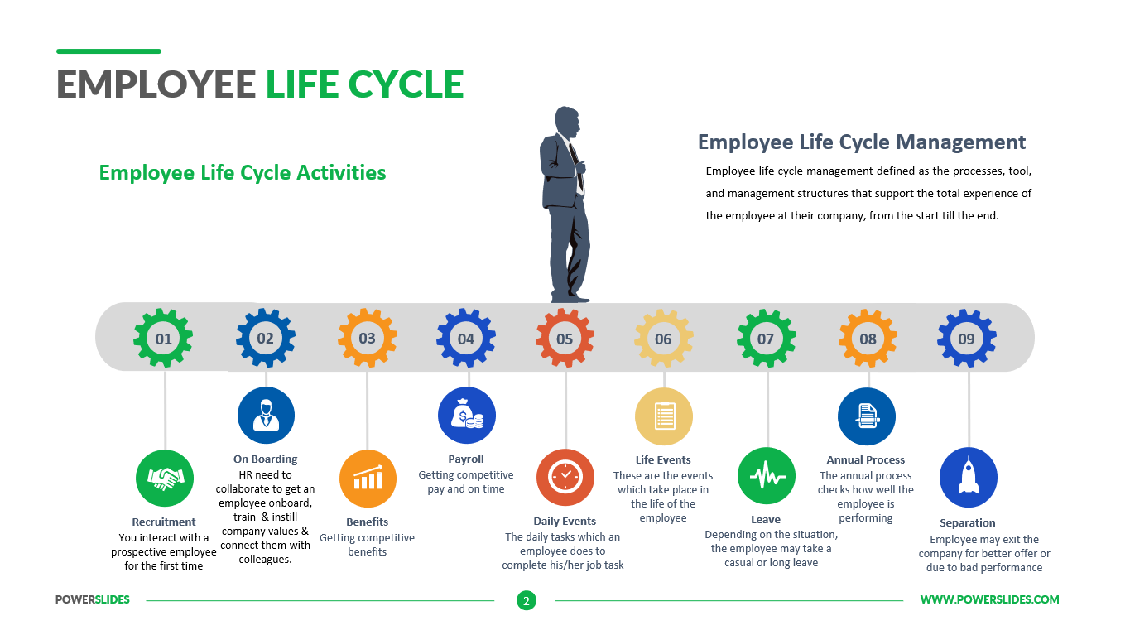

Appendix 2

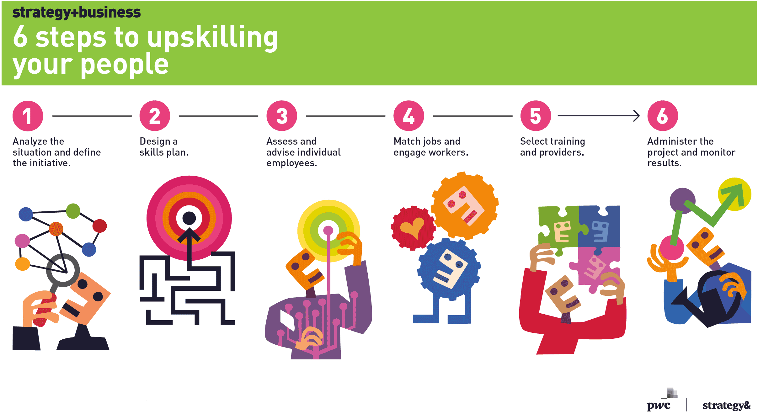
Appendix 3

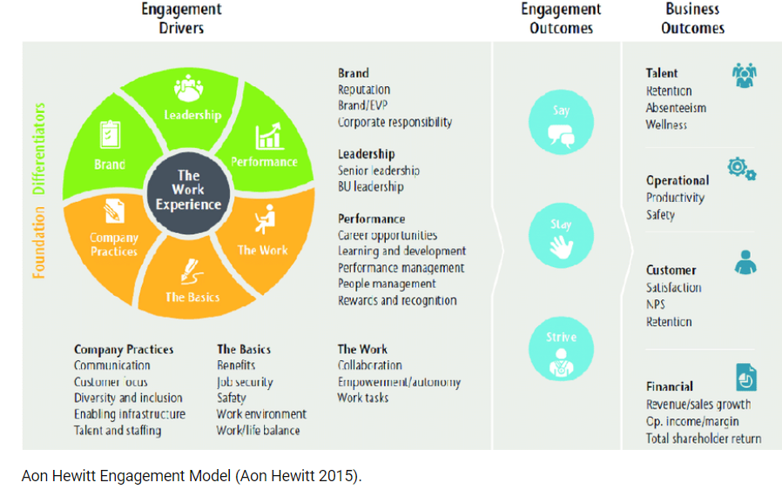

Appendix 4

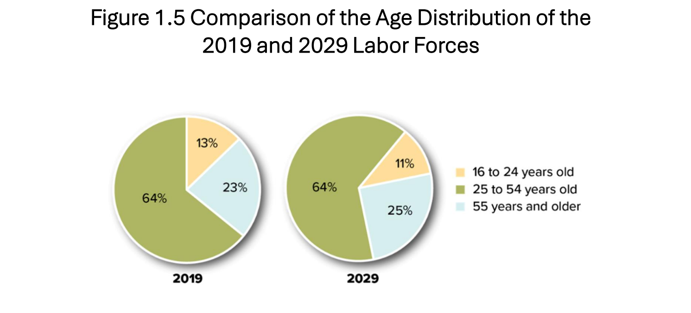

Appendix 5

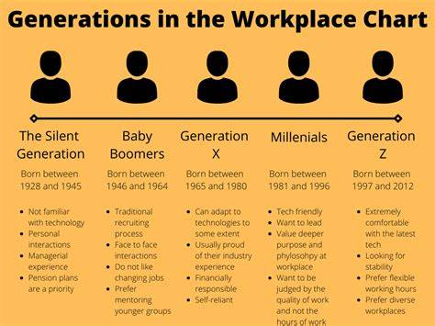

Appendix 6


