Strategic Management
Case study: Netflix goes to Bollywood
MODULE CODE: LCMB7003

Student Number: 2128283

Student Name: MIDHUN KOPPARAMBIL VIKRAMAN

Executive summary:
Netflix is seeking to expand its presence in India, and one potential strategy it may consider is merging with or acquiring established local brands. To effectively execute this strategy, the company will need to conduct a thorough internal and external analysis of its own organization and the Indian market. This may include a value chain analysis to understand the company's resources and capabilities, as well as tools like Porter's Five Forces model to assess the market attractiveness. A SWOT analysis and PESTLE analysis can also help Netflix evaluate its strengths and weaknesses, and inform the development of both deliberate and emergent strategies. As part of this process, Netflix may need to consider merging with other established brands in the market to establish themselves in the Indian market. The strategic management of Netflix will be crucial in helping the company navigate the Indian market and achieve profitability in this key market.

Table of content:
Executive summary: 2
Introduction: 5
Streaming services in India: 6
Revenues of the Indian streaming services: 7
Key trends of the Indian streaming services: 8
Key success factors of Netflix: 9
Internal analysis of Netflix in Bollywood: 10
Value Chain analysis: 10
Resources, competencies, and capabilities of Netflix in India: 11
External analysis of Netflix in India: 12
SWOT analysis: 12
PESTLE analysis: 12
Market attractiveness evaluation of Netflix: 14
The link between stakeholder expectation and purpose of organization: 17
Mendelow’s Stakeholder analysis: 17
Ethical issues, sustainability, CSR and their impact on the strategic development: 19
Organization culture, leadership structure and the impact on the strategic implementation: 19
Strategies for Netflix to sustain the competitive advantage: 20
Strategic Choice development: 20
Ansoff Matrix: 20
Deliberate strategy: Market expansion: 21
Emergent strategy: Netflix should be using advertisement to drive profitability: 22
Merger with other brands in the market: 22
Choice for the best fit strategy and the implementation: 23
Recommendation: 24
Conclusion: 24
References: 25

Introduction:
Subscription Video on Demand (SVOD) is a popular form of entertainment that allows users to stream a wide range of video content, including movies and TV shows, over the internet on a subscription basis. This service has become increasingly popular in recent years due to the convenience it offers users, as well as the wide range of content that is available (Sull and Turconi, 2021). SVOD services are offered by a number of companies, including international players such as Netflix and Amazon Prime, as well as local providers in various countries around the world. These services typically offer a subscription package that allows users to access a wide range of content for a fixed monthly fee (Kumar et al., 2020). In addition, many SVOD services also offer additional features such as offline viewing, the ability to watch content on multiple devices, and the option to purchase or rent individual movies or TV shows. Around the world, the demand for SVOD has grown significantly in recent years. In the United States, for example, the number of people using streaming services such as Netflix, Hulu, and Amazon Prime has increased steadily in the past decade (Pérez, 2020). According to a report from the Pew Research Centre, as of 2021, around 69% of adults in the United States used a streaming service, up from just 32% in 2010. This trend is expected to continue, with analysts predicting that the number of streaming subscribers will reach over 200 million in the United States by 2025 (Wayne, 2018).
The demand for SVOD is also increasing in other countries around the world. In Europe, for example, the number of streaming subscribers has increased by around 50% in the past five years. In Asia, the demand for streaming services is also growing, with countries such as India, China, and South Korea leading the way (Pérez, 2020). The increasing demand for SVOD is being driven by a number of factors, including the convenience and flexibility it offers users, the wide range of content that is available, and the relatively low cost of subscription compared to traditional pay-TV services. In addition, the rise of on-demand streaming has led to the development of new business models, such as the release of entire seasons of TV shows at once, which has proven popular with viewers (Grece, 2021). Overall, the demand for SVOD is expected to continue growing in the coming years, with more and more people turning to streaming services for their entertainment needs. This trend is being driven by a range of factors, including the convenience and flexibility offered by these services, the wide range of content that is available, and the relatively low cost of subscription.
Therefore, the purpose of the following study is to understand the market entry of Netflix in Bollywood and therefore, to understand that the synthesis of the relationship between the external and the internal context is taken into consideration and the impact on the management in the following. Other than that, evaluation of the competitive and the development report is also consideration which can help in the context of understanding the strategic management issues which the Netflix can face while operating in India. Finally, analysing both the internal and the external factors and other things into consideration there are factors which will be relied upon which can be considered for the implementation strategy.

Streaming services in India:
Video streaming services have become increasingly popular in India in recent years, driven by the growing adoption of smartphones and the increasing availability of affordable internet services (Daidj and Egert, 2018). According to a report from KPMG India and the Indian Film and Television Producers Council, the number of streaming subscribers in India is expected to reach over 500 million by 2025, up from around 200 million in 2021.
There are a number of video streaming services available in India, including both international players such as Netflix and Amazon Prime, as well as local providers such as Hotstar and Voot. These services offer a wide range of content, including movies, TV shows, documentaries, and other programming, and typically charge a monthly subscription fee (Tiwary, 2020). The demand for streaming services has increased significantly in India in recent years, with the number of subscribers expected to reach over 500 million by 2025. Both international players like Netflix and Amazon Prime, as well as local providers like Hotstar and Voot, are competing for a share of the Indian market. According to JustWatch, Netflix and Amazon Prime each captured about 20% of the market in Q2 of 2020, while the cooperation of Disney+ and Hotstar reached 17% (Nagaraj et al., 2021). However, the Indian streaming market remains fragmented, with a number of local brands still accounting for nearly half of the market. The COVID-19 pandemic has also led to an increase in the production of Indian-made original content by streaming services, with Netflix releasing 18 Indian-made originals in 2020 and Amazon Prime planning to release 14. Disney+ Hotstar, a brand that combines Disney's global streaming service with Hotstar's Indian programming and cricket league broadcasting rights, has also said it will host seven movies that were originally intended for release in cinemas (Fitzgerald, 2019).
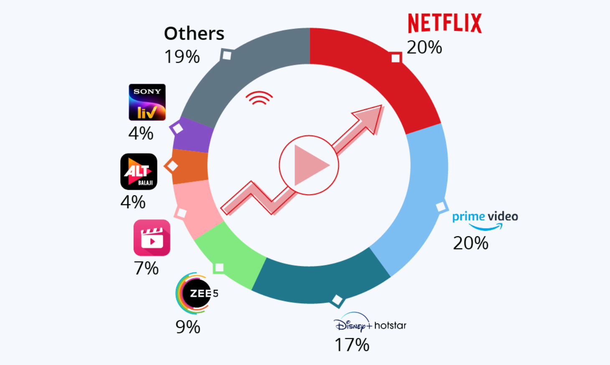
Figure 1: Streaming services analysis in India
Source: Nagaraj et al., 2021
One of the key drivers of the growth in video streaming in India has been the increasing availability of affordable internet services. With more and more people gaining access to the internet, the demand for streaming services has increased significantly (Singh et al., 2021). In addition, the proliferation of smartphones in India has also contributed to the growth of video streaming, as these devices provide an easy and convenient way for users to access streaming content.
The competition among video streaming services in India is fierce, with each service seeking to differentiate itself from the competition through the quality and range of its content. Many of the services also offer original programming, which has proven popular with viewers.
Overall, the video streaming market in India is expected to continue growing at a rapid pace in the coming years, driven by the increasing availability of affordable internet services and the proliferation of smartphones. With a wide range of services available and a growing demand for streaming content, the future looks bright for the video streaming industry in India.

Revenues of the Indian streaming services:
The OTT video market in India has seen significant growth in recent years, driven by the increasing adoption of smartphones and the availability of affordable internet services. The pandemic has also contributed to the growth of the OTT video market, as more people turn to streaming services for entertainment while being confined to their homes especially after the Covid (TM et al., 2021). According to Statista, the revenue of the Over-The-Top (OTT) video market in India is expected to reach $2.52 billion in 2022 and is projected to have an annual growth rate of 9.17% in revenue from 2022 to 2026. This means that by 2026, the projected market volume of the OTT video segment in India may reach $3.61 billion (Dhiman, 2021). The number of users on OTT video platforms in India is also expected to increase, with an estimated 440 million users by 2026 (Nafees et al., 2019). The average revenue per user (ARPU) in the OTT video segment in India is projected to be $7.35 in 2022. The SVOD will be the primary driver for majority of the revenue within the country. Therefore, which in increasing at a rate of around 31% in the year 2019 to $2.8 billion in the year 2024 (Foxman, 2020 ).
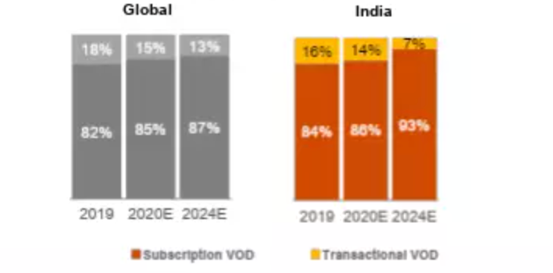
Figure 2: Revenue of Indian Streaming market
Source: Foxman, 2020

Key trends of the Indian streaming services:
One of the main trends is the increasing adoption of smartphones and the availability of affordable internet services. This has led to a significant increase in the number of people using streaming services in India, with the number of subscribers expected to reach over 500 million by 2025 (Van der Voet, 2021). The proliferation of smartphones has also made it easier for people to access streaming content, as these devices provide a convenient way to watch movies and TV shows on-the-go.
Another trend is the growing demand for original content. Streaming services in India, both international and local, are increasingly producing their own original programming in an effort to differentiate themselves from the competition. This trend has been accelerated by the pandemic, as many traditional sources of content, such as cinemas, have been shuttered (Singh et al., 2021).
A third trend is the increasing competition among streaming services. With a number of international and local players vying for a share of the Indian market, companies are seeking to differentiate themselves through the quality and range of their content. Many streaming services are also investing in marketing and promotion in an effort to attract and retain subscribers.

Key success factors of Netflix:
There are a number of key success factors that have contributed to Netflix's success as a streaming service. Some of the main factors include:
- Original content: One of the key factors behind Netflix's success has been its focus on producing high-quality original content. This includes popular TV shows like "Stranger Things," "The Crown," and "Orange is the New Black," as well as movies and documentaries. This focus on original content has helped to differentiate Netflix from its competitors and attract a large and loyal subscriber base.
- Wide range of content: In addition to its own original content, Netflix also offers a wide range of licensed content, including movies, TV shows, and documentaries from various studios and production companies. This helps to ensure that there is something for everyone on the service, and has contributed to its popularity (Sull and Turconi, 2021).
- User-friendly interface: Netflix's user interface is designed to be intuitive and easy-to-use, which has helped to make it a popular choice among users. The service's recommendation algorithms also help users to discover new content that they may be interested in.
- Global expansion: Netflix has successfully expanded its operations to a number of countries around the world, which has helped to drive its growth and increase its subscriber base (Blair et al., 2022). The company has also invested in local content in various countries in order to appeal to local audiences.
- Marketing and promotion: Netflix has invested heavily in marketing and promotion in order to attract and retain subscribers. This includes targeted advertising campaigns, as well as partnerships and sponsorships with various organizations and events.

Internal analysis of Netflix in Bollywood:

Value Chain analysis:
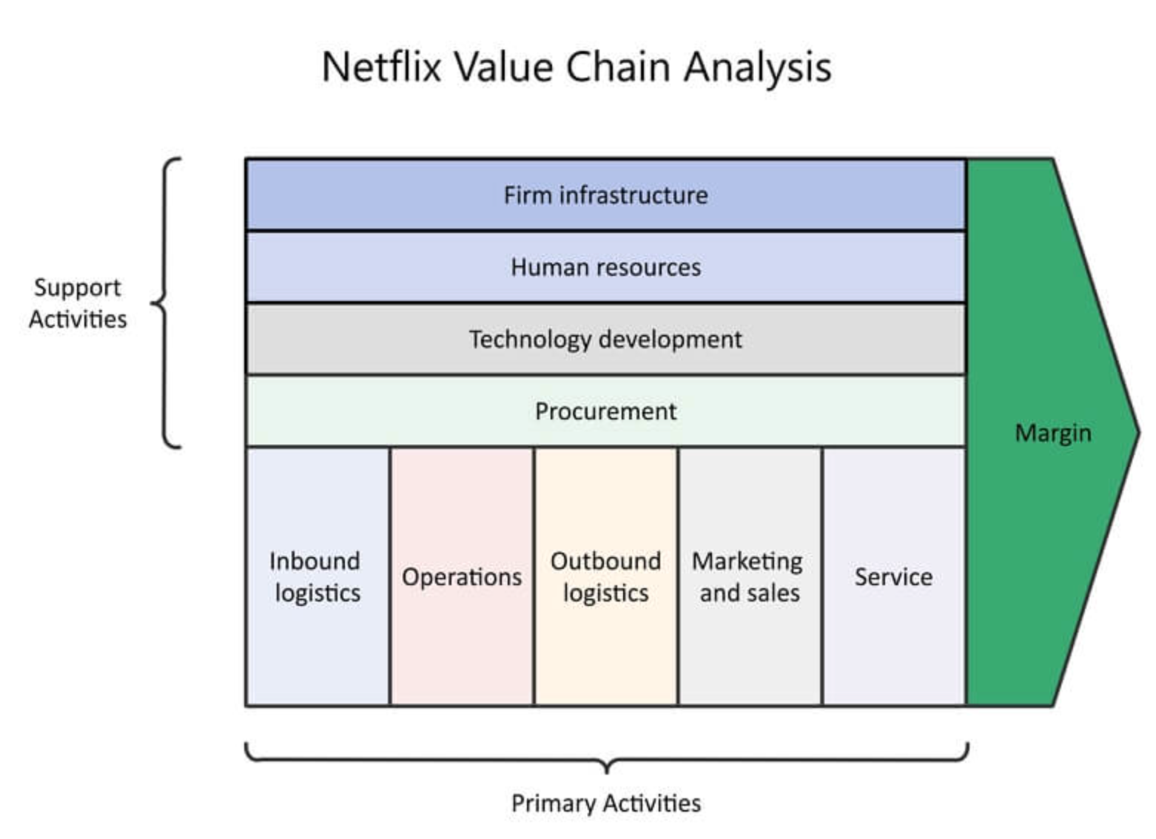
Figure 3: Value chain analysis of Netflix
Source: Burgess and Stevens, 2021
Due to the increased use of smartphones and the expansion of reasonably priced internet connections, Netflix has seen substantial growth in popularity in India in recent years. The value chain of the company in India entails a variety of tasks and procedures required for the creation and delivery of its service.
The production and purchase of content is one of the primary activities in the Netflix value chain in India. This entails obtaining or creating motion pictures, television programmes, and other media that are appropriate for the Indian market (Burgess and Stevens, 2021). The popular TV dramas "Sacred Games" and "Delhi Crime," as well as motion pictures and documentaries, are just a few examples of the unique material that Netflix has heavily invested in creating in India. In order to cater to local consumers, the business has also licenced content from Indian studios and production groups.
Marketing and promotion are two additional key primary activity in Netflix's value chain in India. This entails attracting new customers to the service through sponsorships, partnerships, and advertising (Kannisto, 2019). Additionally, Netflix spends money on customer relationship management (CRM) in an effort to keep its current members and enhance the overall user experience.
Logistics, which deals with the storage and distribution of material to users, as well as technology and IT support, which are required for the service's operation, are support activities in Netflix's value chain in India (Burgess and Stevens, 2021). To keep up with competition and consistently improve the service, the business also invests in research and development.

Resources, competencies, and capabilities of Netflix in India:
Resources:
The content library is one of Netflix's most important assets. The business has made significant investments in purchasing and creating a wide variety of films, TV series, and other types of content for its service. Popular original programming and a large variety of licenced content from different studios and production companies are included in this (Lobato, 2019).
The technology and IT infrastructure that Netflix uses are also significant resources. The business has created a sophisticated platform for consumers to access its streaming service that can handle enormous traffic volumes and give a high-quality streaming experience. In an effort to enhance its recommendation algorithms and assist consumers in finding new material, Netflix has also made investments in artificial intelligence and machine learning technology (Guadiana, 2020).

Competencies:
The capacity of Netflix to create original material of a high calibre is one of its primary strengths. As a result of the company's reputation for producing programming that is well-written, well-acted, and visually appealing, subscribers have been drawn to and kept (Türkmen, 2020). In order to ensure that there is a wide variety of content on the service, Netflix has been successful in licencing content from other studios and production firms.

Capabilities:
Netflix's user-friendly interface and recommendation algorithms are another strength. With an intuitive and simple to use user interface, the company has developed its service to be user-friendly (Rataul et al., 2018). Its recommendation algorithms can also assist users in finding fresh information that they would find interesting.

External analysis of Netflix in India:

SWOT analysis:
Strengths | Weakness
- Strong brand recognition and reputation globally  - Large and diverse library of content  - Strong financial resources to invest in original productions  - Strong distribution and marketing capabilities | - High subscription fees compared to local competitors  - Limited availability of local content compared to local competitors  - Limited understanding of local tastes and preferences
Opportunities | Threats
- Large and growing market for streaming services in India  - Increasing demand for high-quality, original content in India (Sundaravel and Elangovan, 2020).  - Opportunities to partner with local studios and production companies | - Competition from local streaming services with established presence in India, such as Jio and Hotstar  - Potential regulatory challenges or restrictions (Nafees et al., 2021)  - Competition from other global streaming services also entering the Indian market, such as Amazon Prime and Disney+

Table 1: SWOT analysis of Netflix in India

PESTLE analysis:
Political | - India has a federal form of government and a complex regulatory environment, which can impact the ability of foreign companies like Netflix to operate in the country.  - The Indian government has introduced various regulations related to foreign direct investment in the media and entertainment sector, including limits on the percentage of foreign ownership in a company and requirements for local content (Nafees et al., 2019).  - India has a history of censorship and content regulation, which can impact the types of content that are available on streaming platforms like Netflix.  - Relations between India and the United States, where Netflix is based, could also potentially impact the company's operations in India.
Economic | - India has a large and growing economy with a population of over 1.3 billion people.  - The middle class in India is expanding, and there is increasing demand for high-quality, foreign content.  - However, the Indian market is also highly competitive, with a large number of local and global streaming services vying for market share (Nafees et al., 2019).  - The high cost of subscription fees and data plans may be a barrier to adoption for some users.
Social | - India has a diverse culture with multiple languages and a rich history of film and television production.  - Attitudes towards streaming services and online content consumption may vary across different regions and demographics within India (Van der Voet, 2021).  - Social and cultural norms may also impact the types of content that are popular or acceptable in the Indian market.
Technological | - India has a high level of internet and mobile phone penetration, which has enabled the growth of the streaming industry.  - However, there are still significant disparities in internet access and infrastructure across different regions of the country (Jain, 2021).  - The adoption of newer technologies, such as 5G and artificial intelligence, could also impact the streaming industry in India.
Legal | - As mentioned earlier, India has a complex regulatory environment with various laws and regulations related to foreign investment, content regulation, and data protection (Sundaravel and Elangovan, 2020).  - Netflix will need to ensure compliance with these laws and regulations in order to operate in the Indian market.  - Intellectual property laws and licensing agreements may also be relevant to Netflix's operations in India.
Environmental | - Sustainability is becoming an increasingly important concern for consumers, and companies like Netflix may face pressure to reduce their environmental impact.  - India is vulnerable to the impacts of climate change, and the streaming industry may face challenges related to energy consumption and carbon emissions.

Table 2: PESTLE analysis of Netflix

Market attractiveness evaluation of Netflix:
To understand the market attractiveness evaluation of Netflix the use of Porter’s five forces model is taken into consideration as they are the most dynamic and also the powerful tool. Therefore, in the words of Bajaj, (2022) the five forces which could be used for understanding the attractiveness of Netflix in the Indian market are:
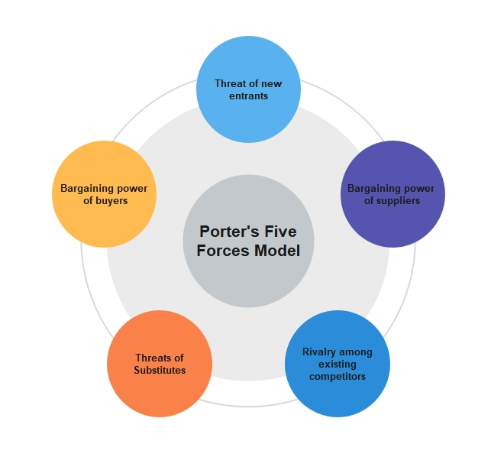
Figure 4: Porter’s five forces
Source: Bruijl and Gerard, 2018

Threat of new entrants:
The streaming market in India is highly vulnerable to new competitors. The entry barriers are relatively low for new businesses, and there are already many regional and international firms contending for market share. In order to compete with well-established firms like Jio and Hotstar, Netflix will need to stand out from the crowd and establish a powerful brand (Morris, 2022).

Bargaining power of the suppliers:
In the streaming market, suppliers have little negotiating power. With its extensive and varied library of programming, Netflix is able to work out advantageous agreements with studios and content producers.

Rivalry among existing competitors:
Intense competition exists among the current rivals in the Indian streaming sector. The industry is characterised by fierce competition and quick changes, with many firms striving for market dominance (Sakal, et al., 2022). To be competitive, Netflix will need to constantly innovate and adapt.

Threats to substitute:
In the streaming sector, the threat of alternatives is moderate. While there are other ways to pass the time, such cable television and movie theatres, streaming services are a good alternative because of their ease and diversity (Bruijl and Gerard, 2018). In order to stay competitive, Netflix will need to consistently provide top-notch content.

Bargaining power of buyers:
In the streaming sector, consumers have strong negotiating leverage. Customers can effortlessly transition between various platforms and have access to a large variety of alternatives. To draw and keep users, Netflix will need to provide competitive pricing and value.

The link between stakeholder expectation and purpose of organization:

Mendelow’s Stakeholder analysis:
The stakeholder analysis of Mendelow’s there are four matrices which needs to be taken into consideration and they are applicable in the case of Netflix as well and they are:
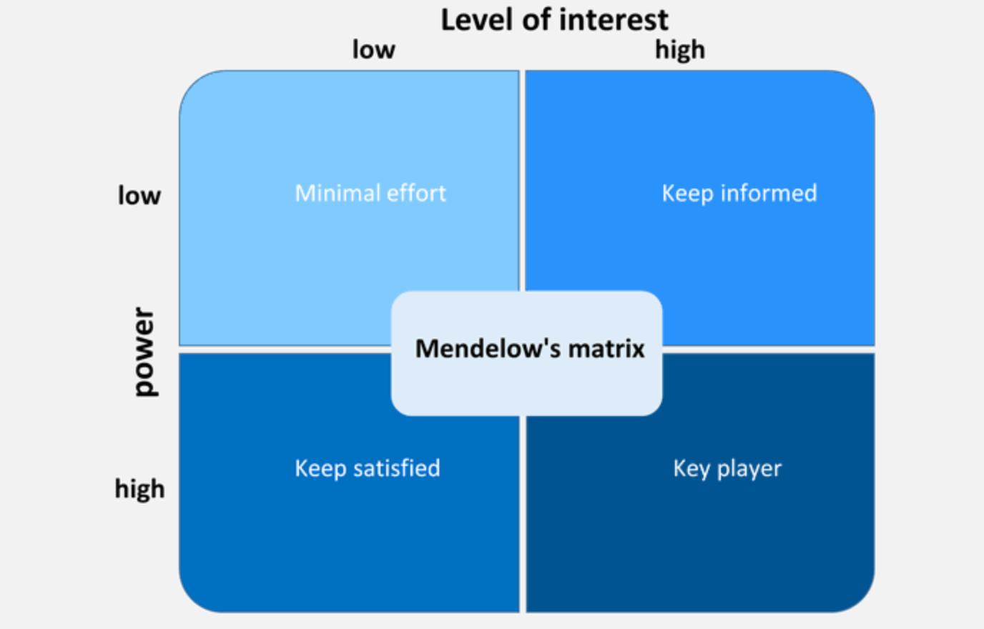
Figure 5: Mendelow’s Stakeholder analysis
Source: Cherla et al., 2021

High influence, high interest:
Shareholders: Shareholders have a high level of interest in Netflix because they have a financial stake in the business's success. They also have a moderate level of influence since they can cast votes on important decisions and hold the management of the firm responsible by owning shares.
Customers: Customers have a high level of interest in Netflix because they pay for the service and anticipate high levels of value and quality. They also have a high level of influence because they can choose whether to subscribe or cancel, and they may also have an impact on the company's reputation through reviews and recommendations (Flew and Lim, 2019).

High influence, low interest:
Regulators: Although they are in charge of ensuring that relevant laws and regulations are followed, regulators have a moderate level of interest in Netflix and a high level of influence because they have the authority to impose fines and other limits on the firm.

Low influence, high interest:
Employees: Employees have a high level of interest in Netflix because their employment and working conditions directly affect their well-being, but they also have a moderate level of influence because they can voice concerns and push for change within the company and possibly affect the company's reputation through their public statements and actions (Cherla et al., 2021).
Society: NGOs, advocacy groups, and other stakeholders can voice concerns and promote change through public campaigns and engagement with the firm. As a result, society is highly interested in Netflix because of its broad impact on a variety of dimensions of social and environmental well-being (Fleischman et al., 2021).

Low influence, low interest:
Content producers: Content producers have a high level of interest in Netflix because the success of the company depends on the calibre and popularity of the content it streams. However, they also have a moderate level of influence because they can negotiate with Netflix about their terms and may be able to secure distribution with other platforms if they are dissatisfied with their relationship with Netflix (Markham et al., 2019).

Ethical issues, sustainability, CSR and their impact on the strategic development:
The company's supply chain may experience ethical problems with labour practises, data protection, and content regulation. Netflix, for instance, might come under pressure to make sure that its programming doesn't harm cultural sensibilities or transgress Indian censorship regulations. In addition, the organisation may need to handle issues relating to the gathering, handling, and protection of client data (Mathur, 2018). Additionally, Netflix may need to think about the ethical ramifications of its manufacturing and sourcing methods and make sure that it is not causing labour exploitation or environmental destruction.
CSR initiatives may also be taken into consideration when formulating Netflix's India strategy. The business can feel compelled to show that it cares about both the environment and society, therefore it might decide to develop programmes like carbon offsetting, sustainability reporting, or community involvement (Mathur, 2018). These activities may be a source of difference and a tool to forge closer ties with stakeholders in addition to helping to reduce negative effects and improve the company's reputation.

Organization culture, leadership structure and the impact on the strategic implementation:
A company's operating style is influenced by its common values, beliefs, and practises, which are referred to as organisational culture. The company culture at Netflix rewards risk-taking, innovation, and customer pleasure (Grover et al., 2022). The company's success has been greatly influenced by its culture, which has also enabled it to upend established markets like the media and entertainment.
A company's organisational structure describes how it is set up and how work is distributed among personnel. Because of Netflix's flat organisational structure, there aren't many tiers of management, and staff members have a lot of autonomy (Corritore et al., 2020). The company is now more adaptable and change-responsive thanks to this structure.
The success of Netflix is also greatly influenced by its leadership. The company's culture and strategy have greatly benefited from the leadership of Reed Hastings, the CEO. He has promoted an innovative work environment and urged staff members to take chances and think creatively (Agnihotri and Bhattacharya, 2021).

Strategies for Netflix to sustain the competitive advantage:

Strategic Choice development:

Ansoff Matrix:
In the words of Schawel and Billing, (2018) Ansoff Matrix is a tool that aids businesses in examining the connections between their target markets, existing products, and both. Using the Ansoff Matrix, a company targeting an existing market can think about methods like boosting sales of current items or launching new ones. The Ansoff Matrix, on the other hand, can be used to assess methods like selling current items in the new market or introducing whole new products if the firm is going after a new market.
Market Penetration:
Increasing the sales of current items to current markets is the goal of this strategy. This might have required Netflix to advertise its streaming service to the already-tapped Indian market in order to grow its market share (Mahadevan, 2020).

Market Development:
Selling existing items to new markets is the goal of this strategy. This could have meant first launching Netflix's streaming service on the Indian market in the context of the company's entry into India (Schawel and Billing, 2018).

Product Development:
This tactic entails providing fresh merchandise to already-established markets. This might have required Netflix to produce original material exclusively for the Indian market in order to appeal to Indian consumers and set itself apart from its rivals.

Diversification:
New items are being introduced to new markets as part of this strategy. This might have required Netflix to introduce a different service or technology to the Indian market in addition to its streaming offering (Mahadevan, 2020). Although this tactic entails more risk, it also has the potential to yield greater benefits.

Deliberate strategy: Market expansion:
To understand the deliberate strategy of the market expansion of the Netflix in India below is the table which could be used for understanding using SMART analysis (Latham, 2020). Therefore, below is the table which is representing the same.
Specific | To be effective, Netflix's market strategy in India would need to be specific and clearly defined. This could include a specific goal for the company, such as increasing its market share in India by a certain percentage within a certain time frame. This goal would need to be specific enough to provide clear direction and focus for the company's efforts.
Measurable | The goal should be measurable, so that the company can track its progress towards achieving it. For example, if the goal is to increase market share, this could be measured by tracking the number of subscribers or the percentage of the market that the company has captured.
Achievable | The goal should be attainable, meaning that it is realistic given the resources and capabilities of the company. This would involve assessing the company's strengths and weaknesses and determining whether it has the necessary resources to achieve the goal.
Relevant | The goal should be relevant to the company's overall expansion strategy in India and should align with its overall business objectives. This would involve considering the current market conditions and competition, as well as the needs and preferences of Indian consumers.
Time Frame | The goal should have a clear timeline for achievement, with specific milestones and deadlines in place. This would help to ensure that the company stays on track and makes progress towards achieving the goal.

Emergent strategy: Netflix should be using advertisement to drive profitability:
As a streaming service, Netflix has never featured commercials and instead relies on subscription fees for income. But as the business seeks to grow in India and increase profitability, it might think again about its promise to remain ad-free. There are a number of ways that introducing adverts into Netflix's business model could aid in the company's expansion and financial success in India.
Selling ad space on its website is one way Netflix may use advertisements to boost profitability in India. Netflix might increase its revenue by allowing other businesses to advertise their goods or services on its streaming service (Sull and Turconi, 2021). This may be especially enticing to businesses trying to connect with Netflix's affluent and highly engaged audience.
Netflix could also employ commercials to promote its own programming, which would help it become more profitable in India. The company has made significant investments in creating unique, high-quality TV episodes and films, and these works play a significant role in the company's value proposition. Netflix may enhance revenue by promoting its original content through adverts, which would increase streaming service subscribers.
Netflix might utilise adverts to lower its pricing segment in the Indian market in addition to utilising them to increase profitability. The company could be able to cut the cost of its subscription service and make it more affordable for a larger spectrum of Indian consumers by introducing adverts into its business model (Stoldt, 2022). Price-conscious customers who might be reluctant to pay for a subscription service in the absence of a cheaper, ad-supported tier may find this to be particularly alluring.
Overall, Netflix might potentially use commercials as a strategy to increase profitability and expand in the Indian market by re-evaluating its commitment to remain ad-free. The company may reach more customers and expand its market share in India by selling ad space on its platform, pushing its own content through commercials, and possibly providing a lower-priced, ad-supported tier.

Merger with other brands in the market:
One potential strategy for Netflix to expand in the Indian market could be to merge with other brands in the market. There are several potential benefits to this approach, as well as some potential risks and challenges.
One potential benefit of merging with other brands in the Indian market is the opportunity to access new customer bases and distribution channels. By merging with a company that already has a strong presence in India, Netflix could potentially reach more consumers and expand its market share more quickly. In addition, the combined company could potentially have a wider range of offerings, which could be appealing to consumers and drive growth (Asmar et al., 2022).
Another potential benefit of merging with other brands in the Indian market is the opportunity to access new technologies or intellectual property. By merging with a company that has developed innovative technologies or holds valuable patents, Netflix could potentially gain a competitive advantage and drive profitability.
However, there are also risks and challenges associated with merging with other brands in the Indian market. One potential risk is the potential for cultural differences or misunderstandings, which could negatively impact the integration of the two companies (Nafees et al., 2019). In addition, there may be regulatory challenges or hurdles to overcome in order to complete the merger. Finally, there is always the risk that the merger may not be successful in achieving the desired outcomes, such as increased market share or profitability.
Overall, while merging with other brands in the Indian market could potentially offer a number of benefits for Netflix, it is also important for the company to carefully consider the risks and challenges involved and ensure that it has a clear plan in place to address them.

Choice for the best fit strategy and the implementation:
Merging with other brands in the Indian market could potentially offer the opportunity to access new customer bases and distribution channels, as well as new technologies or intellectual property. However, there are also risks and challenges associated with this approach, such as cultural differences, regulatory hurdles, and the risk of the merger not being successful.
Re-examining its pledge to be ad-free could also offer potential benefits for Netflix, such as the opportunity to sell ad space on its platform, promote its own content through advertisements, and potentially offer a lower-priced, ad-supported tier. However, this approach could also have drawbacks, such as the potential for negative consumer reactions to the presence of advertisements on the platform or a decrease in the perceived value of the service.

Therefore, from the understanding of the market of Netflix in India it could be suggested that merging with other brands in the market could be strategy to reach majority of the consumer. The primary reason being they will be able to tap into the price conscious consumers of the Indian market and also can take the opportunity of the distribution channel of those brands and therefore, offer their services and bring in more consumers in the market.

Recommendation:
These are some of the recommendations which could be suggested for Netflix for implementing the strategies and they are:
- Collaborating with and partnering with local production companies and creators to produce content should resonates with the Indian audience.
- Offering a wide range of content, including Indian films, television shows, and documentaries, as well as international content, should appeal to a diverse audience of the Indian market.
- Focusing on offering a seamless and user-friendly streaming experience, including through the availability of the service on a variety of devices and through localized payment options can be used to reach more customers in the market.
- Exploring the possibility of merging with or acquiring established local brands, in order to access a larger customer base and further penetrate the Indian market (however, these moves would need to be carefully evaluated in terms of their potential impact on the business and operations, as well as on regulatory and legal considerations).

Conclusion:
In conclusion, Netflix's expansion into the Indian market presents both opportunities and challenges for the company. In order to succeed in this dynamic and competitive market, it will be important for Netflix to implement effective strategies that take into account the unique characteristics of the Indian market and the company's own strengths and weaknesses. One potential strategy that Netflix may consider is merging with or acquiring established local brands, which could help the company tap into a larger customer base and further penetrate the Indian market. However, any such moves will need to be carefully evaluated in terms of their potential impact on the company's business and operations, as well as on regulatory and legal considerations. Ultimately, the successful strategic management of Netflix will depend on its ability to effectively navigate the Indian market and leverage its core competencies to achieve profitability in this key market.

References:
Agnihotri, A. and Bhattacharya, S., 2021. Netflix: The Firing Machine?. In SAGE Business Cases. SAGE Publications: SAGE Business Cases Originals. http://sk.sagepub.com/cases/netflix-the-firing-machine
Asmar, A., Raats, T. and Van Audenhove, L., 2022. Streaming difference (s): Netflix and the branding of diversity. Critical Studies in Television, p.17496020221129516. https://journals.sagepub.com/doi/pdf/10.1177/17496020221129516
Bajaj, D., 2020. Netflix Strategies for Marketing. Issue 2 Int'l JL Mgmt. & Human., 3, p.405. https://heinonline.org/hol-cgi-bin/get_pdf.cgi?handle=hein.journals/ijlmhs4&section=35
Blair, T., Burrer, T., Garcia, J., Hernandez, A., Li-Southwick, Q.Y., Logar, K., Orcutt, M. and Porter, L., 2022. NETFLIX. https://tessacreates.com/wp-content/uploads/pdfs/Netflix-CompanyAnalysis.pdf
Bobmanuel, A.A., 2022. THE STRATEGIC ANALYSIS OF NETFLIX, INC. https://www.researchgate.net/profile/Adetokunbo-Asaye-Bobmanuel/publication/362902311_THE_STRATEGIC_ANALYSIS_OF_NETFLIX_INC/links/63062d401ddd447021070f6e/THE-STRATEGIC-ANALYSIS-OF-NETFLIX-INC.pdf
Bruijl, D. and Gerard, H.T., 2018. The relevance of Porter's five forces in today's innovative and changing business environment. Available at SSRN 3192207. https://www.researchgate.net/profile/Gerard-Bruijl/publication/326026986_The_Relevance_of_Porter%27s_Five_Forces_in_Today%27s_Innovative_and_Changing_Business_Environment/links/5c14165c299bf139c7593f03/The-Relevance-of-Porters-Five-Forces-in-Todays-Innovative-and-Changing-Business-Environment.pdf
Burgess, D. and Stevens, K., 2021. Taking Netflix to the Cinema: National Cinema Value Chain Disruptions in the Age of Streaming. Media Industries, 8(1). https://journals.publishing.umich.edu/mij/article/id/95/
Cherla, A., Howard, N. and Mossialos, E., 2021. The ‘Netflix plus model’: can subscription financing improve access to medicines in low-and middle-income countries?. Health Economics, Policy and Law, 16(2), pp.113-123. https://www.cambridge.org/core/services/aop-cambridge-core/content/view/0D3A4569D70858431C7606778144EFEC/S1744133120000031a.pdf/the-netflix-plus-model-can-subscription-financing-improve-access-to-medicines-in-low-and-middle-income-countries.pdf
Corritore, M., Goldberg, A. and Srivastava, S.B., 2020. The new analytics of culture. Harvard Business Review, 98(1), pp.76-83. https://escholarship.org/content/qt8n75q20g/qt8n75q20g.pdf
Daidj, N. and Egert, C., 2018. Towards new coopetition-based business models? The case of Netflix on the French market. Journal of Research in Marketing and Entrepreneurship. https://www.emerald.com/insight/content/doi/10.1108/JRME-11-2016-0049/full/html?journalCode=jrme&utm_source=TrendMD&utm_medium=cpc&utm_campaign=Emerald_TrendMD_1&WT.mc_id=Emerald_TrendMD_1
Dhiman, D., 2021. Psychosocial Impact of Web Series and Streaming Content: A Study on Indian Youth. Dhiman, B., & Malik, PS (2021). Psychosocial Impact of Web Series and Streaming Content: A Study on Indian Youth. Global Media Journal, 19(46), pp.1-7. https://www.globalmediajournal.com/open-access/psychosocial-impact-of-web-series-and-streaming-content-a-study-on-indian-youth.php?aid=90530
Fitzgerald, S., 2019. Over-the-top video services in India: Media imperialism after globalization. Media Industries Journal, 6(2), pp.00-00. https://espace.curtin.edu.au/bitstream/handle/20.500.11937/76812/77055.pdf?sequence=2
Fleischman, B., Ondracek, J., Saeed, M. and Bertsch, A., 2021. Netflix: Strategizing Corporate Resources and Capabilities. https://www.researchgate.net/profile/Mohammad-Saeed-14/publication/359860573_Netflix_Strategizing_Corporate_Resources_and_Capabilities/links/62530b9bef0134206667e2b5/Netflix-Strategizing-Corporate-Resources-and-Capabilities.pdf
Flew, T. and Lim, T., 2019. Assessing policy I: Stakeholder analysis. In The Palgrave handbook of methods for media policy research (pp. 541-555). Palgrave Macmillan, Cham. https://link.springer.com/chapter/10.1007/978-3-030-16065-4_31
Foxman, M., 2020. Ramon Lobato, Netflix Nations: The Geography of Digital Distribution. International Journal of Communication, 14, p.4. https://ijoc.org/index.php/ijoc/article/download/14138/2938
Grece, C., 2021. Trends in the VOD market in EU28. Strasbourg: European Audiovisual Observatory. https://rm. coe. int/trends-in-the-vod-market-in-eu28-final-version/1680a1511a. https://medienorge.uib.no/files/Eksterne_pub/Trends%20in%20the%20VOD%20Market%20in%20EU28%20-%20Final%20version.pdf.pdf
Grover, V., Tseng, S.L. and Pu, W., 2022. A theoretical perspective on organizational culture and digitalization. Information & Management, 59(4), p.103639. https://www.sciencedirect.com/science/article/pii/S0378720622000519
Guadiana, G., 2020. A Netflix experience: reimagining the direct-to-consumer platform (Doctoral dissertation, Massachusetts Institute of Technology). https://dspace.mit.edu/bitstream/handle/1721.1/126900/1191623004-MIT.pdf?sequence=1&isAllowed=y
Jain, M.K., 2021. The Rise of OTT Platform: Changing Consumer Preferences. EPRA International Journal of Multidisciplinary Research (IJMR), 7(6), pp.257-261. https://www.eprajournals.com/jpanel/upload/1033pm_40.EPRA%20JOURNALS-7270.pdf
Kannisto, K., 2019. The motivations for Netflix to vertically integrate its business model. https://aaltodoc.aalto.fi/bitstream/handle/123456789/39334/bachelor_Kannisto_Kaarle_2019.pdf
Kumar, J., Gupta, A. and Dixit, S., 2020. Netflix: SVoD entertainment of next gen. Emerald Emerging Markets Case Studies. https://www.researchgate.net/profile/Dr-Ashish-Gupta/publication/345410674_Netflix_SVoD_entertainment_of_next_gen/links/601a3ab745851589397a5603/Netflix-SVoD-entertainment-of-next-gen.pdf
Latham, G., 2020. Goal setting: A five-step approach to behavior change. In Organizational Collaboration (pp. 10-20). Routledge. https://www.taylorfrancis.com/chapters/edit/10.4324/9781315881201-4/goal-setting-gary-latham
Lobato, R., 2019. Netflix nations. In Netflix Nations. New York University Press. https://www.degruyter.com/document/doi/10.18574/9781479882281/html
Mahadevan, K., 2020. TLP for Strategic Management 2020-2021. http://dspace.vnbrims.org:13000/jspui/bitstream/123456789/4520/1/Strategic%20Management.pdf
Markham, A., Stavrova, S. and Schlüter, M., 2019. Netflix, imagined affordances, and the illusion of control. Netflix at the Nexus, pp.29-46. https://www.academia.edu/download/58484917/Markham-Stavrova-Netflix-control-imagined-affordances.pdf
Mathur, P., 2018. Netflix Streaming in Indian Digital World. RINITY T. https://www.tips.edu.in/download_pdf/239.pdf#page=36
Morris, K.L., 2022. Netflix Strategic Business Analysis. https://scholarworks.umt.edu/cgi/viewcontent.cgi?article=1425&context=utpp
Nafees, L., Gupta, R., Banerjee, S., Kalia, S. and Mehdi, M.M., 2019. Netflix in India: Too Good a Market to Give Up!. In SAGE Business Cases. NeilsonJournals Publishing. https://sk.sagepub.com/cases/netflix-in-india-too-good-a-market-to-give-up
Nagaraj, S., Singh, S. and Yasa, V.R., 2021. Factors affecting consumers’ willingness to subscribe to over-the-top (OTT) video streaming services in India. Technology in Society, 65, p.101534. https://www.sciencedirect.com/science/article/pii/S0160791X21000099
Pérez, E.P., 2020, May. NEXT EPISODE, NEXT MARKET: SOCIAL MEDIA MARKETING FOR SVOD: THE CASE OF NETFLIX. In GLOBAL (Vol. 4, p. 8). https://onresearch.ch/wp-content/uploads/2020/05/ON-RESEARCH-journal-edition-4.pdf#page=8
Rataul, P., Tisch, D.G. and Zámborský, P., 2018. Netflix: Dynamic capabilities for global success. In SAGE Business Cases. SAGE Publications: SAGE Business Cases Originals. http://sk.sagepub.com/cases/netflix-dynamic-capabilities-for-global-success
Sakal, D.V., Rebić, P., Zrilić, A., Gracin, A., Bubalo, D. and Borovac, J., ANALYSIS OF NETFLIX INC. STUDENT INVESTITOR 2019. https://finance.hr/wp-content/uploads/2019/06/NFLX.pdf
Schawel, C. and Billing, F., 2018. Ansoff-Matrix. In Top 100 Management Tools (pp. 31-33). Springer Gabler, Wiesbaden. https://link.springer.com/chapter/10.1007/978-3-658-18917-4_8
Singh, S., Singh, N., Kalinić, Z. and Liébana-Cabanillas, F.J., 2021. Assessing determinants influencing continued use of live streaming services: An extended perceived value theory of streaming addiction. Expert Systems with Applications, 168, p.114241. https://lukeford.net/blog/wp-content/uploads/2021/05/singh2020.pdf
Singh, S., Singh, N., Kalinić, Z. and Liébana-Cabanillas, F.J., 2021. Assessing determinants influencing continued use of live streaming services: An extended perceived value theory of streaming addiction. Expert Systems with Applications, 168, p.114241. https://lukeford.net/blog/wp-content/uploads/2021/05/singh2020.pdf
Stoldt, T.H., 2022. Streaming Channel Brands as Global Meaning Systems. From Networks to Netflix: A Guide to Changing Channels. https://books.google.com/books?hl=en&lr=&id=vwV0EAAAQBAJ&oi=fnd&pg=PT196&dq=netflix+introducing+ads+in+india&ots=r1UTZEr9kX&sig=JbhqmGVhKeldelQA7vWFbedXBw8
Sull, D. and Turconi, S., 2021. Netflix Goes to Bollywood. https://mitsloan.mit.edu/sites/default/files/2021-03/Netflix%20Goes%20to%20Bollywood.IC__1.pdf
Sundaravel, E. and Elangovan, N., 2020. Emergence and future of Over-the-top (OTT) video services in India: an analytical research. International Journal of Business, Management and Social Research, 8(2), pp.489-499. https://www.researchgate.net/profile/Elangovan-N/publication/341558182_Emergence_and_future_of_Over-the-top_OTT_video_services_in_India_an_analytical_research/links/5fb6365ca6fdcc6cc64a049f/Emergence-and-future-of-Over-the-top-OTT-video-services-in-India-an-analytical-research.pdf
Tiwary, I., 2020. Amazon Prime Video: A Platform Ecosphere. In Platform Capitalism in India (pp. 87-106). Palgrave Macmillan, Cham. https://www.academia.edu/download/65211937/Tiwary2020_Chapter_AmazonPrimeVideoAPlatformEcosp.pdf
TM, A., Singh, S., Khan, S.J., Ul Akram, M. and Chauhan, C., 2021. Just one more episode: exploring consumer motivations for adoption of streaming services. Asia Pacific Journal of Information Systems, 3(1), pp.17-42. https://pure.jgu.edu.in/id/eprint/166/1/APJIS2021.pdf
Türkmen, B., 2020. Utilising digital media as a second language (L2) support: A case study on Netflix with translation applications. Interdisciplinary Description of Complex Systems: INDECS, 18(4), pp.459-470. https://hrcak.srce.hr/clanak/371565
Van der Voet, J., 2021. How Netflix is Changing the Entertainment Industry. EBF Groningen.–2017.–URL: https://screenrant. com/netflix-original-anime-series-future. http://websites.uwlax.edu/kincman/376%20Paperwork/How%20Netflix%20is%20changing%20the%20Entertainment%20Industry.pdf
Wayne, M.L., 2018. Netflix, Amazon, and branded television content in subscription video on-demand portals. Media, culture & society, 40(5), pp.725-741. https://journals.sagepub.com/doi/pdf/10.1177/0163443717736118

