UNDERSTANDING AND ENGAGING IN THE CUSTOMER EXPERIENCE

Instil a critical understanding of quality systems and controls for customers
Student Name: Lorenzo Cordescu (2024420)
Course name: (BMSK5003)

Executive Summary
A positive customer experience is a critical way to achieve success for the business because a happy customer is always a good asset to the company. The current report is focussing on the crucial understanding of customer experience by evaluating different models and thirties used by the organisation for the betterment of their business. Customer service report includes an understanding of customer value, customer services, quality control, the decision-making process of the customers, customer centrality, CRM process and other indicative contents which make the report exclusive and knowledgeable.

Table of Contents
1. Introduction 4
1.1 Brief background of the company 4
1.2 Aims of the report 5
2. Evidence of a critical understanding of quality processes in the workplace 5
2.1 Quality modules and standards 5
2.2 Buying decision-making process: ethical considerations such as fair-trade, sustainable resources 8
2.3 Appreciation of the importance of quality control 9
3. Analyse the customers’ experience of an organisation 10
3.1 Value and purpose of customer relationship management (CRM) 10
3.2 Customer service 11
3.3 Customer centrality 12
3.4 Customer value 12
4. Critically analyse the advantages and obstacles of building and maintaining good customer relationships 13
4.1 Buyer-seller relationships 13
4.2 Managing customer expectations 14
6. Conclusion 15
7. Reference 16

Introduction
According to Zhang et al. (2021), good customer experience helps to make loyal and repeat customers which leads to high sales revenue and long-term business success for the company. Furthermore, extensive customer service is a potential way of marketing because a loyal customer would promote business through word of the mouth marketing process. In this particular CX report, the chosen organisation is TESCO which is U. K’s biggest conglomerate grocery, and general merchandise that can be defined as major among other retailers and has been serving a huge customer base for years.
Brief background of the company
Tesco plc. is a British multinational groceries and general merchandise retail business which is headquartered in Welwyn Garden city in England. It is the third-largest retailer globally and the biggest retail supermarket chain in the U.K according to gross revenue structure. It has shops across U.K and beyond. It has a presence in almost 5 countries in Europe including Ireland, Hungary, the Czech Republic, and Slovakia (Tesco Plc, 2022). The organisation was founded in 1919 by Jack Cohen as a small market stall in Hackney, London. The organisation has been gradually blooming since 1990 and nowadays it operates in 11 countries globally including developed and developing countries. In the 2021-22 financial years, Traci's overall annual sales accounted for more than 56 billion British pounds in U.K and Ireland. The ROI and company profile in U.K has been increased to almost 2181 million in 2022. The organisation holds almost 27 per cent of the grocery market share in UK which makes it a significant market bull (Statista, 2022).

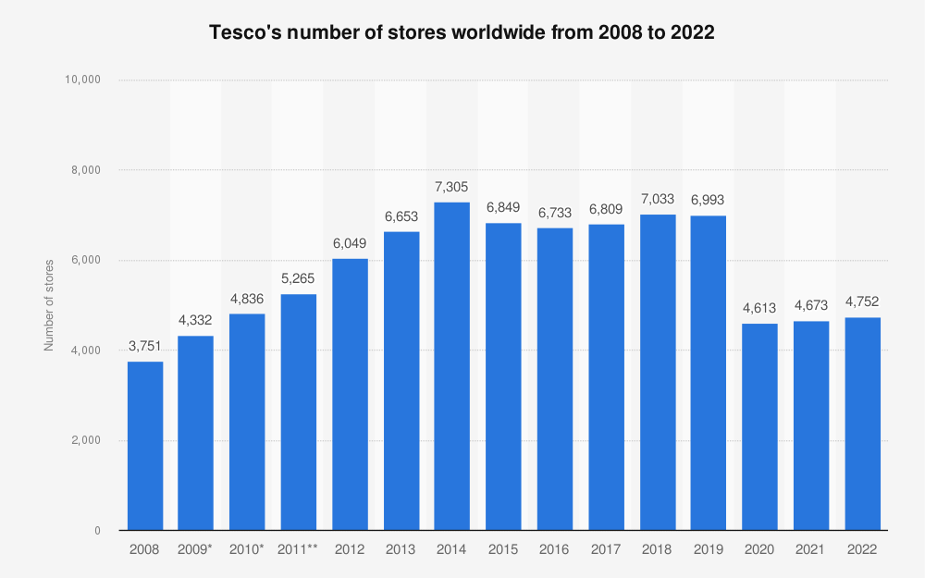
Figure 1: Sales revenue data of TESCO from 2008 to 2022
(Source: Statista, 2022)

1.2 Aims of the report
The current report aims to instil a critical and in-depth understanding of quality systems and quality control measures along with extensive customer experience measures for customers of TESCO in England.
Main Analysis
Critically analyse the advantages and challenges of building and controlling good customer relationships by the evaluation of the customer experience and a critical understanding of its quality process

2. Evidence of a critical understanding of quality processes in the workplace

2.1 Quality modules and standards
Quality standards strategies of Tesco:
TESCO is a major British multinational grocery along with general merchandise and it is denoted as a public service or private retailer that serves supermarket services to the customers. As commented by Hassan, Parvez & Ekiz, (2019), maintaining certain quality standards is highly required for the organisation because the grocery and food market is highly competitive and dynamic at the same time. The organisation follows TQM or total quality management which is directly connected to maintaining quality modules and standards of the organisation. The organisation has several market competitors including, Sainsbury's, Morrison's, Asdaand others. The market context of U.K food and supermarket industry is highly dynamic in the post-pandemic situation because the Covid-19 situation has destroyed the business structure of the grocery and retail industry in the nation.
BCG matrix of TESCO:
As mentioned by Jones and Comfort, (2020), the Boston Consulting Group Matrix or BCG matrix is a growth-share matrix or a planning tool used by the organisation to understand its quality standards and graphical representation of its product and services.
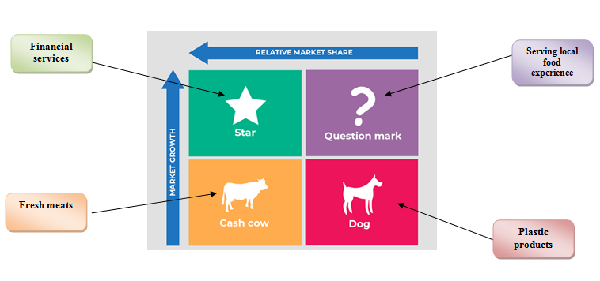
Figure 2: BCG matrix of TESCO
(Source: developed by the author)
According to the above picture, it can be observed that the four square matrix plots TESCO 's offerings and quality measures with an X-axis representing market share and the y-axis representing market growth measures and the four boxes representing the quality standards of the organisation.
Star matrix:
As argued by Pangarkar, Shukla & Charles, (2021), it can be evident through the customer service analysis of the organisation that its financial services are strong and extensive quality service which is referred to as the Star service of the organisation. Star products refer to the services or products which consume high-growth markets and make up the market position of the organisation and the organisation must invest more in this service to enhance its quality standards in the competitive markets. Brand image is one of the essential elements for improving customer engagement and enhancing service quality. The organisation aims to grow at least 5% of its star services for improvement in 5 years at least.
Cash cows matrix of Tesco:
On the other hand, its fresh meats and packaged food are the cash cow of the organisation because this operation has been performed by the organisation for decades and it is quite beneficial for the organisation along with helping to maintain certain growth. Cash cow refers to the low growth areas but it has a large market share that helps the organisation to maintain its market position accurately (Tesco Plc, 2022).
Questioning opportunities of Tesco:
Its local food products are referred to as the Questioning measure matrix of the organisation because in the current time customers are looking for local food and cultures rather than extensive foods which increase its demand highly. Questionable opportunities refer to those qualities of the organisation which are a high-growth market but the organisation has not had enough expertise in this significant field. Local foods are a new market trend in the retail food industry of U.K because people are keen to get knowledge regarding local food. For example, the countryside of U.K food culture is quite different from central London because London is highly corporate but the countryside of U.K serves authentic British cuisine that requires essential raw materials and helps the organisation to attract foreign consumers as well.
Dogs or Pets matrix of Tesco:
Lastly, the dog of the organisation is its high usage of plastic bags which is gradually disturbing its quality standard and control. In addition, nowadays customers are highly concerned regarding sustainability measures because it is high time to discuss sustainability and incorporate sustainability within the organisation. However, dogs refer to the low growth and low market share of the organisation.

Buying decision-making process: ethical considerations such as fair-trade, sustainable resources
Ethical concerns of Tesco:
According to the TESCO customer reviews it can be observed that maximum customers were happy and satisfied with the services of the organisation. As mentioned by Alzoubi, (2020), it has been evident from Hays reports that the organisation performs fair trade strategies to mitigate business ethics issues and serves the customer an ethical and sustained experience. The organisation also participated in the CLIA conference in 2019 which is a conference regarding U.K fair trade policies, daily conferences for improving business quality and understanding change business ethics of the U.K. The Brexit and Covid-19 situation have changed the trading policies of the nation which impact fair trade policies in the organisation as well. In addition, it can be explained that unsustainable treatment of natural resources including waste management and production measures influences social demand for sustained practices that support customer experience and improve economic growth.
Strategies to perform fair trade and sustainable measures in Tesco:
As commented by Elbeshbishi and Al A'ali, (2020), the organisation focused on ethical consumption which is an alternative way used by private organisations to take responsibility and become more responsible regarding sustained measures and empower employees to serve accurate and sustainable services to the customers. The term fair trade represents a conscientious alternative way of customer consumption and purchasing strategy for products and services that can obtain certain ethical challenges including supporting fair wages, employees' health and safety measures, employees' rights and contemporary protection of natural resources (Tesco Plc, 2022).

Appreciation of the importance of quality control
In addition, managing quality helps the organisation to maintain product safety and comply with all the trade laws and regulations regarding food safety. As commented by Petersone et al. (2021), to appropriate product quality measures the organisation developed certain highly skilled teams and employees globally who are highly dedicated to customer trust and satisfaction measures to ensure customer expectations that must be met for achieving accurate growth in the highly competitive market.
Product development:
Through an in-depth understanding of customer needs and preferences along with wider market trends the expert team developers of Tesco build strong quality products by incorporating innovative and good value materials in the market. In addition, the organisation has food testers and food researchers who ensure the shelf lives and food quality of the products before sticking them in the stores.
Labelling and packing process:
After product development labelling and packaging are the second steps of Tesco's quality control process. The organisation has its dedicated labelling and packaging teams who put all the information regarding products including ingredients, shelf life, and others to inform the customers about quality and utility. Labels and packing are used as crucial marketing tools for achieving customer trust.
Supplier audit program:
Not only developing good products and achieving customer satisfaction but also Tesco is highly focused on supplier retention for an uninterrupted supply chain network. Tesco has significantly developed industry product standards that deliver its extensive brand image and ensure supplier retention for quality materials.
Testing process:
Tesco has well-established and comprehensive food safety systems that help to monitor and ensure quality standards of the products. The organisation performs routine checks up of all the testing programmes including Microbial testing, chemical or nutrition testing, and authenticity testing to ensure high-quality products before reaching markets.
Food safety measures in the stores:
The organisation not only promotes product quality but also ensures customers a good shopping experience through developing robust product safety measures, training and store quality standards. In addition, through accurate good safety measures, the organisation ensures good safety, legality and quality of the products to maintain its extensive market position and manage its huge potential customer base.

Analyse the customers’ experience of an organisation

Value and purpose of customer relationship management (CRM)
As stated by Widmar et al. (2021), CRM or customer relationship management is a bunch of strategic practices and techniques that are used by the organisation to control and analyse customer satisfaction measures for betterment and development in the business aspects. Tesco used CRM strategies to ensure the improvement of customer service relationships and assist in customer retention without focusing on the customer life cycle and drive sales revenue accurately. Tesco has incorporated extensive CRM strategies by introducing loyalty Card systems.
As commented by Chkanikova and Sroufe, (2021), this strategic approach helps the organisation to collect certain data including age, preferences and interests of the customers through building good and positive communication channels with its potential customers. An extensive CRM strategy provides the retailer to understand customers' choices, preferences and purchasing attitudes to facilitate sales in near future accurately (Garlick, 2022).

Customer service
For serving good and exclusive customer service Tesco performs some significant strategies for the betterment of its customer service. The organisation offers its potential customers 24-hour service which means the customers can get their products whenever they want. This strategy helps the customer to get the products whenever they need them, whether it is an emergency or night-time. This is surely enrolled as good customer service which can help the organisation to boost its customer retention massively (Ruwanpura et al. 2019). However, for performing this strategy Tesco is required to pay more money to workers for working at night time but it is worthy for developing good customer relationships and extensive brand image in U.K and globally as well. Secondly, Tesco's workers have a significant uniform which makes them a visible and clear outlook regarding the solutions. For example, the customer needs a specific thing but she cannot find anyone from the big crowd.
A uniform can help her to identify the correct people who can help her to find the product or service. This process is quite happening and interesting because it helps the employees also to understand who the customers are and who the workers are.
As discussed by Roberson et al. (2019), the organisation has faced severe consequences in the competitive grocery market of UK because of Sainsbury's extensive marketing strategies grabbing the market. However, the customer-focused business culture has pervaded the organisation that can be understood through its extensive success and it is quite essential for its future success as well.
At first, the organisation developed a customer-focused product development strategy that serves accurate customer value. In addition, Tesco has understood that focusing on customer choices and preferences is the only key to enabling its integrated business approaches globally. For example, the organisation focused on smaller products such as kitchen appliances rather than big and chunky products which are convenient and segregated into different categories well.
Secondly, the organisation adopted customer-focused ranging for its developed products and services. Tesco has adopted a low pricing strategy for faster and integrated pricing for its local audience. In addition, the organisation focuses on ethnicity and nationality for catching everyone's attention and serves a broader approach to its customers because preferences vary from one segment to another.

Customer value
The organisation provides extensive value to its customer choices because it helps the organisation to understand the corrosive marketing approach and helps to understand their expectations as well. The organisation adopted the Ansoff matrix to determine the market value strategy for mitigating the market consequences which affect its customer base as well. Ansoff matrix is one of the useful marketing metrics for generating accurate customer value for the organisation. This matrix has four segments,
Market penetration:
In the case of starting a new business operation, it becomes essential for the organisation to penetrate new markets for achieving new opportunities and growth measures. Tesco adopted this marketing strategy when it was a grocery retailer but wants to expand its business in other markets. Tesco club points and loyalty cards are two examples of its extensive customer valuation to meet the opportunities in the market (Ansoff Matrix, 2022).
Product development:
This is one of the significant strategies adopted by Tesco to grow its market opportunities. The organisation gradually identifies the market opportunities through introducing new products and services such as organic food, credit cards, loans, insurance and other different segments.
Product diversification:
The diversification factor deals with new products that help the organisation to focus on new markets. It also helps to diversify the risk factors to multiple products and markets. This strategy of Tesco helps the organisation to attract new customers through diversifying its product range from grocery to electric goods and others.
Market development:
It is an elemental force adopted by Tesco to expand its business operations in new segments to support new goods in new markets. In addition, new market development helps the organisation to enjoy a competitive edge through product dimensions, strategies and supply networks.

Critically analyse the advantages and obstacles of building and maintaining good customer relationships

Buyer-seller relationships
Tesco is a customer-centric organisation which has adopted significant strategies for improving its buyer-seller relationships for betterment. Its customer-focused loyalty scheme is constantly praised by its customers because it helps to scale up their purchasing ability with a money-back scheme. In addition, it serves the customers accurate points for further shopping and this makes them repeat customers which increase customer relationship between customer and Tesco. This approach includes the “Meet the public'' campaign of the organisation which helps to boost its customer surveys as well (Chen et al. 2021).
According to customer reviews, it can be seen that the organisation's initiatives for developing buyer relationships are effective for its long-term business aspects. The Tesco stores are built according to the customer choices and the designs of its toilets handle taps and dryers are eye-catching and serve a comfortable atmosphere to the customers. As mentioned by Dulmin et al. (2018), it can be evident that comfortable and extensive communication and place clarify customer preferences and make them happy. In addition, this strategic store development is an insight of common sense and empathy rather than focus on unnecessarily complicated fittings which are expensive and not approaching as well. As stated by Lozano-Quilis et al. (2020), customers love to roam in comfortable and resourceful stores which are the primary attention of Tesco. In addition, this strategy helps the organisation to boost its market position and customer base in new markets such as the European market which are highly competitive and building accurate customer relationships is essential for better communication and business culture.
Managing customer expectations
As in the current market scenario, the expectations of consumers are comprehensive and clear, and they can evolve continuously with the current market trends. Hence to enhance the consumer experience in the retail sector, Tesco must focus on developing consumer intimacy by mitigating the gap between digital acceleration in the market (Pantano and Vannucci, 2019). Moreover, the retail sector needs to bring innovation in the process of product development and this strategy can also help Tesco to build a strong connection between customer and brand.

TESCO has changed the art of delivering products like they can bring creativity in the delivery mechanism like drone deliveries and this strategy would play a decisive role to build a superior level of consumer trust and the retail sector can manage the consumer experience by integrating this strategy in their business operation, especially after the global pandemic.
Tesco can also integrate the automation consumer support in their business operation because the automation consumer support assists the business corporation to build the knowledge based on the organisational current facing issues and the resolution to mitigate those issues by changing the process of the delivery mechanism through the expert system (Roy et al. 2018). Moreover, through this automated customer service, this retail organisation can provide their services to their clients 24 hours a day and seven days a week. Hence, by monitoring alarms and identifying the issues based on consumer management this business corporation can manage its consumer experience effectively.
Conclusion:
After analysing the above report, it can be summarised that in the project on engaging and understanding the consumer experience, the researcher has critically analysed the advantages and changes to building and controlling the consumer relationship through the evaluation of the consumer experience. Along these lines, the quality process of TESCO has also been demonstrated in broader terms. Moreover, in this project, the experience of consumers with the organisation of TESCO has also been analysed. Thus, to analyse the consumer experience for the organisation the researcher has demonstrated the consumer service, centrality and consumer value strategy for the organisation TESCO.

7. Reference
Alzoubi, A. (2020). CORPORATE AGGRESSION: A COMPREHENSIVE REVIEW OF PRICE WAR. European Journal of Business and Strategic Management, 5(2), 50-63. Retrieved from: https://iprjb.org/journals/index.php/EJBSM/article/view/1155 [Retrieved on 5th July 2022]
Ansoff Matrix of Tesco UK - Ansoff Matrix. (2022). Retrieved 6 July 2022, from https://ansoffs.com/ansoff-matrix-of-tesco-uk/[Retrieved on 5th July 2022]
Chen, S., Liu, X., Yan, J., Hu, G., & Shi, Y. (2021). Processes, benefits, and challenges for adoption of blockchain technologies in food supply chains: a thematic analysis. Information Systems and e-Business Management, 19(3), 909-935. Retrieved from: https://link.springer.com/article/10.1007/s10257-020-00467-3 [Retrieved on 5th July 2022]
Chkanikova, O., & Sroufe, R. (2021). Third-party sustainability certifications in food retailing: Certification design from a sustainable supply chain management perspective. Journal of Cleaner Production, 282, 124344. Retrieved from: https://www.sciencedirect.com/science/article/pii/S0959652620343894 [Retrieved on 5th July 2022]
Elbeshbishi, A. N., & Al A'ali, E. A. (2020). Fairtrade and ethical consumerism: A complementary perspective. In Ethical consumerism and comparative studies across different cultures: Emerging research and opportunities (pp. 101-125). IGI Global. Retrieved from: https://www.igi-global.com/chapter/fair-trade-and-ethical-consumerism/236884 [Retrieved on 5th July 2022]
Garlick, J. (2022). Put customers first, like Tesco. It works. Retrieved 6 July 2022, from https://www.thegrocer.co.uk/tesco/put-customers-first-like-tesco-it-works-/556072.article[Retrieved on 5th July 2022]
Gil-Gomez, H., Guerola-Navarro, V., Oltra-Badenes, R., & Lozano-Quilis, J. A. (2020). Customer relationship management: digital transformation and sustainable business model innovation. Economic research-Ekonomska istraživanja, 33(1), 2733-2750. Retrieved from: https://hrcak.srce.hr/file/370046 [Retrieved on 5th July 2022]
Hafner, N., Halver, W., Lippold, A., Petersone, E., & von Zobeltitz, A. (2021). Marketing: Klausuren, Übungen und Lösungen (Vol. 9). Walter de Gruyter GmbH & Co KG. Retrieved from: https://books.google.com/books?hl=en&lr=&id=NJc9EAAAQBAJ&oi=fnd&pg=PP5&dq=BCG+matrix+of+TESCO+&ots=2Bmq_Qrz-U&sig=lf6FsfSKekAqIPSqnHLyYW30aKo [Retrieved on 5th July 2022]
Han, J., Zhang, X., He, S., & Jia, P. (2021). Can the coronavirus disease be transmitted from food? A review of evidence, risks, policies and knowledge gaps. Environmental Chemistry Letters, 19(1), 5-16. https://link.springer.com/article/10.1007/s10311-020-01101-x [Retrieved on 5th July 2022]
Hassan, A., Parvez, M., & Ekiz, E. (2019, July). Technology Induced Loyalty Schemes for Customer Relationship Management and Positive Purchase Decisions. In 9th ADVANCES IN HOPITALITY AND TOURISM MARKETING AND MANAGEMENT CONFERENCE (p. 241). Retrieved from: https://www.researchgate.net/profile/Shaohua-Yang-5/publication/334560312_The_Development_of_A_Conceptual_Framework_on_the_Brand_Personality_Self-Congruity_and_Tourist_Loyalty_The_Moderator_Role_of_Tourist_Emotional_Experience/links/5d31870992851cf440903f91/The-Development-of-A-Conceptual-Framework-on-the-Brand-Personality-Self-Congruity-and-Tourist-Loyalty-The-Moderator-Role-of-Tourist-Emotional-Experience.pdf#page=263 [Retrieved on 5th July 2022]
Jones, P., & Comfort, D. (2020). Customer Engagement: Storytelling and the UK's Leading Retailers. In Handbook of Research on Contemporary Consumerism (pp. 57-71). IGI Global. Retrieved from: https://www.igi-global.com/chapter/customer-engagement/238533 [Retrieved on 5th July 2022]
Liu, C., Law, A. C. C., Roberson, D., & Kong, Z. J. (2019). Image analysis-based closed-loop quality control for additive manufacturing with fused filament fabrication. Journal of Manufacturing Systems, 51, 75-86. Retrieved from: https://www.sciencedirect.com/science/article/pii/S0278612518304060 [Retrieved on 5th July 2022]
Maalek, R., Lichti, D. D., & Ruwanpura, J. Y. (2019). Automatic recognition of common structural elements from point clouds for automated progress monitoring and dimensional quality control in reinforced-concrete construction. Remote Sensing, 11(9), 1102. Retrieved from: https://www.mdpi.com/458878 [Retrieved on 5th July 2022]
Pangarkar, A., Shukla, P., & Charles, R. (2021). Minimalism in consumption: A typology and brand engagement strategies. Journal of business research, 127, 167-178. Retrieved from: https://www.sciencedirect.com/science/article/pii/S0148296321000424 [Retrieved on 5th July 2022]
Pantano, E., & Vannucci, V. (2019). Who is innovating? Exploratory research of digital technologies diffusion in the retail industry. Journal of Retailing and Consumer Services, 49, 297-304. Retrieved from: https://www.sciencedirect.com/science/article/pii/S096969891830643X[Retrieved on 5th July 2022]
Rombach, M., Dean, D. L., Widmar, N. J. O., & Bitsch, V. (2021). The ethically conscious flower consumer: Understanding fair trade cut flower purchase behavior in Germany. Sustainability, 13(21), 12133. Retrieved from: https://www.mdpi.com/1342478 [Retrieved on 5th July 2022]
Roy, S. K., Balaji, M. S., Quazi, A., & Quaddus, M. (2018). Predictors of customer acceptance of and resistance to smart technologies in the retail sector. Journal of Retailing and Consumer Services, 42, 147-160. Retrieved from: https://www.sciencedirect.com/science/article/pii/S0969698917306987[Retrieved on 5th July 2022]
Tesco Plc, 2022.Product Safety & Quality. (2022). Retrieved 6 July 2022, from https://www.tescoplc.com/sustainability/documents/policies/product-safety-quality/
Tesco: revenue 2019 | Statista. (2022). Retrieved 6 July 2022, from https://www.statista.com/statistics/490931/tesco-group-finance-revenue-united-kingdom-uk/
Zerbino, P., Aloini, D., Dulmin, R., & Mininno, V. (2018). Big Data-enabled customer relationship management: A holistic approach. Information Processing & Management, 54(5), 818-846. Retrieved from: https://www.sciencedirect.com/science/article/pii/S0306457317300067 [Retrieved on 5th July 2022]

