


optimisastion of production lines using lean priceable, simulations and automation
School of Engineering
BEng (Hons) Mechanical Engineering
May 4, 2020
University of Wales Trinity Saint David
Swansea


Iwan Rhys Dyer p149128
Major project
M6X00417
Declaration of authenticity
Thins thesis is the result of the author’s original research. It has been composed by the author and has not been previously submitted for examination which has led to the award of a degree.
Signed: Iwan Rhys Dyer data: 3/4/2020

Acknowledgments
I would like to express my gratitude to my supervisor’s Dr Arnaud Marotin and Richard Morgan for their assistance and support throughout this project.
I would also like to thank Dr Robert Goodson, Dr Greg Owen for there advice and guidance. I would also like to thank Ryan Cording for his help teaching me plant sim.
I would like to thank all members of staff at UWTSD for their help and guidance during the time I spent at this university.
I would like to give a special thanks to Wayne Waite and the team at Allevard that gave me the information I need to create the simulation.
Finally, I would like to thank all my family and friends for their support during this period.

Abstract
The purpose of this report is to look at Allevard’s production line through the lens of lean manufacturing and the accumulated techniques. Then simulate the production line using Plant Sim with the information provided by the company. This itself was a challenge as alavard did not keep data on any of its processes excluding a few noticeable exception. This report found that alavard like most companies that produce to the 6-sigma level have passive problems with overengineering, over testing and waste of movement. This report also found that replacing manned operations had a surprisingly short payback time for Allevard as they produce produces 24 hours a day and if these process where unmanned that leans that the pay that would have been for the staff can be reinvested in to the company.

Table of content
Contents
1. Abstract 3
2. Table of content 3
3. Introduction 4
Introduction to project 4
Relevance of this project 5
4. Background research 5
History of automation and lean 5
Ways of detecting how effective production lines are 7
Fundamentals of lean 7
Value stream mapping 8
Industry 4.0 9
Ethics of robotics 9
5. Work carried out 10
Layout of factory 10
Hot coiling cutting 10
Hot coiling 11
Cold coiling 12
Discussion on layout 13
Discussion point about factory layout 13
Simulation of factory 13
6. Measuring simulation 16
Results of simulation 16
7. Analysis 17
Analysing what could be changed to improve production 17
Cost associated (worker) 17
Possible detriments to the facility 19
storage of metals 19
Waste in movement 20
Production line max speed 20
Alterations to storage to improve flow of parts 21
8. Improvements 21
Max capacity issues 21
Need to automate manual tasks 22
Failures in machineries 22
Over engineering 22
Batch production over the order 23
Storage arrangement 23
9. Conclusion 23
10. Pandemic 24
11. References 26
12. Appendix 28
13. Glossary 32

Introduction

Introduction to project
This report aims to discuss techniques that are commonly used in industry to optimise a production line, then coupling these techniques with higher levels of mechanisation to further improve the line and reduce the overheads of the facility and in turn boosting profits. This report will use Allevard Springs as a case study and will discuss in detail their production line. It will then identify weakness in their production line or supply chain, and then suggest improvements that could result in increasing their profit margins. There are a few tools that will be used to identify issues in the production line, however, the key will be the group of principles that are collectively called Lean Principle. Lean Principles have changed since the term was coined in 1988 by John Krafick (Krafick, 1988) however the key items have been the same for many years now. The first notable implantation of lean dates back to Henny Fords model T. With his moving production line and making the model T into all standard parts he reduced variation and improved efficiency. This then led to Toyotas implementation of “banishing waste” (James.P.Womack, Daniel T.Jones, 2003) such as wasted movement imbalance in the workload of the facility. At the time this was ground-breaking and is part of the reason why Toyota became such a powerhouse in the automotive marketplace. They gained the ability to go from prototyping to full production in a much smaller time frame than other companies. Nowadays all automotive companies employ lean manufacturing to existing production lines. However now with the increase in computational power and the massive push towards industry 4.0 with data collection software the possibly for optimisation has become practically endless. With this data software such as Technomatix Plant Sim was developed so productions lines can be modelled in a virtual environment allowing different scenarios to be used without effecting the real production and if the simulation proves that the changes may have a benefit worth investigating the companies will carry through with it in reality. This report will use Plant Sim along with any data that Allevard will provide to create an accurate simulation of the plant. It will then run different tests on a proportion of the production line to see where any faults may be, then correct them using the simulation. It will also run costing on the implantation of robots on the line by replacing menial tasks that are currently operated by people.

Relevance of this project
This project is becoming more and more relevant as industry’s move though the fourth industrial revolution, being big date, and highly automated production lines are used more and more the need to maximise the efficacy of the line becomes more and more demanding. With the date that can be collated from lines now along with the speed and dexterity some robots have now is has become easier to fine optimum ways to optimise without incurring massive expense. This can be done though mathematical simulations of the production or part of the production line. In the part to see the effect of the changing a belt speed would have on production you would have to use a combination of induction experience and risk a bottle neck or some other negative effect on production that may even lead to increase in part frailer. A perfect exam of this was the effect that the sister plant to the one in this report had involving the paint plant. They increase the painting belt to increase the speed of that part of the line. The epoxy pain they used is designed to stick to the part at between 10C-20C the change lead to the part entering at approximately 30C this led to a much great amount of pain sticking to the part. This meant in use there was an increase in the stress the paint at the outer most points where under. This would lead to cracks and water ingress under the paint leading to rust and then total part failure after a time. (Ke Gong, Ming Wu, Guangxin Liu, 2020)

Background research

History of automation and lean
Automation may seem to be a relatively new process as most people may assume that it developed alongside the invention of electric generators or steam power, however this is far from the truth. If you take the definition of automation being that a process or object that runs with very little human interaction as stated in the dictionary (lauguagues, 2011) the first true automatic process would be as simple as a windmill. If you take what is recently considered automation, even then it still has been around for decades (P.Janssen, 2019). Though the greatest leaps in automation occurred during the first industrial revolution with the first steam power and the spinning Jenny, Theses lead to the first automated production lines where clothing could be made with looms. In the article The British Industrial Revolution in Global Perspective (Allen, 2006) it discusses the shear impact that these two inventions have have on the production of goods and decrease in goods prices.
With the second industrial revolution came the biggest and most significant change to production of goods, the mainstream use of electricity in production. This coinciding with an advance in steel production making train tracks and other large-scale infrastructure possible. It is widely acknowledged that the second industrial revolution began in America, where not only electricity was harnessed but also where the invention of the internal combustion engine was first beginning production. In the paper The Second Industrial Revolution has Brought Modern Social and Economic Developments (Mohajan, 2020), it details the effect that just the utilisation of electricity had on the world during this time. Nearing the peak of the second industrial revolution cars started to become more popular with the upper class ,however because the process was still a long mostly manned process the cost of a car was incredibly high, At this time most cars where custom built for each costumer resulting in the use of very few standard parts. This is where a very important person rises to prominence, Henry Ford of Ford Motors. He sees that only the rich can afford cars and devises a way to reduce the price of cars by any means necessary. This was the birth of lean manufacturing. Ford decided the best way to cut the price was to limit variation and most important cut down on production time. The way he did this was create the first moving production line. This production line was designed for the model T a car that Ford famously said "Any customer can have a car painted any colour that he wants, so long as it is black." (Ford, 1908)this was in reference to the fact that the car was produced in bulk and all the parts where the same on every car limiting the variation.

Though the term lean manufacturing wasn’t coined until much later on by in John Krafcik in 1991 in (James P. Womack, Daniel T. Jones, Daniel Roos, 1991) the machine that changed the world and now most if not all industry’s strive for lean thinking in there production, though some are much better at this than others. A perfect example of this is Tesla and Toyota. Toyota was the first automotive company to truly embrace lean manufacturing and now it is firmly cemented in their work ethic this is detailed in the book, lean thinking: banish waste and create wealth in your corporation (James.P.Womack, Daniel T.Jones, 2003), the book shows the process which that Toyotas chef engineer started to identify the errors and came up with the belief that banishing waste was the way to make significant improvement. They follow the principal just in time, which means making what is need when its needed, not before or after, this leads to a smooth flow of parts and means that no parts are just sitting around collecting dust. There is one other aspect of lean that Toyota have mastered which is muri, mura and muda which mean overburdened, variation and waste. Which is explained quite well by the following imagine.

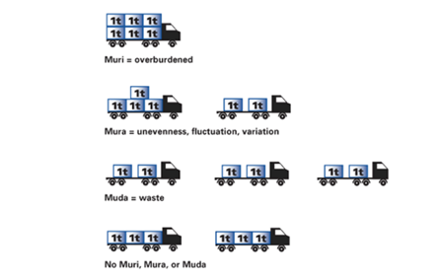
(Anon., n.d.) Figure 1
stating with muri if a truck can carry a max of 4 tones and it is loaded with 6 tonnes its probable that it will fail.
With mura being unevenness, this can cause issues take a cargo ship if you place all the storage on one side it is likely to topple over and sink.
Muda is the easiest to explain as waste can mean anything but, in this term, it means waste in effort or movement. (Lane, 2007)
Going on to Tesla they have been struggling with both muri and mura in the release of the roadster model S 2018 as they have had some large variations in panel size on the doors and also due to demand for the roadster they have been overloading the factory leading to factory shutdowns. In an article by CNBC they reported that due to Tesla’s ineffective production line they are ether producing good parts slowly or having problems with full batches when producing them at the speed they need to keep up with demand , for example 25mm panel gaps on the model X. (Kolodny, 2018)

Ways of detecting how effective production lines are
Obviously just basing how effective a production line on is speed is misguided as there as a plethora of factors that can affect this and singling just one out could lead to problems. Striving to achieve the fastest line speed possible may lead to a lot more failures down the line. Quality, failure rates, scrap rates, and down time all impact on the effectiveness of a line. All of these have their own measurements for example for failure the most used in industry is six sigma.
Six sigma shows a company how may failures per million opportunities it has and identifies ways to improve the failure rates (MD, 2016). Reducing the failure rates is obviously very important as this can lead to unplanned down time and cost of producing more parts to replace the failed parts. According to the six-sigma handbook 4th addition (Thomas Pyzdek, Paul Keller, 2000)by Thomas Pyzdek and Paul Keller, typical company range between 3 and 4 sigma which means they spend anywhere from 25% to 40% of their revenue on fixing these failures. This source then goes on to say “ reportedly General Electric estimated the difference between 3 sigma and 6 sigma to be $8 billion per year” which is if you take their revenue from 2019 , being $95.214 Billion (Anon., 2020)this would equate to 8.4% of their overall revenue being lost to failures. Six sigma come with a few ways to optimise production lines the best example of this is DMAIC which stands for define the goal, measure the existing system, analyse the system to identify issues, improve system and control the new system.

Fundamentals of lean
Some of the fundamentals where covered in the previous chapters such as muda, muri and mura however just the fundamentals go infinitely deeper than these principals and undoubtedly deeper than this paper could explore, however, the lean manufacturing hand book by Ronald Mascitelli (Mascitelli, 2004) gives a good indication of most of the key concepts. In lean there are 3 key dimensions to consider the dimensions are manufacturing cost, market price and the time to market. To increase how profitable the production line is manufacturing cost and time to market should be reduced and the market value should be increased as much of possible. To do this there is a set of lean principles, dare I say the 5 key elements to increasing productivity when using on a production lean, being Define value, map value stream, create flow, establish pull and pursue perfection. This process is not just a one stop system it is a cyclic as show below.

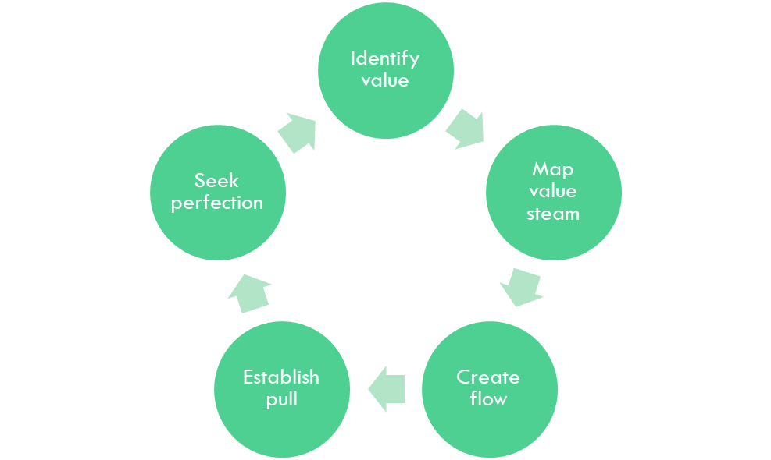
.Figure 2

To start identifying value is defined by what the customer values, for example the customer does not care how vigorous the testing of a part is no matter how much time is sunk into this. The customer values if the part is fit for operation.
Secondly is the creation of a value stream map, this is a flow diagram of the parts life and what adds value and what does not, this process sounds a lot more simplistic than it truly is. This is because most of the time a process adds no value. For example, changing the material property’s adds value, transportation is a waste.
Thirdly is create a flow, this means that like a river the part must flow to its destination with as little interruption as possible removing as much wasted effort as possible.
Fourthly there is establish pull, as inventory is one not if not the biggest waste in industry the principle of just in time came about where a part should arrive just as its need not to create bottlenecks or any waiting times where something is not working.
Finally, there is seek perfection, is the process or repeating these steeps and continually improving the production line until it is the perfect process. These process where coined in lean thinking (James.P.Womack, Daniel T.Jones, 2003) which is still used in industry today even though it is quite old.

Value stream mapping
Value stream mapping is simply a representation of information and material in a process that add value to the product. For example, changing the form of a part would add value but moving it around a factory does not. (Edtmayr, 2016) Value stream mapping almost always leads to improvements in the process by identifying no value adding process in the production cycle. Now with the increase in computational power there has been a push to integrate simulation in to value stream mapping to further improve the process discussed in the follow paper (Antonelli, 2018) as a visual aid the follow image was extracted from a journal
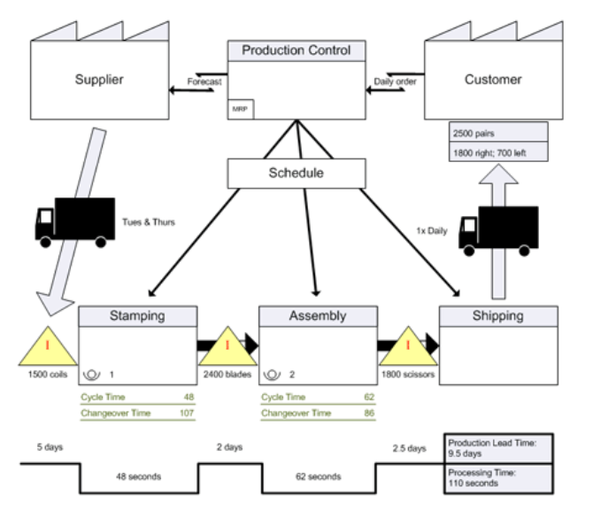
(Gill, 2012)
This is just a simple example of a value stream map showing the value adding processes.
The combinations for simulations and values stream mapping lead to the creation of the software Tecnomatix Plant Simulation which as the capacity to do a value stream map and far more, this allows the software to easily be used to optimise a production line, and see the effects with out any direct physical testing or editing to the current production line. (Bangsow, 2016)Figure 3

Industry 4.0
Industry 4.0 is the application of big data and the internet of things being applied to an industry (Beier, 2020) It is characterized as a technological advancement and is now necessary to maintain the “position as a leader in the manufacturing engineering industry” (KaGermann, 2013). Industry 4.0 has led to a new wave of revolutions in the manufacturing field due to the prospect of increasing output my minimising resources leading to greater revenue streams (S.S. Kamble, A. Gunasekaran, S.A. Gawankar, 2018) (sony, 2018). Industry 4.0 is the current “buzzword” (Michael Sony, Subhash Naik, 2020) around the implementation of a cyber physical systems and cloud computing both being proven method for increasing the effectiveness of a production line may time over what would be possible without these advancements (H.Lasi, 2014) (H.Kargermann, 2015).

Ethics of robotics
An underestimated but yet key prospect to optimisation with aid of robotics, is the ethics behind implementing robots into the workplace. For years robotics have become more and more prevalent in the workplace, Bill Gates stated “ The emergence of the robotics industry is developing in much the same way as the computer businesses did 30 years ago” (Gates, 2007). From this you can take that robotics will follows Moore’s law (Waldrop, n.d.) and they will get increasing faster and by extension more wide spread just as computers are now everywhere. To this extent there is a fear that jobs requiring little creativity or humanity will disappear (Schwab, 2016), it has even been predicted that half the U.S labour force will be eliminated (C.C.Frey; M.A.Osborne, 2017). These predictions are counter balanced by the prediction that such innovation will create new kind of job opportunities (E.Brynjolfsson, A. McAfee, 2014) following the trajectory of the first 3 industrial revolution there won’t be a large change in unemployment however the way the labour force is allocated will never be the same again (Nam, 2019). To protect employment policy makers have begun to look at precautions to mitigate some of the economic effects if the worst outcome happens where there is mass unemployment due to robotics replacing workers. The two that currently see the most likely is robot tax or negative income taxes (A.Etzioni, 2017) (R.W.Lent, 2018).

Work carried out

Layout of factory

Hot coiling cutting
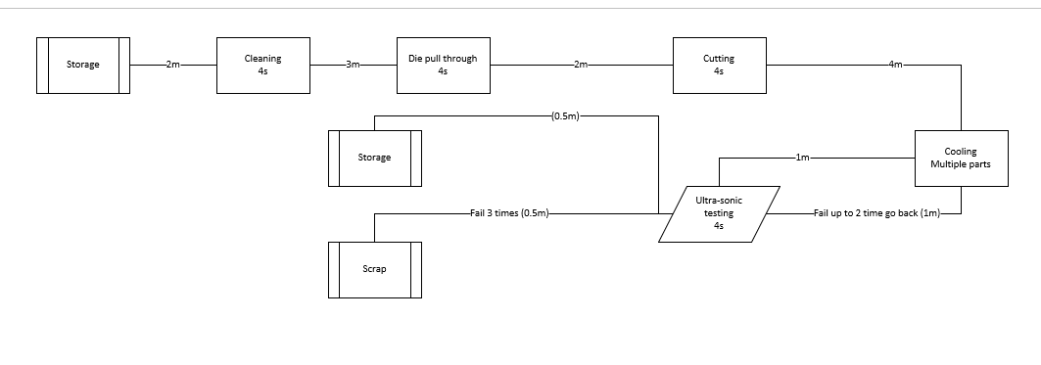Figure 4
To start with you have the coil of metal that will be eventually become the coil for the customer. If the bar comes in on a coil it is normally a 2.5-meter-tall by 1-meter diameter the metal itself is approximately 38 Rockwell when it is stored in this way meaning that it has low elastic potential energy, and if it was removed from its container it would just drop to the floor (this will only become relevant when discussing methods of storage). There is also “pre-pegged bar” that is already cut and been pulled to the correct diameter this bar is normally of a higher Rockwell factor however this bar is unlikely to go over 45 Rockwell. The bar is stored in bundles of 50 by the side of the large coils. The first process of the line is the cleaning of the bar this is done with small swarf (metal shavings) the bar is then pulled through to the die pull, even if it is already cut and pulled tough it will still go through the process but without the die being fitted to the process. Then though the cutting station after the bar is cut because of the stress that the die puts the part under it has been heated so it is sent though a small air-cooling rack. Then once the bar reaches the end of this rack it is sent thought an ultra-sonic tester if the part fails once it is sent back to the cooling rack then is sent though again up to 2 more time than if it fails it is kicked of the line. If it passes it is sent of the line to be bundled ready to be processed.

Hot coiling
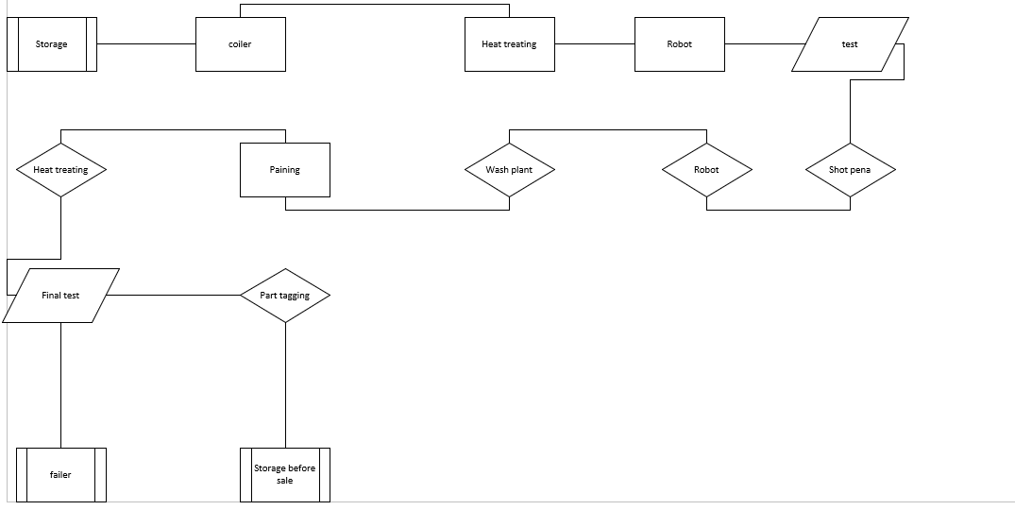Figure 5
When there bundles of cut bar are needed the are taken from there storage area (which can be one of 3 places on site or in a Warehouse across from the factory) to a set of pallets that are used to store the bars for the next coil. Once the bars are removed from the bundled they are placed on the belt by hand. The belt takes them from the storages area though a heating furnace to soften the bar then the hot bar is then taken though and coil and if “pig tails” are needed are coiled again then are quenched (cooled using liquated) for the first time to remove some of the heat from the part. This in turn increasing the hardness of this soft material allowing it to keep its shape (quenching), the liquid that is used in this process is a low viscosity oil to allow maximum thermal defection and because of the oils low viscosity very little will end up clinging the surface of the coil. When the part comes to the end of the quenching tank it is the placed on a belt by a robot which then allows it to ascend to the top of the factory where it travels for approximately 50m. Then is placed on hooks by another robot, the hooks allow the coil to travel though the large heat-treating fence this is approximately 25m long set to 250C. When it excites this part of the line the parts are again quenched in a vat of oil. A robot then removes coils from the vat and places them on a belt where a person will check the orientation of every part using a mould. Once 3 parts have been checked the belt is sent down to the completion test, this test has 2 effect once detects error before going thought the shot peen, also it compresses the coil beyond its elastic limit as up to this point the part was not the correct dimensions and by doing this the extra size give to allow better thermal defection is removed and the part is now the desired shape. After this the parts are moved along a belt to course shot peen, then from that to the fine shot peen, shot peen are mechanism that fire versus small streel bearing at the part to change the stress present in the part, the side effect of this is dust from this process is left on the part. The part then is re-hocked by another robot and sent into the wash plant. The wash plan consists of 2 phases washing then heat drying this happens in the heat in the wash plant is somewhere between 80C and 120C after this they are then air cold at approximately 18C along a 25m line which leaded the paint plant. The coil must arrive at the paint at between 10-20C to ensure that the paint sticks to the coil in the correct way otherwise if it’s two hot it will create cracks and if its two cold it will not stick. After this the part is sent to a curing oven when the paint will set then it is sent to the fine test rig. This is a compression that leads the part in to being give a lab and place in the bin with the rest of the same parts ready to be shipped to the supplier.

Cold coiling
The cold coiling line has a difference storage system along with different metal and cutting process, the metal itself is a lot stiffer being closer to 50 Rockwell. it is stored as large coils of bar that is stored up right to prevent damage to the straps that keep it wound up. For the coils to be unwound they are first place in a machine that is designed to bear the stress and feed the bar slowly to the collier, the coils are then coiled and cut with in one process the bars are then sent via a belt to the hot heat treating furnace from this position they follow the same process of that of the hot coils.
Important notes on the cold coiler, this process is what is used to make prototypes or parts that are too complex for hot coiling, the cold coiler has the ability to do varying diameter coils which hot coiling struggles with. It is also significantly faster than the maximum factory speed, this would normally lead to a fairly critical bottle neck, however ,being that the process is approximately 1300 parts per hour and the fastest the factory can operate is 960 parts per hour. The extra 300 per hour are removed from the belt and stored for when there is a change over, the changeover takes approximately 15 minutes and, in this time, they put the parts back on the belt so that when there is a change in tooling they can still finish the parts this reduces the total factory down time from 15minties due to a tool change down to 3.

Discussion on layout

Storage
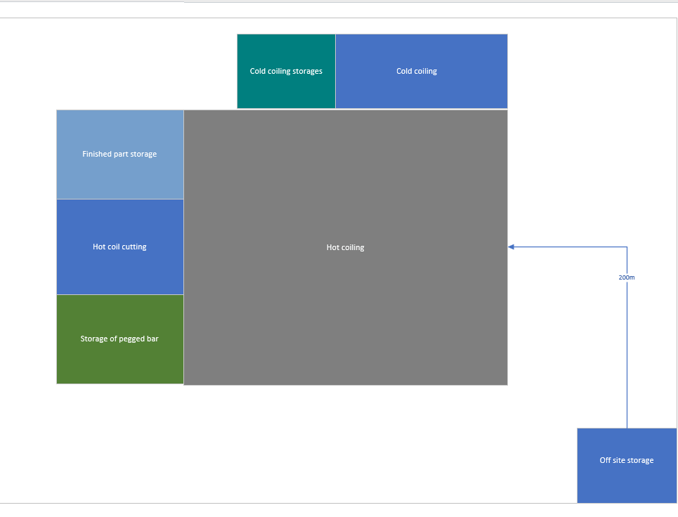 Figure 6

Discussion point about factory layout

Simulation of factory
To understand the importance of data collection and simulation in industry it is key to have at least a basic understanding of the theory of constraints. The theory of constraints fundamentally says that an industry, production line, team or supply chain is only as strong as its weakest link .Obviously it’s not quite as simple as that, and as with all things in lean production there are multiple steps. Starting by using data collected from the process to identify weaknesses. The objective to make fast improvements to the constraint to improve the flow of the process. Subordinate review all other activities to make sure that they truly support the needs of the constraint. Evaluate if the limiting factor has indeed changed and been ‘broken’ to the point where it is no longer the primary constraint. The final step is the repetition of all these steps to identify the new constraint and then improve that part of the process.
This all ties into the principle that every process no matter how refined it is will always have a bottleneck (constraint) that limits the max throughput that a process can achieve. Some constraints are far more clear than others for example in a production line is a plant is running all other process at 1000 parts per hour but one is running at 900 parts per hour then there is going to be a back log behind this process. Clearly identifying this constraint and fixing it would allow the factory to theoretically run at 1000 parts per hour all round, however there may be good reason for this process to be slower than the others such as for the safety of employees , its already at its maximum capacity or any faster may induce more defects to the part/material. This is where data collection and simulation come in to its own even before a factory is set up.
Up till recently most companies did not run simulations on possible production lines to see the outcome and foresee any problems. This was because the high cost of this software was prohibitive and it required very advanced computer to run it, these factors placed it out of the range of SME and some other companies that were stuck in their ways. Now because of the decrease in price in software such as plate sim etc companies have come to use it to set up factories much more frequently. This benefits them by allowing them to see how their line will operate in the factory given a layout, they can then, depending on the software go from seeing line speed and space needed all the way to the cost per part for production and the theoretical amount of power needed to create the part and the effect that difference shift effects the line and the effect on staff down to the person.
With this data it is possible to foresee these constraints before they happen and plan around them giving the factory the option to increase the capacity of the production line without moving factories or having to change equipment after an increase in demand of a product. For existing lines the benefit is just as vital ,it can show the benefits to increasing levels of automation when compared to staffed operation along with how changing belt speeds and other variable process will effect production speed and any bottle necks that exist or will come about due to the changes.

Below is an image of the facility that this report will later discuss, Allevard springs.

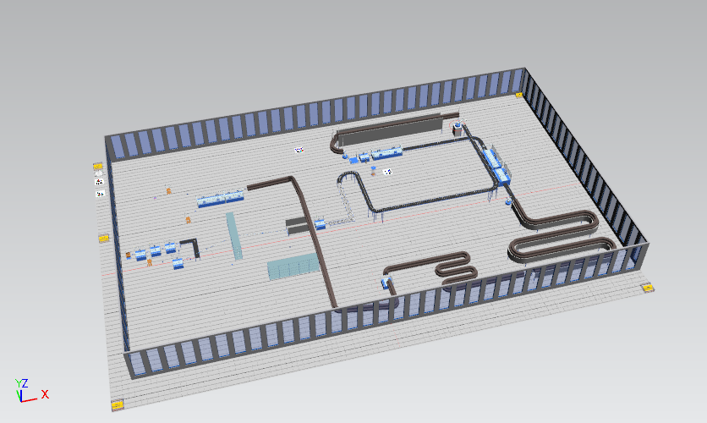Figure 7
This is a basic simulation of Allevard’s factory lay out it is 60mx150m. As discussed, earlier Allevard produces coils for car manufacturers such as ford and Nissan the facility has the capability to both hot and cold coil springs. For this simulation only the hot coiling line is present as the cold coiling follows the same line after large heat-treating furnace and is a much more efficient process so the focus was to be placed on the largest production volume they process which is hot coiling.
Due to the lack of data acquisition software at the time of writing getting accurate data for some production speeds and the overall belt speed ( in meter per second) along with failure rates this simulation was limited to aproximently2/3 of the production speed per hour being 668 parts per hour instead of the true value of the though put ( without failure or maintenance) being between 960 to 980. This is due to the fact that without the correct values speeding up process that in reality may be slower seemed wholey inappropriate as this could lead to a compounding error that would lead to a great discrepancy in the final results. So, using the data that was collected along with some reasonable assumption with speeds such as max coiling speed and belt movement speed the simulation was created. This simulation can be split in to 4 phases. Phase one, the cutting process, this encompasses the lower left side of the simulation. Directly to the left of that is the hot coiling this encompasses the majority of the floor space as the majority of the machinery is taken up my this process. below that is the painting and drying stations. the line ends with testing and packing in the top left of the facility.

Measuring simulation

Results of simulation
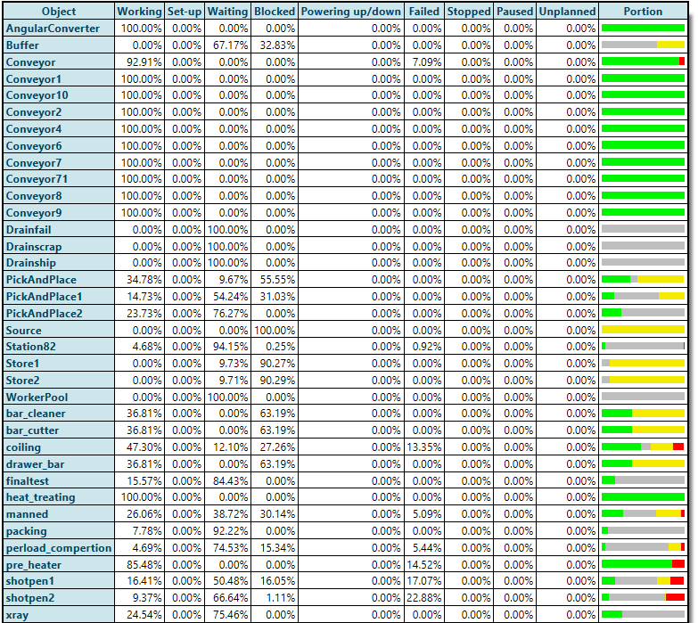Figure 8
Above are the results from the simulation of Allevard’s production line using Plant Sim. As discussed previously there are a few assumptions that where made when making this simulation and it is important for context of the results. 1 the remove of material from the belt is instant, this is to stop back logs forming where in reality there would not be. 2 all belts never break down this is because without information on every belt sections failure rates it would form lager discrepancies in results. 3 there was no planned maintenance, stops, shift changeovers and the there was no time from the start of the simulation to where it could start processing parts. Finally, there was a stockpile of 500 parts of pre-cut bar ready to be processed to accurately simulate Allevard’s state of storage of bar.

Notes on the table, the table does not show the processes in order, so just looking at it you may not be able to see the flow of parts. Green shows time working, yellow is the time where the process is blocked, red shows time spend being repaired and grey means waiting for a part. The 3 drains and also the worker pool should be ignored in the case of this table as they have a been set to run at a speed quick enough so no matter the flow rate of the belt the speed of the drains and worker pool will never effect the overall line speed.

Analysis

Analysing what could be changed to improve production

Cost associated (worker)
Excluding inputting the materials and shipping there is only currently one other maned operation which is the rotation of the part so that it can be compressed passed its elastic limit to insure all the parts are the same size. This process was maned up till the last year which is the removal of parts from the production line after the heat-treating furnace to the rotation checking station. This increased the efficiency of the line but however did not affect the speed. One of these robots being a Kuka 6axis industrial scale robot is worth approximately £45,000 each (Thayer, 2017)this is partly backed up by (i.wagner, 2018)Obviously, this is an investment that industries do not want to waste and will look at in detail before carrying out and what comes of it. In the case of Allevard they wanted to know the payback time that would be expected if the plant was run as it was but with one ( as they are at the moment) and the if they were to replace the other manned operation with 22Kwh (Michele Gadaleta,Arturs Paugurs,Armands Senfelds, 2017)and in wales the average price for electricity is 15.07p per Kwh as stated by Power-compare (Anon., 2020). The final data need to a similarly priced robot. So the first thing to establish was the cost of powering the robotic arms ,then equate this is to pay of the staff member, as Allevard don’t disclose the pay of their staff that meant there was a need to find an average for this the belief that 3 sources would be enough and then take the average as long as there was no large outlier. The website of reed.co. (Anon., 2020), indeed.co.uk (Anon., 2020) and payscale.com (Anon., 2020) to find the average pay for a machine operator giving the data of £10,£9.33,£9.13 respectively. So, make the calculation more simple to cost of employing a operator was taken to be £9.50 a hour using this data the following table was created.
Figure 9
the table above shows the payback time per robot if they were replaced at the same time the time taken to repay the robots is 7276 hours of operation time if this was taken as the factory is run 24 hours a day this would take just shy of a year. The factory itself does attempt to operate 24 hour a day however because of brake down and changer time the operation itself would not. There is also planned maintenance in the summer where the factory us should down for a total of 6 week where no parts are processed so taken this in to account it is sensible to say that the robots would take a total 16 months to become profitable. After this period the profits that the robot would make is £6.19 an hour per robot (£9.50-22*15.07) however this is excluding repair costs as these could vary massively year to year. Repair costs are of course are important when considering cost evaluations however without data it is inaccurate to just label a figure on these cost.

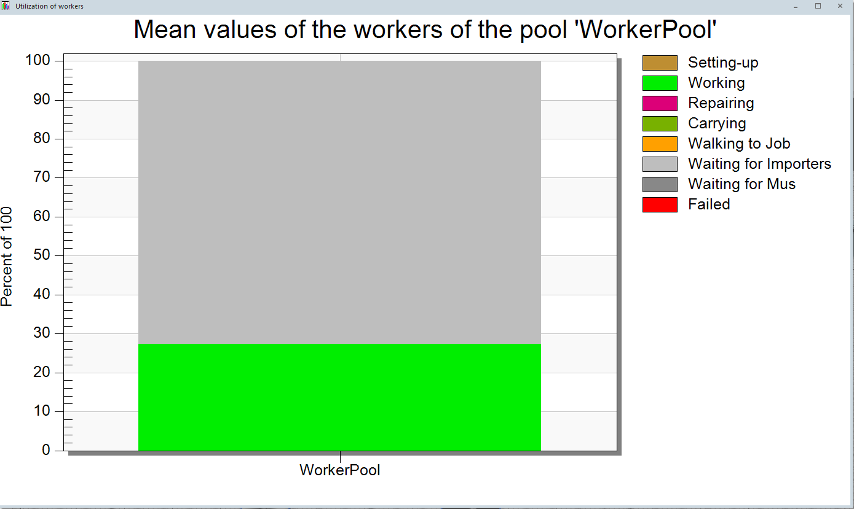Figure 10
Above is the ‘Worker pool’ taken from the simulation of the factory, as discuss previously the current simulation only runs at between 1/3 to2/3 the true value of the plant so these values should be treated as 1/3 of the true value. The graph shows the efficiency of the worker pool, in this case a single worker working for 7 days under the simulated conditions. The value from the simulation shows the efficiency of the workers time to be about 28% if this is multiplied to close to the true value that give you an efficiency of 84% which is not bad. However, if you say that operator is payed £25000 a year and the operator only useful 84% of the time that means you’re paying him £4000 a year to stand around.
This goes against a significant part of lean as this is a waste of time, human potential and of money this will add to the over head of the factory and then increasing effect the cost per part making the company less competitive possibly leading to a reduction in business.

It is much the same case for the second maned process. The removal of the fished coils from the line to the compression tester and label process. This process is currently feed by an operator that takes the part from the belt and so this process will have a slightly different efficiency when compared to the last process however the same principle applies as it could still be seen as a muda (waste) of potential and a drain for the company to employ some on to a menial task that could be easily be automated.

Possible detriments to the facility
Allevard in all due consideration if a fairly effective production line considering nature of the items they manufacture and the standard to which their buyer will hold them. Automotive companies such as Ford Land Rover and Nissan, expect a high 5 sigma product or preferably a 6-sigma product this simply because they all are 6 sigma. This itself is a very impressive having a part failure rate of 3.4 per million or lower. Though in the search for perfection companies, not just Allevard, will overcompensate for different failure in a few distinct ways that are all linked to different muda’s with their process or their suppliers processes that increase production cost and lead to a loss in profit. Below will be a discussion on some of these short comings that Allevard suffer from ether unintentionally or for valid reasons that are evident, then in a later section improvement will be discussed that may relieve some this waste.
The first waste that can be identified is possibly the most important as its linked to several problems that can arise or that already existed in the production of a part. That is the over engineering of a given component in this case a coil, there is a case in Allavard a few years ago when they were producing coils for Land Rover Jaguar. They were given a design criteria coil hight of 500mm, diameter of 200mm and must be able to survive 250,000 full compressions. The physical dimensions are set so cannot be changed but Allavard will ensure that their parts will survive up to 4 times the asked for compressions which ensures the part is safe. However, this means the part is potentially heavier than it would need to be (as the diameter of the bar itself is thicker to add the stability). The difference just a small amount of increased mass can make can have a drastic impact on profits. If you take the mass of the Land Rover discovery 2 coils being 14kg (Anon., 2020) if the mass of the part went up by 50g and you produce 250000 parts. Taken the price for coiling mild steel in 2019 (October) was 480 euros per metric ton (Anon., 2020)give you a loss of 6000 euros which is money that could have been reinvested back in to the company.

storage of metals
As Tachi Ohno once said inventory is the root of all evil (Ohno, 2006) . Allevard has some large waste in movement from the lean prospective of their production line this can be broken up in to two fields, storage, more accurately placement of storage, and transportation between process. The first problem that will be focused on is the placement of storage within the facility. Within Allevard there are 3 main problems with how they store items all in different areas of production, though two are linked heavily. The two that are linked are how they store the unprepared bar for both cold and hot coiling. They keep are buffer stock in both cases close to the operations themselves however the vast majority is kept off site in a warehouse on the same Industrial estate. This means the heavy coils must travel between sites wasting fuel and manpower that could be used more effectively elsewhere in the facility. As stated in Identification of Major Lean Production Waste in Automobile Industries using Weighted Average Method, “unnecessary movement in the manufacturing environment will result in processing delay” (P.Arunagiri, Dr A.Gnanavel Babu, 2013). This is an example from the industry that Allevard supplies of how they see waste in movement, this source shows why the buffer stock is important however storing components off site still goes against the lean principal of reducing waste in motion and should be investigated further in the hope of reducing this. However, in the case of the hot coiling and the limited area for storage or expansion storing to components right next to the line may be impossible.
The second problem with Allevard storage in their large inventory of finished parts that are held there is entire wall in the facility with bins of finished part ready to be shipped. Keeping this wastes space in the facility that could be used in more effective ways. The extra stock also may not be sold thereby costing resulting in a loss to the company.

Waste in movement
Allavard has a large deal of movement that is fundamentally a waste of movement this is shown by the simulation results. 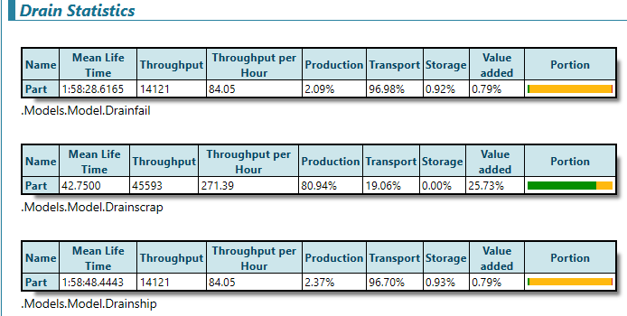 Figure 11
The table above is as break down off the effect in the of the line at the 3 strains in the simulation. The first is the production line that fail the final test, the second is the bar being cut and then scrapped and the third is the parts that get shipped as the 1 and third as the same excluding one step so for this discussion only the second and third will be looked at. The first shows the amount of time that is considered value adding as 25% which is surprisingly good considering the later table showing that is as a value adding of about 0.8% in the full belt. This is due to the fact that the parts spend a large time just being transported around the facility making up well over 90% of the products production time. almost all this time is a waste and Definity is not adding value to the part as can be seen in the results of this table.

Production line max speed
In all production lines there is a limitation to the operational speed that the facility can possibly run at, these are commonly referred to as bottle necks. In the paper A Simulation approach to production line bottleneck analysis, a bottle neck is defined as “a point of congestion in any system” (Michal Leporis and Zdenka Králová, 2010) this is the perfect descriptor of what it is in a production line. There will inevitably be a point in the system that is not operating at its maximum potential slowing down the feed rate after the point and possible creating a backlog in previous operations. In a facility that follows a truly lean production line philosophy this can only be a detriment as this imbalance in production goes completely against Mura. Though in some situations a small imbalance can be used to a small advantage, a good example is how handle the die changeover of the hot coiler. They have not managed to get the die change over to being a single minute, trying to follow SMED (Single Minute Exchange of Die) however following the process laid out in lean manufacturing in the developing world (pp 483-499) (Nobuya Haraguchi , Charles Fang Chin Cheng, Eveline Smeet, 2017)the gaol of SMED is to limit the time the production line is down for. Alavard current change over time for their hot coiling line is 15minutes which is just over 1% of the day the line would have to stand still if there was just one change over every day (assuming the production would stop). As discussed in the simulation section the maximum speed that the facility can process is currently at 980 parts per hour. This limitation is due to the final tester stage of the process as it is always operating close to maximum speed being able to process 980 parts per hour. The way they limited the time the belt is empty is by removing 1/3 or the parts that are produced by the cold coiler as it does not run regularly as its for test batches primarily and runs at 1300 parts per hour making it far faster than the rest of the facility. The 1/3 are left as buffer stock so when there is a changeover they are placed back on the belt to reduce the down time, using this tactic the overall empty time the belt has is 3 minute which is not perfect but is multiple times better than the original 15 minutes.

Alterations to storage to improve flow of parts
From a purely lean prospective Allavard struggle with storage, they keep massive amount of pre cut bar ready to be put on to the production line. This is not ideal but there are acceptable amounts of buffer stock that can be kept ensuring the smooth running of the facility, if a process is to undergo maintenance or fails during any point. However, Allavard stores a portion of their uncut bar off site this is one of the cardinal sins of lean manufacture as it leads to a waste not just of space, but also of movement which and adds additional expenditures in the form of fuel for transport and in the pay of personnel

Improvements
Proceeding January 28th Allavard began to implement the P.O.E.T data capture software. This software, if implemented properly, will allow Allavard to see precisely what is happening on their production line in real time and also will them to make modification the line and compile that data to make continual improvement to the line . This software, once calibrated, would become even more useful when coupled with a simulation software such as Plant Sim or witness.

Max capacity issues
Allevard like all production lines, even with the best of intentions, has a maximum throughput and they are approaching that limit with every change they make to the production line. This is due to their final process of testing and labelling. This is already running at its maximum capacity making a bottle neck that cannot be improved by normal lean methods. There are two potential ways to fix this bottle neck both are expensive. One would require a shutdown and the other could possibly require one. The first is to invest in a machine that can prosses faster to increase throughput however this would most certainly lead to a plant shutdown to remove the old machinery and may not provide a turn over fast enough to be worth the necessary investment. The other alternative would be the production of product on a second of the same machine somewhere in the factory to split the load in half this may lead to less investment being necessary as the cost for a higher end machine would undoubtably be more expansive that the currently used machine however this bring it own issue, as if the factory can’t produce enough parts to keep both machines near capacity both will end up haemorrhaging money as they will be wasted time not having enough part to fill to capacity. It is the belief of this report that to increase maximum potential throughput this area must be look more closely at if it is possible to improve the current machine to increase though put that would be the advisable however after a discussion with one of the plants engineers it seems this might be impossible due to the size constraints.

Need to automate manual tasks
This report section on costing demonstrates just how important automation of manual task are. By employing staff to do a repeatable task you will always be losing money, this is simply due to the time they will be waiting in-between operations. This is without the consideration of breaks, which at minimum is 15minutes every 6 hours. This equates to 4% of a six-hour shift. This also facilitates 2 muda’s being waste of human potential and waiting, both could be reduced or removed by implementing a relatively simple robotic arm to do a pick and place operation. This would also free up the staff to operate the rest of the factory instead of repeating the same menial task for hours on end providing very little benefit to the process. For an example of how effective this can be all one must do is look at Henry Ford’s implementation of a moving production live to see how reducing waste can benefit a production line. (Ford, 1908)

Failures in machineries
Waste in movement
The production line for Allavard spends a substantial amount of time transporting parts. This has been discussed in the previous section. This is shown in the following table.
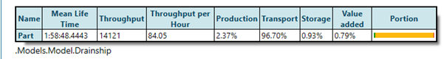Figure 12
this is undoubtably one of the biggest waste the factory has. It could be argued that some of this is necessary as after the paining process the part must be cooled however this only would count for approximately 10% of the time that the part spends in transport. It is the belief of this report that this process needs to reduce the length of the belts to reduce the overall travel time and increase the time undergoing a value adding process. Though this would be mammoth task as the equipment in the factory is massive and would require substantial effort to move. So, it would be essential that any movement be kept to a minimum. To this end this report suggests that the factory itself should have as little movement of machinery as possible however objects such as the belts could be moved, this will reduce effort or even have them modify the speed of the belts to achieve the great least possible waiting time of each process.

Over engineering
Over engineering as a problem. It is easy to simple say reduce the complexity of a part, however this in practice is far harder to accomplish than it seem for one simple reason, the customer expects quality and for their investment and trust to be paid back. In the case of Allavard the customer will ask for a set amount of full compressions that the coil can go thought without failing. At the moment Allavard will over engineer their part to ensure the product can meet this standard, however as discussed in previous sections this can be a detriment if it is two good at what it does. The customer asks for a part that won’t fail before 250,000 compressions, Allevard has in the part made sure the part can outlive 1,000,000 to ensure the quality but by doing this increase the cost to themselves for producing such a part. A 400% increase is excessive by any standard .To reduce this waste they should be to aim for the parts to still function after the asked value plus 40% as a safety margin to still ensure quality and to reduce the overall overheads of producing the parts. This falls in line with one of Taiichi Ohno which was “cost do not exist to be calculated. Cost exist to be reduced” and by reducing the wastes of pre processing you reduce the cost of the part. (Ohno, 1940)

Batch production over the order
Over production of parts in a specific fault that can definitely said that Allalvard has, however it is prevalent though industry so must be identified if it is present. Overproduction over the market demand of a part just ends up creating unnecessary finished goods inventory which just leads to sedimentary stock that may never get sold or is taking up vital space. The fix for this is simple, make sure the process has a little variation as possible, in line with six sigma, and produce the exact amount of stock needed plus the equivalent stock that would normally be produced with defects. This itself should reduce the amount of sedimentary stock though the key for this solution is the data that the company keeps on its parts and its process. Discussed in the book profit-based manufacturing (Sirkanth, 1997)this kind of manufacturing is done to reduce set up cost however in today’s competitive market it’s become more of a lead weight for production than anything else.

Storage arrangement
The solution for the storage issues at Allavard is linked to their need to over transport parts and resources around the factory. The simple solution to their storage is to create an onsite storage area next to the hot coiling line similar to that of the cold coiling line, but even this could be explained to get as much stock close to the line to reduce the material over all travel distance, though with Allevard’s current set up it would be next to impossible to do this admittedly as they is not a great deal of space close to the hot coiling line as it is currently arranged.

Conclusion
This conclusion will be split in to 5 sections based on, what the data shows, usefulness of the simulation, the boost the facility could get from the optimisation a conclusion of the ethics of replacing people with robots and finally an overall conclusion.
The data, limited as it is may be, still shows some untapped potential in the production line this is because the factory still has some large wait times on objects such as the pre heating oven as well as the shot penas this is as well with the fairly kind failure rates on processes such as the hot coiler which could have far greater failure rates than the 13% that it has during this simulation. The data also shows the great potential for investment in robotic arms to do some of the more repetitive work along the line, the upfront investment may be quite large but the time to pay back ( excluding repairs) is just over 300 days for each arm. In then would lead to quite substantial saving for the business after this point as the staff that would normally be operating this section of the line could be doing something more productive than just a pick and place operation.
Due to the lack of data sets that were able to be created due to circumstances that could not be foreseen it is difficult to predict what each dataset would have shown and what changes would have benefited the production rate of the facility. To this extent there is also very limited information out the on similar projects using plant sim. To this extent the production on the effect the simulation could have had on the facility will be taken for examples of other projects using a less engineering focused simulation software being witness. Taken (Moussa, 2019) book section on lean and warehouse simulation as a case study. In this book section Fatima Zahra Ben Moussa discuss the use of both lean ware house solutions and ARIZ ( Algorithm for inventive problem solution) effect on the factory then using witness to analyse and predict the outcomes that could be expected by implementing these optimisation techniques. It states the importance of using these techniques in conjunction with simulations to predict compound variations in productivity and demand rates. This is looked at in greater detail in (E. Cakmak, N.S. Gunay, G. Aybakan, M. Tanyas, 2012). The book later states that the data that it was able to obtain using witness allowed them to find the best possible combination between the lean and ARIZ process. This data would have been next to impossible to achieve without the help of witness in this case the data table was 38 * 8 variables and this where optimised over 3 different set ups and this was just the input data the calculation that would have been run to find the optimum storage sequence.
In conclusion this report demonstrates that there is a need to optimise using lean principles and coupling that with the replacement of repetitive tasks with that are currently manned is a must. However, with the limited amount of data sets produced in relevance to Allavard it is difficult to say what the most effect way to go about optimising their production line would be. There is definitely some areas to improve such as the of site warehouse storage and the bottle neck at the end of the line should be looked in to as possible modification to improve the overall production speed and there certainly is a few operations that should not be manned though there are some problems that must be looked in to as the operations change over. The first is the staff that currently carry out those operations should be ether designated to a different department or trained to have a more suitable role in the company. For example, being a technician, engineer, or forklift operator. Using the buffer stock to reduce down time while making di change is commendable reducing a 15-minute stoppage to a 2/3-minute stoppage is a great just of a weakness becoming a strength.

Pandemic impact

This section will discuss the effect that the pandemic had on this project and the adjustments that had to be made to mitigate as much of the damage as possible. The damage is extensive as can be seen from the lack of simulation data that this report has; this is due to many factors all stemming from the pandemic. Starting in chronological order, the first detriment and by far the biggest was the closing of the robotics workshop on the 16th of March. The warning for the shutdown was given of Sunday night/Monday morning meaning there was very limited time to change the exciting errors and get the simulation up to a close repetition of the true production line. This also meant that only one “accurate” data set could be taken due to the limited time and the severity of some of the errors taking approximately 4 hours to fix and pull data out. This timescale did not allow sufficient scope to fully fix this line leading to the 2/3 inaccuracy discussed in earlier sections of the part.
The pandemic also affected to the data that I could capture from Allevard as their engineer had arranged to send some data on failure modes and some production speeds to increase the accuracy of the simulation as they had just installed POET, a form of data capture software that would allow accurate measurements of this kind of data and this in turn would have allowed the simulation to be come closer to the true running times of the line. This data could not be gathered and sent as the factory had to close down due to the pandemic
The lack of numerical data has had a large impact on the written section of the report, The DMAIC layout (Define, Measure, Analyse, Improve and Control) which is how reports on lean production lines are written has been impacted as the analyse, improve and control section has be massively impacted by the ability to only create one basic data set. Meaning that the effect of what could have been done to improve the effectiveness of the belt is unknown. This also ties in the sections that where planed into the report and now cannot go ahead without the data. Three notable sections of the report would have been the analysis of changing belt speeds, changing levels of automation and combination of these changes. The plan was to analyse the effect these had on output and bottlenecks then use this data to suggest improvement to the production line that could possible benefit Allevard production in some capacity.

At the beginning of the report once of the final steps to the optimisation of the model was going to be maximising the belt speeds to insure the lowest wait time. The idea was to develop a fairly simplistic MATLAB script to work out how the heat would dissipate from the part and given how fast the air flowed over this how long it would take to reduce from 120C to 20 C however with the restriction that came out because of the pandemic it seemed pointless to follow this line of research as there would be no evidence to back up if the code, or the modification to the belt speed ,would slow down the production.

References
A.Etzioni, 2017. Job collapse on the road to New Athens. challenge , pp. 327-346.
Allen, R. C., 2006. How Commerce Created The Industrial Revolution and Modern Economic Growth. The British Industrial Revolution in Global Perspective.
Anon., 2020. Average Machine Operator salary in the UK. [Online]
Available at: https://www.reed.co.uk/average-salary/average-machine-operator-salary
Anon., 2020. Average Machine Set Up Operator Hourly Pay in United Kingdom. [Online]
Available at: https://www.payscale.com/research/UK/Job=Machine_Set_Up_Operator/Hourly_Rate
Anon., 2020. Compare 2020 Electricity Prices: Average UK Rates & Tariffs Per kWh. [Online]
Available at: https://powercompare.co.uk/electricity-prices/
Anon., 2020. Discovery 2 Rear Coil Springs Medium Load +2" TERRAFIRMA. [Online]
Available at: https://www.jgs4x4.co.uk/discovery-2-rear-coil-springs-medium-load-2-terrafirma-tf023v/
Anon., 2020. Europe Steel Prices. [Online]
Available at: https://www.meps.co.uk/gb/en/products/europe-steel-prices
Anon., 2020. General electric revenue 2006-2019. [Online]
Available at: https://www.macrotrends.net/stocks/charts/GE/general-electric/revenue
Anon., 2020. Machine Operator Salaries in the United Kingdom. [Online]
Available at: https://www.indeed.co.uk/salaries/machine-operator-Salaries
Anon., n.d. Muda, Mura , Muri. [Art].
Anon., n.d. Theory of Constraints. [Online]
Available at: https://www.leanproduction.com/theory-of-constraints.html
Antonelli, D., 2018. Combining factory simulation with value stream mapping: a critical discussion. 11th CIRP Conference on Intelligent Computation in Manufacturing Engineering, CIRP ICME ‘17, pp. 30-35.
Bangsow, S., 2016. Tecnomatix Plant Simulation. s.l.:s.n.
Beier, g., 2020. Industry 4.0: How it is defined from a sociotechnical perspective and how much sustainability it includes – A literature review. journal of cleener production .
C.C.Frey; M.A.Osborne, 2017. The future of employment: How susceptible are jobs to computerization?. Technological Forecasting and Social Change, pp. 254-280.
E. Cakmak, N.S. Gunay, G. Aybakan, M. Tanyas, 2012. Determining the size and design of flow type and U-type warehouses. Procedia – Social and Behavioral Sciences, pp. 1425-1433.
E.Brynjolfsson, A. McAfee, 2014. The second machine age: Work, progress, and prosperity in a time of brilliant technologies. s.l.:w.w.norton&company.
Edtmayr, T., 2016. an approach in integrate parameters and indicator of sustainability management into value strea mapping. manufacturing systems , pp. 289-295.
Ford, H., 1908. [Interview] 1908.
Gates, B., 2007. Bill Gates on robotics [Interview] 2007.
Gill, P. S., 2012. Application of Value Stream Mapping to Eliminate Waste in an Emergency Room. Global Joutnal of Medical Research.
H.Kargermann, 2015. Change through digitization—value creation in the age of Industry 4.0. Management of Permanent Change, pp. 23-45.
H.Lasi, 2014. industry 4.0. Business & Information Systems Engineering, pp. 239-242.
i.wagner, 2018. Average selling price of industrial robots from 2009 to 2018. [Online]
Available at: https://www.statista.com/statistics/830578/average-selling-price-of-industrial-robots/
James P. Womack, Daniel T. Jones, Daniel Roos, 1991. Machine That Changed the World: The Story of Lean Production. s.l.:s.n.
James.P.Womack, Daniel T.Jones, 2003. Lean Thinking: Banish Waste And Create Wealth In Your Corporation. s.l.:s.n.
KaGermann, H., 2013. Industrie 4.0..
Ke Gong, Ming Wu, Guangxin Liu, 2020. Stress corrosion cracking behavior of rusted X100 steel under the combined action of Cl− and HSO3− in a wet–dry cycle environment. Corrosion Science, Volume 165.
Kolodny, L., 2018. Tesla employees say automaker is churning out a high volume of flawed parts requiring costly rework. [Online]
Available at: https://www.cnbc.com/2018/03/14/tesla-manufacturing-high-volume-of-flawed-parts-employees.html
Krafick, J., 1988. lean manufactoring [Interview] 1988.
Lane, G., 2007. Made To Order Lean. s.l.:s.n.
lauguagues, O., 2011. Concise Oxford English Dictionary. s.l.:s.n.
Mascitelli, R., 2004. The Lean Design Guidebook. s.l.:s.n.
MD, J. V. R., 2016. current problems in diagnostic radiology. 2 ed. s.l.:s.n.
Michael Sony, Subhash Naik, 2020. Industry 4.0 integration with socio-technical systems theory: A systematic review and proposed theoretical model. technology in society.
Michal Leporis and Zdenka Králová, 2010. A SIMULATION APPROACH TO PRODUCTION LINE BOTTLENECK ANALYSIS, Slovak: Slovak university.
Michele Gadaleta,Arturs Paugurs,Armands Senfelds, 2017. 7th International Conference on Flexible Automation and Intelligent Manufacturing, Modena, Italy: procedia manufacturing .
Mohajan, H. K., 2020. The Second Industrial Revolution has Brought Modern Social and Economic Developments.
Moussa, f. Z. B., 2019. Study of an innovative method based on complementarity between ARIZ, lean management and discrete event simulation for solving warehousing problems. In: Computers & Industrial Engineering. s.l.:s.n., pp. 124-140.
Nam, T., 2019. Citizen attitudes about job replacement by robotic automation. Futures , pp. 39-49.
Nobuya Haraguchi , Charles Fang Chin Cheng, Eveline Smeet, 2017. The Importance of Manufacturing in Economic Development: Has This Changed?. world development , pp. 293-315.
Ohno, T., 1940. [Interview] 1940.
P.Arunagiri, Dr A.Gnanavel Babu, 2013. Review on Reduction of Delay in manufacturing process using Lean six sigma (LSS) systems. International Journal of Scientific and Research Publications.
P.Janssen, C., 2019. History and future of human-automation interaction. international journal of human computer studies, pp. 99-107.
R.W.Lent, 2018. Future of work in the digital world: Preparing for instability and opportunity. The Career Development Quarterly, pp. 205-219.
S.S. Kamble, A. Gunasekaran, S.A. Gawankar, 2018. ustainable Industry 4.0 Framework: A Systematic Literature Review Identifying the Current Trends and Future Perspectives'. Process Safety and Environmental Protection, pp. 408-425.
Schwab, K., 2016. the fourth industrial revolution. new york: crown business .
Sirkanth, M. L., 1997. synchronus management. 1 ed. s.l.:specturm punlishing .
sony, m., 2018. industry 4.0 and lean management: a proposed integration model and research propositions. Prod. Manufactur. Res., pp. 416-432.
Thayer, K., 2017. What Is the Real Cost of an Industrial Robot Arm. [Online]
Available at: https://insights.globalspec.com/article/4788/what-is-the-real-cost-of-an-industrial-robot-arm
Thomas Pyzdek, Paul Keller, 2000. six-sigma handbook 4th addition. s.l.:s.n.
Waldrop, M., n.d. the chips are down for for moore's law. nature.

Appendix
(Anon., n.d.) Figure 1 4
.Figure 2 6
Figure 4 8
Figure 5 9
Figure 6 11
Figure 7 13
Figure 8 15
Figure 9 16
Figure 10 17
Allavard has a large deal of movement that is fundamentally a waste of movement this is shown by the simulation results. Figure 11 19
Figure 12 21

Glossary
Muda = waste
Muri = overburden
Mura = unevenness
Lean manufacturing = a production method derived form Toyota production line the 1930s
Plant Sim = The simulation software used in this report
Allevard = the company that the data for the simulation was taken from

