

Evaluation of a Portable Penetration Testing to discover the effectiveness of a Raspberry Pi

by
Rumen Chowdhury

Supervisor: Dr Carlene Campbell
Second Marker: Dr Kapilan Radhakrishnan

Project submitted as part of the requirements for the award of
MSc Computer Networks and Cybersecurity

Contents
<Table of contents>

Figures
<Table of figures>

Tables
<Table of tables>

1. Introduction

This paper introduces the fundamental concepts and principles of Cybersecurity conceptions towards a communication system. The author shall present the philosophies of Penetration Testing and Vulnerability Assessments within an ethical environment to analyse various security mechanisms. The focal point of this project resides to portable Penetration Testing using a device known as Raspberry Pi. The author shall provide an analysed comparison of traditional penetration compared to portable Penetration Testing to prove the effectiveness of the Raspberry Pi. The outcome of the results shall exist in the form of reports and audits in which the data can be read attentively. The author shall devise various development plans in order to conduct the different variations of security testing. There remains a great deal of consideration for ethics and code of conduct, therefore before attempting any practical evaluations, the author must ensure the relevant applications and consent is given by the intended party.

The complication of computer systems is accumulative in the world of communications, this in turn develops a downfall into the exposure of several vulnerabilities within computer systems. Corporations fail to realise the reliability of Penetration Testing or Vulnerability Assessments. The exposed vulnerabilities are what provides the ability to hackers to exploit a targeted system or organisation, therefore discovering these potential vulnerabilities within the system. Corporations can move ahead of the situation by discovering the exploits by self-testing. Corporations fail to understand the severity of the situation, how hackers can gain quick access via backdoors and alter any aspect attackers wish to affect. The paramount method of testing a network or system is the implementation of Penetration Testing, this way corporations’ own employees can penetrate the network with the doubtful nature of trust, reliability and assurance as opposed to professional pen testers who may take advantage of the exploits discovered. Fortunately for Penetration Testing, there are various ways in which users can approach an intended system or network, some of which are black box, white box, grey box, manual and automated testing. In cases of a full security testing, vulnerability assessments and penetration testing are utilised together which is referred to as VAPT[1]–[5].

One of the major concerns of recent years is the number of data breaches in relation to Cloud Computing and storage, especially within the year of 2019. Cloud computing refers to the principles of storing data onto the cloud capabilities software as opposed to the conventional methods of hard disks. Cloud storage has become far more convenient over the years due to the benefits of assurance that data is stored and managed by the company instead of being self-dependable, cloud computing wide spread which means it can be process anywhere with a given online connection. A company known as Skybox Security revealed in a report, discussing the exploits trends over the beginning of 2019, which amid the verdict of the fast growth of exploits within cloud containers[6]. This is significant due to the creation of more cloud containers that are utilised as opposed to conventional virtual, which were initially utilised. It provided the users the advantage of simplicity and less overhead, however the process of implementing this technology, came with the underlying vulnerabilities and exploits due to the fast growth deployment of these containers. Hackers were able to reproduce the old containers and use them as an entrance to the cloud network. Based on an article from Silicon Valley start-up companies, cloud container software vulnerabilities have seen an increase of around 46% within the first half of 2019[7]. The director of Skybox Security states that this container software utilised for cloud computing is an advancement forward, due to the advantages of easier deployment and managing little to none configuration. Although this seems beneficial to enterprises that utilise cloud computing, the released vulnerabilities are also on the rise, therefore professional need to ensure that the security of these container are efficiently managed[8]–[13].

2. Aim

The focal aim of the project is to conduct portable Penetration Testing to compare the results and analysis against traditional methods. The author produces the standard of Penetration Testing into another concept of portability measures to test alternatives of the methods, this is to discover the benefits of using portability procedures to carry out vulnerability testing within industrial organisations. To provide a more in-depth comprehension of the study, the author will clarify the justification of the project by including research literature, for the background explanation and the support of the focal aim, alongside these aspects, the author will conduct the practical experiment to gather a comparative analysis.

3. Objectives

The reasoning to devise a set of objectives is to develop a set of fundamental guidelines in order to abide by to conduct a successful project in relation to research, aims, research methods, implementation and evaluation. The author will follow these structural guidelines to produce a positive outcome. The author shall develop various objectives, each defining certain steps to complete each criterion, therefore this displays an understanding of a thorough methodology. The list of objectives defined are mentioned below:

Review potential up-to-date technologies which provide possible advantages to portability within penetration testing.
Identify existing security vulnerability method types for performing various penetration testing
Isolate portable penetration testing methods as well as traditional conventional penetration testing approaches
Recognise potential differences with portable penetration testing and conventional approaches
Evaluate the distinctions between the two testing approaches and reach a conclusion on the effectiveness

Structure of the project

The author provides an explanation on the overview of the project including the organisation and planning structure. Primarily, the initial body of the report will comprise of the research literature aspect, this is the one of the main essential area of introducing the project and guiding the reader into an insight of the proposed theory. The related work section offers an inclusive comprehension of a literature review, this affords the reader a highlight into the research that has been completed by published authors and how it is incorporated into the authors project. The author clarifies each section of the report below;
Chapter one (Aims & Objectives) – this section outlines the composition of the aims and objectives of the entire project; it represents a summary of the entire project. If portrayed correctly, will deliver a positive outcome for the research project. It will provide an introduction into the thesis in which the author intends to develop, by providing each focal aspect intended to be completed, therefore supplying the reader with an idea on the purpose and structure of the project.
Chapter two (Related Work) – this section aims to introduce the research literature aspect of the report with an intense exploration of feasible sources. The author attempts to discover and select the most essential research papers in relation to the relevancy of the study, this way the author may gather evidential support to create a basis for the project. This is one of the essential areas of the report for the reason to direct existing literature into the proposed literature. It provides the reader with an understanding of the fundamental groundwork intended to conduct. As well as a basis for the research, the necessary background knowledge will retain a sense of integrity towards the conclusion, in which the author may apply a cross reference where applicable.
Chapter three (Research Methodology) – while conducting research literature from credible sources, it is important to retain a research methodology approach, this will assist the author to gradually follow a research strategy. The author intends to follow a structure of a professional body of research methods and techniques to uphold a systematic standard of approach to advance in the project. This will involve utilising methodical steps in which clarifies each section in relation to resign design, methodology, approach and data collection.
Chapter four (Ethical Constituent) – this section introduces the fundamental aspects of the ethical consideration the author is required to obtain and adhere to. There are variations of ethical obligations which the author must acquire in order maintain a high standard of professional specification. There is a discussion of what is needed and what is understood for the intending participants. The author mentions the necessary ethical rights and permissions required for advancement.
Chapter five (Design & Implementation) – this chapter introduces the fundamental aspect of design and implementation for the practical part of the project. It will explain the reasoning for the proposed experiment chosen and the way the author selected an established method to perform the test. The first aspect of design will present the essential outlook of the implementation prior to the final implementation in relation to the devised problem formulation. The second part of chapter four will involve the final implementation of the experiment in which the author conducted whether justified or not. The author will explain the cross reference between the established problem formulation and the outcome of the experiment discussing the relevant success or failure.
Chapter six (Testing & Evaluation) – this section evaluates the final implementation of the experiment with the justification of results. There will exist a cross reference between the aims and objectives against the evaluation and testing to discover the relevant criteria of reflection, this will illustrate any relevancy in the intended project and how the initial proposal incorporates with the results.
Chapter seven (Future Work and Recommendations) – this chapter discusses any possible further development of the project after completion and provides a summary for any relevant recommendations intended to pursue, therefore this will provide the reader with the necessary criteria to advance in the area of expertise in order to conduct various proposals. Future work allows researchers to gain further knowledge and understanding for the reason of proposing an individual foundation of study.
Chapter eight (Conclusion) – following on from the completion of the project, the author provides a thorough conclusion to summarise the entire report, this will highlight each chapter of the project in relation to aims and objectives, research literature, research methodology, design and implementation and evaluation. A cross reference against each section shall be discussed to evaluate what the author has achieved and what can be improved upon. The main reason for concluding a project is to answer the research question or theory proposed and reflect on the way it was proposed.
Chapter nine (Reflections) – this section will discuss the reflections that are relevant to the outcome of the project. The author will examine possible strengths and weaknesses that have been established throughout the project. The reflections will include the initial research carried and how it incorporates into the intended problem formulation.
Chapter ten (References) – this chapter constitutes an inventory of professional references in which the author has extracted from reliable sources and cited throughout the report. These academic references provide a supporting basis for the research written. The author will cite the relevant publications from online libraries.
Project Management – to create a successful project, it is essential to devise a set of tasks with relevant timescales, this way the author can illustrate the duration of each section of completion. The author will provide evidence of a developed Gantt chart with appropriate time management vectors. The number of advantages it provides ranging from clarity, coordination, flexibility to efficiency and accountability.

4. Related Work

The main body of the project resides with an alternative concept to conventional methods of penetration testing such as portability as opposed to desktop implementation. Although there are many portable devices capable of conducting this implementation, the author devises the concept of using a Raspberry Pi, therefore the research literature will be composed of background knowledge and sustenance around the technology of Raspberry Pi. This thesis has become relevant within the mainstream cybersecurity field due to the benefits it stipulates, these are benefits such as lower cost installation/implementation, less operational power, portability and other various advantages. These advantages will aid organisations in relation to reducing overall costs, restorative and remediation measures[14]–[16].

A primary concern with corporations is the lack of knowledge of each employee who do not possess the necessary operation to secure the network infrastructure. Corporations ought to deploy new set of principles to ensure that each technical employee should ensure the company is protected as opposed to relying on one or two administrators. This demonstrates a solid measure of self-sufficiency of the corporate network, each individual employee within the IT department may benefit from this training as it allows for progression and continuous maintenance of the network by conducting regular security vulnerability checks. The employees may gain more understanding on the aspects of services which are run such as the applications, users, network framework and internal and external mapping of the topology, this allows each individual expert within the company to provide an analysis of self-assessment[17]–[19].

In the event of a security breach within a company, the cost of recovery and disaster planning can persist to become quite expensive in terms of recovering various assets which are deemed confidential, financial and legal data, therefore the cost of maintenance of security services can be affluent in price. Legislative and financial implications may be one of the biggest concerns in terms of security breaches, however company reputation is also at stake due the severity of the lost or stolen data which is agreed to be kept by the company for its clients. The benefits of penetration testing can aid these barriers of implications by providing up to date security mechanisms and valid strong proactive security checks, although alternative methods of penetration testing are what differentiates the traditional methods against portable methods, therefore this provides organisations with advantage of securing data Confidentiality, Integrity and Availability, this is a core cybersecurity established framework of standards and guidelines for best practice of secure management[20], [21].

Research Literature – Relevant Threats and Attacks 2018-19

FormJacking
There are continuously rising cyber threats and attacks which oppose designated targets from minor corporations to large consequential security firms. A new cyber-attack has been highlighted within the latest Symantec Internet Security Threat Report 2019, these type of executive reports feature the most common/paramount threats to date towards corporations. FormJacking is labelled as a simple yet lucrative attack, compared to Ransomware, this attack is deemed elementary in nature. Exclusively severe that it has affected various corporations where the furthermost prominent corporations being British Airways, Feedify and Newegg[22], [23]. The essence of this attack is considered straightforward to the high rate of accomplishment, that the level of detection is almost impossible to discover. In lucid terms, the definition of FormJacking describes the malicious use of scripting code injected into the e-commerce website to steal clients credit card information.

According to the latest Symantec report, over 4800 exclusive websites/e-commerce sites are subjected to FormJacking incidents per month[24]. The severity of this attack is deplorable to various targets due to hacker’s initiation of selling away the client’s credit card details and selling credentials to international participants via the dark web. It was disclosed that ‘23 million stolen credit cards were on sale via the dark web’[25], most of which were issued within the United States of America, while the second highest reported loss was recorded in the UK, considering this was in addition to other cyber related attacks as well as FormJacking[26].

This attack was featured as a serious cybercrime as it represents a severe danger to consumers and corporations as stated by Greg Clark, the CEO of Symantec[27]. British Airways reported hundreds of thousands of consumer’s credit card details were subjected to online theft through cyber-attacks via the website and also the mobile application[28]. The CEO disclosed a statement of apology affirming that 380,000 card expenses were breached, where the revealed information ranged from names, email address to credit card details, which was adequate for hackers to abstract information from consumers.
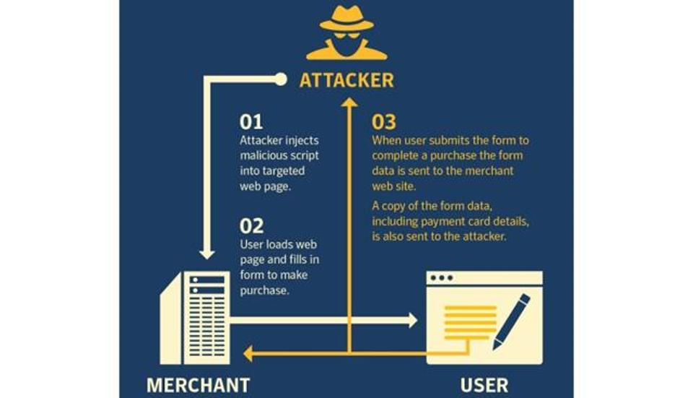
Figure 1 - Form Jacking
Unfortunately, upon successful execution of a FormJacking attack, consumers are unable to discover that they have been subjected to this attack until it is displayed within a credit card statement. It is one struggle for consumers to discover the validity of a website that is visited and a further prudence to realise that confidential information is being extorted through malicious means[29], [30].

Protection from FormJacking attacks
In the absence of appropriate security measures within corporations’ websites, consumers and employees are always vulnerable to these types of cyber-attacks. Symantec introduces the concept of Intrusion Prevention System (IPS) to dynamically defend websites from FormJacking attacks. It is reported that Symantec’s IPS technology has managed to mitigate over 1 million attempts of FormJacking attacks as well as supply chain attacks in relation to over 10,000 prominent websites, the IPS signature aims to identify sceptical behaviours analogous to FormJacking attacks. It examines each packet independently to discover configurations that are associated with network and application attacks[31], [32]. Below is an illustration of the influence in the signature detection rising upon the time scales:

Figure 2 - Signature Detection
It is vital corporations that utilise e-commerce sites that are associated with processing of personal data such card payments, incorporate the best practices to proactively manage a secure website. Best practices can include the minimal software check to discover abnormal signatures and testing each update patch to the extent of scanning each scripting code to identify any malicious code not intended to be present. Alternative methods of protection include incorporating Sub Resource Integrity (SRI) to permit a cryptographic function for the delivery of a resource to match the requesting resource[33], [34].

CryptoJacking & CryptoMining
Over the recent years, the increase of cyber-attacks via ransomware has been reported to become popular due to the elementary nature of execution, it was deemed effortless for hackers to steal financial expenses from targets rapidly. However, due to the low activity in Ransomware attacks in 2018, hackers have shifted the interest towards Cryptojacking/CryptoMining. Although CryptoMining may exist to class as a lawful transactional process for bitcoin mining, the transposition to malicious CryptoMining with unlawful means converts to the interchangeable definition of CryptoJacking[35]–[37].

Due to the international popularity of Cryptocurrency, hackers aim to direct cyber-attacks towards malicious intent of theft via CryptoJacking or malicious CryptoMining. To define the notion of CryptoJacking, it is the intent cyber criminals retain to furtively run crypto currency miners or coin miners on targeted machines in the absence of user’s knowledge. This supplies the hacker with the extended operation of ceasing control of a targeted CPU, with these advantages, attackers can proactively utilise this process to perform malware-based CryptoMining, which allows the designated user in control to overheat the CPU, which in turn causes electric power overload and damages the device, similar to a Buffer Overflow effect. This type of malicious intent is fairly dangerous as browser-based CryptoJacking[38]. To extent the severity of malware-based CryptoMining, hackers may cease control of enterprise networks and breach the infrastructure, which in turn provides the attacker an abundance of control to install malicious content such as a basic virus or worm to more advance malware infections such as backdoors and Trojans which may work through Privilege Escalation procedures[39]–[42]. The statistics from IBM suggests that in the same time frame of a decline of Ransomware attacks have provided an increase in CryptoJacking attacks[43]. As seen from the visual representation below, the data displays a 45% reduction in Ransomware attacks while there was an increase of CryptoJacking attacks of around 450% over the period of 2018. Some of the hacks of credit card detail theft was also related to Card Skimming attacks[43].
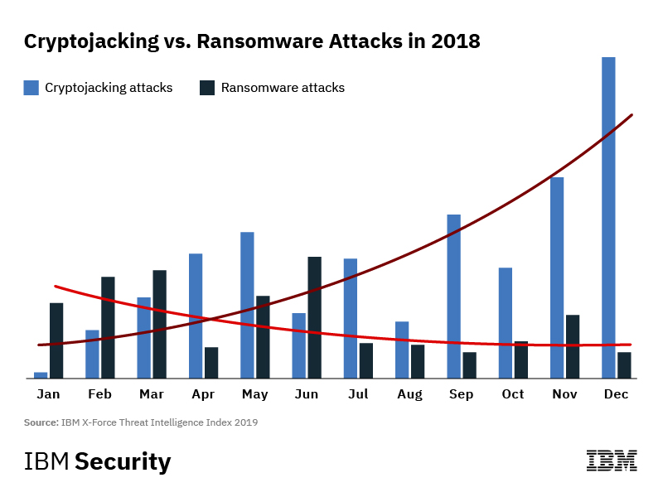
Figure 3 - Difference in Form Jacking & Ransomware
As the author mentioned the severity of both malware-based and browser-based CryptoJacking attacks, the below image represents the difference between the two attacks in relation to the volume of vectors. The reader can visually perceive that the data of browser-based CryptoJacking outweighs CryptoMining malware due to the rapid selling of online scripts which providers simultaneously delivered to clients whether it is legitimate or not. It was reported that a group of vendors known as Coinhive established the disposition of these scripts, as a result the organisation was deemed ceased on March 2019[44].
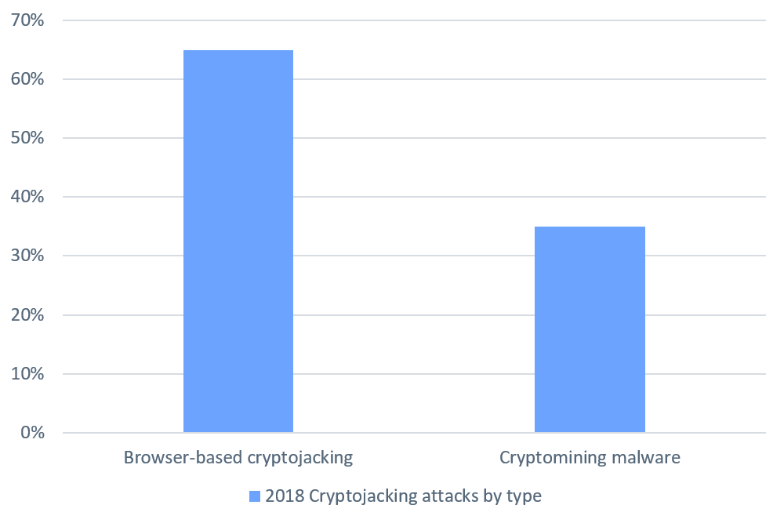
Figure 4 - Difference in Crypto Jacking types
Protection from CryptoJacking/CryptoMining
In the deficiency of appropriate browser-based security such as to defend from malicious software, network layer attacks, application layer attacks etc. A user must also ensure there is appropriate protection from malware-based attacks in relation to hardware and software security to defend against Ransomware and other malicious intent. Although it is difficult to establish a detection from CryptoJacking attacks, in some circumstances that the targeted devices are behaving suspiciously, a user can identify any performance issues via reviewing CPU usage, memory and other hardware related activity from the Task Manager option. Unfortunately, it is not only users of CryptoCurrency clients who are subjected to CryptoJacking, the entire scope of targets appears to perceive as the whole population who retain computers, the justification for this proves that CryptoJacking utilises computer resources such as CPU as mentioned previously, therefore nearly everyone is subjected to some form of financial theft[45].

Fortunately, there are various protection from CryptoJacking attacks, for example McAfee offer an advanced solution for browser security called McAfee WebAdvisor, which affords a client protection from threats while surfing the web, while also offering malware and Phishing security. Although there are various security measures which clients can download, this software may not discover 100% of the vulnerabilities as hackers are rapidly pursing new exploits. One of the most common methods of protection would be to install an add blocker that further blocks malicious CryptoMining on the utilised browser, since most browsers support each individual software extensions, it is made elementary for users to add protection. Due to the nature of CryptoJacking attacks, hackers incorporate malicious scripts into browser add-ons, therefore installing an effective web extension will provide a sufficient protection to detect CryptoMining scripts[45].

As for malware-based CryptoJacking and malicious CryptoMining, installing end device security specific to detecting crypto currency mining would be sufficient for users to discover any malicious intent. Fortunately, there are antivirus software such as Norton LifeLock software that afford users the advantage of detecting malicious coin miners and deliver indications if a device was infected. Although this is a sufficient security measure, coin miners are constantly updating hijacking strategies to avoid these protection actions. In corporations where employees are surfing the web, it is the employee’s responsibility to identify if a website is possessing malicious CryptoMining scripts, the assurance of web filtering is essential for surfing the web as well as updating web extension[35], [46], [47].

Ransomware
An enormous burden which still persist so fall upon corporations, clients and the entire population is Ransomware attacks. Although cyber awareness is increasing, the number of attacks on small and medium sized corporations are growing due to the lack of security measures implemented to mitigate the threats. Ransomware has been labelled as one of the most disastrous attacks of 2018 and continues to produce an appearance in 2019. To define Ransomware, it is a type of malicious software that encrypts a targeted victim’s resources and holds it ransom. In order for the victim to recuperate the files, the hacker demands a ransom to restore them via a decryption key, most commonly in the form of a bitcoin transaction.

Over the years there have been various attack vectors in which Ransomware affects computers, most notably being encrypting computer files and resources as mentioned previously. The reason why Ransomware attacks are statistically high in volume is due to the ease of making money. In 2017, the figure resulting in financial loss was reported as $5 billion in relation to Ransomware payments and recovering from the disaster, which is 15 times more than recorded in 2015 statistics[48].

Unfortunately, hackers aim towards more specific targeted victims who are susceptible to pay the ransom instead of mitigating the attack. It was reported in 2018 that hackers were targeting the healthcare sector and medical operations to demand ransom, the attackers had the assurance that aiming towards healthcare would mean that corporations would be more liable to pay the ransom due to the severity of protecting patient confidentiality. The corporations are more probable to pay the ransom to evaporate the situation rather than delay a more disastrous event which may lead to further ransom demand. The statistics prove that 45% of Ransomware attacks were towards the healthcare sector, where 85% of the malicious content at the healthcare sector were in fact Ransomware infections[49].

It would appear mindless to ignore the fact that one of the largest malware infections are Ransomware attacks, in 2017 corporations were witnessing the disastrous Ransomware called WannaCry. This type of infection infested numerous windows PC’s and encrypted the computer’s hard-disk, which rendered the machines unusable, in turn the hackers demanded a payment of bitcoin to decrypt the data. The interesting aspect of this was that the exploit used is known as EternalBlue which was developed by the National Security Agency but eventually stolen by hackers. The attack eventually came to a decline coming into 2018 due to the patches and updates. There are other notable appearances from Ransomware attacks such as Petya, which essentially made an appearance around 2016, however further after the WannaCry malware, utilising the same malicious software of EternalBlue, hackers used an updated version known as NotPetya in 2018[50]. The purpose relates similar to the WannaCry attack, in which the Ransomware encrypts the targeted files and resources of a victim’s machine and holds it ransom in exchange for a bitcoin transaction. As for the NotPetya malware, this form of malicious software was more targeted in Ukraine but also appeared throughout Europe and further in other states. The severity of this attacks goes beyond the standard Petya malware due to the rapid spreading of infections from one source to another source regardless of acquiring any form of administrative permission, therefore the malware was able to activate on its own. Hackers were able to take advantage of the exploits developed by the NSA to target the specific Windows Server Message Block protocol (SMB)[51]. It was reported that NotPetya originated from a Russian territory cyber-attack however, Russia denied any involvement in the attack[52].

The Symantec Internet Security report of 2019 further mentions other Ransomware attacks known as Ryuk, while reporting significant activity in late 2018. Targeting specifically enterprise corporations, this cyber-attack was responsible for disrupting the production of several notable newspaper and printing corporations such as San Diego Union Tribune, Wall Street Journal and New York Times. Derived from the Hermes Ransomware, Ryuk was sophisticated due to the feature of disabling Windows System Restore protocol, which that users that were infected had little to none rate of mitigation in relation to restoring company data. Initially, after a successful two months’ operation, hackers were able to retain around $640,000 in transaction[53]. To further provide an insight into the statistics on Ransomware, it was reported in 2018 over 77% of corporations were hit by Ransomware while utilising up to date anti-virus technology. In 2019, the annual global financial expenditure was valued around $14 billion, an increase from the previous year of 2018 global spending, the market is estimated to increase by 8.7%. On the account of the Crypto currency platform, 95% of the profits valued from Ransomware attacks went through bitcoin financial transaction[54]. The statistics suggests that the Ransomware attacks were more targeted which shows that the strategic planning of these are becoming more sophisticated, while affected various types of corporations such as healthcare, legal, gaming and many other business sectors[55].

Protection from Ransomware
In defiance of the persistent threat of Ransomware malware, there has been a degeneration of encounters over 2018 coming into 2019. Statistics suggests the collapse was precipitous, Ransomware infected around 48% of corporations in the year of 2017 however, around 4% within the year of 2018[55]. Although that figure represents a high value, corporations have not only been subjected to specific Ransomware such as Ryuk and WannaCry, but also general phishing attempts which incorporates Ransomware infections, thus falls into the category. In essence of targeted attacks retaining a lower infections rate in relation to attacking corporations, the results suggest a much larger volume of success.

The severity of Ransomware infection may seem daunting due to the effects of encrypting targeted files and demanding a payment. Ransomware malware can be countered with appropriate measures. Primarily, beforehand corporations should take measures to protect company data and networks. Regular backups are best practice to guarantee a safe restoration of system backup, backups can also be stored via external drives, therefore hackers cannot physically access the files. The emphasis of training is essential to corporations due to awareness of cyber threats, organisations should establish some ground rules to perform security testing in relation to new cyber-attacks.

Ransomware malware is constantly in a state of flux in the sense of patches and updates by its author, therefore each piece of Ransomware defines its own process of implementation. For this reason, anti-malware or anti-virus software may not always protect a user from being subjected to such attacks. Detection methods will not necessary pick up signatures which may appear as abnormal to security software. To ensure maximum protection, users can take best practices to update computer operating system (OS), this way computers are implemented with the latest patch and are less vulnerable to expose form Ransomware infections. Phishing is one of the most common method of sending an infection incorporated with Ransomware, due to this event, users should take cautious when opening links via email, the legitimacy is almost incomparable to verified websites. Another aspect of email scamming is illegitimacy of attachments, as soon as a user opens a malicious attachment a user can be infected in a matter of seconds. It is essential that users verify the email sender, this can be done by inspecting a previous legitimate email against a new email. As well as installing the appropriate anti-virus software, configuring firewalls and filtration, users should safeguard oneself by observance of up to update cyber-attacks in relation to Ransomware methods. Backing up data is one of the most crucial aspects in relation to protecting against malware infections. In the case of manual malware infections where the hacker is unable to gain access upon the technicians disabling the network’s wireless infrastructure, this in turn allows corporations to isolate the problem. As well as maintaining backups, it is also essential to secure the backups in the event that the files are free from encryption.

Anti-exploit technology allows corporations to optimise and detect Ransomware infections by neutralising multimedia software platforms such as Flash, Adobe, Java and many other types of plug-ins which may contain viruses. Anti-Ransomware technology also exists to enforce maximum detection and mitigation of crypto-ransomware exploits; Kaspersky offers Anti-Ransomware technology to protect corporations from up to date Ransomware. Technologies like these provide cloud protective assistance, blocking capabilities of local and remote access for hackers to encrypt data, block adware and of course crypto-mining tools. Other notable corporations which provide anti-ransomware technology are Avast, Bit Defender, McAfee and many other relatable software. Although there may exist various anti-ransomware technology, not a single anti-virus or anti-ransomware software that can decrypt files that have been encrypted by hackers due to the overwhelming strength of the encryption algorithm such as AES 128/256, as yet of modern day, an encryption key of AES 256 has not been broken, therefore targeted attacks using strong encryption would mean hundred percent success for hackers in relation to complex procedures and little to none mitigation for users. Although victims would be liable to pay a ransom, InfoSec and other law enforcement corporations do not recommend paying the ransom as it provides hackers the ability to conduct further sophisticated attacks[56]–[59].

Iot Malware
An ever increasing trend which corporations will constantly face is the vulnerabilities towards the field of Internet of Things (IoT). The year of 2019 has seen the highest volume of vulnerabilities and exposure recorded. According to the 2019 SonicWall Cyber Threat Report, within the first part of 2019, threat analysis has recorded around 13.5 million attacks in relation to IoT. This suggests the figure of the first half vastly outweighs the previous recorded quarters. Below the author illustrates a graph of the findings from the year 2018 compared to 2019 in relation to IoT malware;
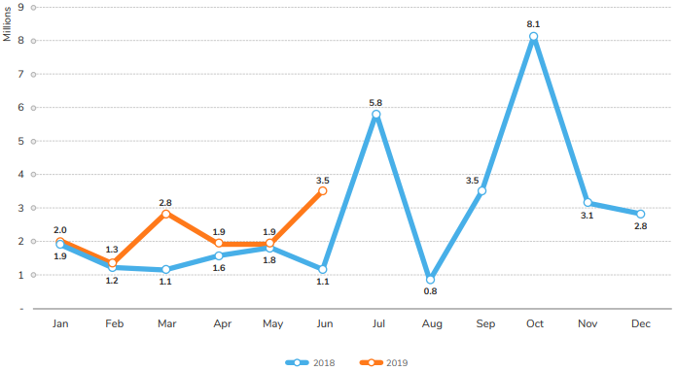
Figure 5 - IoT Malware discovery
For the reason of almost every device that connects via Internet of Things, this also creates a wide gap for hackers to intercept this connection. As this technology increases and becomes more widespread, so do the vulnerabilities and exploits. Throughout the initial deployment to the vast global presence of IoT, it has brought along various security flaws. The landscape of IoT attacks has stemmed from the disastrous threat known as Mirai Botnet which surged back in 2016. This malware infection gained control of infected IoT devices, which eventually allowed the hacker full control of the devices, these were known as bots. Utilising a network of bots, the hacker was able to perform a large Distributed Denial of Service (DDoS) attack against a significant DNS provider known as Dyn DNS, which resulted in a wide spread of internet outages across the US and Europe affecting various services such as PlayStation Network, Spotify, Netflix and more[60]. Enterprise level communication system are less susceptible to be targeted, however if corporations are utilising an abundance of connection devices without proper secure management, organisations could face potential disasters.

According to the IBM X-Force security management, it was suggested that there has been a recent trend within the attacks of IoT malware related to the Mirai Botnet attack, utilising a similar trait of the malware, however with distinct means[61]. The security team recorded an uptrend for the variation of Mirai Botnet targeting minor devices with little security, a certain period in November 2018 has illustrated a huge spike in activity of this trend as seen below, while also receiving an uptrend within the first half of 2019:
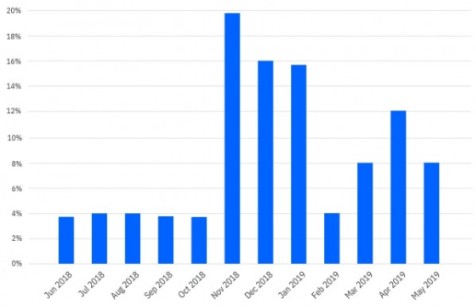
Figure 6 - Trend in Mirai Botnet
The analysis suggests that hackers are not only targeted low end connected devices but are now performing designated attacks against high end devices such as enterprise devices. Due to the rapid growth of IoT devices, this provides hackers with a huge set of targets to attack, it is estimated that around 41.6 billion connected IoT devices will exist while producing around 79.4 zettabytes of digital information by the year of 2025[62]. The severity of attacks in relation to IoT malware has also taken a toll onto cryptocurrency mining, hackers were utilised infected connected devices to actively create backdoor entrances and drop cryptocurrency miners onto targeted devices. According the IBM’s X-Force data analysis, Mirai related variants are the furthermost widespread malware infection which targeted enterprise networks within the year 2019[63].

Protection from IoT malware
As the author has gathered that the overwhelming nature of IoT attacks has become quite severe as seen from the statistical data above. Although this may seem prevalent in nature, corporations can take security measures to prevent potential rising threats. Corporations need to ensure that each connected devices to the network are secure and compliant to the standards and policies. To maintain up-to-date secure management of IoT devices, consistent penetration testing should be implemented to safeguard and test security criteria. Due to the increased volume of deployed IoT devices, engineers often overlook password measures which results in no security procedures, standard default passwords should be altered often to attain secure mitigation management. Unfortunately, due to poor management and placement of each connected IoT devices, engineers often fail to realise that the devices are accessible to the public internet, professional should safeguard these devices via placement behind firewalls.

It is essential that corporations utilise a variation of security measures such as threat intelligence, this in turn allows the organisations to monitor and analyse rising threats and gain relevant strategies to further mitigate threats and attacks. For the reason of rising malware of IoT botnets, it is crucial to implement security software for each connected device, a small device connected to the network can seem overlooked, however this small component allows hackers to intercept through external means and gain internal access. Another issue which individuals fail to realise is the way IoT attacks are conducted, the malicious software will self-install onto designated devices and compromise it, upon successful interception, the devices are rendered unresponsive to its owner, this in turn allows the hacker to gain full control of the infected device and pause until its new owner commands an action. Overall corporations should not only implement anti-malware software which provides detection levels but also prevents techniques. Some concepts which corporations should invest in is advance Machine Learning and Artificial Intelligence, these technologies can provide real-time protection in relation signature detection, advance algorithms for critical analysis and many other vectors of relevance[63]–[65].

Shadow IT Systems
A different outlook on cybersecurity is the underlying principle of Shadow IT systems. This imposition is utilised within enterprises as a secondary platform for hardware and software usage, however it is not made as a primary central platform hence the name shadow. This explores the concept of IT departments’ ability to introduce a separate network or platform for individual use or for a team, however the unfortunate event of overlooking the security risks can lead to harmful complications. In some cases, organisations do not acknowledge the deployment of this platform as it is implemented with discretion, this suggests that Shadow IT systems may impact the network in terms of affecting the network communication link and network data transmission due to overlapping conflicts. According to a research study by Everest Group, it was stated that company expenditure was about 30%-40% on Shadow IT systems within large enterprises and is discovered that it incorporates 50% or above[66].
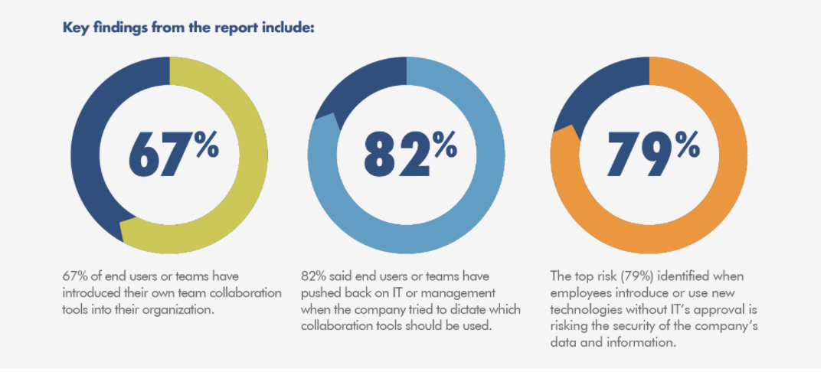
Figure 7 - Shadow IT systems report
The visual data representation above displays that 67% of end users, this being usually the employees, have initiated a new collaborative software technology within the organisation, this would explain the deployment level of new technologies. The figure of 79% of the right illustrates and explains that employees who utilise these new technologies without the acknowledgement of the IT departments endorsements, it is jeopardising the security of the organisation. The concept also relates to the notion of Bring Your Own Device (BOYD) and Internet of Things (IoT) as it brings in the challenges against the security measures of each organisation.

Shifting the issue aside, in most cases the deployment of Shadow IT systems and applications are implemented without the intention to cause harm to the organisation, the employees are unassumingly mindful of the security implications. The concept of Shadow IT systems does have its advantages such as boosting application development, delivering improved business solutions, flexibility on enhanced productivity and ease of managing various tasks. Despite the fact that Shadow IT software can impact organisations heavily, the concern should move away from the disregard of the system and focus on security as a top priority prior to deployment, with proper governance upon Chief Information Officers (CIO) to gain more clarity on the platform and implement secure frameworks[66]–[70].

Protection from Shadow IT exploits
It is one aspect using unapproved applications within organisations and another aspect implementing unsupported or disapproved applications unequivocally by the IT department, especially if the software is used in conjunction with the central network. The concept is similar to the idea of cloud computing, meaning that users may access and store files such as confidential information, therefore only producing a more demanding target for hackers. Due to the deployment of BOYD technology within organisations, Shadow IT applications which are unapproved may be utilised on IoT devise, this can render a huge cybersecurity breach due to the transfer of secure and unsecure exchange through the same platform.

Shadow IT exploits are a common threat which many corporations face, however it is possible to create a deployable secure environment via prior development and mitigation. Corporate polices are a crucial aspect for proper regulation, organisations need to implement suitable governance which outline relevant criteria in relation to the usage of devices that incorporate Shadow IT applications, instantly this precludes unauthorised admission. One of the simplest aspects to incorporate is the disregard to install or access unapproved applications via third-party providers. Another aspect which corporations fail to achieve is thorough monitoring of the network infrastructure and observing what employees are utilising, therefore it would display what is accessed. Employers may also introduce discovery tools which are targeted towards Shadow IT systems as an additional monitoring tool.

A competent method which is considered appropriate is the emphasis on educating employees on all aspects of introducing new technologies, therefore explaining what employees do not know may appear to effectively mitigate implications further along. By providing employees with a variety of different software tools, this instantly disregards the idea of utilising and installing third-party applications. Some employees may feel isolated with structured corporate software tools. Overall organisations should not view Shadow IT systems as deplorable, instead corporations should better understand the needs of the employees, this in turn increases the level of deployed unsolicited software platforms[71].

Related Work – Academic Papers
The author introduces the core literature aspect of the report in which will provide the basis and support for the overall project, considering the reasoning for selecting the appropriate academic papers to back up the research hypothesis. The focal aim of this is to expand in understanding the field of expertise intended to research, in this case Portable Penetration testing. The author will attain the relevant knowledge which will be incorporated into the research hypothesis to guide the project in the designated way.

Evaluation of Portable Penetration Testing on Smart Cities Application using Raspberry Pi III (2018)[72]
This paper introduces the fundamental principles of utilising the concept of Raspberry Pi device in relation to smart city applications to perform penetration testing. The researcher of this paper intended to utilise the mechanisms of the miniature device to test the success for penetration testing. The author would have previously explained what a Raspberry Pi exists as, the use and benefits it provides the user. The researcher of this paper essentially supports this project by defining the Raspberry Pi into a vulnerability assessment machine. The emphasis of portability performance is what the intended purpose was in this paper.

The sole purpose of this paper which the author introduces, is the ability to effectively use the portable device of a Raspberry Pi to perform penetration testing in relation to smart cities. For the reason of evolving threats towards smart city environments, the author proposed to provide a smart solution for security testing due to the low cost and operational power of the Raspberry Pi device. The researcher aims to put forth an effective exploration of utilising such a device for penetration testing. A portable solution which can effectively run vulnerability assessments would provide a huge advantage to various corporations as opposed to the high volume of financial expense which professional hired testers charge.

The researcher advances the explain the hypothesis intended to pursue prior to implementation. These were various questions which required clarity over the research questions. The primary enquiry was to discover the possibility of utilising a Raspberry Pi to perform vulnerability testing on smart city environments. Further study into the expectations of the results which can be produced utilising the Raspberry Pi when performing penetration testing. Additionally, is it possible that the benefits of utilising the Raspberry Pi offsets the use of acquiring conventional methods. Another main aspect of the experiment would be to run an additional experiment utilising traditional method of desktop, this in turn allows the author to compare the results of both methods against each other, and permits the user discover if similar vulnerabilities can be found. Upon successful implementation, the author intends to discover any further development possibilities of improvement. These are the issues which the author shall address throughout the paper.
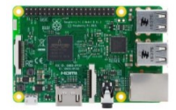
Figure 8 - Raspberry Pi
The above image represents the Raspberry Pi device which the author utilised for the penetration testing. After post researching the area of expertise, the researcher moved on to implementation. To begin the procedure, the researcher acquired the necessary components to build the device which is composed of various computing mechanisms. After configuring the necessary hardware feature, the researcher moves on to install the required software requirements, in this case the Kali Linux distribution. By installing the Kali Linux distribution, the author is admitted plenitude of pre-loaded vulnerability assessment tools to perform penetration testing, while also retaining the ability to install further additional tools.
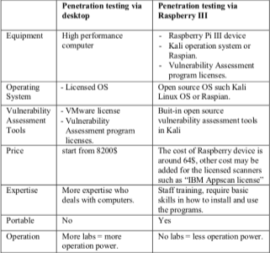
Figure 9 - Comparison between models
The above image displays the necessary information of comparison between the two intended tests in relation to the various features of operation. The researcher felt providing the information for both implementations were essential to cross reference with the results post implementation. The first half of the table represents the information for the desktop version of penetration testing, while the second half displays the data for the Raspberry Pi model.

The author advances the report by discussing the relevant software tools intended to use for testing. As previously mentioned, Kali Linux retains a high volume of built in tools to perform various types of vulnerability scanning while also proving the advantage to install further tools. The tools intended to utilise are known as Nessus, one of the most prevalent vulnerability scanners developed, due to its dominance in the market, it is now a paid subscription but was initially free, with over thousands of plugins and updates, Nessus is ahead of its competitors. The next software tool which the author discusses is known as Nmap, a network discovery tool which is open source for any individual, a popular network and host discovery actions as well as other monitoring related events. The last software tools that will aid in penetrating testing is known as IBM AppScan, an application security tool which discovers potential threats related to web-based, cloud and other software application platforms.
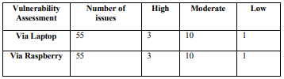
Figure 10 - Comparison between discovery
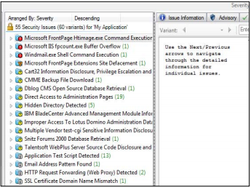
Figure 11 - Discoveries found
After gathering the necessary hardware and software tools, the author proceeds with the implementation. The above two images displayed represent the running results of IBM AppScan application. Figure x represents the first vulnerability assessment for both of running configuration. It displays the implementation of both experiments ran with the relative parameters which the reader can view. Figure x illustrates a more in-depth analysis of the IBM AppScan results as seen above, the pen tester can expand the issues discovered and gather a thorough breakdown.
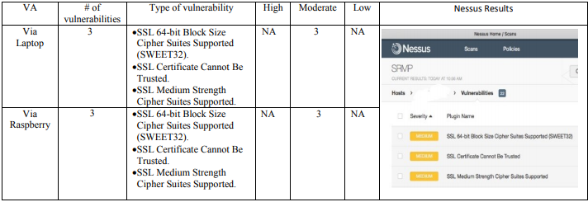
Figure 12 - Comparison between Nessus scan
The author advances the implementation by moving on to the next vulnerability assessment tool which is known as Nessus. Figure x illustrates the results of the completed tests via Raspberry Pi and Laptop as stated above. The test was run against the relative vulnerability parameters as displayed in the figure. Both running experiments were able to capture the same number and type of vulnerability as seen above, therefore this suggests the portability performance of the Raspberry Pi did perform as expected.

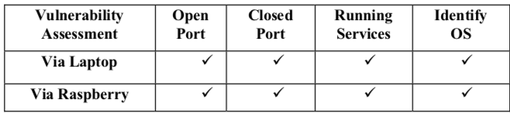
Figure 13 - Comparison of Nmap scan
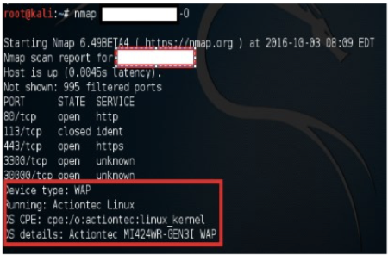
Figure 14 - Nmap output
The final test that was conducted utilising the software tool of Nmap network monitoring tool. The author ran the two tests against the designated parameters utilised by Nmap, in this case these were Open Port, Closed Port, Running Services and Identify OS as seen in figure x. the image above illustrates both experiments were able to discover the identical issues.

To conclude, after successful implementation of both devices, the author discovered that the Raspberry Pi can be effectively utilised for performing vulnerability assessment as the expected results were identical as the actual final results which the reader can view from the tables. The reader can gather that a miniature device such as a Raspberry Pi can perform successful vulnerability tests when programmed in the designated way, while retaining its benefits of low cost, less operational power and portability. High monitoring capabilities were performed such as traffic capture and remote access. The researcher recommends that vulnerabilities assessments should be carried out using Raspberry Pi an as alternative method to penetration testing and auditing functions.

Portable Toolkit for Penetration Testing and Firewall Configuration (2015)[73]
The author proposes another piece of literature which relates to the purpose of this project. The paper which is introduced is based on portable penetration testing within a security testing environment. The researcher of this paper utilises the hardware and software materials of a Raspberry Pi device. The device that is proposed by the researcher is known as Portable Penetration Testing and Firewall Configuration. This portable device was established to permit users to conduct penetration testing towards computer systems. A further adaption on the Raspberry Pi which the author installed was a structure of Firewall management system, where users can practice how to configure a firewall.

After the researcher mentions the necessary information of Raspberry Pi, a small miniature device to allow users to configure it in various ways to carry out different variations of experiments. The author provides an overview on the required software and hardware tools intended to utilise. The aim of the paper was to test and evaluate the security of a designated network, this in turn allows the user to attain the potential vulnerabilities that the network may uncover. It is mentioned by the researcher that the device is capable of running on various operating systems (OS), in this case Linux plays out as the most efficient due to the abundance of software advantages it provides. The OS that is utilised is preconfigured, this benefits the user for the reason of manual installation of the OS, the distribution of Kali Linux is utilised.

The author further continues to explain the next aspect of the necessary software, in this case the firewall configuration. The purpose of the firewall configuration is to filter and restrict access to a designated area within the network, this is comprised of inbound and outbound filtering. The author explains the intended to utilised, an open source software tool called IPFire, the user is provided the ability to install this software onto the Raspberry Pi device. The purpose of this implementation allows the user to configure a portable firewall between the source and destination of a targeted network. The researcher conducts literature on the existing comparison of portable testing framework based on factors of cost, processor, memory, storage capacity, power consumption and dimension. After gaining the necessary hardware requirements, the author display the physical device below;
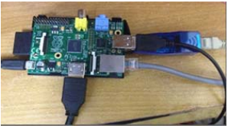
Figure 15 - Raspberry Pi model
Following on from the previous section, the author is able to discuss the proposed system and move forward to the design and implementation. Since the Raspberry Pi is the focal body for the project, it will be utilised for the distribution. It will mimic a computer in the sense of retaining a keyboard and mouse. For the reason of a portable framework, the user is granted the choice of conducting a LAN connection or wireless connection to carry out the penetration testing. The author provides a conceptual diagram of the penetration testing module.
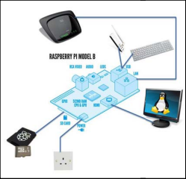
Figure 16 - Illustration of Raspberry Pi
The author further explains the necessary components for the firewall configuration and how the firewall software can be utilised. The user is able to filter in and out what websites can be accessed and what websites can be denied. A filtered website is configured on the GUI of the firewall; the results below display a filtered website and the result of accessing it after filtration;

Figure 17 - GUI illustration
The author conducted further testing of a variation of the system, these were known as User Acceptance Testing, Unit Testing and Integration Testing. Theses testing methods were based on different factors of performance such as usability, stability and graphical performance. The results of the User Acceptance Testing, Unit testing and Integration testing are shown below;
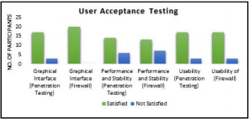
Figure 18 - User Acceptance Testing
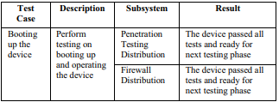
Figure 19 - Testing process
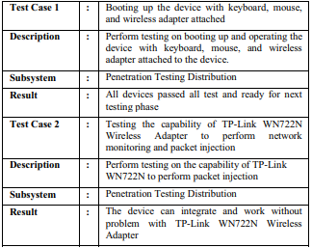
Figure 20 - Testing configuration
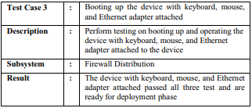
Figure 21 - Testing configuration 2
To conclude, after post testing phases, the author has established that the Penetration Testing Distribution and Firewall configuration is ready for deployment and testing. Unfortunately, the researcher may not have conducted the actual penetration testing, however the principle of the technology remains beneficial to outline, considering the advantages of portability and time constraints.

Penetration Testing of Android-based Smartphones (Networks and Distributed Systems)[74]
The author introduces another paper of relevance, the researcher of this paper proposes a different approach for penetration testing. The concept revolves around the concept of security analysis towards an android-based application. For the reason of the increased deployment of smart phone applications, the risk of critical exposure of these applications is always a risk, especially further crucial applications involving financial transactions such as mobile banking. Within the smart phone environment, android is one of the most common operating systems to date. In this paper the researcher proposes the analysis of the infrastructure of the operating system and perform penetration testing to analyse the security strength. The author tests various methods to penetrate the intended system and provides a discussion about our findings.

The focal point of this paper was to conduct an investigation into the android platform architecture while considering the concepts of security operations existing within the operating system of android. The author will investigate and evaluate the security complications within the network layer of the android operating system in relation to conducting penetration testing. To define the penetration testing procedure further, the author of this paper utilised what is known as White Box testing. This refers to the idea of internal design and implementation testing towards a designated target. The author intended to test three variations of the Android operating version. The penetration testing methodology follows as initially network mapping the intending OS, followed by port scanning to view any port filtration, and lastly penetrating the system utilising various attacks which will be mentioned.

Chapter Summary
In conclusion, the author provided a thorough discussion for the research and literature aspect of the project, considering the factors of relevancy, validity, influence and understanding. The persistence to conduct critical research literature allowed the author to pinpoint various aspects of analysis and provision in relation to aid the research hypothesis. Background research was certainly established to gain an understanding into the field of study, this allowed the author to further develop the research proposal. The author mentioned relevancy in relation to the appropriate research papers conversed. A sense of influence was established via critical analysis on each paper uncovered. Overall, this chapter introduced the necessary knowledge and background in order to advance within the project. The following chapter explains the fundamental principles of research methods and development.

5. Research & Development Methods

This section clarifies the research methodology aspect as well as the development methods of the project. It is essential to produce a professional body of research methods to follow to allow researchers to gain the relevant information to guide a thesis in a designated way. The information researched allows the author to build the requirements of the various methods of data collection which the author will discuss.

The author introduces a professional body of research methodology to follow in order to create a formal procedure of an effective methodology. The professional body of study which the author will utilise is the one developed and known as the Research Onion [REFERENCE]. This exploration exists to provide the researcher with the necessary progression techniques to develop or justify a thesis. The advantage of this methodology is useful due to the effective adaptability towards universal research contexts. The author will clarify each procedure in which will develop each stage of approach intended to pursue.

Understanding the Research Methodology
To understand the Research Onion, the author must elucidate the formulated stages in relation to the research approaches and how the methods can cross-reference the aims and objectives of the project. This section should vindicate the elaboration of the project to identify a form of rationality towards the research approach chosen. In essence, to understand this classification, research design provides an overall clarity of the selected approach and the justification for that decision. It equips the author with the substantial basis of creating a research design plan with initiation and concluding with justified decisions to reflect the study acquired. Throughout the research stages, the reader will gather the sequential nature of the methodology approach[75].
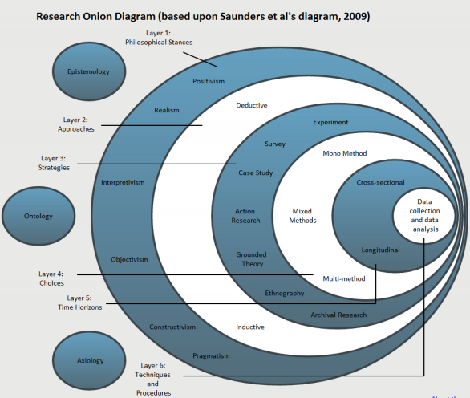
Figure 22 - Research Onion
The author begins to establish a professional body of standard in which will support the process of research methods. The above image displays a thorough illustration diagram of the Research Onion. Each phase of the research body will represent the specific steps for advancing in each stage of the project. The relative layers of the onion will be discussed in relation to the appropriate steps taken. From the illustration above, the reader can view the several variations of research methodology proceeding from the first layers to the last. The author proceeds to discuss the designated chosen layers of the onion;

Philosophical Stances
The relative process of research philosophy outlines the intended process for producing a research hypothesis, which can be developed via testing and exploration against measured parameters with real life scenarios, therefore the philosophical stances will define the contribution to the way the research question is answered. The author allows the appropriate standard of research philosophy by abiding with Positivism approach. The reasoning for this approach establishes the fundamental principles of a real-world environment to test upon.

Approach
Following on from the previous section, the author has already established a basis for the research philosophical stances. Moving on to layer 2 of the onion, there are main approaches which the author can indicate within this section, inductive and deductive. The researcher intends to partake the deductive approach due to the appropriate research methods it progresses to. This approach allows the researcher to originate a hypothesis and conclude with a justified answer. The reasoning for this method ensembles suitable project aims and objectives in relation to the intended experiment, which can be tested with quantifiable measures.

Strategies
This section progresses to the research choices and strategies intending to partake. The strategies refer to the way the style of the hypothesis is intending to conduct. In this case, the author proposes to conduct an experimental methodology as it reflects the aim and objectives. An experimental based project will allow the author to justify the reasoning for the designated research strategies. The experiment will produce statistical data which can then be analysed according to the relevant collected data.

Choices
As the established practical approach has been chosen as an experiment, the author must come to a decision to establish suitable measurable variables. To define an appropriate method of either quantitative or qualitative approach, in some cases where the researchers conducts both types of methods in relation to mixed-methods or multi-methods. Quantitative measures are related to data which deals with measures of quantity. Qualitative measures relate to non-numerical research such as concepts and descriptions. This is one of the essential aspects of the selected method due to the way the data is measured and analysed. The author will propose to follow a quantitative measure due to the nature of the experiment. Variations of large data will have to be established to quantify and analyse the expected outcome of the results.

Time Horizon
This section defines the time scales of the research hypothesis in the sense of time horizons. There are two divergent concepts relating to the time horizons, these are cross-sectional and longitudinal method. Both methods can utilise either quantitative or qualitative measures. The distinct nature of the studies is that cross-sectional are concerned with the relative measures which can be measured at any point, while longitudinal studies are concerned with relative data which is measured over a long period of time. As for the intended time scales, the author will propose to proceed with both studies due to the relative nature of the experiment, some tests will be concerned with quick measures while some may take a longer response to receive.

Data Collection & Analysis
The final stage of the onion relates a focal point of the research design, the data collection and analysis. The research plans to develop a systematic approach to obtain the relative data necessary to the hypothesis. The process of data collection requires the author to proceed in a scientific and analytical way. The nature of data collection process is distinctive in two sections; the first part resides with primary data while the other exist in secondary data. Primary data collection results in extracted data from self-obtained studies such as surveys and interviews. Secondary data counts as data that has been extracted from external studies, sources of credible references completed via other researchers. The data collection and analysis will represent the intended research literature incorporated within the studies. the author will provide a wider clarity on the methods of collection further on.

Research Design
A well thought out research hypothesis requires a suitable research design plan to appropriately answer the question of statement. The research design and methods are interchangeable sometimes however, each term relates to some aspect of research. Based on the relative objectives of the project, the author has previously established that the project will be defined by an experimental research design, independent variables are tested against dependant variables. The research design allows the author to devise a systematic methodology to follow in order to produce a positive outcome. The author intends to develop an action plan which reflects the research process in relation to investigation techniques. Based on the research methodology, the author produces a systematic development of the structure below;
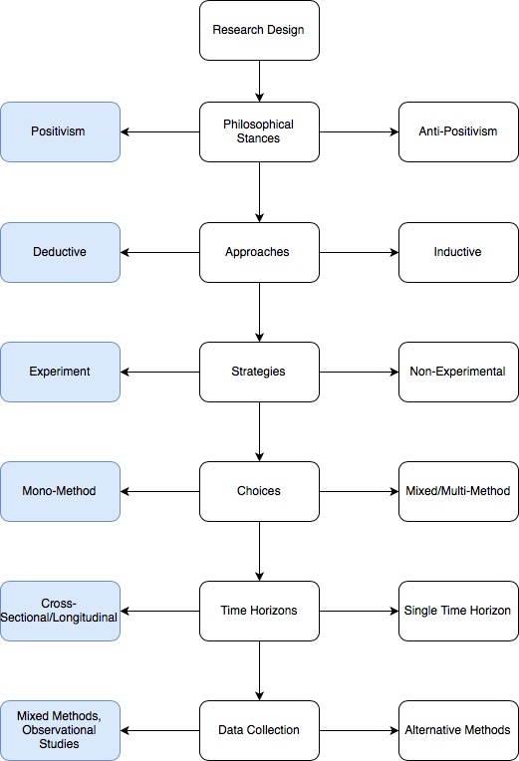
Figure 23 - Research Design model
The above image displays the illustration of the research design model overview in a methodical approach. It represents the various aspects of the development process of the objective guidelines to follow, the author illustrates the designated steps intended which is displayed by the blue boxes on the left. The alternative methods are represented on the right, these are strategies which the author could follow in relation to the intended thesis.
Research Methods of Data Collection
Constituent | Research Method
Introductory Chapter – 1 | Online journals, Web articles, Books
Aim & Objective – 2 | Project knowledge & understanding
Research Literature – 3 | Online journals, Web articles, Books  IEEE Xplore Library, Science Direct etc
Related Work – 4 | Online journals, Web articles, Books  IEEE Xplore Library, Science Direct etc
Research Methodology – 5 | Web articles, Web based literature
Ethical Constituents – 6 | Web articles, Web based literature  Project Knowledge & understanding
Design & Implementation – 7 | Project knowledge & understanding
Evaluation – 8 | Project knowledge & understanding
Future Work & Recommendations – 9 | Project knowledge & understanding, Web articles
Conclusion – 10 | Project knowledge & understanding
Reflections – 11 | Project knowledge & understanding
References | Academic sources

The author provides the relative table above which illustrates the methods of data collection utilised by the author proceeding from start to finish, a list of originated sources will be identified. These assists both author and reader as it displays a level of professional standard of research being conducted.

Research Deliverables
When conducting a research proposal, it is essential to outline the intended outcome, or what is known as a deliverable. It states what tangible outcome can be delivered upon completion, considering the elements of origin, approach and accomplishment. There can be many variations of what is classed as deliverables, what is suitable for each researcher can be designated a specific deliverable. As the author intends to conduct an experimental approach, the deliverable will be defined by results from an implementation. The deliverable will be justified at the end of the report discussing a cross reference between the intended deliverable and outcome of the implementation.

Chapter Summary
To conclude with this chapter, the author explained the necessary research methods intending to follow, while considering the concepts of research design, approaches, strategies and data collection. A professional body of literature was examined thoroughly as the author cited within this chapter. The author discussed the relevant literature which will aid in the decision-making process when conducting a research project. Additionally, a research design model was devised to act as a systematic process for directing a project. A well-established research methodology affords the author a stable assembly to follow. After careful consideration of choosing the designated methodology approach, the author leads to the introduction of the design and implementation which will define the practical experiment aspect of the project.

Ethical Constituent
The author proposes a research hypothesis to implement a portable penetration testing towards a communication system, although this proposal provides a straightforward procedure, there are some legal and ethical requirements which the author must adhere to. The author must attain several permissions to retain a professional standard of ethical rights, therefore without ethical concerns, the author is deemed an unethical hacker if the implementation is conducted without the necessary permissions of acceptance. As the project is aimed towards the enterprise network, there will be numerous ethical considerations involved, some of which are mentioned below relating to the enterprise and external constituents;
Enterprise Standards:
- Information Technology and Systems: Acceptable Use Policy V2.4
This policy covers the necessary scope of the IT systems and services in relation to the enterprise standards. A requirement for students and staff to adhere to in the event of misconduct, where if a problem should arise, the security assurance of any individual shall not be considered valid. The measured capacity of the scope extends to any electronic device that is able to connect to the enterprise network whether locally or remotely must be considered. External connections via the enterprise network is reflected due to the exposure of malicious content. There are many other aspects which the policy covers from systems and structure, to roles and responsibilities. The scope extends to explain the level of appropriate and inappropriate use of the IT systems to allow participants to understand the degree of usage. Overall, the policy not only sets out rules and regulations for users, but also protection of security for the both academic and professional profiles.
- Code of Practice for Research Degrees
This principle denotes that participants who are within the enterprise follow a set of policies and procedures in relation to conducting research majors. It applies to various individuals related to the enterprise and provides a management framework to carry out research degrees. This accord relates more towards the way a research degree is regulated, and the roles and responsibilities, which the intending participants retain to successfully keep in accordance within the scope a conducting research major.
- Research Ethics & Integrity Code of Practice (2017-2020)
This intuitive reflects the necessary preservation of ethical standards in relation to research conducted by academic and professional attendees regardless of internal or external conduct. The policy ensures that the standards of appropriate principles and governance is properly measured. The intuitive covers aspects of good practice and integrity such as honesty, severity, communication and respect in relation to research ethics.
- PG2-E1 Ethics Form
One of the most essential ethical constituents to consider is the enterprise ethical form itself. This document outlines the necessary rights and permission for the author to attain in order to conduct an ethical project, in this case to gain ethical hacking permission to conduct penetration testing to examine the strengths and weakness of the network. This document applies to all participants who undertake any research degree for final ethical approval. The document requires the principal researcher to supply obligatory details for an intending project outlining various factors of scope, activity, participants, risks, consent, data protection, process and declaration procedures.
External Ethical Constituents
- Data Protection Act (1998)
As well as enterprise standards, there are other external considerations which the author requires to acknowledge while conducting a research degree of ethical consent. The researcher is obligated to understand what aspects of external standards affect the intending project, participant and organisation. The policy covers aspects of Information Security in relation to the handling of sensitive data. The Act applies to individuals who hold any confidential information of participants within the EU and United Kingdom. Breaches of the Data Protection Act can result in illegal violations which can cause severe consequences. The governance emphases the principles of lawful use, data security, accountability and other related Information Security policies. This relates to the research project due to the event of attempting to breach a network, therefore this may reveal sensitive data of students and staff which is deemed confidential. It would apply to the principal researcher for the reason of handling this personal data in accordance with ethical and legal rights.
- Computer Misuse Act (1990)
This legalisation was implemented to protect individuals utilising computers against unlawful acts of information theft and misuse. There are various factors which is explained that cover the legalisation such as unlawful hacking, access of unauthorized use towards computers, the spreading of malicious intent and other harmful computer related viruses. Unauthorised access can include variations of factors such as data modification, system altering, computer impairment and other related issues towards and misuse of computer systems. The legalisation states that unauthorised access towards a computer is a violation and may result in legal prosecutions.

The above information represents the up-to-date regulations and policies which students and staff need to adhere to in relation to conducting research studies and general admissions. It is crucial that the author attains the role of an ethical hacker in the event of testing a corporation’s network infrastructure due to the level of confidentiality it retains, sensitive information in relation students, staff and other personnel as well financial and legal information. The right of access to this information is held by the corporation. A certain degree of trust and compliance is required by both parties to allow advancement of the implementation, as well as verbal accord, a written accord is the most essential document for engagement. Ethical constituents are important for various aspects of integrity such as the safeguarding rights of participants and non-participants, to established little to none risk of exposure. The assurance of conducting legitimate studies in relation to the intending researcher and corporation. The reputation of the intended corporation should also be a risk factor to be taken into consideration to avoid claims of irresponsibility. The declaration that any investigation is properly supervised considering the factors of legal and obligatory standards. Furthermore, as well as enterprise governance and standards, the author must comply with external collaborations which affects the legal, ethical and professional aspect of the university for students and staff.

6. Chapter 4 – Design & Implementation

6.1 Introduction

In this chapter the aims to put forth the instigation of the practical aspect of the project, in this case, it the representation of the experiment to conduct. The two phases involve the design and implementation aspect. The design section should provide the reader with an illustration on the concept of the prior implementation, therefore this displays some clarity on the overview practical development. After elucidating the design aspect, the author implements the completed experiment which was conducted, this will be explained in more detail further on.
Problem Formulation
The problem formulation is as much as a research question in the sense of proposing a thesis to answer. The author devises a research problem and addresses the criteria of relevance. The problem formulation is the core foundation of the thesis, this in turn allows the researcher to return to the proposed question in the event of loss of coordination and organisation. The reasoning of this is the focal point of the thesis in which the author further advances in an explorative research investigation. A well devised problem formulation affords the author with an exceptional framework to work from as it constructs work coherence.
The problem formulation in this case is defined within the aims and objectives of the project, does portability performance aid in penetration testing as opposed to conventional industrial desktop penetration testing. The author would have already created a research question at the initial start before conducting any form of practical development, this way there would exist little to none uncertainty to develop further in the project. Overall it outlines the need for attentive exploration into the specified research, in this case it the benefits of portability.
Design
The author introduces a conceptual blueprint prior to implementation to illustrate the experiment before conducting any practical development. The design aspect affords the author with the relevant overview of what is intended to conduct, it provides a sense of clarity of what can be done and the various ways it can be produced. The illustration below displays the blueprint of the visual concept which the author intends to carry out. From the visual concept, the reader can analyse each component within the structure. The first component displays the core element of the implementation, the Raspberry Pi. The second piece represents the software architecture intended to use, the Kali Linux platform. Utilising the Kali Linux platform, the author will conduct the penetration tests. The third component symbolises the internal router, in which the connection begins from. The fourth element signifies an intended firewall; this component is indeed logical as well as a physical firewall which protects the network. The final component displays the actual network, which is the target victim, assuming intended success, the network shall be reached. Below, the author provides a visual representation which defines the physical implementation:
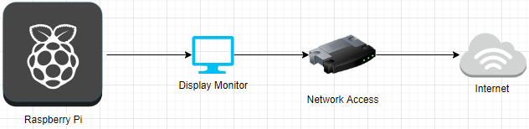
Figure 24 - Illustration of Raspberry Pi

Implementation Phase I
Following on from the design section, at this stage the author would have gained the necessary visual perception of the intended experiment. The first stage of the practical development may continue, the essential required of the Raspberry Pi are needed to be configured and installed prior to implementation. The author will discuss in detail the necessary elements of configuration and installation to provide the reader with the overview of the implementation process.
Requirements & Implementation of the Raspberry Pi
The primary stage of implementation requires the author to configure and install the necessary software platform of Kali Linux. As the Raspberry Pi is previously built, the author shall provide the reader with the requirements of the Raspberry Pi, the components which make up the device. Below is a list of the requirements of the miniature device;
Requirements:
Raspberry Pi
CPU (Minimum 1GHz with 1GB RAM)
HDMI Cable
USB Keyboard (Wired or Wireless)
USB Mouse (Wired or Wireless, Optional)
Display Screen (Optional)
SD Card (Minimum 8GB)
Power Supply (Power Bank)
Bluetooth Wi-Fi (Optional)
Micro USB Adapter
Kali Linux Distribution
Vulnerability Assessment Tools (Explained further on)

Kali Linux Installation
As the author has already discussed the operating system intended to utilise on the Raspberry Pi, this being Kali Linux distribution. It is essential the author mentions the method of installation for the reader to gain an insight into the process for further implementations in relation to further research development. At this point in time, the author would have already decided to use the Raspberry Pi model 4, which is most suitable for the implementation due to the benefits, this being the Raspberry Pi model 4. The steps to download and install the relevant software in mentioned below;
- Download image – The first step would be to decide which software is the most suitable for the chosen Raspberry Pi, this image can be located on various sites. The author intends to download a ‘Kali ARM image’ to burn onto the micro SD. This can be obtained from the official Kali website as it provides variations of downloads for different platforms.
- Micro SD – After obtaining the suitable Kali image, the user can begin to insert the Micro SD card into a computer whereby the installation will start. From this point the installation process should be straight forward as the user can follow the on-screen instructions to flash the image on the micro SD card. There are appropriate software tools which aid in installation such as a tool called Etcher. Upon successful installation, the user can remove the SD card and insert into the Raspberry Pi where the next set off instructions will need to be completed.
- Connect – As the micro SD card is loaded with the Kali image, the user requires to insert the card into the Raspberry Pi and connect it to a monitor via HDMI cable. Once the screen is loaded, the user requires to enter the login details, the default user and passwords are enabled pre-configuration for all platforms, this being ‘root’ and ‘toor’.
- Update – Upon successful login, the user is required to upgrade and update the platform due to various software packages which may differ after initial download, this in turn allows the user to retain an update version of the platform. The author intends to connect to the internet foremost to run an update, this is done via terminal window. The command the author requires to implement is ‘~# apt update && apt upgrade’.
- SSH Keys (optional) – The user has an option to change the default login details however it is entirely optional and does affect any configuration. Despite the login credentials, the user has the option of altering the SSH keys. The reason for this is that default SSH settings can be open to unsecure applications, therefore changing this setting will enable a secure boot into the Raspberry Pi. For the user to configure this new setting, the following commands are displayed, ‘~# cd /etc/ssh/’, ‘~# dpkg-reconfigure openssh-server’, ‘~# update-rc.d -f ssh remove’, ‘~# update-rc.d -f ssh defaults’, ‘~# nano /etc/ssh/sshd_config’. After entering these commands, to apply these settings the user needs to restart to issue the full effect. The commands to issue these statements are ‘~# sudo service ssh restart’, ‘~# update-rc.d -f ssh enable 2 3 4 5’. Upon successful implementation of this process, the Raspberry Pi should be ready to run applications.
https://null-byte.wonderhowto.com/how-to/load-kali-linux-raspberry-pi-4-for-ultimate-miniature-hacking-station-0201737/

Implementation Phase II
Upon installation and updating the software intended to utilise, the author proceeded to conduct the appropriate testing. The author will provide the reader with the comparative overview of both the Raspberry Pi and Desktop experimentation. Each experiment will be illustrated to allow the viewer to analyse the difference between the two implementations. The author begins by demonstrating the experiments below and develop a comparative view upon completion of each experiments:
Nmap (Network Mapper) – Raspberry Pi

Figure 25 - Nmap output
Above the author provides a screenshot which displays a scan using the software known as Nmap, a network scanner which can detect a range of services upon a chosen network. The results display the running scan based on the given address which can be seen on the two windows. The output shown presents information such as port filtration, packet latency, discovered/open ports, OS detection, hop count and fingerprint of the public key shown under ‘SSH-Host-key’.

Figure 26 - Nmap output II
The above screenshot represents the running scan against the loopback address to discover additional information. As the previous commands suggest that the host is offline, the command ‘-Pn’ skips the host discovery stage as the author has already established that the host is in fact online. The reader can view the results of the open ports and the number of filtered ports.

Nmap – Kali Desktop
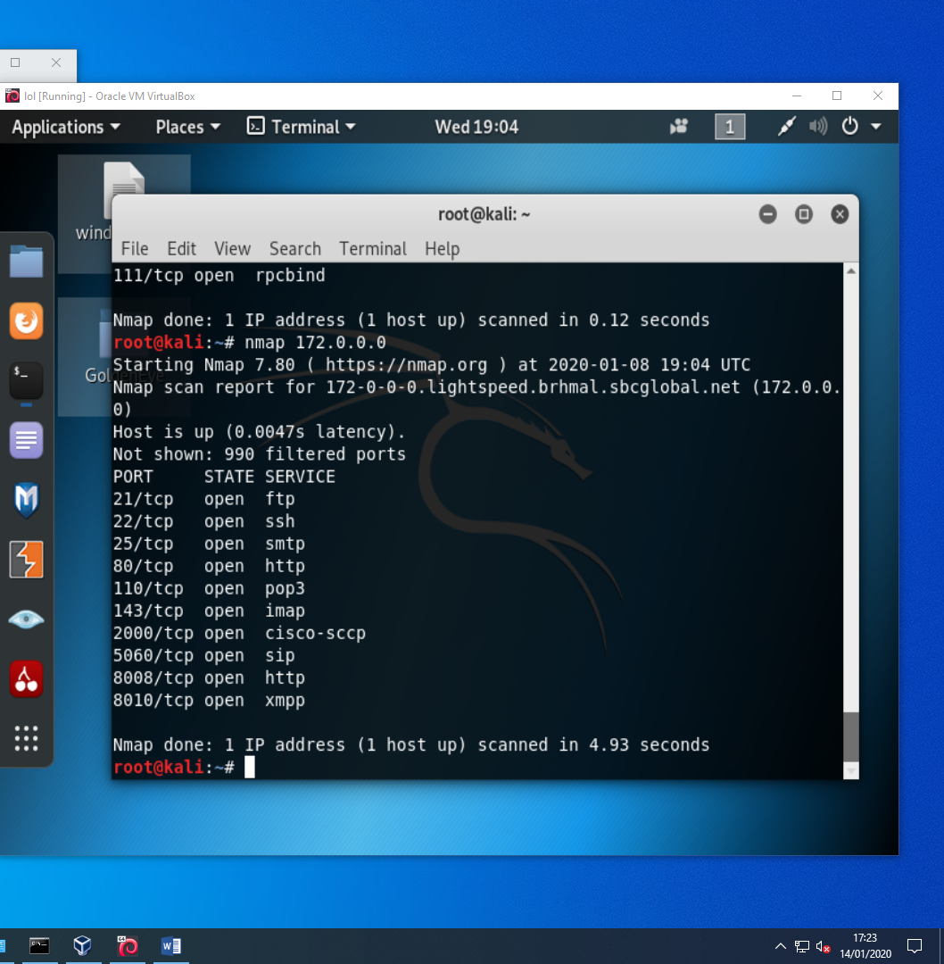
Figure 27 - Nmap port discovery
Upon running the scans for the Raspberry Pi, the author proceeds to run Nmap using the Kali Linux desktop. The reader can analyse the same results compared to the Raspberry Pi.

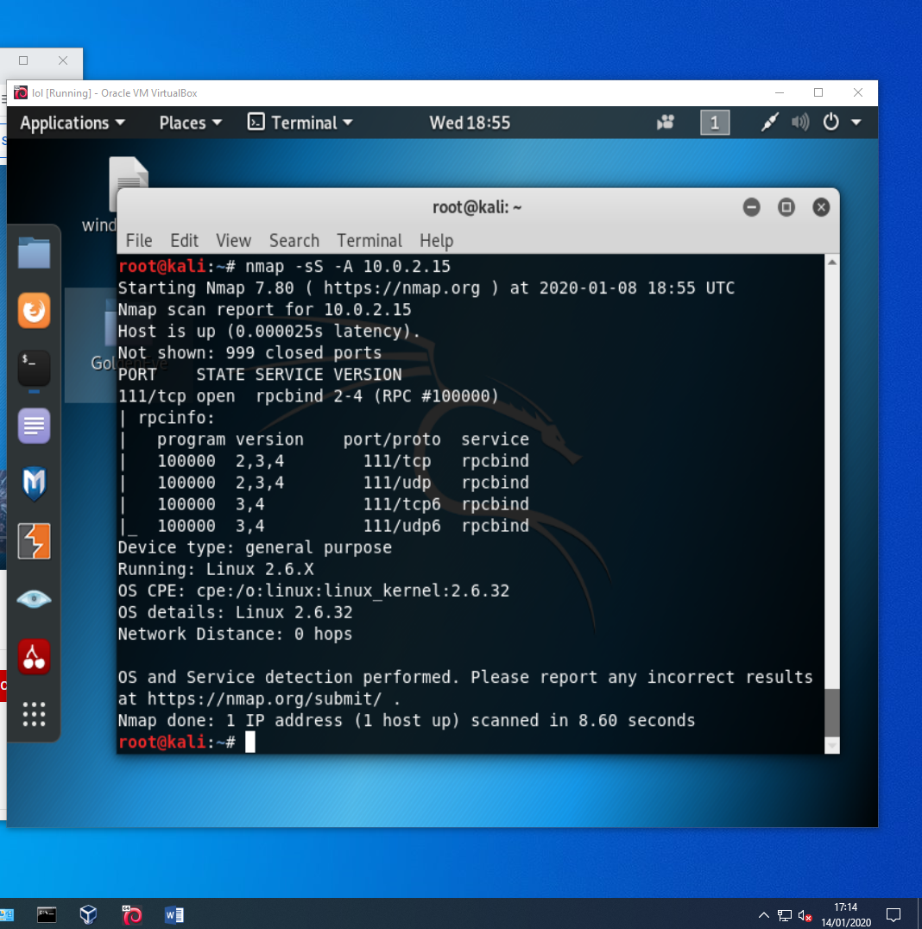
Figure 28 - Nmap port discovery II
The running scan above illustrates the results of the Nmap scan on Kali desktop which display similar results as the Raspberry Pi, considering aspects of packet latency, port filtration, discovered/open ports and OS detection.

Nikto (Web Vulnerability Scanner)
Raspberry Pi
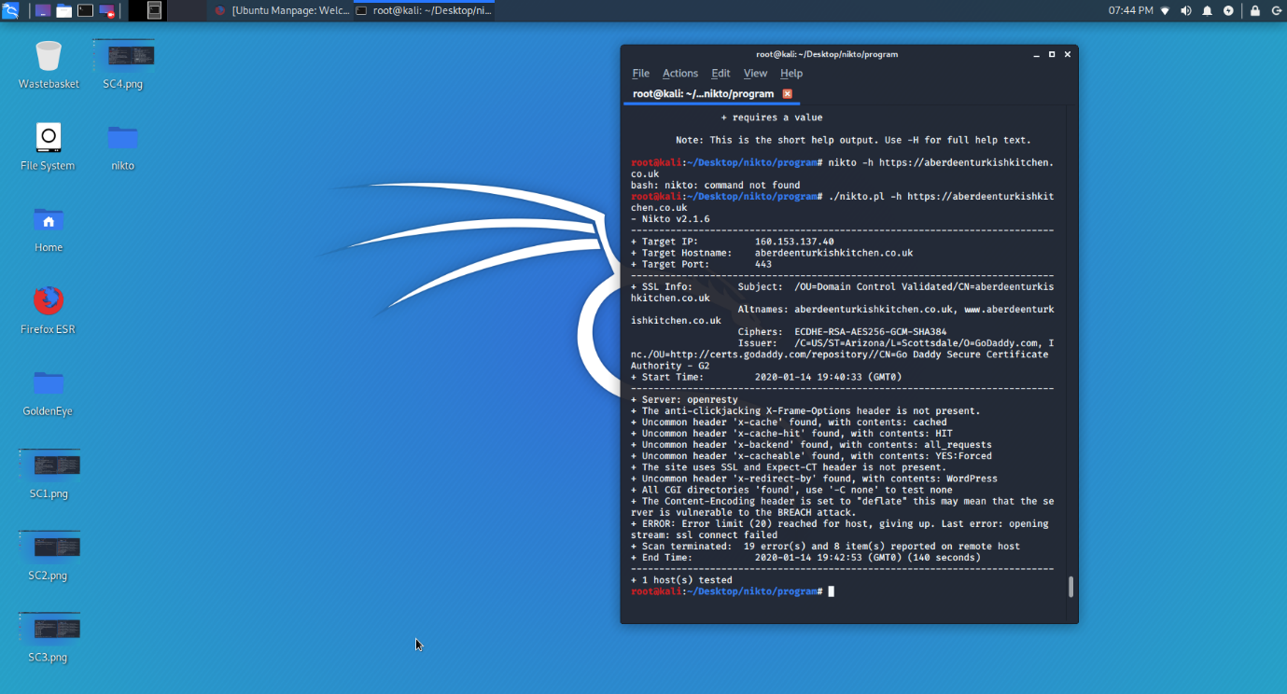
Figure 29 - Nikto Web vulnerabilities
The screenshot provided above allows the reader to analyse the running scans of the Nikto scanner. This software retains the capabilities of discovering installed web servers, potentially dangerous files, scan plugins and other possible configuration files. The output displayed information such as IP address, hostname, port (443, which is HTTPS), SSL information, encryption ciphers, certification authority (GoDaddy).
Nikto – Kali Desktop
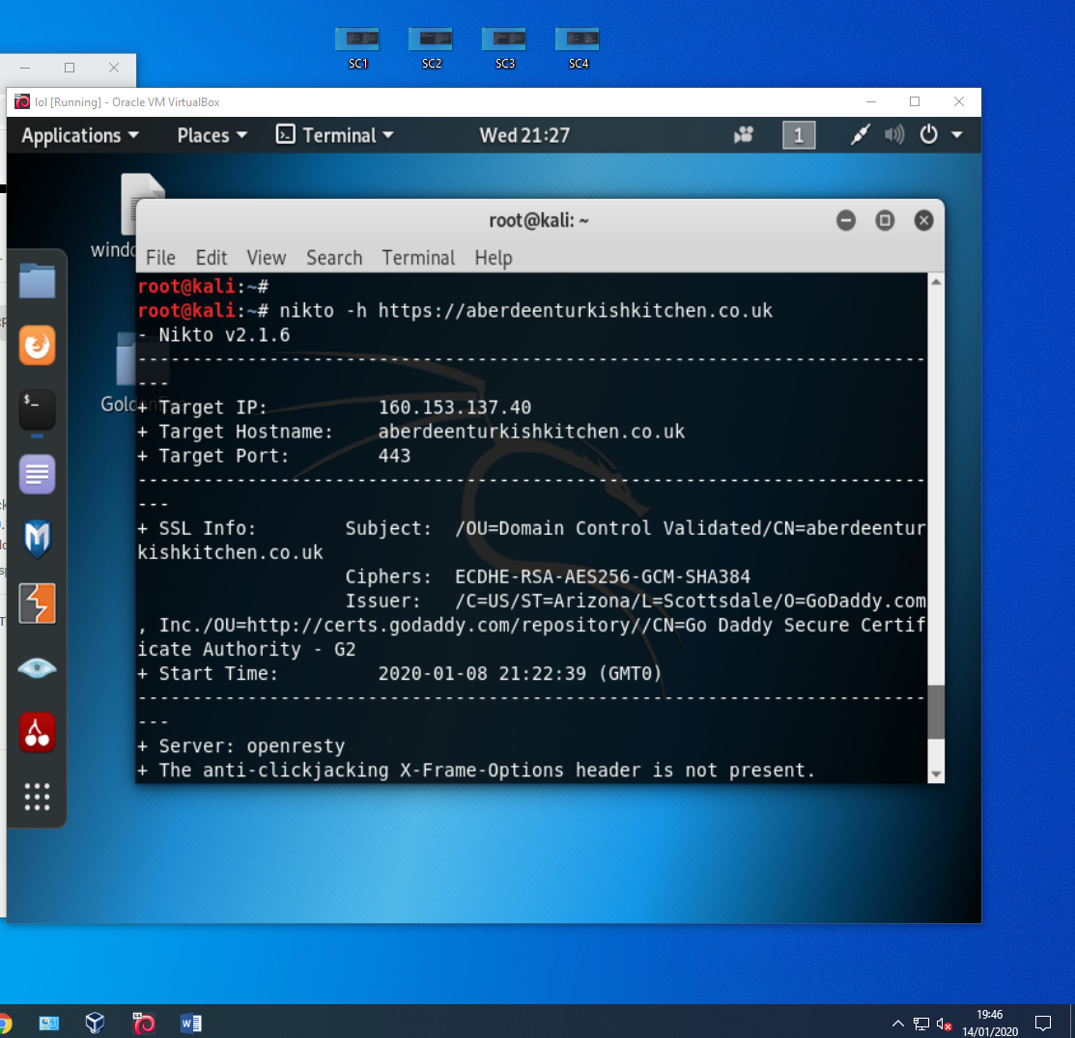
Figure 30 - Kali Nikto output
Above the author presents the reader with the illustration of a web vulnerability scan run by the software known as Nikto. The image displayed shows the first part of the output.

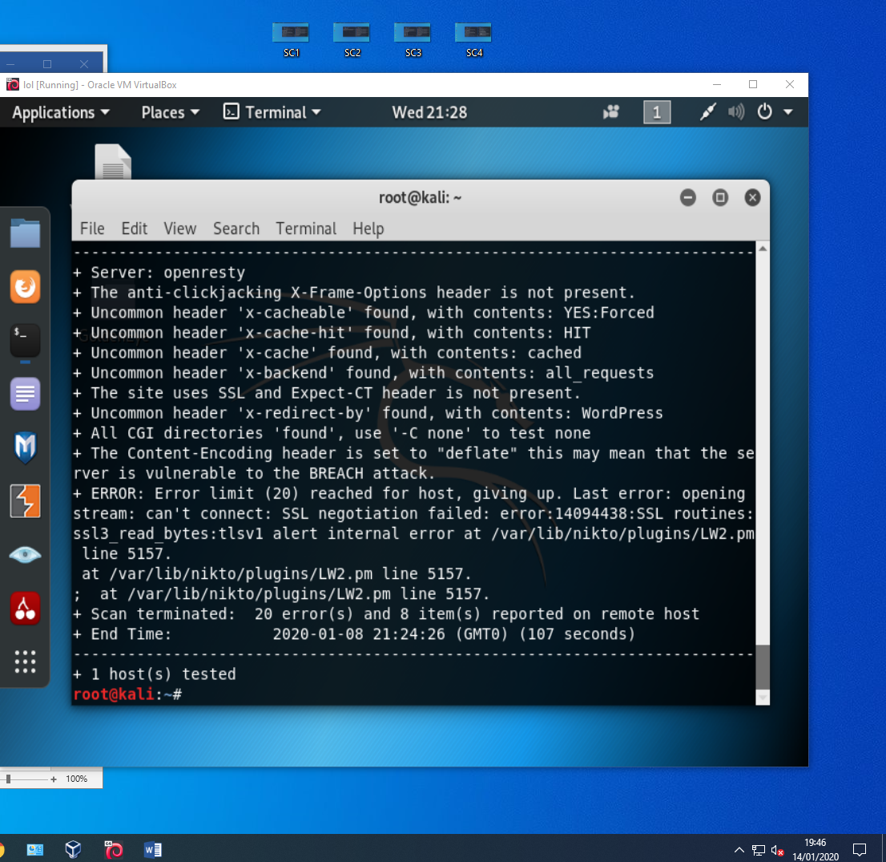
Figure 31 - Kali Nikto output II
The last section of the Nikto scan illustrates further web server information as seen from the screenshot. The anti-clickjacking header returned as not present, this means the website is at risk via clickjacking attacks. ‘x-cacheable found’ suggests that the server retains https responses which can be vulnerable to the website. Further ‘x-cache’ discoveries such retained cache could lead to web poisoning. ‘Expect-CT header is not presents’ is an additional web security feature which prevents the misuse of malicious certificates, as seen above, the header is not defined. ‘Content-Encoding header is et to deflate’ which may allow attackers to breach the web server, both implementations were able to discover identical results.

Red Hawk (Information gathering)
Raspberry Pi

Figure 32 - Red Hawk output
The implementation provided above presents the running scan of an information gathering tool which is capable of detecting a range of services such as server detection, cloud flare scanner, word press, port scanning, domain discovery, crawler and other network related services. The scan was able to pick up detection such as name servers and web server (GoDaddy).

Harvester – Raspberry Pi

Figure 33 - Harvester output
The screenshot above illustrates the program of gathering emails, domain information, hosts, banners and search parameters. It allows users to attain email accounts which can be used in a malicious way via phishing. The screenshot provided displays the scan results of the Harvester scan, within the output, the scanner was able to detect some Gmail accounts and several twitter accounts. This suggests the Raspberry Pi is capable of information gathering techniques as opposed to traditional methods.

WPScan – Raspberry Pi
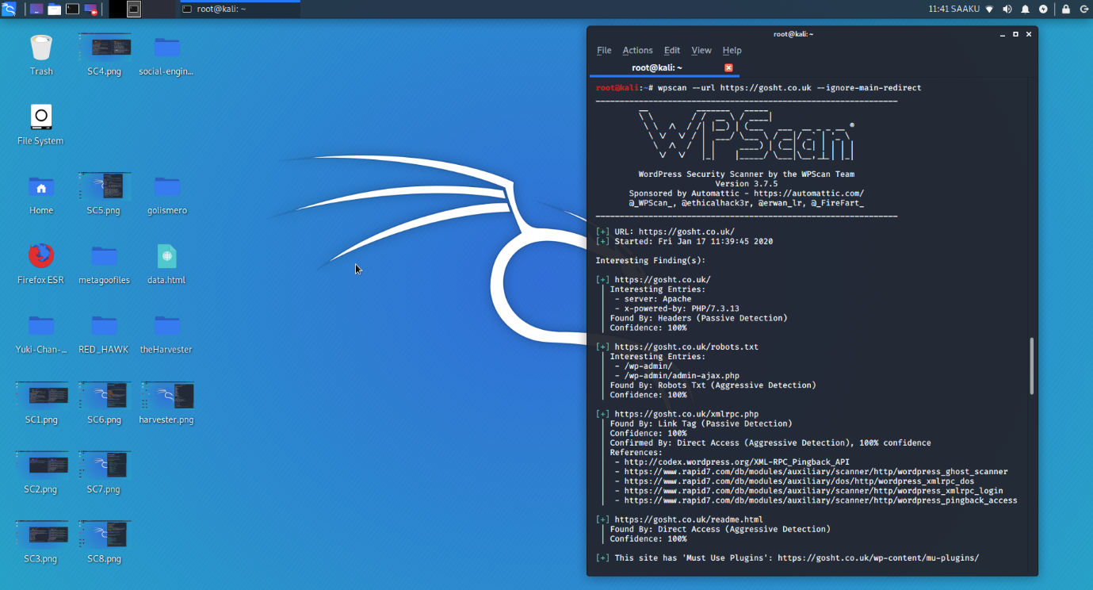
Figure 34 - WPScan ouput
The above screen displays the running scans of the WordPress vulnerability scanner which discovers remote installations to detect security problems. The output illustrates that a word press plugin is enabled on the website. The discovered results can mean the WordPress page is vulnerable to brute force attacks.

Evaluation
Upon completion of the implementation phase, the author displayed the running scans in relation to vulnerability assessments and provided a discussion based on the results. the primary hypothesis was to provide a comparative analysis between the two implementations, upon successful experiments, the author attains the appropriate results to present this information. The first experiment conducted was Nmap, from this implementation the author was able to gather information such as host discovery, open/closed ports, software and OS detection, hardware and operating system version, vulnerability and security weaknesses. Based on the results for the Raspberry pi, it retained the capability to discover these information as well as the desktop version.

The next experiment which the author conducted was the Nikto Web vulnerability scanner. The purpose of this test allowed the author to scan vulnerabilities within web servers, security implications such as configuration errors, can detect potential harmful CGI directories, web server version and other error related vulnerabilities. Both tests were able to discover the same vulnerabilities displayed in the implementation phase, therefore the Raspberry Pi becomes successful with this experiment. Other web vulnerability scanners such as Red Hawk was also able to discover web server information can lead to further exploitation based on the information received. Harvester implementation proved effective as it provided relevant information in relation to discovering email accounts via scanning web hosts. The output displayed various social media accounts and a few email accounts, this information gathered can lead to further phishing attacks which are more targeted.

The author provided another vulnerability analysis utilsing the software known as WPScan, this allows user to discover WordPress login pages, which in turns allows attackers to use brute force cracking upon the page to gain administrative access. Overall, the author implementation each experiment with the conclusion of success, although exploitation was not ethical for the project, the vulnerability analysis proved the success of the Raspberry Pi.

Future Work & Recommendations
Upon achieving the completion of the project, it is appropriate to notably mention potential insights into improvements and further work for the important factors of using a Raspberry Pi for scientific research. As the rise of the Internet of Things is evolving each day, Raspberry Pi falls into the category of an IoT device, therefore the improvement into inexpensive devices can prove to benefit potential experiments such as security testing, research purposes, programming and other technological related implementations. In this case, as a security testing purpose, the Raspberry Pi can be improved in various aspects such as higher operational power, faster and stronger processors, more available ports which can accommodate various types of input, more storage capacity and other improved hardware implementations. The suggestions mentioned allow testers themselves to perform penetration testing within corporations without the concern of hiring expensive professionals and the drawbacks of the Raspberry Pi. As well as the hardware future improvements, there is also the further work into a software distribution that can be established for systems, although this does take the concept of portability away from the concept, there can be a range of benefits that derive upon each system.
Conclusion
In conclusion, the author summarises the overall report by providing a detailed finalisation of the project including the aims, objectives, structure, research literature, planning/design, implementation and evaluation. The author set out a hypothesis to test and introduced the fundamental focal principle, which was to evaluate the effectiveness of the Raspberry Pi and provide a comparative analysis in relation to a conventional method of desktop usage. The testing method to gain appropriate comparative results was to run penetration testing experiments such as vulnerability assessments using the ethical hacking distribution of Kali Linux.

Upon defining a research hypothesis, the author set out an aim to follow, which in principle provides as essential guideline to reflect on as the author proceeds throughout the project. The aim of the project was to evaluate the effectiveness of the Raspberry Pi in conducting penetration testing to portrays the benefits of the portable device. The end results suggest that the author has met the aim of the project as the intended experiments were successful on the Raspberry Pi device. The research objectives were established for the purpose of creating a structural body of guidance to abide by. The objectives influence the aim of the project to the extent of achieving a positive outcome. In essence, the structural governance of the objectives was met as the primary objective to discuss the advantages of portability implementation was recognised. Penetration testing methods were well known as the distribution for the implementation was equivalent. The author met the objective to define the differences between portable penetration testing and conventional methods such as aspects of operational power, cost, graphical and audio capabilities, interface availability and operating system support. Finally, the author produced a distinction between the two testing methods to reach a conclusion of the evaluation of the effectiveness of the Raspberry Pi, which was mentioned in the Evaluation section of the report.

After defining the aim and objectives of the project, the author pursued the research literature and related work aspect of the hypothesis. The research literature revolved around the concept of relevant threats and attacks with the conclusion that appropriate security testing in relation to penetration testing needed to be thorough within corporations. It was essential for the author to justify the research literature to provide the reader with the overview of trending threats and attacks, upon this being established, the author conducted research into related work to gain the appropriate theoretical and scientific studies in relation to portable penetration testing. The purpose of conducting such research was to expand in the knowledge and understanding of the field of study and back up the research hypothesis. The research literature was defined to guide the project into the designated way. As well as strong research literature, it would render the author disordered without a methodology, therefore the author presented a professional body of research methodology to understand the approach methods to pursue. It is was developed within the report to justify each procedure in relation to introducing each chapter.

A primary segment of the project fell upon the ethical constituents; therefore, the author ensured the appropriate ethical permissions were completed. It was essential the ethical rights were taken into consideration due to the underlying implications that may fall upon the network intended to use. There were several policies which incorporated best practice to conduct an appropriate research project and additional ethical permission to conduct a safe practice ethical project. These ethical constituents were clearly defined and mentioned within the report.

After attaining the appropriate permissions, the author was able to conduct the intended implementations. Prior to the implementation phase, the author established a design section which illustrated the visual representation of the proposed experiments. This allowed the reader gain a pictorial overview of the planned implementation. The design aspect was justified by the author as the visual concept was developed. The problem formulation introduced and clarified to reflect the research hypothesis of the project. The design aspect was incorporated into the implementation phase which supported the reasoning for the production of the illustration provided. Following on from the design, the focal point of the project was the implementation. The author presented a thorough analysis of the experiments considering various of aspects such as installation, configuration, updating and utilisation. Each aspect of the implementation was explained in detail to develop a strong structure to analyse. The process to install and configure the Raspberry Pi was important due to main segment of using the device to conduct the testing. Overall, the running experiments were conducted successfully and documented appropriately to allow the reader to analyse each step of the process. The comparative analysis proved to accept the justification of the use of Raspberry Pi device to conduct penetration testing as a portable device.
Reflections
The author finalises the project by discussing the extent to how the research hypothesis was reached. Each criteria of principles will be mentioned to the scope of achievement and limitations, these aspects being aim, objectives, research hypothesis, research literature, research methodology, design and implementation. The aim of the project reflects the entire ensemble of the project as it provides a basis for what the author will intend to achieve. The author achieved the designated aim of the project as it conducted the implementation of a portable penetration testing framework which was the focal aim. The reader can analyse the documentation of the process and procedures which are mentioned within the implementation phases. The author clearly defined the experiential learning and determined the suitable best practices to conduct an experimental approach. Whilst the author outlined the objectives of the project, each criterion defined its aspect which was intended to complete. The author established clear refined objectives to the extent of managing a suitable project, the structure was followed in an effective manner which brought success to the development. The aims and objectives have contributed to the effectiveness of conducting a research hypothesis by stipulating a structure of an efficient guideline to follow.

The research literature aspect stipulated the rationale for conducting critical evaluation on theoretical studies relating to the area of knowledge for the project. The author provides a justification to the extent of refining the purpose of the research literature, the focal awareness of the knowledge area was shown within the research literature by providing rationale to the study. The literature expressed the appropriate exploration which the author intended. A sense of clarity was stated to a clear understanding which disregards any ambiguity; therefore, the reader is able to gain a distinction into the focus of the project, this finalised the foundation for a refined hypothesis. Due to the lack of extensive research within the area of portable penetration testing, the author discovered it was difficult to obtain many sources of content to support the thesis, however, the relevant material procured demonstrated sufficient to conduct the appropriate research hypothesis. To render the research question into designation, the author established a refined hypothesis due to the lack of sources available, therefore it was essential that the analysis retained a solid foundation and was interpreted with rationale. Overall, the author constructed a plausible research question to address and critically analysed to reach a conclusion of appropriate justification.

Upon defining the research question, the author introduced a detailed construction of a research methodology. The methodology was refined to the extent of the philosophical position is procured, this being the approach the dissertation acquired and why it what chosen. The author established an appropriate correlation between the research question and the methodology, this is because the research methodology will define the reasoning for the approach methods. The author founded a scientific study as it justified the appropriate purpose in relation to conducting a suitable research hypothesis. The philosophical stances were outlined to express the nature of the approach, which was Positivism, this position was appropriate as it allowed a simulated advance to a scenario. The deductive approach method allowed the author to justify the outcome of the project whether accepted or rejected. Research strategies were validated by stating the intending experimental approach which was befitting for the project. It was essential to explain the measurable approach intended to follow, a quantifiable variable was chosen as it suited the way the data would be measured and analysed. Research design required a defined time scaled environment, the author described the time scale measures as both cross-sectional and longitudinal, the reason for this was to test both measures with one accord time framework, some aspects of the implementation were quicker than other aspects which resulted in a prolonged comportment. The final criterion of the research methodology resides in data collection. The extraction methods for each aspect of the steps taken for collecting data have been stated within the methodology chapter. in relation to the research literature, the data obtained has been web based through professional libraries such as IEEE, Science Direct and many others. As for the implementation section, the author discussed the tools and software utilised, the origin of source has been expressed as well as the procedures for further installation and development. Overall, the author provided a systematic method of guidance to abide by which incorporated variations of strategies and procedures to fulfil the aim of the project.

In reflection to the design and implementation aspect of the project, the author ensured a suitable outline of a visual representation intended to create, this allowed the researcher to begin to develop various reasoning for implementation. The design section provided the reader with an illustration prior to the implementation phase. It was important to justify the design technique chosen, the author proved this by demonstrating each component within framework, therefore the design developed to justify the approach. The author provided specimens for the design diagrams to illustrate stages of the intended implementation. The limitations that can be discussed are the variations of design structures, meaning that as much as the author defined the approach taken, other design representations could have been displayed to illustrate other methods of development. Upon successful design strategies, the author proceeded to the implementation phase. The testing phase correlates with the design techniques mentioned prior to conducting any test. It was essential to validate the experiment procedures with expected results against actual results, which is a suitable acceptance for testing techniques. The author portrayed the outcome of the experiments within the implementation phases, which software and hardware tools were utilised for the development. The author mentioned each individual tool with the explanation of its purpose along with the procedures for construction. Overall, provided a justified evaluation to analysis the comparison between the Raspberry Pi and conventional method of desktop implementation, the results evaluated the effectiveness of the portable device to conduct penetration testing.

As well as the project delivering a positive outcome, there are a few limitations to mention, this would define the reasoning for the project not retaining further work such as research, design and implementation. One of the main limitations for the project was the use of a previous generation Raspberry Pi model and not a new developed model. Although the project was successful, the drawbacks of the proposed Raspberry Pi failed to retain up to date technical specifications as opposed to the new model, these are aspects such as operational power consumption, storage, speed and other hardware aspects. The reason is justified due to financial issues. In retrospect, the author shall improve this project by acquiring an updated Raspberry Pi model to achieve a higher level of experimental approaches. Overall, however the limitations appear, this can only improve in further development for research and testing purposes.

Project Management
The final section of the report presents the time management of the project and how it achieved accomplishment within the time framework. The author established this by creating a Gantt chart to illustrate each chapter within the report in accordance with the time scales. Below the author displays the visual representation of the Gantt chart which allows the reader to observe each section:


Figure 35 - Gantt Chart

7. Reference List

8. Bibliography

