THE GLOBAL BUSINESS ENVIRONMENT

Table of Contents
Introduction 2
a. 2
Major forces shaping the business environment of the car manufacturing industry 2
A critical assessment of the organisational and other changes that may take place in the future 8
Discussion of the reason for a drive toward the production of electric cars 8
b. 8
Identification of new and emerging business opportunities for the entrepreneurs 8
A critical assessment of other businesses currently linked to the global automotive industry 9
Conclusion 9
Reference List 11

Introduction
Electric mobility is becoming the main focus of global vehicle business in order to achieve electric mobility. Production of an electric vehicle is important as it reduces the chance of environmental degradation and reduced ecological damages improving public health. The present study has discussed the forces in the environment that influence the business of the car mechanized industry. The organizational changes that may take place in the future within this industry have also been discussed along with the reasons for producing electric cars. The aim of the study is to identify the national and international markets and other trends that are impacting on the business of Volvo Cars.

a.

Major forces through which car manufacturing industry environment is shaped
The major forces found in the environment of business that affect the car industry the most include demands of the customers, development of the industry and inputs, made by the government.
Consumer demand:
There are several forces that influence the considerations of the customers. These include the design of the cars, a brand of the car, the performance of the cars and others. However, there are three key motives that influence people to adopt electric cars such as Carbon footprint reduction which influence the environment concern buyers to purchase electric cars. For instance, it has been observed that about 29% of the customers from Norway purchase electric vehicles only because of its environmental effectiveness “(Amsterdam Round Table Foundation and McKinsey & Company, 2014)”. Electric vehicles have the permits of preferential parking even in urban areas with dense population. Therefore, the driving usage befits also influences the buyers to purchase electric vehicles. As the government provides subsidies for EVs it is sometimes cheaper than the ICE cars. Therefore, start saving opportunity is also a reason for purchasing EV.
Industry development:
There is an increased interest among the major Original Equipment Manufacturers (OEM) about introducing new models of EV cars. The number of new models of EVs is increasing day by day reports show that it has increased gradually since the year 2010. At the end of the year 2014, the introduction of 60 vehicles has taken place. This is due to the fact that the OEM industry is needed to constantly innovate their products making them more appropriate to the demands of the customers along with placing a competitive price for the product ranges.
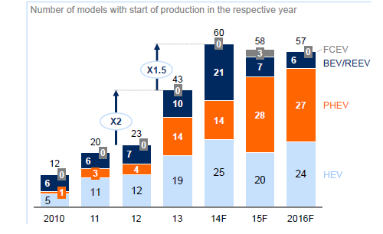
Figure: Number of EV model launches doubled in 2013
(Source: Influenced by “Amsterdam Round Table Foundation and McKinsey & Company, 2014)”
Inputs from the government:
It has been observed that the governmental bodies have taken the initiatives to promote the purchase of electric vehicles as those reduce the carbon emission. Therefore the reason for promoting electric vehicle use by the government is due to the reason of gaining a technological edge and gaining economic benefits. Government has also set targets for CO2 emissions which is enhanced by the promotion of the EVs.
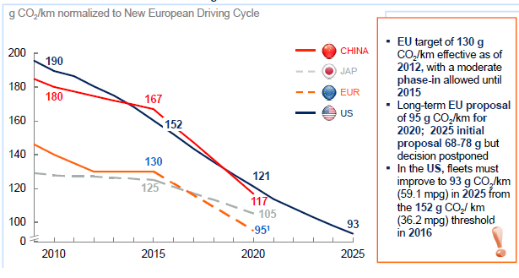
Figure 2: Planned emission standards in select regions
(Source: Influenced by “Amsterdam Round Table Foundation and McKinsey & Company, 2014)”
PESTLE:
The global automobile industry is a multi billion industry with a few huge brands seeking market share (Kushwaha and Sharma, 2016). The vehicle industry has been observed to affect the world economy significantly based on the income it has generated in nineteenth century (Biresselioglu et al., 2018). There is a money related emergency that has affected this section recently (Kushwaha and Sharma, 2016). Be that as it may, since the global downturn has passed, the offers of automotives are again in the groove again. It has been observed that there is a lack of governmental support upon the release of electric vehicles. The global and fiscal legislations are also found to be unsupportive of the electric vehicle launch. It has been recently observed that the public policies that are funded have increased the adoption rate of electric vehicles. Europe is as place for large number of huge sized industry. Therefore, the country’s income is influenced by these factors.
Political:
The ease of doing business in Europe is a positive sign for the manufacturers of Electric vehicles. There is a high unity among the states of Europe. The joint venture of the Europian states has increased the collaboration about a new product launch. Political variables assume a significant job and directly affect the benefit of the car industry (Biresselioglu et al., 2018). It has been observed that low discharged vehicles are mostly supported by the government. The Government is also conscious about launching fuel guzzlers (Kushwaha and Sharma, 2016). The markets like EU and UK are giving government appropriation to the low outflow vehicles. Condition neighborly vehicles have become sought after globally.
Economic:
A specific significance is also needed to be provided to the economic forces when it comes to car industry (Biresselioglu et al., 2018). Due to the bad condition of the economy of Europe the vehicle offers ahave been observed to fall down. There is an increased interest for costly vehicles that could also contribute to overcome the poor economic conditions of the country. (Kushwaha and Sharma, 2016). Also, the expenses on the costly vehicles are high in a few markets.The European asset under management is $18.8 trillion making it the largest economy of the globe (worldbank.org, 2019).European countries are ranked as the top five GDPs in the world which indicates that the economy is supportive of the businesses. The employment rate of a European country has resulted high in the year 2018 that resulted in 73.2 % (europa.eu, 2019).
Social:
The European population is increasingly aware of the environment.The affordability is high due to the supportive economic condition of the country. The automotive industry has also been observed to be influenced by the socio-logical patterns on individual inclinations (Biresselioglu et al., 2018). Vehicle creators need to embrace to these powers. Consistently new models are discharged remembering individuals' inclinations. In addition to this, it has been observed that specific societies favour explicit styles (Kushwaha and Sharma, 2016). In certain markets while the SUVs may be more sought after, in the others the cars may be liked. Environmental awareness has increased the purchase of Electric vehicles.
Technological:
There is a rapid urban growth observed in the European countries. Technological improvement and implications have resulted in mass employment contributing to business by increasing availability of cheaper workforce. Technology and development have become significant determinants of market share in the car industry. The more creative the organization, the higher is its market share. All the significant car manufacturers showed interest in innovation of their products and to overcome the flaws. Brands like Toyota, Hyundai and Portage are putting resources into low outflow and condition inviting vehicles (Biresselioglu et al., 2018). Toyota is in any event, has intended to release driverless vehicle in the near future (Kushwaha and Sharma, 2016). Not simply this, the major mechanical players are attempting to enter this part of the industry.
Legal:
Law is another significant factor that gets the opportunity to influence the gainfulness and execution of the vehicle brands. It is very important for the companies to comply with the laws and regulations which are mostly concerned with quality and security of the vehicles. There is an existence of strict competition law in Europe which is also needed to be considered. The vehicles that are being sent out abroad need to pass severe discharge controls. Next are the laws identified with item wellbeing that importantly affects the offers of the vehicles (Biresselioglu et al., 2018). It has been identified that Toyota needs to review its vehicles in order to modify its disputed airbags. There have been comparative cases in the past putting traveler wellbeing under question. These are the reasons based on which the vehicle manufacturers of Europe need to comply with the government law concerned with the security of public. Businesses operating in Europe are needed to comply with anti-discrimination law, social laws and rules for the transport sector (europa.eu, 2019).
Environmental:
The CSR rules are also to be maintained in order to keep the business-standard.
Analysis:
It can be stated that the aim of the Volvo card for launching electric vehicles from the year 2019 may be achieved due to the ease of conducting business in Europe may make it possible for procuring materials and build a strong supply chain. As influenced by the views of Sharma and Aggarwal (2019), high unity among the states of Europe indicates that collaboration between these states may lead to harmonious business. High GDP rate and Mass employment opportunity have been identified which may contribute to employ a cheaper workforce reducing the operation cost. The technological improvement also indicates that the business of Volvo Cars may perform effectively by increasing its production and profitability. Rapid urban growth has increased the ease of purchasing cars which may influence the customers to purchase EV in spite of its costly nature. Along with this, Volvo cars need to comply with the laws related to business along with effective corporate social responsibilities in order to lead the business in a standard position.
Porter’s Diamond and Competitive advantage:
The diamond model provided by Porter can be used in this section in order to understand the competitive stand of the organization in the European environment.
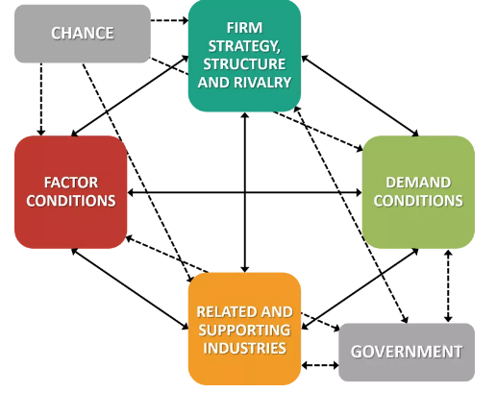
Figure 3: Porter’s Diamond Model
(Source: Influenced by Sharma and Aggarwal, 2019)
The firm’s strategy to manage the domestic rivalry is an influence in the field of competitive advantage of the industry itself. Domestic rivalry increases international competitiveness. As influenced by “Amsterdam Round Table Foundation and McKinsey & Company (2014)”, there is a very high amount of domestic rivalry among the car manufactures amongst the European countries.
It has been predicted by Kushwaha and Sharma (2016), by the year 2030, electric power trains are about to play major roles in Europe and the globe as well.
As indicated by Zhou et al. (2015), in order to become more competitive in the European market Volvo car needs to develop some factors unique to them.
It is also required to assess the demand conditions and it has been observed that the European buyers are tending to purchase EVs more.
As there is a harmonious relationship between the European states it can be stated that help from supporting industries to procuring advanced quality raw materials would be easier.
Government is also supportive of the launch of electric vehicles that can be beneficial for gaining competitive advantage.
Lastly, chances such as random events may lead the organization to gain competitive advantage.
Value Network:
A value network is created between the customers, suppliers and the organizations in order to maintain harmonious relationship between the stakeholders for ensuring productivity and effectiveness of the business. As influenced by Biresselioglu et al. (2018), it can be stated that these value network can be created by Volvo cars by providing effective services to its customers. Suppliers are also needed to be provided with the ease of doing business with the organization to maintain this relationship.
Five Forces:
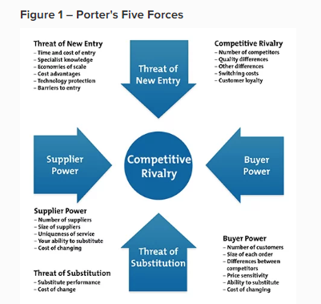
Figure 4: Porter’s five forces
(Source: Simon et al. 2015)
Volvo Cars is trying to introduce a new range of product to the market which can become profitable if it can set a competitive price for the products as there is a tendency of large OEMs to produce new models. Supplier power tends to be high in the market as there is a large number of companies procuring materials from a different organization. Buyer’s power is also high in this context as they have a high range of options available to them for purchasing. The threat of substitution can be overcome by incorporating innovation in production and marketing as well. The threat of New entrants also may hamper the business of Volvo Cars as there is a high demand for EVs in the market.

Possible organizational changes
It is evident that ICE vehicles are playing a dominant role in the European car industry though it is required to focus on the increasing demand for the EVs. Therefore, as stated by Narins (2017), organizations need to reduce their production of ICE and start to increase the production of EVs. As argued by Dokic et al. (2015), both the ICE and EVs production is required to be high in an amount in order to meet the demands of all types of customers.
Volvo Cars also need to produce Fuel Cell Electric Vehicles in order to gain competitive advantages. It is required by the organizations to employ qualified candidates or engineers for implementing innovation to car production. As influenced by Ellingsen et al. (2016), it is also required for the organization to integrate the distributed generation and manage the demand of the customers by providing them with personalised car services. In order to gain competitive advantages, this organization needs to conduct market research in the relevant field.

Discussion of the reason for a drive toward the production of electric cars
There are several reasons behind the drive towards the production of electric cars.
Electric cars are cheaper than the other types of cars as it takes electricity to charge a car which lasts longer and works around three times higher than the fuel cars.
These cars are also cheaper to maintain as there is a lack of moving parts which reduces the requirements of car servicing. Along with this, there is no need for an exhaust system making it cheaper.
Harmful air pollution can be reduced by increasing the use of the EVs as it has a zero exhaust emission.

b.

Identification of new business opportunities for the entrepreneurs
- The availability of EV chargers provides the opportunity for increased mobility connectivity. This helps to increase the sales of EVs rising in emerging markets. It is expected that that charging stations would increase in 12.7 million by 2020 (Dijk et al. 2016).
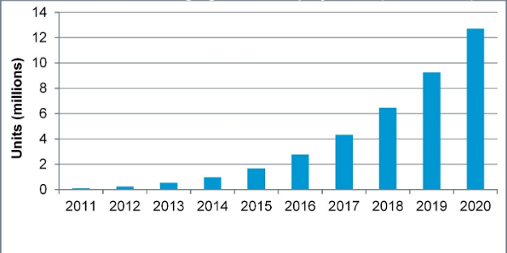
Figure 5: Global Cumulative charging station deployments
(Source: Influenced by Dijk et al. 2016)
There is also a wide opportunity for the entrepreneurs and the business executives to partner with the EV charging stations in order to provide the customers with wide opportunity to charge their car without any hassle making it more convenient for the buyers.
The entrepreneurs can adopt proper disposal strategy for the batteries used in the electric vehicles making it more effective environmentally. It directly satisfies the need of the customers for environmental protection.

A critical assessment of other businesses currently linked to the global automotive industry
Vehicle manufacturers in Europe need to be prepared for the disruptions at doing business in this specific industry. It has been observed that there is a falling demand for traditional cars such as Nissan and Honda (bbc.com, 2019). As the economy is slowing down it has become impossible for gaining profit from investing these businesses. As argued by Simon et al. (2015), there is increased use of fuel cars emission issues are currently increasing the threat for lowering down the sales of diesel cars. Along with this, the taxation charges are high for fuel cars which lead to decreased profit. Increasing demand for environmentally effective cars such as electric vehicles are also creating a challenge for the other businesses in performing effectively in the market.

Conclusion
It can be concluded from the study that Volvo Cars has an opportunity of introducing Electric vehicles successfully in the European market though some areas of concern are to be understood by the organization. Competitive pricing for producing electric cars is required for increasing sales. The present trend of purchasing electric cars resulted from its cost-effectiveness and environmental performance making it more convenient to business for the entrepreneurs and the business executives. As the cheaper workforce is available with a highly advanced technological ground it will create an opportunity to gain success from the new idea implementation of producing. The stand of the national and international market of electric cars has also been analysed to understand the competitive stand of this industry in a global environment. As domestic and international competition is high for electric cars it would provide a wide opportunity for Volvo Cars to produce cars according to the demands of the customers.

Reference List
Amsterdam Round Table Foundation and McKinsey & Company, (2014). Electric Vehicles in Europe: Gearing Up for a New Phase?.
bbc.com, (2019), Five reasons the car industry is struggling. Available at: https://www.bbc.com/news/business-48545733 [Accessed on: 17th November 2019]
Biresselioglu, M.E., Kaplan, M.D. and Yilmaz, B.K., (2018). Electric mobility in Europe: A comprehensive review of motivators and barriers in decision making processes. Transportation Research Part A: Policy and Practice, 109(8), pp.1-13.
Dijk, M., Wells, P. and Kemp, R., (2016). Will the momentum of the electric car last? Testing an hypothesis on disruptive innovation. Technological Forecasting and Social Change, 105, pp.77-88.
Dokic, J., Müller, B. and Meyer, G., (2015). European roadmap smart systems for automated driving. European Technology Platform on Smart Systems Integration, p.39.
Ellingsen, L.A.W., Singh, B. and Strømman, A.H., (2016). The size and range effect: lifecycle greenhouse gas emissions of electric vehicles. Environmental Research Letters, 11(5), p.054010.
europa.eu, (2019), Employment rates and Europe 2020 national targets. Available at: https://ec.europa.eu/eurostat/statistics-explained/index.php/Employment_rates_and_Europe_2020_national_targets [Accessed on: 17th November 2019]
europa.eu, (2019), European and International Business Law. Available at: https://ec.europa.eu/ploteus/en/content/european-and-international-business-law [Accessed on: 17th November 2019]
Kushwaha, G.S. and Sharma, N.K., (2016). Green initiatives: a step towards sustainable development and firm's performance in the automobile industry. Journal of cleaner production, 121, pp.116-129.
Narins, T.P., (2017). The battery business: Lithium availability and the growth of the global electric car industry. The Extractive Industries and Society, 4(2), pp.321-328.
Sharma, S.A. and Aggarwal, A., (2019). Aspects of marketing strategy impacting the commercial vehicle industry–A critical review of literature.
Simon, B., Ziemann, S. and Weil, M., (2015). Potential metal requirement of active materials in lithium-ion battery cells of electric vehicles and its impact on reserves: Focus on Europe. Resources, Conservation and Recycling, 104(1), pp.300-310.
worldbank.org, (2019), GDP growth (annual %) - European Union. Available at: https://data.worldbank.org/indicator/NY.GDP.MKTP.KD.ZG?locations=EU [Accessed on: 17th November 2019]
Zhou, Y., Wang, M., Hao, H., Johnson, L. and Wang, H., (2015). Plug-in electric vehicle market penetration and incentives: a global review. Mitigation and Adaptation Strategies for Global Change, 20(5), pp.777-795.

