How to use the Academic & Employability skills to develop you career

Prepared by
Marius-Catalin Bobitiu
BSc Cloud Computing
University Of Wales Trinity Saint David

Table of Contents

Introduction 3
A. Self-evaluation 3
B. Behaviour 3
C. Making a presentation 3
D. Talking in public 3
E. Conclusion 3
I. Skills Evaluation 7
1. Different types of skills 7
Communication skills 7
Time management skills 7
Team working skills 8
Creative thinking skills 9
Problem-solving and decision-making skills 9
Personal skills 10
2. Self-evaluation 10
Leadership and Management 10
Problem Solving and Decision Making 10
Communication Skills 11
Time Management 11
Personal Mastery 11
II. Goals and Action plans 11
III. Application 13
1. Data protection 13
2. Time management and organisation 13
IV. Summary 14
V. Appendices 14
References: 14
Bibliography: 14

Introduction

Who am I?
Well, my name is Marius-Catalin Bobitiu, I am coming from a small city called Constanta, it is in Romania, it is situated on the south east side, near the sea. It’s a great city, but here we are not talking about the city, we are talking about me. I know that sound so selfish, but I can assure I am not a selfish person, but I am stubborn, and that is pretty bad, in my opinion.

Something about me
I was raised in that small beautiful city for 19 years, then I moved in Uk for a better education. I finished high school, got my degree and then I came here to learn more about my passion, computers. I choose the Cloud Computing, because my passion is computers, and I want to learn more about them. When I got in the University and started learning the courses, I found the Academic & Employability skills and it really got my interest, even though it is not about computers.
Here I learned a lot of things about the career, and about the personal development. The first thing we did was a PowerPoint presentation about ourselves. So, in the PowerPoint presentation I learned this:

Self-evaluation

Behaviour

Making a presentation

Talking in public

Conclusion

- Self-evaluation
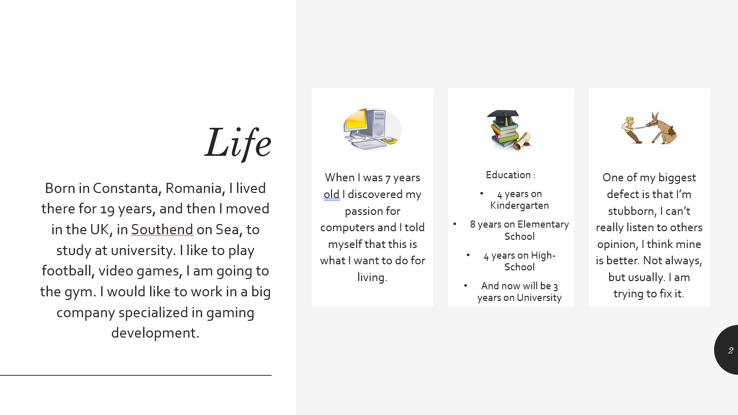
In this topic we learned how to auto evaluate ourselves, I learned to see the good parts that represents me, but we also learned about the bad parts. Having bad parts if part of human being, every human has at least one thing that is bad for him, even I have. I am stubborn and I know that, but I am assuming the fact, and I face it. Sometimes I use it as a “weapon” to reach my goals.
Fig.1
- Behaviour
Now in this topic we learn how important is the body language in making a good presentation. The way we behave can turn a good presentation into a bad one, or vice versa. So, we learned how you can have a very good presentation, even if you have only 3 or 4 slides, the way you behave will may be all for your advantage. Human behave is very important in generally, mostly when you make a presentation.
Prabhu [1] states that “The better the behaviour, the higher the chances of being admired and worse the behaviour, higher the chances of being chastised.” We can learn a lot from that.

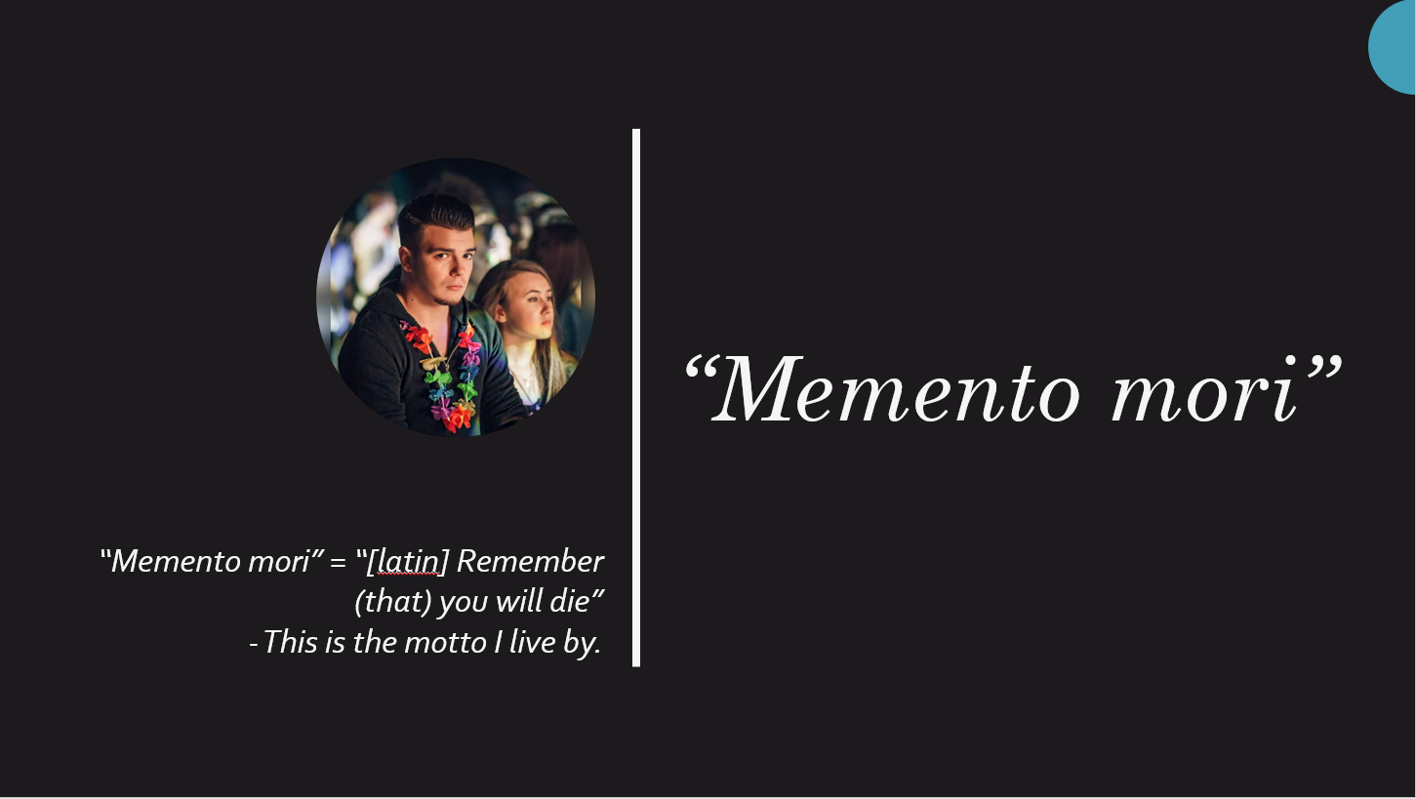
Fig. 2
- Making a presentation
We learned how to use the behaviour in our advantage, but we still need a good presentation. So, another thing that we learned is how to make a good presentation. Making a presentation takes time, you need to work, need to see what you can do, what makes it special, why do you think is important your presentation, all this stuff.
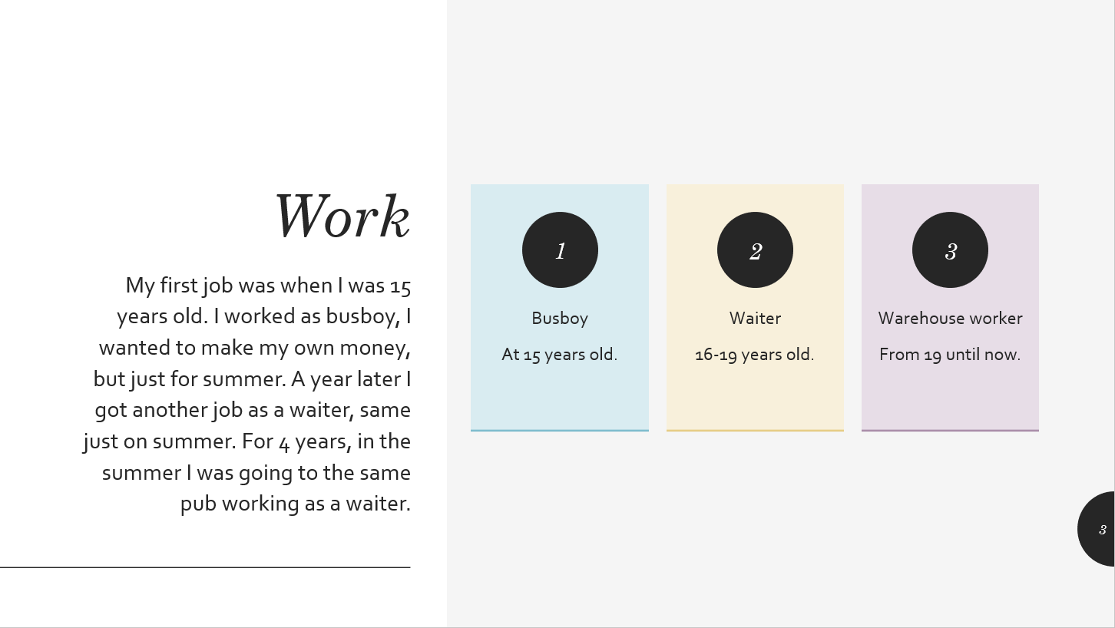
Fig. 3

- Public speaking
Now we are talking about the fact that you have to present it in front of other people, and one of the problems that a lot of people have, is the public speaking. It is difficult to speak in public, as Dawson [2] states that “public speaking can create a strong flight, fight or freeze response in us”. So, we need to fight that. Okay, but how?
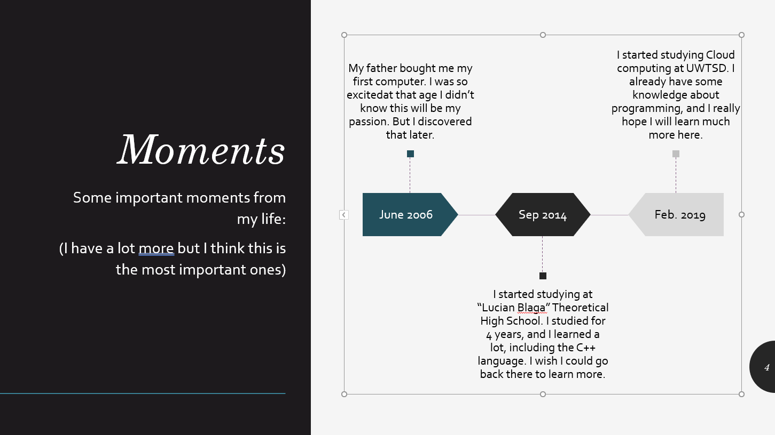
Well, in this course we learned how to fight the public speaking problems, all you need is to be confident in your presentation, and to exercise, like we did.
Fig.3

- Conclusion
The last thing we learned about the presentation, but not less important, is that we learn how to end a presentation. When you want to end the presentation, you should summarize the content, to give focus on the key points, and to see if the audience has any questions about the presentation, so we can solve the misunderstandings and curiosities.

Skills Evaluation

Different types of skills

What is a skill?
According to Wikipedia [3], a skill is “the ability to carry out a task with determined results often within a given amount of time, energy, or both.” So, basically, a skill is an ability to do something well.

What skills do we need?

Well, it depends of what type of skill do you want to acquire. Here are some high education learning skills:

- Communication skills
- Time management skills
- Team working skills
- Creative thinking

And here are some employability skills:

- Communication skills
- Team working skills
- Problem solving and decision-making skills
- Personal skills

As you can see, 2 of them are common in both skills. Because we need a lot of skills to get a better education, a better job. We need to develop our skills.

Communication skills

It is a very important skill, and it is fundamental for students or employees. The only way we can understand each other is communication, you need to know how to speak, how to listen, when to speak and when to listen. You need to know how to communicate with another person, to understand him, and to make you understood.

Time management skills

Another important skill that we need is the time management. You really need to know how to plan your activities, and how to organize your day. It is very important to have a specified plan about your activities and it is also important to prioritize them.
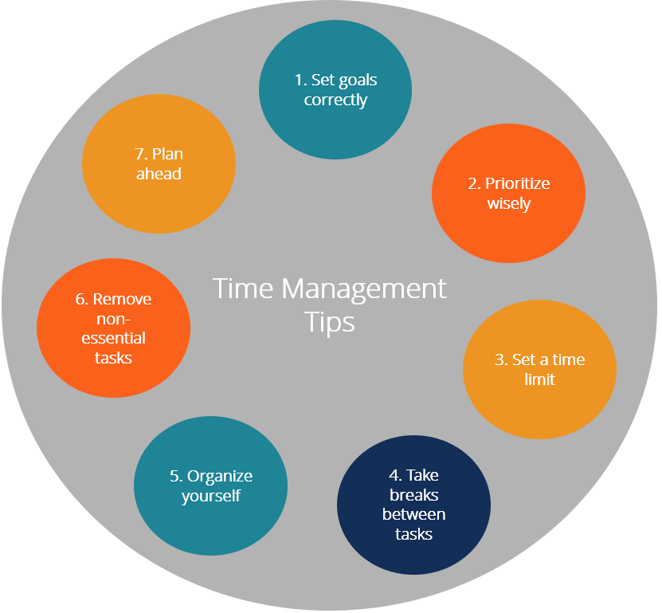
In my opinion, it is a very good thing to have a specified plan for every activity, like that u are sure that u will not miss something, or forget about something, and it is good to have a time limit for each activity, so you will know exactly when you can stop for a lunch for example. You need to take a break between every task, like that you will be more relaxed, because you will not have to run from a task to another, you have a short break before you will go for the next task .
Fig.4

Team working skills

This skill requires multiple skills, like communication, respectfulness, collaboration, reliability. So, it’s a complex skill we can say, but it’s easy to develop it, by working together with another people. In this Academic & Employability skills course, I learned how to work with people, how to develop my teamwork skill. During the first term, we had a lot of practise exercises where we had to work in groups. By doing this, we developed our teamworking skill, without any hard work or something, just talking to each other, listening other people ideas, putting them together and that’s it.
It is quite easy to develop your teamworking skill, just do some group projects, or some group exercises, and you will gain a good experience. You don’t need to be in school to develop your skills, just pick up some friends, a subject and try to work together on that subject. It is a good way!

Fig.5

Creative thinking skills

Basically, a good definition of this skill would be “thinking outside of the box”. Not all the people can have this skill, some of them would have it native, some will have to work hard to gain it. But it is very good to have it, as you can use it anytime. Being creative means being open-minded, giving new ways to a solution, maybe better ways. Every kid has this skill, because their mind is not busy by anything, so they can just use their imagination, but if you grow up, and don’t use this skill, you may lose it. It’s a good thing to keep thinking like a child, but not all the time.

Problem-solving and decision-making skills

These 2 skills are working the best together, you need to have the ability to handle difficult situation, but also you need to take a decision about what would be the best solution for it. So, they are like 2 in 1. I learned about this skill in the course, and it helped me so much, by making me think more about a solution, before taking the decision. Because there are many solutions, but you need to pick the best one, not the first one that comes in your head.

Personal skills

The last skill you need, is this one, you need to have this type of skill as it includes a lot of skills, including one of them that we mentioned before. It’s like your personal book of skills. You need to have this to see which skills you have, which one is the best one you got, how can you use them to develop yourself.

Self-evaluation

I took the Mind Tools – Test your skills questionnaire, where you have to answer 15 statements by giving an honest opinion about your abilities. This test aims to check your skills, discover what we are good at, it will help us to know what skills we need to develop. When you finish the test, it will give you a total based on our answer and some information about our answers.
Here are my results:
I’ve had a total of 42.

Leadership and Management
(Questions 5, 7, 12)
Your score is 8 out of 15
Whether you're in a formal leadership position or not, you need good leadership and management skills if you're going to make best use of the opportunities open to you. (After all, you can get much, much more done when you have the help of other people.) The good news is that you can learn how to lead and manage effectively!

Problem Solving and Decision Making
(Questions 2, 10, 14)
Your score is 8 out of 15
Problem solving and decision making are two areas where you'll need to excel to be a success in your career. (Together with people skills, they're what make up "good judgment" and "wisdom.") Like leadership and management, these two areas are closely related.

Communication Skills
(Questions 9, 11, 13)
Your score is 7 out of 15
The ability to communicate clearly is key to your success, whatever role you're in.
If you want to improve your communication skills, start by taking our communication skills quiz. Also, make sure that you know how to plan your communications effectively.
Active listening is a very important communication skill. This is when you focus on the other person, and you make sure that you understand exactly what he or she is trying to say. Conflict resolution and negotiation are other areas that you'll need to work on to be a great communicator.

Time Management
(Questions 1, 4, 6, 15)
Your score is 13 out of 20
Time management is one of the most important career skills areas. Not only does it help you to be more productive; you'll also be much less stressed!
It's also important that you avoid procrastination - this is when you put off tasks and activities that you should be focusing on right now.

Personal Mastery
(Questions 3, 8)
Your score is 6 out of 10
When you know how to "lead yourself" and make good choices for your future, you'll be that much further ahead when it comes to the other skills areas that we've already looked at.

Goals and Action plans

So, I identified what skills do I have, now I need to know how to improve them. For this, I need a plan to let me develop them in the next few years of my studies. I have here a table with my short-term and long-term plan:

 | Short-term plan | Long-term plan
My goals | - Learning a programming language  - Improve my personal skills  - Finish the cloud computing course  - Attend to a master course | - Career in gaming development  - Developing my own game  - Working in a big gaming industry
My skills | - Improve my personal skill  - Work in more group projects to develop my team-working skill  - Work under pressure to make sure I can develop my critical thinking skill | - Try to be more productive  - Read more books  - Improve my language so I can communicate better  - Try to make a big project by my own

In order to reach my goals, I need also to improve my skills. I can use the tips from the Mind Tools questionnaire, but I think it would be better if I can make my own system. So here it is:
Communication skills:
- Improve my language by reading books, also trying to speak with people more often in English to gain more experience.
- Listening to people to increase my active listening, and also my English.
- Watching movies with English subtitles.
Time management skills:
- Making a schedule for every week.
- Prioritize the task in the schedule by their importance
Creative thinking skills:
- Trying to take risks to see if another option is good.
- Look for a different solution for a problem, not just for the first that came to my mind.
Team-working skills:
- Participate to group projects.
- Paying more attention at work, because it is a very good place where you can develop your team-work skill.

Application

Data protection

A good thing that we learned in the Academic & Employability skills module is that we need to have a back-up of our data every time. My strategy is like this, I have the data in my computer’s hard drive. I have them in the cloud, and also in the portable SSD. So, I have my data in 3 places, one of them being online, so if both, the hard drive from the computer, and the portable SSD break, I am still able to find my data in the cloud.
Some disaster scenarios:
- Let’s say someone breaks into my cloud and deletes everything. I still have the data in my hard-drive and portable SSD.I can just reupload everything on cloud and change my password.
- Someone hacked my computer and deleted everything from my hard disk. I have the portable SSD and the cloud also. So, I can just copy the data on the hard drive.
- I dropped my portable SSD and now I cannot use it. I just go to the service, to make a copy of the data from the chip and everything will be all right. Also, I have the hard disk and cloud data. So I don’t lose anything.

Time management and organisation

So, I need to increase my productivity and reduce the stress I accumulate at work and university. For this I make some things to follow:
- Make a schedule for every week
- Prioritizing the tasks that I made in the schedule.
- Breaking the big task into small one.
- Taking breaks between every task

Summary

I will try to use the thing I learned in the Academic & Employability skills module about the conclusion. In this report I learned about what is a skill, how many types of skill exists, how to develop them, and how to use them in my studies and work. To develop a skill requires a lot of work and time, but it comes with a lot of advantages. In this module I learned how to make my personal development plan.

Appendices

References:

[1] Prabhu, A. (2016). Public relations is about Behaviour. Retrieved May 2019, from www.reputationtoday.in:
http://reputationtoday.in/taking-pride/public-relations-is-about-behaviour/
[2] Dawson, J. (2017). Why is public speaking so difficult? Retrieved May 2019, from www.quora.com:
https://www.quora.com/Why-is-public-speaking-so-difficult
[3] Wikipedia (2019). Skill. Retrieved May 2019, from en.wikipedia.com:
https://en.wikipedia.org/wiki/Skill

Bibliography:

Dawson, J. (2017). Why is public speaking so difficult? Retrieved May 2019, from www.quora.com:
https://www.quora.com/Why-is-public-speaking-so-difficult
Doyle, A. (2019) Important Teamwork Skills That Employers Value. Retrieved May 2019, from www.thebalancecareers.com:
https://www.thebalancecareers.com/list-of-teamwork-skills-2063773
Mind Tools LTD. (2015). Retrieved May 2019, from www.mindtools.com:
https://www.mindtools.com/pages/article/get-started.htm
Prabhu, A. (2016). Public relations is about Behaviour. Retrieved May 2019, from www.reputationtoday.in:
http://reputationtoday.in/taking-pride/public-relations-is-about-behaviour/
Skills You Need (2017). Employability skills: The Skills You Need to Get a Job. Retrieved May 2019, from www.skillsyouneed.com:
https://www.skillsyouneed.com/general/employability-skills.html
Wikipedia (2019). Skill. Retrieved May 2019, from en.wikipedia.com:
https://en.wikipedia.org/wiki/Skill

