Socket Programming and Concurrency

Assignment 1

BSc Applied Computing

Nathan Williams

250717

Contents
Design Statement 3
Purpose 3
Audience 3
Intended Audience 3
Usability/ Accessibility 3
Intended Functionality 3
Justified Choice of Technologies and Framework 4
Application Logic Planning 8
Data Requirements 10
Application flow and layout design 11
Test Programme 13
Bibliography 15

Design Statement

Purpose
The app that is being made is a gym chat application for a local gym, the purpose of the chat app is to allow the different groups within the gym communicate about class information and possibly how the workout is going. This will then allow the different classes to be able to communicate and share information and techniques that could be used to further everyone’s training.

Audience
The audience for this app is members of the gym, this will allow each member to be able to join a group and will then be able to communicate with the different people within the group. This may then be used by the gym staff to ask for general improvements or new things that can be added to the gym such as equipment and possible new cleaning services such as disinfectant wipes and disinfectant sprays that can be used to wipe and clean equipment after use.

Intended Audience
The intended audience for this application is the different members and demographics that go to the gym, this can range to younger member and even older members that may go on the chat. This them means that the application will attempted to be catered for a wide range of users, this will be done via a simple interface and easy to use buttons and other features.

Usability/ Accessibility
This application will attempt to cater for most ages that will go to the gym and will attempt to make each features as simple as possible for the member to use, the main feature of the application are the rooms which will allow the user to be able to switch to their favourite section of the gym and gain knowledge and ask questions about that area. This will be achieved via a simple drop-down box which will enable the user to simple select a room and join with their created username.

Intended Functionality
This will be created for a gym so multiple users will need to be able to access the chat at one time, as well rooms will be added so that the users can access the area that they would like to access. as well since this is a chat application the users will be able to talk to each other and send messages to and from each other.

Justified Choice of Technologies and Framework
Node.js vs asp.net
The first tool to be discussed is Node.js code academy.com states that “Node.js is an event-driven JavaScript runtime. Node has myriad potential uses for JavaScript development including being a great environment for building efficient network applications.” (1) Node.js is simply the runtime that the project will be ran through, this will then allow each of the parts of the projects to be started here. One example if this maybe when the server is started as then user writes node server.js to run the JavaScript to start the server. Another source from netguru.com states that “Node.js is very efficient with real-time applications: it facilitates handling multiple client requests, enables sharing and reusing packages of library code, and the data sync between the client and server happens very fast.” (2) This then suggests that node.js is very good for real time application which will be very good for whatever application is made, it also states that node.js can handle multiple client requests, which is also very good as most apps that could be created will require multiple client requests from the users to the server. As well as this the data sync between the client and the server happens very quickly which is very good as the users and the server should always be able to communicate quickly.
Another technology is asp.net dotnet.microsoft.com states that “ASP.NET extends .NET, you can use the large ecosystem of packages and libraries available to all .NET developers. You can also author your own libraries that are shared between any applications written on the .NET platform.” (3) This then suggests that ASP.NET extends the .NET framework and adds more packages and libraries that the developer can then use. There are many advantages of using ASP.NET the first being that ASP.NET supports cross platforms which is very good of the gym will want to put the chat on multiple devices which would then allow them to be able to reach more users and have more users chatting. As well as this there is lesser code for this language which is good as it will allow the developers to make the program smaller which will allow it to load quicker.
Based on the advantages of node.js this has been chosen to create the chat application, this is firstly because this is very good for creating real time applications in which this chat app will be, as well as this node.js can also handle multiple client requests which it will need to be able to do for the chat application.
Socket.io vs web sockets
The next tool to be discussed is socket.io socket.io.com states that “Socket.IO is a library that enables real-time, bidirectional and event-based communication between the browser and the server. It consists of a Node.js server and a JavaScript client library for the browser (which can be also run from Node.js” (4) this then suggests that socket io is the framework that allows for communication between a browser and a server. There are many advantages to using Socket io the first of which is that it is real time, this is very good for the chat application as the user would most likely want to receive the message immediately, also this also links with node.js which is very good as it shows that this technology is compatible with other technologies.
There is also another technology that can do that socket.io does, this is WebSocket’s developer.microsoft.com states that “The WebSocket API is an advanced technology that makes it possible to open a two-way interactive communication session between the user's browser and a server. With this API, you can send messages to a server and receive event-driven responses without having to poll the server for a reply.” (5) This then suggests that web sockets can do all of the things that socket.io can when designing and creating a real time chat application. One major advantage of this technology is the security that it can provide as this protocol uses SSL and TLS so it then means that all of the messages can remain secure from user to the application. however, for this application this will not be needed as there will be no personal information that will be transferred.
The technology that will be chosen is socket.io this has been chosen from the various advantages that it offers, one advantage of socket.io is that it is real time which is good as this chat application will be real time. As well as this socket.io is a vary compatible technology that will work with node.js which is good as this is another chosen technology.
JavaScript vs C#
The next tool to be discussed is JavaScript developer.mozilla.org states that “JavaScript is a scripting or programming language that allows you to implement complex features on web pages — every time a web page does more than just sit there and display static information for you to look at — displaying timely content updates, interactive maps, animated 2D/3D graphics, scrolling video jukeboxes” (6) this then suggest that JavaScript is an extremely expansive language that will allow then users to be able to create many different things using the language. One main advantage of JavaScript is its simplicity as it is simpler to learn than other applications, which is very good for this project as it will reduce the learning time for this. Another advantage is that JavaScript is very fast as it can run immediately within the client side which means that it will load faster for the user which will make it more usable for them.
An alternative to JavaScript is C# docs.microsoft.com states that “C# is a modern, object-oriented, and type-safe programming language. C# enables developers to build many types of secure and robust applications that run in the .NET ecosystem. C# has its roots in the C family of languages and will be immediately familiar to C, C++, Java, and JavaScript programmers.” (7) This then suggests that this language is part of the .NET framework so it should make it easy to learn this language as other .NET languages have been used before. One advantage of C~ is that it is cross compatible, this is really good for the gym chat app as it means that it can be made for multiple devices and ported over which is very good as it means that the gym can have multiple people on different devices talking to each other.
The chosen technology here is JavaScript, the main reason for this is the simplicity of the language which will make is easier to learn that other languages which will greatly reduce the learning time for the building of the chat app which is needed for this build. Lastly JavaScript is very fast which means that is will be faster to run for the chat application which will improve the user experience using the application.
HTML and CSS vs Hamel and SASS
The next chosen technologies were HTML and CSS, w3schools states that “HTML stands for Hyper Text Markup Language HTML is the standard markup language for Web pages” (8). HTML is the standard language for creating websites, this paired with CSS can create very stylistically pleasing websites, itconnect.uw.edu states that “Cascading Style Sheets (CSS) is a simple mechanism for adding style (e.g., fonts, colours, spacing) to Web documents.” (9) This then suggests that CSS and HTML can be used to create websites that can be used by users. One advantage of using these is that they are consistent over multiple browsers which means that the chat app can be used on multiple browsers by users.
Some alternatives to these technologies are Hamel and SASS, sass-lang.com states “Sass is the most mature, stable, and powerful professional grade CSS extension language in the world.” (10) This then suggests that SASS is an extension of CSS which means that is should have the functionalities as CSS. Once example of this is that it uses less code that conventional CSS and HTML. One disadvantage is that there are a lot newer features which could hinder the build.
Next are the frameworks that can be used, the two methods that can be used are asynchronous and synchronous communication. Asynchronous communication “Communication that takes place between participants, typically online, but occurring at different times. Communication and interaction with the student takes place over a period of time, and not simultaneously.” (11) Whereas synchronous communication is requires immediate responses from all users involved at the same time, some examples of these can be call conferences. (12) For the creation of this app asynchronous is better for a chat app as firstly one of the previously technologies being Node.JS which is also asynchronous meaning that this technology is viable for this project.
The chosen technologies here are HTML and CSS, the main reason that this was chosen was because these two languages work really well together and are very compatible for website development, as well this has been chosen as these languages have been used extensively so less learning time will be needed.
Race Conditions
Docs.microsoft.com states that “A race condition occurs when two threads access a shared variable at the same time. The first thread reads the variable, and the second thread reads the same value from the variable. Then the first thread and second thread perform their operations on the value, and they race to see which thread can write the value last to the shared variable.” (13) . an example of this is shown below.
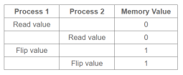
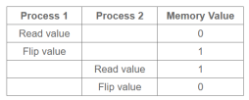

Figure 2
Figure 1
So, in essence a race condition is when 2 or more threads carry out the same process, this can result is issues such as incorrect values being gained from this. This can then happen if the process happen when they should not, this is then illustrated in the images above, the first image is how a normal process should take places. This is shown as process 1 will read the value of 0 and will then flip it, then process 2 will read the value of 1 and flip is. This is then where race conditions come in so in figure 2 process 1 reads the value and then process 2 reads the value when it should not, then process 1 and process 2 flip the values which then leads to incorrect input. To stop this a mutex can be used. Race conditions were considered for the application.
Mutex
A mutex “a mutex is an object used to provide mutual exclusion in the execution of a protected region of code. This region of code that needs to be protected with mutual exclusion is usually known as a “critical section.”” (14) This then suggests that mutexes work almost like a token ring topology, in essence, it stops too many threads accessing resources at one time, which could put too much strain on the server and cause it to crash. Looking at the example above can lock process 2 out of the memory. This will then for the process to run correctly and in the way that they were designed to work. Mutexes were also considered for the application.
Multi-Threading
Another technology that was used was multi-threading ocw.mit.edu states multi-threading as “Multitasking is the ability of a computer's operating system to run several programs (or processes) concurrently on a single CPU. This is done by switching from one program to another fast enough to create the appearance that all programs are executing simultaneously.” (15) This then suggests that multithreading allows many different tasks to be completed at one time so this maybe have more than one user join and begin messaging in the chat as one time which would need multi-threading. This was used even though java script was a single thread socket io allows for multi-threading on JavaScript as this is only single threaded.
Semaphore
Geeksforgeeks.org states that “A semaphore is a generalized mutex. In lieu of a single buffer, we can split the 4 KB buffer into four 1 KB buffers (identical resources). A semaphore can be associated with these four buffers. The consumer and producer can work on different buffers at the same time.” (16) this then suggests that a semaphore work in very much the same way that a Mutex does as it allows only a certain number of threads to access the resources at one time and will block all others from entering. A semaphore consists of 2 different atomic operations one being wait and the other being the signal for the process synchronisation.

Application Logic Planning
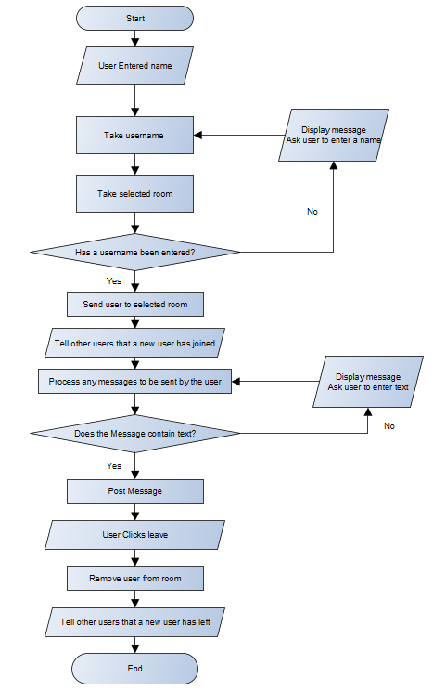

Above is the decision processes for the chat this then shows the decisions that both the user will make and how the system will react to these decisions.

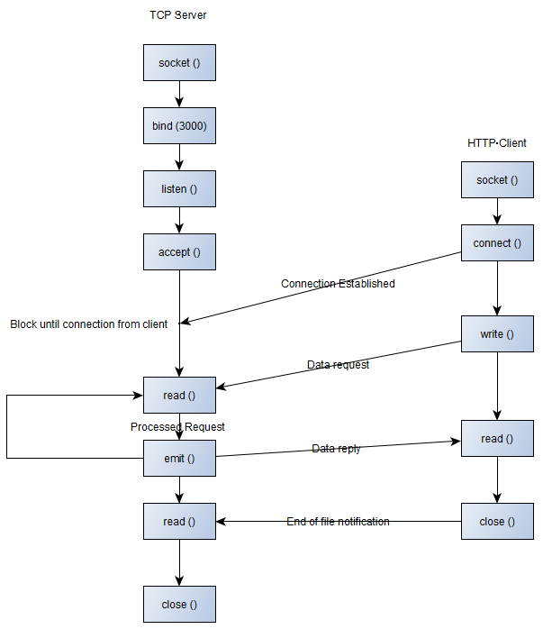

Above are the client server processes that place within the system, this then allows the each of the different processes within the system to be documented, this will help not only the build but the testing as it will show all of the different ways in which the user and system interact.

Data Requirements
There are a 3 main types of data that will be needed for this application that will be temporarily stored in variables; these will be the username of the person the room that they are in and the messages that they then send. The username will act as the persons identifier so that the application knows who sent the messages, also the room is for where the messages have been sent. The rooms are also shown in the drop down so these will need to be stored. Lastly is the chat messages, these are sent by the user to the chat after they click enter and then the messages are stored in the chat until all of the users have left the chat.

Application flow and layout design

Page 1 - Username Entry and Room Selection
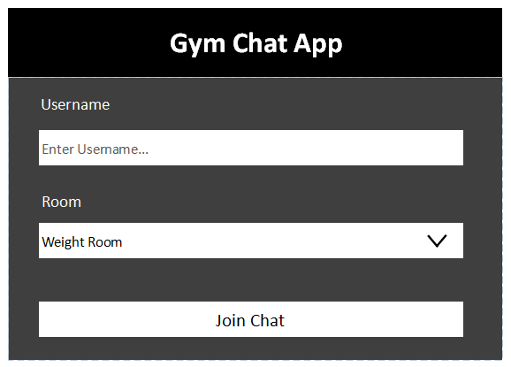

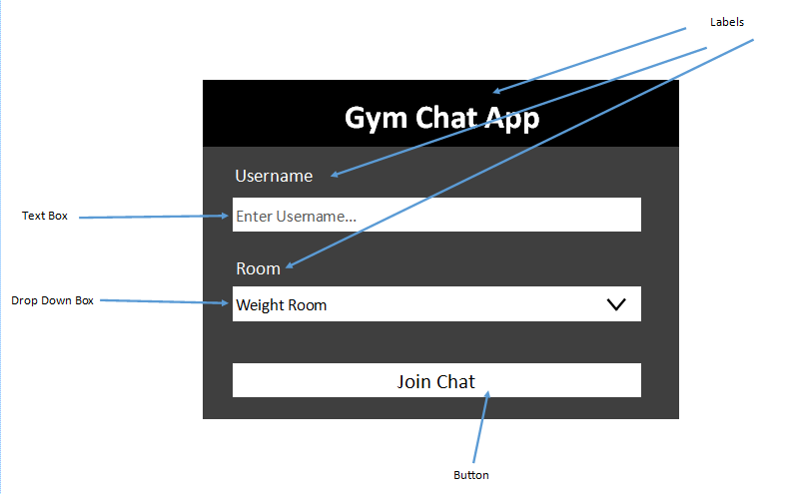

The pictures above are of the designs of the chat app, the different parts of the application are labelled above. The main reason for using a drop-down box is for the usability as the user can chose instead of a menu which may complicate the process, which was attempted to be made as simple as possible.
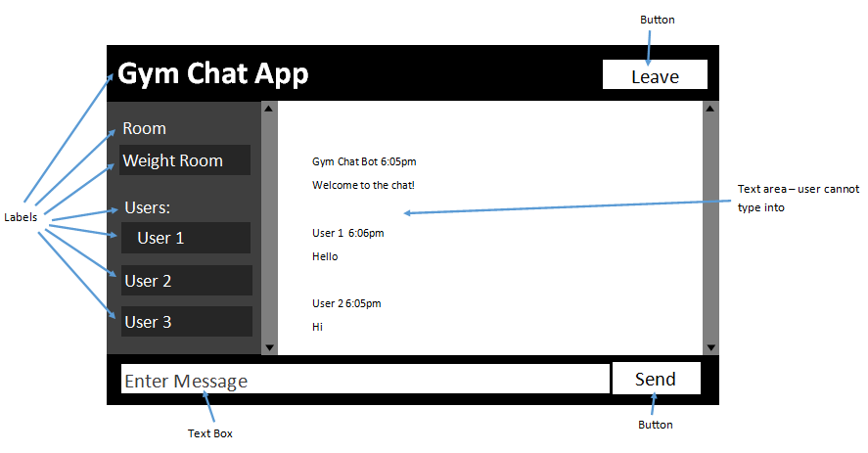
Page 2 - Chat Room
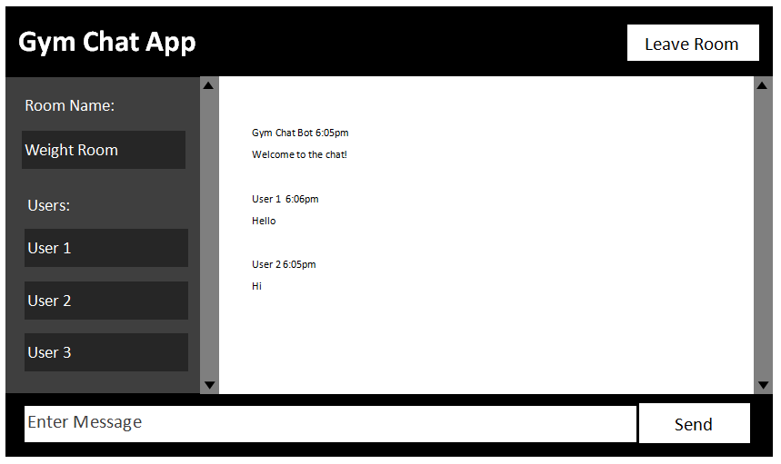

Test Programme

Testing
The application testing will be broken down into two sections the first is unit testing, for this a table will be created to document each of the tests, the expected outcome and what happened within the tests. This will also show if any corrective action has been taken. The table has been used as it can document all of the small parts of the test and allows for each parts of the system to be tested easily.
Next acceptance test will be used. These will be given to 3 users who will test the application. they will then be given a questionnaire to gain their thoughts on the effectiveness and usability of the application, as well any bugs that they encountered. They will also be asked if they will continue to use the app which be used to see if there is a possibility of the application can be implemented in the future. This will be used to get feedback on the application and to see necessary changes in order to make the application usable.
Unit Testing
Test Number | Name | Test Description | Expected Results | Actual Results | Action
1 | Username Validation | Attempt to connect to a chat room without entering a username | A validation message will appear, with no connection established | As Expected
2 | Leave Button | Attempt to leave the chat | The user leaves the chat | As Expected
3 | Room Validation | Connect to a room without selecting an available room | A validation message appears with no connection established | As Expected
4 | Username and Room Selection | Attempt to connect to one of the rooms | The connection is established | As Expected
5 | Chat Welcome Message | Once a user is connected a welcome message will appear | The message Appeared | Failed To Appear | The code was amended, and the message appears
6 | Send Button | A blank message will attempted to be sent to the chat | No message weas sent | As Expected
7 | Send a Message Into The Chat | The message will be sent to the chat | The message is sent | As Expected
8 | User List | Users in chat will appear in a list in the side of the screen | The users list will appear on the side of the screen | Failed to Appear | The code was amended, and the list appeared
9 | Stress Tests | 8 people will attempt to join the chat at once | 10 people can chat | As Expected
10 | Join message | A join message will appear when a user has joined the chat along with their name | The join message appeared | As Expected

User Acceptance Testing
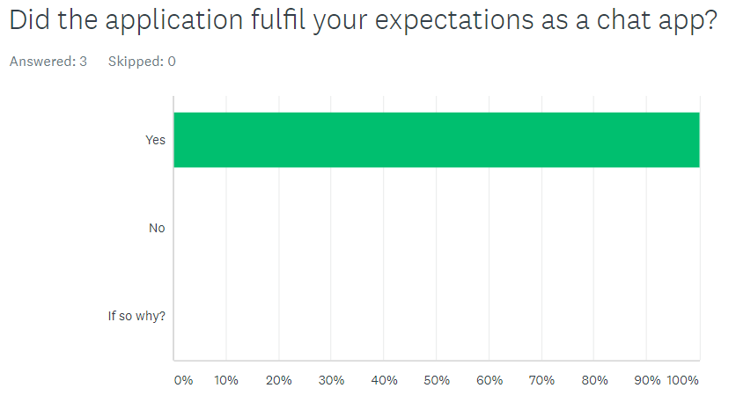
The first result of the user acceptance is that 100% of the user said that the application fulfilled their expectations, this then shows that the user have most likely used chat apps before and believe that this works the same, so they have accepted the design of the chat app.

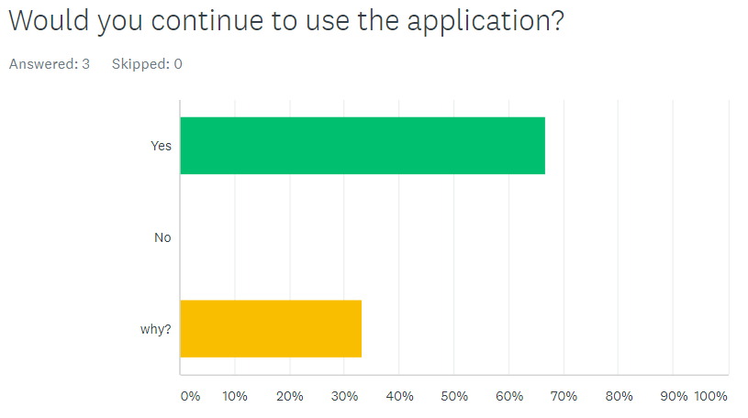
The next result was that the users would continue to use the application which is very good as it shows that they like the application, with some users saying that the application works like any other so they will continue using it. This then clearly shows that the users have accepted the application of they would continue to use it.

Bibliography

1. What is Node? | Codecademy [Internet]. Codecademy. 2021 [cited 15 March 2021]. Available from: https://www.codecademy.com/articles/what-is-node
2. When, How And Why Use Node.js as Your Backend | Netguru [Internet]. Netguru.com. 2021 [cited 16 March 2021]. Available from: https://www.netguru.com/blog/node-js-backend#:~:text=js%20is%20very%20efficient%20with,and%20server%20happens%20very%20fast
3. What is ASP.NET? | .NET [Internet]. Microsoft. 2021 [cited 15 March 2021]. Available from: https://dotnet.microsoft.com/learn/aspnet/what-is-aspnet
4. Introduction [Internet]. Socket.IO. 2021 [cited 15 March 2021]. Available from: https://socket.io/docs/v4/index.html
5. WebSocket <webSocket> [Internet]. Docs.microsoft.com. 2021 [cited 15 March 2021]. Available from: https://docs.microsoft.com/en-us/iis/configuration/system.webserver/websocket
6. JavaScript | MDN [Internet]. Developer.mozilla.org. 2021 [cited 15 March 2021]. Available from: https://developer.mozilla.org/en-US/docs/Web/JavaScript
7. A Tour of C# - C# Guide [Internet]. Docs.microsoft.com. 2021 [cited 15 March 2021]. Available from: https://docs.microsoft.com/en-us/dotnet/csharp/tour-of-csharp/
8. What is HTML [Internet]. W3schools.com. 2021 [cited 16 March 2021]. Available from: https://www.w3schools.com/whatis/whatis_html.asp
9. What is CSS? – CSS Tutorial [Internet]. IT Connect. 2021 [cited 16 March 2021]. Available from: https://itconnect.uw.edu/learn/workshops/online-tutorials/web-publishing/what-is-css/
10. Sass: Syntactically Awesome Style Sheets [Internet]. Sass-lang.com. 2021 [cited 14 March 2021]. Available from: https://sass-lang.com/
11. Synchronous Communication | iTeachU [Internet]. Iteachu.uaf.edu. 2021 [cited 16 March 2021]. Available from: https://iteachu.uaf.edu/synchronous-communication/
12. Synchronous Communication | iTeachU [Internet]. Iteachu.uaf.edu. 2021 [cited 17 March 2021]. Available from: https://iteachu.uaf.edu/synchronous-communication/
13. Race conditions and deadlocks - Visual Basic [Internet]. Docs.microsoft.com. 2021 [cited 15 March 2021]. Available from: https://docs.microsoft.com/en-us/troubleshoot/dotnet/visual-basic/race-conditions-deadlocks
14. Mutex vs Semaphore - GeeksforGeeks [Internet]. GeeksforGeeks. 2021 [cited 15 March 2021]. Available from: https://www.geeksforgeeks.org/mutex-vs-semaphore/
15. OpenCourseWare M. Multithreading | Lecture Notes | Foundations of Software Engineering | Civil and Environmental Engineering | MIT OpenCourseWare [Internet]. Ocw.mit.edu. 2021 [cited 15 March 2021]. Available from: https://ocw.mit.edu/courses/civil-and-environmental-engineering/1-124j-foundations-of-software-engineering-fall-2000/lecture-notes/multithreading/#:~:text=1.,all%20programs%20are%20executing%20simultaneously.
16. Mutex vs Semaphore - GeeksforGeeks [Internet]. GeeksforGeeks. 2021 [cited 15 March 2021]. Available from: https://www.geeksforgeeks.org/mutex-vs-semaphore/

Appendix 1 – Questionnaire

Question 1
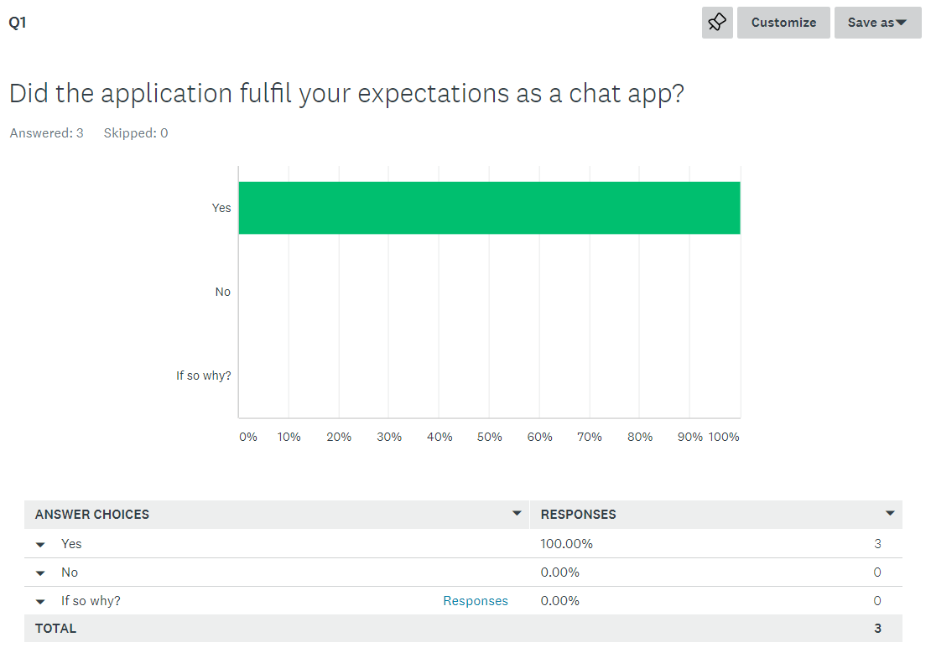
100% of the respondents answered yes to this question which is the answer that was expected from this.

Question 2
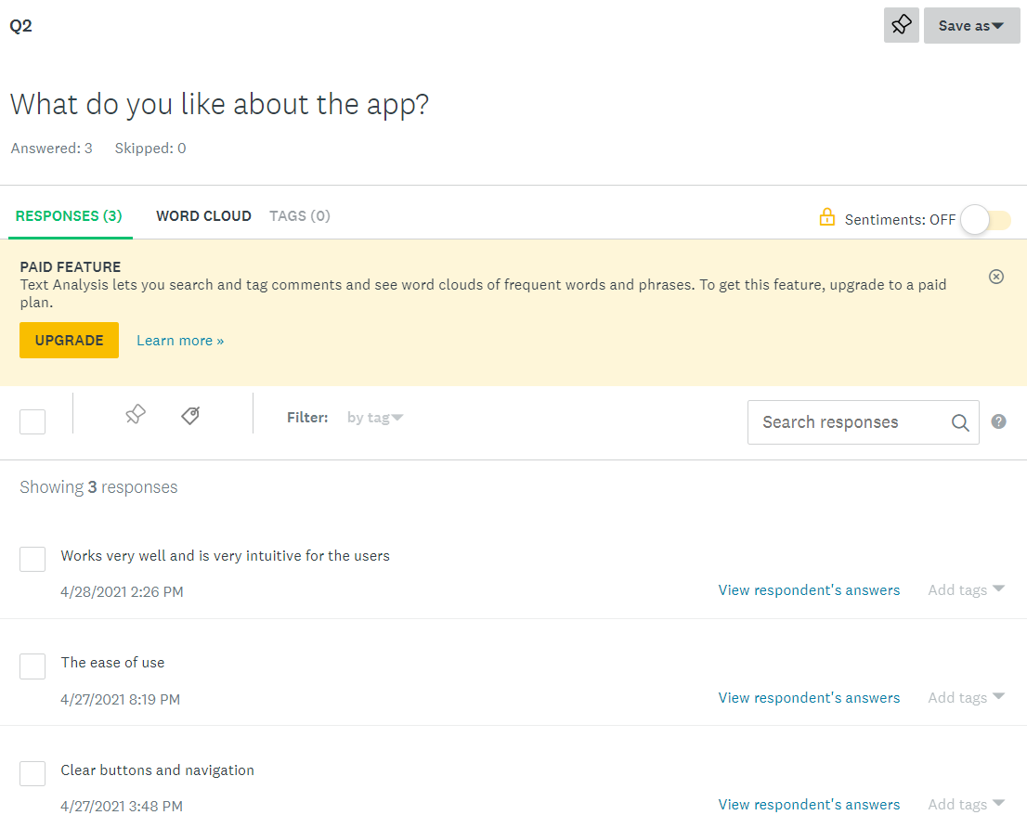

Next was what do the user like about the application and most of the answers included the ease of use and the simplicity of the application.

Question 3
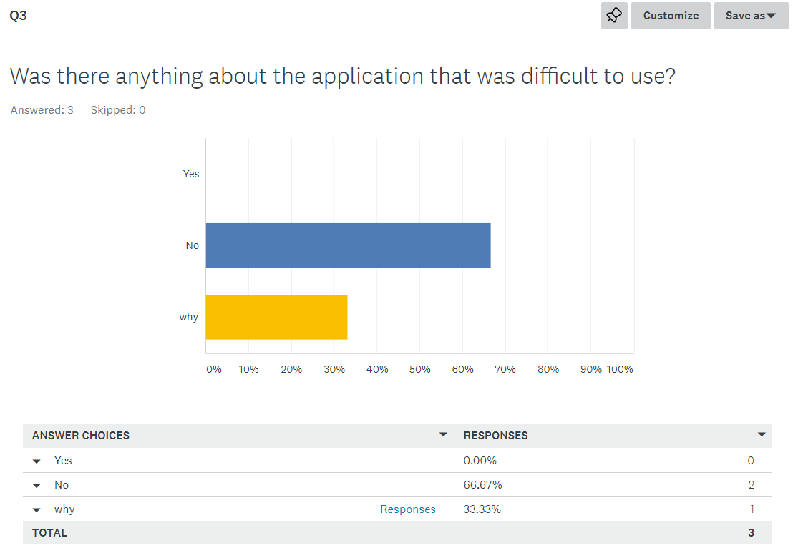
This question also got the response that was hoped for as there were no issues that arose from the testing, this question was then answered correctly from the users as the majority said that there were no issues.

Question 4
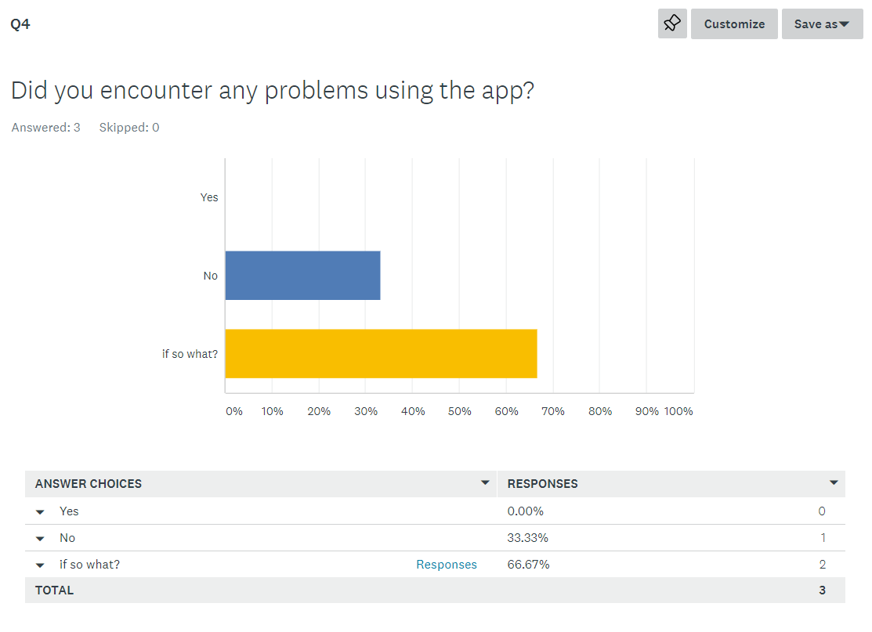
There were some negative responses from the questionnaire from the users which is very good for the application as it means that it can be improved, some of the responses stated that the chat app would expand to accommodate screen space, however this was a planned feature that was meant to be added to the app.

Question 5
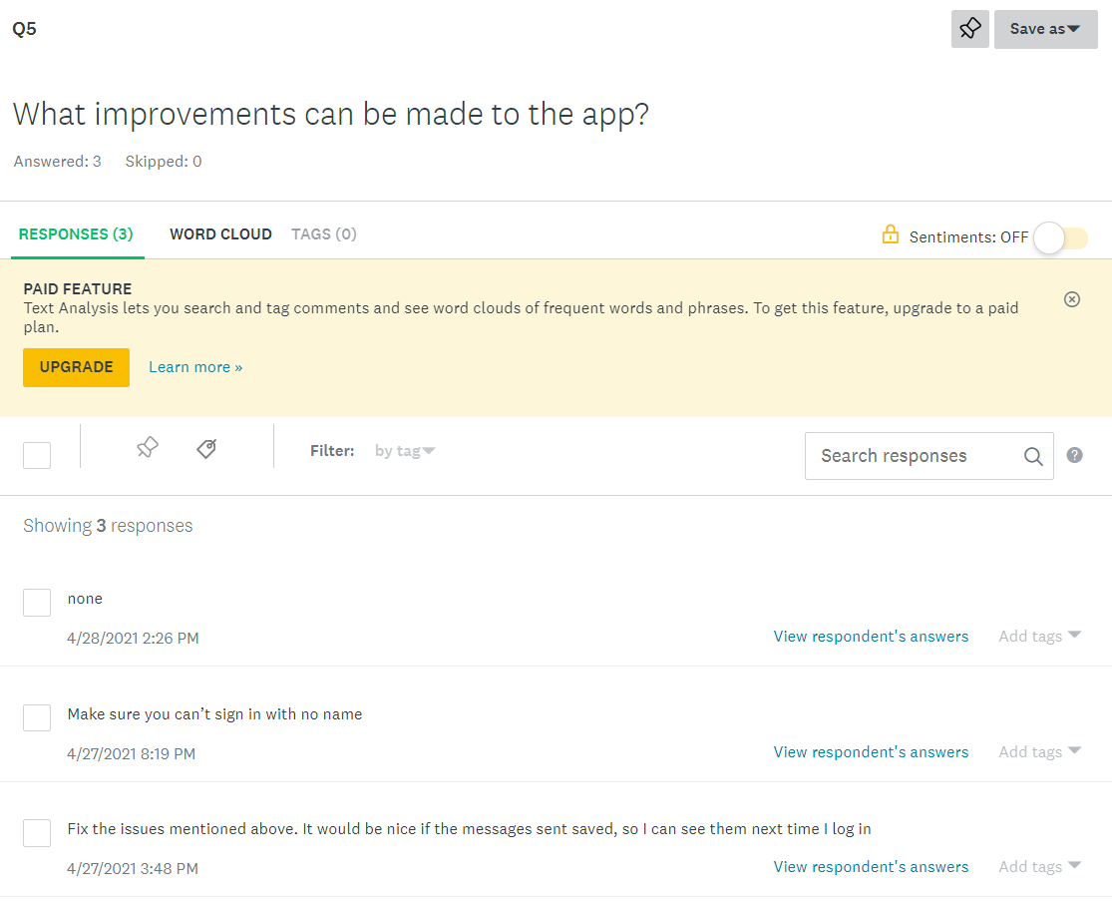
One of the responses from this question is that the chat responses can be saved so that the user can look back on them as a later date, this could then be added if this app is a success.

Question 6
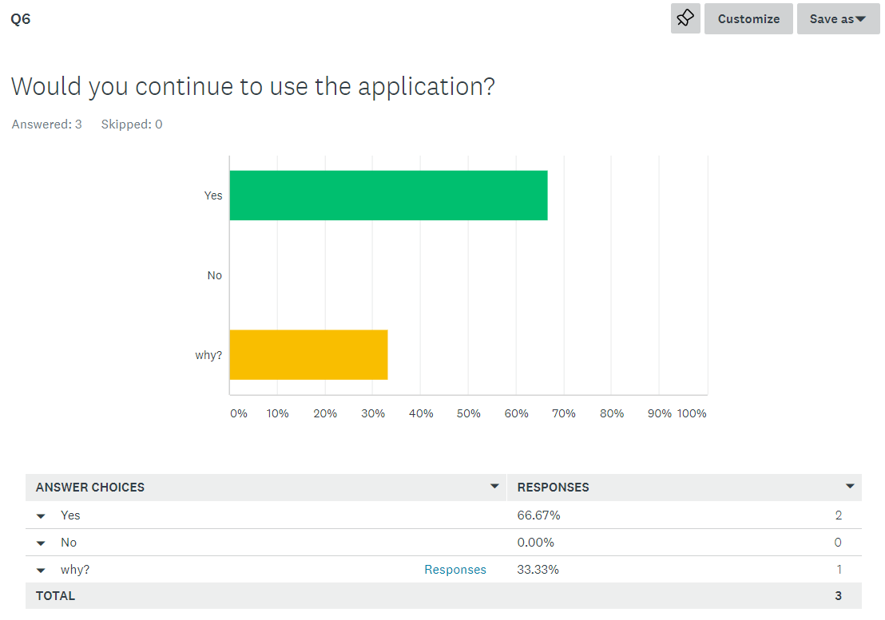
For the last question, 66% of the respondents stated that they would continue to use the application which I believe means that the user have accepted the application.

