
Module: | Effective teamworking and communication
Module code: | BMSW4002
Assignment No: | Assessment 1
Student Name | Bilkis H Rashid
Student ID | 1817627

Resit (June’19 Student)
Resubmission date:15/12/2020

Table of Contents
Table of Contents 1
Introduction 3
Communication models 3
Communication approach 4
Requirements for effective communication in care home 6
Impacts of effective communication on team working and collaboration 7
Theories of team structure 8
Collaborative working 9
Group Dynamics 10
Conclusion 11
References 12

Introduction
The collaboration and team working process is connected with each other where effective team work depends on the effective collaboration among the employees. The employees of an organisations are meant to communicate among themselves and establish effective relation for collaboration (Moss, 2008). This report is about the team working and collaboration among the staffs in care home organisation. The whole report have been conducted based on the scenario of the care home organisation Westport Care Home opened on 5 July 2016. The services and support it provides Residential care, Residential Dementia car, Respite care and End of life care. It is owned by care home group Ferrolake Limited and it is run by 25 staff members including three managers and it is advertised in the website UK care homes. In this report the scenario of collaboration, communication among the employers and workers, relations among themselves and the team working process of the staffs have been described based on which the management would be recommended.

Communication models
The communication means to derive message, information or data from one person to other or others. In an organisation communication takes place among the staffs and employees of the organisation to share information for working together and provide effective service. For care home organisation the communication method takes place with the collaboration and team working by the staffs and workers of an organisation. For team work and collaboration among the employees and workers, the effective communication model in the care home organisation Westport Care Home should be established among the staffs and employees. Some of the major communication models and methods are explained below:
Verbal communication
Verbal communication is the process of expressing sounds or words or talking directly with other person for communicating with the message or information (Pavord and Donnelly, 2015). In the verbal form of communication the speaking, using the tone of voice, voice call over phone, videos etc. are used as medium for communicating. In the organisation Westport Care Home the verbal communication takes place with the direct communication be the employees with their presence and talking with each other. This is the most effective communication media where the message can be clearly expressed.
Non-verbal communication
The non-verbal communication is the process of conducting communication with different people without the use of voice or tone rather using message with signals, gestures and expressions. The presentation of video, graphics without sound is also a non-verbal communication form (Williams, 2008). The non-verbal communication in the Westport Care Home takes place with the sign of the employees like red alert system, gesture of the staffs and the expression.
Written communication
The written form of communication is another non-verbal communication which is most effective in formal communication process within an organisation (Williams, 2002). The written documents, reports, messaging via mobile phone, email, social media is the form of written communication. In the care home Westport, the written communication takes place with the implication of report, recording, involving other in formal documentation process and

Communication approach
To view the communication approach with effectiveness in organisational team working and collaboration, the Shannon-Weaver mathematical model can be presented here.
Shannon-Weaver Mathematical communication model
The Shannon-Weaver communication model is considered as the mother of all communication model since it reflects the basic model of communication based on which different other scientific communication model are explained. According to this model, Shannon expressed that the communication flows with proper encoding message sent by the sender which flows with a specific channel connected to the receiver (Mulder, 2016). The encoded message is decoded in the receiver decoder and the receiver gets the full message. The receiver and sender are connected with the communication channel where the feedback is also derived from one another. Another thing that interrupts the communication model is the noise which makes it unclear to the receiver due to some circumstances which is considered as the distraction of communication.

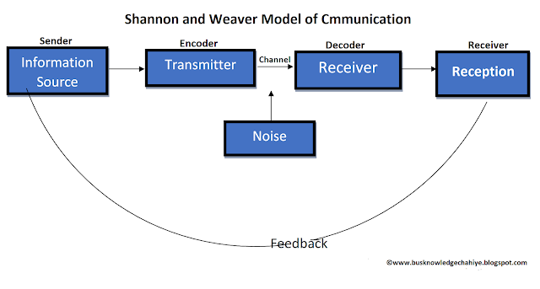
Figure: Shannon Weaver Model of communication (Mulder, 2016).
Berlo’s Model of Communication
Berlo’s model of communication states that all the communication takes place with the flow of communication model starting from the source from where the message is sent. The message is sent through a media or channel after encoding the message (BERLO’S SMCR MODEL OF COMMUNICATION, 2016). The channel decodes the message and formulate a meaningful communication between the sender and receiver. The feedback of the communication also takes place with the similar process where the sender becomes receiver with the feedback and the first receiver becomes the sender. The model can be explained with the following graph:
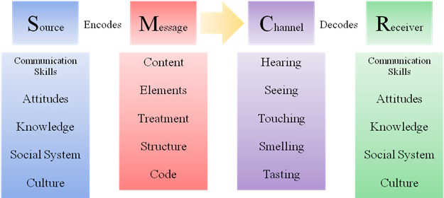
Figure: Belo’s Communication model (BERLO’S SMCR MODEL OF COMMUNICATION, 2016).

Requirements for effective communication in care home
The effective communication helps to convey the perfect message to the receiver and help in collaboration and team working. To make communication effective the receiver and sender of message should bear in mind the following things.
Listening or reading carefully
The receiver of communication should listen or read the message carefully to understand the meaning and motive. With the understanding of the communication process the sender and receiver of the communication can interpret what is guided from the communication (Kneafsey, 2007). In the care home Westport, the communication takes place among the employees and staffs where the experts or operational communicates to command the caretaker about the service to the patients and service users.
Concise, complete and correct
The correct information should be sent to the receiver with concise form and the message should be completed with proper guidance. For instance if an operational manager sends command to the caretaker about implying medication process, without proper instruction about patient name or bed number the receiver of command would not understand clearly what to do and there would be mistake with the service.
Conveying respect
To capture attention, the communicator should respect the audience either individual or public (Kneafsey, 2007). Conveying respect adds value to the conveyed communication or message. In the care home, all the staffs are required to respect one another which raises the relationship and their importance.
Feedback
Getting feedback after communicating with each other makes a communication complete. The sender of message expects feedback about the message or command. In the Westport Care Home, the caretaker and staffs should give feedback about the patient with reports and message about patient condition after applying service.
Easy and accessible medium
A sender should not email a person who does not use email, or send message who does not use phone (Milaneschi, Tanaka and Ferrucci, 2010). The message should convey with proper utility and tools which is available and accessible. In the care home organisation the communication media of phone, server network within the organisation are mostly used by the staffs and employees.

Impacts of effective communication on team working and collaboration
The team working and collaboration requires proper communication. The effective communication is the major requirements for establishing effective team and collaborative relation among the employees and staffs of an organization. The organisational activities and works are interpreted with proper communication among the employees and staffs. The employees and staffs are required to conduct the organisational communication with the requirements of collaboration and team forming. The impact of effective communication on team work and collaboration are explained below:
A team is formed with different members. In case of care home organisation the team of organisation is formed with the employees and staffs of the care home organisation. The team member are meant to communicate about the common requirements of the team. Without proper communication among the staffs there would not be any sound relation possible within the team. So effective communication among the members of the team would help most for building a team for working (Norouzinia et al., 2015). In the care home organisation there are different medium that the staffs and employees use to communicate among themselves and perform team working. The service are provided with the team of operations by proper communication. The superior staffs and caretaker gets suggestion and command about the service depending on which the employees perform their duties and activities. The collaboration takes place among the team members to interact learning of new skills with shared value. By sharing thoughts and suggestions the team members collaborate and enhance team working in the organisation.

Theories of team structure
There are different theories that reflects the team structure for an organisation. In case of organisational team work, the Belbin Team Role theory is most popular and useful. The Belbin Team Role model is shortly described below:
Belbin Team Role model
The Belbin Team Role model is a team forming model was proposed by Meredith Belbin depending on the behavioral aspects of team members. In the model different behavioral people and their role have been explained which helps to imply person centered approach in forming the team in care home organisation (Batenburg, et al, 2013). The Belbin team model is reflected with certain behavioral test based on which the team members are allocate with their duties and responsibilities. The team responsibilities are also implied depending on the behavioral aspects. In his model Belbin introduced some basic model of team working and behaviour. Here the plant thinks of the idea that is to be implemented, the implementer puts the idea into practice, the specialist makes sure that the specialised takes are carried out, the resource investigators takes care of all the necessary resources, the team workers and coordinator works with the workers to distribute tasks and solves task related issues and finally the completer looks into the completion of each and every task.
The team working model stated by Belbin can be shown with a graph, presented below:
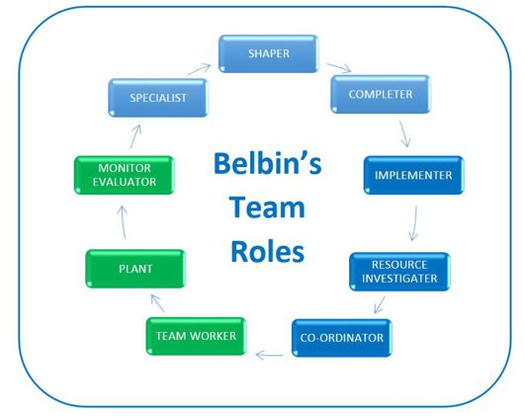
Figure: Belbin’s Team Roles (Batenburg, et al, 2013)

Collaborative working
The term collaborative working is a one kind of synonym to the team working which means to collaborate with two or more people about completing a tasks. In collaborative working two or more people distributes their activities and working for achieving a common goal. Although the team working and collaborative working are related, they are not complete identical. The team working requires to form a team with different members, where the collaborative working requires a common goal or achievement with the distribution of work (Braye and Preston-Shoot, 2015). The collaborative working is more effective in care home organisation where the service providers collaborate among themselves about the service to patients. For instance, a patient might require different types of service which would not be rendered by one care professional so two or more professional can collaborate about serving the patient together. This would raise efficiency of service as well as the professionals involved in the collaboration would learn new skills with shared value.

Group Dynamics
Shared objectives
The objectives of a team should be shared in such a way that if the performance is boosted it should be profitable for all and negative outcome should impact all (Bridges et al., 2011). In group dynamics of team, the shared objectives help the most in forming collaboration and effective relation among the employees and workers. For the organisation Westport Care Home, the group dynamics with shared goals helps to achieve the service goals easily for the professionals.
Group agreements
The members of the group should be agreed to the process of working. The superior and subordinate care professional should agree to the process and imply the collaborative process for care service in the organisation Westport Care Home.
Meaningful schedule
The meaningful schedule is to be set for collaborating among staffs and employees of the organisation (Bridges et al., 2011). The care home organisation Westport Care Home maintains different service to different patients and service users. The employees and staffs are required to imply service to the service users with proper collaboration in different shifts to allow other serve with comfort.
Effective delegation
The effective delegation means to imply control and guide properly by the leader or manager of the team. In the care home organisation, Westport Care Home, the operational manager plays the most important role in the delegation process to lead the staffs and employees with the required service.

Conclusion

The communication in care home organisation is one of the basic requirements to formulate effective team working consisting of the employees and staffs to serve the patients and service users. The service providers, care takers and specialists are required to form team with proper communication and collaboration to make the team work effective for service. This report have been conducted with the explanation of communication model, theories, team working, impact of effective communication on team working and collaboration and group dynamics to clarify the team working and communication in care home organisation. The whole report has been conducted based on the scenario of the London based care home organisation Westport Care Home.

References
Batenburg, R., van Walbeek, W. and in der Maur, W., 2013. Belbin role diversity and team performance: is there a relationship?. Journal of Management Development, 32(8), pp.901-913.
Braye, S. and Preston-Shoot, M., 2015. Empowering Practice In Social Care. Buckingham: Open University Press.
Bridges, D., Davidson, R., Odegard, P., Maki, I. and Tomkowiak, J., 2011. Interprofessional collaboration: three best practice models of interprofessional education. Medical Education Online, 16(0). Available at: <http://med-ed-online.net/index.php/meo/article/view/6035/html_115>
Communication Theory. 2016. BERLO’S SMCR MODEL OF COMMUNICATION. Available at: <http://communicationtheory.org/berlos-smcr-model-of-communication/>
Kneafsey, R., 2007. A systematic review of nursing contributions to mobility rehabilitation: examining the quality and content of the evidence. Journal of Clinical Nursing, 16(11c), pp.325-340.
Milaneschi, Y., Tanaka, T. and Ferrucci, L., 2010. Nutritional determinants of mobility. Current Opinion in Clinical Nutrition and Metabolic Care, 13(6), pp.625-629.
Moss, B., 2008. Communication Skills For Health And Social Care. Los Angeles: SAGE.
Mulder, P., 2016. Communication Cycle Model By Shannon And Weaver | Toolshero. ToolsHero. Available at: <https://www.toolshero.com/communication-skills/communication-cycle-shannon-weaver/>
Norouzinia, R., Aghabarari, M., Shiri, M., Karimi, M. and Samami, E., 2015. Communication Barriers Perceived by Nurses and Patients. Global Journal of Health Science, 8(6), p.65.
Pavord, E. and Donnelly, E., 2015. Communication And Interpersonal Skills. 2nd ed. Banbury: Lantern Publishing.
Williams, C., 2008. Therapeutic Interaction In Nursing. Sudbury, Mass.: Jones And Bartlett Publishers.
Williams, D., 2002. Writing Skills In Practice. London: Jessica Kingsley Publishers.

