Radiographer

X Ray vision since 1895

X Rays are high energy electromagnetic radiation discovered by physicist Wilhelm Rontgen in 1895. X Rays are ionizing radiation. Dosage, length of exposure and frequency must be controlled and regulated to avoid harm to professionals and patients alike. Radiographers use physics to capture medical images. Different parts of the human anatomy absorb X Rays at contrasting levels. Bones due to their large amount of calcium and high atomic number absorbs X Rays effectively. This produces a high contrast on the X Ray detector.

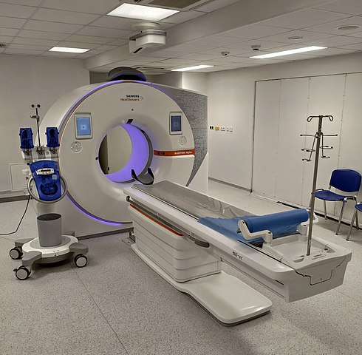

Radiographers use specialist equipment to obtain images of human anatomy. This is a Computed Tomography or CT scanner. It is a rotating X Ray spun around a central axis of the area of the anatomy to be scanned. It uses multiple projected radiographs (X Rays) to build up an image that is reconstructed by computer. It obtains a detailed internal image that is used in the diagnosis and treatment of pathologies. It is an example of the ‘application of cutting edge science’ Keevil p. 4 (2024).

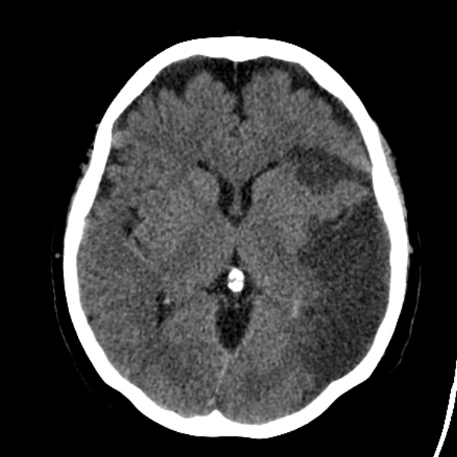

This is an image obtained by a radiographer using a CT scanner. It is a section from an internal image of the human brain. The patient has a left sided ischaemic infarct or stroke. The patient is scanned from the feet up in the anatomical position. This image will be used to diagnose and treat the patient. CT scans can be performed with a perfusion which is a contrast agent that highlights abnormalities in within internal structures. The ability to view the interior of the body is the ‘greatest challenge in medical diagnosis.’ Keevil p. 10 (2024).

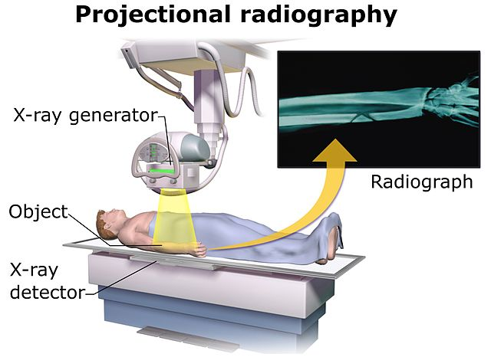

This is a X Ray Machine. It takes singular images that are used in the diagnosis and treatment of pathologies. The X ray is passed through the patient to the detector. It is the most common equipment used by Radiographers. X Rays have ‘changed from analogue (film) to direct digital images (DDR)’ Whitley p.34 (2024)

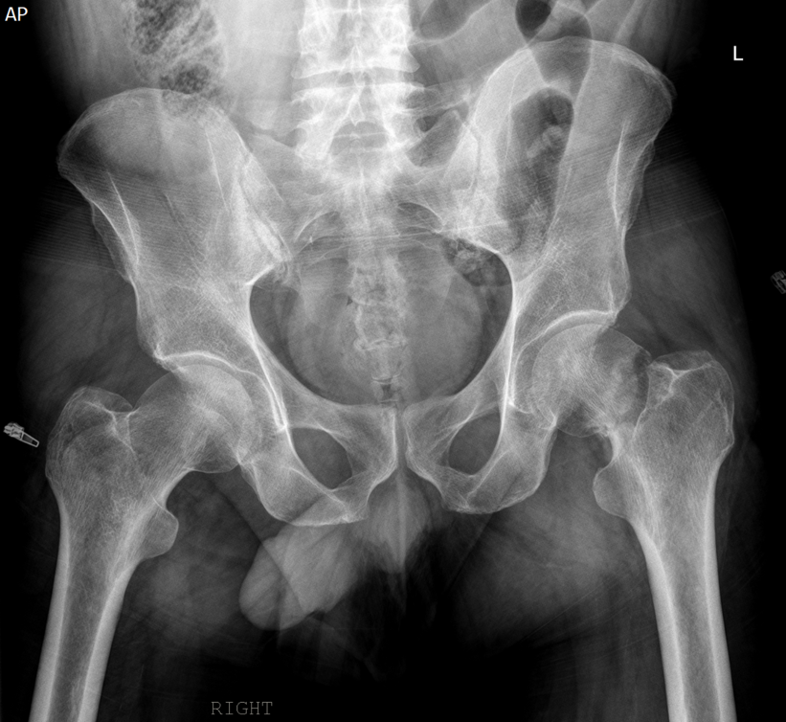

Here is an X Ray of a patient’s pelvis after a fall. They have a fractured neck of femur of the left leg. This will require surgical intervention to reduce the fracture. The patient will have further X Rays obtained by different Radiographers during and after surgery. X Rays are used in Orthopaedic surgery to obtain correct alignment of replacement and fracture reductions.
X Ray images can be ‘enhanced digitally post acquisition and not controlled by film exposure’ Hayre p.38 (2020). This reduces the amount of exposure the patient receives from repeated X Rays.

Radiographers are Healthcare professionals that are members of the Society of Radiographers and are ‘registered under the Health and care Professions Council’ HCPC (2024).

Medical Physics is integral to the diagnosis and treatment of pathologies. X rays, MRI, CT, ultrasound and radiology are examples of applied science in medicine. “Physics is the basic science for the diagnosis and treatment of many conditions.’ Keevil p. 54. (2024).

References

Hayre, C.M., Cox, W.A.S. (2020). General Radiography: Principles and Practices. CRC Press, Oxon.

Health and Care Professions Care Council (2024). Standards, (online) https://hcpc-uk.org.

Keevil, S. (Editor). (2024) Introduction to Medical Physics. CRC Press, Oxon.

Whitley, A.S et al (Editor). (2024). Clark’s Pocket Handbook for Radiographers. 3Rd Edition. CRC Press, Oxon.

