global marketng strategy
Assignment 1 – Identifying Potential Markets for Tomos Watkins Brewery

Andrew Booth-Jones
P146202

Table of Contents
1.0 Introduction 2
2.0 Company background information 2
3.0 Main body 2
3.1 Reasons to enter Global markets 2
3.2 Competitive and Absolute advantage 3
3.3 Marketing Model 4
3.4 International markets and research 4
3.5 UK beer export 6
3.6 Possible markets 6
4.0 Conclusion 7
Bibliography 8

Figure 1 - Beer consumption in Europe 2016. 5
Figure 2- Leading 5 exporting countries of beer from the United Kingdom in the first quarter of 2018. 6

Introduction
This report aims to contain relevant information about the organisation that has been chosen which is Tomos Watkins Brewery, identifying the potential markets that have been evaluated and potential new markets for the organisation to enter. It aims to critically evaluate the new market entry options that may be available for the brewery to enter. There are two tasks in which the report aims to fulfil, the first is to identify the key market that the organisation will benefit from and be worth entering and recommend the priority country/countries to establish a connection and contact in.
The report aims to accomplish is to evaluate the possible options for entry to these new markets that have been discussed, providing the Tomos Watkins Brewery board with a recommended course of action that includes full justification with the choice of country that has been picked for the company.

Company background information
Tomos Watkins brewery is a tight-knit third generation family business based in Swansea South Wales, they have been bottling mineral water and producing lemonade and cordials since 1982 whom have always shown a key interest in the drinks industry. It Is a welsh run brewery that is determined to become an iconic welsh beer brand. They use the motto ‘Made in Wales, enjoyed worldwide’ as an insight on how Driven by determination the company is (www.tomoswatkin.com , 2019).
The mission for Tomos Watkins is to support, encourage and help develop the welsh economy whilst increasing the profile of ‘Brand Wales’ around the world (www.tomoswatkin.com , 2019). The brewery is extremely committed to their wider customer base and they constantly ‘Strive to fully understanding the needs, developing strategies, products and services’ that other countries need fulfilling (www.tomoswatkin.com , 2019). Furthermore, the brewery treats their employees and customers with the respect and loyalty that they would hope to be treated themselves (www.tomoswatkin.com , 2019).

3.0 Main body

3.1 Reasons to enter Global markets
Global marketing is defined as the process of adjusting the marketing strategies of your company or organisation to adapt to the conditions of other countries. Global marketing is more than selling your product or service globally, it consists of the full planning, positioning, creating and the promotion of your products or services in the market (Martin, 2016).
Globalisation is an important factor that needs to be considered, globalisation is the ‘Process enabling financial and investment markets to operate internationally largely because of deregulation and improved communications’ (Jeffery, 2002).
Analysing further, it’s when organisations begin to buy, develop produce and sell their products to countries worldwide (Hollensen & Dawsonera., 2013).
Other reasons it’s beneficial to enter global markets is because it could increase innovation and management learning, by extending the customer base internationally I can help the brewery finance new product developments, gaining a good knowledge base and learning from other competitors and competitive markets. (MaDi, 2015)
By preparing to expand products globally, Tomos Watkins will be exposed to entering new markets that could be profitable and beneficial in the long run when looking to enter different countries markets, although preparation is needed beforehand as there are risks that come with entering new markets.

3.2 Competitive and Absolute advantage
For company’s and organisations to enter the global market they must gain competitive advantage and it should be considered if attempting to enter global markets (Hollensen & Dawsonera., 2013).
Competitive advantage is defined as a ‘Superior performance relative to other competitors in the same industry or superior performance relative to the industry average’ (Jurevicius, 2013).
Competitive advantage is at the heart of the firm’s performance when it comes to competitive markets, it’s about how a firm puts the generic strategies into practice (Porter, 2008). Furthermore, one of the reasons to enter the global market is to analyse what countries the brewery can gain competitive advantage in, in their markets.
Apart from competitive advantage, the brewery will need to investigate absolute advantage, it is believed that absolute advantage is when a company can ‘Produce a greater total of goods for the same quantity of inputs’ (Pettinger, 2017). Expanding further, fewer resources are needed to produce the same amount of goods and there will be lower costs than in other economies (Pettinger, 2017).
For the brewery wanting to expand their business, it is crucial for them to enter the global market with the knowledge on the three key parts discussed above, it is important that they know how to gain competitive advantage, absolute advantage and how globalising their products will affect their profits and the expansion of the company if they want to continue to grow.

3.3 Marketing Model
There are a range of different models that can be linked to Tomos brewery to define the potential markets the company could enter, one of the models used in this report Is the Uppsala model. This theory is influenced by the Penrose’s growth theory of a company (Penrose, 1995) it is a theoretical base in the behavioural theory of the firm. The theory describes the internationalisation of the company as a process in which the company would gradually increase its international involvement (Hansson, et al., 2004).
The model distinguishes four different steps of entering a different market. Which cannot be viewed independently company’s situation or their knowledge of the market they are entering (Zoharj, 2012) the first of four steps to this theory is no regular export activities, the second is export via independent representative, the third step is establishment of a foreign sales subsidiary and the fourth step is foreign production/manufacturing (Hollensen, 2007).
Expanding further, Tomos brewery must analyse each step correctly, looking at the first step, the company would need to ensure that when exporting their goods and services to international markets, they need to be consistent and not irregular or having their goods and services shipped over at different stages. They need to ensure it is in coherence with the country they are exporting too.
They must make sure that if they are directly dealing with the exportation of goods to these markets and are not using an independent representative, ensuring that all workers are directly affiliated to the country. They must make sure that they are able to us the establishment of foreign sales subsidiary as this which allows them to sell and export good.
Lastly, they must ensure that everything they produce must be done so outside of these countries and aren’t specifically edited and changed for specific countries.

3.4 International markets and research
There are a few potential markets that Tomos Watkins Brewery could enter, influenced by the research that has been conducted three potential markets are chosen as markets that the brewery could enter. By analysing the beer consumption for 2016 there are many potential countries that the brewery could decide to export their products too.
Analysing the statistics, it shows that Germany is the country that consumes the most beer in Europe, followed by the UK in second and third is Spain. Included in the top 5 highest consumers for beer Poland and France come close whereas Luxembourg, Cyprus and Malta are the three countries that consume the least amount of beer (See figure 1) (Photiades, 2017). These three countries that don’t consume that much beer are the type of markets the brewery doesn’t want to go into as the risk is too great to export products there as there may not be a profit to be made.
Three potential markets that the brewery should focus on should be Germany, Spain and France. The reasons for these markets to be picked as potential markets is the fact that they are in the top 5 for countries that consume the most beer in Europe.
In 2016, Germany consumed 85,532 HL, followed by Spain whom consumed 38,634 HL and France which consumed 21,290 HL Correct of 2016 (Photiades, 2017). Although Germany is the highest country for beer consumption the brewery shouldn’t go into that market, although great success comes with great risk, there may already be a lot of competitors in Germany’s market selling their beer brands. Tomos Watkins brewery may not make a profit and the risk may be too big to take on in case they lose control in terms of the volume, market share and profit margin requirements.
Although the geographical proximity isn’t too bad, the psychological proximity may be an issue. The reason for this could be because the products that Tomos Watkins brewery could export may not be excepted by the citizens of Germany which could be a risk that may be related to the failure of succeeding this market.

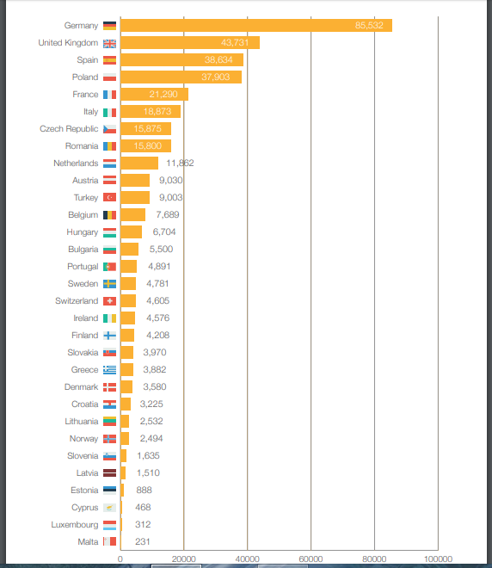
Figure 1 - Beer consumption in Europe 2016.
https://brewersofeurope.org/uploads/mycms-files/documents/publications/2017/Statistics-201712-001.pdf

UK beer export
The UK is the third biggest food and drink export after Scottish whiskey and chocolate (French, 2017). The British beer revolution shows no signs of slowing down, the food minister George Eustace stated that the latest figures that one billion pints were exported around the world, bringing a £600 million boost to the economy (www.GOV.uk, 2017).

To ensure that the brewery connects with a market that will help increase the profits of their company and their export trade then knowledge on the top 5 markets that are bringing in a profit need to be analysed. (see figure 2).

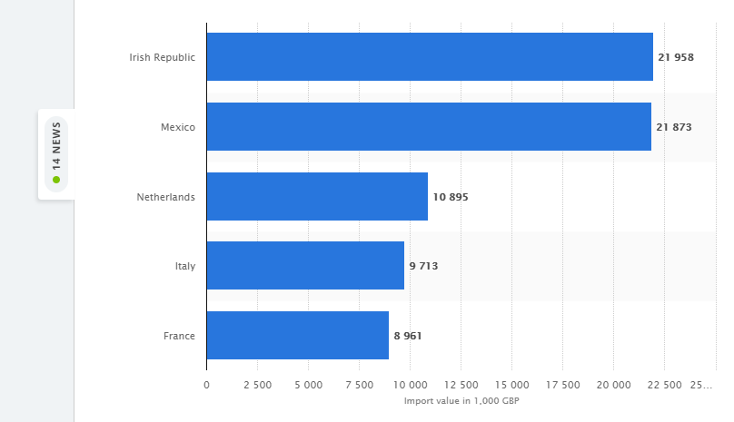
Figure 2- Leading 5 exporting countries of beer from the United Kingdom in the first quarter of 2018.
https://www.statista.com/statistics/305163/uk-beer-imports-leading-5-countries-by-value/
shown above, these are the leading 5 countries that the UK has exported beer to in the first quarter of 2018 making profits from these countries (www.statista.com, 2018).

Possible markets
By looking at the statistics above, Spain isn’t in the top 5 leading countries that the UK are making a profit exporting two, Spain also had a high beer consumption level which can still be a risk when entering a potential global market. There could be operational risks when it comes to micro factors for the brewery, as there is higher consumption then there may be a higher demand for the products that the brewery is exporting, this could influence the channel of distribution causing the export process to be indirect and long if being purchased by wholesalers or retailers.
If there isn’t a demand and there aren’t that many customers purchasing the products the process of direct selling and exporting my cost the company more than what they are profiting. There are also customer and consumer characteristics that could potentially be a risk, if there are many different products on the market then this could mean that the brewery products may not be in demand and consumers for this potential market may not be influenced to buy the products that the brewery would be selling.

France is the only potential market left to explore, they are in the UK’s leading 5 countries that products and goods are being exported too, France spent roughly £8,961 pound on beer from the UK in the first quarterly. This means that France are importing beers from the UK already suggesting that there is a demand for our beers in their market. Although the main process of going over to potential markets is not to raise issues of control or risk, there already seems to be a demand for UK products and these two factors are the biggest issue the Brewery will face.
There are many methods of exporting the goods to France that the brewery will be able to keep the risk down to minimum and be able to control how to export more whilst keeping costs minimal. One of the methods the brewery could look into is piggyback operations, this is when the company could join with another organisation that is already exporting to that market, and shown in the statistics the brewery now knows that there are other UK companies doing so this is also known as a indirect exporting.
Indirect exporting may be a beneficial method for this company to go through, as they may find other trading companies that are long standing trading and trade between the country’s government departments.

Conclusion
By investigating and analysing different potential markets for the Tomos Watkins brewery, it has shown which country may be beneficial for them to enter in the market. There were many different aspects that needed to be investigated to gain vital and critical information to help influence the decision that has been chose.
The prospects that have been analysed include the reasons why the company should enter into global markets, looking at the competitive advantage of entering these markets and analysing the absolute advantage to see what the company may benefit from by entering these markets. Knowing information from different potential markets and giving reasons as to why some markets may not work for the brewery and other reasons suggesting why it would have been given.
The overall decision of the report shows that France is the most beneficial market for the brewery to go into, as there are markets that are there already and are making money from there, but there isn’t an over demand or consumption of beer there making their chances higher of turning over a profit.

Bibliography
French, P., 2017. New export strategy to boost british beer by £100M. [Online]
Available at: https://www.thedrinksbusiness.com/2017/10/new-export-strategy-to-boost-british-beer-by-100m/
[Accessed 1 March 2019].
Hansson, G., Sundell, H. & Ohman, M., 2004. The new modified Uppsala Model - , Sweden: Kristianstad University .
Hollensen, S., 2007. Global Marketing: A Decision-Orientated Approach. 4th ed. s.l.:Pearson Education.
Hollensen, S. & Dawsonera., 2013. Global Marketing. 6 ed. Harlow: Harlow, Pearson Ltd. .
Jeffery, S., 2002. What is globalisation?. [Online]
Available at: https://www.theguardian.com/world/2002/oct/31/globalisation.simonjeffery
[Accessed 28 February 2019].
Jurevicius, O., 2013. Competitive advantage. [Online]
Available at: https://www.strategicmanagementinsight.com/topics/competitive-advantage.html
[Accessed 28 February 2019].
MaDi, 2015. Five reasons to enter the International Marketplace. [Online]
Available at: https://madi.uc3m.es/en/international-research-en/international-business-en-2-en/why-internationalize-reasons-international-marketplace/
[Accessed 28 February 2019].
Martin, 2016. Global Marketing: Strategies, Definition, Issues, Examples. [Online]
Available at: https://www.cleverism.com/global-marketing-strategies/
[Accessed 27 February 2019].
Penrose, E., 1995. The Theory of the growth of the firm. 3rd ed. Great Britain: Oxford University Press. .
Pettinger, T., 2017. Absolute advantage definition and examples. [Online]
Available at: https://www.economicshelp.org/blog/glossary/absolute-advantage/
[Accessed 28 February 2019].
Photiades, P., 2017. Beer statistics 2017 Edition. [Online]
Available at: https://brewersofeurope.org/uploads/mycms-files/documents/publications/2017/Statistics-201712-001.pdf
[Accessed 1 March 2019].
Porter, M. E., 2008. Competitive Advantage: Creating and Sustaining Superior Performance. reprint ed. Brookline, Massachusetts: Simon and Schuster 2008.
www.GOV.uk, 2017. Global demand for British beer boosts exports. [Online]
Available at: https://www.google.co.uk/search?source=hp&ei=w018XKK2CMOSlwTUoYrIAw&q=uk+beer+export&btnK=Google+Search&oq=uk+beer+export&gs_l=psy-ab.3..35i39j0j0i10l4j0i22i10i30j0i22i30.8121.13016..13407...0.0..1.479.2124.5j8j1j0j1......0....1..gws-wiz.....0..0i131.AOJn
[Accessed 2 March 2019].
www.statista.com, 2018. Leading 5 importing countries of beer into the United Kingdom in the first quater of 2018 ranked in value (in 1,000 GDP). [Online]
Available at: https://www.statista.com/statistics/305163/uk-beer-imports-leading-5-countries-by-value/
[Accessed 1 March 2019].
www.tomoswatkin.com , 2019. Our mission. [Online]
Available at: https://tomoswatkin.com/pages/our-mission
[Accessed 27 February 2019].
Zoharj, T., 2012. the Uppsala Internalisation Model and its limitation in the new era. [Online]
Available at: http://www.digitpro.co.uk/2012/06/21/the-uppsala-internationalization-model-and-its-limitation-in-the-new-era/
[Accessed 1 March 2019].

