BSMW4001_LON

Name: Shumana Begum
Student number: 1913892
Academic Report
Module Name: Academic and Employability Skills
Lecturer’s Name: Tim Hopkins
Date: 05th May 2020

Table of content
- Summery
- Introduction
- Academic skills
  - Research
  - Paraphrasing & Summarizing
  - Referencing
  - Academic writing; Essay & report
  - Note taking
- Employment skills
- Transferrable skills
- Time management
- Personal Development plan
- SWOT analysis
- Eisenhower method
- Review employment sector
- Result and findings
- Discussion
- Conclusion
- Recommendation

1).Summery
The aim of this report is to analyse academic and employability skills using methods such as PDP, SWOT and time management.
2) Introduction
The purpose of this report is to have an understanding about academic and employability skills and transferrable skill and what is required in order to have these skills. A skill is the interest of doing something so that it can make you confident and successful. This is useful in order to do a job or task in everyday aspects. Skills You Need (2020) was the source of f this information, it allow you to do a particular job and it requires you the types of skills that can help you through everyday task.
Good writing skill allows you to send your message with the correct information than through face to face or telephone conversation.
(www.skillsyouneed.com/writing-skills)
Active listening is a skill that can be used and developed with practise which involves giving full attention to the speaker who’s giving information( Sills You Need)
(www.skillsyouneed.com/ips/active-listening.html)
3) Academic skills help you become a more effective learner which you can develop research and study skills that will help you in the future. This is also used to describe things that relates to the work in order to learn about academic skills. Developing good academic skills will help you achieve the academic goals that reflect on your career.
According to Morgan (2017, P. 22) There are several academic skills that can be useful in you potential career such as
- Time management
- Critical thinking
- Essay writing
- Report writing
- Research &library skills
- Presentation skills
- IT skills
- Group work
- Self-awareness
- Communication skills
- Quantitative skills
- Analytical skills
- Resourcefulness

  - Research is the investigation into and study of materials and sources in order to establish facts and reach new conclusion.

3.2 Paraphrasing involves using you own words to express ideas and information of where this information comes from and to have the ability to convey information. Here are some examples which we have discussed in class of how to paraphrase a text.
- Read the text carefully
- Make sure you understand
- Make notes
- Put text into own words
- Use different terms
A successful paraphrase is using your own explanation or interpretation of ideas Paraphrasing in academic writing is an effective way to clarify author’s ideas while also providing credibility to your own argument or analysis. Successful paraphrasing is essential for strong academic writing.
Summarizing is a brief overview of a discussion or argument. Summarizing includes leaving out detail or examples that may distract the reader from the most important information, and they simplify complex arguments, grammar, and vocabulary. You might summarize an article in a single paragraph for example with a series of bullet points by using you own style of words. Summererizing involves using key facts of a text or an article and it’s used to simplify.
(www.mindtools.com/pages/article/paraphrasing-summarizing.html)

3.3 Harvard referencing is a style we used to cite accurate information. This is a style of referencing used by university students to cite information sources.
- Name of the author(s)
- Year published
- Title
- City published
- Publisher
- Pages used

3.4Academic writing: Essay & report
Academic writing is clear, concise structured evidence. The purpose of this is to be able to convey the readers understanding.
3.5 Note taking
Note taking involves taking notes which is a beneficial way to understand information clearly and allowing applying new information
4)Employability skills is what makes you apply for a new job to make you achieve as well in most roles but you will need skills that you are likely to develop overtime
5) Transferrable skill are a set of skills and abilities that you can apply within all different jobs which can be gained from different positions
6) Time management is a process of organizing task which allowing you time for each activity. Time management refers to how long you spend on daily tasks
7) Personal Development Plan is a method that’s helps to understand what skills I need to improve to achieve my goals.
8). SWOT analysis is a method to help me understand the four aspects that you need to have to make you independent.
9) Eisenhower method is a method which organizes duties and task in order to helps me figure out what is important and what I need to do first.

10. Review employment sector
In my employment sector I have decide to work with children in a nursery which involves taking care and supervising them.
A nursery assistant plays an important role in assisting in the care of young children. They plan and organise both fun and educational activities and take care of children’s personal needs. This involved helping them with class activities.
These professionals take care of play with or teach children while they are at the Nursery in the day time. They must be trustworthy to children’s needs. They may also bathe them and take care of their hygiene needs.
These are some of the job roles that are involved
• Engaging children in learning and play activities
• Keeping and updating records
• Working with team member
There are many skills which you need to develop in this sector which includes:
- Being proactive & motivated
- Communication & listening
- Being happy
- Being flexible and understanding
- Initiative and time management
- Professionalism and time management

11. Result and findings: In class exercise I have created my Personal Development plan that shows my skills and what I need t improve to achieve my career goals.
 | Short-Term Time Frame | Mid –Term Time frame | Long- Term time frame
Section 1-My goals | I want to have more confidence in team-working skills by listening effectively. | In the next six months I want to learn ore skills and knowledge in by the end of this course | By the next two or three years I hope I can achieve good communication skills and be able others during this course
Section 2- Skills & Knowledge to be learned | The skills & knowledge I need to learn during this course is to improve on researching skills | By the next six month the skills I need to have is good time management and to prioritise my work. | In the long term the skills I will have is learn to focus and know how to give ideas in a group
Section 3- Next step | I am going to focus on the work and read through what I have learnt during this course | In the next month I want to do more research and improve my computing skills & hope to gain more ideas and knowledge. | The skills I already have is good communication and listening skills

Created by author

Personal development planning is the process of: establishing aims and objectives (or goals) what you want to achieve or where you want to go, in the short, medium or long-term in your career.
In class exercise we discuss as well about SWOT analysis regarding own my own Strengths Weakness Opportunities and Threats and what to develop
SWOT analysis refers to Strengths, Weakness, Opportunities and Threats. This is about developing and planning new strategies.
SWOT analysis assesses internal and external factors, as well as current and future potential.
(https://www.investopedia.com/terms/s/swot.asp
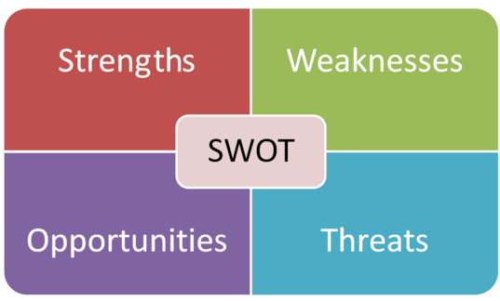
Interviewing skills

Oranizing something
Qualifications

Getting my driving licence
Getting a job
Punctuality
Giving ideas
Teamwork
Helping others
Computer skills
Active listening
Time management
Driving licence
A SWOT analysis is a technique used to determine and define your Strengths, Weaknesses, Opportunities, and Threats
Strengths are things that your organization does particularly well or in a way that distinguishes you from your colleagues in a particular job role.
Weaknesses are what to improve and what you think you should avoid.
Opportunities are a chance for something positive to happen but you will need to find a way to achieve this.
Threats include anything that can have a negative impact on your business such as supply problems, or a shortage of recruits.
It's important to focus on threats and to take action against them and know what to solve this issue. (https://www.mindtools.com/pages/article/)
Following this class exercise by Tim Hopkins he showed me a method which is useful so I have created the ‘Eisenhower method’ which is a table that describes all the tasks that is important and not important.
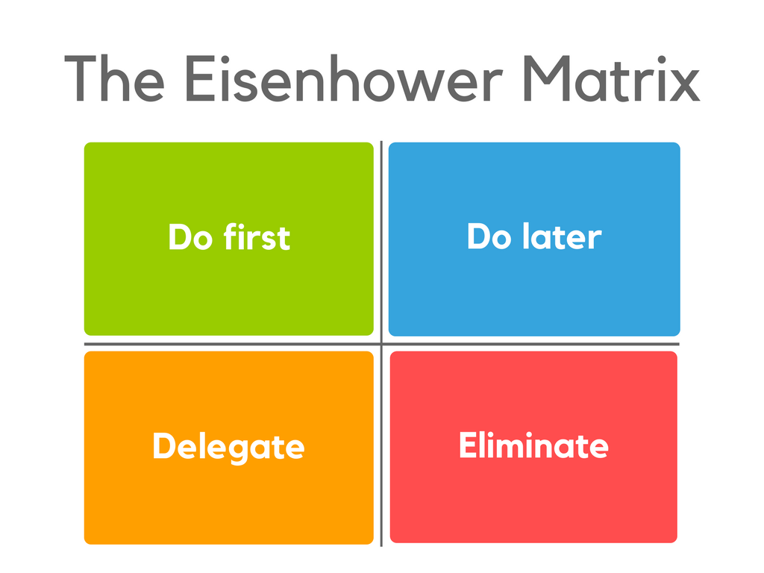
clean the house
Doctors apponitment
Doing house shopping
Making dinner
Doing the school runs
Going out with friends
Listening to music
Getting assignments done

Getting my brother ready for school
Shopping online
Watching movies
Attended class on time
Finding a job
Clean the house
dccd
C
here
This method explains the list tasks that are evaluated by using the criteria that is important and unimportant and put in according quadrants
Tasks in unimportant/not urgent are dropped tasks in important/urgent are done immediately and personally tasks in unimportant/urgent are delegated and tasks in important/not urgent get an end date and are done personally.

12. Discussion
During the class exercise I have created some methods to help me with this report such as my Personal Development Plan, SWOT and Eisenhower method. This will help me work through my abilities and skills that I need to improve on to achieve my goals.
Following my Personal Development Plan this helps me understand what skills I have and what to improve in order gain more knowledge and plan my goals for my career.
I have also created my Eisenhower method where I have given list of examples on what is Important and not important.

I have given my own list of examples for my SWOT analysis so this shows me what my strengths, Weakness Opportunities and threats are.
13. Conclusion
Following this report this shows my understanding about the concept of academic skills and the purpose of it.
We have learnt a lot about what is the purpose of academic skills and some of the skills they require.
I have created some method which can help me develop my own abilities in order to apply for different job roles.
I also looked at the similarities between paraphrasing a text and summarizing to show understanding of summarizing.

14. Recommendation
In order to learn new skills based on communication skills I need to be confident to speak if I am working with a group of people.
I need to also learn time management so that I can finish my work on time, making sure I prioritize my work.
I need to do some training course in order for me to improve this.
15) Reference list:
Morgan, P (2017) The business student’s guide to study and employability. London Sage
SkillsYouNeed (2020) Writing skills Available at http//www.skillsyouneed.com/writing-skills.html) Access 10.05/2020)
http//www skills you need.com/ Active liistening-skills.html Access 10.05.2020)
(https://www.mindtools.com/pages/article/paraphrasing-summarizing.html) Accessed: (https://www.skillsyouneed.com/general/employability-skills.html)
Accessed 10.05.2020
10.05.2020
(https://www.skillsyouneed.com/general/transferable-skills.html)
Accessed 10.05.2020

(https://libary.lrrds.ac.uk/info/14011/writing/106/academic_ writing) Accessed 2020)
(https://www.mindtools.com/pages/article/swot analysis) Accessed: 2020)

(https://www.productplan.com/glossary/eisenhower-matrix) Assessed10.05.2020)
(https://www.jobisjob.co.uk/nursery-assistant/job-description) Case study Assessed 10.05 2020)

