Plan A at Marks and Spencer- Does it deliver on CRM?

BEN NSUKA
University of Wales Trinity Saint David
1816136

Understanding and Engaging in the Customer Experience (BMSW5103_CARD)

Abstract
Customer Relationship Management helps organisations focus on the relationships with their customers, service users, colleagues, or suppliers. CRM is not just for sales, although CRM software literally helps to boost sales (Plaksij, 2021).
Customer relationship management can be understood as a technology for managing all company's relationships and interactions with customers and potential customers. This helps companies stay connected to customers, streamline processes, and improve profitability.
At Marks and Spencer, Customer relationship management means to conduct a post-implementation review using a software to meet productivity targets and help in coping with the large number of inquiries.
Marks & Spencer launched Plan A in January 2007, setting out 100 commitments to achieve in five years. In 2012 they extended Plan A to 180 commitments to achieve by 2015, with the ultimate goal of becoming the world's most sustainable major retailer. In 2014 they launched Plan A 2020 with 100 new, revised, and existing commitments. Through Plan A, M&S is working with its customers and suppliers to combat climate change, reduce waste, use sustainable raw materials, trade ethically, and help customers to lead healthier lifestyles.
'We are only as strong as the communities in which we trade, so it makes good sense for us to be a fair partner – paying a fair price to suppliers, supporting local communities, and ensuring good working conditions for everyone involved in our supply chains' (My Learning, 2020).
A 2012 annual report about the famous Plan A can be resumed as follows:
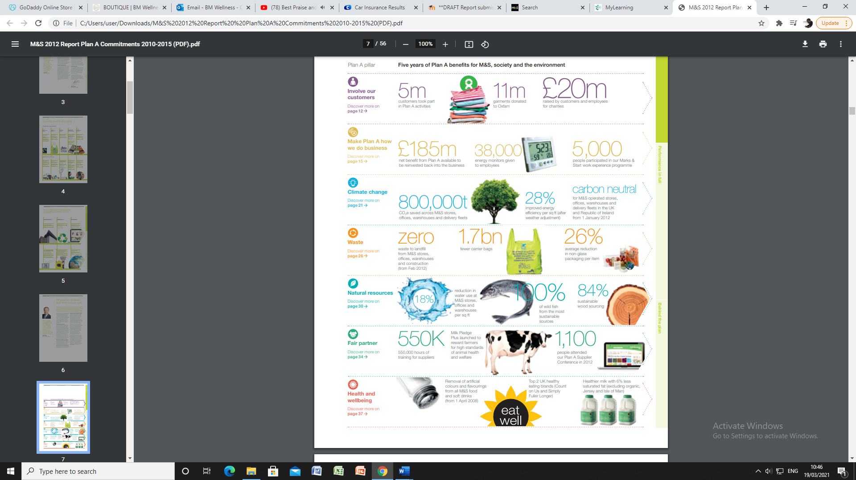
Contents
Abstract 1
Introduction 4
Main Findings 5
Building Customer Relationships 6
Segmentation 9
Ethics & Sustainability 11
Quality Management 14
Conclusion 18
Options/Recommendations 19
Reference List 20

Introduction
This report was requested by lecturer Christian Felices on 20 February 2021. It is compiled by Ben Nsuka (1816136) and must be submitted via Turnitin on 19 March 2021 by 3 pm.
The purpose of this report is to describe what the term ‘Customer Relationship Management’ means at Marks and Spencer and investigate Marks and Spencer’s customer relationship experience.
All the efforts have been made to find academic references to back up this report using the online library, journal articles as well as official websites.
Due to the COVID-19 regulations, we have been unable to visit local libraries to get access to books, but despite that, all the effort was made to present the present report.

Main Findings
The story of Marks & Spencer (M&S) began with one figure, Michael Marks, as a young man, he fled his hometown of Slonim (the Russian Poland) for a new life in Britain to escape anti0Semitic persecution. It was a precarious new beginning: Michael spoke no English, had no money, and knew no trade – nor was he physically strong (Chislett, 2009).

Marks & Spencer started in 1884 as a stall in an open market in Leeds, Yorkshire. Then known as Marks’ Penny Bazaar, it was the household goods, haberdashery, toy, and sheet-music business of Michael Marks, a Jewish refugee from Poland. His sign read “Don’t ask the price—it’s a penny.” In 1894 he took Thomas Spencer as a business partner. Marks’s son Simon transformed the business from several outdoor stalls in various markets in northern England to several indoor shops, and he launched the company’s St. Michael brand name—a popular label for decades. In 1988 the parent firm, Marks and Spencer Group PLC, purchased Brooks Brothers, the oldest U.S. clothing retailer, but it sold that division in 2001. By this time, the company operated more than 300 retail outlets in the United Kingdom—known colloquially as “Marks and Sparks”—with additional stores in dozens of other countries, including France, Germany, Spain, and Hong Kong; a decade later the number of U.K. shops had more than doubled to some 700 (Eldridge, 2020).

Marks & Spencer brought revolution in Clothing, Home and Food after World War II, and has now become one of the UK’s leading retail chains with a unique market position. The recent statistics show that M&S operates 1,035 UK outlets and 428 international stores in 57 countries, with over 80,000 employees ready to serve the millions of customers worldwide (M&S Corporate Archive, 2019).

The above-mentioned facts indicate that M&S has built a strong customer relationship which made its business efficient, despite a few areas of weaknesses that we will elucidate in this report.

Building Customer Relationships

At its core, customer relationship management is all the activities, strategies and technologies that companies use to manage their interactions with their current and potential customers. A saying frequently heard and said in many businesses is "customer is king."
Customer relationship management helps businesses build a relationship with their customers that, in turn, creates loyalty and customer retention. Since customer loyalty and revenue are both qualities that affect a company's revenue, CRM is a management strategy that results in increased profits for a business. At its core, a CRM tool creates a simple user interface for a collection of data that helps businesses recognize and communicate with customers in a scalable way. Customer relationship management is simple. However, it can be implemented in a huge array of methods: websites, social media, telephone calls, chat, mail, email, and various marketing materials can all be integrated into a CRM solution. Due to CRM's diversity, it does not only benefit larger businesses -- using and maintaining a CRM tool is the basis for a scalable sales and marketing system. Any company will benefit from maintaining a record of which conversations, purchases and marketing material can be associated with leads and customers (Kulpa, 2017).
Customer relationship management is the process of managing all aspects of interaction a company has with its customers, including prospecting, sales, and services. Customer relationship management applications attempt to provide insight into and improve the company/customer relationship by combining all these views of customer interaction into one picture. It is an integrated approach to identifying, acquiring, and retaining customers. By enabling organisations to manage and coordinate customer interactions across multiple channels, departments, lines of business. This also helps organisations maximise the value of every customer interaction and drive superior corporate performance (Buttle and Maklan, 2019).

An article by Sales Force (2020) states: “Customer Relationship Management is a strategy for managing all the company's relationships and interactions with customers and potential customers. It helps improve the company’s profitability. More commonly, when people talk about CRM they are usually referring to a CRM system, a tool which helps with contact management, sales management, workflow processes, productivity and more.”

M&S is doing all the effort to manage customer relationship in different manners. The article below from M&S (2018) will tell us more about.
Marks & Spencer today announces the appointment of data science company, Starcount, as part of its ongoing programme of change under its five-year transformation plans. The partnership will help enhance customer understanding and insight through personalisation of M&S’ loyalty and CRM programmes including M&S's Sparks Card.
Sparks, which currently has over 6 million members, is a key tool for customer insight and engagement and central to helping M&S become a digital-first retailer. Starcount, led by Edwina Dunn and Clive Humby, will utilise its pioneering and innovative approach and technology to map out customer passions in order to predict future buying behaviour.
Starcount’s appointment follows a Marketing Team restructure last month to ensure that the team is more closely aligned to the strategic priorities of the business. Marketing and customer engagement play a significant part in M&S’ transformation ensuring it is faster, more commercial and acutely focused on our customers.
Rob Weston who was appointed Marketing Director, Brand & Customer as part of the restructure, said: “I am really looking forward to working with Starcount in my new role. Sparks plays a huge part in helping with our transformation and having the best partners will enable us to focus on achieving a seamless experience for our customers.”
Edwina Dunn, CEO, Starcount, said: “We are delighted to be working with M&S and partnering with them on predicting their customers’ wants and needs. Starcount’s expertise is the science of purchase and intent, understanding the ‘why’ behind M&S customer purchases to help deliver growth, profitability as well as a seamless customer experience.”

Business benefits of using CRM
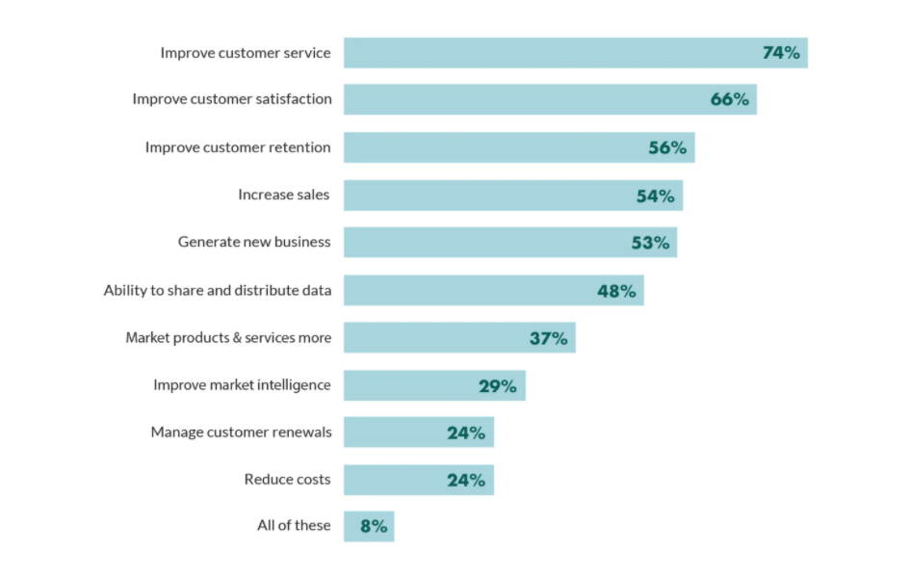
Despite the productivity issues, M&S is happy to apply effective CRM software to track customer inquiries and respond to them more quickly and effectively. This helps to review all written letters are now scanned electronically, which means we can avoid embarrassing situations where we lose a customer's record of complaint.
To increase customer loyalty, trust and satisfaction amid increasingly competitive business environments, organisations are looking to customer relationship management to help provide a solution. Despite Customer relationship management failure rates cited as being as high as 70%, organisations continue to invest a lot of money on Customer relationship management implementations. Attempts of past research to resolve why failure rates are so high have tended to focus on technological factors such as database integration or factors internal to the organisation such as system adoption or organisational culture. While these areas are important, reactions of customers may also play a role (Wetsch, 2005).
Some advantages and disadvantages have been registered on the account of Customer relationship management, such as:
Advantages | Disadvantages
- Identifying key customers.  - Developing appropriate. relationships with key customers.  - Establishing customer segments.  - Creating additional shareholder value.  - Identifying needs to minimise lead times.  - Increase customer satisfactions.  - Adding values to the interaction with customers.  Bock (2010) | - New customers are treated as a secondary commodity.  - Negative information can ruin a relationship marketing campaign.  - It takes time for relationship marketing to be effective.  - Relationships can become to close sometimes.  - Value propositions change over time, so the marketing efforts need to change too.  - It can require a culture change.  - Some returning customers may expect a discount.  Gaille (2016)

Segmentation
Market segmentation is a decision-making tool for the marketing manager in the crucial task of selecting a target market for a given product and designing an appropriate marketing mix. It is one of the key building blocks of strategic marketing. Market segmentation is essential for marketing success: the most successful firms drive their businesses based on segmentation, because market segmentation lies at the heart of successful marketing.

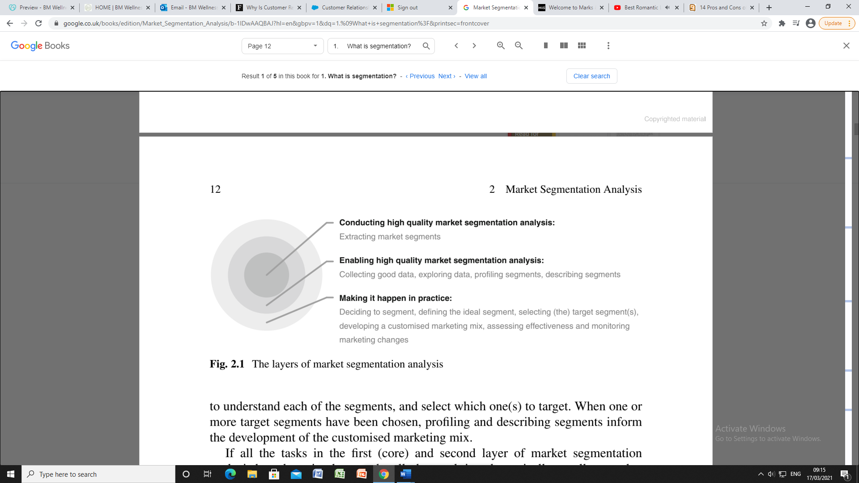
To compare to M&S main rival Tesco, the market segmentation analysis below is applied to target potential customers:
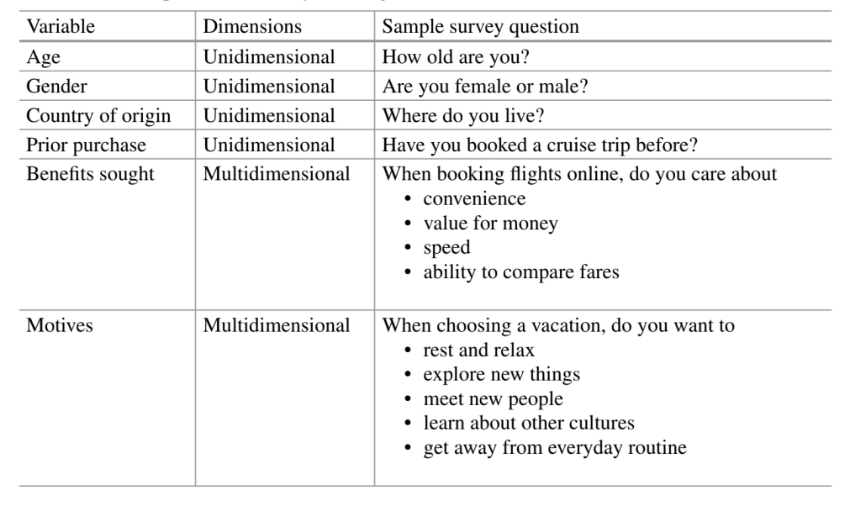
To ensure that the grouping of consumers is of the highest quality, a number of additional tasks are required. All these tasks are still primarily technical in nature. Collecting good data, for example, is critically important. The statiscal segment extraction process at the core of market segmentation analysis cannot compensate for bad data. The grouping of consumers can always only be as good as the data provided to the segment extraction method.
Upon completion of data collection, but before the actual segment extraction takes place, the data needs to be explored to gain preliminary insight into the nature of the market segmentation study that can be conducted using the data. Finally, after consumers have been grouped into market segments, each of these segments needs to be profiled and described in detail.
This market segmentation analysis is explained step-by-step in the image below:
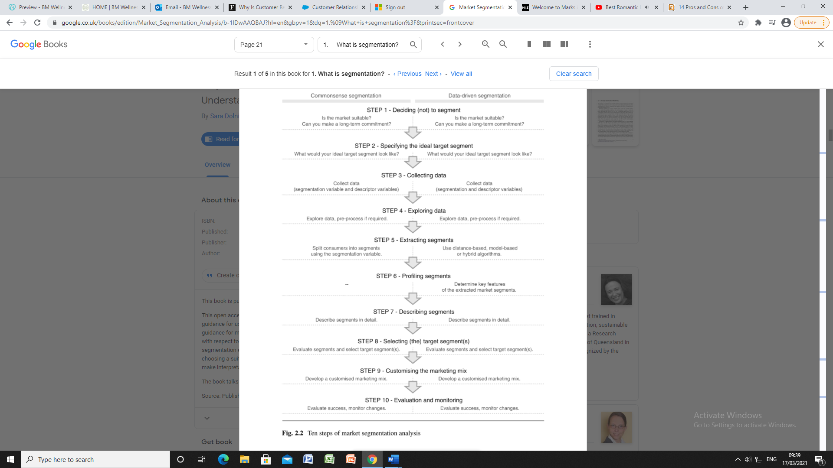
At the same time, consumers belonging to different market segments are very different from one another with respect to those consumer characteristics. Consumer characteristics deemed critical to market segmentation by management are referred to as segmentation criteria (Dolnicar, S. et al., 2018).
The view about touchpoints is divided. Some suggest experience, others suggest interaction and type. In the case of M&S, the touchpoint applied is interaction with customers (Ozwem And Bowen, 2016).
Segmentation improves business relationships with customers, specifically focusing on ultimately driving sales growth and customer. For a company to grow and increase its revenue, it needs to compete for the more profitable customers. Businesses are using CRM to add value to their products and services, which will allow them to attract the more profitable customers (Piuri et al., 2020).

Ethics & Sustainability
Shopping with a conscience. In recent years, pressure from consumers and NGOs had led to a growing number of products being labelled according to their ethical as well as their physical ingredients (Bishop, 2016).
Each M&S’s store has an annual budget which allows it to donate to local charities at its own discretion. At the other end of the scale is the support that M&S gives to its selected charities, notably Breakthrough Breast Cancer, Oxfam, Groundwork and WWF (Chislett, 2009).
The above lines confirm that M&S does stick to its statement of “Here to help” and keeps to its ethics in this matter.
M&S Plan A is a multi-year sustainability transformation plan that has been updated several times (2010, 2014 and 2017) to reflect the evolution of its business and the risks and opportunities that social and environmental issues pose for the organisation.
The business transformation programme aims to return M&S to sustainable, profitable growth and to deliver long-term value for all stakeholders. Our priority in 2019/20 has been to evolve Plan A to reflect our new operating model and to embed the programme into the core strategy rather than continuing to exist in parallel with our operations. Over the past year we have:
- Begun the transition to a new Plan A operating model to embed sustainability into our business units.

- Conducted a detailed review of Plan A considering the views of colleagues, customers, shareholders, pressure groups and campaign bodies, and conducted a benchmarking exercise against the wider consumer goods and retail sector.

- Created a simplified framework that:
  - Is aligned to the business strategy;
  - Has clear deliverables owned and actioned by each business unit;
  - Maintains our position as a committed sustainable retailer; and
  - Provides a programme to build competitive advantage in selected areas and to engage our customers on the issues that matter to them.

Towards the end of this process, the business’s focus was rightly on managing the impact of Covid-19 pandemic on colleagues, customers, and communities – particularly the most vulnerable and healthcare workers. Therefore, confirmation of Group level governance and sign-off of targets will now be completed in 2020/21 (M&S, 2020).
Going through a deep study and analysis of the above-mentioned plan A by M&S, we can agree that M&S is non-consequentialist, as it does not care for people, employees, and nature. This also display the image of what they are.
The lines below will explain how M&S is currently utilising the 2 ethical approaches:
Listening, learning, responding, and working in partnership is an important part of how we do business.
Many Plan A issues are too large or complex for us to tackle alone, so it is vital that we work with others. Our external partners have already provided solutions, improved our understanding of issues, and helped us inspire our customers.
To give just two examples, Oxfam is helping us encourage clothes reuse and recycling through shwopping, while WWF has helped us tackle environmental issues associated with water, cotton, wood, fish, and sourcing of palm oil (M&S, 2020).

Despite the self-praises by M&S, several articles are showing that M&S is not ethical. The evidence is that much research highlight ethical issues with M&S, awarding them negative marks as for their stand on climate change, human rights, the rights of the workers, the rights of animals, factory farming, irresponsible marketing, anti-social finance, controversial technologies, and political activities.
Although M&S came up more positively in some categories, however, even getting Best ratings in some of the same categories that they lost marks in, for example, environmental reporting, habitats and resources, palm oil policy, pollution and toxics and supply chain management.
However, several issues have been reported by other organisations. This includes an investigation by The Guardian and Repórter Brasil, showing that a supplier to M&S (JBS, one of the world's largest meat processing companies), purchased cattle from a farm under investigation in Brazil for using workers as modern-day slaves. JBS says it ceased buying from the farm on discovering the alleged link to labour abuses. M&S was one of several UK retailers said to have sold tinned corned beef produced by JBS.
Ethical Consumer's own research found that M&S had operations in several countries considered by Ethical Consumer to be governed by oppressive regimes. This included India, Kazakhstan, Libya, Philippines, Russia, Saudi Arabia, Thailand, and Vietnam.
Marks and Spencer have a mixed record on animal rights. For example, the company was ranked highly in the 'Business Benchmark on Farm Animal Welfare' (BBFAW) for its Policy on Farm Animal Health and Welfare, along with its approach to supplier engagement. The company was said to "provide a consolidated and organised account of their approach to farm animal welfare." However, the company still sells leather, silk, and merino wool.
The company was found by Ethical Consumer to have:
- a holding company based in Hong Kong with subsidiaries in Hong Kong, Macao and Cambodia
- another holding company in Hong Kong with subsidiaries in China and a holding company in Singapore with a subsidiary in India
- six companies based in Guernsey
- seven companies in Jersey
- six companies in Singapore
Marks and Spencer had a tax statement that stated that the company intended "to manage our global tax affairs in a manner that is in keeping with our longstanding values and aligned to our shareholders’ interests" and which ensured that "any tax planning is based on commercial business activity" (Ethical Consumer Team, 2020).
Linking into the ethical and sustainability side of things, we can agree that M&S do use business intelligence to come across customer satisfaction, the same way does Tesco. M&S have embarked on their sustainability revolution by shifting their focus from mere compliance and philanthropy to attaining a sustainability edge and explicates the transformation from traditional business models to sustainable business models (Dhanda, U. and Shrotryia, V.K., 2020).
On the other hand, Marks & Spencer are certified by SEDEX Members Ethical Trade Audit who look at universal human rights in business practices and global supply chains. M&S are on a quest to be a leader in the abolishment of Modern Slavery, human trafficking, and all forms of discrimination from their business, although the animal rating of Marks & Spencer is the brand’s lowest rating at ‘It’s A Start’. The brand uses leather, down and cashmere without being transparent about its sources. However, they do comply with the Responsible Wool Standard with their use of wool. Plus, M&S has taken the step not to use fur, angora, and other exotic animal skins! Here is hoping they keep it this way (Brown, 2018).

Quality Management

Quality management is the act of overseeing all activities and tasks needed to maintain a desired level of excellence. This includes the determination of a quality policy, creating and implementing quality planning and assurance, and quality control and quality improvement. Quality management requires that all stakeholders in a business work together to improve processes, products, services, and the culture of the company itself. In general, quality management focuses on long-term goals through the implementation of short-term initiatives (Barone, 2020).
Answering to the question either people are the ones ignoring the quality or it is what they think they know that is the problem, Crosby (1926-2001) said: “People say things like the workers are the problem with quality. That is not true. Workers pretty much do what management tells them to do. People think that quality is some undefinable thing that you only know when you see it. Yet quality requirements are clear. They talk about vague things like delighting the customer, but you cannot tell people what that really means, so you cannot manage that way. They think that error is inevitable, that as long as humans are involved, you will have mistakes. These things are only true when management makes it happen that way. And if you are going to be a quality leader, you must be able to explain to people what you want, have an agenda, and have measurements… Quality is conformance to requirements, not goodness. That means that we are going to make it very clear what we are going to give the customer, internal or external. We are going to all row in the same direction. As we get smarter, we are going to improve the requirements (Stevens, 1995).
Referring to Crosby, Slack (2007) inferred that quality is conformance to requirements, with focus on zero defects. However, implied quality management to be the totality of features and characteristics of a product or service that bear on its ability to gratify given needs. Implicit in this assumption is a person with needs and objectives to be satisfied. Quality is a measurable effect; quality management improvement is more about the trip than the result. What we do and how we do it establishes quality and the actionable elements of quality involve the procedure rather than the outcome. Top quality reduces the cost of rework, waste, claims and returns and most importantly, creates satisfied customers.
Most organisations including M&S make an effort to continue to gratify or meet their customer requirements. M&S over years have constantly developed and sell quality products with their consumers. That is reflected as they continue steadily to dominate their industry and the actual fact that consumers is convinced that whatever they obtain M&S, it is essentially an excellent item. Total Quality Management is a continuing process and must have the contribution of everybody in the organisation from the corporate leadership right down to the shop floor personnel for the organisation to keep meeting their responsibility in delivering quality. Organisations with quality expectations and awards must regularly review their processes and find ways to continue steadily to improve to be able to maintain their market show and most essentially their success and competitiveness. (Test My Prep Team, 2010).

On this matter, some feedback is done through internet surveys and some directly with M&S customers using survey forms to help M&S examine areas of improvement. And based on the customers’ survey, it is strongly believed that quality of services and products is M&S's competitive edge.
M&S is controlling and monitoring its business practices by using surveys and questionnaires to adapt to Brexit and climate change as well as the Covid-19 requirements. This helps the organisation to quickly identify and effectively respond to the challenges of the above-mentioned factors to keep the smooth running of the business and customer satisfaction.
Measures have been put in place to offer a safe contactless delivery, as read in this article from M&S (2020): “We have now introduced contact-free home delivery for all clothing, home, flowers, hampers and wine orders. This gives the option of no hand-to-hand contact and the driver can leave the delivery safely at your door. You do not need to take any action to enable this. Our couriers are offering this as standard.”
Adhering to social distancing measures and the government regulations about the Covid-19, M&S is doing better in protecting its employees, its customers as well as the communities where it operates.
In a recent update, M&S (2020) sates: “It is mandatory for customers to wear face coverings in stores across the UK, with the exception of young children or people with certain health conditions. M&S colleagues are required to wear face coverings in England, Scotland and Wales. As with customers, the government has made some exceptions for colleagues. In our M&S cafés, it is a legal requirement to wear face coverings when not seated. Customers do not wear face coverings when seated to eat or drink.”
Another recent update from M&S (2020) infers: “We are closely following expert health guidance and have put in place additional social distancing and extensive hygiene measures to keep all of our hard-working colleagues healthy and well at work. This includes changes at our distribution centre, which supports our online and delivery operations.”

M&S and change management.
The importance of being able to embrace and manage change cannot be underestimated (Palfrey, C. et al., 2018).

M&S is also using its Siebel database to assist food and textile technologists with the research and development of new products and services (Thomas, 2002).
By doing so, the organisation is working hard to improve trading performance, business transformation, food online joint venture, food safety and integrity, corporate compliance and responsibility, technology capability, information security, business continuity and resilience, third party management, treasury and funding, brand loyalty and customer experience. This is made possible by using:
- A Data Governance function, overseen by the Data Governance Steering Group.
- Mandatory data protection training for colleagues, including responsibilities for the use of personal data in compliance with GDPR.
- Dedicated Cyber Security function, comprising a multi-disciplinary team of cyber security specialists, with 24/7 monitoring and defence tools.
- Established security controls, including policies and procedures and adoption of security technologies, subject to periodic independent testing and improvement.
- Completion of a comprehensive maturity review by an independent consultancy during the last financial year covering network security, identity and access management, security software development, and project and programme assurance.
- Third-party cyber maturity assessments performed and periodically refreshed. Targeted reviews of third-party control compliance.
- Ongoing monitoring of developments in cyber security threats, engaging with third-party specialists as appropriate.
- Periodic penetration testing by Internal Audit (M&S, 2019).

M&S does utilise Strategy and Skills Models, which have set M&S apart, especially during this coronavirus pandemic. This has been well managed with the organisation partnership with Ocado, which has enabled M&S to be highly rated for its professionalism in delivery speed. Customers are happy to meet their demands.
Using Skills Model, M&S is relying on its employees’ capability to demonstrate their knowledge and experience to manage international market thanks to technology.
The article below enlightens the fact that M&S is leading ahead in terms of online shoppers’ satisfaction with food delivery.
Ocado said shoppers had responded positively to its new grocery partner, with demand for M&S food, including its popular ready meals and bags of Percy Pig sweets, driving both an increase in the number of products in customer baskets and strong forward demand.
The M&S launch has been closely watched by the retail industry after Ocado and Waitrose ended a 20-year partnership.
When the tie-up with M&S was announced, some analysts suggested the online grocer risked a customer exodus as shoppers were loyal to Waitrose and did not see M&S products as an adequate replacement. Waitrose has embarked on a marketing push of its own to persuade customers to move to its website.
The initial range of 4,400 M&S food products replaced about 4,000 from Waitrose, with the online grocer billing them as high-quality alternatives at the same or better prices (Wood, 2020).
Speaking of 6-sigma, it is a relatively new concept as compared to Total Quality Management. However, when it was conceptualized, it was not intended to be a replacement for Total Quality Management. Both 6-sigma and Total Quality Management have many similarities and are compatible in varied business environments, including manufacturing and service industries. While Total Quality Management has helped many companies in improving the quality of manufactured goods or services rendered, 6-sigma has the potential of delivering even sharper results (Project Management, 2019).
Referring to the above lines, it is doubtlessly believed that M&S is using 6-sigma to TQM.

Conclusion
The SWOT analysis of the factors that influence their current CRM in terms of strengths and weaknesses is presented in the table below.

Strengths | Weaknesses
- Strong offerings in line with latest industry trends  - Strong e-commerce infrastructure  - Highly effective corporate social responsibility  - Strong focus on enhancing customer experience | - Poor financial performance  - Too much reliance on UK markets makes it vulnerable to market conditions in the local country  - Future of M&S in China gone for a toss  - Frequent product recalls lead to loss in customer confidence

The above SWOT analysis illustrates the areas to work on to implement market segmentation and presents challenges that the organisation faces for its growth and success (S&P, 2020).

Options/Recommendations
Based upon the above conclusions, we have come up with following recommendations for M&S to improve its Customer Relations and its CRM:
- Focus on core competencies: M&S should identify the core competencies and outsource the rest. Outsourcing basic business task frees up the staff to focus on what they are good at. Bringing the specialist will usually means faster execution.
- Go East: Focus should be placed on Asia where the organised retail sector is growing and there is potential of growth.
- Strengthen M&S Sparks: Make club cards available and open to everyone to allow customers shop, shwop or write a review to collect sparks.
- Offer customers a selective selection of high-quality products.
- Encourage suppliers to keep high quality expectations in production and working environment.
- Store expansion for the convenience of customers, with a larger width of product choice.
- Support the UK industry and purchase abroad only when new ideas, technology, quality, and value are not available in the UK.

Reference List
- Plaksij, Z. (2021) 10 Reasons why salespeople need CRM. Available at: https://www.superoffice.com/blog/why-sales-people-need-crm/ (Accessed: 19 March 2021).

- My Learning (2020) What is Plan A? Available at: https://www.mylearning.org/stories/mands-making-a-mark--plan-a/ (Accessed: 14 March 2021).

- Chislett, H. (2009) Marks in time: 125 years of Marks & Spencer. The Orion Publishing Group, London, p.8.

- Eldridge, A. (2020) Marks & Spencer PLC. Available at: https://www.britannica.com/topic/Marks-and-Spencer-PLC (Accessed: 25 February 2021)

- M&S Corporate Archive retrieved from https://corporate.marksandspencer.com/investors/key-facts (Accessed: 07 March 2021).

Kulpa, J. (2017) Why Is Customer Relationship Management So Important? Available at: https://www.forbes.com/sites/forbesagencycouncil/2017/10/24/why-is-customer-relationship-management-so-important/?sh=42188ea27dac (Accessed: 11 March 2021).

Buttle, F. & Maklan, S. (2019) Customer Relationship Management: Concepts and Technologies. 4th edition, Routledge, New York, p.4

- Sales Force (not dated) Available at: https://www.salesforce.com/in/learning-centre/crm/what-is-crm/ (Accessed: 10 March 2021).

- M&S (2018) Marks & Spencer announces new customer insight partnership. Available at: https://corporate.marksandspencer.com/media/press-releases/2018/marks-and-spencer-announces-new-customer-insight-partnership (Accessed: 5 March 2021).

Wetsch, L.R. (2005) Trust, Satisfaction and Loyalty in Customer Relationship Management. Available at: https://www.researchgate.net/publication/233084660_Trust_Satisfaction_and_Loyalty_in_Customer_Relationship_Management (Accessed: 04 March 2021).

- Bock, M. (2010) The Advantages and Disadvantages of Relationship Management, Grin Publishing, p.4.

Gaille, B. (2016) 14 Pros and Cons of Relationship Marketing. Available at: https://brandongaille.com/14-pros-and-cons-of-relationship-marketing/ (Accessed: 14 March 2021).

- Dolnicar, S. et al. (2018) Market segmentation analysis: Management for professionals, Springer Open Publications, pp.11-22.

- Ozwem, W. and Bowen, G. (2016) competitive social media marketing strategies, Business Science Reference Publications, Hershey, USA, p.40.

- Piuri, V. et al. (2020) Trends in deep learning methodologies: Algorithms, applications and systems, Academic Press, London, p.56.

- Bishop, M. (2016) Economics: An A-Z guide. Profile Books Ltd, London, p.113.

- Chislett, H. (2009) Marks in time: 125 years of Marks & Spencer. The Orion Publishing Group, London, p.215.

- Marks & Spencer (2020) Delivering Plan A. Available at: https://corporate.marksandspencer.com/sustainability/delivering-plan-a (Accessed: 11 March 2021).

Marks & Spencer (2020) Delivering Plan A. Available at: https://corporate.marksandspencer.com/sustainability/delivering-plan-a (Accessed: 15 March 2021).

Ethical Consumer Team (2020) Is Marks and Spencer ethical? Available at: https://www.ethicalconsumer.org/company-profile/marks-spencer-group-plc (Accessed: 16 March 2021).

Dhanda, U. and Shrotryia, V.K. (2020) Corporate sustainability: the new organizational reality. Available at: https://www.emerald.com/insight/content/doi/10.1108/QROM-01-2020-1886/full/html (Accessed: 17 March 2021).

Brown, C. (2018) How Ethical Is Marks & Spencer? Available at:

https://goodonyou.eco/how-ethical-is-marks-spencer/ (Accessed: 17 March 2021).

Barone, A. (2020) What Is Quality Management? Available at:

https://www.investopedia.com/terms/q/quality-management.asp (Accessed: 25 February 2021).

Stevens, T. (1995) Philip Crosby: Quality is Still Free. Available at: https://www.industryweek.com/operations/quality/article/21964139/philip-crosby-quality-is-still-free (Accessed: 16 March 2021).

Test My Prep Team (2010) Quality and Performance Management of M&S. Available at: https://testmyprep.com/subject/business/quality-and-performance-management-of-m-s (Accessed: 11 March 2021).

- M&S (2020) Covid-19 Information. Available at: https://www.marksandspencer.com/c/help/covid-19 (Accessed: 18 March 2021).

- M&S (2020) Covid-19 Information. Available at: https://www.marksandspencer.com/c/help/covid-19 (Accessed: 19 March 2021).

- M&S (2020) Covid-19 Information. Available at: https://www.marksandspencer.com/c/help/covid-19 (Accessed: 19 March 2021).

- Palfrey, C. et al. (2018) The business secret. Penguin Wealth, Cardiff, p.37.

- Thomas, D. (2002) M&S reviews CRM system after drop in productivity. Available at: https://www.computerweekly.com/news/2240044628/MS-reviews-CRM-system-after-drop-in-productivity (Accessed: 10 March 2021)

- M&S (2019) M&S 2019 annual strategic report. Available at:
https://corporate.marksandspencer.com/documents/msar-2019/strategic-report.pdf (Accessed: 10 March 2021).

Wood, Z. (2020) Ocado's market value closes in on Tesco's as online grocer hails M&S switch. Available at: https://www.theguardian.com/business/2020/sep/15/ocado-m-and-s-cancelled-orders-booked-delivery-slots (Accessed: 18 March 2021).

Project Management Online Team (2019) Six Sigma vs. Total Quality Management. Available at:

https://project-management.com/six-sigma-vs-total-quality-management/ (Accessed: 11 March 2021).

- Swot & Pestle Team (2020) Marks & Spencer Swot & Pestle Analysis. Available at:
https://www.swotandpestle.com/marks-and-spencer/ (Accessed: 24 February 2021).

