Assignment Task 2 - Report

Student name: Geminiano (Gio) Aguilar
Programme: BSc/HND Computing (All Streams)
Module: Introduction to Web and Database Concepts
Module code: ACCA4023
Submission deadline: 26th April

Table of Contents:

Introduction……………pg. 1

Requirements…………pg. 1

Implementation……….pg. 2-7

Evaluation……………..pg. 7-8

References…………….pg. 8-9

Appendices……………pg. 9-22

Introduction
I have created a website relating to peace and self-awareness with the use of HTML and CSS. In this report, I will be assessing the requirements, implementation, and evaluation of the website which I have created for this assignment.

Requirements
The purpose of the website that I have created is to make people aware of the importance of peace and taking breaks. I feel like this website could help a lot of people who are struggling to deal with stress as I provide useful information on how to cope. This website is extremely relevant as everyone faces stressful situations every day. I created this website to gently remind people that taking breaks and keeping still for a moment is fine. I have created five different pages that the user can navigate to by clicking on the link for each section. These five different pages are home, peace, gallery, about, and contact. This website is mostly aimed towards adults as they deal with a great amount of stress or to anyone who is struggling to find peace in their life.

Implementation
Screenshots of the pages on the website:
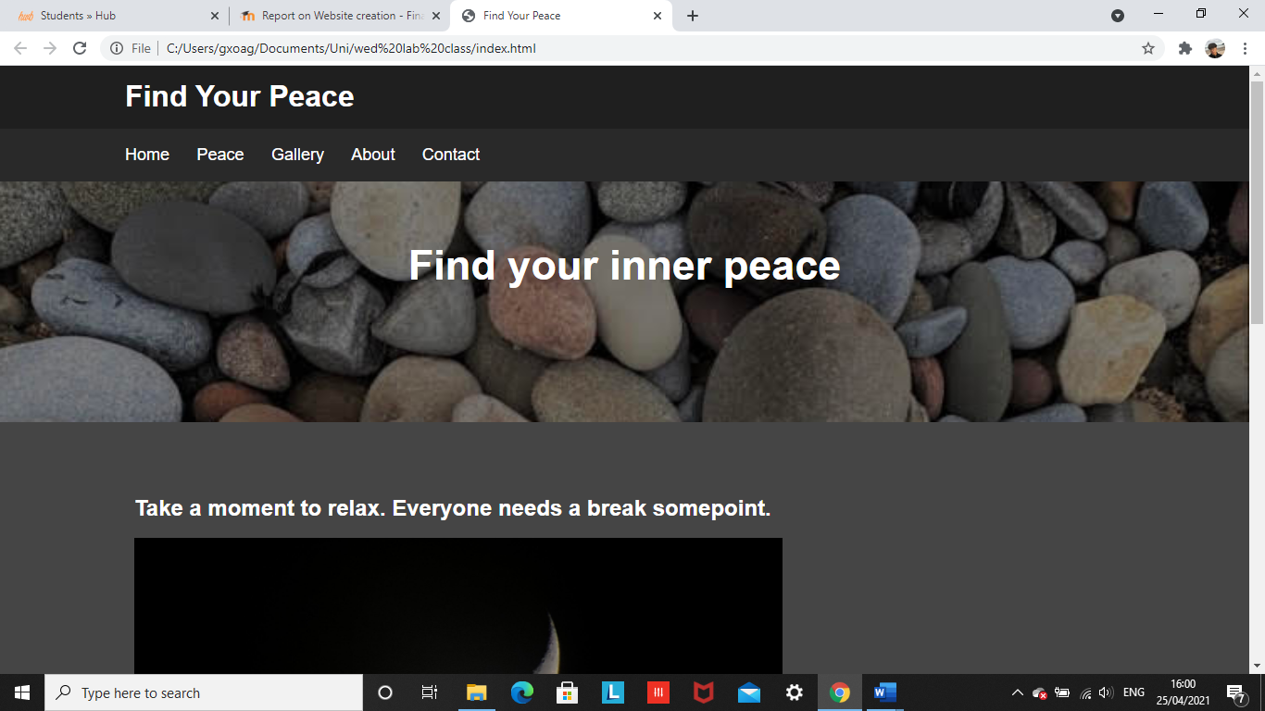
Main page (index.html)

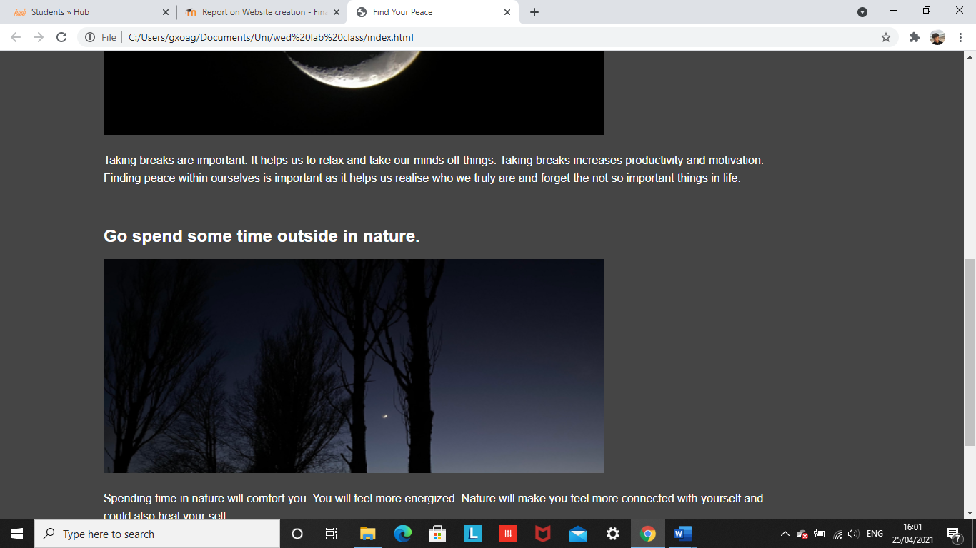
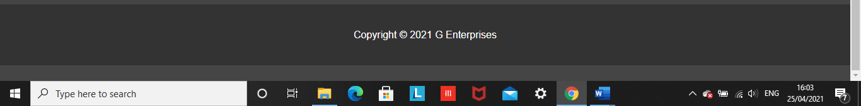

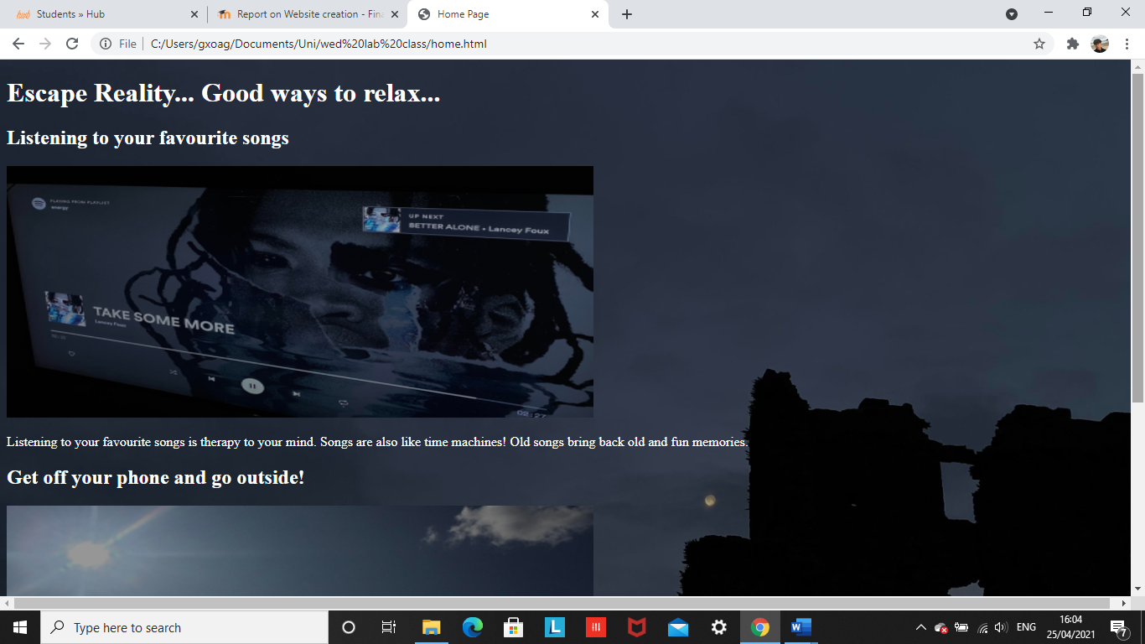
Home page:
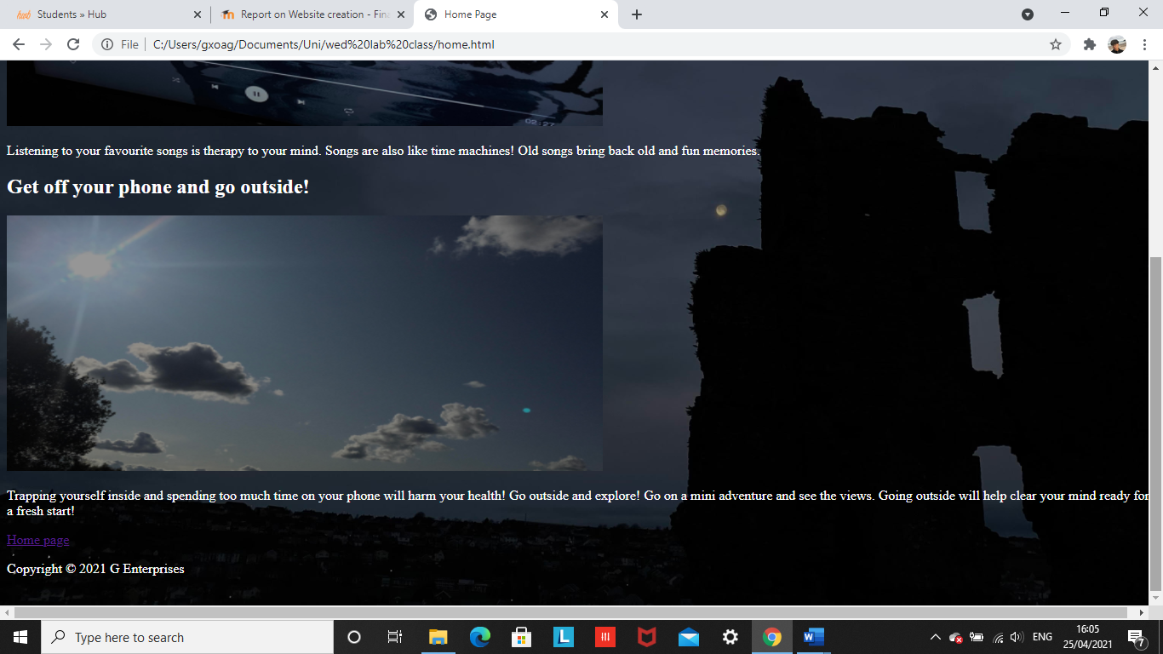

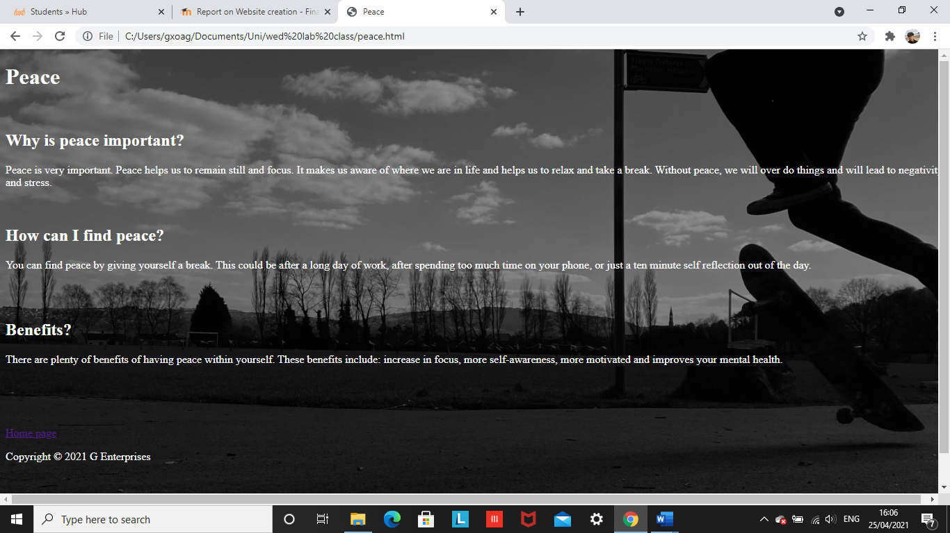
Peace page:

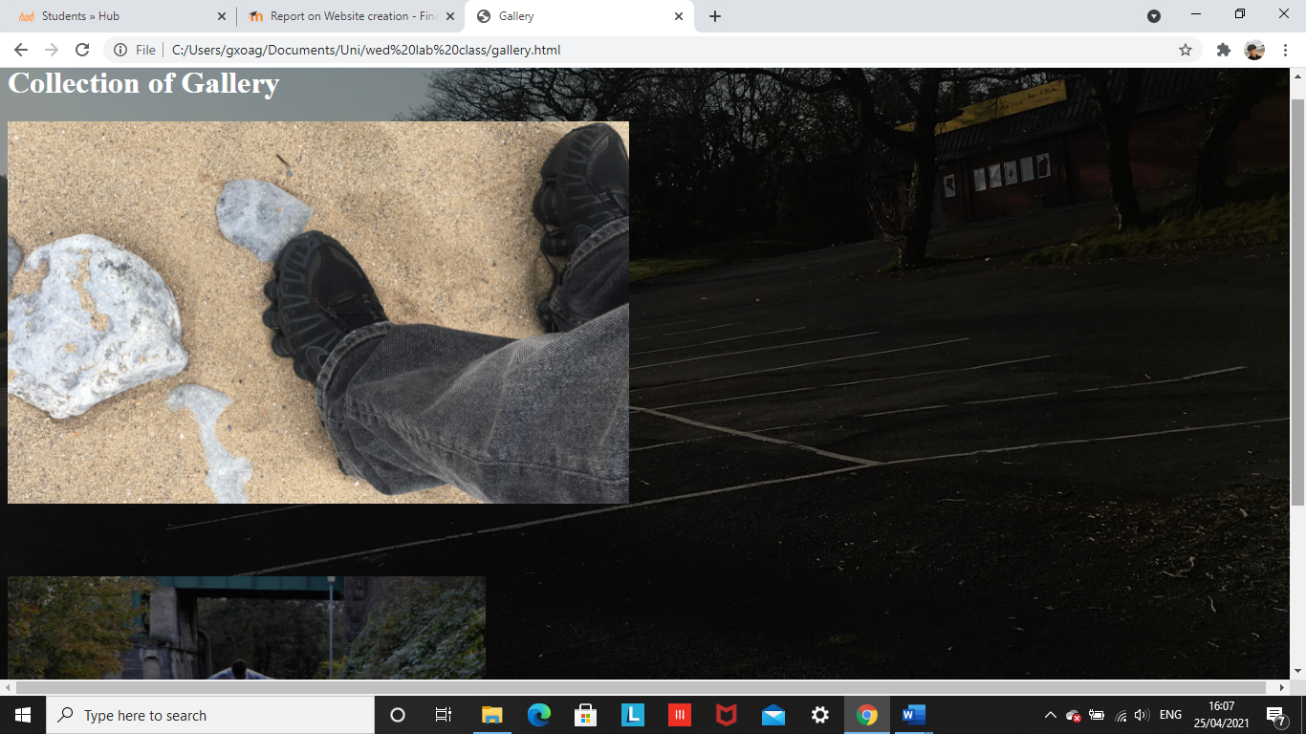
Gallery page:

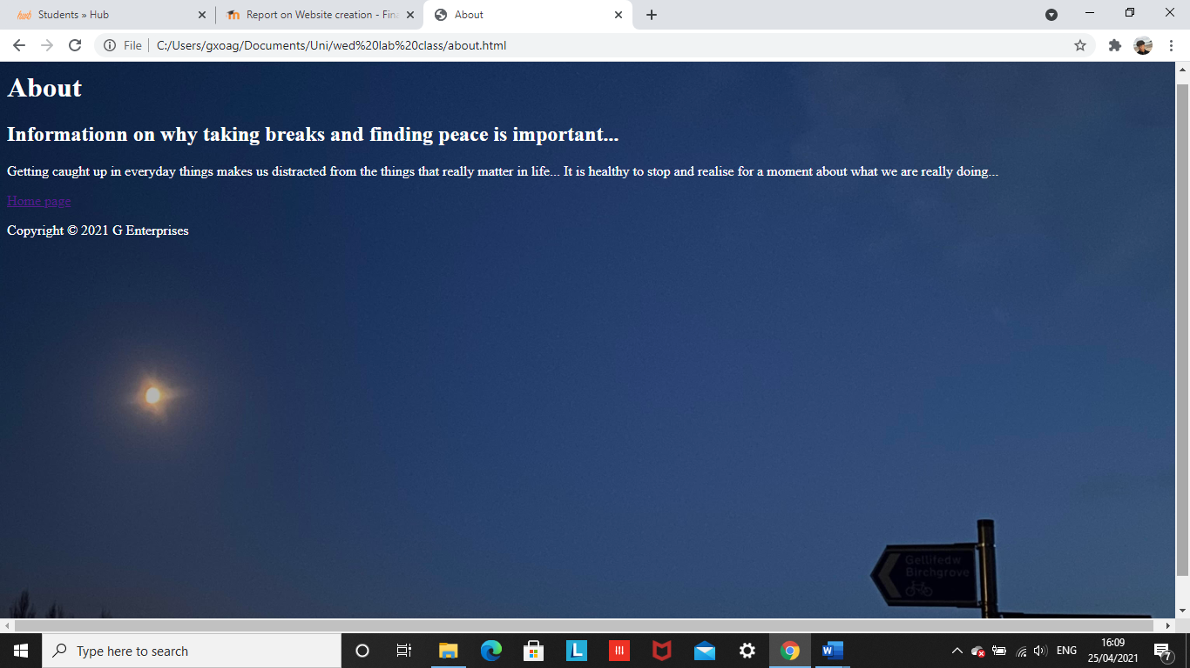
About page:

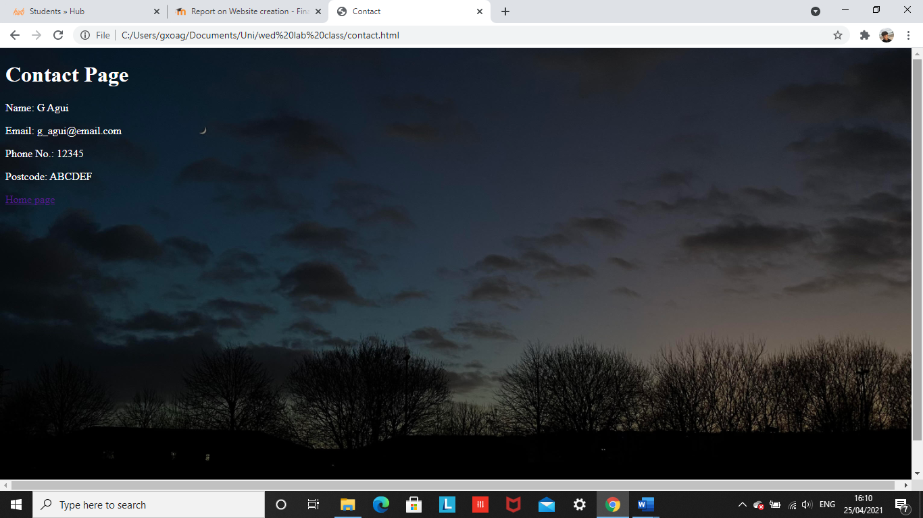
Contact page:

Validation
I used an online validation checker tool to check my HTML and CSS code.
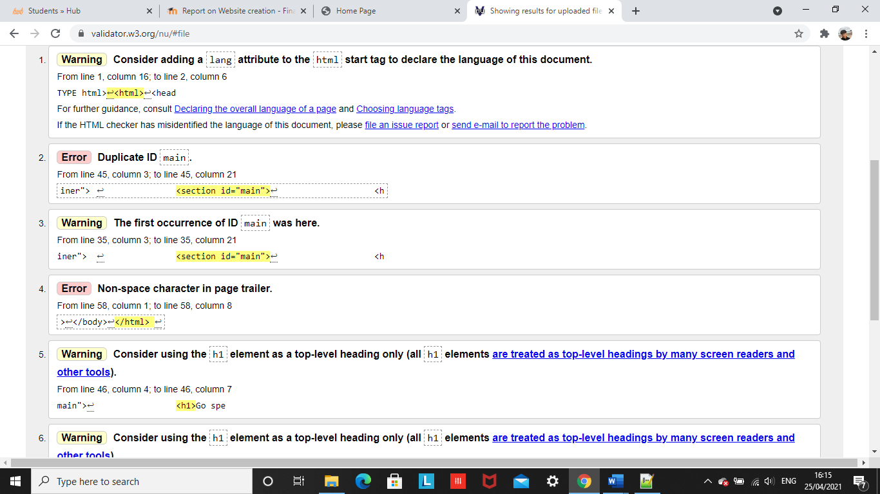
HTML

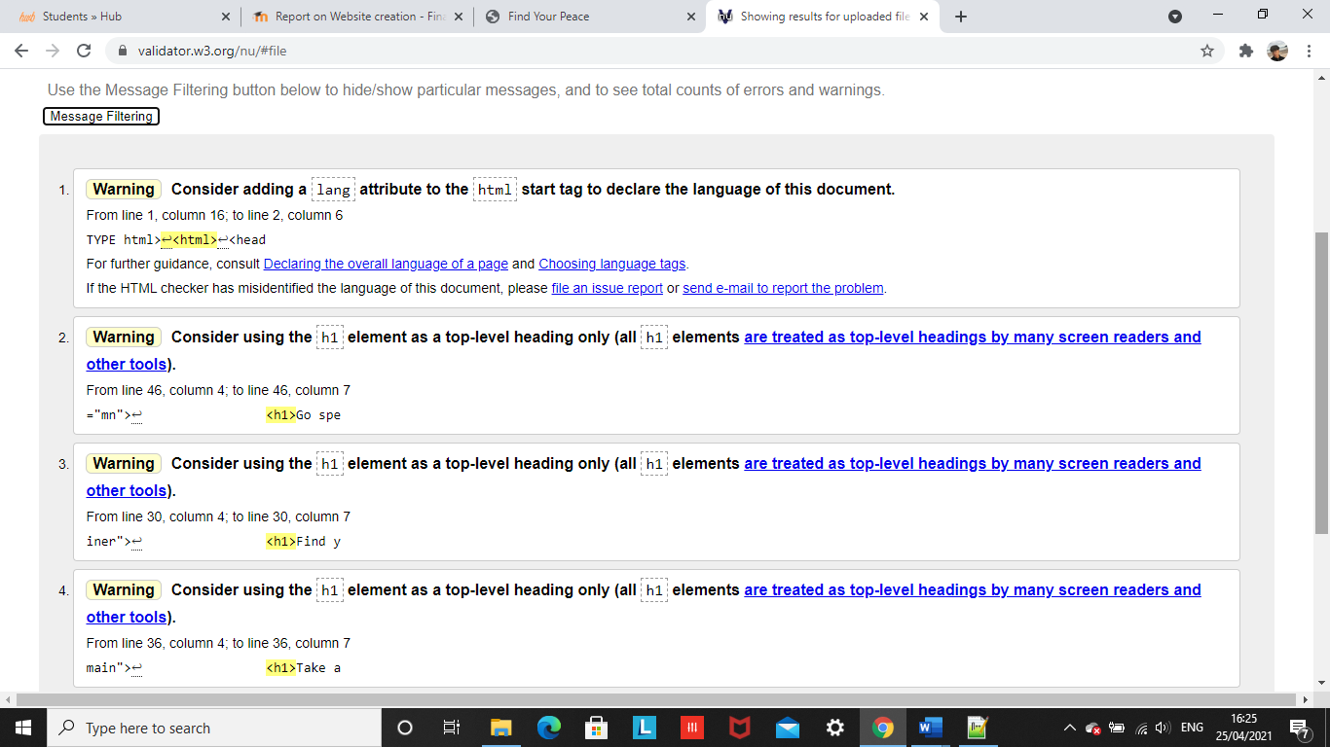
As shown from the results, I had two errors. One error is that I wrote the same ID twice. This can cause problems with creating a website because by using the same ID, the section will just be duplicated. To solve this, I changed the ID to a different name. The second error states that there is an extra character at the end of the html closing tag. To solve this issue, I removed the extra character.

There are now no more errors shown after correction.
CSS
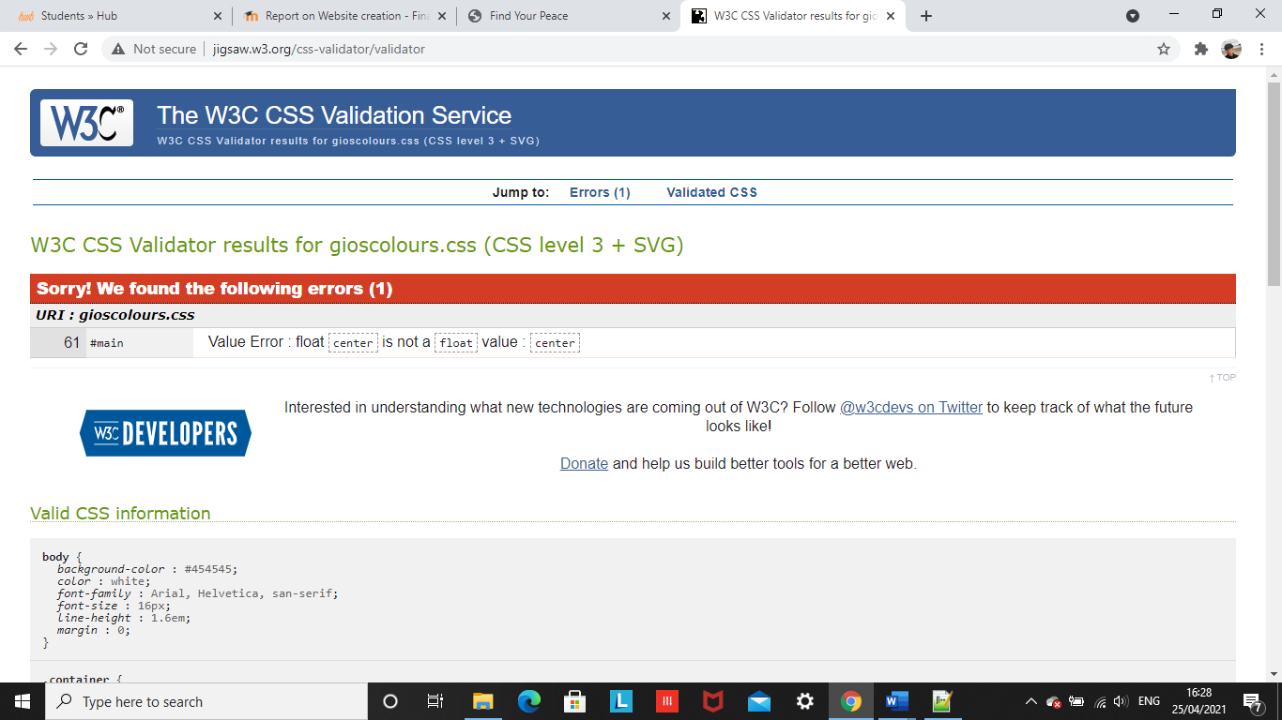

The validation check shows that there is one error with my CSS code. It states that the center value is not a float value. To change this, I need to change float to a different type.

Evaluation
a.
Website usability
The usability of the website is important. The practicability of a website has an impact on whether the user will stay on the website or not. The usability is described as the complexity that the user must face while accessing information on a website [1]. “Braddy et al. (2003) showed that the ease of navigation to a job advertisement on a company’s website was positively related to general impressions of the hiring organization under investigation [2].” This study proves that the usability of the website could have a positive or negative impact on the user. Website usability is considered important in web development because websites are used by people every day. It is important to create a website that users can easily navigate. This is because if the website is attractive and easy to navigate, the user will have a positive experience and is likely to come back to the website. However, if the website is poorly designed and hard to navigate, the user will have a negative experience and is not likely to come back to the website.

Website accessibility
Accessible websites are websites that contain features that are designed in a way that people with disabilities can use without complexity. Accessible websites “take into account of work of various groups” meaning that websites can be easily navigated by everyone [3]. Essentially, website accessibility refers to the “degree” the website can be used and accessed by all types of people and their “limitations” [4]. Website accessibility is important in web development because all types of people will be using and access websites such as disabled people, and elderly people. It is crucial that the design and accessibility of the website is appropriately made for all types of people otherwise people will struggle to navigate the website.

Search engine optimisation
Search engine optimisation is used to increase the amount of traffic driven to a website. This is done by increasing its search engine page rank. Words in a HTML document will be optimized meaning that relevant words used in the document will appear in the search. The relevance to the topic searched will determine the rank results. Search engine optimisation is important in web development as the more relevant key words used in the search, the higher the website is ranked. An American retailer - JCPenny shows the impact of search engine optimisation. “This retailer’s organic links sky-rocketed during the 2010 holiday shopping season and suddenly climbed to the top of the search results for many general keywords such as “dresses”, “bedding”, and “furniture”” [4]. This information proves that using relevant keywords will increase the websites rank on the search engine. This is vital for companies because having a high rank in the search engine will drive more traffic to the website.

b.
Usability
The website I have created has exceptional usability. This is because the website is easy to navigate. The design of the website is simple and tidy. The title, subheadings and images are clearly displayed on the homepage. The subheadings on the homepage are clickable, once clicked it will lead the user to the relevant page containing information and images laid out neatly and clearly. Anyone can use my website with ease as it is very simple and designed appropriately for anyone to use. To improve my website, I could add more relevant text and images on the homepage to make it look more professional.

Search Engine Optimisation (SEO)
I used relevant keywords to increase the rank of the website in the search engine.

Accessibility:
My website has good accessibility because it is appropriately designed for anyone to use. All types of people including disabled and elderly people can access and use the website with ease because of its simple design. The colours used in the website were similar to each other and bright colours were not used to distract the audience.

References
[1], [2] Braddy, Phillip W ; Meade, Adam W ; Kroustalis, Christina M, “1.2. Website usability”, Online recruiting: The effects of organizational familiarity, website usability, and website attractiveness on viewers’ impressions of organizations, vol. 1.2., 2008. [Online]. Available: https://www-sciencedirect-com.ezproxy.uwtsd.ac.uk/science/article/pii/S0747563208001027#aep-section-id12 [Accessed Apr. 25, 2021]
[3] Król, Karol ; Zdonek, Dariusz, “3. Internet without Barriers—Website Accessibility”, Local Government Website Accessibility—Evidence from Poland, vol. 3., Mar. 31, 2020, [Online]. Available: https://search-proquest-com.ezproxy.uwtsd.ac.uk/docview/2386076625?accountid=130472&pq-origsite=primo [Accessed Apr. 25, 2021]
[4] R. Berman, Z. Katona, “1. Introduction”, The Role of Search Engine Optimization in Search Marketing, vol.1 p.644. [Online] Available: https://www-jstor-org.ezproxy.uwtsd.ac.uk/stable/24545014?seq=1#metadata_info_tab_contents [Accessed Apr. 25, 2021]
Appendices
Main page html + css
Html
<!DOCTYPE html>
<html>
<head>
<meta charset="utf-8" />
<title>Find Your Peace</title>
<link rel="stylesheet" type="text/css"
href="gioscolours.css">
</head>
<body>
<header id="main-header">
<div class="container">
<h1>Find Your Peace</h1>
</div>
</header>

<nav id="navbar">
<div class="container">
<ul>
<li><a href="home.html">Home</a></li>
<li><a href="peace.html">Peace</a></li>
<li><a href="gallery.html">Gallery</a></li>
<li><a href="about.html">About</a></li>
<li><a href="contact.html">Contact</a></li>
</ul>
</div>
</nav>

<section id="showcase">
<div class="container">
<h1>Find your inner peace</h1>
</div>
</section>

<div class="container">
<section id="main">
<h1>Take a moment to relax. Everyone needs a break somepoint.</h1>
<img src="mymoon.jpg" alt="my-moon" style=
"width:700px;height:300px;"/>
<p>Taking breaks are important. It helps us to relax and take our minds off things. Taking breaks increases productivity and motivation. Finding peace within ourselves is important as it helps us realise who we truly are and forget the not so important things in life.
</p>
</section>
</div>

<div class="container">
<section id="mn">
<h1>Go spend some time outside in nature.</h1>
<img src="tree.jpg" alt="my-tree" style=
"width:700px;height:300px;"/>
<p> Spending time in nature will comfort you. You will feel more energized. Nature will make you feel more connected with yourself and could also heal your self.
</p>
</section>
</div>

<footer id="main-foot">
<p> Copyright &copy; 2021 G Enterprises</p>
</footer>
</body>
</html>

Css
body{
background-color:#454545;
color:white;
font-family:Arial, Helvetica, san-serif;
font-size:16px;
line-height:1.6em;
margin:0;
}

.container{
width:80%;
margin:auto;
overflow:hidden;
}

#main-header{
background-color:#1F1F1F;
color:#fff;
}

#navbar{
background-color:#292929;
color:#262626;
}

#navbar ul{
padding:0;
list-style:none;
}

#navbar li{
display:inline;
}

#navbar a{
font-size:18px;
padding-right:25px;
}

a{
color:white;
text-decoration: none;
}

a:hover{
color:black;
}

#main-foot {
background:#333;
color:#fff;
text-align:center;
padding:20px;
margin-top:60px;
}

#main{
float:center;
width:90%;
padding:10px;
box-sizing: border-box;
}

#showcase{
background-image:url("rocksss.jpg");
background-size: 1500px;
opacity:1.0;
background-position:center right;
min-height:200px;
margin-bottom:50px;
text-align:center;
color:white;
font-size:30px;
line-height:1.6em;
padding:30px;
}

Home HTML + CSS
Html
<!DOCTYPE html>
<html>
<head>
<meta charset="utf-8" />
<title>Home Page</title>
<link rel="stylesheet" type="text/css"
href="home.css">
</head>
<body>
<header id="main-header">
<div class="container">
<h1>Escape Reality... Good ways to relax...</h1>
</div>
</header>

<div class="container">
<section id="main">
<h1>Listening to your favourite songs</h1>
<img src="song.jpg" alt="my-song" style=
"width:700px;height:300px;"/>
<p>Listening to your favourite songs is therapy to your mind. Songs are also like time machines! Old songs bring back old and fun memories.
</p>
</section>
</div>

<div class="container">
<section id="main">
<h1>Get off your phone and go outside!</h1>
<img src="sky.jpg" alt="my-sky" style=
"width:700px;height:300px;"/>
<p> Trapping yourself inside and spending too much time on your phone will harm your health! Go outside and explore! Go on a mini adventure and see the views. Going outside will help clear your mind ready for a fresh start!
</p>
</section>
</div>

<a href="index.html">Home page</a>

<footer id="main-foot">
<p> Copyright &copy; 2021 G Enterprises</p>
</footer>
</body>
</html>

CSS
.p-welcome {

}
body {
height:100vh;
width:100%;
background-image:url("castle.jpg");
background-position:center;
background-size:cover;
background-color:gray;
color:white;
}

<a href="index.html">Home page</a>

Peace HTML + CSS
Html
<!DOCTYPE html>
<html>
<head>
<meta charset="utf-8" />
<title>Peace</title>
<link rel="stylesheet" type="text/css"
href="peace.css">
</head>
<body>
<header id="main-header">
<div class="container">
<h1>Peace</h1>
</div>
</header>

<br>

<div class="container">
<section id="main">
<h1>Why is peace important?</h1>

<p>Peace is very important. Peace helps us to remain still and focus. It makes us aware of where we are in life and helps us to relax and take a break. Without peace, we will over do things and will lead to negativity and stress.
</p>
</section>
</div>

<br>

<div class="container">
<section id="main">
<h1>How can I find peace?</h1>

<p>You can find peace by giving yourself a break. This could be after a long day of work, after spending too much time on your phone, or just a ten minute self reflection out of the day.
</p>
</section>
</div>

<br> <br>

<div class="container">
<section id="main">
<h1>Benefits?</h1>

<p>There are plenty of benefits of having peace within yourself. These benefits include: increase in focus, more self-awareness, more motivated and improves your mental health.
</p>
</section>
</div>

<br>
<br>
<br>
<br>

<a href="index.html">Home page</a>

<footer id="main-foot">
<p> Copyright &copy; 2021 G Enterprises</p>
</footer>
</body>
</html>

CSS
.p-welcome {

}
body {
height:100vh;
width:100%;
background-image:url("skate.jpg");
background-position:center;
background-size:cover;
background-color:gray;
color:white;
}

Gallery HTML + CSS
HTML
<!DOCTYPE html>
<html>
<head>
<meta charset="utf-8" />
<title>Gallery</title>
<link rel="stylesheet" type="text/css"
href="gallery.css">
</head>
<body>
<header id="main-header">
<div class="container">
<h1>Collection of Gallery</h1>
</div>
</header>

<div class="container">
<section id="main">
<img src="beach.jpg" alt="my-beach" style=
"width:650px;height:400px;"/>
</section>
</div>
<br>
<br>
<br>
<br>
<div class="container">
<section id="main">

<img src="ollie.jpg" alt="my-ollie" style=
"width:500px;height:300px;"/>

</section>
</div>

<a href="index.html">Home page</a>

<footer id="main-foot">
<p> Copyright &copy; 2021 G Enterprises</p>
</footer>
</body>
</html>

CSS
.p-welcome {

}
body {
height:100vh;
width:100%;
background-image:url("store.jpg");
background-position:center;
background-size:cover;
background-color:gray;
color:white;
}

<a href="index.html">Home page</a>

About HTML + CSS
HTML
<!DOCTYPE html>
<html>
<head>
<meta charset="utf-8" />
<title>About</title>
<link rel="stylesheet" type="text/css"
href="about.css">
</head>
<body>
<header id="main-header">
<div class="container">
<h1>About</h1>
</div>
</header>

<div class="container">
<section id="main">
<h1>Informationn on why taking breaks and finding peace is important...</h1>

<p>Getting caught up in everyday things makes us distracted from the things that really matter in life... It is healthy to stop and realise for a moment about what we are really doing...
</p>
</section>
</div>

<a href="index.html">Home page</a>

<footer id="main-foot">
<p> Copyright &copy; 2021 G Enterprises</p>
</footer>
</body>
</html>

CSS
.p-welcome {

}
body {
height:100vh;
width:100%;
background-image:url("night.jpg");
background-position:center;
background-size:cover;
background-color:gray;
color:white;

}
Contact HTML + CSS
HTML
<!DOCTYPE html>
<html>
<head>
<meta charset="utf-8" />
<title>Contact</title>
<link rel="stylesheet" type="text/css"
href="contact.css">
</head>
<body>
<header id="main-header">
<div class="container">
<h1>Contact Page</h1>
</div>
</header>
<p class="p-welcome">Name: G Agui</p>
<p class="p-welcome">Email: g_agui@email.com</p>
<p class="p-welcome">Phone No.: 12345</p>
<p class="p-welcome">Postcode: ABCDEF</p>

<a href="index.html">Home page</a>

<div>

</div>
</body>
</html>

CSS
.p-welcome {

}

body {
height:100vh;
width:100%;
background-image:url("view.jpg");
background-position:center;
background-size:cover;
background-color:gray;
color:white;
}

