Workshop: Purchasing Power in Pompeii
Pompeii: The life, death and rediscovery of a Roman town (HPAH5078/HPAH6078)

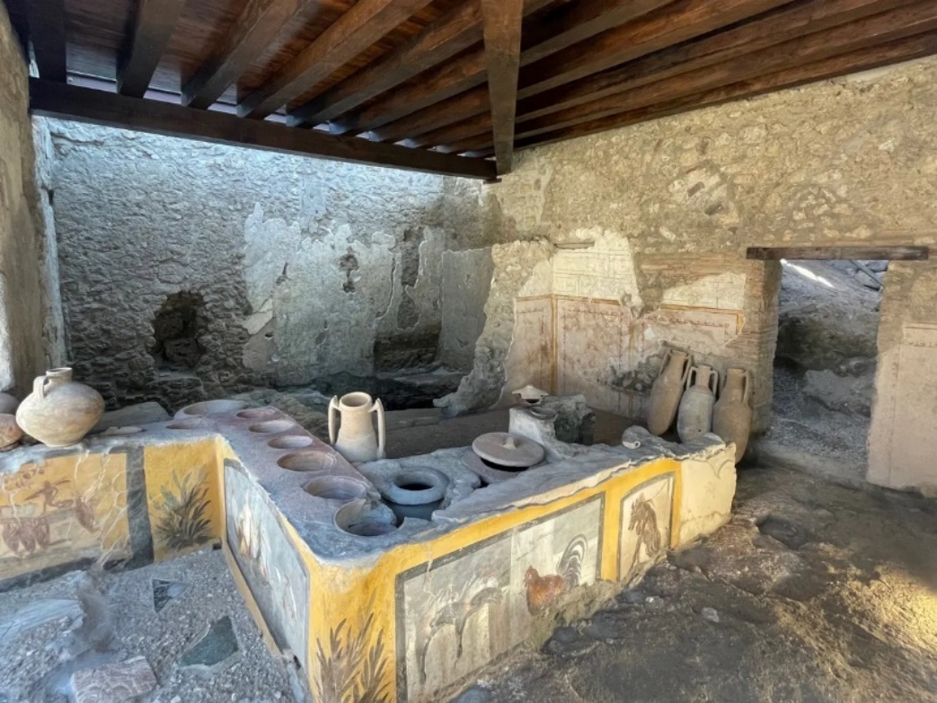

This tasked based workshop centres around four hypothetical characters who happen to be in Pompeii on a particular day (either as a resident or a visitor) – you need to keep them fed for the day. Each character has a different socio-economic, occupational, and legal background – and has a specified amount of money to spend. You need to try to ensure, based on the economic means on each one, that they either eat a minimum of 1500 calories worth of food, for basic survival, or around 2,000 calories for moderate consumption, or 2,800 calories for a decent food intake for the day. You can add condiments / flavourings, and things like lard, oil and wine to the mix, but you cannot have your character subsist only on these.
On the following page you will find the character synopses, as well as a list of currency values, and a rough approximate of the calorie values of different items mentioned in the graffiti from Pompeii and Herculaneum. Unfortunately, quantities are not always mentioned, so I have had to make reasoned deductions in some cases. Are evidence for pay levels is also diffuse and patchy, but we do have evidence for parts of the Roman Empire for the types of pay individuals in different professions or roles might receive.
Keep a record of what your character spent their money on and how much it cost them, so that your group can share this with the rest of the class.

Hypothetical characters

Felix the slave
Felix is a trusted house-born slave (verna) from a household of middling economic means. He is not particularly skilled but is entrusted to perform various household chores and runs errands for his master, meaning he travels a fair bit across the town. Felix gets a ration of bread per day equal to 800 calories and an allowance of 20 sestertii a month (Seneca, Ep. Mor. 80.7) or 80 asses that he can spend at his own discretion – working out to around 2 ½ to 3 asses a day.
You need to try and ensure that Felix gets an extra 700 calories at a minimum

Fabius the day labourer
Fabius lives in a cramped upper story apartment in Pompeii, with sections separated by flimsy wooden partitions. As an unskilled casual day labourer, he can earn around 3 sestertii or 12 asses (Cic., pro Rosc. Com. 28). However, he needs to keep 1 sestertius aside to “pay on the day” for his rent, otherwise he will be kicked out of his lodgings. This leaves him with 8 asses for food to purchase on a typical day. He does not receive any regular rations, but on certain festival he is able to supplement his diet with distributions of sacrificial meat and other foodstuffs.
You need to try and ensure that Fabius gets at least 1500 calories or more

Gaius Annius Draco
Draco is a sailor from the Classis Misenensis, the naval fleet at Misenum. He is visiting Pompeii with a friend for the day to watch the munera being held in the amphitheatre and is staying in overnight lodgings. He typically receives 5 modii of wheat as rations, among other deductions from his pay, but he has 6 asses to spend. Two asses are set aside for the lodging fee he is paying to the landlady of the hospitium he is staying at for the evening, leaving 4 asses to spend on “small luxuries”.
As Draco has already consumed 2,200 calories in rations, you can spend the remaining 4 asses on other goods, foodstuffs or drinks

Gaius Pumidius Dipilus
Dipilius is a clerk (scriba) who works for one of the duumviri (senior magistrates) of Pompeii and earns 1,200 sestertii per annum, or 4,800 asses. The nice lodgings he rents and the cost of maintaining his wife and young son (with food, clothing and other needs) takes up 85% of this income.
Dipilius has consumed 1,500 calories at home but will go out to meet friends at a one of the nicer popinae in Pompeii. He has saved up 15 asses to spend on his evening out.

Simplified Roman currency table and a table of calories

Most day-to-day transactions are being conducted in lower value coinage bronze and copper coinage like the as, semis and quadrans, or possibly the dupondius and sestertius for higher value transactions. Gold and silver coins (aurei and denarii) would mainly be used for very costly items (most poor people are unlikely to have handled an aureus with much frequency).
You can consult the table below, the but the key thing to note is that aureus = 25 denarii; 1 denarius = 4 sestertii; 1 sestertius = 4 asses; 1 as = 4 quadrans.

 | Aureus | Denarius | Sestertii | Dupondius | As | Semis | Quadrans
Aureus | 1 | 25 | 100 | 200 | 400 | 800 | 1600
Denarius | ¹⁄₂₅ | 1 | 4 | 8 | 16 | 32 | 64
Sestertii | ¹⁄₁₀₀ | ¹⁄₄ | 1 | 2 | 4 | 8 | 16
Dupondius | ¹⁄₂₀₀ | ¹⁄₈ | ¹⁄₂ | 1 | 2 | 4 | 8
As | ¹⁄₄₀₀ | ¹⁄₁₆ | ¹⁄₄ | ¹⁄₂ | 1 | 2 | 4
Semis | ¹⁄₈₀₀ | ¹⁄₃₂ | ¹⁄₈ | ¹⁄₄ | ¹⁄₂ | 1 | 2
Quadrans | ¹⁄₁₆₀₀ | ¹⁄₆₄ | ¹⁄₁₆ | ¹⁄₈ | ¹⁄₄ | ¹⁄₂ | 1

Table of calories

Item | Portion | Calories equivalent
Wine | One cup | 160 (“empty”) calories
Wine | Half a litre | 420 (“empty”) calories
Bread | A loaf | 650-700 calories
Cabbage | Medium size | 220 calories
Beetroot | 1 beet | 35 calories
Leek | 1 leek | 55 calories
Onion | 1 onion | 45-60 calories
Lard | 85 grams | 750 calories
Olive oil | 20 grams | 180 calories
Cheese slice | 30 grams | 120 calories
Dates | 5 dates | 115 calories
Pork | 1 chop | 210 calories
A small sausage | Ca. 50 grams | 150 calories
Salt | 6-gram portion | Negligible

Mint, salt and mustard – low in calorie intake but will add flavour. Salt is also needed for survival (a few grams a day).
Translations come from Cooley, A. and M. Cooley (2013). Pompeii and Herculaneum: A Sourcebook (second edition). Routledge.

Drinks and snacks available in bars (plus their cost)
‘Hedone says, ‘You can drink here for one as, if you give two, you will drink better; if you give four, you will drink Falernian’. – CIL IV 1679.

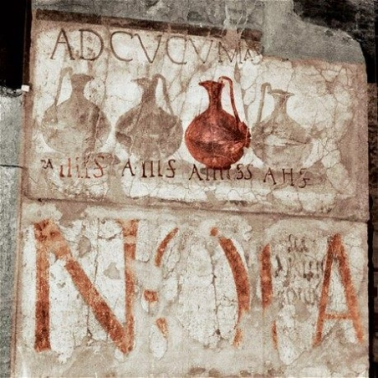
At the cooking-pots. [AE (1989) 182a]
4 asses | 3 asses | 4 asses | 2 asses
per sextarius | per sextarius | per sextarius | per sextarius

A painted sign and imagery from Herculaneum, next to the entrance of a shop on the decumanus maximus. 1 sextarius = 0.545 litre.

Graffito (CIL 4.4888) linked to a workshop (VII.2.30).
firewood
steward/land-agent? 4
bread 6
cabbage 2
beetroot 1
mustard 1
mint 1
salt 1

This is one of two graffiti in a bedroom in this building, listing expenses – the type of coins is not specified, but this is most probably in asses.

Pompeii
[. . .] 31 ⁄2 asses p(ound?)
of lard 3 asses
wine 1 as
cheese 1 as
oil 1 as
bread 2 ½ asses
pork 4 asses

This list was found in connection with the Large Palaestra (II.7.3) – CIL 4.8561 [presumably representing goods sold by a vendor and their prices]

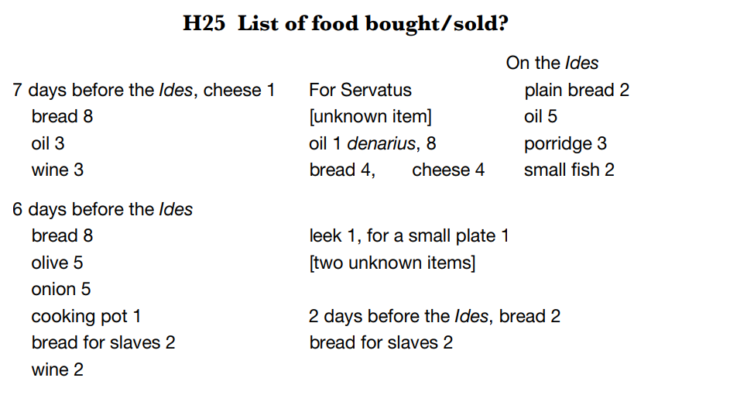
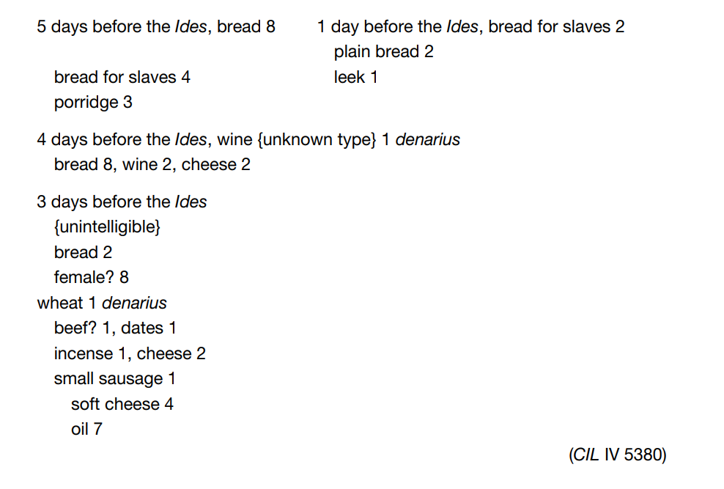
This long list of products was discovered in the atrium of IX.7.24–25 (a building acting as either a Popina or Hospitium) at Pompeii, which a doorway connected to a bar with a serving counter. The list (written in 3 unequal columns) is divided up into individual days, and it records either food either sold or bought. The numbers are probably prices in asses, except where the symbol for denarius (= 16 asses) occurs.

‘11 September, for a tunic: 1 denarius, 7 asses.’ – CIL 4.10664.

A graffito found in connection with shop in the Insula Orientalis II building complex at Herculaneum – it relates either to the price for purchasing a tunic, or perhaps of cleaning a tunic.

