The First 1000 Days- Stephanie Rees 2100655- ECEY4005
Introduction
The first 1000 days identifies the time from the start of pregnancy to a child's second birthday. This is a period which evidence shows plays a vital role in whether children grow up happy, healthy and well adjusted (New Parent Support (NPS), n.d.).
The first 1000 days is an extremely important time, whether mums are poorly, and children nourished and cared for during this time can have a profound impact on a child's ability to grow learn and thrive. This is because the first 1000 days is when a child's brain begins to grow and develop and when the foundations for their lifelong health are built (NSP, n.d.).

Pregnancy


(1,000 Days, 2020).
Good nutrition during the first 1,000 days provides the building blocks for healthy brain development.
During the 1,000 days the brain can grow very quickly than any other time om a person's life. nutrition provides the fuel that drives much of the brain growth and development. Beginning early in pregnancy and throughout their childhood, nutrition provides the building blocks for a
child's cognitive ability, motor skills and socio- emotional development, which in turn impacts their future success in school or opportunities later in life.
Parliament UK (2014) states:
When a baby’s development falls behind the norm during the first year of life, for instance, it is much more likely that they will fall even further behind in subsequent years than catch up with those who have had a better start.
(Parliament UK, 2014).
With support, it is possible to rebuild the brain properly and put the children back on a course of a healthy development, but doing it is very challenging. Sir Michaels Marmot’s review of health inequalities (2010, cited in Parliament, 2014) stressed that ‘what happens in these early years, starting in the womb, has lifelong effects’

Holistic Play
The holistic Development in EYFS is an approach to learning that emphasises the importance of the physical, emotional psychological well-being of children especially in early childhood (Twinkl, 2022). This can help children to connect with the world around them and learn in a way that differs from the conventional form of schooling that many people choose to adopt.
What is Holistic Development in the Early Years?
Holistic development in the Early Years can recognise the connectedness of mind, body and spirit. When the Early Years practitioners take a holistic approach to child development, they pay attention to the children’s physical, personal, social and emotional and spiritual wellbeing, as well as cognitive aspects of their learning (Twinkl, 2022).
Holistic development approach in the early years is important when planning and assessing the needs of the child. This allows practitioners to assess the child as an individual and understand what they have achieved, as well as what they have not achieved by looking at how their developmental areas link up and how progress in one area can affect progress in another.
There are five aspects to early holistic development.
❖ Physical
❖ Emotional
❖ Social
❖ Mental
❖ Intellectual (Twinkl, 2022).

How can we support a child’s holistic development in the early years?
Holistic Development in the early years allows practitioners to develop an activity that a child enjoys and turn it into a learning opportunity. You should always create a comfortable and safe environment for children to connect and be themselves and make individual small groups and space for some creative play.
Why not use colourful classroom area signs for early years to brighten up your classroom and add a splash of colour to your setting? Create some interest and corners that individual children and small groups like to play in.

Here is an example of areas you can have for the early years
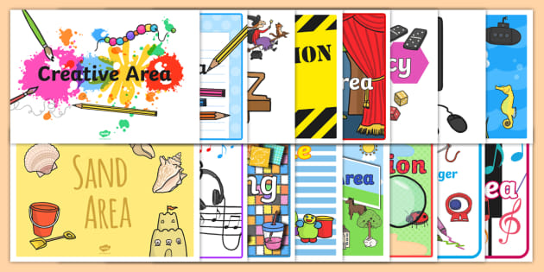
(Twinkl classroom areas 2022)
This is an example of early overall development. Babies and toddlers can learn and develop as a whole. That is, many areas develop at the same time and can usually occur during one activity (Williams, 2020). For example, a child may use a spoon. This means meeting their physical needs which increases independence and self-esteem to meet emotional needs. The overall developmental approach allows early childhood professionals to plan future activities with their children which will benefit their overall learning, development and well-being (Williams, 2020).
What are the benefits of early holistic development?
The greatest benefit of the overall developmental approach lies not only in the child's intellectual development, but also in the location and importance of the child's psychological, social and emotional growth. This will improve communication and social skills and give birth to a confident child (Williams, 2020).
Practitioners find it very enjoyable to learn and challenge a particular topic they can associate positive reactions with learning (Williams, 2020).

Treasure Baskets
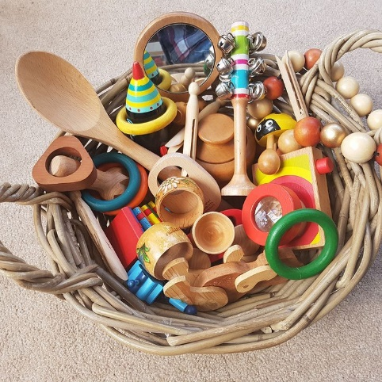 (Williams, 2020).

Treasure baskets are flat baskets, usually made of rattan, however, any type of basket can be used that can hold a lot of random everyday items. These objects are chosen to stimulate the baby's curiosity and allow the baby to interact independently with the object while sitting (Williams, 2020).
Treasure basket games are easy to create and very rewarding. The Treasure Basket is perfect for creating awe and mysteries and inspire babies allowing them to fully focus on what they are doing. Babies like to use them when they are old enough, initially when the baby can sit straight with support and when they can stand up with help. Normally, babies can continue to play in the treasure basket without worry until the they crawl a little and try to move around in surrounding area (Williams, 2020).
Piaget states that development is divided into four phases (Sherrell, 2021). The Sensorimotor Stage 2002 is when babies begin to deepen their understanding of the world through their senses by touching, grasping, observing and listening. They also begin to develop a sense of permanence for the object. In other words, understand that the object exists even if they cannot see it (Sherrell, 2021).
Preoperative Stage is when a 2–7-year-old child develops language and abstract thinking. This means that they can develop non-physical concepts and ideas. They also start with an iconic game (pretend), for example to unzip photos and tell them what happened in the past (Sherrell, 2021).
Concrete Operational Stage is when 7-11-year-old children learn logical and concrete rules about objects such as size, weight, and volume. Children can also see that the properties of the object remain the same even if the appearance of the object changes (Sherrell, 2021)
Formal Operational Stage (12+years) when adolescents understand abstract concepts and learn logical rules for solving problems. For example, they can understand the concept of justice (Sherrell, 2021)

(McLeod, 2007).

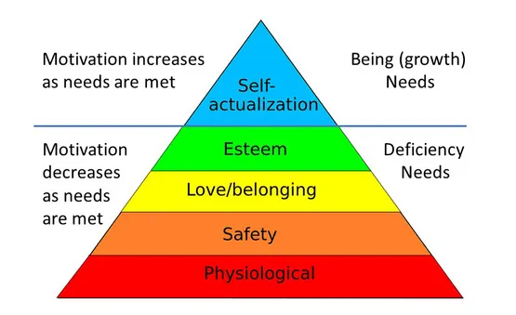
Maslow's Pyramid of Desire is a psychological motivational theory that covers a five-levels of human desire (McLeod, 2007). The bottom of the pyramid should be worked through first and from the bottom of the hierarchy, the needs are: Physiology (food and clothing), security (work security), love and attribution needs (friendship), self-esteem, self-actualization (McLeod, 2007).

Story Telling
Story telling is one of the maximum effective methods that leaders ought to influence, train and inspire (Boris, 2017). What makes storytelling so powerful for learning, is from the beginning of evolution storytelling forges connections and ideas amongst human beings. Stories can bring the culture, records and values that may unite human beings. When it involves countries, groups and households they are able to connect with the stories as they are an essential part of our heritage (Boris, 2017).
There are many types of stories, such as poetry, song, movement, pictures to say but a few, which can be presented in numerous mediums such as, braille, sign language and dance in order for children and people with various disabilities to enjoy with others. Children can discover objects in a bag to match the story being read. Stories are fresh when they are written, however become eternal as they are read many times (Hurst, n.d.).
Children who are visually impaired deaf or blind can also additionally enjoy a tale with the aid of using tactually exploring gadgets gathered on a stroll or gambling with the substances used to take a tube for those are located in an enjoy container or bag. A baby with low imagination and perception can also additionally revel in an easy image book or e-book with restricted print. Audio and braille are different mediums that can be used to percentage a tale with others. The shape or the medium are not as essential because the tale itself or the advent of the tale (Hurst, n.d.).
Challenges for caring an infant within a setting
Working in childcare can be accompanied by challenges that can lead to overcoming some headaches and disabilities. Many people get the impression that working with children is easy, but the opposite is true. It can get that reward and it can take on that challenge. So what do you think is the biggest challenge managers and practitioners face when working in childcare?
- Manager don't have enough time to do everything in a day
- Too much paperwork
- Not spending enough time with children
- Difficulty in hiring qualified personnel
- Not getting enough support
- Difficulty in communicating with parents
- Wage table does not represent dedication and effort
- Requires math and English GCSE
- Not enough funds
- Kindergarten locations cannot be filled immediately

Many of the above challenges can be frustrating for individuals and difficult for teams. These challenges are common when working in childcare, and the only solution to them is to work together as a team to find strategies to overcome them. The impact of the child's environment on their development is well documented.
Friedrich Frobel (early 1800) compared the design of environments for children Plan an organic and ever-changing garden that can give you inspiration and guidance The child's imagination and behaviour.

According to Maria Montessori Adults admire their environment; they can remember it and think about it – but a child absorbs it. The things he sees are not just remembered; they form part of his soul. He incarnates in himself all in the world about him that his eyes see and his ears hear. ‘

Reference list

Boris, V. (2017) What Makes Storytelling So Effective For Learning? Available at: https://www.harvardbusiness.org/what-makes-storytelling-so-effective-for-learning/ (Accessed: 20 January 2022).
Hurst, K. The Importance of Storytelling and Story Creation. Available at: https://www.pathstoliteracy.org/playing-words/why-it-important/importance-storytelling-and-story-creation (Accessed: 20 January 2022).
Parliament UK. (2014) Written evidence submitted by Barnardo’s. Available at: https://publications.parliament.uk/pa/cm201314/cmselect/cmeduc/364/364we20.htm (Accessed: 20 January 2022).
Sherrell, Z. (2022) What are Piaget’s stages of development, and what are examples of each. Available at: https://www.medicalnewstoday.com/articles/325030 (Accessed: 20 January 2022).
Twinkl. (2022) What is Holistic Development (EYFS) Available at: What is Holistic Development (EYFS)? - Answered - Twinkl Teaching Wiki (Accessed: 20 January 2022).
Williams, M. What Is A Treasure Basket? The Essential Guide. Available at: https://earlyimpactlearning.com/what-is-a-treasure-basket/#:~:text=A%20treasure%20basket%20is%20a,the%20objects%20whilst%20sitting%20up. (Accessed: 20 January 2).

