

BA BUSINESS MANAGEMENT
Assignment 2

Name & Student ID: Daniela Ambros - 2115350
Gianina - Maricica Chirila - 2131738
Crina Mihut - 2218982
Florin Mistreanu - 2220307

Module name: Academic Skills
Module code: LCBB4006
Lecturer: Dr Lizeta Demetriou

Table of contents:
1. Introduction .....................................................................................................3
2. Analyse of academic skills: ......................................................................4 - 12
2.1 Reflection ...........................................................................................................4 - 6
2.2 Critical thinking .................................................................................................7 - 9
2.3 Motivation …....................................................................................................10 - 12
3. Conclusion .....................................................................................................13
4. Reference list ..........................................................................................14 - 15

- Introduction
Nowadays, the primary objective of educational institutions is to assist their students in developing academic skills that go beyond their academic and technical knowledge. Throughout the university curriculum, students are required to learn academic skills and apply them to various situations. This raises the question of why academic skills are so emphasised? Prior to examining the importance of these skills, it would be relevant to clarify the meaning of the term ’skills’. According to McMillan (2012), a person's skills are determined by their personal attributes and their ability to accomplish certain tasks more successfully than others. There are two types of skills: soft and hard skills. The term ’hard skills’ refers to those skills that can be easily acquired, such as the ability to speak a foreign language, solve mathematical problems, or operate a complex machine. When it comes to ’soft skills’, things are slightly different. While many of these skills are acquired through our experiences in life, at university they are taught in a manner that prepares students for professional success (Smale and Fowlie, 2009; Du Boulay, 2009). This report aims to explain why academic skills are so important to student’s and employee's success. Specifically, three academic skills will be analysed: reflection, critical thinking, and motivation. Moreover, the analysis of these skills will be supported by theories and examples from the areas of education and employment.

- Analyse of academic skills:
2.1 Reflection
Reflection is an academic skill that may significantly impact a person's actions, thoughts, and conclusions. It can be seen as a broad and meaningful process, with various levels of significance for diverse groups. According to Hargreaves and Page (2013), reflection is emphasised in the health sector as a useful tool in dealing with complex decisions, in the educational sector as a means of learning, and in the field of social work as part of an intuitive and self-reflective behaviour process. As it relates to the educational environment, Cottrell (2017) also describes reflection as a process of revisiting our own experience to clarify our thinking and learn from our mistakes. Moreover, Schon (1983) argues that reflection has two phases, one during which students are learning in the context and the other during which they are learning from the context. The following sections will discuss the importance of reflection in education and professional development. Also, to facilitate reflection, a reflective model will be introduced.
Gibbs’ reflective cycle
There are several models of reflection available in academia: Gibb’s ‘Reflective Cycle’ (1988), Kolb’s ‘Experiential Learning Cycle’ (1984), Driscoll’s Model (1994, 2000). However, this paper will focus on Gibbs' reflective cycle. This model of reflection was developed by Graham Gibbs in 1988. There are six stages in the framework: description, feelings, evaluation, analysis, conclusion, and action plan, each containing a question that requires an honest response. Gibbs (1988) believed in the possibility of innovative ideas and lessons arising from human feelings and thoughts in response to reflection upon experience. As the individual progresses through each stage, he can stand back and gain a comprehensive understanding of what went well and what went wrong, analysing and synthesising the actions and motivations they have taken. Upon completion of the process, a summary of what needs to be improved for the next time will be provided, along with an action plan (Gibb’s, 1998).
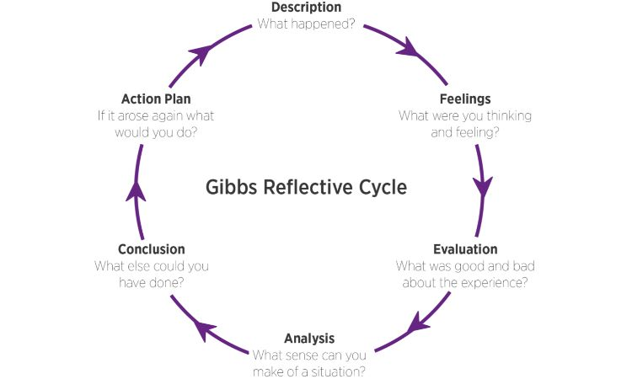

Table 1. Gibb’s reflective cycle

Reflection – academic success
Reflection is an essential element of professional development in undergraduate studies. It is critical to emphasise that as students reflect on their feedback as part of their university experience, they are engaged in a learning process. Also, the focus is not on superficial learning but on active learning based on a sense of the situation (Cameron, 2021). Further, learners have the opportunity to structure their thoughts and feelings through the use of the model of reflection. When working in a team or individually, students will benefit from asking themselves what they did well and what they did wrong, as well as exploring the implications. In other words, reflection will reveal one's own weaknesses as well as how others' actions have an impact on one's own thinking. As a result of evaluating and analysing their personal experience, they will be able to draw a conclusion and plan how to improve future situations.

Reflection – professional success
Throughout the employment process, reflection is an integral component. When practicing reflection, a wide range of prior thinking and knowledge is synthesised to make sense of it for a purpose that extends beyond personal understanding or knowledge. Meanwhile, it illuminates the uncertain aspects of the problem and provides solutions (Moon, 2007). According to Boud, Cressey, and Docherty (2006), reflecting at work can contribute to organisational productivity and employee engagement. Therefore, reflection and its importance at work will be explained in the next example. When a manager in an organisation faces a problem of staff shortage during a busy time of year, he will reflect on what occurred and draw lessons from it. For example, one may decide to hire more employees during the next high-demand period. Further, he may plan a schedule for the staff to ensure that their holidays are split throughout the year and that they work during busy times.

2.2 Critical thinking
Many people view critical thinking as a negative process of searching for faults and making negative observations. There is a sense of unfairness that people feel when someone criticises their actions or words. Nevertheless, possessing and using this skill has many advantages. According to Haber (2020), individuals with critical thinking skills can look at a problem from a variety of perspectives. As the author points out, critical thinking refers to the ability to identify, analyse, and solve problems or challenging situations. Our days, these skills have become increasingly important and in demand for academic and professional success. The following paragraphs address Bloom's Taxonomy and how it works in conjunction with critical thinking skills as well as the benefits of applying it.
Bloom’s Taxonomy Theory
Benjamin S. Bloom developed the taxonomy for the University of Chicago in 1956. The taxonomy was designed to reduce the labour involved in preparing an annual comprehensive examination. However, this framework was revised 45 years later, and it is now known as a revised taxonomy. The revised version has proven to be a valuable resource for teachers, trainers, and instructional designers due to its simplicity and effectiveness when it comes to assisting students with higher-order thinking (Krathwohl, 2002). Moreover, the table below illustrates the hierarchical levels of thinking and expectations that Bloom's taxonomy encompasses.

Higher order thinking skills

Create
Evaluate
Analyse
Apply
Understand
Remember

Lower order thinking skills

Table 2. Bloom’s Revised Taxonomy Model

Critical thinking – academic success
As lecturers evaluate students' knowledge through their reports, the ability to write a variety of reports is an important skill for students in an academic setting. To receive a high grade, students should critically evaluate their own work before submitting it. Time spent on critical analysis is comparable to time spent elaborating on a problem (Cottrell, 2019).
Additionally, another benefit of critical thinking is the ability to analyse someone's work based on the information provided. It is important to note that Cohen (2015, p.177) made the following statement: "Critical Readers do not accept passively what they read — they read actively". The author believes that critical readers should ask for evidence before assuming any information is factual. To illustrate, students are required to analyse a case study in class. They must read the text carefully, identify the line of reasoning remaining objective and formulate their opinion before expressing themselves (Cottrell, 2019). As a result, they will develop their critical thinking skills for academic success.
Students who listen to a podcast or attend a lecture synthesise the information received with the help of critical thinking skills. Similar to reading, this process involves identifying the most pertinent information from secondary data. During the lesson, the teacher, for example, asks students to rank certain skills according to their importance for academic and professional success. Many students have completed the exercise; however, a few have evaluated the listened information and claim they are unable to complete it. Critical thinking allows students to judge the meaning of someone's words and the way they present their arguments before committing themselves to a particular viewpoint (Cottrell, 2019).
Critical thinking – professional success
To stand out from other applicants in the current competitive job market, candidates seeking high positions in companies must possess strong academic skills (Schulz, 2008). Recruiters look for candidates who are critical thinkers, open-minded, and objective in dealing with challenging situations. Acquiring these skills at university will enable an individual to develop a unique personality and distinguish themselves from others.
For professional success, Bloom's Taxonomy framework is essential. This can be elaborated by analysing the role of a lecturer. First-term students in the BM course will be taught the academic skills module at the lowest level of the hierarchy, from taxonomy, to ensure that they will be able to remember and understand the keywords and definitions. Students will be provided with more solid information after few lessons, which they will be able to apply and analyse based on the information provided by the lecturer. To reach the top of the pyramid, the lecturer will use critical thinking to evaluate the student's needs and understanding through assignments, presentations, and exams.
The same tool is applied when dealing with new employees in a business environment. To prevent future issues, the operational manager will not delegate tasks to his new assistant that he is not familiar with. Nevertheless, he will use Bloom's Taxonomy model in order to ensure that the appropriate level of thinking skills is met. The ability to evaluate information and make decisions alone will demonstrate that the assistant is ready to work independently. Furthermore, the ability to plan the next steps without supervision and produce pieces of work and solutions to daily problems will demonstrate critical thinking skills and a higher level of maturity.
2.3 Motivation
When it comes to motivation, some people struggle to explain and share their opinions about the term. There is a possibility that humans have cultivated this skill from childhood and are not aware of the meaning and importance of it. However, Wlodkowski (2008, p.2) describes motivation as ''the natural human process for directing energy to accomplish a goal''. In other words, this force encourages people to attain their highest level of performance by remaining positive, energetic, committed, and focused. A key consideration is that motivation encompasses ALL the factors that influence our behaviour (Adair, 2006). In order to understand the motivations behind people's behaviour, it is imperative to dig deeper and examine a motivational theory called Maslow's Hierarchy of Needs. Furthermore, the importance of motivation as an academic skill for educational and professional success will be discussed further.
Maslow's Hierarchy of Needs Theory
Various motivational theories have been proposed by psychologists who have studied human behaviour. Moreover, these theories address the factors that influence people's behaviour, their needs, and the motivations they feel. Among the most famous motivational theories are the Maslow Hierarchy of Needs Theory, Alderfer's ERG Theory, and the Hertzberg Theory. However, in this paper, Maslow's theory of motivation will be discussed.
In 1943, psychologist Abraham Harold Maslow published 'A theory of human motivation' (Maslow, 1943). This was the first time Maslow's theory of needs was introduced to the public. A hierarchy of five human needs is the basis for the framework. Therefore, a person's lower needs must be met before they are able to satisfy their higher needs, according to the model. In addition, Maslow believed that people tend to lose motivation if a level of needs is satisfied (Stoyanov, 2017).
However, this theory has been subjected to some criticism. First, 'A theory of human motivation' was not a scientific article due to a lack of research and evidence. Secondly, Maslow's concept of self-actualisation has more than one interpretation, and there are several ways to achieve it. Finally, the order of needs is not necessarily followed by all people. For some the need for love is more supreme than the need for safety. In response to some criticism, Maslow has revised his theory and made some adjustments (Stoyanov, 2017).
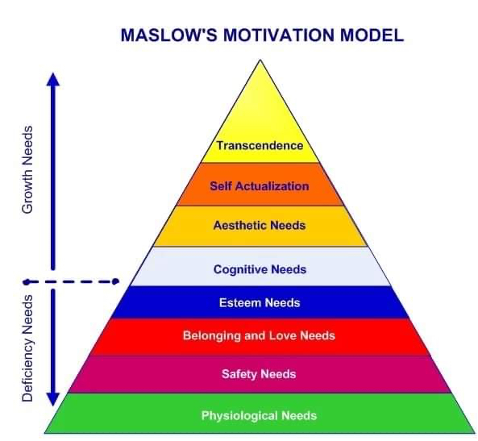
Table 3. Maslow’s Motivation Model

Motivation – academic success
It is imperative that university management applies Maslow's theory of motivation in order to motivate students to earn a bachelor's degree with distinction or to pursue a PhD. How does it work? Initially, students are motivated to obtain primary necessities such as a warm home, food, and clothing. Students will not think about getting a good mark or evaluating themselves if they do not have a place to sleep or eat. Aside from this, all of them wish to feel safe and to be surrounded by their loved ones. As a result of meeting all these needs, they will feel a sense of self-worth and will be more likely to seek acceptance from others. Due to this, students are more likely to consider higher level needs such as cognitive needs, aesthetic needs, self-actualisation, and transcendence. A variety of options are available at the university to assist students in reaching their needs. There are, for example, English language and academic workshops designed to support them in improving their language skills. Also, academic support tutors and librarians that are happy to meet with students in person or via Teams. Moreover, disability services and financial help are available to students that faces some challenges. Each of these components is designed to motivate students to study, to achieve their goals, and to become a better version of themselves. The ability to motivate oneself requires reinforcement as well as a sense of discipline. To gain a better understanding of the students' opinions, some surveys are conducted. Also, a student is assigned to represent the class by attending meetings with management and serving as an intermediary between students and administration.
Motivation – professional success
Maslow's hierarchy of needs theory is one of the most widely used in the field of employment. Through the identification and determination of the most important needs and the provision of targeted incentives, managers can improve the productivity of their employees (Alam et al., 2020). It would be beneficial to use an example from the workplace to extend this concept. Managers in a company with many employees must keep close track of human resources needs and how they are being met. Occasionally, in a company, there may be some employees who are unmotivated or achieving different results from the rest, and with some research, this can be identified. Psychological behaviour is a common way people express their concerns. Therefore, steps must be taken in order to solve this issue and motivate employees. Motivation may come from a promotion, a higher salary, or even positive feedback from the manager.
Additionally, brainstorming meetings or surveys will make them feel important and valued. While they may have similar needs, they are not aware of them at the same time. This indicates that motivation does not remain constant, and that employees are frequently in need of innovative motivational actions.

- Conclusion
This report was designed to enable readers to better understand the significance of academic skills and their relationship to academic and professional success. Moreover, this report identifies three main skills: reflection, critical thinking, and motivation. There was no classification of these skills according to their importance, as humans require all of them in order to reach the highest version of themselves. As work environments are constantly evolving, students must develop and integrate all their skills to make themselves more flexible and adaptable. As a result, they will benefit from these skills today, by acquiring better knowledge, achieving high grades, and by securing jobs and promotions in the future. Additionally, some examples from the educational and workplace environment were discussed to emphasise the value and efficiency of skills when used appropriately. This study also examined and implemented some famous frameworks, including Gibbs', Bloom's, and Maslow's, in real life situations.

Reference list:
Adair, J. (2006) Leadership and motivation: the fifty-fifty rule and the eight key principles of motivating others. London: Kogan Page.
Alam, M.N. et al. (2020) ‘The Effects of Wages and Welfare Facilities on Employee Productivity: Mediating Role of Employee Work Motivation’, Australasian Accounting Business & Finance Journal, vol. 14(4), pp. 38-60. Available at: https://doi.org/10.14453/aabfj.v14i4.4 (Accessed 13th December 2022).
Cameron, S. (2021) The Business Student’s Handbook: Skills for study and employment, 7th Ed. Harlow: Pearson.
Cohen, M. (2015) Critical Thinking Skills For Dummies. Chichester: John Wiley & Sons, Ltd.
Cottrell, S. (2017) Critical Thinking Skills: Effective Analysis, Argument and Reflection, 3^{td} Ed. London: Palgrave.
Cottrell, S. (2019) The study skills handbook, 5th Ed. London: Red Gobe Press.
David Boud, Peter Cressey and Peter Docherty (2006) Productive Reflection at Work: Learning for Changing Organizations. London: Routledge. Available at: https://search-ebscohost-com.ezproxy.uwtsd.ac.uk/login.aspx?direct=true&db=nlebk&AN=160405&site=ehost-live (Accessed: 29th December 2022).
Du Boulay, D. (2009) Study skills for Dummies. Chichester: John Wiley & Sons, Ltd.
Gibbs, G. (1988) Learning by Doing: a Guide to Teaching and Learning Methods. London: Further Education Unit.
Haber, J. (2020) Critical Thinking. 1st Ed. London: MIT Press.
Hargreaves, J. and Page, L. (2013) Reflective Practice. Cambridge: Polity Press.
Krathwohl, D. (2002). ’A revision of Bloom's taxonomy: An overview’. Theory into Practice, 41 (4). Available at: https://www.tandfonline.com/doi/abs/10.1207/s15430421tip4104_2 (Accessed 14th December 2022).
Maslow, A. H. (1943). ‘A theory of human motivation’ Psychological Review, 50 (4), pp. 370-396. Available at https://doi.apa.org/doiLanding?doi=10.1037%2Fh0054346 and https://psychclassics.yorku.ca/Maslow/motivation.htm (Accessed 22nd December 2022).
McMillan, K. (2012) The study skills book. 3rd ed. Harlow: Pearson Education Limited.
Moon, J. A. (2007) Reflection in Learning and Professional Development: Theory and Practice. London: Routledge Falmer.
Schon, D. A. (1983) The reflective practitioner: How professionals think in action. New York: Bask Books.
Schulz, B. (2008). ‘The importance of soft skills: Education beyond academic knowledge’, Journal of language and communication, 2(1), 146-154.
Smale, B. and Fowlie, J. (2009) How to succeed at University: An essential guide to academic skills and personal development. London: SAGE Publisher Ltd.
Stoyanov, S. (2017) An Analysis of Abraham H. Maslow's a Theory of Human Motivation. London: Macat International Limited.
Wlodkowski, R. J. (2008) Enhancing adult motivation to learn: a comprehensive guide for teaching all adults, 3rd Ed. San Francisco: Jossey-Bass, A Wiley Imprint.

