James Evans Student number:2025643 MASTERS PROJECT - ACFA7003

Robotics and the use of automation in the uk steel industry ay laboratory scale.

Contents page
List of figures and tables 2 Abstract 3
‌ Acknowledgements 3
Declaration Statement 3
Introduction 4
Background 6
Aims & objectives 7
Justification 7
Problem outlines 8
Limitations of the study 9
Negative impact of the research 9
Literature review: 10
  - Robot vision 14
  - What is a degree of freedom 15
  - UNs Sustainable development goals 16
  - Future wellbeing act 17
  - LOSTPED parameters 17
  - ISOs 19
  - Circular economy 20
  - Today’s steel recycling 20
  - Blockchain 21
  - Automation 22
  - Cyber security regarding robotics 24
  - End effectors 24
  - Weighing systems 25
  - Using simulation and Cad software 26
  - Lightweighting using nTopology 27
  - Implicit modelling 29
  - Field driven designs 29
  - Triply periodic minimal surfaces 29
Financial implications of automation 31
Innovation management 31
Methodology 33
Discussion 35
Conclusion 50
Further research and areas of study 51
Limitations of this study 51
References 52
Bibliography 58
List of figures and tables.
Figure 1: The four industrial revolutions
Figure:2 Schematic of hardware used in autonomous rock breaking experiment
Figure:3 Robot arm hardware used for stone stacking experiment
Figure:4 Representation of how additions size will diffuse into molten steel related to time
Figure:5 of a human comparison to a 7 DOF robot arm Image
Figure:6 Graph of risks to existing jobs to automation to mid-2030s
Figure: 7 A meter-long robot arm that was sand cast using topology optimisation that was manufactured using AM.
Figure: 8 Original design to final export in nTopology of robotic arm.
Figure: 9 Image of the cells for gyroid, diamond and primitive, and the lattice structures are below
Figure:10 Innovation matrix
Figure: 11 Image of Robotic arm with both tooling and depth camera
Figure: 12 Fusion 360 side image of the sketch of the end effector gripper
Figure: 13 Fusion 360 image of the sketch of the end effector gripper
Figure: 14 Material selection for gripper in fusion 360
Figure: 15 Keyshot renders of end effector
Figure 16: NTopology image of the Frame & Infill mesh geometries
Figure: 17 nTopology image of the Frame & Infill implicit geometries
Figure 18: nTopology image of the Gyroid building block
Figure 19: nTopology image of the Cell Map
Figure 20: nTopology image of the Periodic Lattice
Figure 21: NTopology image of the Frame & Infill implicit Boolean intersection geometries
Figure 22: NTopology image of the Weight ratio analysis
Figure: 23 nTopology image of the Boolean intersection of the infill Implicit body
Figure:24 nTopology image of the static analysis
Figure:25 Fusion 360 images of drawing of addition pot alongside the physical object
Figure:26 Fusion 360 images of drawings of additions alongside the physical objects
Figure: 27 additions pot, manganese, titanium and nickel ball .Stl files exported into RoboDK
Figure:28 Gripper claw open fully picking up Mn additions.
Figure: 29 Gripper claw attaching to Mn additions.
Figure: 30 Gripper claw detaching Mn additions to the pot.
Figure: 31 Gripper claw detaching Ni ball to additions pot.
Figure: 32 System design flaw constraints of sizes of multi end effectors.
Figure:33 lightweighting of fusion 360 gripper using nTopology lightweighting exported to RoboDK (Evans, 2023)

Abstract
The steel industry is going through a paradigm shift of traditional steelmaking to green steel and circular economy. The emergence of new technology could be deployed to help steer the steel industry into global industrial leaders for cleaner, digitalised smart processes. This paper has looked at how simulation and cad software can be utilised for changing a laborious process of manually handling and weighing addition for secondary steel making at laboratory scale. A literature review was performed looking at an array of information including but not limited to, automation advantages and disadvantages, blockchain, topology optimisation, simulation and isos. A working two finger gripper was designed in fusion 360, and lightweighting topology applied for weight reduction. Multiple parts were drawn in fusion 360 and uploaded to roboDK for accurate simulation of environment and processes. Followed by a conclusion and recommendations.

Acknowledgements
I’d like to thank the Diamond Centre of Wales for starting my MSc journey, but in particular Simon Evans who not only encouraged me to join the MSc project but also supported me all the way through the process in too many ways to mention. Adam Evans for his continued support and help with imagery and advice for my final project. I’d like to thank the MADE team and my lecturers for giving me the skillset and knowledge to complete my assignments and final project. Finally, I would like to thank Emily for her love and support, keeping me relatively sane while writing my dissertation, you have helped more than you know.

Declaration Statement:

I certify that this is all my own work and that all other sources of information, data, images etc. have been acknowledged and referenced This work has not been previously accepted in substance for any other degree and is not being concurrently submitted in candidature for any other degree:

Signed: James Evans Date: 27/02/23

Introduction

Humans have benefited from multiple industrial advancements at various points in our timeline, the benefits that have happened during these times throughout history have had an overwhelming impact on society and industry, that they have been referred to as “revolutions”. They have the power to lead changes in medicine, health, industrialisation, the economy, transportation and education etc (Groumpos, 2021). The first being through steam power and mechanisation in 1760, followed by the second industrial revolution that encompassed electricity and mass production which peaked during the period 1870-1914, and the third revolution which harvested IT and electronic systems during the 1970s. Currently the term industry 4 has been coined, it feels like a silent industrial revolution is happening in all industries, new technologies coupled with resurgence of advancements in older technologies are growing at an exponential rate.
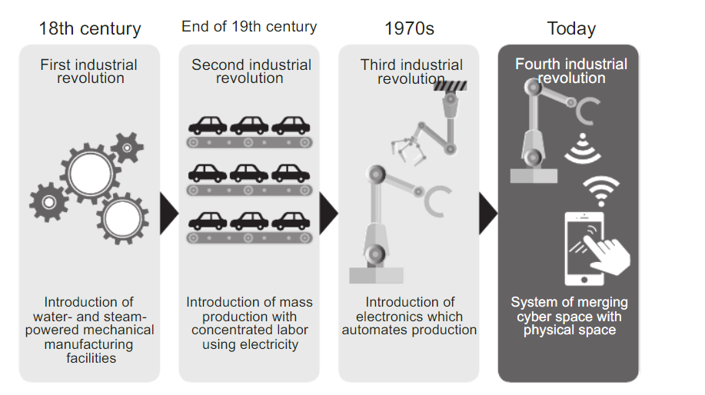
Figure 1: The four industrial revolutions (Deguchi et al., 2020).

The fourth industrial revolution known as I4.0 is driving manufacturing industries across the world to changing their production lines, business models and products, but it will not come in one big sweeping change, it will be a multitude of small steps, towards bespoke production, which is digitalized and intelligent (Sangwan and Bhatia, 2019). It’s with these two important factors, which will allow control of the complete life cycle of products which can lead to innovation tackling important global issues.
Industry 4.0 can be realised with a Cyber Physical System (CPS), where a manufacturing process would have a digital twin, where the system can run simulations, predict when maintence is needed and make changes to the process. Arora, (2021) describes a Cyber physical system (CPS) as a platform comprising of a system that is mechanical but controlled by algorithms, and integrated with both Internet and the networked users. The mechanical components are represented by both sensors and actuators, the software components are realised by computational devices that are networked and intrinsically linked through the system.
Industry 4.0 developments are in essence an integration of company data, information systems, and computerized production, autonomous vehicle and controls, sensor networks that are wireless and devices with the capabilities to connect to the Internet Of Things (IOT). They will be essential for society's stability and economic viability and this highlights the need for cyber security. A barrier with CPSs is the requirement of an autonomous system, current design trends are increasingly aiming to remove the human element from these systems. Complex autonomous systems that can interact digitally coupled with physically, can evolve into a cloud, transparent infrastructure that can support our daily challenges and activities. Careful consideration is important when designing CPSs as the behaviours that are desired are as important as analysing the emerging properties and the results of their interactions. A further barrier is most CPSs have limitations owing to the operational and environmental barriers, for example, battery life, communication ranges, computational power, and access to the internet (Zanero, 2017).

Background
The steel industry
The individual enables of I4.0 have been adopted across the steel industry globally, automsation, blockchain, cyber security, AR/VR, big data and analytics, but the adoption of the “smart factory” seems an unachievable goal for steel producers to integrate a CPS to run a fully automated product line from raw materials to a finished coated product shipped to consumers. Having processes that involve high temperatures and product loads, microchips and sensors would need to be fitted to products that are hot rolled in extreme temperatures (Govender, Telukdarie and Sishi, 2019).

The world is changing at a rapid pace, quicker than pervious times in our history, there is a increased need for improvements and new ways of looking at technology, science and societal implications to improve our understanding of our planet. The consumption or resources and critical raw materials are being used at a rapid rate and our population is increasing. With the increase in powerful communication that is available to us we are aware of the state of the planet and have the data to influence change and make improvements where needed. An example of this laid out by (Taha, Taha and Thunberg, 2020) is the number of smart communication devices has already surpassed 3 billon which is approaching half the number of the world’s population (Statista, 2022), leading to a collective ability to distribute and receive information in a matter of seconds. Furthermore, they refer to the world’s population reaching close to 8 billion, energy usage at 20MWh/year and the equivalent 2 tonnes of oil a year would be.

With the decarbinsation targets of governments worldwide, steel production is in a precarious position needing to implement greener processes to guarantee their survival while keeping costs low, coupled with the opportunity to make higher quality grades of materials, it is a worrying time for producers. The shift away from blast furnaces that account forapproximently7% of total co2 emissions worldwide (Jin et al., 2017). Furthermore, they are responsible for water pollution and negative ecological factors.

The future of the steel industry
Bhatnager, (2021) discuses five key drivers for the steel industry steady the sustainable transition between current processes and industry standards and the improvements needed to reach the decarbonisation targets set out but governments. They are adopting cleaner technologies balancing quality and capital cost. Produce sustainable steels to capitalize on increasing demand. Improve environment, social and governance performance to align with the expectations of shareholders. Embrace digitization to unlock value of cyber physical systems, big data capture and blockchain technologies. Collaborate with stakeholders leading to improved output of higher quality products. The shift to greener electric arc furnace (EAF), and induction melting technology is growing rapidly. This technology will come with its own set of barriers but also enablers for better greener manufacturing. A key benefit is smaller batch sizes of materials, to enable a slight change of a steel chemistry in the current blast furnaces 350 tonnes of steel would need to be produced, this makes product development on plant inefficient.
This research sets out to discuss concept of the secondary stage of steel manufacturing for selection of optimal additions sizes using a robotic system, storage of data on blockchain to promote circular green steel and produce better quality materials.

Aim:
To critically evaluate automation benefits, barriers and risks, and the suitability to embed a robotic system for a secondary steelmaking process optimisation at laboratory scale for choosing optimal additions for steel alloy creations when using vacuum induction furnaces.

Objectives:
- Research and evaluate current robotic systems, technologies and international standards needed for picking, placing and weighing of element additions.
- Perform a literature review for current robotic advancements, societal, financial and environmental benefits, barriers and risks, how blockchain can be utilised for transparency of materials made.
- Simulate a robotic system to automate picking alloying additions, design an end effector using fusion 360 including topology optimisation.
- Provide recommendations for lab scale advancements for using robotics.

Justification
Alloying additions for the steel industry are hazardous to humans. Examples of common injuries are cuts, dust inhalation from fine particulates, and handling or ingesting toxic/dangerous materials such as sulphur and phosphorus. Key benefits from automating this process are, allowing operators to work on more meaningful tasks, process optimisation, potentially upscaling this process to plant and eliminating human operator error. Furthermore, there is a skill shortage in the UK regarding digital skills, The Office for National Statistics (2019), evaluated the digital divide through the UK, it was reported Wales has smallest proportion of humans with the five basic digital skills at 66% coupled with the largest proportion of people with no basic digital skills at 19%. Furthermore, from the data collected, households across the UK who reported they had no access to the internet, 64% stated they didn’t find the internet interesting or useful, and 20% reported the lack of skills to use it as reasons to not implement it in their homes.

Location setting
The Steels and Metals Institute (SaMI) based at Swansea university is a research and development department that supports industry with decarbonisation markets through novel research into hazardous environments and bespoke metal creation. They are equipped with a foundry (Pilot lab), fatigue and fracture, characterisation and extreme environment simulation departments.

Problem outline
Steel alloys require multiple elements to create unique compositions, for example a common structural steel has nine additional elements that are mixed with Iron (FE). Large foundries located in the steel industry have automated processes for their measuring and alloy addition systems but without AI or accurate measure of the addition rock sizes, this causes poor alloy production where metallic “fines” are added to molten metal resulting in compositions with lower percentages of the target composition, this leads to products that need to be reprocessed or scrapped. Common problems that occur when care isn’t given to additions sizes are:
- Longer time for additions to dissolve
- Lost additions particles through dust particles
- Lost additions through vaporisation when dust particles hit the molten pool effecting results.
Optimal size for additions
Reducing addition size improves the dissolution rate, historical practices were contrary to these as large additions were used to penetrate the slag layer, when using vacuum furnaces, the slag layer is heavily reduced as the air is removed from the chamber before melting begins, small alloy size increase elemental losses through “dust fines” and results in handling difficulties, therefore, the optimum size for additions sizes have been determined between 3 mm - 20 mm (Satyender, 2019).

The more complex shaped elements that are used in steel industry, resulting in the need for multiple end effectors for the robot to carry out its task efficiently. One benefit of several elements such as cobalt and nickel are their magnetic properties, this would allow for an electromagnetic end effector. For elements such as carbon and copper granules a scoop or dispenser could be utilized, and finally rock shape elements such as chromium, manganese and aluminium would benefit from a gripper end effector.

Current process
At laboratory scale a composition request is raised, the percentages of the target steel creation are inputted into a computer calculator with the available element additions selected. A melt sheet is produced with the required elements highlighted and the exact weight required. These elements come in sealed bucket to protect them from becoming oxidised, when required, they are picked by machine operators and the elements are removed from their sealed containers, and broken into smaller addition sizes and weighed, either with a lump hammer or a hydraulic press, this leads to accurate compositions using higher quality additions and exact measurements. Furthermore, there is an optimal addition size that homogenises with the molten FE. IF the addition to big or small, it can have adverse effects such as
The additions are added to a molten pool of iron in a vacuum furnace using faradays law of induction. The iron is placed in a crucible surrounded by a copper coil, when voltage is passed through the coil electrons enter an excited state and move rapidly generating heat and causing the iron to reach its melting temperature of 1538 degrees. Once this has been reached aluminium is loaded into the additions pot and charged into the molten iron to remove the oxygen embedded in the molten pool, then the remaining additions pot is introduced to the chamber and the elements enter the molten pool. Several minutes 5 to 10, the additions should be humongous with the iron resulting in a grade of steel.
A sample is taken while the pool is still molten and left to cool, once it is cold enough to handle it is ground down using a grinding machine and sent for chemical analysis (OES) to test the chemical composition targets have been hit within their desired tolerances.

Limitations of the study
Key limitations of this study are:
- Brittle alloy additions such as sulphur, carbon, and phosphorus are harder to handle and would need a gentle end effector or dispenser.
- A finite amount of time.
- financial limitations.
- No access to a physical robotic system.

Because of the limitations, the elements chosen for this study are nickel (Ni), titanium (Ti) and manganese (Mn) These three elements in raw material form will lay a foundation for the other remaining elements commonly found in the steel industry. The practical element will use RoboDK to simulate a robotic system.

Key Initial Design considerations and negative impact of this research.
The literature review will cover important aspects of the physical components needed to make a robotic system. It will cover the degree of freedom for the robot arm and different types of end effector. Potential issues for the system regarding vibration from machine affecting weight measurements, robotic vision, oxidisation of chemical elements and weighing systems. Initial robotic costs and funding streams and automation leading to job losses

Literature review

A key technology coupling human and technology interactions in industry is refered to as collaborative robots (Cobots). The manufacturing processes using Cobots are a new generation of automation using robotics that due to increased sensor technology and design criteria have afforded the work area to be utilised without the need of an enclosure or fence. Allowing for cohabitation in the work area with human’s counterparts. The sensors used are highly responsive to any force unexpectedly which allows them quick reactions to stop immediately if encountering people or objects misplaced in their working area. This affords them to be reliable and safe robotic colleagues compared to traditional industrial robots (Kadir, 2019).
People have advanced dexterity abilities to manipulate items of different items made of different materials, shapes, and sizes, and control the objects position even in confined spaces with their hands. Making machinery that replicates human hands that can autonomously manipulate or pick up items is an important robotic component. The original end effectors and manipulators can be traced back to the 60s where manipulation was prescribes sequences of movement and could be executed by a robot that didn’t have the ability to change to its environment. As time has progressed robots have increased the ability to generate automatically sequences of movements by drawing on AI, an example of this is stacking items according to size and weight and having the ability to handle errors if the parts do not fit the desired size (Billard &Kragic, 2019).
Previous research regarding automatisation of rock measuring in both dimension and weight systems are limited. Papers are available regarding the utilisation of robotics in mining and construction, with the main driver of this technology being safety and operational costs. Primarily these have used either stereo or depth sensor cameras which have been used to map out point clouds of the rock materials scattered in the field of vision of the camera.
Lampinen et al., (2021) designed a novel autonomous ore breaking robot, that has a vision system for detecting ore and breaking it into smaller pieces, a process that is usually done with a human operator. Their system was capable of being autonomous with no human intervention, furthermore it could recognise oversized rock. The visual perception system as seen below had a 3D stereo camera that overlooked the robotic work area.

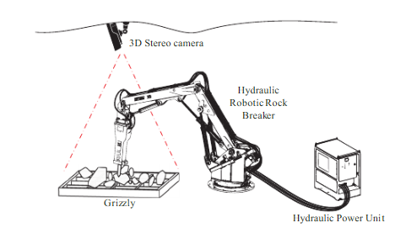

Figure:2 Schematic of hardware used In autonomous rock breaking experiment Lampinen et al., (2021)

Furrer et al., (2017) introduced a robot programmed to measure and stack rocks on top of each other for autonomous construction. They used a ROBO TIQ, utilising a force torque sensor and finger gripper with a mounted camera (RGB-D) fitted above the gripper. In their paper, they introduced an autonomous robot that could build a balancing tower vertically out of stones of irregular shapes without and compound to fix them together. Their system proved to be successful and the system could build the stone stack autonomously using complex algorithms.

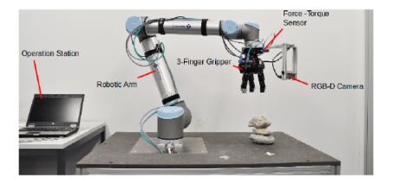
Figure:3 Robot arm hardware used for stone stacking experiment (Furrer et al., 2017).

Using robotic vision.
Robotic vision would allow a robotic arm processing ability for visual data by coupling a camera with software. 3D attached vision systems allow robotic systems the ability to perceive and detect visual patterns and shapes, while having the ability to react to them. Examples of where this technology is used is quality checking of parts, choosing the correct part in the right orientation, barcode reading and having the ability to take a multitude of measurements.
This affords adopters of this technology increased flexibility on their production lines, as robots have the ability to adapt to changing parts or automatically detect defects in their products.
When data is captured via a visual feed, it can be rendered into 1D, 2D, or 3D imagery. This system would benefit from 3d vision so the depth of objects can be detected, assessed then utilised, furthermore it would allow additions that are stacked or tilted as they can judge the rotation, depth and hight of additions. They can handle tilted, stacked objects and varying workpiece distances.
If a camera is not utilised with a robot, then the machine would be blind, and rely on the programming by the operator. Relying on operating through code it means the function would be rigid, ideal for tasks that are repetitive. With the evolution of robots, systems, and the demand for the capabilities of AI and machine learning, integrating robotic vision is a key enabler.
With machine learning applied to robotics, you can teach Cobots to perform novel tasks based on collected data patterns. It allows them to visualise complex search and corrective movements, such as the removal of overlapping issues or potential misalignments. Giving robots the ability to see is important, giving the systems the ability to see their immediate environment enhances its capabilities, increasing the benefits for workers, companies, and industries. As discussed in the literature review Lampinen et al., (2021) systems that can “see” via integrated cameras located above the robot cell, they can also be mounted on the robotic arm itself, giving the robot eyes replicating human vision. Some robotic systems combine the two, having a set of cameras in the vicinity in strategic areas to capture data to perform functionally with the human counterparts.
Safety feature of robotic vision
Automatic machines will move through set directions and speeds that have been programmed. If something gets in the path of the machinery, there will be a collision. Cobots with vision and sensors that can detect potential collisions or obstructions across their paths will stop at once their sensors register the issue instead of continuing on at full speed reducing the risk of accidents significantly.

Point clouds.
A point cloud is a dataset of points that correlate to a 3D digital physical item or area in the 3D system. It can have millions of individual measurements within a x, y, and z work area. 3D Point clouds are a detailed and accurate record of a digital item. They are used to generate meshes and models for 3D applications, Multiple industries are utilising them for manufacturing 3D printing, architecture, gaming, and VR and AR applications.
Alloying additions ideal size are between 3mm to 20mm at laboratory scale (Satyender, 2019)., this allows the metal to homogenise effectively, smaller particles of elements can vaporise, react negatively and form slag on entering the molten pool effecting their required efficiency (Holappa, 2014). This is shown in figure (4) where Ferromanganese (FeMn) at 40mm dissolves into the molten FE three times quicker than (FeMn) 100mm sized additions It is also visual to see the effects of ferrochromium (FeCr) using the same size alloying additions. The larger the additions size the longer it will take to humongous with the FE melt pool resulting in longer processing times.

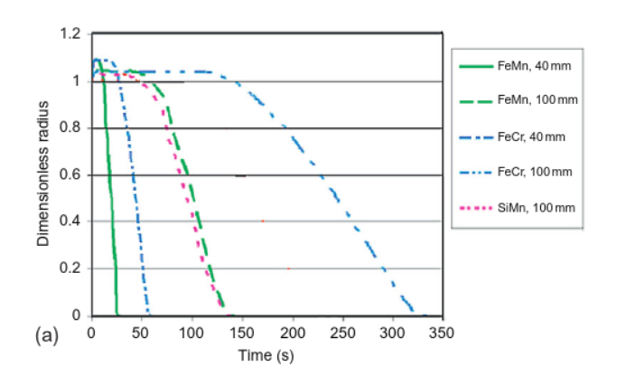
Figure:4 Representation of how additions size will diffuse into molten steel related to time (Holappa, 2014)

NASAs space mission to Mars is using a sophisticated set of robots mounted on to an autonomous vehicle called Perseverance. Perseverance has a multitude of cameras for entry, landing, potential hazards and damage and wear, moreover it has 7 cameras for scientist experiments. Some of these cameras are for chemical analysis but the ones interesting to this paper are the Mastercam-Z that uses a stereo camera to act as the robot’s vision, and the Watson camera which is mounted on the end of the robotic arm, to monitor dust accumulation and can capture the fine-scale structures and textures of rocks and their rocky debris that covers much of the surface of mars (mars.nasa.gov, 2020).
Metals will oxidize when in contact with both oxygen atmospheric moisture due to the chemical reaction on the surface of the metal. The oxygen present in the earth’s atmosphere air will cause the metal to corrode or oxidize which forms the metal oxide on the surface. Having metallic additions on a table in open air will cause slower melting times, oxygen formation in the melt resulting in slag and the potential issues of affecting the tight tolerances needed for good quality steel. Two options to avoid this would be to have the robotic system operate under vacuum or have an inert atmosphere by using elements such as argon or nitrogen. Other industries and manufacturers have designed specialist containers or closed cabinets for materials and processes, this has been utilised in metal powder storage for AM. When opening a container or cabinet, humidity and ambient air enter, resulting in affects to the physical and chemical characteristics of AM powders resulting in them aging. This could cause degradation of the metallic powders and increased porosity, leading to a reduction in tensile strength, corrosion resistance and heat tolerance. When materials are stored in traditional cabinets, materials will react with the atmosphere in its environment. Even purging the cabinet, ambient air and humidity would fill the cabinet each time the doors are open, increasing degradation and potential contamination.
Linde has designed a ADDvance powder cabinet (Linde Gas, 2022), an innovative solution to reduce this challenge for storage. The powder cabinet has sensors that detects moisture and can monitor it continuously for the humidity levels. It can admit a high-volume gas to purge the atmosphere as soon as the door is closed to remove moisture in the air rapidly. Furthermore, it then admits a flow of gas to enable a consistent low level humidity environment. This can be applied to the robotic system in this paper, to incorporate a vacuum pump and chamber to remove the oxidation of alloying elements or purging the environment with argon once the system is loaded with raw materials.

Yap et al., (2022) fabricated a necrobotic actuator by inserting a needle in the prosoma area of a dead spider and using glue to seal the needle. This resulted in a spider gripper as an end effector using the hydraulic legs. This system would naturally revert to its closed position and if pressure is applied the gripper legs would open. Both high loads relative to the spiders’ mass can be lifted (130%) and can grasp complex geometry objects, allowing this novel idea to be an effective end effector for soft and brittle additional elements sulphur, phosphorus, or heavier nickel balls. Soft hydraulic actuators that simulate human touch have been researched by multiple sources Li et al., (2022) discussed how soft actuators are under development for a multitude of applications such as, soft grippers, wearables, and artificial muscles. However, the performance of these biological systems and their complexity are not replicated in current synthetic designs. Their paper discussed new composites and designs for of soft actuators coupled with advanced properties and physical intelligence. They highlighted real-world applications of soft actuators and discussed both opportunities and challenges for modernised soft actuators, including circular economy aims, such as end-of-life strategies and extended lifetime. Kandasamy et al., (2022) presented a shift from current approaches of using externally powered soft robotics toward using robotics powered by the human body. Wearable robotics would need to be lightweight and portable. Removing rigid linkages, normally seem using traditional actuators that require servo motors. The design was soft and powered by the body it can bend with variable stiffness created using a material of elastomer which is braided with the length of the actuator. They then used water and air which generated pressure, the end effector could then effectively be used to grip objects, they concluded they could be used for applications such as prosthetics for hands. When the pressure is generated by hydraulics or pneumatics, the soft actuator can be used to grip an object potentially. A gripping force originates from the mechanical bending of the actuator and can be used in many applications, such as prosthetic hands, or to pick up challenges additions such as sulphur and carbon.

What is a Degree of Freedom (DoF).

A DoF when related to robotic arms is the ability of an independent joint that can provide movement for the robotic manipulator. This can be in a rotational or linear protectory. Each geometric axis that the individual joints can rotate or extend is a Singular DoF. Theses joints are prismatic or revolute joints, which either provide the linear or rotational freedoms. Robotic arms are normally described by how many total DoF they are capable of moving (Reachrobotics 2021).

Why use 7 degrees of freedom?
Robotics designers and engineers are traditionally required to pre determine the degrees of freedom (DOF) in a robot system in the early design stages, the knock-on effect of this will be a potential limitation the robot's future use. Revzen and Koditschek, (2017) discus the motivation to achieve “mechanical versatility” within a robotic system, where higher degrees of freedom will eventually out compete a system that has lower capabilities of DOF. Simulation is an effective way to replicate a robotic system at low cost and can afford the luxury of using robot components that would be unavailable if relying on a physical system. The system outlined in this paper is replicating a job which is currently being performed by a human operator. It is therefore important we replicate the same degrees of freedom that is possible with human movement, this system on that basis will use an articulated robotic arm with 7 degrees of freedom. Figure (5) is a visualisation of what a 7 degrees of freedom robotic arm equates to. Traub, Legenstein and Otte, (2021) discuss how a low-cost robot arm based on an elephant trunk can be built with up to 75 articulated DOFs. Their system had high accuracy to the mm and was built with basic 3D printing equipment.
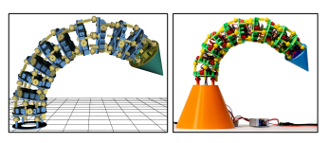

Figure: Image of ten joints. The image on the left is the cad file and the image on the right the actual model (Traub, Legenstein and Otte, 2021).

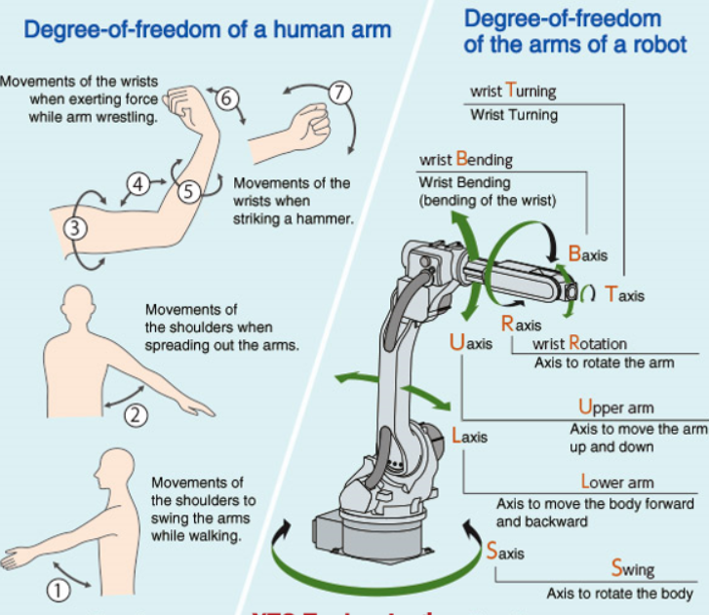
Figure:5 of a human comparison to a 7 DOF robot arm Image (NEWPAGES, 2022)
The UNs Sustainable Development Goals and The Well-being of Future Generations Act.
‌it can feel as if technology is a more powerful force than people, making employers and their workers adapt to changes or risk collapse, but governments are a key driver in how technology will advance. Governments, should integrate with the rest of society and examine what the future impact of this paradigm shift of I4 will be, the sooner they act the more likely the shift will benefit society (Wong, 2015).
The UNs Sustainable Development Goals (SDGs)
The UNs Sustainable Development Goals (SDGs) are goals to protect the planet and tackle the poverty crisis that plagues societies, the target date is set at 2030 where improvements should be made for prosperity and peace. 17 SDGs recognize the need for action, and where a positive change in one sustainable goal will affect outcomes and development of the other 16 SDGs, with the overarching goal must benefit and balance economic, environmental, and societal sustainability resulting in a prosperous and peaceful planet. Multiple Countries have already committed to focus on the progress of the countries or areas that are furthest behind. The SDGs are coupled with the previous goals but to ensure an end to poverty, hunger, infectious diseases, and discrimination in all forms. Resources, creativity, financial, human skillsets, and technology from society will be needed to achieve all SDGs.
Hatayama, (2022) highlights the shift of public governance, social and environmental interest for businesses and organisations to address the SDGs. Furthermore, they highlighted the metal industries previously have been reluctant to engage with the goals compared to other industries and focus SDG 12 which concentrates on production and consumption. They conclude that the steel industry could find an opportunity for greater commitment to the SDGs by realising benefits and values that their products create throughout their entire value chain.
The Well-being of Future Generations Act
The Well-being of Future Generations Act gives a frame work for the ambition, and legal obligation to promote benefits to the social, culture, environment and economic well-being of Wales. It promotes that public bodies in Wales should evaluate the long-term impact of their decisions, promote better working with the people of Wales, and communities and to reduce or prevent persistent problems, like health inequality, climate change and poverty. The Act was introduced by Wales and unique legislation; however, it has attracted interest from multiple countries across the globe as it promotes opportunities to make lasting, positive changes to both future and current generations (Future Generations Commissioner for Wales, 2015).

Initial design considerations of robot system.
When designing a robot application or system, it is important at design stage to evaluate in the decision-making process, the resulting parameters in and around the robot that are important. These are referred to as the LOSTPED parameters. They are a defined set of criteria that evaluate the required robotic features required. They are load, orientation, speed, travel, precision, environment and duty cycle.
Load
All robotic arms have a load capacity, there will be a maximum load each robot can take, and it would need to be higher that the payload including attachments like the gripper or electromagnet attachments. For this project the payload would not exceed 200 grams.
Robot arms have differently frameworks depending on their job, which can lead to both an increase or decrease of overall l capacity of its load capabilities, so careful consideration of the footprint and physical placement of the robot is important. For this project the robot arms footprint will be less than a meter squared.
Orientation
The footprint and mounting position of this robotic arm will only have a table and possible scale equipment in the production line. Affording the arm full range of movement.

Speed
It is thought that the speed will be slow to begin with, within the capabilities of the chosen robot but can be increased when the robotic process and machinery has been proven to work.
Travel
Tolerances and accuracy are jeopardised when using a robotic arm over increased spans. Development In this area at the design stage can mitigate problems later in the application.
This application could require longer travel points between different additions pots with varying payloads, this could complicate what sorts of robotic arms would be suitable for performing the task, placing the robot on a rail on the x axis allowing it to run alongside the addition’s pots would be a viable solution.
Precision
Programming the robotic arm for this process will need high levels of precision in both the range of movements and the articulations of the grippers used. This will increase the cost but shouldn’t affect the factors previously mentioned such as footprint, travel distance, speed or orientation. This industrial applications for picking and placement, is not a new concept robotic arms are capable of extremely precise and repeatable. Repeatability for robots depends on manufacturer and the model, but accounts for the margin of error associated for the robot’s precision. Having a factor of 0.1mm it means the motion of the Kuka’s robot will land within 01mm of the positioning set by the operator for that given task. |This shouldn’t be confused with accuracy of the robot, that is a metric of error between what the robot arm is supposed to do and how often it meets that’s criteria.

Environment
This robot arm would ideally be placed inside a vacuum chamber to reduce the elements oxidisation rate and will have potential hazards such as in the immediate working environment. For the robot arm that will be used in this research the dust amount will be minimal and is deemed to not cause any adverse risks to the robot and its workings. The Physical footprint and range of movement of this robot is also not a risk to their equipment and workers in its immediate environment.

Duty cycle
Duty cycle can be interpreted as the evaluation of how the robotic arm will be expected to perform and can be coupled with maintenance period that the robot will have to go through, this should include a preventative maintenance schedule. Robotics that run continuously will suffer Wear and tear sooner, which can become a problem as opposed to one which is only operated on shorter cycles.
This robotic system will be operated as and when it is required allowing downtime in its duty cycle to perform preventive and/or reactive maintenance.

The International Organisation for Standardisation

After looking at LOSTPED parameters it is essential to look at the International Organisation for Standardisation (ISO) for robotic systems. ISO, is an international non-governmental organisation built of national standards bodies, who develops and release a large range of industrial, proprietary, and commercial standards. It has representatives from multiple national standards organisations. ISO publish technical reports & specifications, which are publicly available specifications and guidance, this facilities world trade by united standards. These standards are available for not just manufacturing and technology industries but healthcare, environment, and security fields (Kenton, 2019).
According to the ISO website regarding robotics there are 27 ISO standards to take in to consideration when designing a robotic operating system, they range from safety considerations, manufacturing processes and more detailed standards for end effectors or Cobots (ISO, 2023).
Industrial robot applications are traditionally separated from humans to reduce the risk of injury. With advancements in technology, there is the need to safely bring the precision and uses of these robotic systems and couple them with their human counterpart for problem-solving and creative ability resulting in increased productivity, but would require closer working
Advancements in technical specifications in the robotic industry has created many opportunities and provides guidance to users and robot system developers, promoting investment and adoption of this advance technology
Because of the overlapping work area between Cobots and humans, where both are required to carry out tasks. The new ISO/TS 15066 has provided guidance for the design or implementation of Cobots in designated areas, reducing risks to humans. These include details on design factors, safety features that should be built into the systems, and guidance on implementing collaborative techniques.
ISO/TS 15066, could lead to advancements in removing traditional guards or protective systems that separate operators and robots apart as it may no longer be required for the power or limited force barriers that are implemented because of ISO 10218 1 & ISO 10218 2. Specification has incorporated data from the study for pain thresholds of areas of the human body. The information could be useful to advance the Cobot power & force robotic systems.
Human and robot systems could work in harmony by using monitoring techniques. In that system, a minimum distance that is safe would be set between the robot and human and through productive sensors the distance could be maintained avoiding contact. This would effectively lead to the operator could move toward the robot, then the robot system moves back. This Technical specification gives guidance for maximum speeds and separation distances required. This will stimulate advancements for protective tech coupled with the requirement to develop materials that could soften physical encounters, advanced motion control, improved sensors, and further innovations.
If a robot system is fixed, a human could still physically walk or bump into it, the new ISO standard address this potential risk is reduced by stating sharp edges reduced for the complete systems and equipment (Lazarte, 2016).

Circular economy
‌‌‌Steelmaking currently is responsible for about 8% of the total carbon emissions worldwide and has made decarbonisation a priority globally. Technological advances of course have helped with the reduction of emissions but there are further actions that could be used to accelerate the transition to sustainability, circular and green steel. These can be realised by adopting technologies that are clean such as electric arc and induction melting furnaces, produce sustainable steel, advance ESG performance and embrace digitalisation that will unlock its value, and finally if consumers governments and industry work collaboratively they can build a green steel market that is commercially viable (Bhatnager, 2021). The circular economy for the steel sector will need to develop the circular steel strategy, this would be in the form of steel that would go back into production after it had been recycled Recycling steel is good for the environment, but big improvements are needed for it to be as efficient as it should be.
The multiple properties of steel raises issues for recycling steel, the key benefit from recycling steel is that it can stay within multiple steel life cycles which saves large amounts of energy from the need to mine new raw materials.
A key barrier to recycling steel is that different steel compositions and quality get mixed and melted together, which causes more complications. It’s thought through automation of not only the physical process using a robotic system but also digitally capture data and use blockchain technology to contribute to energy savings resulting in a smaller carbon footprint.
Today’s steel recycling.
Most steel products origin and composition are unknown at the point of recycling. This results in different types of quality of steels and raw materials are reprocessed after they have been mechanically shredded. To guarantee the expected quality after recycling, requires extensive energy to process steel. The process could utilise data capture of the alloy composition from the Optical Emission Spectroscopy (OES) results and gathered into a database, this has advantages not only having traceability of who made the material and its origin but also better products through better raw materials selected for processing and creating a database of the residual elements are found in the steels, this can be used to the advantage of downstream processing and when material comes to its end of life.
Data gathered from the melt sheet calculated pre-production and chemical analysis after the material has been cast can be transferred to a database and uploaded to a blockchain giving the material a passport of its composition, but there must be a sufficient marking process included in the materials production lifecycle. Dot peen and laser engraving marking systems would you need to be evaluated and applied.

Blockchain

What is blockchain
Distributed ledger technology (DLT) can be defined as technologies that distribute information and records for those using it both public and private. A blockchain is an example of DLT, a sub-category of the broader DLT definition. A blockchain is a way of storing data in which the group validates transactions, these are called blocks, they form a chain, and each block is linked to the block before. Each block had a digital fingerprint unique to its block. Blockchains are permanent, removing the risk of “bad actors” altering the encoded data encoded within a blockchain if set up correctly. No single entity i.e., a participants or “node” can own or controls the blockchain (IBM, 2021).
Blockchain and the metals industry.
Campbell & Omietanski, (2018) discussed how Blockchain could benefit the supply chain for the metals and mining supply chain owing to the role blockchain could promote for transparency, trackability and security though peer to peer data sharing that in incorruptible. Furthermore, they discuss how Blockchain could be pave the way to a new era of tools that can confirm or monitor the compliance with sustainability, ethical standards or environmental issues. The information record would flow through the mining and commercial functions and be captured on the blockchain, the participants from the mining and metals sector, from producer to the end-user, would have the ability to track the technical, environmental, and regulatory data, throughout the global supply chains they use, from mine to final sold product.

Traceability of steel using blockchain technology regarding this project.
Using blockchain for traceability of steel products it would be possible to identify the origin and composition of materials when they come to their end of life and go for recycling. This traceability has two major advantages when discussing recycling, the first being, knowing what’s in the chemical makeup of the steel, when it came identified with its unique ID, steel with similar compositions, when arriving at the smelting plant can be melted together, preventing quality steel from contaminating poor composition steels, or steels with unwanted elements such as copper and nickel that hard to remove from already made steels. Moreover, less processes would be required to recycle the steel, and it provides transparency of the recycled metal. Reducing the carbon footprint is another key benefit of using blockchain to assist in the green steel production. As outlined in the introduction the steel industry is responsible for 8% of the global C02 emissions with 7% coming from primary steel making. By identifying the compositions and having better scrap. Recycling will drastically reduce emissions, by having traceability for steel and making a profit in the recycling processes, and reducing emissions, would positively impact on the climate. Companies that use or make steel would be able to demonstrate through certificates, they source responsibly and are using a quality of steel that has come from circular steel (Meulendijks, 2020).
Blockchain has great potential but has its limitations, one being scalability, one of blockchains benefits of having traceability through each node having the ability to see transactions means the process can be slow, and effectively inhibit the scalability of the technology, for steel recycling to be efficient it will require multiple businesses, suppliers and producers to adopt and adhere to the rules. Secondly the large energy consumption is needed to collect and compute the data. It’s important to consider that although the process will promote and work towards green steel, the high carbon footprint shouldn’t be reduced by one action while adding to energy intensive “solutions”.

Automation
Automation is the process of automatically making products using robots or control systems with little to no human operation required. In the manufacturing sector it has increased productivity with less workers needed, but with the same throughput achieved. This has led to a perception that automation has led to workers being displaced, which in essence is true. What hasn’t been widely realised is how automation through AI and robotics has created other jobs in areas such as marketing, research and development, robotic manufacturing, and software development. Concerns are still relevant because of the social and economic impact of job displacement from automation.
One industry that has flourished with the adoption of automation is the modern farm and operations are different than previous times. primarily because of technology advancements such as sensors, machinery, robotics devices, and IT. These sophisticated technologies coupled with aerial imagery, and Global Position Systems (GPS) allow farming to increase its profits, efficiency while being safer and more environmentally friendly. Farmers have benefited from agricultural technology, they don’t have to apply fertilizers, water or pesticides across entire fields, they can now use the smaller quantities and target specific areas, or individual plants can be treated differently. Key benefits are larger crop productivity, less usage of chemicals and water, reducing prices and reducing the risk to natural ecosystems by having less chemical runoff into ground water and has increased workers safety. These robotic technologies have enabled more reliability in monitoring and management of natural resources. Producers have gained greater control over animal and plant production, processes & distribution, and how they utilise storage which has increased efficiencies resulting in lower prices, safer foods and a reduction in ecological and environmental impacts (Nation Institute of Food and Agriculture. 2023).
Research into job losses because of automation have showed that the potential risk is there, PricewaterhouseCoopers (PwC) estimates that by 2030s 30% of jobs are at risk of being automated (Evans-Pughe, 2018). However a report by the The World Economic Forum Future of Jobs Report 2020 estimated that 26 countries in 2025, would lead to 85 million jobs being displaced, but the creation of new jobs could be upwards of 97 million (World Economic Forum, 2020).

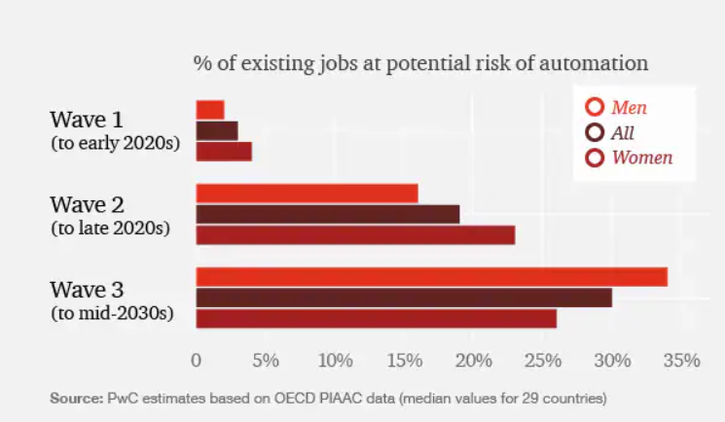 Figure:6 Graph of risks to existing jobs to automation to mid-2030s. (Evans-Pughe, 2018)

Prettner and Strulik, (2019) Modelled the effects of automation on inequality, education and economic growth, using an R&D-driven growth model The model predicted that automation would lead to an increase of graduates, increasing income and result in wealth inequality. They discussed that standard policy suggestions for automation would trigger inequality and have a negative effect on growth, and welfare, regardless of whether government changed policy to gain revenue from robot or progressive wage tax.
A significant concern for the introduction of robots will be the impact for workers. It is a fair assumption if a robot could perform at a faster and consistent rate, then the need for humans would not be required. Worries regarding automation are understandable, but aren’t always reported accurately, this can be related to previous industrial revolutions where human involvement was expected to decline but they continued to be an important role. Previously manufacturers have struggled in sourcing skilled staff to work specialised roles in their workplaces. Applying automation will raise another factor to that issue as robotic programming and knowledge of how to utilise and operate these systems will require further specialists in their fields, but the counter to that issue is a key advantage of upskilling existing workers.
Schwabe and Castellacci, (2020) discuss the pace of employing industrial robots, and smart processes into manufacturing in the past is a process of Schumpeterian creative destruction. This paradox could in the future lead to negative consequences for employment in multiple sectors and countries, and it will at the same time allow novel opportunities for productivity, wealth coupled with improved well-being. Furthermore, they state the transition period will not be quick and smooth and will have negative impacts in the short term but in time the resulting societal and economic benefits will be realised.
Having increased automation and having the possibility of humans to benefit from reduced working weeks, Mourtzis, Angelopoulos and Panopoulos, (2022) discuss that I4.0 is revolutionised production and manufacturing systems by implementing novel or nuanced business models, products and services while improve sustainability and efficiency and digitalising entire systems, they discuss the evolution of I4.0 transferring into I5.0 which encompasses system and machine oriented instead of human and machine, they highlight several countries that have begun to implement initiatives towards the development and utilisation of humancentric parts of I4.0 technology and services which would extend and transform society into society 5.0.
Bouchrika, (2022) discusses a consensus across current literature and studies that interpersonal and creativity will be the leading defence against a robot removing human jobs. Although some scenarios are fear driven regarding robots replacing humans. Many businesses are exploiting the technologies of I4 as a strategic priority. Products, operations and services are being infused with digital models, twins and generating digital assets. Automation and digitalisation will need bold wholesale changes (Miscovich, 2017).

Cyber security and robotics
Robots are being implemented in our daily lives, it’s a necessity to take in to consideration security to avoid attacks and robot communication being exploited. Morante, Victores and Balaguer, (2015) highlight that if security isn’t adopted to prevent external cyber-attacks, the implementation of mass robots will lead to an ever-increasing risk to humans, especially humans and robots are working collaborating. Tampering with these systems could end in serious injury and invasion of privacy. Cyber safety good practices should be adhered to when developing and adopting this technology.
The problems that are prevalent for Cobot systems are relatable to the same ones during the computer revolution when the Internet was adopted by the masses three decades ago. Key attacks these systems could suffer are: denial-of-service (DOS), tampering, Ransome wear, or information theft and robot reprogramming. Cobots increase the danger by having additional factors of physical interaction with humans, losing control of a computer or a server may result in loss of money or information but high jacking the control of a Cobot can endanger whoever or whatever is in the field of movement.

End effector for robotic system

Every robot will have an end effector, this can be defined as the part of the robot that will interact with both part and environment. Grippers are the most common end effector which allows the robot to grip for processes such as placing, picking, assembly or sorting. Traditional robot systems that require multiple end effectors to be changed either by the operator or having an end effector changing capability within the robotic cell can potentially lead to a higher cycle time for the entire process. Westmoreland, (2018) discusses an effective way to minimise this increased in cycle time is with a dual-end effector.
A dual end effector gives the robot the ability to perform the process as a human operator can. Using the first end effector the robot performs the first process required then the secondary end effector could be used to finish the second required process. With the configuration of a dual end effector for processes the end effectors can be designed for the unique job they are performing and can be specifically designed for unfinished parts, semi-finished or finished items, which guarantees precision handling of the product.

Weighing system.
There are several ways to weigh additions with the robot arm, one way would be using a laboratory scale with IOT capabilities to be linked to the system. When the additions are placed on the scale the measurement would be taken, computed and then either pass or fail depending on the required weight and size. The robot arm would either disregard the item or place it in the additions pot ready for processing. Another way of measuring weight with this system would be to fit a load sensor between the end effector and actuator of the wrist of the robot. They are a force sensor that can be used to measure weights although that isn’t their only use as they can be utilised to measure forces such as pressure, compression and torque.
Aujeszky et al., (2019) discuss how people will guess rough weight from a initial visual estimation then from a executed grip. Weight estimation for a robot would involve multiple steps, the initial position of arm, gripping and lifting, the load is held unsupported, putting the load back to original position and the arm then returning to its original position. The weight of the load would be estimated by the difference of the forces between grasping the object and holding the object. The limitation of this method id the robot needs to make physical contact to make the estimation.
Pick and place robots are already widely used in different industries and used across manufacturing and logistics etc. Load cells are commonly used to measure the objects weight. The injection moulding industry has used automatic weighing systems attached to their production lines where parts are weighed for quality and process consistency. They have high precisions load cell sensors located between robot rotary axis and the end effector that allow in transit measurements of weight, removing the loss of time that resulted from having to deposit the products first and manually weighing. Reliability and precise measurements that come directly from the robotic arm is difficult from external influencing factors that affect the measurement. For example, the vibrations caused by movements from the machinery or external environmental factors. The less extreme the robot moves the higher potential accurate the measurements would be.
Commercially available robotic system for weighting and calibration was made in the late 90s by METROTEC. This system could weigh from 1 mg to 5 g. Because of demand, these systems have been incrementally improved for higher weight and throughput capacity. Productivity, reliability, and accuracy are the driving force behind increased demand for this process for robotic weighing. Calibration laboratories normally have a substantial throughput, so time efficiency is a pressing factor without losing any accuracy or reliability.

Utilising software like LabX™ weighing packages on the process could ensure every product would have Minimized mistakes or calculation errors because all calculations would automatically and immediately have confirmation that the results have met the specified addition tolerances. All the data, including metadata, would be stored automatically in a centralized database and would result in a reduction of the time necessary for a operator to manual input the data and remove the risk of operator errors and can generate customised reports (LabX Balance Software, 2023).

Using Simulation and Cad software
Simulation can be used to evaluate effects on process changes, capital investment of equipment or new procedures, all three points raised are covered in this paper. Designers, engineers or operators can assess performance of current systems and predict potential performance of planned changed into systems and affording the option to compare and make incremental or disruptive changes. This system will be a digital version but will emulate a physical working environment.
Using Cad software and the availability of 3d printing, it would be feasible to design the robot system component parts for the robotic arm and print them affordably. The more complex pieces such as the end effector could be drawn in multiple parts and a working model could be seen before a piece is printed, but with the range of Cad and simulation software it would be possible to design all the parts and sustainable practices such as sustainability through lightweighting with out losing strength could be utilised.
One way is through Generative design (GD) software which could afford time to set parameters, these could include, materials, constraints, stress limitations, wall thickness, design space availability, loads, contacts and costings, coupled with set performance tasks for the desired product. It can consider the manufacturing methods required, whether that is casting, milling, forging, injection moulding or additive manufacturing. Computing power today has grown exponentially and the push for design that are unique and mass customisable have been enabled by AM and have driven the requirement for this type of AI software. Much like the premise of this robotic system, the usage of this software isn’t to replace a designer or engineer, but to allow more free time from tasks that are repetitive, human error or design constraints, affording the operator time that could be used of innovating or problem solving. Time will be saved in new product development, and having an array of design solutions that can be evaluated that may not have been considered because it explores all the possible outcomes of a solutions, rapidly generating alternatives, which are tested and can learn from each iteration of what could work (Autocad, 2022).

Lightweighting the gripper using nTopology
The opportunity to utilise lightweighting with customisable designs can improve the success of products and parts, leveraging intelligent lightweighting technology has led to improvements in performance across multiple industries such as space, automotive, manufacturing and sports teams., Benefits include energy efficiency, a reduction in manufacturing costs, resulting in greener products. In manufacturing equipment that has range and payload constraints, such as automation where if weight is reduced, but the range, and payload requirements are not affected, it could lead the way for an efficiency increase, throughput, and a reduction in operational costs. Lightweighting industrial equipment can improve safety of workers during the assembly as the weight reduction would make handling of part manageable and reduce potential injury (nTopology, 2022).
1-meter-long robotic arm using AM and sand casting.
3D printing for sand casting moulds has changed the process for high-performance, larger metallic products are manufactured. AM has enabled modern foundries to produce complex parts onsite or just in time. The benefits of combining advanced design tools with 3D printed sand casting allowed Varotsis, (2021) to redesign and manufacture a 1meter long robotic arm. Metal casting has been well-proven for manufacturing and 90% of all manufactured products and most machinery will have components that have been made by using casting. Initial considerations of generating a robotic arm that is lightweight was to optimise the geometry of the component. They managed to achieve a weight reduction of 40% but lose no load capabilities and manufactured it with 7 days. The automated stages of design and optimisation allowed them to smooth and reconstruction using the capabilities of nTopology to make iterations with minimal work. They discuss the only way to make this part this big and complex was to leverage advanced manufacturing. Direct AM such as Powder bed fusion (PBF) or electron beam melting (EB) couldn’t be used due to part size. They decided to combine traditional sand casting with AM. Additive manufacturing had eliminated the constraint for hard tooling and complex casting patterns and the resulting geometry barriers.

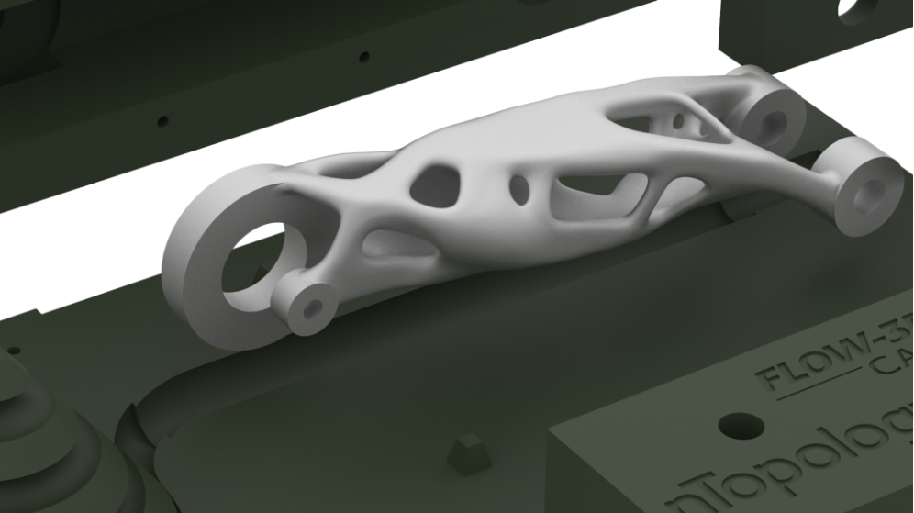
Figure: 7 A meter-long robot arm that was sand cast using topology optimisation that was manufactured using AM (Varotsis, 2021).
.
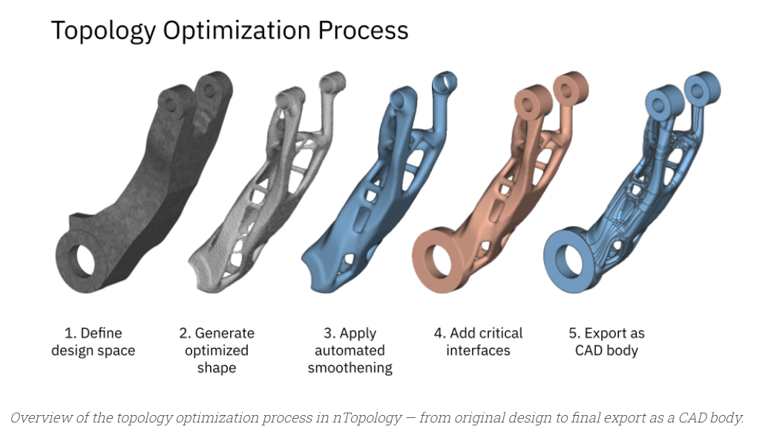
Figure: 8 Original design to final export in nTopology of robotic arm (Varotsis, 2021).

Above shows the original design, and the multiple stages to final cad film ready for printing.

Generative design software packages use AI to then explores all the possible designs and offers a solution. The capabilities of this GD software can learn and test each iteration resulting in a multitude of designs (Autodesk, 2022).

Implicit modelling

Implicit modelling uses a maths calculation for generation of its complex structures compared to traditional cad models
Implicit modelling is a useful tool when used for engineering design where specific modelling tasks have complex geometries. In ntopolgy it is not currently used for parametric designs, that use constraints to define their geometries.
AM enables highly complex geometries, for example repeat lattice structures or organic designs, The design freedom could lead to improvements of performance in terms of stress, weight or heat transfer. Currently modelling, and processing geometry that are complex have been challenging for the current CAD software because the file size or rebuild times grow exponentially. Implicit modelling could be utilised to remove these problems
For this project the body of the gripper arm has utilised nToplopgy lightweighting software and had a reduction 0f 75% in weight.

Field driven design.

Fields in design allow engineers to manipulate geometry using collected data Field-driven design is built on implicit modelling. Its advantages for end-users by enhancing design agility. Fields afford the ability to express spatial difference of the design components, allowing you to manage the difficult geometry’s that haven’t been possible previously. Design for engineers is dependent on the fields, fields represent different data sets, Spatial positions such as volume, velocity, and distances are examples of the definition of a “field.’ It’s possible to convert CAD or CAM in to fields and generate or make iterations to designs by directly incorporating them into the working model. This is important as it allows you to get full control of the shape, field-driven design is advanced as it allows you to gain the precise amount of mobility into designs. They enable solutions with a path for manufacturing.

Triply periodic minimal surfaces.

lattice structures have been Manufactured and tested using triply periodic minimal surfaces (TPMS) by changing Lattice geometries the mass will deform in different ways. A TPMS lattice of gyroid was chosen for this robot part because it offers potential advantages over strut-based lattices such as body-centred-cubic (BCC) Properties of TPMS include a good combination of stiffness coupled with enhanced surface-to-volume ratios (Maskery et al., 2018).

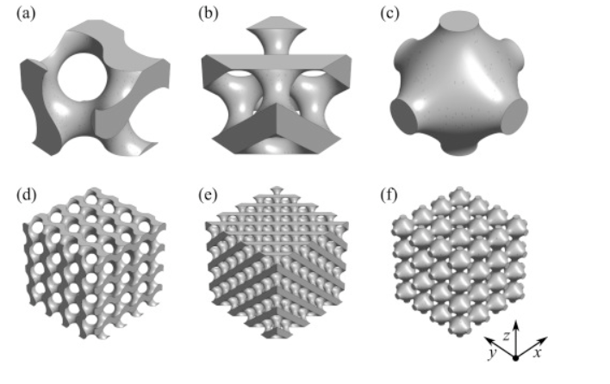

Figure: 9 Image of the cells for gyroid, diamond and primitive, and the lattice structures are below (Maskery et al., 2018).

Financial implication of automation
Financial costs
If this system were to be implanted and run through a financial model, it would be classed as a tangible asset, however as there is no financial metric of throughput, it would be hard to justify the purchase. The robotic system would depreciate over time and the high initial outlay with no profit year on year could sway the decision to implement this robotic process. Applying cost benefit analysis would complement the financial modelling and should allow for the merits of its intangible value, to be critically evaluated before a decision is made, these include: new industry processes, upskilling staff, ability to free up operator time, better quality of life and work, ability to automate processes, leads to the ability to scale production first mover advantage, The Cobot learnings can be franchised or taught to more robots leading to IP that could be licensed, robots don’t get sick and have 100% attention span, the option to run 24/7. By using these opportunity costs, I the decision-making process it would avoid the potential missed opportunity of adoption of this new process, financial modelling is only as good as the data gathered and analysed (Hayes 2022).

Financial aid.
AI and robotics industry is in its nature innovative and requires research and development. A large amount of this research could qualify for R&D tax relief. HMRC do not have a different classification for this technology, but robotics and AI are heavily involved in sectors looking to increase productivity and drive automation. Two highlighted areas that coincide with this project are‌ creating efficacy in a process and data capture (GovGrant, 2023).
Another financial aid that could be used for this project is combining with another department located at the steels and metals institute, by coming together, the financial burden would be shared but the operations, and skill set of different departments will allow for greater innovation and solutions to problems will also mitigating the high expenditure of implementing a robot system.
Innovation management
Innovation management is an important aspect of I4.0, utilising new technology or innovating aspects of any business will have pro and con what is clear, that if certain criteria isn’t met, managing new automation being implement into a business is going to be met with fear. This process is effectively replacing the need of an employee doing part of the process, which at first may seem productive freeing up time for more meaningful work, but once automation replaces multiple steps, it’s only a matter of time before the doubt of their longevity in the business is questioned. Failing to manage new processes and products could result in stagnation offerings and become victim of the threat of disruption that I4 brings. Great ideas will flourish in organisations that have effective leadership and clear strategic goals, having these values will promote success and growth. To manage automation through robotics, brainstorming was utilised with other members from the course at the beginning of the module. This was further developed through smaller groups of like-minded individuals and staff at SaMI. Ideas were recorded and shared with stakeholders and evaluated to see how this innovation could be implemented and if an additions robot would fit with the wider strategic goals at SaMI.
Culture.
Two keys’ strategies for an innovation culture required for the adoption of not just this innovation but the wider benefits of I4 is promoting and encouraging employees to learn and upskill, if this is taking seriously by employees and employers the teams generated will be able to take and identify opportunities to innovate rapidly. Secondly, making failures is to be expected and seen as part of the process, a key barrier that stifles sustainable progress is that if an idea doesn’t work or doesn’t work as planned that it was an inherently bad idea. This isn’t true, not all ideas will be implemented or work.
A robotic arm replacing a human operator doing a mundane task improving the quality of a product according to Satell, (2017) would be a sustaining innovation. He created the Innovation Matrix to help identify the correct strategy to solve problems. Defining the problem will help innovate smoothly and define the skills needed to implement this innovative process.

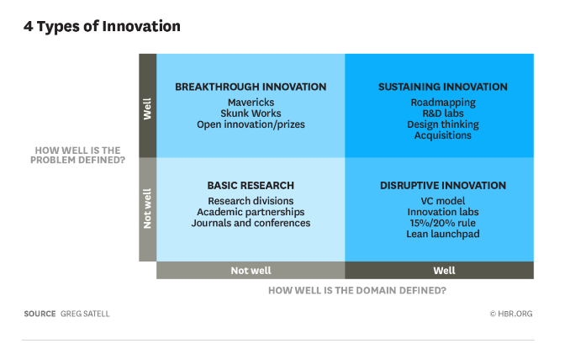
Figure:10 Innovation matrix (Satell, 2017)

Methodology

From the literature review it was prevalent the need to design specific systems and parts for automation is key to embed I4.0 technology to modern day practices. Objectives for this project will be to observe whether parts drawn on fusion 360 could utilize implicit modelling and be exported to simulation software roboDK. Research triangulation was utilised with more than one method to research and analyses a range of data and software was used to increase the accuracy of the research (Noble and Heale, 2019). Peer reviewed Journals, ISOs, and selected manufacturers for software and key parts for robotic systems were utilised websites with a range of dates from 2014 to 2023, were read and considered to aid the literature review. Communications with Industry leaders and suppliers from across the UK and advanced manufacturing show in 2022 at the NEC in Birmingham contributed to this paper. This system would require multiple end effectors for picking up complex objects, including granules, sheet, and rock-based elements. The design for this research will be a dual end effector utilising a gripper and suction cup tool.

Design of end effector part for this system.
A working robot gripper was drawn in fusion 360 from multiple parts and the main body was subject to lightweighting using implicit modelling through nTopology. The robot gripper was rendered using Keyshot to see a realised visualisation to simulate what the part would resemble when printed. Using these tools will encompass AI design tools that aid in the design process where engineers or industry professionals can set goals into design software, coupled with parameters including spatial requirements, materials performance manufacturing methods, loads and even cost constraints.

RoboDK simulation software.
A limitation for RoboDK is the library, it has an expansive range of robotic cells, robotic and accessories with useful environment objects such as, tables, boxes etc, but the limitation is with custom parts for unique processes. For this reason, an additions pot and additions were drawn using fusion 360 and uploaded to RoboDK, the simulation of picking additions and filling the additions pot will be carried out using the following items from the online library.
The Intel® RealSense™ depth camera D435 is available in the RoboDK library and is a stereo camera that can be utilised for a multitude of applications. It can have a wide field of view and is suitable for robotics, VR and AR.
This simulation will utilise a KUKA LBR iiwa 7 R800 MF Robot located in the RoboDK software. It is a 7axis robot, with a reach of 800mm capable of a 7.0kg payload. The mass of the robot is 24kg with a repeatability factor of 0.1mm.
A Robotiq 2f 140 gripper mechanism that has been designed for collative robots with a 140mm wide opening was used for the roboDK simulation, that have a high pinch load and suitable for the payload of this additions system, coupled with a RoticQ-EPick-Vacuum-Gripper with 1 cup.

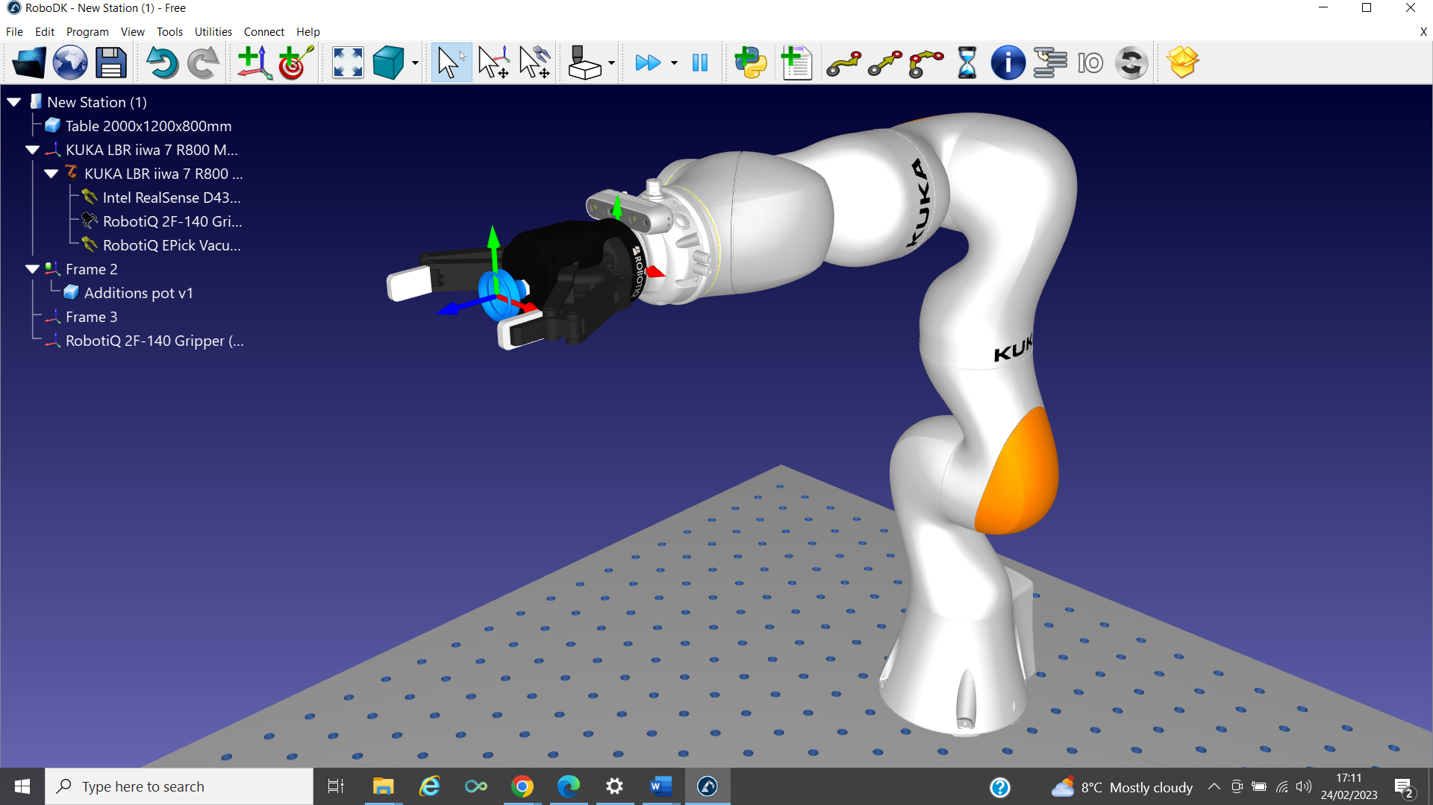
Figure: 11 Image of Robotic arm with both tooling and depth camera (Evans, 2023)

Discussion

For this paper a mechanical gripper was drawn using fusion360 in multiple parts and assembled so it has 60 degrees range of movement to allow the gripper to open and close, and can be fitted with a standard stepper motor. It was rendered by importing an STL into the 3D render software Keyshot. Rendering is a process that involves a generation of a two- or three-dimensional image of a model. This is a tool to visualise what a completed product could look like Rendering increases efficiency and can reduce costs from prototyping or making an unwanted product. A white background was used and the material for the model was “Clear Shiny Black Plastic 1”

Fusion 360 design for robotic system.

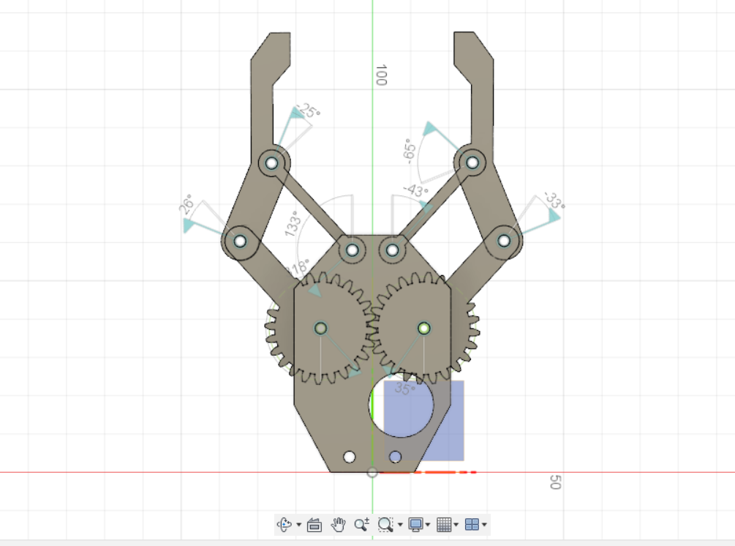
Figure: 12 Fusion 360 side image of the sketch of the end effector gripper (Evans, 2023)

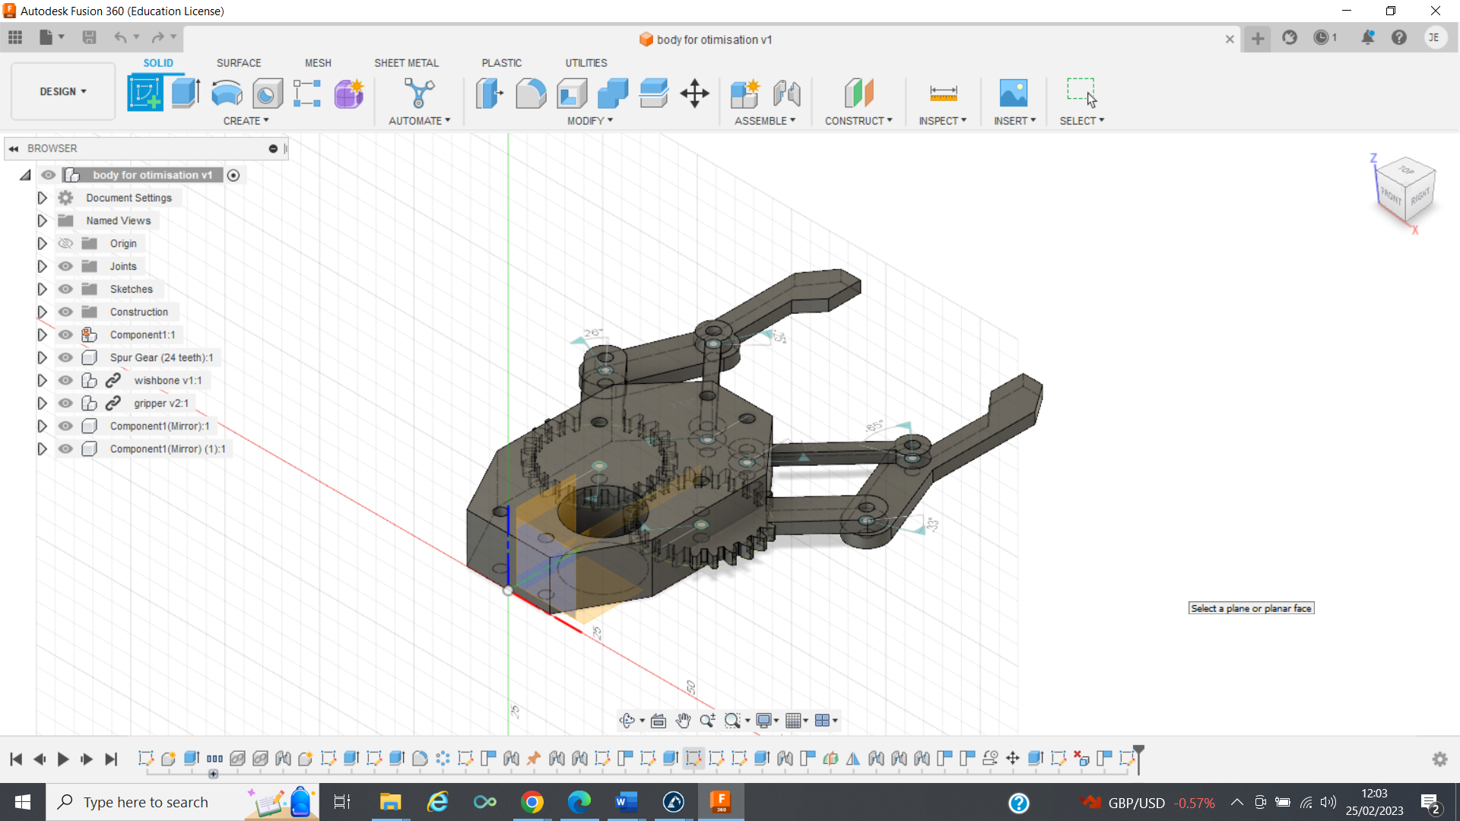
Figure: 13 Fusion 360 image of the sketch of the end effector gripper (Evans, 2023)

Using fusion 360 materials library, PEKK Carbon 3D filament Polyetherketoneketone is thermoplastic polymer reinforced with carbon fibre was chosen to simulate the build. The material as a large level of rigidity and is heat-resistant. It has the added benefit to be used as a gripper that could then be exposed to acids or hydrocarbons. Allowing for a change of process for the system in the future. This material is compliant with the REACH standard.
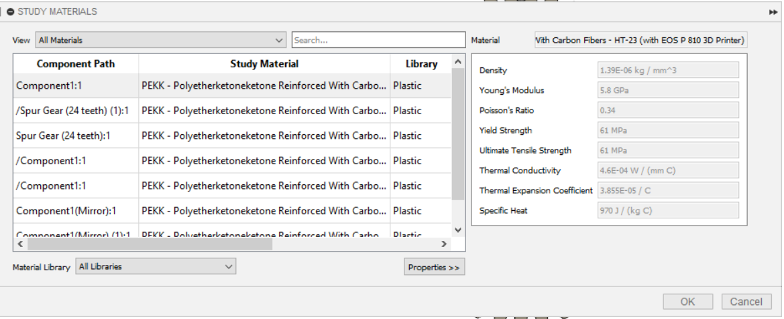 Figure: 14 Material selection for gripper in fusion 360 (Evans, 2023).

Below are images of the renders from Keyshot that help designers and engineers see visualisations of parts that have been drawn through computer software. A key benefit to this process is that parts can be seen before manufactured saving on potential unwanted parts or changes to designs can be adjusted at this stage.
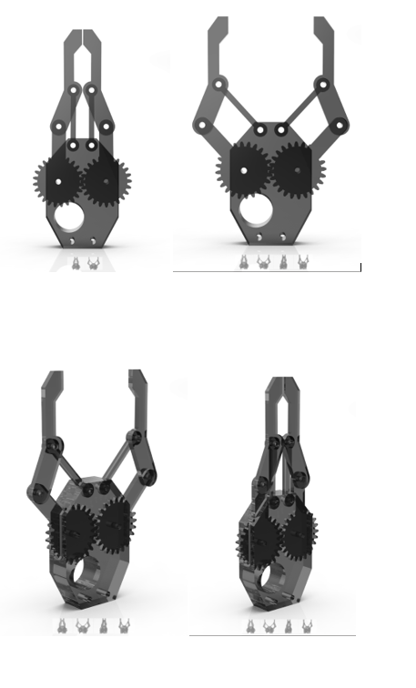

Figure: 15 Keyshot renders of end effector (Evans,2023)
nTopology lightweighting.
In order to take advantage of TPMS the main body of the gripper was Imported into nTopolgy for lightweighting. The meshes were created, one was the frame of the part and the second was the infill. Both of these were sent as, OBJs. OBJ is a popular format for 3D modelling and can be used for 3D graphics applications. It consists of a 3D item and all its geometry, including vertex’s, free form curves, polygonal faces and texture vertices. Their strength is that it is text based and easy to understand. Its normally the 3D tool used for imports and exports.
For part production the mesh is usually translated to a print file, such as. STL.

Below is the frame & the infill that have been imported a mesh from the OBJ. File. The light blue background is the frame.

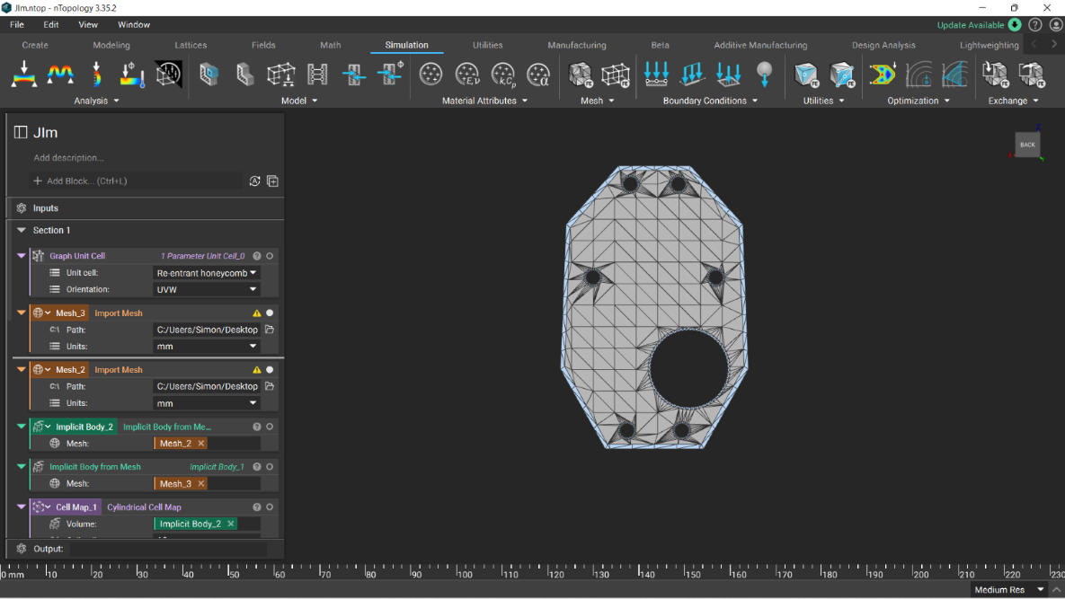
Figure 16: NTopology image of the Frame & Infill mesh geometries (Evans, 2023.)

The implicit body as seen below is the 3D geometry realised by a mathematical equation, converted from the mesh. When converting a model from CAD software such as or Fusion into an implicit body, the item will not be using fixed surfaces or edges like traditional models. Instead, the item is transferred into mathematical equations that are the geometry of the item, in this case the gripper body. These equations take less time to work out. The mesh surrounds the item defining the edges, faces and vertices of the gripper body.

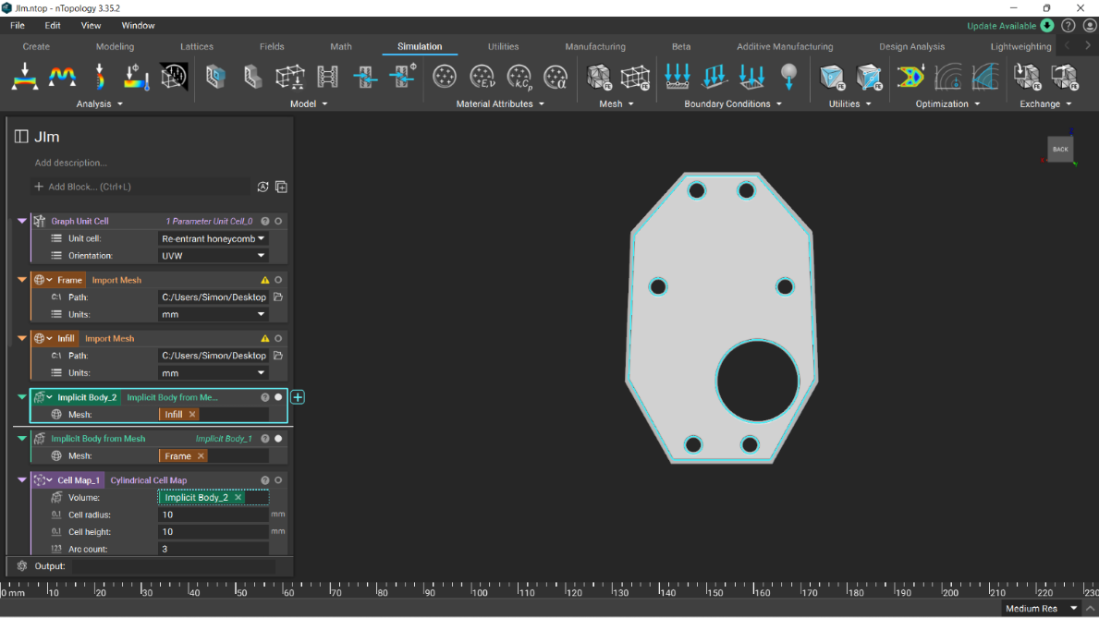
Figure: 17 nTopology image of the Frame & Infill implicit geometries (Evans, 2023.)

The building block used for this project is a gyroid, & below is the cell unit that was used to create the component. A gyroid infill gives the part isotropic properties, demonstrating similar strength and properties in every direction they are subject to for loads and stresses.
By using the gyroid building block will allow for retaining strength, while also lightweighting.

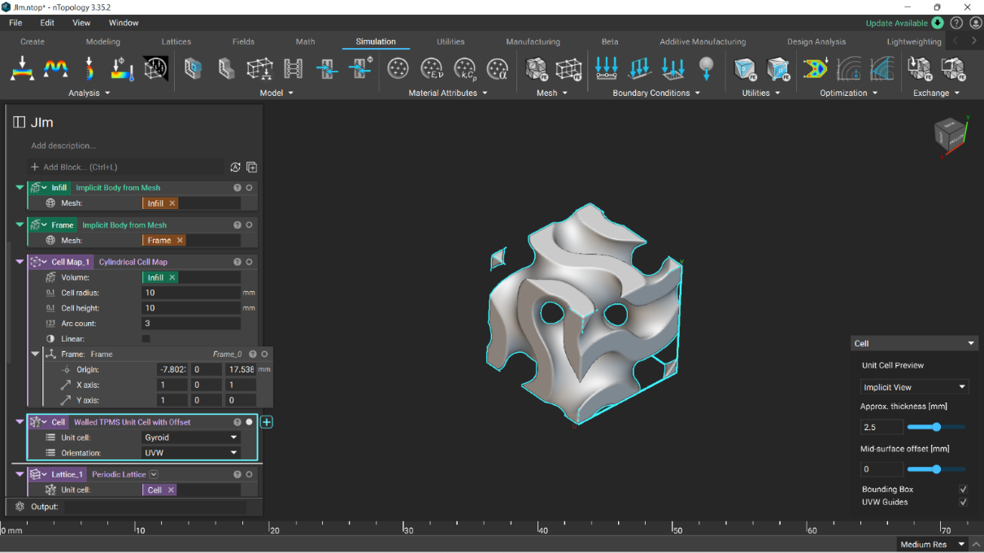
Figure 18: nTopology image of the Gyroid building block (Evans, 2023.)

A Cylindrical cell map mas created and radiated out from the center hole where the stepper motor would be located, this is because that area is needed to hold the strength of the part.

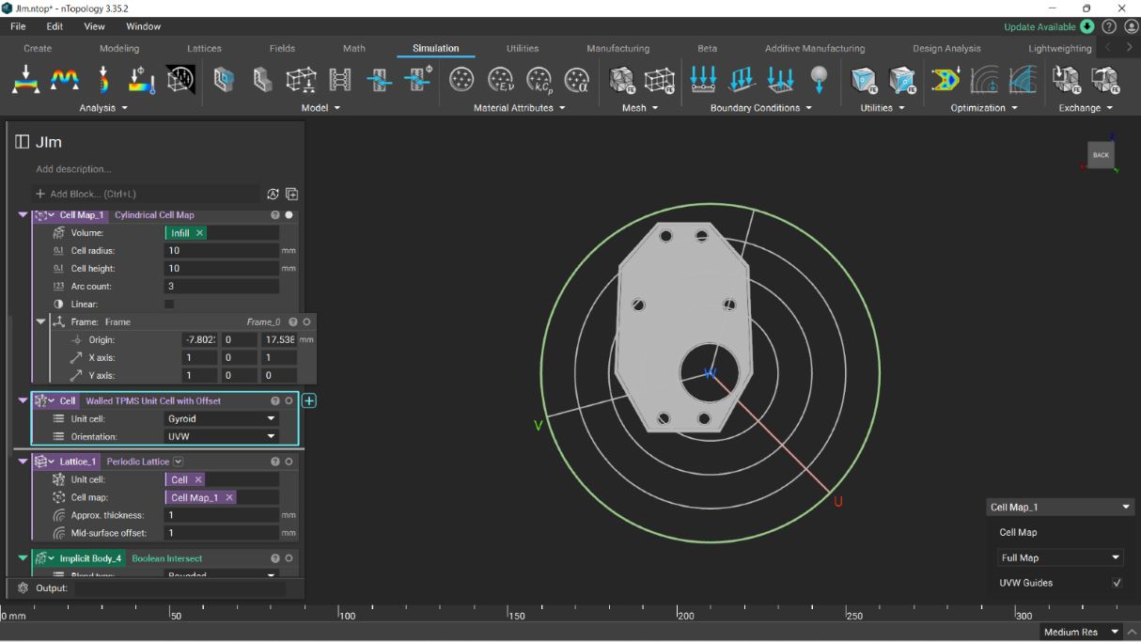
Figure 19: nTopology image of the Cell Map (Evans, 2023.)

Combining the gyroid building block and the cylinder cell map created a periodic lattice that can be seen below.

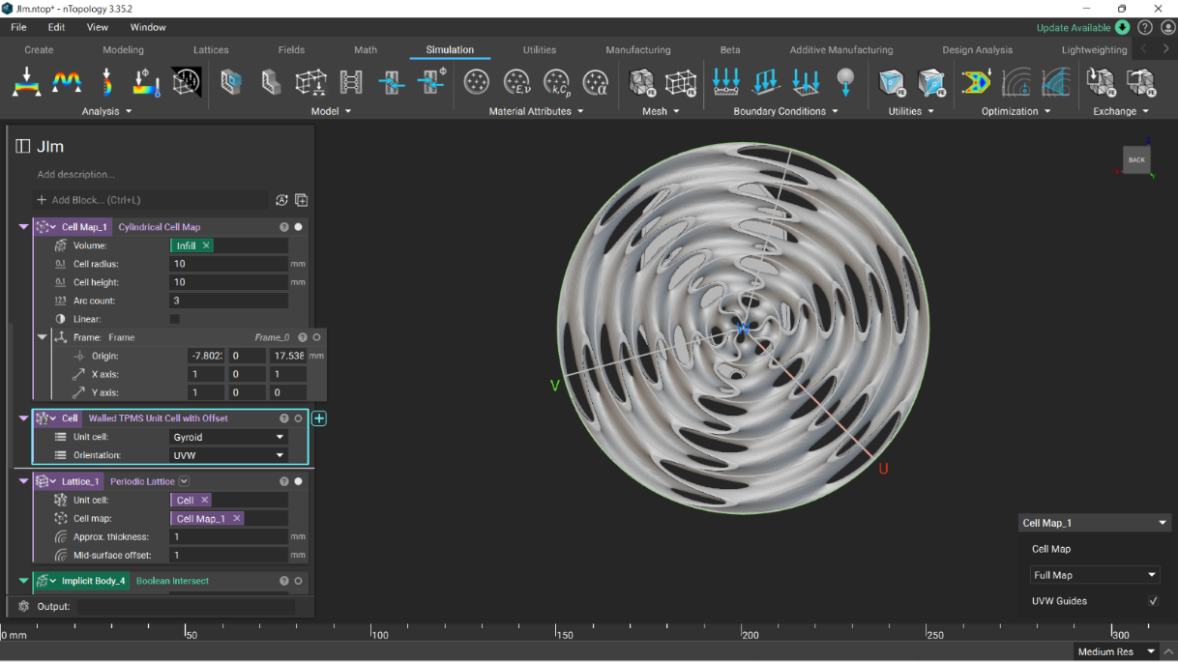
Figure 20: nTopology image of the Periodic Lattice (Evans, 2023.)

Below is the gripper body where Boolean intersection of the Implicit model infill section has removed the material for lightweighting. This can be fully controlled and customised by controlling the thickness of the TPMS cell and changing the Arc count and size of the cell map. 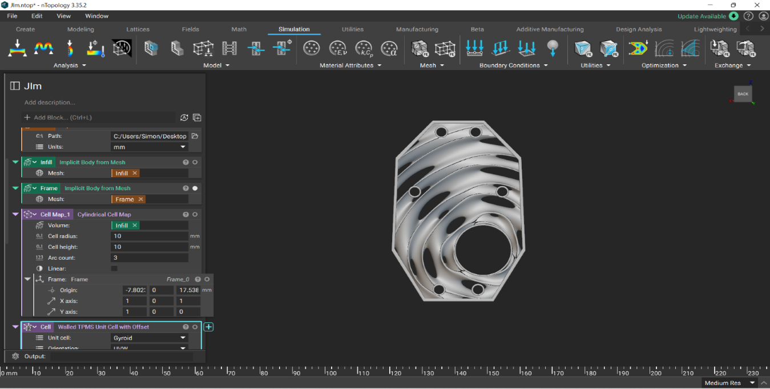
Figure 21: NTopology image of the Frame & Infill implicit Boolean intersection geometries (Evans, 2023.)

By utilizing this software, it would be possible to reach a weight Reduction Ratio of infill 87.96%
However, this may be too much weight removal. Further investigation is needed to determine optimal material, TPMS, lattice cell, and lightweight reduction for proposed forces through simulated material testing (static analysis for compression or tensile.)
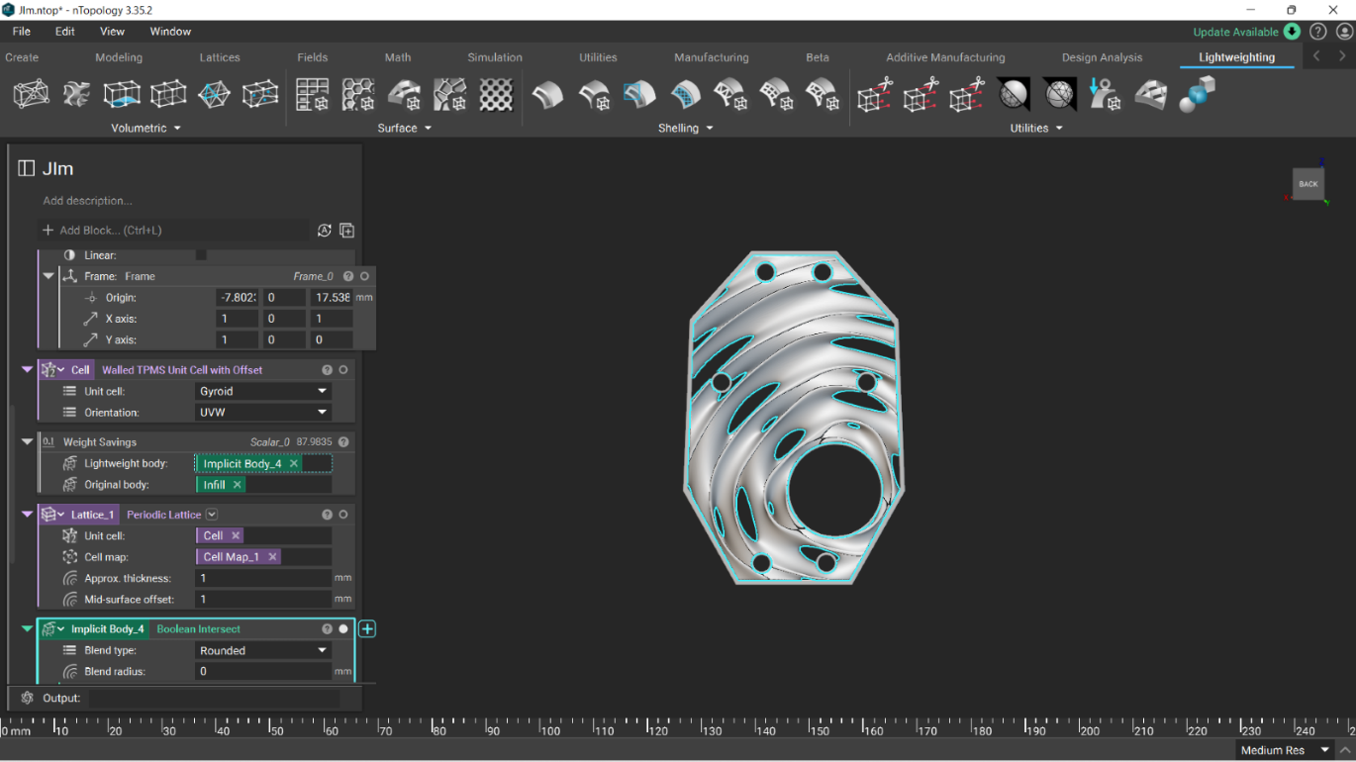 Figure 22: NTopology image of the Weight ratio analysis (Evans, 2023.)

Below is a side view of the Boolean intersection extreme lightweighting. This was used to demonstrate how much material can be saved by using this software. With material scarcity being a global issue weight reduction of parts that will not affect the product properties of life cycle should be considered where possible.
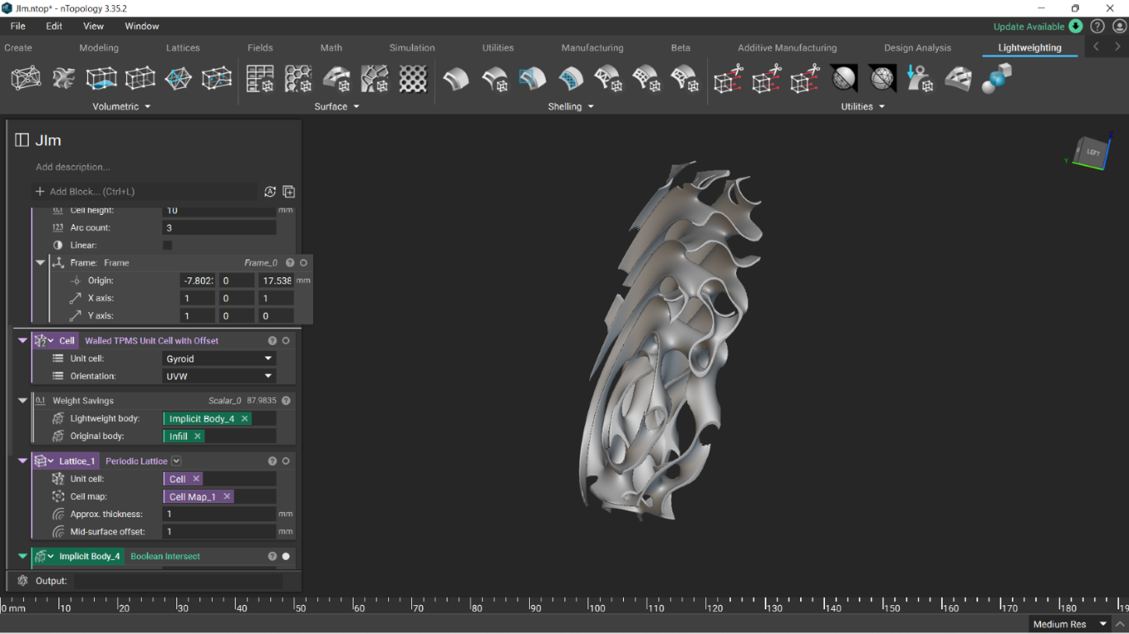Figure: 23 nTopology image of the Boolean intersection of the infill Implicit body (Evans, 2023.)

Compression tests & tensile can be simulated in ntopology called static analysis where forces can be applied to the gripper body.

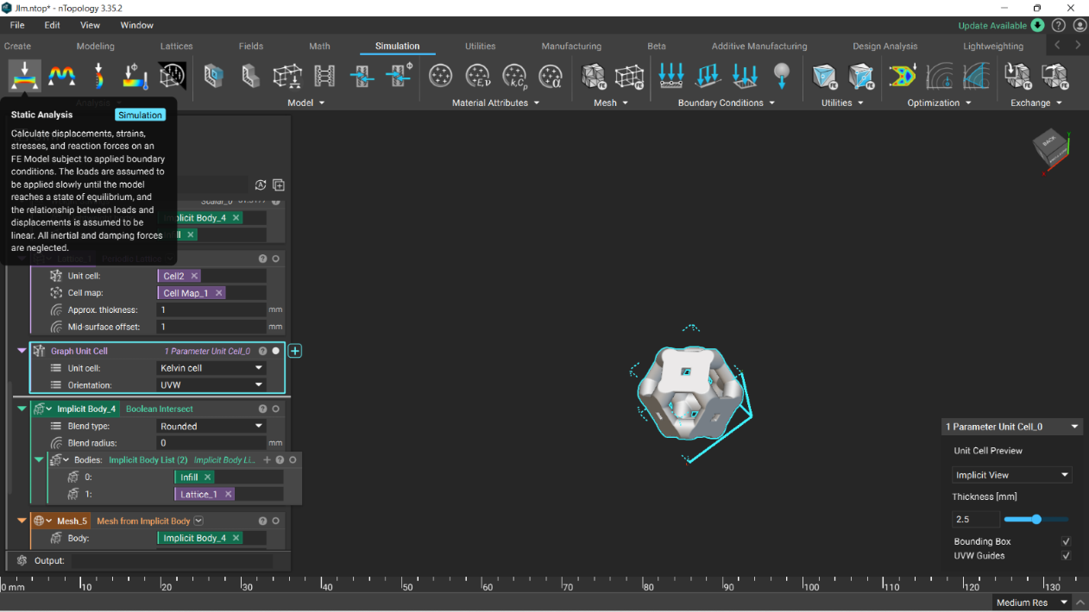
Figure:24 nTopology image of the static analysis (Evans, 2023.)

RoboDK simulation software
A robot system has been designed using RoboDK to programme a robot and simulate a robotic industrial simulation as it is cost effective way to test the system before a high upfront financial cost of implementation. This study will use a 7-axis robotic arm that utilizes multiple end effectors to pick and weigh additions used in a steel foundry.

RoboDK software has a large online catalogue of robots, objects, and tooling, but is limited for bespoke simulation, however, it is possible to use cad software, export as a STL file and upload to RoboDK. Fusion 360 was used to draw the three additions Ni balls, Ti plate Mn rock and the additions pot, these can be seen below in their digital and physical state.
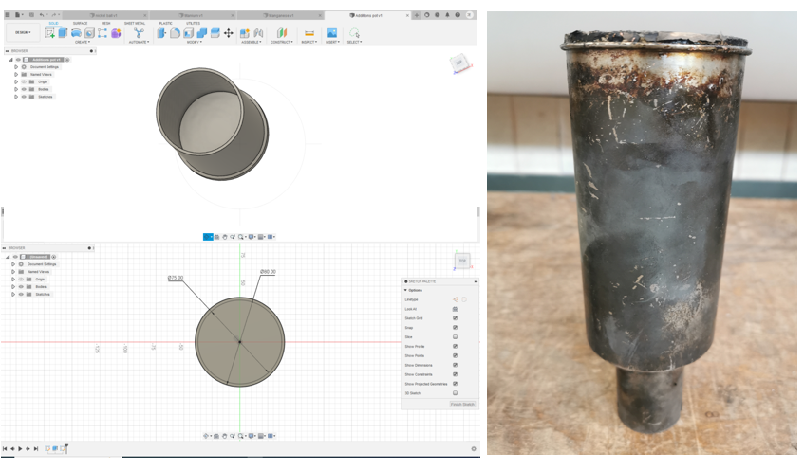
Figure:25 Fusion 360 images of drawing of addition pot alongside the physical object (Evans, 2023).

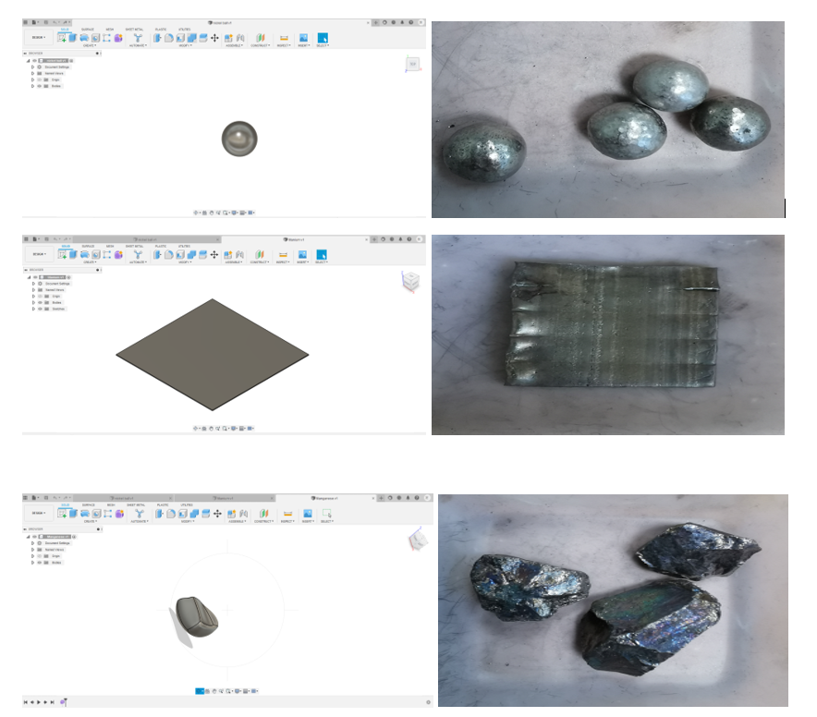
Figure:26 Fusion 360 images of drawings of additions alongside the physical objects (Evans, 2023)
Once these components were drawn thew were exported into RoboDK to be utilised in the software as seen below.
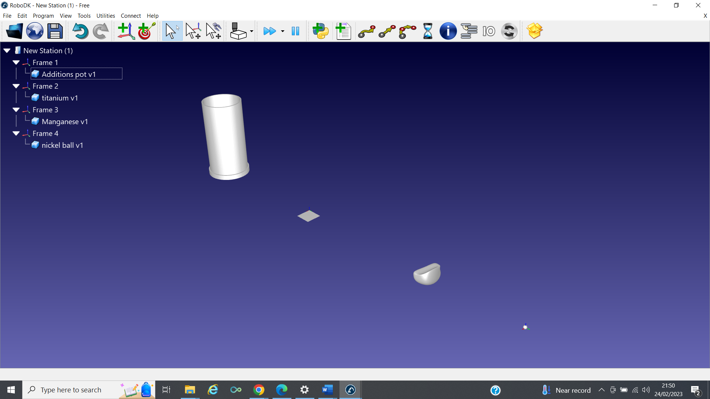
Figure: 27 additions pot, manganese, titanium and nickel ball .Stl files exported into RoboDK (Evans, 2023)

The gripper was placed over the manganese element and the claws of the gripper were shut to clamp the object. The gripper was programmed to attach the manganese and detach over the additions pot.

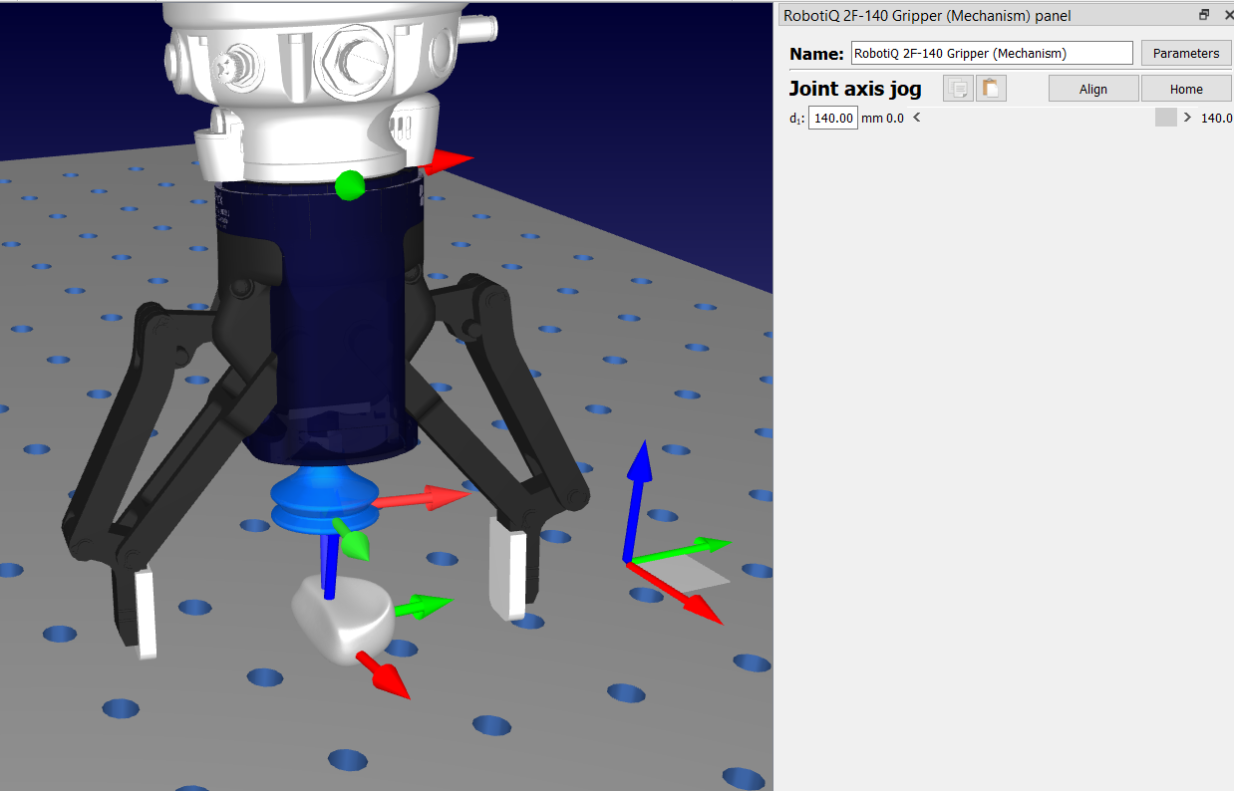

Figure:28 Gripper claw open fully picking up Mn additions. (Evans, 2023)

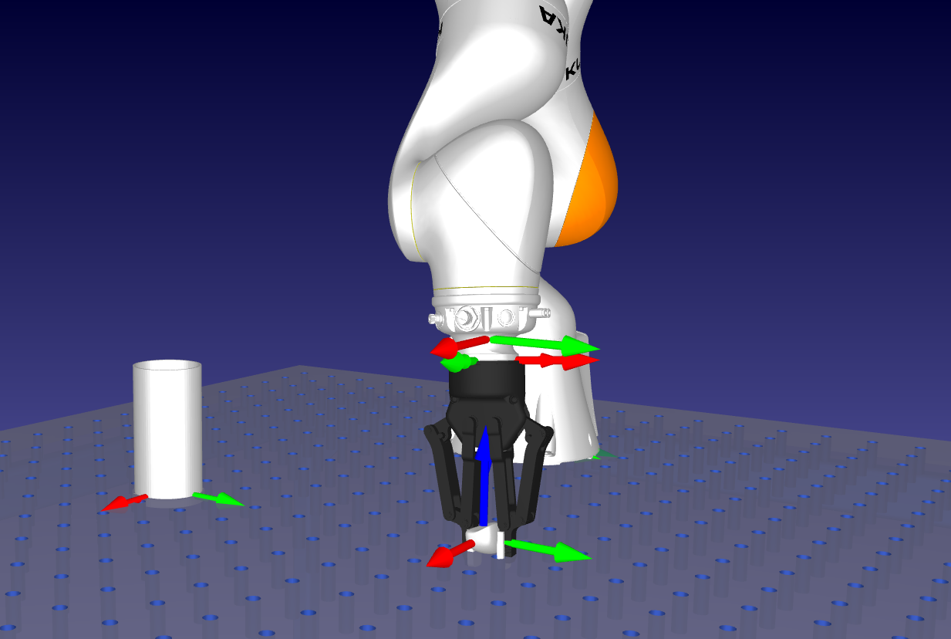
Figure: 29 Gripper claw attaching to Mn additions. (Evans, 2023)

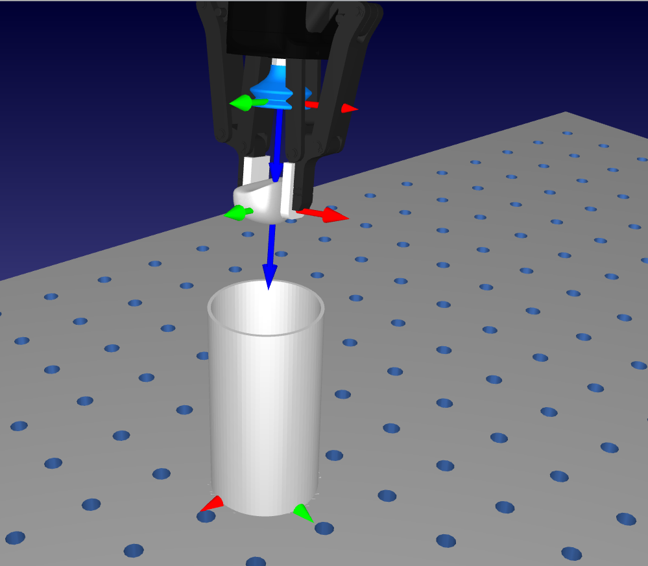

Figure: 30 Gripper claw detaching Mn additions to the pot. (Evans, 2023)

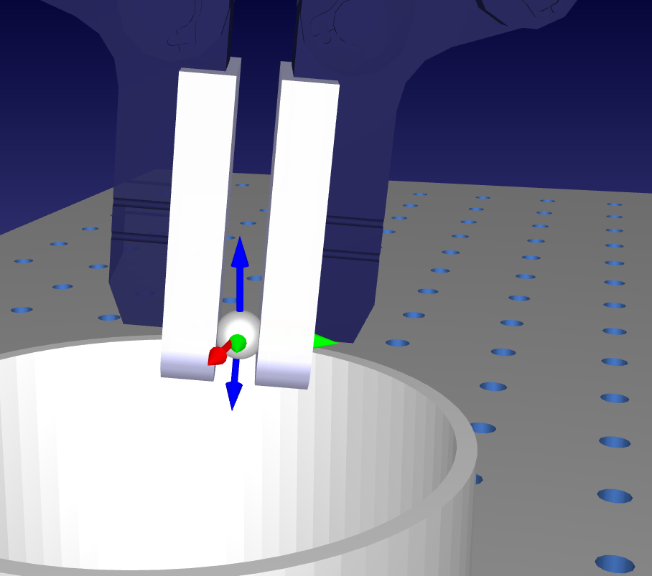
Figure: 31 Gripper claw detaching Ni ball to additions pot. (Evans, 2023)

Key design flaws with this system were with the attachments of the suction cup and gripper is constrained by size, and the Ti plate is too small to fit with the suction cup so couldn’t be utilised. The gripper needs to be improved. This will come under future work of gripper design to incorporate a smaller designed suction cup.
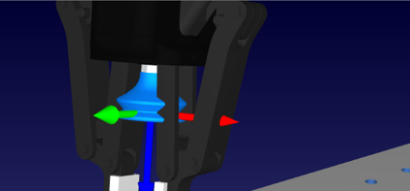
Figure: 32 System design flaw constraints of sizes of multi end effectors. (Evans, 2023)

Below is the end effector with lightweighting body, with the issues from the simulation software roboDK this project would have benefited from having a suction cup built into the design with a cup small enough to accommodate the Ti plate.
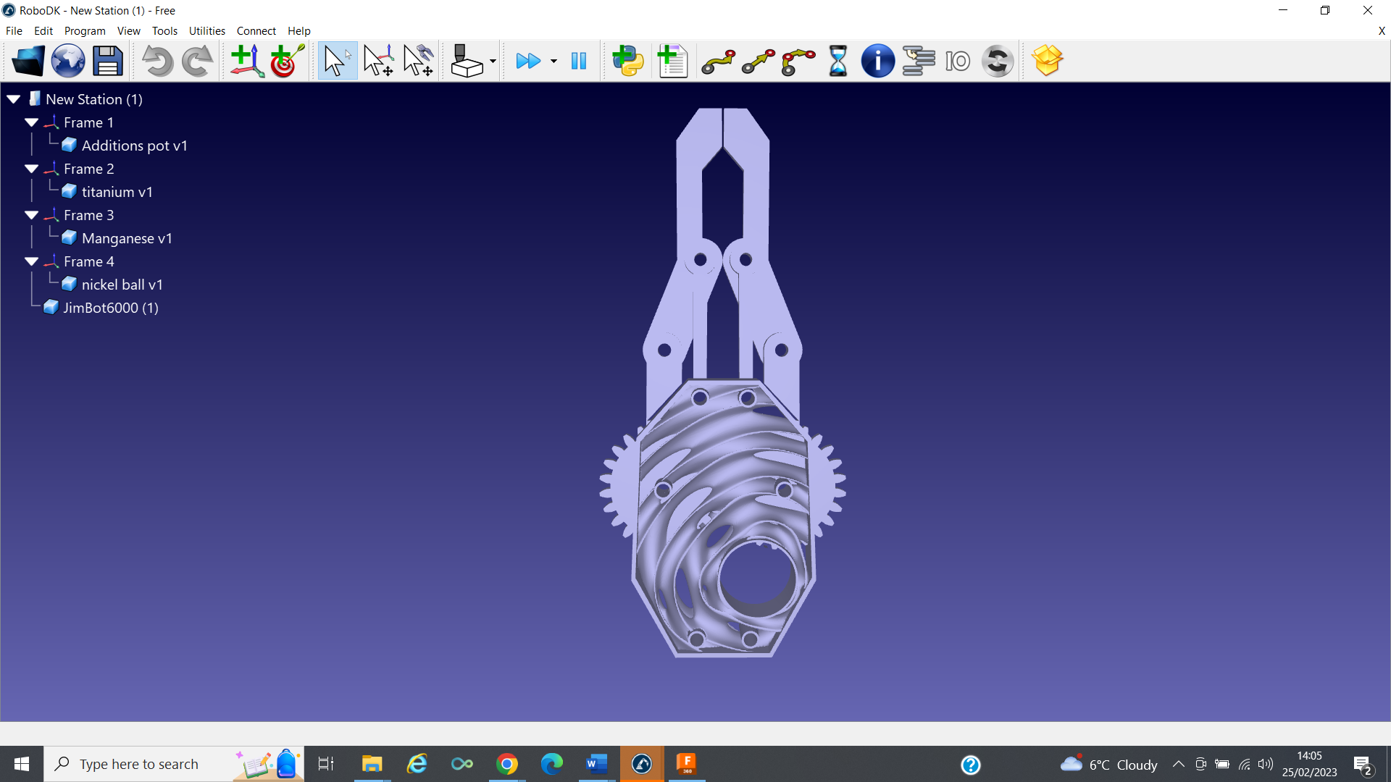
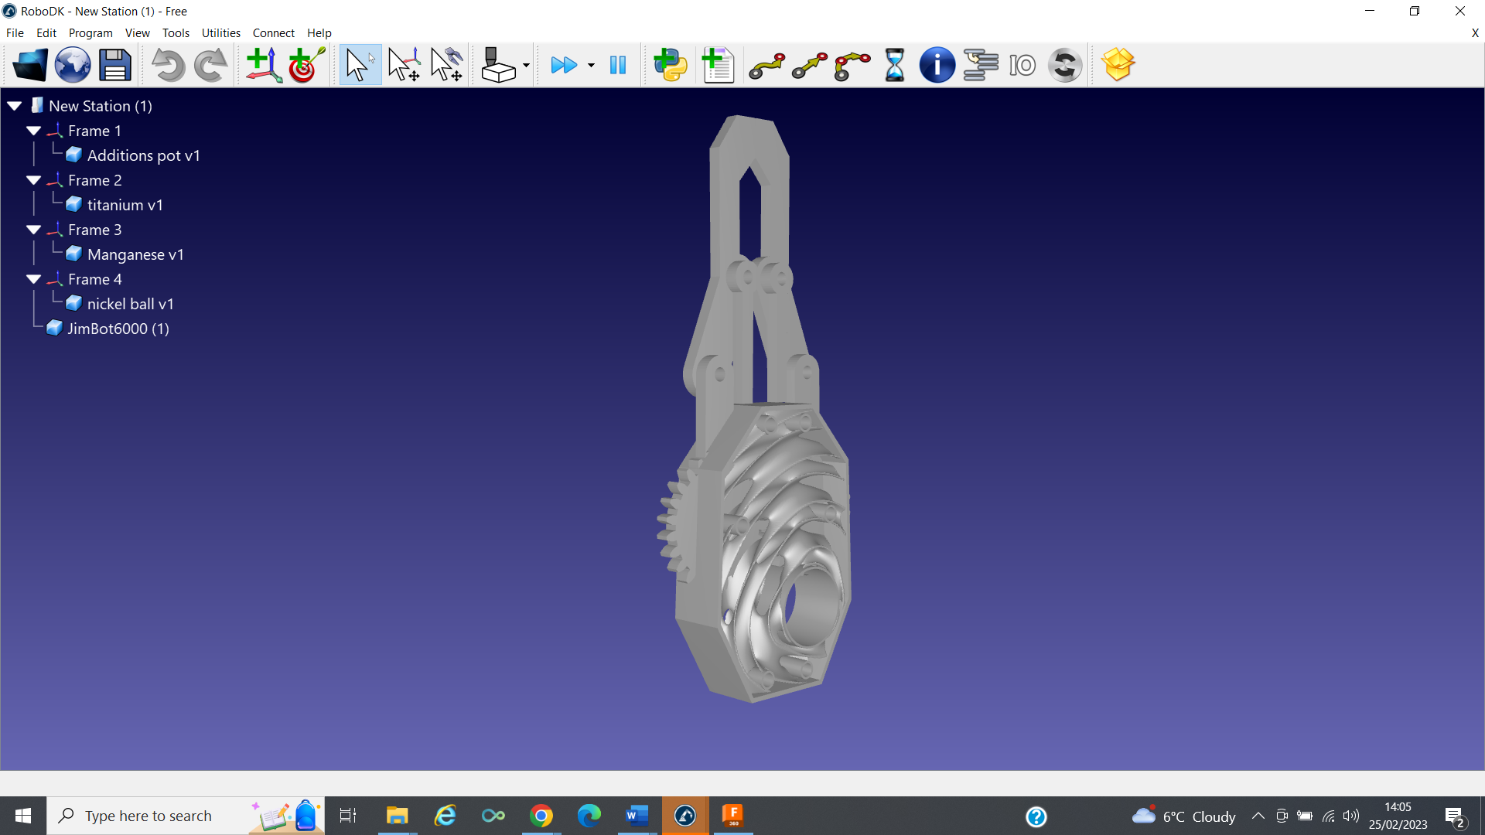
Figure:33 lightweighting of fusion 360 gripper using nTopology lightweighting exported to RoboDK (Evans, 2023)

Conclusion
To fully embrace the positive effects of I4.0 technologies for businesses, there will need to be paradigm shift of mindsets across the whole value chain, bold action should be taken, challenging the current methods and ideology of the manufacturing industries will lead to advantages and rewards for the future pioneers of global production.
Not embracing new technology such as automation and robotics shouldn’t be an option Instead of resisting new technology, it should be embraced and care needed to ensure workers whose jobs can be performed by robots have the opportunity to develop or learn new skills that will carry them into the current industrial revolution and beyond. The onus doesn’t lay just with the worker, but with the employer and governments worldwide, the planet and society shouldn’t come at a cost for the majority and enjoyed by the privileged few. The process outlined in this paper is used to aid the operator in a mundane time-consuming task, allowing more time to spend on research and analysis of results.
We should be pushing I4 enablers to its limits, the biggest barrier to innovation is staying the same, doing what we have always done shouldn’t be a core principle of any department or business. Innovators who take advantage using software to remove barriers in part design and manufacture will see a balance of risk and reward favoured to reward.
AM and digital manufacturing have transformed the image of the traditional manufacturing sector and attracts younger talent and new workforce to the industry. Automation is needed to compete internationally, which ever countries delay adopting automated processes, could lead to the consumers switching their production to countries who do as they have a comparative advantage. Combining lightweighting, 3d printing and generative design would result in reduced transportation costs and just in time manufacturing. Engineers and designers will have the opportunity to harness these processes for optimization and have a reduction in weight of cast parts. By using this they can also improve its performance, durability and strength. Further research into which TPMS structure are best for this model would need to be carried out.
Simulation isn’t real and is built on rules based on research and events that have past, and software and time to build and run these models can be costly. Even with these negatives the advantages of modern simulation are apparent, it can be used to find unexpected problems, which was demonstrated in the design of this system regarding the suction cup stopping a potential expensive error. Simulations has proved to be a useful tool.
Cobots with robot vision systems will require a large investment, any returns on investment are impossible to guarantee but with correct planning and adoption of the right system there will be measurable benefits, consistence product and process rates, time and resources saved, and better-quality products Robotic vision has been called the gateway to a new advanced set of technologies by developing robotics and coupling them with computer vision. Previously robots have been machines that interact with physical tasks, adding vision systems would require understanding imagery, processing and analysing data. If successful with combing the two technologies together it could produce changes that would transform work and society.

Having a positive culture magnifies the success rate and promotes innovating thinking, having a negative culture would severely hamper innovation and drives innovators away. Having a culture that empowers employees to think about improvements, and know their ideas would be evaluated and implemented on merit and not hierarchy stating which innovations are to be implemented.

Recommendations

Careful decision making on what machine vision systems are suitable will be an important initial process for businesses adopting this technology for industrial utilisation and a detailed technical report should be carried out.
R&D tax credits, grants and joint ventures should be considered to ease the initial high capital expenditure required to implement robotic systems.
A comprehensive business plan must be evaluated during consideration of these technologies
Contact OEMS for quotes demonstrations and advice on current available systems.
Further research areas of study
Further research into vision systems and machine learning algorithms.
Complete the full process with remaining elements.
Investigate the weighing system that can be connected to the process.
Investigate field driven design robotic systems to understand the fields for full topology optimisation and optimise TPMS structure deployment.
Make design changes the end effector with a smaller suction cup than supplied on the RoboDK library.
Explore in more detail how blockchain can be applied to this process to utilised its transparency for the steel recycling problem.

Limitations
The researcher’s knowledge on simulation and cad software is not at the standard it needed to be to fully employ the simulation software RoboDK to a sufficient standard.
Brittle alloy additions such as sulphur, carbon, and phosphorus are harder to handle and would need a gentle end effector or dispenser.
A finite amount of time and financial barriers.
No access to a physical robotic system to trial process.
References

Adomynaite, E., (2021). What is Field Driven Design and Why is it Important? - IT Briefcase. [online] Available at: https://www.itbriefcase.net/what-is-field-driven-design-and-why-is-it-important#:~:text=Field%2Ddriven%20design%20is%20a [Accessed 19 Feb. 2023].
‌Arora, R. K., (2021). Cyber Physical Systems – Concept to reality. [online] Available at: https://indiaai.gov.in/article/cyber-physical-systems-concept-to-reality. [Accessed 18 Jan. 2023]
Aujeszky, T., Korres, G., Eid, M. and Khorrami, F. (2019). Estimating Weight of Unknown Objects Using Active Thermography. Robotics, 8(4), p.92. doi:https://doi.org/10.3390/robotics8040092.
Autodesk (2018). What is Generative Design | Tools & Software | Autodesk. [online] Autodesk.com. Available at: https://www.autodesk.com/solutions/generative-design. [Accessed 2 Jan. 2023].
‌‌‌
Bhatnager, S. (2021). Five actions to improve the sustainability of steel. [online] Available at: https://www.ey.com/en_jo/mining-metals/five-actions-to-improve-the-sustainability-of-steel. [Accessed 13 Jan. 2023].

Billard, A. and Kragic, D. (2019). Trends and challenges in robot manipulation. Science, 364(6446), p. eaat8414. doi:https://doi.org/10.1126/science.aat8414.

Blosch, M. and Fenn, J. (2018). Understanding Gartner’s Hype Cycles. [online] Gartner. Available at: https://www.gartner.com/en/documents/3887767.

Bouchrika, I. (2021). Job Automation Risks in 2021: How Robots Affect Employment. [online] Research.com. Available at: https://research.com/careers/job-automation-risks. [Accessed 1 Dec. 2022].
‌ Campbell, R. Omietanski, A. (2018). Digitalising the mining & metals global supply chain: Rise of blockchain and the smart contract | White & Case LLP. [online] Available at: https://www.whitecase.com/insight-our-thinking/digitalising-mining-metals-global-supply-chain-rise-blockchain-and-smart#:~:text=A%20key%20selling%20point%20of%20blockchains%20and%20the [Accessed 9 Feb. 2023].
Deguchi, A., Hirai, C., Matsuoka, H., Nakano, T., Oshima, K., Tai, M. and Tani, S. (2020). What Is Society 5.0? Society 5.0, pp.1–23. doi:10.1007/978-981-15-2989-4_1.

Erol, S., Jäger, A., Hold, P., Ott, K. and Sihn, W. (2016). Tangible Industry 4.0: A Scenario-Based Approach to Learning for the Future of Production. Procedia CIRP, 54, pp.13–18. doi:10.1016/j.procir.2016.03.162.

Furrer, F., Wermelinger, M., Yoshida, H., Gramazio, F., Kohler, M., Siegwart, R. and Hutter, M. (2017). Autonomous robotic stone stacking with online next best object target pose planning. 2017 IEEE International Conference on Robotics and Automation (ICRA). doi:10.1109/icra.2017.7989272.
‌
Future Generations Commissioner for Wales (2015). Well-being of Future Generations (Wales) Act 2015 – The Future Generations Commissioner for Wales. [online] www.futuregenerations.wales. Available at: https://www.futuregenerations.wales/about-us/future-generations-act/. [Accessed 1 Dec. 2022].
Frank, M.R. (2019). Toward understanding the impact of artificial intelligence on labor. Proceedings of the National Academy of Sciences, [online] 116(14), pp.6531–6539. doi:10.1073/pnas.1900949116.
‌Groumpos, P.P. (2021). A Critical Historical and Scientific Overview of all Industrial Revolutions. IFAC-PapersOnLine, 54(13), pp.464–471. doi:10.1016/j.ifacol.2021.10.492.

Govender, E., Telukdarie, A. and Sishi, M.N. (2019). Approach for Implementing Industry 4.0 Framework in the Steel Industry. [online] IEEE Xplore. doi:https://doi.org/10.1109/IEEM44572.2019.8978492.
‌
GovGrant. (2023). R&D Tax Credits for AI and Robotics Companies. [online] Available at: https://www.govgrant.co.uk/rd-tax-credits/sector/technology/ai-and-robotics-tax-relief/ [Accessed 9 Feb. 2023].
Hayes, A. (2022). Cost-benefit analysis. [online] Investopedia. Available at: https://www.investopedia.com/terms/c/cost-benefitanalysis.asp [Accessed 9 Feb. 2023]

Hatayama, H. (2022). The metals industry and the Sustainable Development Goals: The relationship explored based on SDG reporting. Resources, Conservation and Recycling, 178, p.106081. doi:10.1016/j.resconrec.2021.106081.
‌Holappa, L. (2014). Secondary Steelmaking. Treatise on Process Metallurgy, pp.301–345. doi:10.1016/b978-0-08-096988-6.00012-2.
‌IBM (2021). What is Blockchain Technology? - IBM Blockchain. [online] www.ibm.com. Available at: https://www.ibm.com/uk-en/topics/what-is-blockchain. [Accessed 03 Jan. 23]
ISO. (2023). ISO - Search. [online] Available at: https://www.iso.org/search.html?q=robotics&hPP=10&idx=all_en&p=0 [Accessed 3 Feb. 2023].
Jin, P., Jiang, Z., Bao, C., Hao, S. and Zhang, X. (2017). The energy consumption and carbon emission of the integrated steel mill with oxygen blast furnace. Resources, Conservation and Recycling, 117, pp.58–65. doi:10.1016/j.resconrec.2015.07.008.

Kadir, B., (2019). [online] Available at: https://www.linkedin.com/pulse/robot-vs-cobot-what-difference-bzhwen-a-kadir?articleId=6574193577742737409 [Accessed 26 Jan. 2023].

Kandasamy, S., Teo, M., Ravichandran, N., McDaid, A., Jayaraman, K. and Aw, K. (2022). Body-Powered and Portable Soft Hydraulic Actuators as Prosthetic Hands. Robotics, 11(4), p.71. doi:https://doi.org/10.3390/robotics11040071.
‌Kenton, W. (2019). International Organization for Standardization (ISO). [online] Investopedia. Available at: https://www.investopedia.com/terms/i/international-organization-for-standardization-iso.asp.
‌LabX Balance Software, (2023). [online] www.mt.com. Available at: https://www.mt.com/gb/en/home/products/laboratory-software/labx-software/labx-balance-software.html.
‌Lampinen, S., Niu, L., Hulttinen, L., Niemi, J. and Mattila, J. (2021). Autonomous robotic rock breaking using a real‐time 3D visual perception system. Journal of Field Robotics, 38(7), pp.980–1006. doi:10.1002/rob.22022.
‌ Lazarte, M,. (2016). Robots and humans can work together with new ISO guidance. [online] Available at: https://www.iso.org/news/2016/03/Ref2057.html.

Li, M., Pal, A., Aghakhani, A., Pena-Francesch, A. and Sitti, M. (2022). Soft actuators for real-world applications. Nature Reviews. Materials, [online] 7, pp.235–249. doi:10.1038/s41578-021-00389-7.
‌
Linde Gas. (2022.). Powder Storage. [online] Available at: https://www.linde-gas.com/en/processes/additive_manufacturing/metal_powder_production/addvance-powder-cabinet/index.html [Accessed 1 Dec. 2022].

Mars.nasa.gov (2020). Rover Cameras. [online] mars.nasa.gov. Available at: https://mars.nasa.gov/mars2020/spacecraft/rover/cameras/. [Accessed 12/10/22]
‌
Maskery, I., Sturm, L., Aremu, A.O., Panesar, A., Williams, C.B., Tuck, C.J., Wildman, R.D., Ashcroft, I.A. and Hague, R.J.M. (2018). Insights into the mechanical properties of several triply periodic minimal surface lattice structures made by polymer additive manufacturing. Polymer, 152, pp.62–71. doi:https://doi.org/10.1016/j.polymer.2017.11.049.
‌
Meulendijks, T. (2020). Traceability improves recyclability - SteelTrace. [online] steeltrace.co. Available at: https://steeltrace.co/traceability-improves-recyclability-reduction-of-carbon-footprint/#:~:text=SteelTrace%20uses%20blockchain%20technology%20to%20ensure%20complete%20traceability [Accessed 9 Feb. 2023].
‌
Miscovich, P. (2017). The future is automated. Here’s how we can prepare for it. [online] World Economic Forum. Available at: https://www.weforum.org/agenda/2017/01/the-future-is-automated-here-s-how-we-can-prepare-for-it/[Accessed 13 Jan. 2023] .

‌Morante, S., Victores, J.G. and Balaguer, C. (2015). Cryptobotics: Why Robots Need Cyber Safety. Frontiers in Robotics and AI, 2. doi:https://doi.org/10.3389/frobt.2015.00023.
‌ Mourtzis, D., Angelopoulos, J. and Panopoulos, N. (2022). A Literature Review of the Challenges and Opportunities of the Transition from Industry 4.0 to Society 5.0. Energies, 15(17), p.6276. doi:https://doi.org/10.3390/en15176276.
‌‌‌‌‌‌
Nation Institute of Food and Agriculture. (2023). | National Institute of Food and Agriculture. [online] Available at: https://www.nifa.usda.gov/topics/agriculture-technology#:~:text=Today. [Accessed 19 Feb. 2023].

NEWPAGES (2022). FUN FACT by Yaskawa Global - XTS Technologies Sdn Bhd - Australia :: Malaysia NEWPAGES. [online] newpages.com.my. Available at: https://m.newpages.com.my/en/company/728640/news/88894/FUN-FACT-by-Yaskawa-Global.html. [Accessed 19 Feb. 2023].
nTopology. (2022). Lightweighting Applications through Smart Engineering Design. [online] Available at: https://ntopology.com/blog/lightweighting-applications/. [Accessed 1 Dec. 2022].
Office for National Statistics (2019). Exploring the UK’s Digital Divide - Office for National Statistics. [online] Ons.gov.uk. Available at: https://www.ons.gov.uk/peoplepopulationandcommunity/householdcharacteristics/homeinternetandsocialmediausage/articles/exploringtheuksdigitaldivide/2019-03-04. [ Accessed 02 Feb. 2023]
Prettner, K. and Strulik, H. (2019). Innovation, automation, and inequality: Policy challenges in the race against the machine. Journal of Monetary Economics. [online] doi:10.1016/j.jmoneco.2019.10.012.
Reachrobotics (2021). ‘Degrees of Freedom’ Vs ‘Functions’ of a Robotic Arm. [online] Available at: https://reachrobotics.com/blog/degrees-of-freedom-vs-functions-of-a-robotic-arm/. [Accessed 24Jan 23]
‌‌‌Revzen, S. and Koditschek, D.E. (2017). Why We Need More Degrees of Freedom. Procedia IUTAM, 20, pp.89–93. doi:10.1016/j.piutam.2017.03.012.
‌Rosen, J., Perry, J.C., Manning, N., Burns, S. and Hannaford, B. (2005). The human arm kinematics and dynamics during daily activities - toward a 7 DOF upper limb powered exoskeleton. ICAR ’05. Proceedings., 12th International Conference on Advanced Robotics, 2005. doi:10.1109/icar.2005.1507460.

Sangwan, S.R. and Bhatia, M.P.S. (2019). Sustainable Development in Industry 4.0. A Roadmap to Industry 4.0: Smart Production, Sharp Business and Sustainable Development, pp.39–56. doi:10.1007/978-3-030-14544-6_3.

Satyender,. (2019). Utilization Optimization of Ferroalloys during Steelmaking – IspatGuru. [online] Available at: https://www.ispatguru.com/utilization-optimization-of-ferroalloys-during-steelmaking/. [Accessed 10 July 2022]
‌Satell, G. (2017). The 4 Types of Innovation and the Problems They Solve. [online] Harvard Business Review. Available at: https://hbr.org/2017/06/the-4-types-of-innovation-and-the-problems-they-solve. [Accessed 13 Jan. 2023].
Schwabe, H. and Castellacci, F. (2020). Automation, workers’ skills and job satisfaction. PLoS ONE, [online] 15(11). doi:10.1371/journal.pone.0242929.
Statista,. (2022). Number of Smartphone Users Worldwide 2014-2020 | Statista. [online] Statista. Available at: https://www.statista.com/statistics/330695/number-of-smartphone-users-worldwide/. [Accessed 19 Feb. 2023].
Stuhlenmiller, F., Weyand, S., Jungblut, J., Schebek, L., Clever, D. and Rinderknecht, S. (2021). Impact of Cycle Time and Payload of an Industrial Robot on Resource Efficiency. Robotics, 10(1), p.33. doi:10.3390/robotics10010033.
Sunol, H. (2020). Warehouse Technology: Robotics and Automation. [online] articles.cyzerg.com. Available at: https://articles.cyzerg.com/warehouse-technology-robotics-and-automation. [Accessed 19 Feb. 2023].

‌Taha, W.M., Taha, A.-E.M. and Thunberg, J. (2020). What is a Cyber-Physical System? Cyber-Physical Systems: A Model-Based Approach, pp.3–18. doi:10.1007/978-3-030-36071-9_1.
‌
‌(TrauTraub, M., Legenstein, R. and Otte, S. (2021). Many-Joint Robot Arm Control with Recurrent Spiking Neural Networks. [online] Available at: https://arxiv.org/pdf/2104.04064.pdf [Accessed 27 Feb. 2023].

United Nations (2022). Sustainable Development Goals. [online] United Nations. Available at: https://www.un.org/en/sustainable-development-goals. [Accessed 13 Jan. 2023].
Varotsis, A, B.(2021). Design Brief: 3D Printed Casting of 3-Foot Long Robot Arm. [online] Available at: https://ntopology.com/blog/design-brief-3d-printed-casting-of-3-foot-long-robot-arm/ [Accessed 19 Feb. 2023].
‌Wang, Y., Karasev, A., Park, J.H. and Jönsson, P.G. (2021). Non-metallic Inclusions in Different Ferroalloys and Their Effect on the Steel Quality: A Review. Metallurgical and Materials Transactions B, 52(5), pp.2892–2925. doi:https://doi.org/10.1007/s11663-021-02259-7.
‌Westmoreland, J., (2018). Dual-end effectors on collaborative robots can reduce cycle time. [online] Available at: https://www.controleng.com/articles/dual-end-effectors-on-collaborative-robots-can-reduce-cycle-time/ [Accessed 13 Dec. 2022].
Wong, J. (2015). How will automation affect society? [online] World Economic Forum. Available at: https://www.weforum.org/agenda/2015/01/how-will-automation-affect-society/. [Accessed 13 Jan. 2023].
World Economic Forum (2020). The future of jobs report 2020. [online] World Economic Forum. Available at: https://www.weforum.org/reports/the-future-of-jobs-report-2020.
‌ Evans-Pughe, C. (2018). Will robots steal our jobs? Engineering & Technology, [online] 12(9), pp.50–54. doi:https://doi.org/10.1049/et.2017.0905.

Yap, T.F., Liu, Z., Rajappan, A., Shimokusu, T.J. and Preston, D.J. (2022). Necrobotics: Biotic Materials as Ready‐to‐Use Actuators. Advanced Science, p.2201174. doi:10.1002/advs.202201174.
‌
Zanero, S. (2017). Cyber-Physical Systems. Computer, 50(4), pp.14–16. doi:10.1109/mc.2017.105.
‌
Bibliography
Atrill, P. and Mclaney, E.J. (2017). Accounting and Finance for Non-Specialists. 11th ed. Harlow, England ; New York: Pearson
Fields, E. (2016). The essentials of finance and accounting for nonfinancial managers. New York: American Management Association.
‌Gajdzik, B. and Wolniak, R. (2021). Transitioning of Steel Producers to the Steelworks 4.0—Literature Review with Case Studies. Energies, 14(14), p.4109.
‌Khan, G., Dean, I. (2018). 101: 1,2,3… Here comes the 4th Industrial Revolution. [online] PwC. Available at: https://www.pwc.com.au/digitalpulse/fourth-industrial-revolution-guide.html. [Accessed 20/01/23]
Kumar, R. Et all,. (2021). How Tata Steel built its analytics capabilities | McKinsey. [online] Available at: https://www.mckinsey.com/industries/metals-and-mining/how-we-help-clients/how-a-steel-plant-in-india-tapped-the-value-of-data-and-won-global-acclaim.
Lu, Y. and Xu, X. (2018). Resource virtualization: A core technology for developing cyber-physical production systems. Journal of Manufacturing Systems, 47, pp.128–140.

Peters, H. (2016). “Application of Industry 4.0 concepts at steel production from an applied research perspective.” [online] Available at: https://tc.ifac-control.org/6/2/files/symposia/vienna-2016/mmm2016_keynotes_peters [Accessed 22 Jan. 2023].

Satell, G. (2017). Mapping innovation : a playbook for navigating a disruptive age. New York: Mcgraw-Hill Education.
‌Tidd, J. and Bessant, J.R. (2018). Managing innovation : integrating technological, market and organizational change. 6th ed. Hoboken, Nj: Wiley.

