Changemakers: Creativity and Value Creation (BMHP5014)

Component 1: Online Portfolio of Set Exercises

Name:Abosede Adesanya
Student Id:2428011
Lecturer:Caroline Salami
Table of Contents
Introduction 2
Task 1: Defining Key Concepts in Practice 2
Task 2: Mind Map – Identifying a Health and Social Care Problem 3
Task 3: Self-Reflection of Group Activity 4
Task 4: Case Study Analysis of a UK Innovation 5
Task 5: Research Task 6
Task 6: Exploring Digital Innovation in Health and Social Care 6
6.1 Wearable Health Technologies 6
6.2 Electronic Health Records (EHRs) 7
6.3 Digital Technology for Preventative Care and Health Promotion 7
Task 7: Understanding the NHS Leadership Framework 8
Task 8: Self-Reflection Journal Entry 8
Reference 10

Introduction
This portfolio extends the themes of creativity, innovation, the creation of value and leadership in the context of health and social care. It shows how the theoretical knowledge can be applied to specific issues being faced in the work of health and social care organisations through a series of structured tasks. The portfolio focuses on ways in which creative thinking, digital technologies and good leadership can help to enhance patient outcomes, the quality of service and organisational performance. It reflects academic research, current NHS practice and reflective learning to emphasise the need for innovation and value creation in health and social care practice to ensure the services are person-centred, sustainable and of high quality (NHS England, 2023).

Task 1: Defining Key Concepts in Practice
The application of new ideas, processes or technologies that enhance the quality, efficiency or effectiveness of services is known as innovation. As a health and social care worker, innovation is a key factor in meeting rising service demand, addressing staffing and meeting changing patient needs (Forde-Johnston et al., 2023). In the case of the NHS, they have launched virtual wards, which allow hospital care to be given at home with remote monitoring. This innovation has helped to lower the number of hospitalisations without compromising the quality and safety of care. The Diffusion of Innovation Theory provides an understanding that innovations are adopted as they are seen as useful and practical and fit into current routines (World Health Organisation, 2021).
Creativity involves producing novel and practical ideas and innovations for problem-solving or upgrading existing practices. Creativity allows health and social care workers to find person-centred ways of improving care and service delivery to patients. For instance, the discharge planning process can be innovatively redesigned to reduce the rate of delayed hospital discharge and enhance the continuity of care at the healthcare provider level, in a multidisciplinary fashion (Stark et al., 2022). The Componential Theory of Creativity suggests that creativity results from the interaction of domain knowledge, creative thinking skills, and intrinsic motivation.
Value creation is about providing more effective services to the user and optimising use of resources. In health and social care, value is created by ensuring that patients are safe, care is of good quality and that patients' wellbeing is enhanced, with opportunity for cost savings. Preventive health programmes, for example, that promote healthy lifestyles can help to decrease the burden of chronic disease over time and help to improve population health. The Value-Based Healthcare framework focuses on the need to measure value in terms of what health outcomes are realised for how many resources (World Health Organisation, 2021).
Change is a process of planned or unplanned modifications to organisational practices, behaviours or systems that are designed to enhance performance and to address new healthcare needs. Technological developments, changes in population and changes in policy requirements all mean that there needs to be a continuous change in health and social care. An example of this is electronic health records (EHRs) that have revolutionised the way health care professionals share information. Lewin's Change Management Model suggests that the changes that must be made to the status quo must be unfrozen, moved and then refrozen (Willis et al., 2022).
Innovation, creativity, value creation and change are the drivers that allow health and social care organisations to be effective in addressing complex problems whilst providing safe, person-centred and sustainable services.

Task 2: Mind Map – Identifying a Health and Social Care Problem
Health and Social Care Problem: Staff Burnout in the NHS
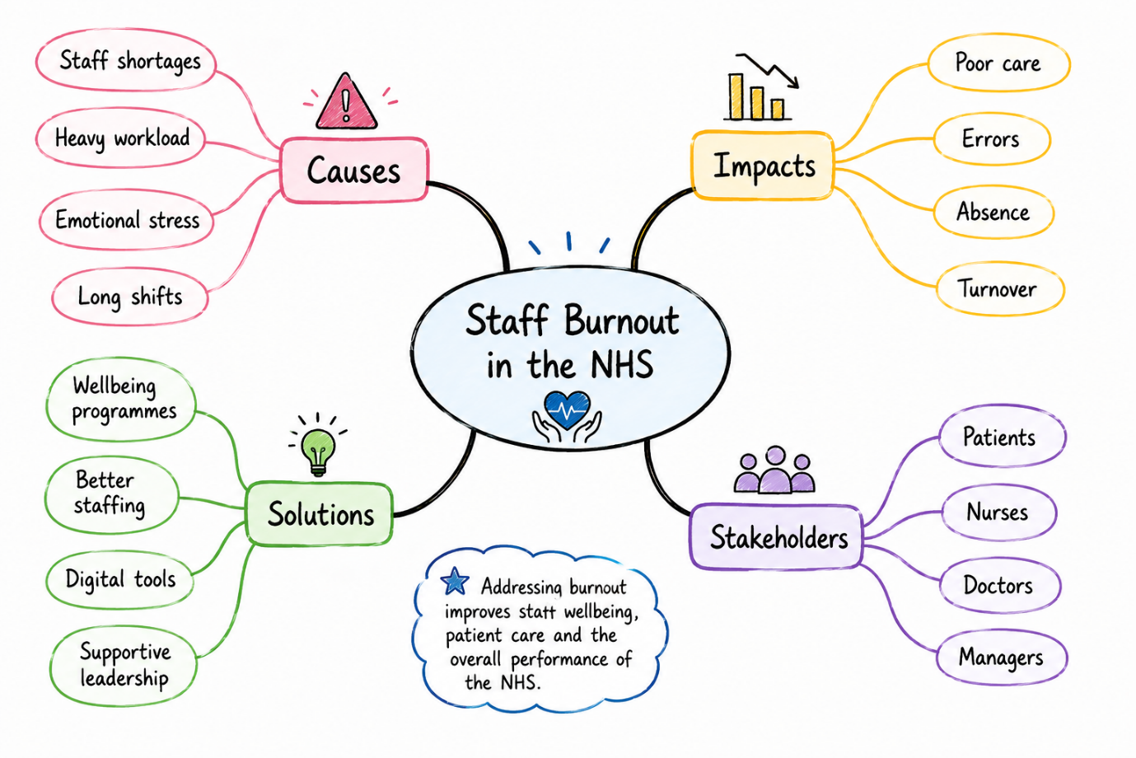
A major issue in health and social care is staff burnout, as this impacts on the well-being of staff, the safety of the patients and the quality of care they provide. The causes that I have found through my mind map are connected, and they are a lack of staffing, workload pressure, emotional demands, and not enough organisational support (NHS England, 2023). These can lead to stress, absence, lower job satisfaction and higher staff turnover among employees, which can impact service users through longer waiting times and higher risk of clinical error (De la Torre et al., 2025). The suggested solutions involve more effective staff planning, encouraging staff wellbeing programmes, better leadership of staff and the use of digital technologies to minimise administrative load. A systems thinking approach shows that burnout is caused by a combination of factors in the systems at work. Combating these problems together offers a way to boost staff morale, better patient care and a more sustainable health and social care system (NHS Leadership Academy, 2013).

Task 3: Self-Reflection of Group Activity
I have applied Gibbs' Reflective Cycle (1988) in reflecting on my experience with the convergent/divergent thinking group activity. Divergent thinking was a process of producing a multitude of ideas without judgement, and convergent thinking was a process of judging ideas and selecting the most feasible approach.
In the activity, my group first came up with a list of ways that we thought communication could be enhanced in health and social care settings. I encouraged other team members to share their ideas and thoughts differently and recommended that we document all ideas before determining feasibility. This strategy allowed us to build an inclusive context and promoted the consideration of all contributions. We discussed the pros and cons of each option so we could come to an agreement when the group couldn't agree on what was the best option (NHS England, 2023).
Looking back on it, I think that divergent thinking was easier for me because I like to think outside of the box. The activity helped me develop more effective communication, teamwork and decision-making skills and to see that having a mixture of the two approaches can produce more balanced problem-solving (Smith et al., 2023). In future group activities, I will be able to undertake my role with greater confidence, encouraging quieter members to join the group activity and applying the technique of structured decision making to assist the group in reaching an agreement more efficiently (Meadows, 2008).

Task 4: Case Study Analysis of a UK Innovation
The Virtual Wards programme is one of the more innovative aspects of the NHS, which allows appropriate patients to be supported at home by health care professionals and monitored remotely, in a similar way to what is done at hospital level. The initiative was launched in response to the rising demand for health services, especially after the COVID-19 pandemic, and the strain on NHS services such as the NHS waiting list for interventions, which is now more than 10 million (NHS England, 2023).
The development of virtual wards was driven by creativity to integrate with digital technology, remote monitoring devices and multidisciplinary team working to rethink the concept of inpatient care. This means that health care providers can track patients' health remotely instead of them spending time in hospital and communicate with and act quickly on them if necessary (Erkutlu and Chafra, 2022).
This innovation has added value for service users as it has made their lives more comfortable and independent and improved their patient experiences with a reduction in risk of hospital-acquired infections (Frost et al., 2024). The healthcare system enjoys better bed availability and more efficient use of clinical resources, enhancing the performance of the system. The outcomes reported show that virtual wards have reduced unwarranted admissions to hospital, delayed admissions, and provided safe, high-quality care for the right patients. Rogers' Diffusion of Innovation Theory states that innovations like virtual wards are more likely to be adopted if they offer clear benefits, are easy to implement, and have a positive impact on patient care and healthcare quality (Rahmatullah et al., 2022).

Task 5: Research Task
Current Issue: Staff Burnout in Health and Social Care
Staff burnout is a significant problem with healthcare workers and their care for patients. Three main factors contributing to nurse burnout, in the study by Dall’Ora et al. (2020), are excessive workload, inadequate staffing levels, and long working hours. This can lead to emotional exhaustion, lower job satisfaction and higher employee turnover. The study points to a significant impact of ongoing workplace stress on employee well-being and patient safety and recommends organisational mechanisms to enhance working environments.
Similarly, Woo et al. (2020) concluded that emotional demands, workplace stress, and organisational support are linked to burnout. The systematic review demonstrates that burnout negatively impacts staff engagement, absenteeism, and patient care quality. Leaders, wellbeing programs and strategies to build resilience are recommended to help minimise burnout and improve staff retention, according to the authors.
The two studies agree that burnout is a problem caused by the interplay of several factors in the workplace, not a lack of personal strength, and is a problem that should be addressed by the organisation. Woo et al. emphasise the psychological and organisational aspects, while Dall'Ora et al. focus on workload and staffing pressures. These studies collectively offer an overall picture of the understanding of burnout and stress the need to build safe, effective and sustainable health and social care services that are supportive of the workers' health.

Task 6: Exploring Digital Innovation in Health and Social Care

6.1 Wearable Health Technologies
Smartwatches and glucose monitors are examples of wearable health technologies that facilitate real-time health monitoring and management of chronic diseases. They track data such as heart rate, blood glucose, activity and sleep and alert users to any potential health risks at an early stage (Kosiol et al., 2024). A continuous monitoring system is helpful for those with diabetes to manage blood sugar levels and lower the likelihood of complications, for instance. Clinicians can also make more informed decisions on a more personalised basis, using the data collected remotely. The Technology Acceptance Model (TAM) states that users are more likely to accept digital tools when they improve efficiency and are easy to use. In summary, wearables foster self-care, enhance patient involvement, and positively impact long-term health outcomes (World Health Organisation, 2021).

6.2 Electronic Health Records (EHRs)
Electronic Health Records (EHRs) enhance communication for healthcare professionals. For example, EHRs can provide real-time access to medical information for healthcare providers, including doctors, nurses, and other professionals, which enhances communication and collaboration among them. For instance, if a patient transitions from hospital to community care, their medical history and treatment plan can be readily accessed, eliminating delays and inaccuracies. The TAM also holds that staff will be more willing to use EHRs if they make them more efficient and user-friendly. In summary, EHRs improve patient safety, the quality of care, and teamwork (NHS England, 2023).

6.3 Digital Technology for Preventative Care and Health Promotion
By keeping people in good health and identifying risks at an early stage, digital technology can help to support preventative care. Reminders, health tips, and personalised support can be provided via mobile apps, wearables and online platforms (Lin et al., 2022). For instance, the NHS App lets people book appointments, order prescriptions, as well as obtain health information, which promotes healthier behaviours. These tools also enable the identification of risk groups and monitoring them remotely by healthcare providers. The adoption of the system is based on perceived usefulness and ease of use according to the Technology Acceptance Model (TAM). The benefits of digital innovation summarise that it can help with early intervention, prevent unnecessary illness and enhance the health and wellbeing of the public (NHS England, 2023).

Task 7: Understanding the NHS Leadership Framework
The NHS Healthcare Leadership Model is a set of behaviours that are expected of effective leaders in health and social care. It is based on nine key dimensions which aim to improve the patient's experience and organisational performance, such as inspiring shared purpose, leading with care, evaluating information and engaging the team (NHS Leadership Academy, 2013). These behaviours promote collaboration, innovation and person-centred care. The framework is crucial as it contributes to establishing suitable workplace cultures, enhancing employee engagement, and promoting ongoing service development. It also allows organisations to meet the evolving healthcare needs and ensure maximum safety and quality of care.
Leading with Care is one behaviour that promotes creativity. Empathetic and respectful relationships and leadership atmospheres enable staff to contribute their ideas. For instance, if a ward manager can hear what staff have to say, then they could be involved in the development of improved ways of reducing waiting times. This relates to Transformational Leadership Theory, which focuses on how supportive leadership is a motivator and innovator. Consequently, employees are likely to come up with innovative ideas for better patient care (Garad et al., 2022).
In this module, I have been developing my knowledge of how creativity and leadership help to create value in health and social care. I now recognise that innovation involves both generating and applying ideas to improve services.

Task 8: Self-Reflection Journal Entry
I used Gibbs' Reflective Cycle (1988) to think about how this module has helped me to understand more about creativity, innovation and value creation in health and social care. I had not seen innovation other than the introduction of new technology before I started the module. I now understand, however, that innovation can also be a means of improving processes, of encouraging collaboration, of providing person-centred solutions that will improve service quality.
This module has made me realise that the activities that have been carried out throughout the module, and especially the mind map, case study analysis of NHS Virtual wards, and group reflection on convergent and divergent thinking, helped me to appreciate the use of creativity to solve real healthcare situations. I also gained a lot of insights on how important it is to have effective leadership when promoting ideas and successfully executing them in a culture.
My future work practice will involve using creative thinking, reflective practice and evidence-based decision-making for enhancing the care of patients and for the ongoing improvement of services. This module has boosted my confidence in providing support to innovation that generates value for service users and health service organisations.

Reference
Dall’Ora, C., Ball, J., Reinius, M., & Griffiths, P. (2020). Burnout in nursing: a theoretical review. Human resources for health, 18(1), 41.
De la Torre, K., Min, S., Lee, H., & Kang, D. (2025). The application of preventive medicine in the future digital health era. Journal of Medical Internet Research, 27, e59165.
ERKUTLU, H. V., & CHAFRA, J. B. (2022). Organisational Behaviour: Theory, Concepts and Practice. Akademisyen Kitabevi.
Forde‐Johnston, C., Butcher, D., & Aveyard, H. (2023). An integrative review exploring the impact of Electronic Health Records (EHR) on the quality of nurse–patient interactions and communication. Journal of Advanced Nursing, 79(1), 48-67.
Frost, H., Tooman, T. R., Aujla, N., Guthrie, B., Hanratty, B., Kaner, E., ... & Mercer, S. W. (2024). New models of health and social care for people in later life: mapping of innovation in services in two regions of the United Kingdom using a mixed-method approach. BMC Health Services Research, 24(1).
Garad, A., Haryono, S., Yaya, R., Pratolo, S., & Rahmawati, A. (2022). The relationship between transformational leadership, improving employees' performance and the raising efficiency of organisations. Management and Production Engineering Review, 13(2), 15.
Kosiol, J., Silvester, T., Cooper, H., Alford, S., & Fraser, L. (2024). Revolutionising health and social care: innovative solutions for a brighter tomorrow–a systematic review of the literature. BMC Health Services Research, 24(1), 809.
Lin, L. L. C., Irawan, A. P., Anggarina, P. T., & Kumar, S. (2022, May). Transformational Leadership Impact on Organisational Effectiveness. In Tenth International Conference on Entrepreneurship and Business Management 2021 (ICEBM 2021) (pp. 511-518). Atlantis Press.
Meadows, D. (2008). Thinking in systems: International bestseller. Chelsea Green Publishing.
NHS England (2023) Virtual Wards Including Hospital at Home. Available at: NHS England – Virtual Wards.
NHS England (2023) What are Electronic Health Records? Available at: NHS England.
NHS Leadership Academy (2013) Healthcare Leadership Model. Available at: NHS Leadership Academy.
Rahmatullah, A., Ramdansyah, A. D., Kambara, R., & Haryadi, D. (2022). Improving organisational performance with organisational culture and transformational leadership through intervening organisational commitment variables. Dinasti International Journal of Digital Business Management, 3(2), 180-194.
Smith, J., Ellins, J., Sherlaw-Johnson, C., Vindrola-Padros, C., Appleby, J., Morris, S., ... & Fulop, N. J. (2023). Rapid evaluation of service innovations in health and social care: key considerations. Health and Social Care Delivery Research, 11(11).
Stark, A. L., Geukes, C., & Dockweiler, C. (2022). Digital health promotion and prevention in settings: scoping review. Journal of Medical Internet Research, 24(1), e21063.
Topol, E. (2019). The Topol review. Preparing the healthcare workforce to deliver the digital future, 1-48.
West, M., Eckert, R., Collins, B., & Chowla, R. (2017). Caring to change: How compassionate leadership can stimulate innovation in health care. King's Fund.
Willis, V. C., Craig, K. J. T., Jabbarpour, Y., Scheufele, E. L., Arriaga, Y. E., Ajinkya, M., ... & Bazemore, A. (2022). Digital health interventions to enhance prevention in primary care: scoping review. JMIR Medical Informatics, 10(1), e33518.
Woo, T., Ho, R., Tang, A. and Tam, W. (2020) 'Global prevalence of burnout symptoms among nurses: A systematic review and meta-analysis', Journal of Psychiatric Research, 123, pp. 9–20.
World Health Organisation (2021) Ethics and Governance of Artificial Intelligence for Health. Geneva: World Health Organisation.
World Health Organisation (2021) Global Strategy on Digital Health 2020–2025. Geneva: World Health Organisation.

