The overall proven reoffending rate was 23.1% for October to December 2020 offender cohort, according to the National Statistics. This shows a gradual decrease of 2.1 percentage points from the quarter in 2019, the lowest in the time series. I believe that rehabilitation has played a crucial role in the decrease of this statistic. Rehabilitation is one of the key objectives of criminal justice. It aims to bring about positive behavioural changes within offenders (Coomber et al, 2015). In simple terms, it attempts to tackle reoffending. It is a method of intervention. The target is to punish the offender by keeping them under constant surveillance and applying treatment and training to prepare them for the chances of returning to society as a functioning, law abiding citizen. The criminal justice tries to achieve this but the question to ask is, does work? In contemporary society, this topic is still for debate. This report will cover factors that cause an offender to relapse and attempt to give a balanced argument in support and against rehabilitation as an effective method intervention.
Reoffending rates are calculated based upon the number of offenders who reoffend within a set timescale of their previous conviction. Recidivism which results in a court conviction or caution is referred to as proven. Recidivism is a Latin word coined in the 19th century meaning ‘to relapse into sin or crime’ (Merriam Webster date). There are a series of personal and social factors that can tempt or influence an offender to relapse into crime. This may include lack of employment, not having a source of income may be frustrating resulting in an offender finding illegitimate methods to attain that income. Another example, lack of support from family or I intimate relationships. Having no guidance or anyone to talk to can lead to the return of old habits and cause an offender to go off their pathway.
Some people see individuals as rational beings who can make their own decisions, including whether to commit a deviant act or crime. Others acknowledge relative deprivation and believe that crime happens when individuals or groups compare themselves to others who are like them but feel as if they are not treated the same.
Rehabilitation as an intervention method has been in debate in prisons throughout Wales and England. I tend to find myself having the same conflicts when it comes to this topic. Do we punish or reform? An obvious thing to consider is statistics. According to the National Statistics there has been a small but gradual decrease of 2.1 percentage points. On the other hand, these statistics do not measure how much rehabilitation could have affected this figure.
Despite this drawback, I am a firm believer that every little helps and even if it only stops one individual from reoffending, it is still a difference. ‘If I can save one person and have them go back to society, sleep at home, and raise a family, we’ve done our jobs’ (Weston Baton Rouge Sheriff Mike Cazez). Sheriff Cazez looks at this from the perspective that benefits an offender and fails to consider the victims. I see it as, one less reoffender could result in one less victim. That is one less person to be traumatised.
Rehabilitation has the power to make a victim feel wanted and needed. It focuses on tackling the root cause of deviant and criminal behaviour. It seeks to improve the criminal’s character and outlook so that he or she can function in society without committing another (David 2004). It gives them another a chance to do better. Whereas punishment may lead to them feeling helpless (Beel & Graham, date|). This is because of the labelling theory. This concept focuses on ways agents of social control attach stigma to certain groups, resulting in their stigmatised label reflecting on their behaviour. This is associates with the self-fulfilling prophecy which refers to a false definition of the situation evoking a new behaviour which makes the originally false conception come true’ (Merton 1948). It describes what happens when a false label influences and changes an individual’s behaviour. Although Merton’s theory is used for education, it can be used in crime. For instance, if an offender in prison is constantly being told by officers that they are a criminal, they may start to believe that label and self-fulfil. If an officer gives them a lot of support, guidance and label them positively, it may alter their attitude. This could result in them becoming law abiding citizens.
Rehabilitation deters future misconduct. It helps to alter the attitudes and behaviours to reinterrogate offenders into society. As a Christian, I am taught to treat others the way you want to be treated. If I was to make a mistake, I would hope the person/ parties I have affected would give me a second chance. The bible says, “Be kind and compassionate to one another, forgiving each other, just as in Christ Gog forgave you”. This scripture implies that when you forgive others when they sin against you, God will also forgive you for your sins. Rehabilitation is about forgiveness and second chances. A second chance to do better. Others have no interest in rehabilitation. Azad 2008 believes that the wrongdoer is not only to be punished to prevent from doing wrong the second time. He states that punishment is used to set an example to members of society that are tempted by crime. There is some truth to his beliefs. I know that if I was to touch a hot hob causing me to injure myself, whoever witnessed it is unlikely to repeat my actions.
Azad proceeds to quote Salmond; “Punishment is before all things deterrent and the chief end of the law of crime is make the evil doer an example and a warning to all that are likeminded with him”. Salmond believes that fear needs to be implemented in people’s minds to tackle reoffending rates. I partially agree with his theory as well as Azad based on the analogy above. However, this theory is flawed because, regardless of using punishment to create fear, people are still committing crimes. There is no argument that without punishment and deterrence crime rates would inflate dramatically. On the other hand, I don’t believe that this is the only way to deter crime.
Rehabilitation is also needed to keep the balance of society. If we aren’t helping to improve our society and the members of it, how do we plan to create a safer environment for each other? Ghandi stated “an eye for an eye and the whole world would be blind”. It expresses the principle of reciprocal justice. Punishment on punishment does not work, it doesn’t allow room for improvement or change. Teaching on the other hand does. I’m not being naïve in saying this, but even the most notorious criminals can be reformed and can be converted to law abiding members of the community. (Find example). Modern penologists insist in reformative methods of practice, but they fear that it may not extend that far. This is true because they can see this is as an easy way out.
Overall, National statistics show that the reoffending rates have decreased, however, there isn’t much evidence to show that it was caused by rehabilitation. You can rehabilitate an individual, but you cannot rehabilitate the people around them and block the temptations they may face in the outside world. There are several factors that can influence the changes in an individual’s behaviour. Prison experiences may have a negative impact on them. There are criminological theories that try to explain the causes, each carrying their pros, cons and gaps. I feel like a lot of people respond negatively to rehabilitation, they feel like it doesn’t carry enough lesson, in terms of punishment. People carry a ‘if it’s not harmful for me, it doesn’t matter’, mind-set. This is not the case. Crime is like oxygen; it is all around us even when we do not witness it occur. Salmond suggested that punishment should not be regarded as an end but should be seen as a mean, the end being social security. In my opinion Salmond is ignorant to the idea rehabilitation. I do agree that punishment should be still put in place, without society would collapse. He refers to social security as the end, which is not wrong, but he refuses to consider rehabilitation. As stated by Sherriff Cazez, even helping one individual is enough. Furthermore, focusing our minds on the younger generation, they are our future. When they commit crimes, they lack levels of mental maturity, if they are punished in our natural system, again society would collapse. Rehabilitation gives them the opportunity to try understanding their mistakes and how they are not acceptable. Crime to me isn’t nature, it is a characteristic we may nurture or get from somewhere else. No one is born a criminal. This characteristic can be removed by methods of reformation such as rehabilitation which is I believe is crucial for the function of society. But is it effective? Again, some change is better than none.

Poster

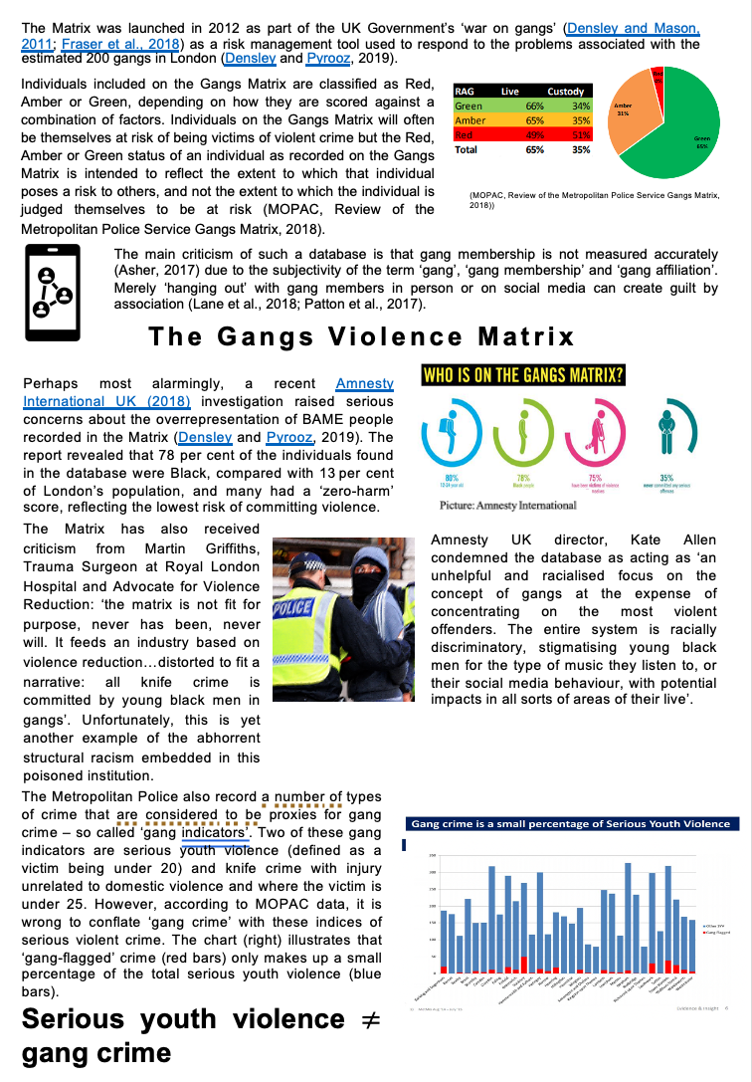

Article : Being silenced: The Impact of Negative Social Reactions on the Disclosure of Rape – Courtney E. Ahrens

Introduction…
Silence is loud.
Police and Legal Systems
Courtney E. Ahrens
Survivors have been disillusioned with this notion due to their experiences with the police and legal systems. The role of the police is to protect and serve. It states on the South Wales Police website that their vision is to be ‘the best at understanding and responding to our communities’. Many victims do not feel like this. They must heal inwards rather than seeking outward support. The police are supposed to be an institution that protects you but many people don’t see this. There are many examples where the system has failed us. For instance, the Sarah Everards case, this reveals the scale of sexual misconduct by our authorities.
Victim Blaming
Media
Conclusion

