UNIVERSITY OF WALES TRINITY SAINT DAVID
LONDON CAMPUS
Assignment 2
Learning in the Digital Era
Video Link: https://youtu.be/7IOOo6faooY
Please be sure to give unrestricted access to your video presentation so that your work can be marked by the examiner.
Module Name: Learning in the Digital Era
Module Code: ACCA 4025

Student Name: Mohammed Saleem
Student ID:2542914
Group: 2

Lecturer’s Name: Suneth Ferdando

Table of Contents
Introduction 2
Main Body 2
Conclusion 9
References 9

Introduction
Self-Evaluation, Professional Development Plan.

Main Body
Personal Development
Video Link: https://youtu.be/7IOOo6faooY
Slide 1 COVER PAGE
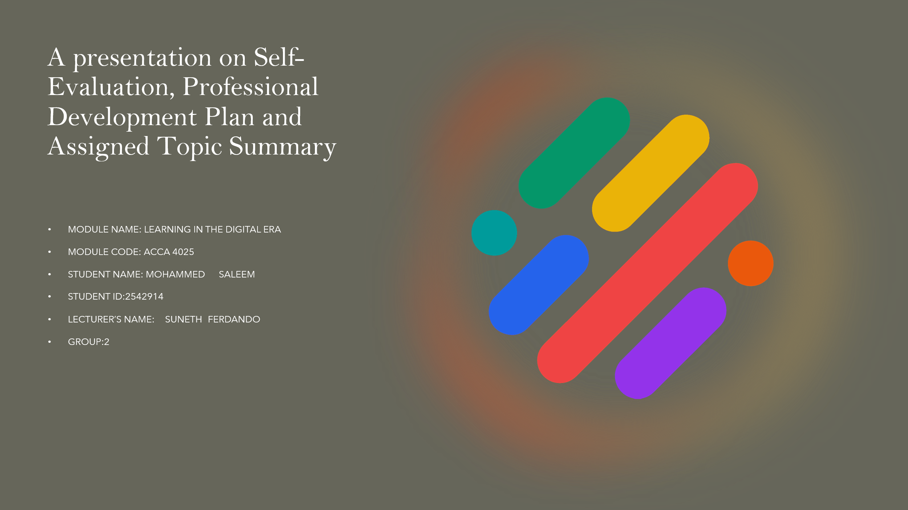

Slide 2 CONTENTS

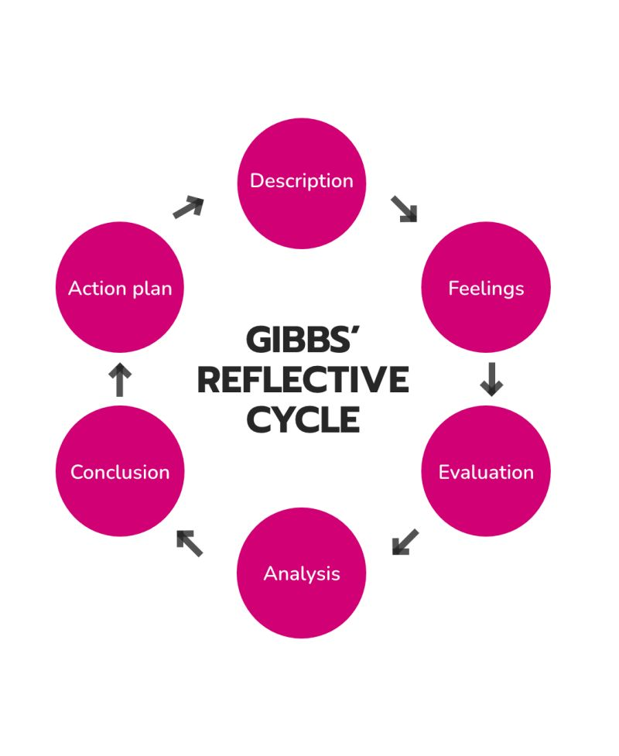

Slide 3 INTRODUCTION
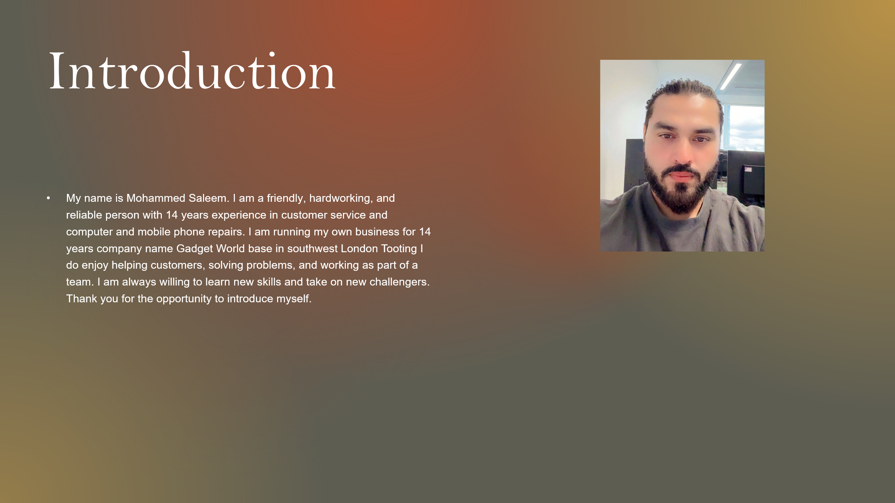

Slide 5 GIBB’s REFLECTIVE MODEL
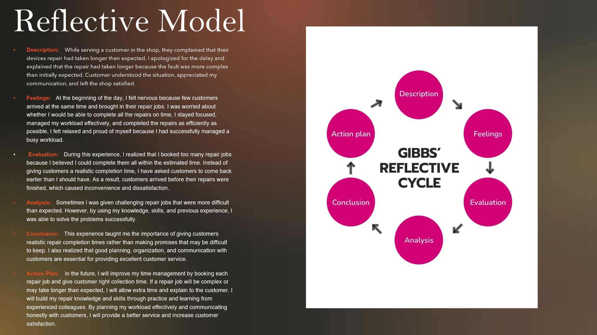
Brief explanation:
Gibbs’ Reflective Cycle is a model that helps individuals learn from their experiences through six stages Description, Feelings, Evaluation, Analysis, Conclusion, and Action Plan. In Assignment 2, I plan to use Gibbs’ Model to reflect on my learning experiences, identify my strengths and weaknesses, understand what I have learned, and create an action plan for improving my skills and future professional development.
Intext citations are required in this section along with the corresponding full citation at the end in the List of references.

Slide 6 TASK 1: SELF EVALUATION
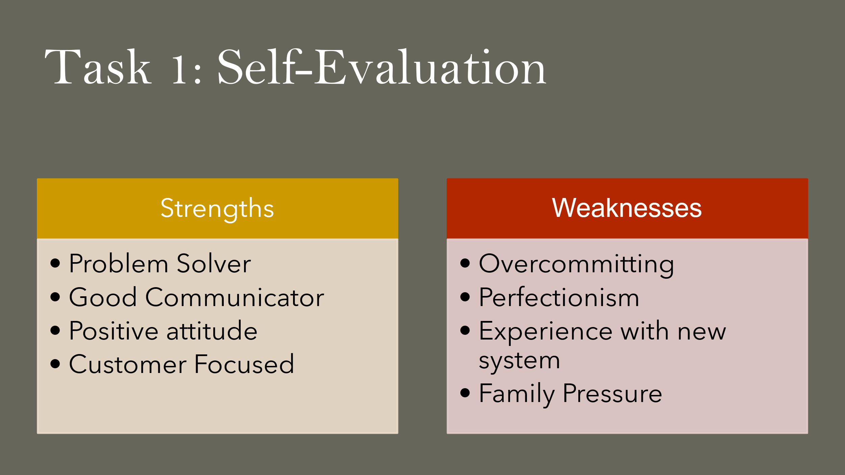
Brief explanation: My SWOT analysis helped me identify my personal strengths and weaknesses. One of my main strengths is communication, as I can work with others and share my ideas clearly. Another strength is willingness to learn, which helps me develop new computing and cybersecurity skills.
One weakness is time management, as I sometimes find it difficult to manage different tasks and meet deadlines. Another weakness is that I need to improve my technical knowledge, particularly in cybersecurity. Identifying these areas helps me understand what I need to improve through my personal and professional development plan.

Slide 7 TRAITS GAINED FROM THE SELF EVALUATION
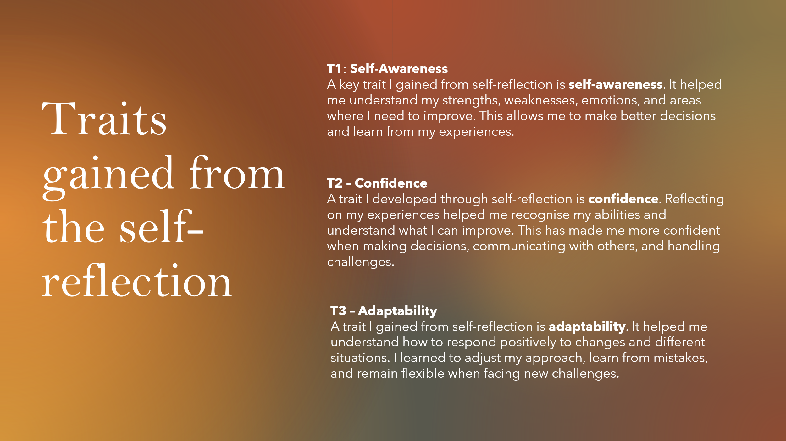

Brief explanation:
Self-evaluation helped me develop self-awareness, confidence, adaptability, communication, and time-management skills. It helped me understand my strengths and weaknesses and identify areas for improvement in my education and future cybersecurity career.

Slide 8 PROFESSIONAL DEVELOPMENT PLAN
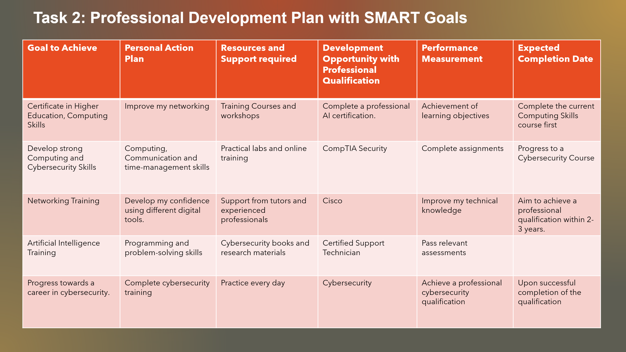
Brief explanation:
A Professional Development Plan (PDP) helps me identify my career goals, skills, weaknesses, and areas for improvement. My plan focuses on developing my computing and cybersecurity skills, improving my communication and time management, completing relevant qualifications, and preparing for a future career in cybersecurity.

Slide 9 UNIT 4 TOPIC SUMMARY
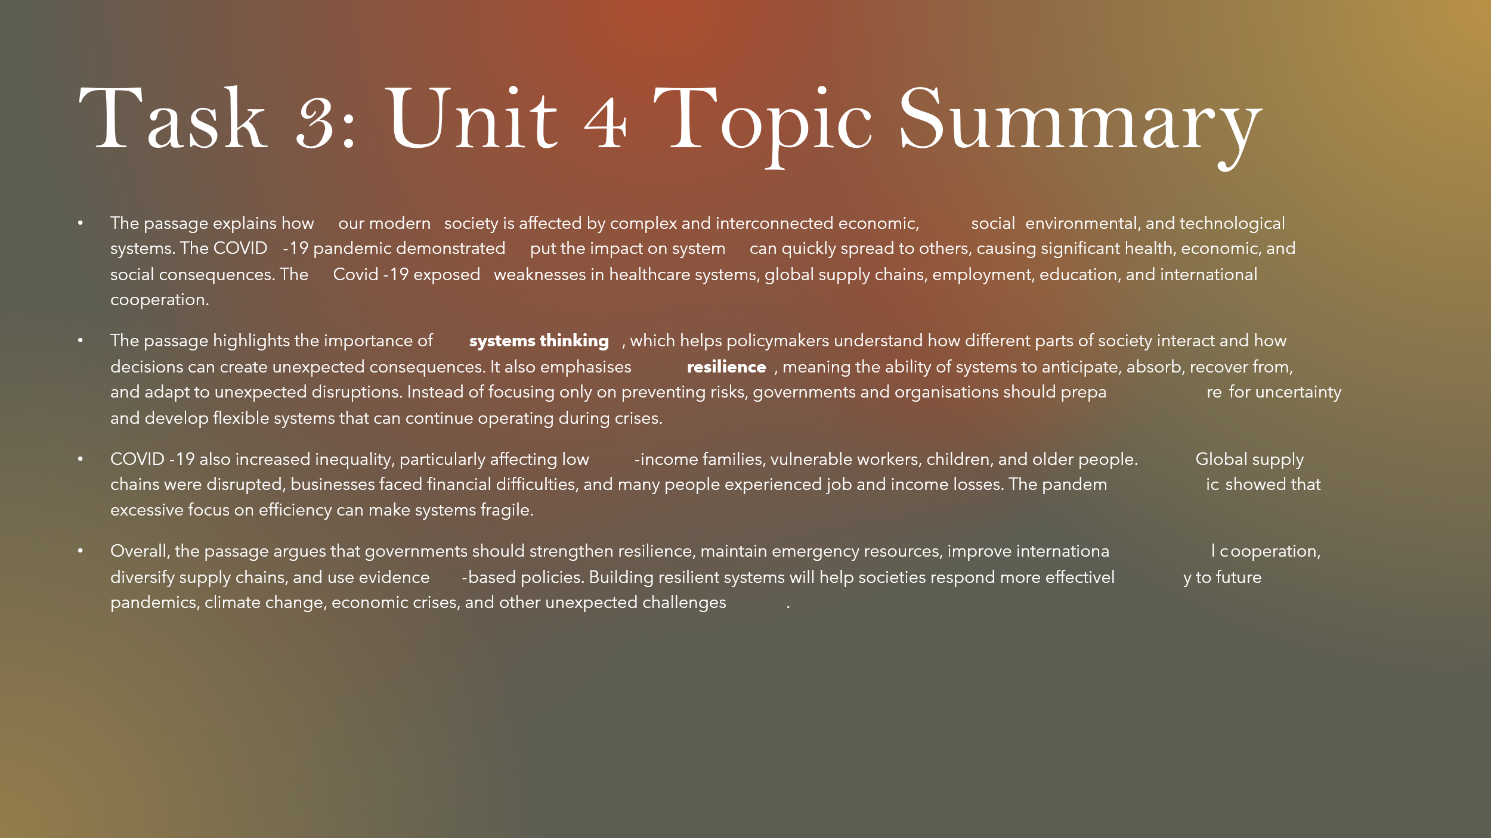
- Brief explanation:
- The passage explains how our modern society is affected by complex and interconnected economic, social environmental, and technological systems. The COVID-19 pandemic demonstrated put the impact on system can quickly spread to others, causing significant health, economic, and social consequences. The Covid-19 exposed weaknesses in healthcare systems, global supply chains, employment, education, and international cooperation.
- The passage highlights the importance of systems thinking, which helps policymakers understand how different parts of society interact and how decisions can create unexpected consequences. It also emphasises resilience, meaning the ability of systems to anticipate, absorb, recover from, and adapt to unexpected disruptions. Instead of focusing only on preventing risks, governments and organisations should prepare for uncertainty and develop flexible systems that can continue operating during crises.
- COVID-19 also increased inequality, particularly affecting low-income families, vulnerable workers, children, and older people. Global supply chains were disrupted, businesses faced financial difficulties, and many people experienced job and income losses. The pandemic showed that excessive focus on efficiency can make systems fragile.

Slide 10 CONCLUSION

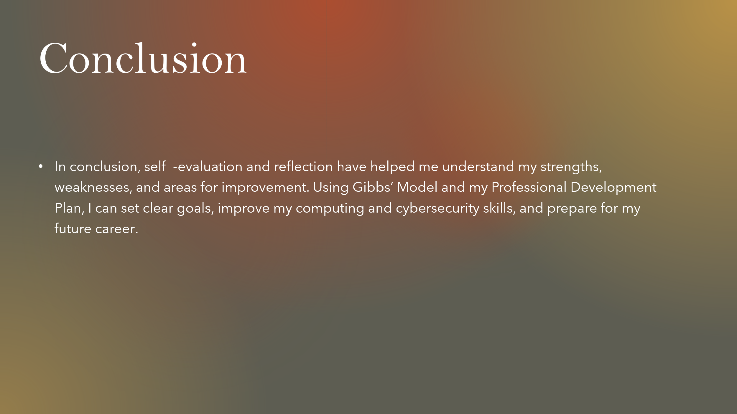

Brief explanation:
- In conclusion, self-evaluation and reflection have helped me understand my strengths, weaknesses, and areas for improvement. Using Gibbs’ Model and my Professional Development Plan, I can set clear goals, improve my computing and cybersecurity skills, and prepare for my future career.

References
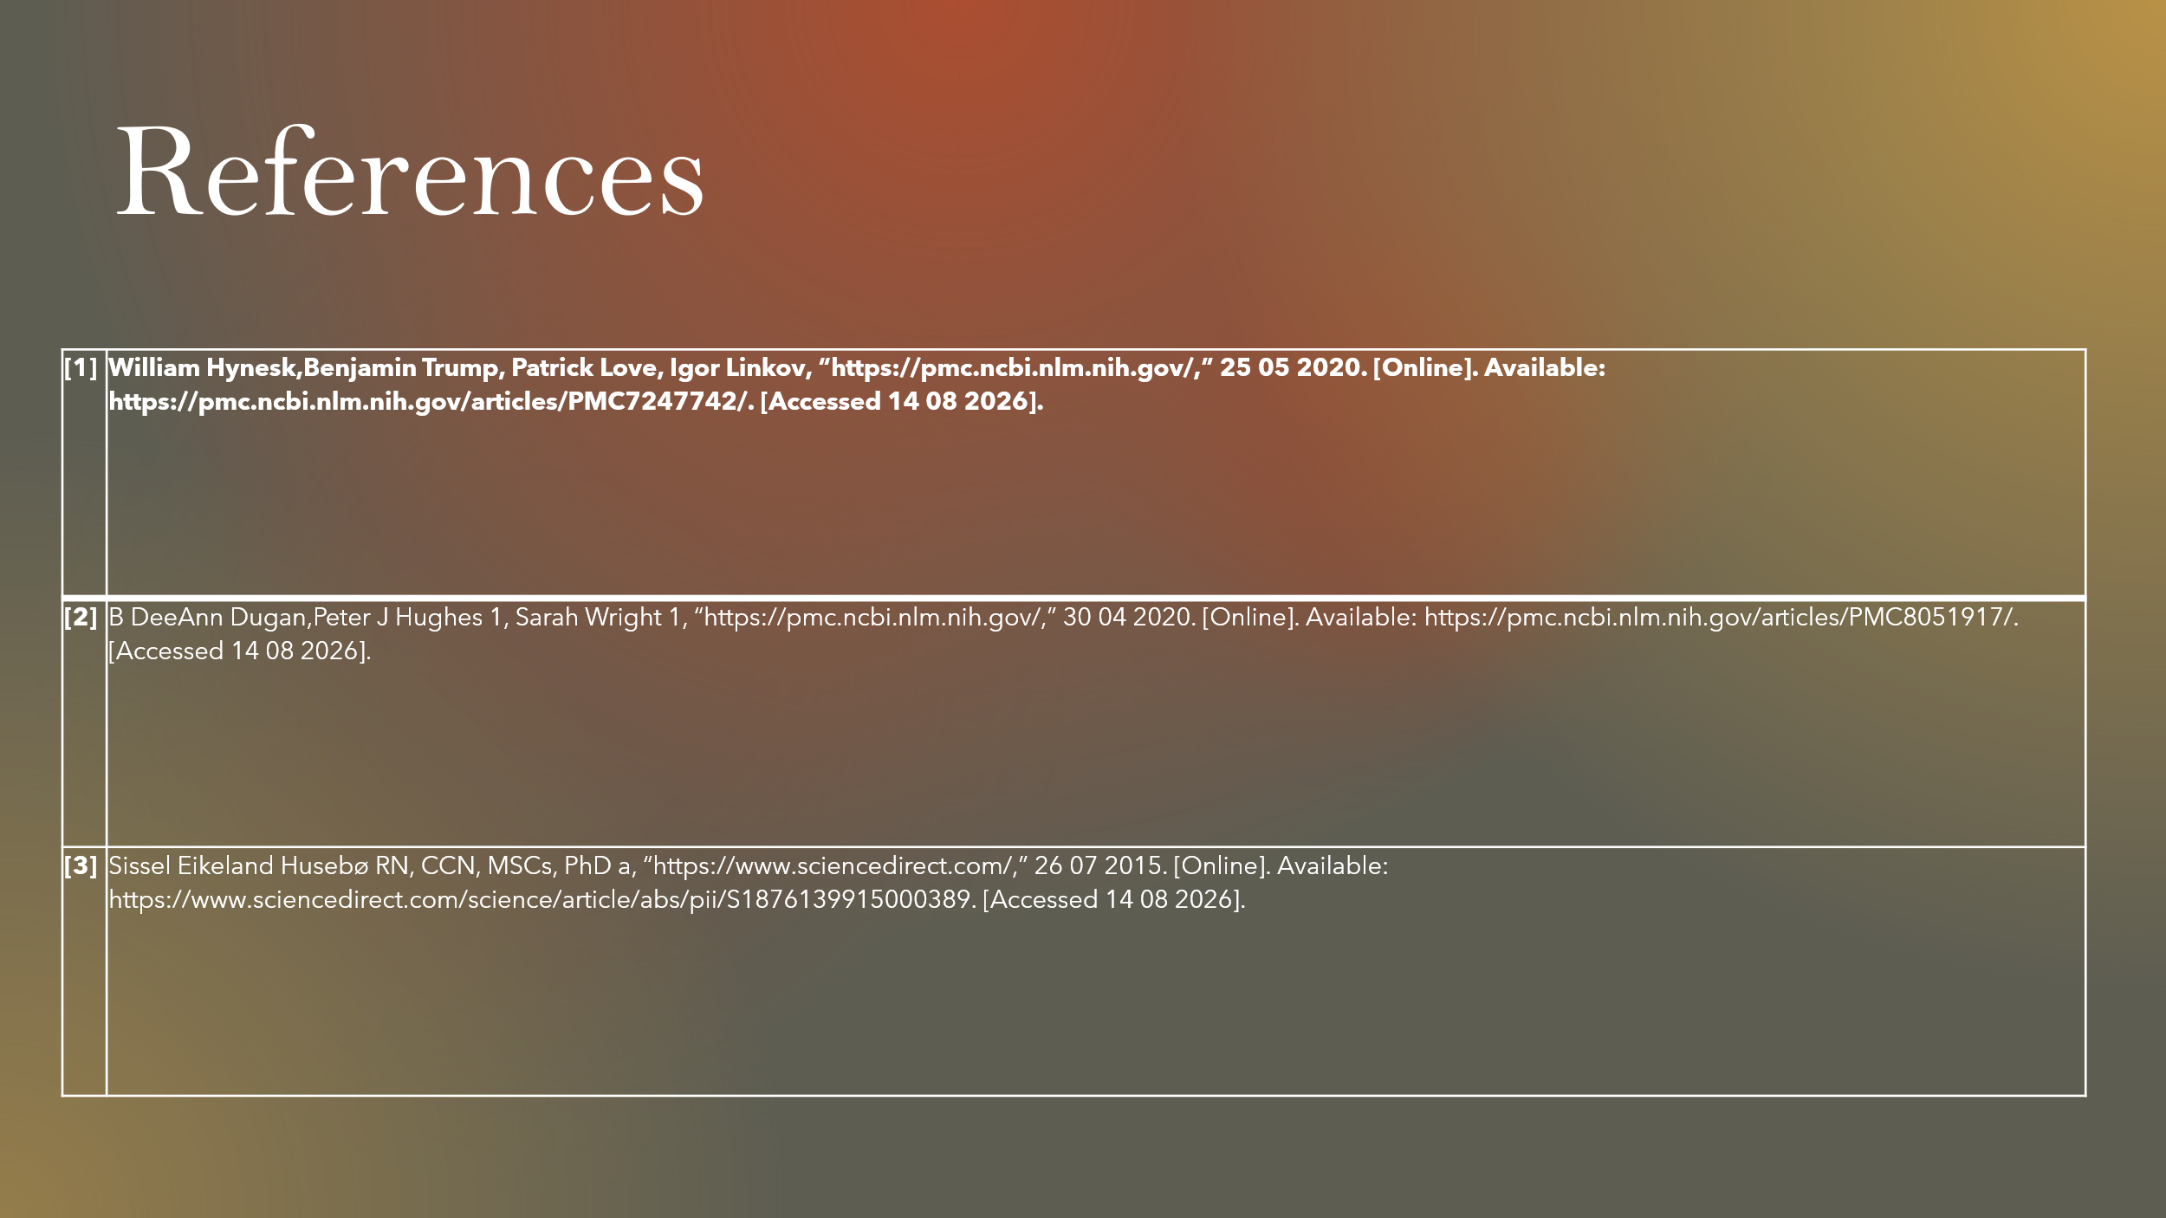

References

[1] | William Hynesk,Benjamin Trump, Patrick Love, Igor Linkov, “https://pmc.ncbi.nlm.nih.gov/,” 25 05 2020. [Online]. Available: https://pmc.ncbi.nlm.nih.gov/articles/PMC7247742/. [Accessed 14 08 2026].
[2] | B DeeAnn Dugan,Peter J Hughes 1, Sarah Wright 1, “https://pmc.ncbi.nlm.nih.gov/,” 30 04 2020. [Online]. Available: https://pmc.ncbi.nlm.nih.gov/articles/PMC8051917/. [Accessed 14 08 2026].
[3] | Sissel Eikeland Husebø RN, CCN, MSCs, PhD a, “https://www.sciencedirect.com/,” 26 07 2015. [Online]. Available: https://www.sciencedirect.com/science/article/abs/pii/S1876139915000389. [Accessed 14 08 2026].

