Effective Team working and communication report:

Student name: Haleema Sadia Qureshi
Student ID: 2121158
Lecturer’s name(s): Dami Pokubo, Sujeewa Herath, dale Clarke, Yohan Mendis & MD Nazmul Hasan.
Module code: BMSW4002

Contents
• Introduction: `3
• How students develop an effective team: 3
Build trust: 3
Organizing plans/meetings: 4
4 phases of Tuckman’s teamwork theory: 4
• Define the impact of effective teamwork can have on team success: 5
• Personal experience using Beblin’s theory: 7
• Barriers to effective teamwork: 8
• Belbin and Tuckmans theory: 9
My personal experience using Tuckman’s Theory: 9
• Gersick theory: 9
• Conclusion: 10
• References: 11

Introduction:
This assignment discusses the various types of theoretical models and how they can be used in developing an effective team. On top of this, the report will talk about the impact of an effective team and how we can resolve barriers in certain scenarios.
Teams are people who collaborate to achieve a common aim or mission. They are a group of people who operate together to accomplish a certain set of goals. Teamwork is represented when a collective of peers create a positive working environment and strive together to overcome any dilemmas. Whatever job you land in life, you'll also be on a team. A team is any group of people organized to work together, both interdependently and cooperatively to accomplish a purpose or a goal. Three common types of workplace teams include functional or departmental, cross-functional, and self-managing (Heathfield, 2019)

How students develop an effective team:
When it comes to developing an effective team, it is good to pair up with colleagues of similar interests. This could be done through extra-curriculum activities, sports, clubs, and classroom events which include group involvement. It is vital to learn as much as you can about those in your team; including their skill sets, motivation, and likes and dislikes. Leaders will benefit from this knowledge because it will allow them to match each employee's skills and competencies to specific problems, enhancing productivity and job satisfaction. An effective team can be built by using Tuckman’s theory. Tuckman's theory aims at how a group deals with certain tasks.
Additionally, if possible, attempt to involve your employees in decision-making. Give your staff open-ended projects instead of tasks and let them decide the best answer. This will inspire them to work together and promote learning. Below is one of the many things one must obtain to build great connections in the workplace:

Build trust:
Nurture a team-oriented environment based on trust and respect, without which there will only be limited success. A start-up is like a ship going through high uncertainty. The captain needs the trust of his team because people follow trust and integrity, not a person (Council, 2013)
It contributes to improved speed, productivity, and cost savings by establishing a foundation of trust. The ability to make decisions is enhanced by the ability to trust one another. Trust increases a team's devotion and desire to stay together. Trust decreases stress and eliminates antagonism in the workplace.

Organizing plans/meetings:
By doing this it will allow individuals to get to know each other more personally and Informal interactions bring individuals together and help to strengthen interpersonal bonds.

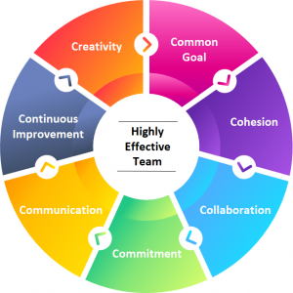
(Ragala, 2019)

4 phases of Tuckman’s teamwork theory:
- Forming:
The team leader must be ready and vocal to respond to several questions about the team's targets, goals. Each colleague relies on the leader, especially for guidance.
- Storming:
It is when colleagues are conscious of the workload. Some individuals can find this straining and often stressful and may quarrel over differences. This is usually common, but it is the leader’s responsibility to understand and resolve any matters before they blow out of proportion.
- Norming:
This is the stage where the team begins to operate and strive together. Individuals get to understand each other’s good and bad habits and values. However, it is also where the team clears any misunderstandings due to miscommunication- and a plan of action is put into place to avoid any future implications.
- Performing:
In the performing stage, the group focus is getting the work done. Relationship and cohesion have been built, optimal strategies have been constructed, underlying group structure has solidified. the group is now positioned for maximum productivity (Griffiths and Dunham,2015).

- Adjourning-This is the final stage where achievements are celebrated, and peers’ hard work is recognized and will finish things on a positive note. Team members must receive a form of closure as well as an appreciation for their efforts.

Define the impact of effective teamwork can have on team success:

- Facilitates unique and innovative ideas:
When a collective of people graft together in a collaborative environment, where mostly magical ideas are born! People can learn from each other and this will construct new ideas.

- Boosts motivation and builds a sense of loyalty:
When the environment has a level of trust built up and is reliable; this will impact one’s progress positively as this will allow colleagues to move forward and flourish in many aspects.

- Promotes a sense of responsibility and ownership:

When there is a shared goal to achieve, peers can often take ownership of certain tasks and overcome dilemmas with joint companionship. Likewise, being a part of a team can allow one another to share the feeling of ownership and success.

Types of roles needed to create a cohesive and effective team:

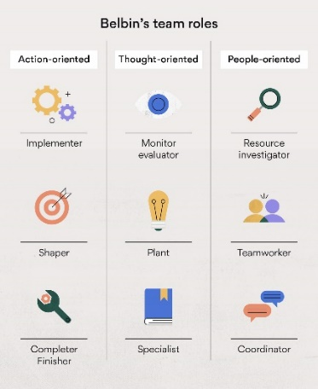

(Asana, 2016)

In the 1960s the influential researcher Meredith Belbin fashioned his team role theory, which states that certain roles need to be fulfilled within an effective team, among them outgoing, enthusiastic resource investigators, sober, strategic monitor-evaluators and innovative, introspected plants (Gale, 2016)

According to Belbin’s theory, most people can perform between one and three of these roles, so creating a strong team is about making sure you find out what roles people are suited for and then put them in it (Gale, 2016)

When interacting instinctively in a group, everyone appears to choose one or more of these 'Team Roles.' You can move between your 'natural roles' if you have more than one, which itself is useful knowledge to have if you ever need to fill a different role in a team.

Shaper
The Shaper is a task-oriented, outgoing team member who could often be viewed as combative, aggressive, and restless.

These characteristics could result in conflict with other members of the group. Shapers are productive employees. They encourage the group to reach an agreement and implement choices, and they are motivated to break down boundaries and take on additional tasks.

Plant
The plant is the term for the person who is creative in a team and devises the majority of the ideas and plans.

Resource Investigator
This is a role that necessitates someone to find contacts, explore a variety of opportunities, construct new ideas, and positively influence others. Resource Investigators are often keen.

Implementers are also the ones who make things happen.

Implementers are individuals who want things implemented correctly. They are compliant and organized, which also explains their energy to execute tasks. Implementers, on the other hand, sometimes get caught in ways that aren't always open to fresh ideas.

Completer Finisher
Then there is the Completer–Finisher. They enjoy completing chores.
They are high achievers with excellent attention to detail, but they are apprehensive to assign tasks. They would often prefer to execute something themselves and know it was implemented correctly than to delegate it to someone else.

Coordinator/Chairperson
The Coordinator is usually a calm, cheerful, and charismatic team member. They also encourage decision-making by clarifying goals.

Coordinators have strong interpersonal skills and can efficiently connect with team members through verbal, active listening, and nonverbal communication

Team worker
Aids and promotes cooperation so a goal or target is met and has a positive outcome.

Personal experience using Beblin’s theory:
Discovering Beblins theory has been interesting, as it has helped me recognize strengths and weaknesses in the work environment. I work at Amazon where It is quite fast-paced and the majority of the time requires decision-making, and leadership. However, most of my tasks set at Amazon are discussed with other associates- so we can execute responsibilities accurately as we are constantly learning from one another.

Barriers to effective teamwork:
Working in teams to solve problems and achieve collective goals is a common experience for many. While teams can achieve extraordinary results, they can deteriorate into an ineffective and immobilized group of frustrated individuals (Griffiths and Dunham,2015).

Problems can occur in any team, jeopardizing the efficacy of the group. Here are some of the most typical issues that teams confront and how to cope with them:

- Inconsistency in team: This could be poor punctuality, the poor form of communication between peers. This could be solved with a group meeting to address problems.

- Lack of information sharing: This is linked to trust as well because sometimes colleagues can withhold information. In each company, some specific people hold what is referred to as “deep smarts” when it comes to a particular topic. Not sharing knowledge automatically means that you will fail to identify these valuable team members. In this case, sharing knowledge can also help employees create stronger bonds while solving problems quickly and effectively (Postolache, 2017)

- Conflict- 4 Factors that Contribute to Workplace Conflict:
Communication could be an issue as it is one of the most common dilemmas in work environments. It could be a language barrier, confidence issues, limited supplies, and workload capacity is too high for some.

- Fatigue: Workload and tiredness both have an impact on performance, and a high workload can contribute to weariness.

Effective team collaboration means that peers put their trust in one another regarding their set tasks and certain objectives. Introverted people could struggle to speak up hence the miscommunication/misconceptions could be mistaken for lack of trust but in reality, they are just shy and not used to group work.

Belbin and Tuckmans theory:
When incorporating Belbin and Tuckman’s theory into day-to-day experiences, will majorly improve the efficiency and deliverance of the work. Abdul should include the Belbin theory into his work environment and offer various roles to the workers in which they feel comfortable. Likewise, the Tuckman theory is also practical in this case, as it will allow peers to create a plan of action to act professionally and accordingly. In the Tuckman theory, Abdul should, ‘form’ in a way to gather all colleagues together to discuss future goals and career aspects. This can be attained by going out together, to break the ice. Moreover, the goal should be ‘norming’ where expectations should be nearly met with reality, as individuals become more comfortable in each other’s presence and there is no animosity involved. (to avoid storming) Finally, all achievements should be celebrated through ‘adjourning’ and everyone should feel appreciated for their efforts and skills. You can utilize Tuckman’s model to improve the performance of your team. Determine which stage your team is in, then move forward by using the appropriate techniques to improve on things that need to change.

My personal experience using Tuckman’s Theory:

During my studies, I have subconsciously utilized Tuckman’s theory in my group work. Since some of my peers were absent, I had to ‘Form’ with the rest of my teammates to create a plan of action as soon as possible to avert ‘storming’. After presenting our work to the class we ‘adjourned’ one another for the team spirit.

Gersick theory:
Gersicks research stated that groups don’t develop in a universal sequence of stages as suggested by the five-phase model. Her research, which is based on punctuated equilibrium group development, found that the timing of when groups form and change the way they work is highly consistent (Puscasu, 2022)
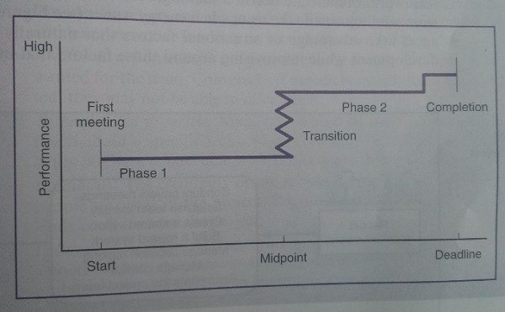
(Puscasu, 2022)

Conclusion:
In conclusion, working in a team is a great opportunity to build confidence, since it allows your group to work collaboratively and share duties, reduces the pressure, and enables you to be more attentive and thorough in the set tasks. Everyone's thinking method is different, but when we pair up with other people, we are learning from one another to accomplish a certain goal. This can improve intrapersonal and interpersonal soft skills. To foster a healthy and open environment, the team leader role should encourage employees to spend the opportunities to get to know one another on an individual and professional level.

In every aspect of a business, the diverse skills of teams are needed for reaching success. Make use of every opportunity you must engage in teamwork, so you develop effective communication skills (Wehbe, 2017)

References:
Asana, T., 2016. Team Roles: 9 Types to Create a Balanced Team • Asana. [online] Asana. Available at: <https://asana.com/resources/team-roles> [Accessed 5 March 2022].

Council, Y., 2013. Five Ways To Build An Effective Team. [online] Forbes. Available at: <https://www.forbes.com/sites/theyec/2013/06/07/five-ways-to-build-an-effective-team/?sh=d865106e0adb> [Accessed 5 March 2022].

Gale, A., 2016. How to 'bake' the perfect team. [online] Managementtoday.co.uk. Available at: <https://www.managementtoday.co.uk/bake-perfect-team/leadership-lessons/article/1412504> [Accessed 6 March 2022].

Heathfield, S., 2019. Understand Exactly What a Team Is and Its Role In the Workplace. [online] The Balance Careers. Available at: <https://www.thebalancecareers.com/what-is-a-team-1919226> [Accessed 5 March 2022].

Postolache, A., 2017. 10 Ways Not Sharing Knowledge Impacts Your Company - Quandora. [online] Quandora. Available at: <https://www.quandora.com/10-ways-not-sharing-knowledge-impacts-your-company/> [Accessed 6 March 2022].

Puscasu, A., 2022. The Punctuated Equilibrium Model of Group Development. [online] Ape. Available at: <http://apepm.co.uk/punctuated-equilibrium/> [Accessed 6 March 2022].

Ragala, S., 2019. 7 C’s of Effective Team Building Activities. [online] Latest Updates on Executive Coaching, Leadership, and Team Building. Available at: <https://www.executivecoachingindia.com/training/7-cs-of-an-effective-team-building-activities/> [Accessed 5 March 2022].

Wehbe, S., 2017. 5 Important Reasons Why Teamwork Matters - Potential.com. [online] The Online Learning Platform. Available at: <https://www.potential.com/articles/5-important-reasons-why-teamwork-matters/> [Accessed 6 March 2022].

