A Personal Learning Environment
Submission date:3/04/2018
Honorata Sieczych, Student no. 1708007
Learning and Collaboration for Global Citizenship
BMSP 4003
Tutor: Dr Alex Bell

1. Introduction
2. Digital technology
3. Digital literacy
4. Personal learning environment
5. Conclusion
Introduction
Advanced digital technology gives students an opportunity to create their own opinion about any subject at any time and in any location. Digital technology allows students to observe and reflect upon their own way of learning. It enables students to be more aware about their level of knowledge and be independent and responsible learners. Everyone has their own unique type of personal learning environment.
Digital technology consists of different forms such as virtual classes, emails, online video or conversation as well as software and many more. Digital technology improves and advances constantly and the education system must adapt to attract students and engage them within educational activities because for students a one to one approach it is not enough anymore. The students want to participate and engage more personally with their studies (Thomas & Morris, 2017) (Wesch, 2010).

Digital technology
Digital technology is used in learning environment as well as in many aspects of life by a majority of people across the globe on a daily basis. It makes easier life for students by allowing them to collaborate their ideas regardless of location (Thomas & Morris, 2017).
Web 1.0:
Web 1.0 was introduced in 1991 and refers to www web browser and is also the world wide web connected by hyperlinks. However, any information on web 1.0 is static and it doesn’t interact with many sources. The users have to spent long time on research to gather relevant information (one hyperlink by one). Web 1.0 uses a ‘one to many approach’ which is an authoritative approach; similar to where the lecturer is always right, and we must respect this regardless of our own opinions: A lecturer gives a speech and students gain knowledge without active participation. On Web 1.0 students retrieve an information online but cannot interact and exchange their experiences within a subject (Handsfield, Dean, & Cielocha, 2009).
Web2.0
Web 2.0 was introduced in 2004, Web 2.0 is a second generation of world wide web and can be described as a more social web where all users of the internet have ability to influence and can contribute to the content of the subject without great knowledge and experience of internet use. Web 2.0 uses a ‘many to many’ approach and gives students or users the ability to collaborate, share their knowledge and experience on the internet, additionally students can interact within a subject. Web 1.0 and web 2.0 can cooperate giving student’s and users greater opportunity to use a wide variety of websites tools (O'Reilly, 2009).
Web 2.0 gives me wide range of choices of collaborative learning. The biggest advantage is that I have wide range of choice of tools for learning and therefore, it makes it easier to understand a subject and content. I have freedom of choice in which the way I learn and the opportunity to learn at home. This means the learning process doesn’t exist just in university as I am learning constantly through internet, social media, television, radio etc. On web 2.0 society combine, generate and process information all the time. Society can contribute and influence the content of a web 2.0 such as Facebook, Twitter etc (Dabbagh & Kitsantas, 2011).
The biggest advantage of web 2.0 is wide range of advance technology. It gives me choice and independence. It also it gives me an opportunity to search multiply sources and find the answers that I am looking for. It's easier those days to compare information, find both sides of story and create my own objective opinion on a subject or issue.
However, in my opinion the disadvantage of web 2.0 occur when a huge amount of information is received from all sources and some of the sources are not credible or some of the information might be false. Therefore, students must research and choose carefully when looking at sources and evidence for their assignments. On the other hand, these days we are privileged to have easy access to online sources and libraries therefore students can analyse a subject thoroughly.
One example of where I have found Web 2.0 useful is through a student’s forum within a module. During our presence and participation on the forum students generated information, shared opinions and compared different perspectives and views. It was a great experience, but at times the amount of information gathered and shared through email was almost overwhelming.
Digital technology invites and involves us in other people’s lives through social media such us Facebook, Twitter, Instagram, Snapchat, blogs, forums and many more. It can be an advantage to gain a knowledge, however, as a society we often spent too much time online interacting in the virtual world rather than meeting face to face for a conversation. Social media gives me opportunity to socialise with family, friends and fellow students. But I recognise that I have to be self-disciplined and responsible for time spent online. At times it is easy to be distracted from research for an assignment by social media or using another form of digital technology when I know I should be concentrating on university work.
Digital literacy
Digital literacy is an ability to effectively use digital tools as well as understand the way these tools works. Furthermore, digital literacy includes an online code of ethics which can be described as a suitable attitude of how to behave on the internet in a respectful and responsible way when we communicate with others (TEDx Talks, 2012) (Koltay, 2011).
Digital literacy puts a strong emphasis on a student’s creative and critical thinking as well as their analysis and understanding of the content of any subject (Koltay, 2011).
In my opinion my own digital literacy abilities are above an average however, with more practise of online usage of web 2.0 then I will continue to progress and will become more advanced in my digital literacy skills.
My strengths within digital literacy are usage of: You Tube channels, using search engines, social media, blogs and communications tools as well as Google Maps.
However, if a tool doesn’t appeal to me at first sight then I am reluctant to use it and practise more unless I must. Sometimes lack of confidence and belief in myself which leads me to doubting myself without a reason taking me away from developing my skills more, for example: Using the Excel programme.
Another difficulty is creating a balance between family life, university studies and my job. Having family with kids makes it hard to juggle a private life, do an assignment be fully focused on lectures and participate, as well achieving full potential in developing my abilities in university and workplace.
However, I believe that there is always room for improvement in life for everyone and my aim is to; improve my writing skills and grammar (I have had 12 years break from formal education before this course). Also, I would like to improve the balance between the number of hours I have spent online and offline. I feel I could use some of my online time better to focus on assignments or even doing something useful online such as learn an Excel or another language and that I could also spend more time having face to face interactions with friends and my family. Another thing I could improve is; keeping up to date with my emails, messages, subscribed websites and online content. From time to time I feel as if I have wasted time online without any real outcome. In other words; sometimes it is hard to find a balance between online life and real life.

Personal Learning Environment
Personal learning environment is a new approach to using technology for our own learning. Any web tools that contribute to student’s formal or informal experiences is considered as a part of individual’s personal learning environment (Dabbagh & Kitsantas, 2011) (Attwell, 2007)
Students are consumers of technology and producers of their learning (Lepitak, 2018). PLE provides a greater flexibility and choice of learning as well as enabling students to learn on their own and at their own pace (Akbar, 2016) (Gallego & Gamiz, 2014).
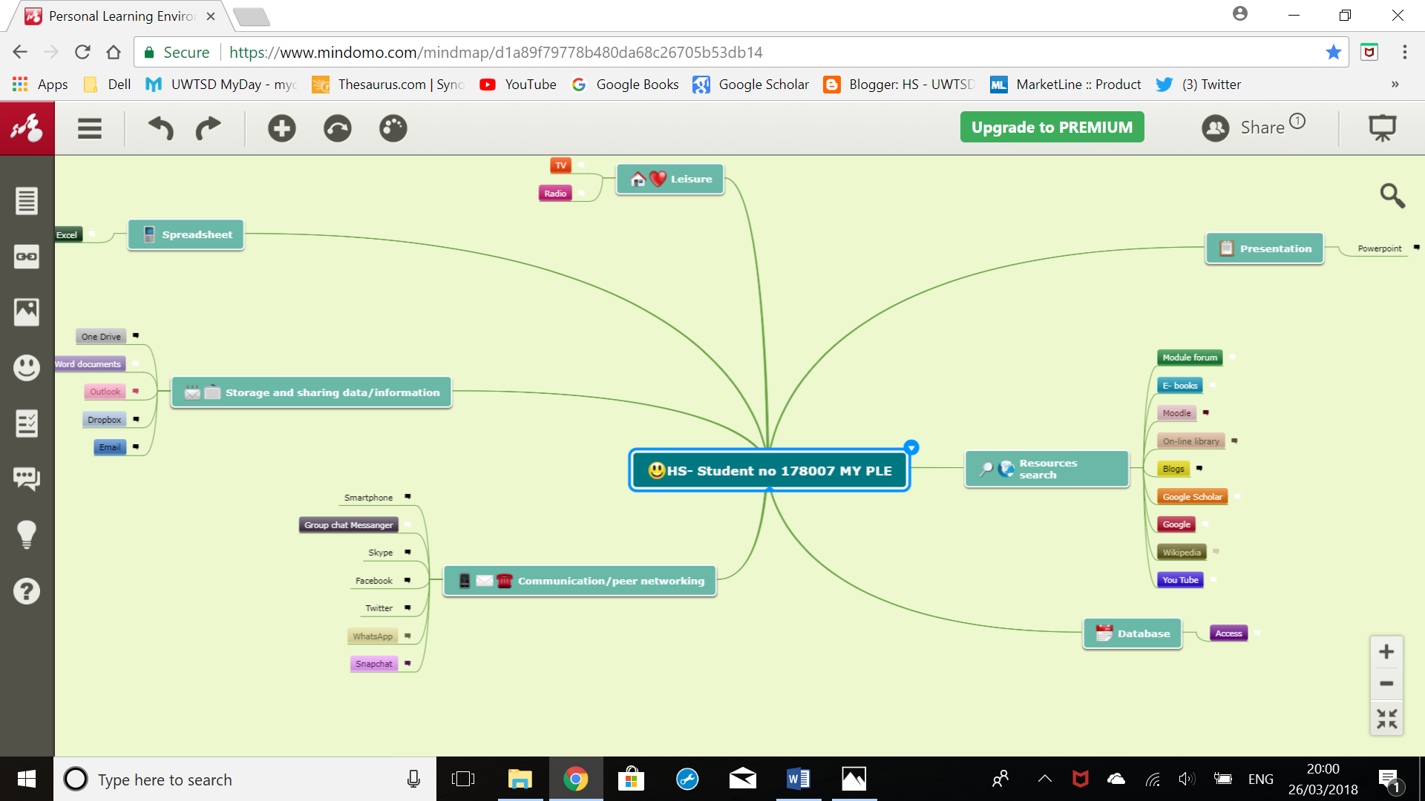
Above: This is my personal learning environment diagram.

My PLE consists of seven main topics and each of main topic consist of subtopics.
First of main topic is research sources which include: Google, Google Scholar, Wikipedia, You Tube, blogs, online library, Moodle, e- books and Moodle forum.
On daily basis I am using a Google search engine and quite frankly can't imagine myself without it. Having the advantage these days of advance technology and search beyond the surface, it gives a great opportunity to create your own opinion about any subject that you are interested in. It is a vital tool for my daily usage and keeps me up to date with any information that interests me.
Google Scholar is a research and referencing tool, it is very important for me as well as helping me in producing any of my written documents for university.
Wikipedia is my navigator tool for my prime research. This source is not always credible but gives me an idea about my studied subject.
You Tube channels gives me independence within my research on daily basis. If I'm not sure about some subject or need to introduce myself to new subject, for example; database, then I can use this tool. It gives me a basic understanding of a subject and then I can move on to a deeper search for a topic that I am attracted to. I have many subscriptions on You Tube that allow me to gain knowledge and observe and the experiences of different people through listening to TED talks, watching tutorials and many more. The biggest advantage of You Tube for me is that I am saving time while learning. An example is - TED talk as a mother this allows me to multitask – I can produce a dinner for family while listening, so I don’t waste my time.

Online library permits me an endless list of e- books as well as articles and study cases for writing an assignment, moreover, it gives me a flexibility of usage regardless of time and location.
Blogs as well as the above are a great opportunity to explore someone else’s opinion and generate my own during research.
The Moodle forum for this module helped me to gain a deeper understanding of the meaning of subjects required for this assignment. Moodle is a prime tool for me for research and communication with tutors. As well as substantial link between students. Also, the content of the module and vital information are stored for students.
Second of main topic in my PLE is communication and this is a vital tool for me.
On daily basis I have use communications tools such as; smartphone, Skype, Messenger, WhatsApp, Twitter and Snapchat which helps me to keep up to date with my fellow students, family and friends regardless of my location. However, usage of social media and Skype can be a problem as sometimes I overuse it and become distracted from important tasks or duties at home and at university.
Another main topic in my PLE is storage and sharing information which includes email box, Outlook, One Drive and Word document.
All above tools are important to me as again keeps me up to date and I can securely storage any of produced written documents. One Drive doesn’t take away any space as this is cloud storage which storage my documents virtually. The most effective tool in my opinion is ‘Word document’ as it allows me to produce written assignments and allows me to review and correct grammar, punctuation and provide a referencing tool which is great advantage for me.
Spreadsheet on Excel and Access on Database tools improve my analytical and computational skills and are important for my learning.
Presentation on PowerPoint is a visual representation of produced work and gives me an independency to create my own unique presentation for an audience.
Finally, radio and television are my leisure tools as not only can I use them to relax but I can also gain knowledge through, for example documentaries. However, I need to be careful that they don’t distract me from important tasks such as assignments.

Conclusion
Digital technology, digital literacy and personal learning environment underlines the importance of collaboration between students and the online world as well as contributing to their own learning.
Students contribute to their own learning and have the great advantage of the usage od advanced technology to help them improve their skills as well as progress in their education.
There are some disadvantages of digital technology in PLE. However overall digital technology has a positive impact within students learning and with wise usage of technology, we all have the opportunity to benefit from it.

References
Akbar, M. (2016, February 17). frontiersin.org Department of Computer Science, University of Texas at El Paso, El Paso, TX, USA. Retrieved from frontiersin.org: https://www.frontiersin.org/articles/10.3389/fict.2016.00001/full
Attwell, G. (2007, January 1). The Personal Learning Environment- The Future of e Learning. E Learning Papers, vol2 no1. Retrieved from Digtechitalia.pbworks.com: http://digtechitalia.pbworks.com/w/file/fetch/88358195/Atwell%202007.pdf
Dabbagh, N., & Kitsantas, A. (2011, June 25). Science Direct. Retrieved from Science Direct: https://moodle.uwtsd.ac.uk/pluginfile.php/151485/mod_resource/content/1/Dabbaugh_and_Kitsantas_PLE_2011.pdf
Gallego, M. J., & Gamiz, V. M. (2014, n.d. n.d.). Australian Educational Computing. Retrieved from Australian Educational Computing: https://moodle.uwtsd.ac.uk/pluginfile.php/148824/mod_resource/content/2/Student%20PLEs%202015.pdf
Handsfield, L. J., Dean, T. R., & Cielocha, K. M. (2009, September n.d.). The Reading Teacher. Retrieved from https://search.proquest.com/docview/203280235?pq-origsite=gscholar
Koltay, T. (2011, March 23). Sage Publications; The media and the literacies: media literacy, information literacy, digital literacy. Retrieved from Sage Publications: http://journals.sagepub.com/doi/abs/10.1177/0163443710393382
Lepitak, S. (2018, March 10). The drum com. Retrieved from The drum: http://www.thedrum.com/news/2018/03/10/tim-o-reilly-the-good-technology-can-do-society-our-digital-systems-are-crying-out
O'Reilly, T. (2009). What is a Web 2.0. California: O'Reilly Media.
TEDx Talks. (2012, March 22). You Tube, TEDx TalksThe essential elements of digital literacies: Doug Belshaw at TEDxWarwick. Retrieved from You Tube: https://www.youtube.com/watch?v=A8yQPoTcZ78
Thomas, A., & Morris, N. (2017, March 15). www.jisc.ac.uk. Retrieved from www.jisc.ac.uk: https://www.jisc.ac.uk/news/is-digital-technology-changing-learning-and-teaching-15-mar-2017
Wesch, M. (2010, October 12). You Tube, TEDx Talk From Knowledgable to Knowledge- Able. Retrieved from You Tube: https://www.youtube.com/watch?v=LeaAHv4UTI8

