Summary of essential skills for study and employment

University admissions suggest that there are 6 essential skills for learning. These are [1] Academic Writing, Critical Thinking, Time Management, Reading, Communication and Soft Skills.

This compares to 54 skills listed for employees’ essential skills show in the image below from Science Direct.
[2]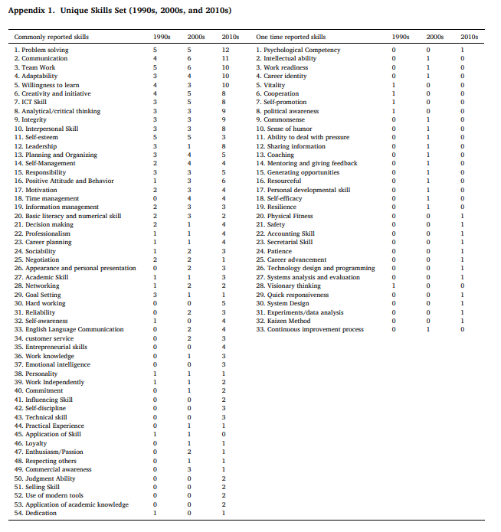
If we compare this to an image about academic essential skills [1] three of the essential skills overlap, communication, Time Management and Critical Thinking. Although Soft Skills in not directly quoted in [2] it does arguably come under several areas such as sociability and self-efficiency.

[1]
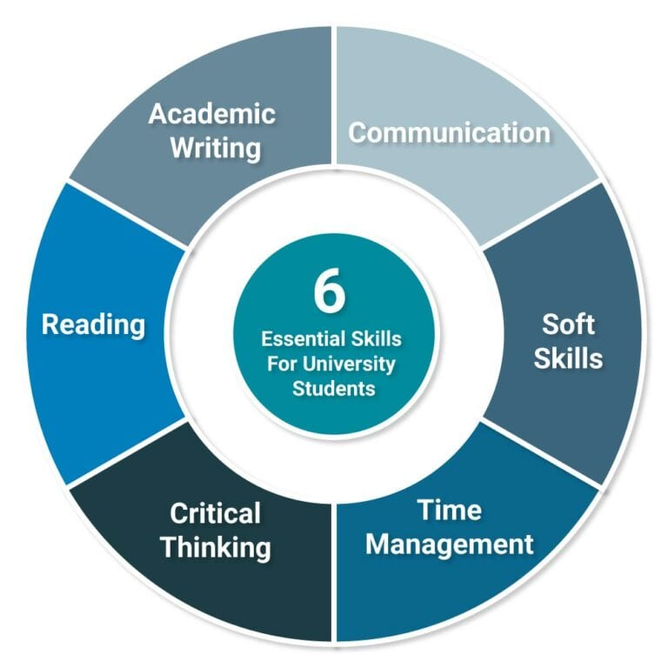
You will note in the first image [2], that the type of skills considered important for employment have changed dramatically over the years. For example, “Selling Skills” [2] were not considered important in the 1990’s but are invaluable in 2010. This is why it is vital to recognise the need for continuous learning within the workplace. As such, being able to identify and become skilled at the essential skills required for academia as a basis for employee skills development.

Plato reported Socrates saying, “The job of the educator is not to put knowledge where knowledge does not exist, but to turn the minds eye to the light so it may see it for itself.” [3]. The ability to identify the need for continuous learning and having the sills to be able to do this for yourself enable you to master all the essential employee skills desired by employers.

References
[1] | R. Needleman, “Uni Admissions,” Application Guides, 4th August 2025. [Online]. Available: https://www.uniadmissions.co.uk/application-guides/6-essential-skills-for-university-students/. [Accessed 26th January 2026].
[2] | H. T. &. N. Sooraksa, “Global employability skills in the 21st century workplace: A semi-systematic literature review,” Heliyon, vol. 11, no. 9, p. 12, 2023.
[3] | R. Hoyle, “Informal learning in organisations - How to create a continous learning culture,” Kogan Page Limited, London, 2015.

