

Student name: Tasha Young
Student ID: 2316846

Module name: Psychopathological Classifications and Provisions (Lou Wells)
Module code: (BMHP6029_LON)
Acknowledgement of the use/non-use of AI:

Anorexia Nervosa
Author name Tasha young

Introduction  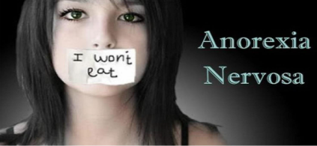  Classification:  Anorexia nervosa is recognized as a feeding and eating disorder in both the ICD-11 and DSM-5 diagnostic frameworks. As per the ICD-11 (World Health Organization, 2023), it is characterized by significantly low body weight, an intense fear of gaining weight, and a distorted perception of body image, with diagnostic criteria including a BMI of less than 18.5 for adults. The DSM-5 (American Psychiatric Association, 2013) also specifies criteria such as limited energy intake, fear of weight gain, and disturbances in body image, while further differentiating between the restricting and binge-eating/purging subtypes. Both diagnostic systems highlight the psychological and behavioral aspects of the disorder, in addition to its physical symptoms. Anorexia nervosa remains a major public health concern in the UK, with a prevalence of 102 per 100,000 people (Therapy Clinics, 2025). It disproportionately affects young females, with 12.5% of 17–19-year-olds in England diagnosed with an eating disorder in 2023 a fourfold increase since 2017 (Priory Group, 2025). Although binge eating disorder is more common, Anorexia has one of the highest psychiatric mortality rates due to medical complications and suicide risk (World Population Review, 2025). Hospital admissions have doubled over the past decade, underscoring the need for early, person-centered intervention (Statista, 2025).  Historical perspectives and treatments  Historically, anorexia nervosa was misunderstood and often moralized. In medieval times, extreme fasting especially by women was seen as spiritual devotion, exemplified by cases like Catherine of Siena (Simonovic et al., 2015). The first medical description came from Richard Morton in 1689, who linked it to melancholy (Academic Library, 2025). By the late 19th century, it was recognized as a mental illness, though early 20th-century views focused on biological causes. Freud’s psychoanalytic  theories later emphasized psychological origins (Academic Library, 2025). Today, Anorexia is classified as a psychiatric disorder in DSM-5 and ICD-11, understood as multifactorial and treated through therapies, nutritional support, and family-based care (SpringerLink, 2024; IJIRME, 2024).  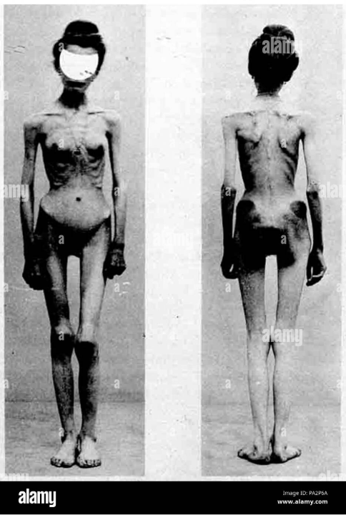  (Alamy Limited, 2025)  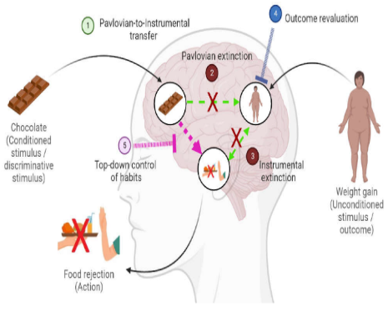  (Garcia-Burgos et al., 2023)  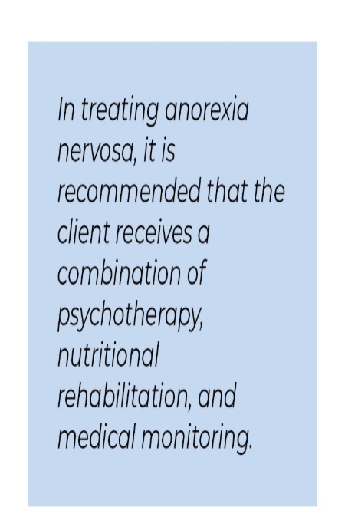 (Manifoldapp.org, 2017)  L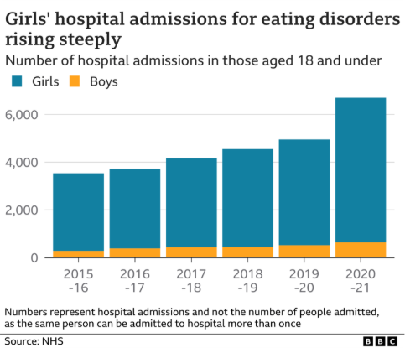  (Roxby, 2022)  The graph presented above illustrates a significant increase in hospital admissions for eating disorders among girls aged 18 and younger in England from 2015–16 to 2020–21. In contrast, the admission rates for boys remained comparatively low and stable. The surge in admissions for girls, particularly in 2020–21, indicates a widening gender gap and raises alarms about the mental health of young females. It is important to note that the data pertains to hospital admissions rather than individual cases, implying that some patients may have been admitted on multiple occasions. |  | Anorexia Nervosa  Definition  Anorexia nervosa is a severe eating disorder categorized as a mental and behavioral condition, marked by restrictive eating habits, an intense fear of gaining weight, and a distorted perception of body image. It is acknowledged worldwide as a psychiatric issue that necessitates both medical and psychological treatment (NICE, 2017).  Individuals might resort to extreme dieting, excessive workouts, or purging behaviors to manage their weight. Even when they are underweight, they frequently view themselves as overweight.  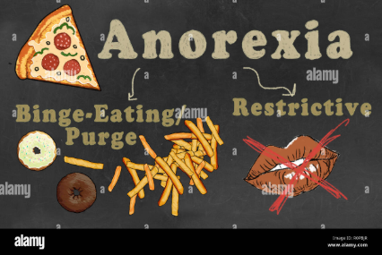(Alamy Limited, 2018) |  | Current services and treatments  In the UK, the treatment for anorexia nervosa involves a blend of psychological therapies, nutritional assistance, and medical supervision, all provided by specialized eating disorder services following NHS guidelines.  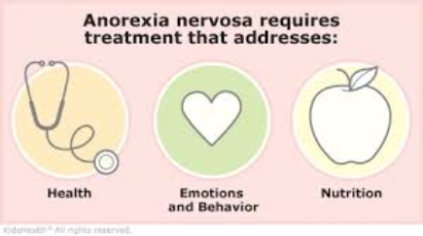  (kidshealth, 2025)  Treatment for anorexia nervosa generally requires a coordinated multidisciplinary approach led by specialized eating disorder teams. As stated by the NHS (2025), the essential elements include:  • Psychological therapies: The cornerstone of treatment, particularly for adults, consists of Cognitive Behavioural Therapy for Eating Disorders (CBT-ED), Maudsley Anorexia Nervosa Treatment for Adults (MANTRA), and Specialist Supportive Clinical Management (SSCM). For children and adolescents, Family-Based Therapy (FBT) is frequently the primary intervention.  • Nutritional rehabilitation: Dietitians collaborate with individuals to re-establish healthy eating habits and facilitate weight restoration. This process encompasses meal planning, psychoeducation, and tackling food-related anxieties (NHS, 2021)  • Medical monitoring: Consistent physical health assessments are crucial to track complications such as electrolyte imbalances, heart function, and bone density. In critical situations, inpatient care may be necessary (NHS, 2021).  • Inpatient and day services: For those experiencing severe or treatment-resistant anorexia, NHS England funds Specialised Adult Eating Disorder Inpatient Services, which are currently being revised to align with best practices and address service deficiencies (England, 2024)  • Children and Young People’s Mental Health Services (CYPMHS): Young patients are referred to CYPMHS or paediatric teams for care that is suitable for their age, often incorporating family and school-based support (NHS, 2021)  • Community and voluntary sector support: Organizations like Beat Eating Disorders provide helplines, peer support, and online resources to enhance NHS care.  The National Institute for Health and Care Excellence (NICE) offers comprehensive guidance (NG69) on the identification, evaluation, and treatment of eating disorders, with the goal of ensuring uniform, evidence-based care throughout the UK (NICE, 2017).  Recommendations  (Bence, 2022)  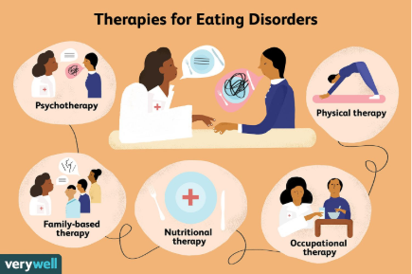  The current approach to treating anorexia nervosa in the UK employs a multidisciplinary strategy through specialized NHS services.  Psychological therapies such as Cognitive Behavioral Therapy for Eating Disorders (CBT-ED), Maudsley Anorexia Nervosa Treatment for Adults (MANTRA), and Family-Based Therapy (FBT) are recommended according to the person's age and particular symptoms (NICE, 2020).  Dietitians support nutritional rehabilitation to promote healthy eating habits and tackle food-related anxieties, while medical monitoring involves regular assessments for complications like heart irregularities and malnutrition (NHS, 2025).  In cases of severe anorexia, inpatient and day services are accessible, with NHS England in the process of enhancing adult inpatient services to ensure better access and consistency (NHS England, 2024).  Community organizations such as Beat Eating Disorders provide additional peer support and helplines to supplement clinical care. Prompt access to evidence-based, person-centered treatment is crucial for recovery and long-term health.  Conclusions  Anorexia nervosa is a multifaceted and severe mental health disorder that necessitates prompt, evidence-based, and individualized intervention.  Anorexia nervosa does not stem from a single cause but arises from a mix of genetic predisposition, psychological characteristics, sociocultural influences, and environmental factors (Therapy Clinics, 2025; Priory Group, 2025). Once misinterpreted and moralized, it is now acknowledged as a psychiatric condition with one of the highest mortality rates among mental health disorders (Simonovic et al., 2015; WHO, 2023). Symptoms can include significant weight loss, distorted body perception, and compulsive behaviors related to food and exercise (NHS, 2025). Diagnosis is based on DSM-5 and ICD-11 standards, bolstered by clinical and psychological evaluations (APA, 2013; NICE, 2020).  Current services in the UK encompass psychological therapies (CBT-ED, MANTRA, FBT), nutritional rehabilitation, and medical oversight, provided by Current services in the UK encompass psychological therapies (CBT-ED, MANTRA, FBT), nutritional rehabilitation, and medical oversight, provided by specialized NHS teams and supported by organizations like Beat (NHS England, 2024; NICE, 2020). Nevertheless, issues such as limited access, stigma, and continue Thus, essential recommendations include enhancing early detection, broadening specialist services, fostering inclusive care, and assisting families and caregivers. In conclusion, the effective management of anorexia nervosa necessitates a compassionate, multidisciplinary strategy that emphasizes recovery, dignity, and long-term wellness.  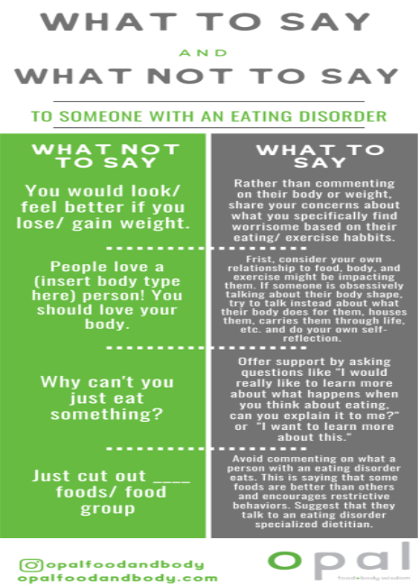(Church, 2020)

Causes
(UK Addiction Treatment Centers, 2017)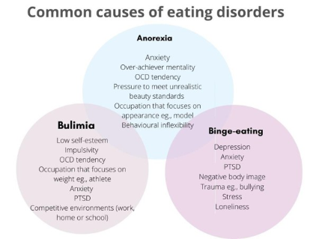
Anorexia nervosa does not stem from a single cause; instead, it is associated with a mix of genetic, psychological, sociocultural, and environmental factors.
Research indicates that Anorexia nervosa develops from a complex interaction of various influences rather than a singular cause. Genetic factors are significant, with studies showing heritability rates as high as 60% (Therapy Clinics, 2025). Those with a family history of eating disorders, anxiety, or depression face a greater risk. Psychological aspects such as perfectionism, low self-esteem, and obsessive-compulsive traits are frequently linked to anorexia (Priory Group, 2025). Sociocultural influences, including media representations of thinness and societal beauty ideals, can lead to body dissatisfaction and restrictive eating behaviors, particularly in adolescents. Environmental stressors like trauma, bullying, or life transitions (such as puberty and academic pressure) may also play a role in the onset of the disorder.
The NHS points out that anorexia typically begins during adolescence and is more common among young women, although it can impact individuals of any gender or age. Crucially, anorexia is now recognized as a serious mental health issue that necessitates early intervention and comprehensive care, rather than being viewed as a lifestyle choice or a trivial concern (NHS, 2025).

Symptoms
Individuals suffering from anorexia nervosa often undergo significant weight loss, possess a profound fear of weight gain, have a skewed perception of their body, and engage in restrictive eating habits. These manifestations can be categorized as physical, psychological, and behavioral (NHS, 2021)
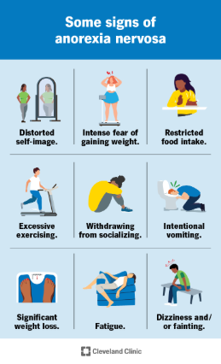
(Cleveland Clinic, 2024)
As stated by the NHS and Beat Eating Disorders UK, the most prevalent symptoms are:
Physical symptoms:
• Markedly low body weight or BMI
• Tiredness, lightheadedness, and feeling chilly
• Thinning hair or hair loss, dry skin
• Irregular or missing menstrual cycles
• Digestive problems (e.g. constipation, bloating)
Psychological symptoms:
• Overwhelming fear of gaining weight

• Distorted perception of body image (thinking one is overweight despite being underweight)
• Obsessive preoccupation with food, calorie intake, and body shape
Behavioral symptoms:
• Skipping meals or consuming very little
• Steering clear of foods considered fattening
• Excessive exercising or purging (vomiting, laxatives, diuretics)
• Wearing loose-fitting clothing to conceal weight loss
• Deceiving others about food consumption or weight (NHS inform, 2024)
These symptoms can differ in intensity and manifestation. Some people may not seem underweight but still face significant psychological and behavioral issues; this condition is referred to as atypical anorexia (Beat eating disorders, 2023).

Diagnosis
Anorexia nervosa is identified through a mix of clinical evaluation, physical examination, and psychological assessment, following established diagnostic guidelines. As per the DSM-5 (American Psychiatric Association, 2013), a diagnosis necessitates proof of limited energy intake resulting in significantly low body weight, a profound fear of weight gain, and a distorted perception of body image. The ICD-11 (World Health Organization, 2022) also characterizes anorexia by low body weight, an excessive focus on body shape, and behaviors like food restriction or purging, with BMI cutoffs of <18.5 kg/m² for adults or below the 5th percentile for children. In the UK, the NHS and NICE advocate for a multidisciplinary strategy that includes GPs, mental health experts, and dietitians. The diagnostic process encompasses medical history, BMI evaluation, blood tests, ECGs, and psychological assessments to recognize both standard and atypical cases (NHS, 2024) (NICE, 2017) (Team, 2025).

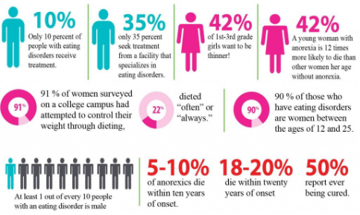
(Long, 2022)

References
Academic Library. (2025). History of the Treatment of Anorexia. Available at: https://ebrary.net/238437/sociology/history_treatment_anorexia [Accessed 11th November 2025]
Alamy Limited (2018). Anorexia illustrated with Classification. Two types: Binge-Eating/Purge and Restrictive Eating Disorder. Available at: https://www.alamy.com/anorexia-illustrated-with-classification-two-types-binge-eatingpurge-and-restrictive-eating-disorder-image224226879.html [Accessed 11 Nov. 2025]
Alamy Limited (2025). 139 Anorexia case 1900. Available at: https://www.alamy.com/139-anorexia-case-1900-image212732306.html [Accessed 11 Nov. 2025]
Beat Eating Disorders (2023). Anorexia Nervosa. Available at: https://www.beateatingdisorders.org.uk/get-information-and-support/about-eating-disorders/types/anorexia/ [Accessed 15th November 2025]
Bence, S. (2022). How Eating Disorders Are Treated. Very well Health. Available at: https://www.verywellhealth.com/eating-disorders-treatment-5112475 [Accessed 15th November 2025]
Church, J. (2020). What NOT to say to someone with an eating disorder. Opal Food+Body. Available at: https://opalfoodandbody.com/what-not-to-say-to-someone-with-an-eating-disorder/ [Accessed 15th November 2025]
Cleveland Clinic (2024). Eating disorders: Anorexia. Available at: https://my.clevelandclinic.org/health/diseases/9794-anorexia-nervosa [Accessed 15th November 2025]
England, N. (2024). NHS England» Specialized Adult Eating Disorder Inpatient Service: Consultation Guide. Available at: https://www.england.nhs.uk/long-read/specialised-adult-eating-disorder-inpatient-service-consultation-guide/ [Accessed 15th November 2025]
Fixsen, A. (2024). Anorexia Nervosa: The Making of the First Eating Disorder. In The Construction of Eating Disorders. SpringerLink. Available at: https://link.springer.com/chapter/10.1007/978-3-031-70318-8_3 [Accessed 11th November 2025]
Garcia-Burgos, D., Wilhelm, P., Vögele, C. and Munsch, S. (2023). Food Restriction in Anorexia Nervosa in the Light of Modern Learning Theory: A Narrative Review. Behavioral Sciences, 13(2), p.96. doi: https://doi.org/10.3390/bs13020096 [Accessed 15th November 2025]
Jade, H. (2017). Anorexia Nervosa - Symptoms, Causes, Statistics & Treatment. Health Jade. Available at: https://healthjade.net/anorexia-nervosa/ [Accessed 28 Oct. 2025]
kidshealth.org. (2025). A to Z: Anorexia Nervosa (for Parents) - Children’s Health Network. Available at: https://kidshealth.org/ChildrensHealthNetwork/en/parents/az-anorexia.html [Accessed 15th November 2025] • Long, P. (2022). Eating Disorders Awareness Week. Innovative Trials. Available at: https://innovativetrials.com/eating-disorders-awareness-week/ [Accessed 15th November 2025]
Manifoldapp.org. (2017). 14. Eating Disorders in Children and Adolescents. Temple University Press. Available at: https://temple.manifoldapp.org/read/a-developmental-systems-guide-for-child-and-adolescent-behavioral-health-practitioners-da7c780a-7f9d-4c6a-ad85-b6736f8df14f/section/d12c123a-6e74-468e-a562-5aeb990e64e5 [Accessed 15 Nov. 2025]
Nguyen, T.T., & Vu, H.X. (2024). Eating Disorders: A Historical Perspective and Analysis of Current Treatment Approaches. International Journal of Innovative Research in Multidisciplinary Education, 3(4), 513–519. Available at: https://www.ijirme.com/v3i4/Doc/7.pdf [Accessed 11th November 2025]
NHS (2021). Symptoms - Anorexia. Available at: https://www.nhs.uk/mental-health/conditions/anorexia/symptoms/ [Accessed 15th November 2025] NHS (2021). Treatment - Anorexia. Available at: https://www.nhs.uk/mental-health/conditions/anorexia/treatment/ [Accessed 15th November 2025]
NHS (2024). Overview - Anorexia. Available at: https://www.nhs.uk/mental-health/conditions/anorexia/overview/ [Accessed 15th November 2025] • NHS (2025). Overview – Anorexia Nervosa. Available at: https://www.nhs.uk/mental-health/conditions/anorexia/overview/ [Accessed 11th November 2025]
NHS informs. (2024). Anorexia Nervosa. Available at: https://www.nhsinform.scot/illnesses-and-conditions/mental-health/eating-disorders/anorexia-nervosa/ [Accessed 15th November 2025]
NICE (2017). Overview Eating Disorders: Recognition and Treatment Guidance NICE. Available at: https://www.nice.org.uk/guidance/ng69 [Accessed 15th November 2025]
NICE (2017). Overview Eating Disorders: Recognition and Treatment Guidance NICE. Available at: https://www.nice.org.uk/guidance/ng69 [Accessed 28th October 2025] • Priory Group. (2025). Eating Disorder Statistics UK 2025. Available at: https://www.priorygroup.com/eating-disorders/eating-disorder-statistics [Accessed 11th November 2025]
Priory Group. (2025). Eating Disorder Statistics UK 2025. Available at: https://www.priorygroup.com/eating-disorders/eating-disorder-statistics [Accessed 11th November 2025] • Roxby, P. (2022). Eating Disorder Hospital Cases Up 84% in Five Years in England. BBC News. Available at: https://www.bbc.co.uk/news/health-61480898 [Accessed 24th November 2025]
Statista. (2025). Eating Disorders in the United Kingdom - Statistics & Facts. Available at: https://www.statista.com/topics/12267/eating-disorders-in-the-united-kingdom/ [Accessed 11th November 2025]
Team, A. (2025). Diagnostic Criteria. Gpnotebook. Available at: https://gpnotebook.com/en-GB/pages/psychiatry/anorexia-nervosa/diagnostic-criteria [Accessed 15 Nov. 2025]
Therapy Clinics. (2025). Eating Disorders in the UK: Comprehensive Statistics, Trends, and the Future (2025/2026). Available at: https://www.therapyclinics.co.uk/the-rise-of-eating-disorders-in-the-uk-statistics-2025/ [Accessed 11th November 2025]
Therapy Clinics. (2025). Eating Disorders in the UK: Comprehensive Statistics, Trends, and the Future (2025/2026). Available at: https://www.therapyclinics.co.uk/the-rise-of-eating-disorders-in-the-uk-statistics-2025/ [Accessed 11th November 2025]
UK Addiction Treatment Centers. (2017). Eating Disorders UK Addiction Treatment Centres. Available at: https://www.ukat.co.uk/eating-disorders/ [Accessed 11th November 2025]
World Health Organization (2022). ICD-11. Available at: https://icd.who.int/en [Accessed 15th November 2025] • World Population Review. (2025). Eating Disorders by Country 2025. Available at: https://worldpopulationreview.com/country-rankings/eating-disorders-by-country [Accessed 11th November 2025]

