

Built Environment Programmes – Level 6. BSc (Hons) Quantity Surveying
Lukas Mark Molnar Riis - 2015801
ACBA 6000 - Construction Management
Programme Control

Hello,
The below report uses data from the Gantt chart I have produced for the works involved in the construction of the new innovation matrix building at UWTSD, SA1 Campus.



The above cost overview shows the overall costs as £486,693.10 for the element of works I have assigned resources to. In this case the element of works is landscaping which as shown in the breakdown of the costs is part of the construction and manufacturing phase of the project.

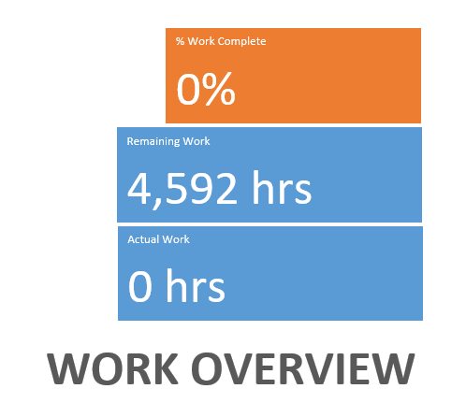

Plant and labour are under the work category within the resources. The resources under the work element expanded on have been put into a graph as above and show which labour and plant is used the most and least. We can see here that the supervisor/project manager and gateman are the most used labour for the project. This will be because the gateman will need to be present for the entirety of the project to ensure that the site has security, this will ensure no theft of any goods as well as only allowing access to site for people who are supposed to be on site. I have been in contact with the client over the past two weeks, they advised it is a requirement under health and safety rules that a supervisor is present at all times on site, this will be why the supervisor is also present for the entirety of the works. The least used labour is a fork driver. Forks will only need to be used for deliveries of goods and for some distribution around site for materials. Other than that, they won’t be as active as other workers.

The least used plant is the forklift and the rotavator. Again forks will only be used as mentioned above, and the rotavator will only be needed for this section of the works when planting areas need to be turned over or cultivated ready for planting, so again this makes sense as to why it is the least used plant and machinery.

Resource Overview
Resource Stats
Resource statistics
Work status for all work resources.

The above graph shows how the workload will be spread for this section of the works. As mentioned above the most used labour is the supervisor and gateman as they are constant. Behind them is the site operative 1 and then site operative 2. Site operatives are the men on the ground so it’s no surprise they will be carrying out works on site more often than machine operatives or dumper drivers as they are required more often. The dumper driver 2 and excavator operator 2 are used less so than the first drivers as it is rarer within the works that a second piece of plant will need to be used. When materials are being distributed it’s likely two dumpers will be needed and when any excavations are being carried out it’s more likely a second excavator will be needed. But in most cases when at least one dumper is needed at least one excavator will be needed. The site engineer is on site for a longer overall duration than for example the forks driver, even though within the programme the forks driver will come on to site more times. This is because the engineer’s stint on site is longer than the forks driver’s multiple stints on site combined.
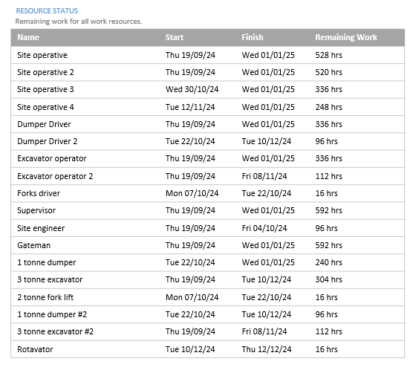
The above shows a schedule version of the above graphs data. The amount of time programmed varies from each type of labour and plant because of the quantity of works required on site varies. Landscaping works usually require an on the ground operative for a strong majority of the activities programmed this is why they will be needed most, of course other than the constantly present gateman and supervisor of works.

Resource Cost Overview
COST STATUS
Cost status for work resources

COST DISTRIBUTION
How costs are spread out amongst different resource types

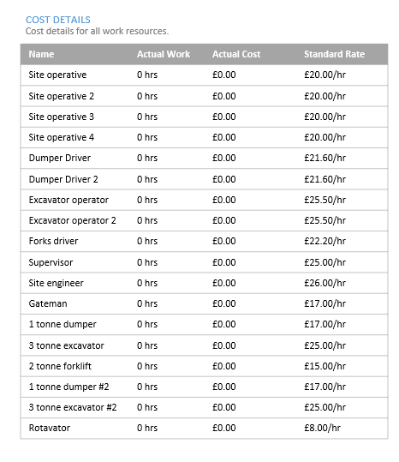
The three above diagrams show what affect each resource has on the costs. The above schedule of rates included all resources on site for the landscaping for plant, materials and labour. The plant and materials are closer to raw costs, but the labour rates have been devised by using a charge out rate approach. A charge out rate will take into consideration overhead costs that come with employing operatives, two examples are insurances and annual leave, using a charge out approach will give a more accurate depiction of the costs for the project than if we were to use raw cost rates for labour.
The first diagram in the resource cost overview shows how the work programmed combined with applied rates affect the landscaping programmes costs. The highest cost was a supervisor, this no surprise as the supervisor/project manager will be on site the joint most and is on the highest rate. Next was the site operatives 1 and then 2, although they are on site for less duration than the gateman their rate will mean they increase the project’s costs more overall.
The first 3 tonne excavator is the most expensive piece of plant on site as it is used often and is charged out at a higher rate than dumpers. The cheapest tool is the hire of a rotavator and this is also the least used piece of machinery level with the forklift therefore it will have the lowest cost implication.
Within the above pie chart, we can see that the materials element of the landscaping is almost four times the size of the plant and labour in terms of cost. When speaking to the client I requested the landscaping drawing for the project so I could quantify materials, so we know this is accurate. Materials often outweigh the cost of other variables in landscaping works as the materials can often be of high value especially with the cost increases in recent times. If procurement can be carried out efficiently then we can ensure there are no price increases that could explode the programmes costs.

Delay in the programme
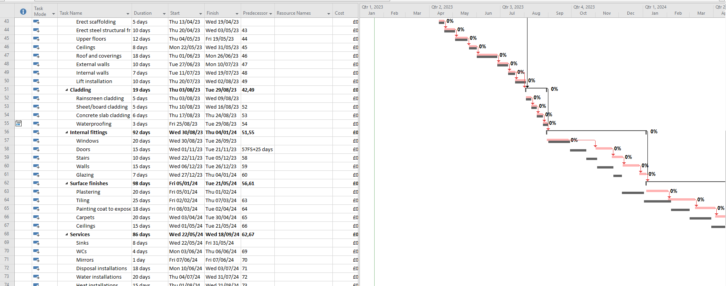

Unfortunately, there has been a five-week delay on the manufacturing of the windows for the project. As we can see in the above section of the programme everything is running along the critical path until we get to the windows section. After the windows we can see that the programme is out of sync with the critical path, and for the rest of the programme the project will be running 5 weeks behind schedule (the critical path). In order to overcome this delay and ensure that it has no effect on the duration of the project and meeting targets set, incentivisation needs to be used in order to motivate.

Incentivisation
An incentive within the UK construction industry can be something that will motivate the workforce on site to perform at their best. Incentives are usually used as a way of increasing the output of work being done on site, or the actual performance of the workforce. An incentive will benefit the site operative and the client they work for.
There can be different types of benefits to come from incentives, some can be financial benefits, and some can be more psychological. Although incentives involving money can be more effective overall, psychological incentives are a big part of giving positive feedback and recognition to the supply chain.
(CWC, 2015)
In the delay we have above, I would introduce some incentives which would be for financial and non-financial rewards to try to optimise the output of the workforce. Firstly, I would introduce a cash bonus reward for site operatives. This reward will be the result of goals in terms of productivity on site. If we set a target for a certain amount of works to be complete by a certain date following the delay, this will motivate the workforce to work at their fullest capacity to try and receive the cash bonus. In turn this will help us gain back some time lost with the delay we have faced.
(Appelbaum, S.H and Kamal, R, 2000, p.735)

The second incentive I propose is an employee of the month award on site, each month. The winner of the employee of the month will have their name on the wall in some areas of the site welfare facilities and receive a gift card for online shopping. This reward although does involve a small amount money in the form of a gift card, is mainly a psychological incentive. By having an award each month to work towards this will motivate site operatives to carry out their work to a high standard, high quality of work means less snagging and re-doing work, with less time spent on this there will be fewer future delays. As well as quality of work completed productivity can increase. The reward of getting the recognition for carrying out good work is the main incentive for this case.
Next, I propose another psychological incentive, this time weekly meetings on the same day each week with the trades on site. If works are reviewed and upcoming works are discussed the workforce know what targets they need to achieve. By applying small amount of pressure where it is not too much to stress out the labour this can also motivate them with them having the knowledge that their work is being monitored each week.
(Bryde, J and Joby, R, 2007, p.146)
Conclusion
We need to agree on a budget for incentivisation in order to make back lost time from the delay caused by the manufacturing of the windows. The project baseline and critical path can still be achieved if we can get more out of our workforce. The programme has allowed for this delay currently but with the above proposals I believe we can end the project as previously planned.

Reference List
- CWC, (2015). SETTING INCENTIVES AND SHARED SAVING SCHEME. Available at: https://www.constructingexcellence.org.uk/ (Accessed 5th January 2023).
- Appelbaum, S.H and Kamal, R (2000) An analysis of the utilization and effectiveness of non-financial incentives in small business. Quebec, Canad: Dover Finishing Products, Inc.
- Bryde, J and Joby, R (2007) Incentivising project performance in the construction of new facilities. Pamber Heath: 1to1to1.

Bibliography
- Islam, R and Ismail, A (2008) Employee motivation: a Malaysian perspective. Kuala Lumper: International Islamic University of Malaysia.
- Smith, A and Rupp, W (2003) Knowledge workers: exploring the link among performance rating, pay and motivational aspects. Pittsburgh: Robert Morris Unviersity.

