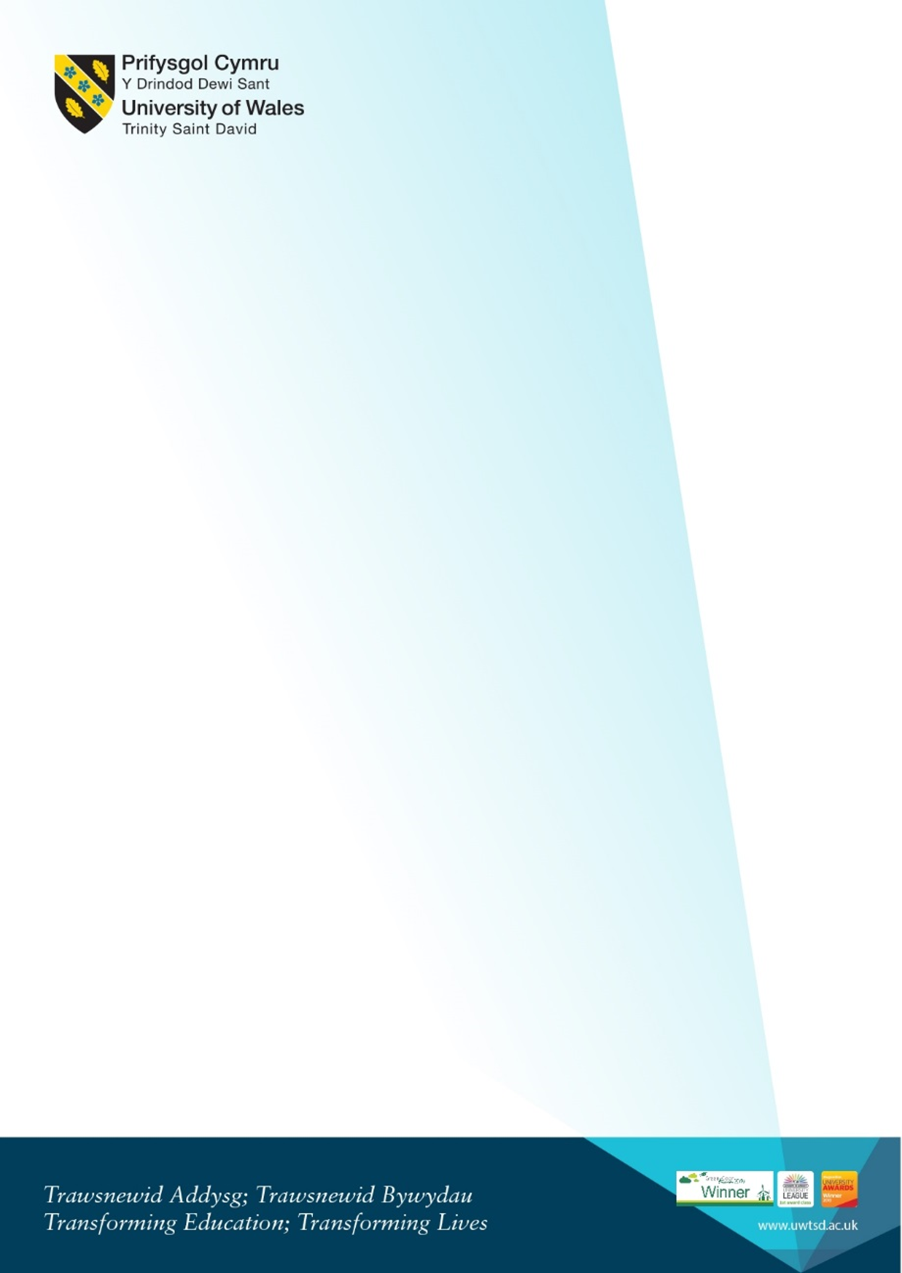
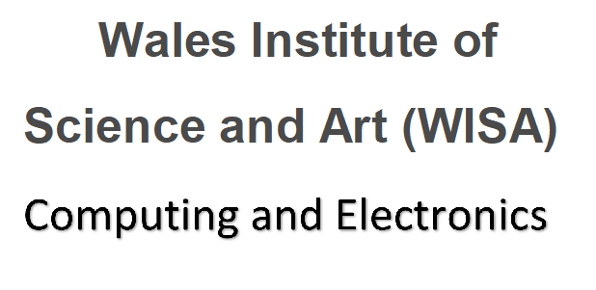
Welcome for Returning Level 6 DDA students
Sept 2020 + Jan 2021 cohorts (Year 4)
Tuesday 19th September 2023 10AM – Room IQ109

10am-10.30am  IQ109 | Meeting with the team Kapilan, Gaynor and Bridget. Also Liaison Officers | - Welcome back  - What’s changed? Staffing, new VC etc  - Updates from liaison officers, Bridget etc
10.30am - 11.15am ish | Gaynor Course overview for Year 4 | - Introduction to the course pathway for this academic year and overview of the modules  - Timetable/study day  - Workshop Days 2023/4  - Moodle and any changes  - Sem 3 modules debrief  - Graduation  - Hwb what’s new  - SOAC logins – forgotten passwords  - Student services and procedures to follow  - Q and A
3.15pm-3.45pm |  | - Opportunity to discuss individual circumstances

