
Master of Business Administration
Student Name: Mahabub Islam
Student Number: 2407067
Module Code: LCMB7023
Assessment: Individual report
Course Name: Human Capital Management
Lecturer: Ejike Udeogu
Word Count: 2742
Submission Deadline: 17th October 2025

Table of Contents
Introduction 1
Question-01: How are technological advancements reshaping labour markets, and what implications does this have for HRM and IHRM strategies? 2
Strategic Imperatives for HRM and IHRM in a Technologically-Driven World: 2
Implications for HRM and IHRM Strategies: 3
Question-02: What are the key demographic and geopolitical factors influencing employment markets today, and how do they create challenges for HR professionals? 4
A Critical Analysis of Challenges for HR Professionals: 4
Key Demographic Factors and HR Challenges 4
Geopolitical Factors and HR Challenges: 6
Question-03: How can organisations address persistent skills gaps and talent shortages in critical sectors through strategic HRM? 7
Proactive Strategies to Cultivate and Retain Critical Sector Talent: 7
Internal Talent Management: Upskilling and Reskilling: 7
Expanding Talent Pool and Acquisition: 8
Employee Experience and Strategic Retention: 8
Question-04: Global Readiness: A Reflection on My Capabilities for the Evolving Workplace 10
Analysing Strengths and Development Areas in an International and Digital Context: 10
Conclusion 14
Reference 15

Contents of Figure
Figure 1: Effect of Strategic Human Resource 2
Figure 2: Geopolitics and Economic Statecraft 6
Figure 3: Employee Experience 9

Introduction
This reflective report assesses my ability to work in a globalised, digital workplace. Using the existing academic and work-based evidence, I assess my strengths and weaknesses in the domains of technology, communication, teamwork, leadership, and self-directed learning. The report will end by showing a strategic plan for development, which will ensure that I am ready to face the changing labour market.

Question-01: How are technological advancements reshaping labour markets, and what implications does this have for HRM and IHRM strategies?

Strategic Imperatives for HRM and IHRM in a Technologically-Driven World:
Technology, especially AI, automation, and digital platforms, is reshaping global labour markets and requiring major changes in HRM and IHRM. This algorithmic change affects local and global enterprises' labour, skills, and management styles.
The first effect on the job market is polarisation and the requirement for reskilling and upskilling (IMF, 2024). Robotics and AI destroy tedious, routine middle-tier jobs. However, generative AI is rapidly affecting highly skilled and cognitively taxing occupations including finance, law, and research (IMF, 2024). Some jobs are destroyed, but many are improved, and AI technologies improve human abilities and provide new jobs in AI maintenance, ethical oversight, and data science (CIPD, 2024). Digital platforms like gig economy platforms enable flexible and remote work and provide access to a global talent pool, but they also increase job instability and flexibility (ILO, 2021).
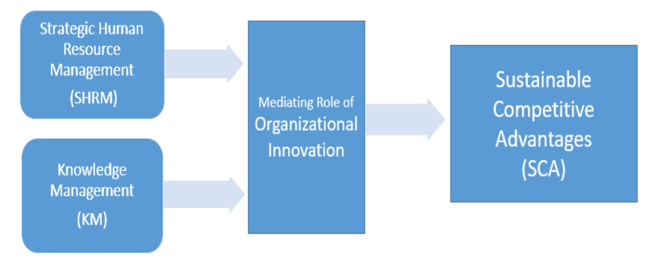
Figure 1: Effect of Strategic Human Resource
Source: mdpi.com

Implications for HRM and IHRM Strategies:
This technological transformation poses acute challenges together with strategic opportunities for people management.
1. HRM Strategy: Augmentation and Data-Driven Decisions
In the domestic market, the HRM strategies will have to shift the focus of their work towards strategic workforce planning that revolves around the human-machine collaboration model (Chowdhury et al., 2023).
- Talent Management and Development: AI implementation in human resource operations, including recruitment and performance management, shortens the process and provides information that is based on data (Al-Tikriti and Fadel, 2025). AI can be used to predict performance by analysing large amounts of data, detect skills gaps, and provide individual learning journeys, instead of relying on subjective yearly appraisals to evaluate performance (Noe et al., 2020).
- Ethical and legal compliance: AI in hiring and evaluation also brings on risks of algorithmic bias, data privacy violations, and perceived unfairness and requires explicit and transparent AI governance and lawful legal frameworks (Pazzanese, 2020; Gupta and Mishra, 2022). HRM will have to make sure that algorithms are biased and encourage employees to consent to the use of their data (Smith and Johnson, 2024).
2. IHRM Strategy: Overcoming the Digital Divide in the World
In the case of IHRM, the global digital divide exacerbates the technological change (Dutta and Lanvin, 2020).
- Global Talent Sourcing and Mobility: Digital and remote work will compel new IHRM policies to allow managing a globally dispersed workforce with complex cloud-based HR systems and virtual collaboration tools necessary to ensure engagement and culture regardless of geographical boundaries (Al-Tikriti and Fadel, 2025).
- Standardisation vs. Localisation: IHRM has to deal with the issue of global standardisation provided by AI and automation systems (e.g., a uniform global HRIS) but the necessity to localise the policies to consider different labour laws and digital readiness and cultural norms in different countries (CIPD, 2024). As an example, MNEs in the emerging markets could have to address the limited infrastructural capacity and higher lack of digital skills, which would demand specific development and investment approaches (Dutta and Lanvin, 2020).
Because of technological changes, both the HRM and the IHRM are being compelled to drive organisational change by taking on agile, evidence-based approaches that harness technology in an effort to enhance efficiency and focus on the human aspect by engaging in constant reskilling, ethical governance, and a human-centric and machine-centric approach to collaboration (Budhwar et al., 2022).

Question-02: What are the key demographic and geopolitical factors influencing employment markets today, and how do they create challenges for HR professionals?

A Critical Analysis of Challenges for HR Professionals:
The modern world of employment is being redefined in a most drastic way due to the specific demographic trends and the rising level of geopolitical unsteadiness, and Human Resources (HR) specialists have a lot of issues to oversee over the period of 2020-24. All these aspects require a radical reassessment of the conventional approaches to HR in terms of talent procurement, labour planning, and conformity (World Economic Forum, 2025).

Key Demographic Factors and HR Challenges
The changes in demographics are resulting in structural imbalances within the labour market that have a direct effect on the workforce availability and the workforce make-up.
1. Elderly People and Shortages in Skills
In most affluent nations, a falling birth rate and rising life expectancy are causing the greying of the labour force and a reduction in the number of young entrants (ILO, 2025). This causes a talent shortage that is endemic, especially in the highly specialised industries such as healthcare and IT (ManpowerGroup, 2024).
- HR Issue: Retention and Management of Talent
HR professionals have the two-fold problem of ensuring that they retain the knowledge and experience of the older generations of workers and at the same time fight cutthroat competition over limited younger and skilled employees. This must be complemented with the formulation of specific policies of phased retirement and knowledge transfer, as well as cross-training to reduce the growing skills gap (Belvedere Meridionale, 2024). Moreover, the HR has to handle the challenge of managing a multi-generational workforce, such as managing various work preferences and technological skills (Saleem, 2024).
2. Workforce Diversity International Migration
The workforce is becoming increasingly diverse globally because of migration flows, as people are often compelled to leave their native countries due to economic necessity, political instability, or the demand for skilled labour.
HR Challenge: integrating and complying with culture
Human resources must promote diversity, equality, and inclusion (DEI) to include migrant workers and avoid cultural barriers (IIARD, 2024). Multinational businesses (MNCs) must negotiate complex immigration laws and visas and ensure that remuneration and benefits comply with local labour laws (Atlas HXM, 2025). Brain drains in home nations complicates global talent management (Britichenko et al., 2024).

Geopolitical Factors and HR Challenges:
Geopolitical tensions and trade friction create volatility, compliance risks and moral dilemmas in international business operations, all of which have a direct effect on global mobility and employee security.
1. Geopolitical Warfare and Economic Disintegration
There have been major geopolitical flashpoints in 2024 with conflict being permanent and trade battles (IBA, 2025). Such occurrences are increasing economic uncertainties, supply chain disruptions across the globe, inflation, and job losses in the impacted sectors (ILO, 2025).
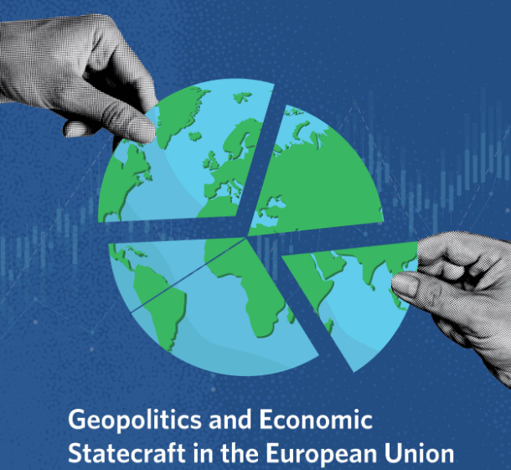
Figure 2: Geopolitics and Economic Statecraft
Source: carnegieendowment.org
- HR Issue: Risk Management and Staff Wellbeing
HR must actively establish organisational resilience by placing workforce plans against geopolitical risks, including the necessity to shift the staff at any time or cope with a drop in operations (Ius Laboris, 2025). Geopolitical tensions may cause serious psychological and emotional stress among employees, especially those with conflict connections, necessitating HR to increase mental health and well-being support services (IBA, 2025).
2. Trade Wars and Protectionism
The increase in nationalism and trade conflicts, including between major world players, results in the introduction of tariffs and sanctions, which forces businesses to near-shore or re-shore (IBA, 2025).
- HR Dilemma: International Human Resources and Global HR Planning
HR directors must monitor and follow the ever-changing international labour legislation and compliance environment, which is a top priority for most organisations (Atlas HXM, 2025). To adapt to the new manufacturing/service sites, the workforce must be rapidly reorganised, including involuntary downsizing and adversarial reskilling/upskilling (Ius Laboris, 2025).

Question-03: How can organisations address persistent skills gaps and talent shortages in critical sectors through strategic HRM?

Proactive Strategies to Cultivate and Retain Critical Sector Talent:
Strategic Human Resource Management (SHRM) strategies that change from reactive recruiting to long-term workforce planning are needed for firms with persistent skills gaps and talent shortages in high-demand areas. HR policies and practices are coordinated with strategic business to generate a sustainable and adaptable workforce (Boxall and Purcell, 2016; Stone et al., 2023).

Internal Talent Management: Upskilling and Reskilling:
After the rapid developments in technology and digitalisation, modern SHRM relies on active internal talent development to meet changing work needs (Li, 2022). Upskilling helps present employees operate more efficiently, whereas reskilling gives them new firm obligations (Storey and Wright, 2023).
- Investment in Learning: Organisations are increasingly focussing on in-house training and development, with many reporting increased talent development (CIPD, 2024). Such programs should be continuous and comprehensive, using adaptive learning algorithms to design courses for faster skill development (Unterhofer and Wunsch, 2022; Rasch and Middelbeck, 2021).
- Apprenticeships and Career Pathways: Introduce formal apprenticeship programs and give well-defined career routes to develop people for specific objectives, reducing shortages and improving retention (SHRM, 2024).

Expanding Talent Pool and Acquisition:
The organisations should enhance their talent search by strategically expanding it to respond to the tightness of the labour market and using digital technologies to be more effective in recruitment (CIPD, 2024).
- Diversity and Inclusion: A concern with Equality, Diversity, and Inclusion (EDI) encourages organisations to seek talent in areas with limited reach to extend the talent pool and introduce fresh points of view (CIPD, 2024).
- Tapping into the Underutilised Pools: Organisations can tap into underutilised segments of the workforce, including women that have re-entered the workforce, by providing flexible work options and return-to-work schemes (People Element, 2024).
- The advantage of digital HR: digital transformation has changed the way of recruiting. Digital platforms, data analytics, and artificial intelligence (AI) can simplify the hiring process, offer a more in-depth understanding of the potential of the candidates, and improve the overall talent acquisition plan, but organisations have to deal with ethical issues, such as algorithmic bias.

Employee Experience and Strategic Retention:
Recruiting talent is not enough; organisations should also engage in SHRM activities that help encourage loyalty and minimise turnover since employees are demanding a reason and alignment of values (CIPD, 2024).
- Holistic Employee Well-being: The retention strategies should now provide a holistic picture of well-being, including the support of physical, mental, and financial well-being, which is a part of job satisfaction and retention, especially during the post-pandemic period (Thompson and Walters, 2021).
- Competitive Compensation and Flexibility: Competitive salary and benefits are necessary but rarely enough. To meet evolving expectations, businesses should provide remote or hybrid working circumstances and personalised career advancement strategies for Gen Z (Thompson and Walters, 2021; ResearchGate, 2025).
- Positive Culture and Engagement: A great employer brand and a workplace culture that promotes cooperation, respect, and lifelong learning boost employee engagement and loyalty (MDPI, 2024; ResearchGate, 2025). HR directors should frequently survey workers to anticipate their requirements and establish retention tactics (People Element, 2024).
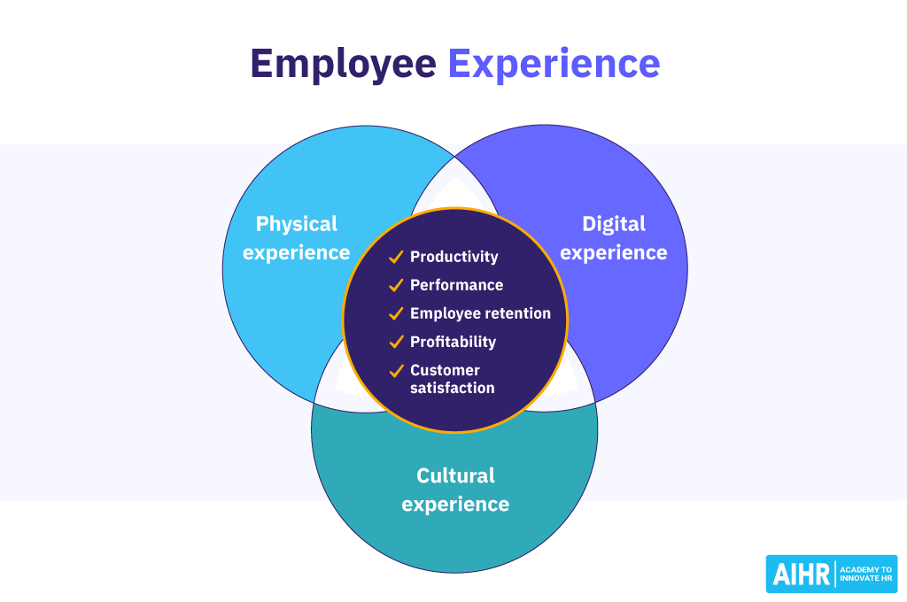
Figure 3: Employee Experience
Source: aihr.com
Finally, SHRM should be involved in the business to address skills and talent shortages.

Question-04: Global Readiness: A Reflection on My Capabilities for the Evolving Workplace

Analysing Strengths and Development Areas in an International and Digital Context:
Modern global workplaces demand cross-cultural skills and technological dynamism. My current talents, gained via academic work and recent experiences, give a sound foundation but also indicate areas where I need emphasis to properly adapt to the global job market. I reflect on my readiness in five areas: technology, communication, collaboration, leadership, and self-directed learning in my report.

1. Technology: Agility and digital literacy
My experience has demonstrated my exceptional ability to use digital tools and adapt to new technologies, a crucial skill in the world of the fourth industrial revolution (Schwab, 2016).
Strengths:
Strong computer abilities, rapid software and platform learning. As an example, this term I quickly incorporated new advanced data analysis tools (i.e., statistical software) and applied them to online marketing strategy analysis for my Tesco Plc research. Modern workplaces need digital solutions; therefore, adaptability is essential (Davenport, 2020).
Weaknesses:
My biggest problem is the lack of a bridge between my application expertise and a strategic grasp of emerging technologies like GenAI beyond their fundamental functions. I can utilise AI-based goods, but I'm still learning about ethics, data legislation, and large-scale business model disruption. This vulnerability is concerning as businesses prioritise responsible technology usage (Manyika et al., 2023).
Leveraging and Addressing:
I will direct my technical upskilling process to leverage my strength in quickly adopting tools by prioritising the strategic context of emerging technologies. My weaknesses will be addressed by taking an online AI Ethics and Governance course that is accredited and offered by a recognised provider during the term.
2. Communication: Sensibility and Cultural Subtlety
In a world environment, communication is not only a matter of language skill but also the level of cultural intelligence (CQ) to overcome various norms and expectations.

Strengths:
I communicate clearly, concisely, and in a structured manner; feedback on my academic reports has consistently been high, with the most recent report focusing on my project about consumer engagement in the UK retail sector dated July 10, 2025.
Weaknesses:
My biggest weakness is high-stakes spontaneous cross-cultural oral discussions. I'm pleasant and typically successful, but my previous group project with three distinct cultures demonstrated that I'm more reserved, which might be deemed passive in some corporate cultures (Meyer, 2014).
Leveraging and Addressing:
I will use my strength of effective written communication to develop preparation materials and proposals for internal and external stakeholders. To address my weakness, I will actively participate in simulated international business negotiations or debate clubs this semester, specifically focussing on altering my communication style to be more direct and culturally appropriate based on the situation, as recommended by cross-cultural management literature (Meyer, 2014).
3. Teamwork: Diversity Collaboration
Virtual, multidisciplinary, and multinational workgroups characterise the contemporary work environment. My effectiveness is related to my ability to contribute value and manage conflict within these diverse structures.
Strengths:
I value teamwork and encourage varied teamwork. My most recent project, which studied the global retail market, showed this because I actively sought and included the input of team members with diverse expertise, resulting in a more comprehensive and well-rounded final product.

Weaknesses:
My weakness has been that I tend to over depend on process structure at times when the team's needs require agile and ad hoc decision-making. In one fast-turnaround case study recently, I took an excessive amount of time to set the ground rules in detail, which made the first progress slow a bit. Global markets can be very demanding in terms of quick thinking and contented vagueness (Hofstede et al., 2010),
Leveraging and Addressing:
My strength of inclusiveness will remain to be used effectively whereby all voices are heard in my future team activities. To meet the requirements of being more agile, I will engage in the active application of a minimum viable structure strategy in my future collaborative project and establish only the most necessary boundaries and knowingly hand the first step over to a more malleable strategy.
4. Leadership: Vision and Influence
The globalised context is changing its leadership style to a more servant and transformational style, which is more inspiring and empowering to diverse teams (Northouse, 2021).
Strengths:
I thrive at data-driven decision-making and evidence-based leadership. When my group was at a crossroads on how to interpret market data for my emphasis, the retail industry. This fact-based technique helped the team reach a decision based on empirical data, which is the kind of intellectual leadership valued in knowledge-driven international firms (Davenport, 2020).
Weaknesses:
Charismatic and motivational leadership is my greatest weakness as a leader. Although I can drive with reason, I am not always capable of creating enthusiasm or motivating a team when morale is low or a radical shift in direction is needed.

Leveraging and Addressing:
I will still use my strength of analysis to bring out clarity and direction in difficult situations. To overcome my weakness, I will aim to enhance my emotional intelligence skills. Particularly, I will perform the role of a mentor to junior students, which will involve motivational and empathic guidance and small-win celebrations to implement the relational dimension of being a leader (Northouse, 2021).
Conclusion
In conclusion, I am highly equipped to adapt to the contemporary labour market with core strengths of digital agility and evidence-based and analytical leadership. To be fully prepared, though, it takes a strategic approach to overcome the weaknesses in the cross-cultural negotiation, teamwork that is agile, and inspirational leadership. My determination to ensure continuous, self-guided growth will make sure that I cease being an able professional and would become a very versatile and outstanding member of the globalised workplace.

Reference
Al-Tikriti, S. A. & Fadel, A. (2025). Digital Transformation in HR How Technology is Shaping the Future of Global Workforce Management. Journal of Global Human Resource Management. [Source: https://openjournalshub.com/index.php/JOGHRM/article/view/9]
Budhwar, P., Malik, A., & Varma, A. (2022). Humanizing AI in HRM: An agenda for research and practice. Human Resource Management Review, 32(4), 100881. Source:https://publications.aston.ac.uk/id/eprint/44576/1/Malik_Budhwar_Kazmi_HRM_Review_AAM_AI_Assisted_Human_Resource_Management.pdf
Chowdhury, S. K., Rahman, S., & Jahan, S. (2023). Transformative AI in human resource management: enhancing workforce planning with topic modeling. Cogent Business & Management. [Source: https://www.tandfonline.com/doi/full/10.1080/23311975.2024.2432550]
CIPD. (2024). Technology and the Future of Work. [Source: https://www.cipd.org/en/knowledge/factsheets/emerging-future-work-factsheet/]
Dutta, S. & Lanvin, B. (2020). The Global Information Technology Report 2020: The Digital Divide and the Future of Work. Cornell University, INSEAD, and WIPO. Source: https://www.insead.edu/sites/default/files/assets/dept/globalindices/docs/GII-2020-report.pdf
Gupta, A. & Mishra, D. K. (2022). Decoding AI-powered HR: Opportunities and challenges for the future of work. Journal of Business Research, 144, 562-574. Source:https://www.researchgate.net/publication/385655140_Artificial_intelligence_in_the_workplace_challenges_opportunities_and_HRM_framework_a_critical_review_and_research_agenda_for_change
International Labour Organization (ILO). (2021). World Employment and Social Outlook: The Role of Digital Labour Platforms. ILO. Source: https://www.ilo.org/sites/default/files/wcmsp5/groups/public/@dgreports/@dcomm/@publ/documents/publication/wcms_771749.pdf
International Monetary Fund (IMF). (2024). AI Will Transform the Global Economy. Let's Make Sure It Benefits Humanity. [Source: https://www.imf.org/en/Blogs/Articles/2024/01/14/ai-will-transform-the-global-economy-lets-make-sure-it-benefits-humanity]
Noe, R. A., Hollenbeck, J. R., Gerhart, B., & Wright, P. M. (2020). Human Resource Management: Gaining a Competitive Advantage. McGraw-Hill Education.
Pazzanese, C. (2020). Ethical Concerns Mount as AI takes Bigger Decision-Making Role in More Industries. The Harvard Gazette. [Source: https://news.harvard.edu/gazette/story/2020/10/ethical-concerns-mount-as-ai-takes-bigger-decision-making-role-in-more-industries/]
Smith, J. & Johnson, D. (2024). Mitigating algorithmic bias in HR: A framework for fair and transparent systems. Journal of Human Resource Management. Available at: https://www.researchgate.net/publication/392106375_Addressing_Algorithmic_Bias_in_AI-Driven_HRM_Systems_Implications_for_Strategic_HRM_Effectiveness
Atlas HXM. (2025). Top 3 Global Workforce Challenges in 2025. [Online]. Available at: https://www.atlashxm.com/resources/global-workforce-challenges-hr-leaders-2025
Belvedere Meridionale. (2024). The impact of demographic changes on HR processes: a highlight on workplace learning, upskill and reskill in the context of the future or work. Belvedere Meridionale, 36(1):91-101. [Online]. Available at: https://www.researchgate.net/publication/382836620_The_impact_of_demographic_changes_on_HR_processes_a_highlight_on_workplace_learning_upskill_and_reskill_in_the_context_of_the_future_or_work
Britchenko, I., Vyshnevskyi, O., & Vlasenko, S. (2024). Analysis of Funding for HRM and Its Relationship with Brain Drain in Greece from 2020 to 2024. Administrative Sciences, 14(6), 205. [Online]. Available at: https://www.mdpi.com/2076-3387/15/6/205
International Bar Association (IBA). (2025). Global war, global trade: an IBA Global Employment Institute perspective. [Online]. Available at: https://www.ibanet.org/New-insight-report-Global-war-global-trade-an-IBA-Global-Employment-Institute-perspective
International Labour Organization (ILO). (2025). World employment and social outlook trends 2025. [Online]. Available at: https://www.ilo.org/sites/default/files/2025-01/WESO25_Trends_Report_EN.pdf
IIARD. (2024). International Human Resource Management Trends, Future Challenges & Solution. International Journal of Business and Economic Administration, 10(1): 48-56. [Online]. Available at: https://iiardjournals.org/get/JBAE/VOL.%2010%20NO.%201%202024/International%20Human%20Resource%2048-56.pdf
Ius Laboris. (2025). Geopolitical disruption and the future of work: what does this mean for employers?. [Online]. Available at: https://iuslaboris.com/insights/geopolitical-disruption-and-the-future-of-work-what-does-this-mean-for-employers/
ManpowerGroup. (2024). Global Talent Shortage study. [Internal Research Referenced in Recruitee].
Saleem, Q. (2024). Human Resource Management: Emerging Trends, Challenges and Global Practices. [Online]. Available at: https://www.researchgate.net/publication/382530086_Human_Resource_Management_Emerging_Trends_Challenges_and_Global_Practices
World Economic Forum. (2025). The Future of Jobs Report 2025. [Online]. Available at: https://www.weforum.org/publications/the-future-of-jobs-report-2025/in-full/introduction-the-global-labour-market-landscape-in-2025/
CIPD. (2024). Resourcing and Talent Planning Report 2024. Chartered Institute of Personnel and Development. Available at: https://www.cipd.org/globalassets/media/knowledge/knowledge-hub/reports/2024-pdfs/8662-resource-and-talent-planning-2024-report-web.pdf
Li, S. (2022). Upskilling and Reskilling in a Rapidly Changing Job Market: Strategies for Organizations to Maintain Workforce Agility and Adaptability. European Journal of Business and Management Research, 7(6). Available at: https://www.ejbmr.org/index.php/ejbmr/article/view/2502
Martínez-Peláez, R., Huesca, J., & Almazán, S. P. (2023). Traditional to digital: human resource management transformation. Journal of Work, Automation and Migration.
MDPI. (2024). Talent Management Practices and Employee Retention: Does It Make a Difference? Journal of Human Resource Management, 4(4), 32. Available at: https://www.mdpi.com/2673-8104/4/4/32
People Element. (2024). How HR Can Respond to the Labor Shortage: Strategies for Talent Acquisition and Retention. Available at: https://peopleelement.com/blog/hr-respond-labor-shortage/
Rasch, A. K., & Middelbeck, T. (2021). Enhancing employee engagement in times of digital transformation: A conceptual framework. International Journal of Digital Culture and Electronic Tourism, 3(2).
ResearchGate. (2025). Talent Management: Strategies for Attracting and Retaining Generation Z. International Journal of Organizational Analysis. Available at: https://www.researchgate.net/publication/389048749_Talent_Management_Strategies_for_Attracting_and_Retaining_Generation_Z
SHRM. (2024). Bridging the Skills Gap: Preparing Future Talent for the Workforce. Society for Human Resource Management. Available at: https://www.shrm.org/enterprise-solutions/insights/bridging-the-skills-gap--preparing-future-talent-for-the-workfor
Thompson, R., & Walters, J. (2021). Strategies for employee retention in high turnover sectors: An empirical investigation. International Journal of Research in Human Resource Management, 6(1), 33-38. Available at: https://www.humanresourcejournal.com/archives/2024/vol6issue1/PartA/6-1-13-579.pdf
Unterhofer, A., & Wunsch, J. (2022). Human-machine skill complementarity in the digital transformation: a literature review. Journal of Business Economics, 92(5).
Davenport, T. H. (2020). The AI Advantage: How to Think Strategically About the Age of Artificial Intelligence. MIT Press.
Hofstede, G., Hofstede, G. J., & Minkov, M. (2010). Cultures and Organizations: Software of the Mind (3rd ed.). McGraw-Hill.
Manyika, J., Chui, M., Miremadi, M., Bisson, P., Woetzel, J., Klemens, S., Edmonson, S., & Mefford, B. (2023). A New Look at the Future of Work. McKinsey Global Institute. Available at: https://www.mckinsey.com/featured-insights/future-of-work/a-new-look-at-the-future-of-work

