Equifax Data Breach Cybersecurity Programme Design
A Structured Security Governance and Risk Mitigation Approach Using Zero Trust Architecture and NIST Cybersecurity Framework

Author
Student Name: [sana Quyyam]
Student ID: [2312087]
Module Title: Cybersecurity Architecture & Risk Management
Module Code: [ACCA5034]

Table of Contents
TASK 1: Zero Trust Architecture & Modern Cybersecurity Compliance 4
1. INTRODUCTION 4
2. BACKGROUND OF CYBERSECURITY THREATS 5
3. ZERO TRUST ARCHITECTURE 6
4. PRINCIPLES OF ZERO TRUST (NIST BASED) 6
5. ZERO TRUST FRAMEWORK ARCHITECTURE 7
6. SECURITY TECHNOLOGIES USED IN ZTA 8
7. SECURITY ARCHITECTURE ECOSYSTEM 9
8. COMPARISON: TRADITIONAL VS ZERO TRUST 10
9. BENEFITS OF ZERO TRUST 11
10. CHALLENGES OF IMPLEMENTATION 12
11. SECURITY OPERATIONS TOOLS ECOSYSTEM 12
12. INCIDENT RESPONSE + DATA PROTECTION MODEL 12
13. RISK MANAGEMENT & THREAT ANALYSIS 13
14. DISCUSSION (CRITICAL EVALUATION) 13
15. CONCLUSION 14
References 15

Abstract
Cybercrime is now one of the greatest threats to global security and the industry recently released estimated cost figures that will increase greatly in the coming years. This growing volume of cyber-attacks is a testament to the weaknesses of perimeter-based security models that rely on implicit trust within the organisation's network, and that do not provide for today's distributed and cloud-based networks. This has resulted in organisations facing increased data breach, unauthorised access and extended dwell time by an attacker. To overcome these drawbacks, Zero Trust Architecture (ZTA) has become a new cybersecurity model based on the “never trust, always verify” principle. It provides round-the-clock authentication, access control, and device and user monitoring, no matter where they are. This paper provides a critical assessment of the core principles of ZTA, the enabling technologies, implementation hurdles and how ZTA can support an organisation's resilience to emerging cyber threats.

TASK 1: Zero Trust Architecture & Modern Cybersecurity Compliance

1. INTRODUCTION
The digital transformation process has dramatically changed the way organisations operate today, fueled by the widespread adoption of Cloud Computing, hybrid infrastructures and remote working policies/structures. All these developments have introduced a huge attack surface and made it more complex to secure data and systems in distributed networks (Saeed et al., 2023). Organisations are increasingly becoming cyber connected and so are cyber threats increasing in size and sophistication. This is a big challenge as reflected in the global cybercrime trend data showing that cybercrime attack costs have been increasing exponentially over time. As the trend continues, the traditional security methods are not enough to cope with new threats. In these dynamic cloud and hybrid environments, the traditional perimeter-based security models, based on trusted internal networks and external firewalls, are no longer effective. These models are very old and do not stop the lateral movement of an attacker after gaining access and are not able to prevent insider threats (Ali et al., 2025). So, it is crucial to transition to a continuous verification, identity-centric approach to security that does not rely on any implicit trust in the network.
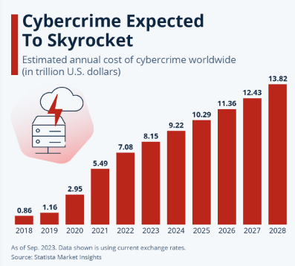
Figure 1: Cybercrime Expected to Skyrocket graph (Fleck, 2024)
This cybercrime trend illustrates the extent of the rising cybersecurity threats worldwide, and the estimated cost is rising from around $0.86 trillion in 2018 up to more than $13 trillion by 2028 (Fleck, 2024). The significant increase in size reflects how cyber threats are increasing in both number and depth and how they are causing financial harm as the cloud service, remote work and interconnected digital ecosystem continues to expand. The projected rise in the cost of cybercrime should not be seen as merely representing a rise in the number of cybercrimes, however, but also the sophistication and complexity of the attacks, such as ransomware, supply chain attacks and identity based attacks.

2. BACKGROUND OF CYBERSECURITY THREATS
Over the last several years, the cyber threat has grown more intricate and more comprehensive, given the rapid evolution of the world, its digital transformation and the increasing number of interconnected systems. The worldwide economic damage of cybercrime is significant and is expected to grow significantly in the next decade as cybercrime becomes a multi-trillion-dollar industry (Magazine & Magazine, 2024). The growth indicates that cyberattacks are not only happening more often, but are also deeper in impact to the money.
These threats are becoming more sophisticated and organisations must take a proactive and intelligence based approach to security, rather than a reactive approach. The nature of cyber risks is constantly changing and the usual measures of defense are simply no longer adequate to reduce those risks, to become cyber resilient more complex frameworks and constant monitoring are needed.
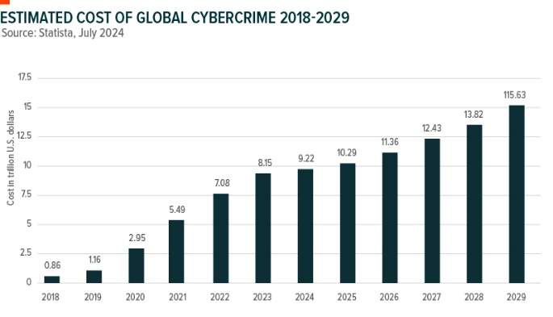
Figure 2: Cybercrime Growth Chart (2018–2029) (X, and X, 2025)
The impact of cybercrime on the global economy is becoming more significant as cybercrime costs are projected to increase by 15% annually. These costs are expected to increase from around $0.86 trillion in 2018 to more than $115 trillion by 2029, highlighting cybercrime as a significant economic threat, and not just a technical security concern (Magazine & Magazine, 2024). This is a massive surge of reliance on digital platforms, cloud-based systems and connected networks within organisations, giving hackers more avenues to exploit vulnerabilities. The financial implications are not confined to monetary damages, though, as organisations face further operational downtime, regulatory fines and penalties, recovery costs and reputational damage after cyber incidents. The economic impacts can have a significant impact on customer trust and the sustainability of businesses, especially those with sensitive data. This means that traditional cybersecurity defenses are not enough, and proactive security strategies are necessary to ensure ongoing monitoring, early detection, and enhanced threat prevention (George et al., 2024).

3. ZERO TRUST ARCHITECTURE
Zero Trust Architecture (ZTA) is an emerging cybersecurity approach that dictates that there is no implicit trust in organisation networks. It runs on an Identity-based Security model where each user, device and application need to be continuously authenticated before permitting access. Unlike perimeter-based security, ZTA is based on the premise that threats may lurk both within the network and on its perimeter, and must be verified at all access points (Kerman, 2025). One of the unique aspects of ZTA is continuous authentication, which requires access to be granted only when it meets the required standards of user behaviour, device health and context-based risk (Palo Alto Networks, 2020). All accesses are verified as they occur, so there is no implicit trust conveyed to users and systems on the internal network. This helps to limit the possibilities of lateral movement of competitors and increases the general level of resilience of the organisation. ZTA offers thus a proactive security model, which is suitable for today's cloud and hybrid environments (Lindemulder & Kosinski, 2024).

4. PRINCIPLES OF ZERO TRUST (NIST BASED)
The Zero Trust model is based on specific principles that NIST has established to help secure its implementation in today's organisations. The first way is that all resources are treated equally, which means that every system, device and application is a potential source of threats. Secondly, by applying continuous monitoring, all activities are constantly analysed for abnormalities and suspicious activities (NIST CSF, 2017).
Thirdly, least privilege access is enforced, and users have access only to what they need to do their job. Fourth, authentication is not permanent but is done periodically instead they have to be reauthenticated. Last but not least, dynamic policy enforcement allows for access decisions at runtime, based on the identity of the user, security posture of his or her device, and contextual risk factors. These principles are all interlinked and together provide the guarantee that trust is never taken for granted, but is always established.

5. ZERO TRUST FRAMEWORK ARCHITECTURE
A multi-layered approach to cybersecurity, Zero Trust Architecture (ZTA) is designed to break the implicit trust between users, devices, applications and data by constantly validating all of these. While traditional security generally relies on trust after users get inside the network boundary, Zero Trust secures both inside and outside the network. Hence, all access requests should be authenticated, authorised and continually assessed before access is granted (Reddy, 2025).

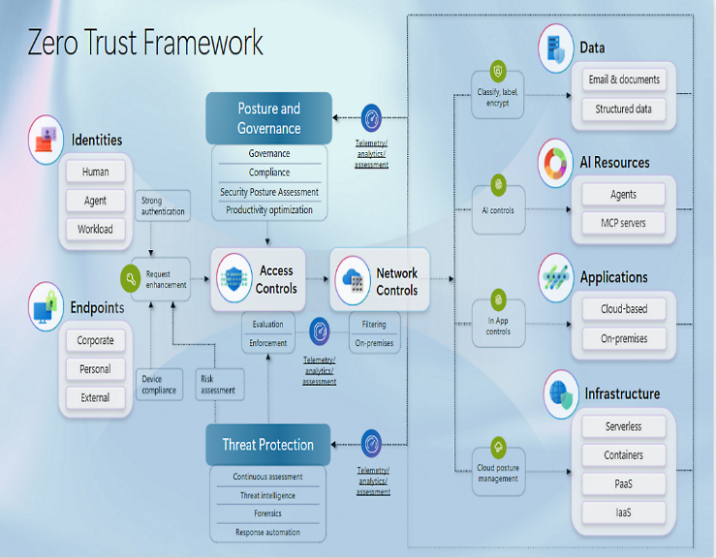
Figure 3: Zero Trust Framework Diagram (Microsoft, 2025).

Identity Layer
The identity layer is the starting point of the Zero Trust experience, as it starts with the question of what or who is trying to access. This layer manages identities, devices and workloads using authentication methods, including multi-factor authentication (MFA) and identity-based access controls. By continuously verifying identity, the risk of an attacked account being used is minimised (Ren et al., 2025).

Access Control Layer
The access control layer implements the principle of least privilege where users are only given what is necessary to complete their respective jobs. In contrast to traditional network policies that give all users access, Zero Trust is based on dynamic policies that take into account user identity, device health, location and risk score before making an access decision (Reddy, 2025).

Network Control and Segmentation Layer
The network control layer enhances the security by segmenting infrastructure into smaller protected segments. This allows attackers to only move laterally within systems once they have achieved initial access. By dividing the network into smaller segments, micro-segmentation can help to contain the effects of security breaches, and it can also help to reduce the amount of unnecessary communication that occurs between different areas of the network (Ren et al., 2025).

Application Security Layer
Application security layer ensures continuous monitoring and secure access to software services, APIs and cloud-based applications. This keeps applications safe from being accessed by anyone unauthorised in the business and throughout their functionality lifespan (Yeoh et al., 2023).

Data Protection Layer
The data protection layer is concerned with data protection for the organisation via classification and encryption as well as controlled access policies. Security of data is maintained while it is at rest and in transit, even if other security layers are breached (Ajish, 2024).

Threat Protection and Continuous Monitoring Layer
The threat protection layer offers continuous threat assessment by monitoring, threat intelligence and automated detection solutions. With continuous analysis on the other hand, organisations can detect suspicious activities in a speedy manner and act on time to prevent any serious damage from done by attackers (Song, 2024). In sum, Zero Trust offers a comprehensive security environment, with every component working towards minimising attack opportunities, minimising breach impacts, and enhancing organisational resiliency. The success of ZTA is dependent on the successful combination of these security blocks instead of on a single type of defense (Yeoh et al., 2023).

6. SECURITY TECHNOLOGIES USED IN ZTA
Zero Trust Architecture (ZTA) is the result of combining multiple security technologies to ensure continuous verification, minimise attack surface and reduce the dwell time of threats. These technologies together put the trust of any user, device or system on equal footing, and every access request must be authenticated on the fly (Lindemulder & Kosinski, 2024). In access management systems, one of the most important identity security controls is Multi-Factor Authentication which is an authentication technique that requires more steps for users to access content, such as entering a password, one-time code or user biometrics. This minimises the chances of credential theft and unauthorised access in cloud and hybrid environments. In contrast to breaches by Equifax, which use weak authentication to gain access to stolen credentials, MFA is another authentication method that provides an additional level of security to verify access before granting access (Microsoft, 2026).
SIEM systems gather, analyse and correlate security logs in real time from various sources. This enables organisations to detect any suspicious activity, anomalies and threats across the entire infrastructure. In a Zero Trust environment, SIEM becomes crucial for continuous monitoring and quick detection of malicious activities. It assists with reducing the time it takes to detect incidents and improves visibility into incidents in distributed systems (IBM, 2023). SOAR platforms help to automate incident response tasks by embedding security tools and workflows.
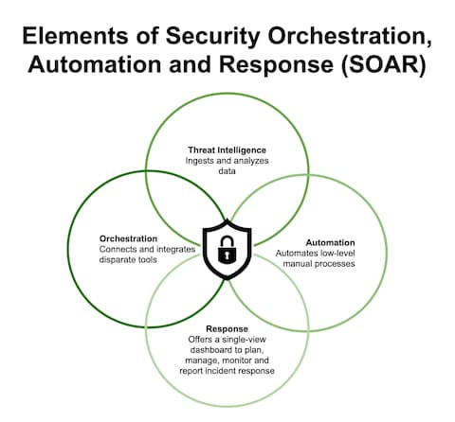
Figure 4: SOAR Architecture Diagram (Palo Alto Networks. 2020)
The SOAR provides for increased efficiency as it decreases the amount of manual actions required and the delay in responding to the attacker, which is important in preventing extended access. EDR solutions continuously monitor endpoint devices like mobile systems, laptops, and servers. They identify suspicious behaviour, abnormal behaviour patterns and APTs.
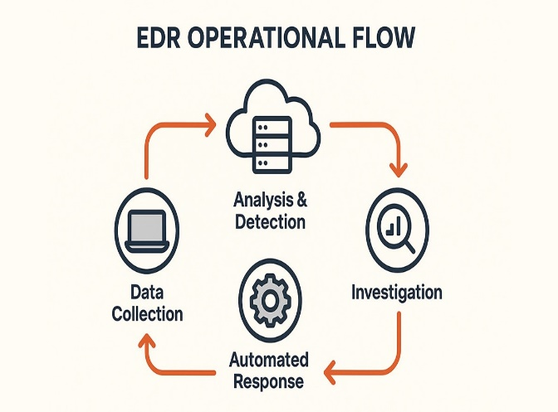
Figure 5: EDR Operational Flow Diagram (Palo Alto Networks, 2020).
Lateral movement and insider threats are prevalent in large-scale breaches such as Equifax, and are a critical part of EDR's ability to detect them. It helps to quickly contain and investigate the problem, minimising organisational impact (IBM, 2022). When used in conjunction, MFA, SIEM, SOAR and EDR form a multi-layer defense system and a robust framework to implement Zero Trust, providing continuous authentication, real-time monitoring, automated response and endpoint protection.

7. SECURITY ARCHITECTURE ECOSYSTEM
Cybersecurity ecosystems are becoming more complex and are now incorporating and integrating new technologies, including cloud computing, artificial intelligence (AI) and Internet of Things (IoT) (Aslam and Rasheed, 2023). They are key components to facilitating continuous monitoring, intelligent threat detection, and adaptive security responses in Zero Trust systems, while maintaining security across distributed systems. Today's digital operations rely on cloud-based infrastructure, which offers scalable data storage and access options. But it also brings risks of security like misconfiguration, unauthorised access and leakage of data. To tackle these issues, Zero Trust concepts are instrumental in setting up robust identity verification and continuous authentication mechanisms in cloud settings (Sinan et al., 2025).
AI analytics offers a number of advantages in cybersecurity, one of which is predictive threat detection and behavioural analysis. AI systems can detect anomalies as they occur, which can help to speed up response times and minimise human reliance (Mohamed, 2025). If not secured, AI systems, however, may be a target of adversarial attacks. IoT devices are a lot more vulnerable to attack, resulting in a large attack surface due to weak security configurations and low processing power. Smart devices such as sensors and monitoring equipment, that are interconnected, have enabled increased efficiency in healthcare and smart spaces, but also increased vulnerability to attack. There are various threats to smart healthcare systems and connected infrastructures, such as data breaches, device manipulation, and service disruption.
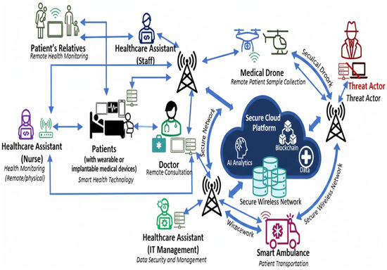
Figure 6: Architecture of the healthcare systems (Qureshi and Koo, 2026)
In healthcare environments, connected medical devices, cloud platforms and AI analytics increase operational efficiency but also create new attack surfaces requiring Zero Trust controls.

8. COMPARISON: TRADITIONAL VS ZERO TRUST
Traditional security models are based on perimeter and trust since internal networks are safe. Unlike Zero Trust, there is no implicit trust and continuous identity verification is in place, limiting lateral movement and the ability to control threats (Wells et al., 2020).

Feature Area | Traditional Security Model | Zero Trust Architecture (ZTA)
Trust Model | Assumes internal network users are trusted once inside the perimeter. | Assumes no implicit trust, every user and device must be verified continuously.
Access Control Approach | Access granted after initial login, with broad internal access. | Access granted based on identity, device health, and contextual risk for each session.
Network Security Design | Perimeter-based (firewalls protect internal network boundary). | Identity-centric and micro-segmented network structure.
Monitoring Capability | Limited monitoring after access is granted. | Continuous real-time monitoring of all activities and behaviours.
Attack Movement Risk | High risk of lateral movement once attacker enters network. | Lateral movement is restricted through segmentation and strict policies.
Authentication Method | One-time authentication at login stage. | Continuous authentication throughout session lifecycle.
Suitability for Modern Systems | Poor suitability for cloud, IoT, and remote environments. | Highly suitable for cloud, hybrid, and distributed systems.
Incident Response Efficiency | Slow detection and response due to limited visibility. | Faster detection and automated response using integrated security tools.

The comparison clearly demonstrates that traditional perimeter-based security policies are no longer adequate for the digital world as they are based on implicit trust upon the successful authentication. This method has many dangers especially lateral movement (when an attacker gets into one account and is able to use it to gain access to others). However, Zero Trust Architecture is a more adaptive type of security that always verifies identities, always adheres to least-privilege access, and continuously monitors user activities during the session (Wells et al., 2020). ZTA is more effective in cloud, hybrid and remote deployment, but costs more, demands more technology and organisation maturity. Thus, organisations should take steps to gradually move from traditional approaches to Zero Trust to ensure a high level of resilience while being able to deal with the challenges of implementation.

9. BENEFITS OF ZERO TRUST
The following are some of the major advantages of Zero Trust Architecture, which contribute to the strengthening of organisations' cybersecurity resilience (Karamchand, 2022). This has several benefits, one of the main ones being the minimum footprint affected by security breaches as access control and constant verification keeps attackers confined to the network. This means that in case of a breach, it will be effectively contained. Additionally, Zero Trust helps to enhance regulatory compliance, especially in relation to standards like GDPR or NIST, which are known for their stringent standards on data protection and identity verification (Ajish, 2024). Moreover, Zero Trust can enable secure remote working scenarios, allowing users to access resources in an organisation securely from any location without jeopardising security. It also drastically reduces attack surface by removing the implicit trust and implementing, least privilege, for all users and devices.

References
- ‌ Karamchand, G. (2022). ZERO TRUST SECURITY ARCHITECTURE: A PARADIGM SHIFT IN CYBERSECURITY FOR THE DIGITAL AGE. INTERNATIONAL JOURNAL OF CYBER SECURITY, 1(2), pp.1–20. https://www.researchgate.net/publication/392562723_ZERO_TRUST_SECURITY_ARCHITECTURE_A_PARADIGM_SHIFT_IN_CYBERSECURITY_FOR_THE_DIGITAL_AGE.
- ‌ Mohamed, N. (2025) 'Artificial intelligence and machine learning in cybersecurity: a deep dive into state-of-the-art techniques and future paradigms,' Knowledge and Information Systems, 67(8), pp. 6969–7055. https://doi.org/10.1007/s10115-025-02429-y.
- ‌ Sunkara, G. (2024) 'THE IMPORTANCE OF NETWORK SEGMENTATION IN SECURITY,' Zenodo (CERN European Organization for Nuclear Research) [Preprint]. https://doi.org/10.5281/zenodo.15792900.
- Ajish, D. (2024) 'The significance of artificial intelligence in zero trust technologies: a comprehensive review,' Journal of Electrical Systems and Information Technology, 11(1). https://doi.org/10.1186/s43067-024-00155-z.
- Ali, S. et al. (2025) 'Security and privacy in multi-cloud and hybrid cloud environments: Challenges, strategies, and future directions,' Computers & Security, 157, p. 104599. https://doi.org/10.1016/j.cose.2025.104599.
- Aslam, R. and Rasheed, H. (2023). Integrating AI, Cloud Computing, and IoT for Robust Cybersecurity Ecosystems and Adaptive Threat Mitigation. ResearchGate. [online] https://www.researchgate.net/publication/384052326_Integrating_AI_Cloud_Computing_and_IoT_for_Robust_Cybersecurity_Ecosystems_and_Adaptive_Threat_Mitigation.
- Cyber, M. (2026) 'Data Breach Protection | Guide to Preventing, Detecting, and Recovering from Breaches,' DeXpose, 24 May. https://www.dexpose.io/data-breach-protection/.
- Fleck, A. (2024) 'Cybercrime expected to skyrocket in coming years,' Statista Daily Data, 22 February. https://www.statista.com/chart/28878/expected-cost-of-cybercrime-until-2027/?srsltid=AfmBOopL6vyEc0wX_CPkC8bqvcIcr3jMXaLTBMtG22LnkY7eCDno3X4i.
- Folorunso, A. et al. (2024) 'Security compliance and its implication for cybersecurity,' World Journal of Advanced Research and Reviews, 24(1), pp. 2105–2121. https://doi.org/10.30574/wjarr.2024.24.1.3170.
- George, Dr.A.S., Dr.T.Baskar and Srikaanth, Dr.P.B. (2024) 'Cyber Threats to critical Infrastructure: Assessing vulnerabilities across key sectors,' Zenodo (CERN European Organization for Nuclear Research) [Preprint]. https://doi.org/10.5281/zenodo.10639463.
- ‌IBM (2022). Patch management. [online] Ibm.com. Available at: https://www.ibm.com/think/topics/patch-management [Accessed 3 July 2026].
- Kerman, A. (2025) Zero Trust Cybersecurity: ‘Never trust, always verify.’ https://www.nist.gov/blogs/taking-measure/zero-trust-cybersecurity-never-trust-always-verify.
- Kuppuraju, S.Y., Moharir, C. and Baniya, V. (2025) 'Patch management automation for vulnerability mitigation of the Creative Commons Attribution License (CC...,' ResearchGate [Preprint]. https://www.researchgate.net/publication/392168652_Patch_Management_Automation_for_Vulnerability_Mitigation_of_the_Creative_Commons_Attribution_License_CC_BY_40.
- Lindemulder, G. and Kosinski, M. (2024). Zero Trust. [online] Ibm.com. Available at: https://www.ibm.com/think/topics/zero-trust [Accessed 3 July 2026].
- Lund, B.D., Lee, T.-H., Wang, Z., Wang, T. and Mannuru, N.R. (2024). Zero Trust Cybersecurity: Procedures and Considerations in Context. Encyclopedia, [online] 4(4), pp.1520–1533. https://doi.org/10.3390/encyclopedia4040099.
- Magazine, C. and Magazine, C. (2024) Cybercrime to cost the world $10.5 trillion annually by 2025. https://cybersecurityventures.com/hackerpocalypse-cybercrime-report-2016/.
- Microsoft. (2026). What Is Security Operations (SecOps)? | Microsoft Security. [online] Available at: https://www.microsoft.com/en-us/security/business/security-101/what-is-security-operations-secops [Accessed 3 July 2026].
- Microsoft.com. (2025). Zero Trust Security and Strategy | Microsoft Security. [online] Available at: https://www.microsoft.com/en-us/security/business/zero-trust#modal-21 [Accessed 3 July 2026].
- Ngema, N., Nleya, B. and Maswanganyi, R.C. (2026) 'A review of Zero Trust Architecture: Principles, applications, and implementation challenges in Communication, Navigation, and Surveillance (CNS) systems,' Sensors, 26(12), p. 3813. https://doi.org/10.3390/s26123813.

Task 2: Equifax Data Breach Cybersecurity Programme Design

1. INTRODUCTION
Equifax data breach has been one of the biggest and most notable cyber security incidents in recent years, with about 147 million people having had their data leaked (Equifax Data breach settlement, 2024). The exposure was found to be the result of the successful exploitation of a known vulnerability in the Apache Struts application library which was not patched in time, giving attackers extended access to the sensitive systems for an extended period without detection. This incident demonstrates poor cybersecurity governance practices, such as inadequate vulnerability management, delayed patching practices and inadequate monitoring controls (Thomas, 2019). At the governance level, the incident is a failure of both the technical and managerial aspects. A lack of effective oversight and poor accountability systems meant that many security alerts were ignored and a lot of data was exposed. In addition, the lack of coordination between security teams and executive leadership led to slower response times to incidents and a greater impact on the organisation (U.S. House Report, 2018).
This report aims to develop a structured cyber security programme to tackle the shortcomings that were found in the case of Equifax. It implements current security concepts like the NIST Cybersecurity Framework 2.0 and Zero Trust Architecture principles to increase resilience, enhance governance and minimise potential exposure to risk in the future (Njeri & Kumar, 2019).

2. ORGANISATIONAL STRUCTURE & ACCOUNTABILITY (Equifax Case Programme)

2.1 Proposed Security Governance Structure
Roots of the failures in the Equifax breach must be countered with a strong governance structure. On the highest level, the Board of Directors calls upon to provide strategic direction and assurance that the enterprise's cybersecurity strategy is aligned with enterprise risk goals. The CISO, reporting to the board, is responsible for the overall security governance, policy enforcement and risk communication across the organisation (Gale et al., 2022).
The Security Operations Centre (SOC) oversees all operational security, offering round-the-clock monitoring, threat detection and escalation. The Security Architecture team is responsible for ensuring the infrastructure is designed securely and adheres to Zero Trust principles.

2.2 Roles & Responsibilities
The proposed cybersecurity programme clearly defines roles and responsibilities for accountability and efficiency of operation. The CISO positions himself as the strategic leader who is responsible for the management of cyber security risks and is directly accountable to the Board of Directors thus having executive level visibility and accountability (Monzelo & Nunes, 2019). The SOC team's job is to continuously monitor, detect security threats in real time and escalate security incidents for timely response. DevSecOps development team makes security a part of the software development process, and it helps them spot and resolve vulnerabilities before the applications are released. This directly helps to tackle problems like unpatched software, which was a big mistake in the Equifax case. The Risk Committee is responsible for the governance, risk assessment and compliance with regulatory frameworks. These are combined to form a multi-layered security accountability structure which helps to proactively identify and address risks, respond quickly, and bolster organisational resilience (Caluwe et al., 2024).

2.3 Equifax Failure Analysis
The Equifax breach underscores some key governance, accountability and risk management shortcomings. The one big problem was there was no escalation to the board level, so that meant that the decisions on vulnerability patching were delayed. While the Apache Struts vulnerability is known, there is weak remediation timeline accountability within the organisation, as reflected in the poor enforcement of remediation timelines (Gale et al., 2022). Furthermore, Equifax's IT governance framework was also found to be insufficient for effectively managing IT security, with responsibilities for IT security being scattered and not clearly assigned. This enabled a window for an attack that could be missed or postponed, thus giving opponents more time to get in. Lack of good coordination among the technical teams and executive leadership also played a role in prolonged exposure of the system. The failures show the need for integrated governance and the need for cyber security risks to be actively monitored, escalated, and addressed in the top positions within the organisation (Caluwe et al., 2024).

3. POLICIES & PROCEDURES

3.1 Required Security Policies
Enforceable and measurable policies are essential to a strong cybersecurity programme to stop the next incident like the Equifax breach. All policies should be compliant with risk management, governance, and operational security rules and practices.

Patch Management Policy
The Patch Management Policy guarantees that all critical vulnerabilities are patched within a tight 48-72 hour Service Level Agreement (SLA). All systems should be patched using an automated patching tool to ensure that security patches are identified, tested and deployed. This policy tackles vulnerabilities head-on, like the Equifax breach, where attackers were able to access the system for an extended period of time due to the unpatched Apache Struts vulnerability (IBM, 2022).

Vulnerability Management Policy
This policy will have all internal and external systems scanned for vulnerabilities once a week using an automated tool. Any vulnerabilities identified should be classified as either critical, high, medium or low and should be escalated for remediation as quickly as possible.

Secure SDLC Policy
Secure Software Development Lifecycle (SDLC) policy is designed to have security integrated throughout the entire development lifecycle: design, coding, testing, and deployment. All code changes and security tests (SAST/DAST) must be done prior to release to production. This decreases the risk of introducing vulnerabilities in live systems (Holdsworth & Badman, 2025).

Data Protection Policy
This policy requires that sensitive data be encrypted while at rest and in transit and will guarantee the confidentiality and integrity of personal and financial information. Sensitive data should be accessed on a 'need to know' basis and should be monitored at all times in accordance with the requirements of (GDPR, 2018).

Asset Management Policy
Every organisation needs to have an up-to-date asset register of internet-facing assets, such as servers, applications like APIs, and cloud services. This will provide visibility of all attack surfaces, and ensure that unknown or unmanaged systems are not an entry point for attackers.

Policy Compliance & Metrics Table
Policy Area | Key Control | Performance Metric | Responsible Owner | Monitoring Method
Patch Management | Automated patch deployment | 72-hour SLA compliance for critical vulnerabilities | IT Operations Team | SIEM + Patch dashboard
Vulnerability Management | Weekly automated scanning | 95% vulnerability remediation within 7 days | Security Operations Centre (SOC) | Vulnerability scanner reports
Secure SDLC | Code review + security testing (SAST/DAST) | Zero critical vulnerabilities in production releases | DevSecOps Team | CI/CD pipeline security checks
Data Protection | Encryption at rest & in transit | 100% encrypted sensitive data assets | Data Security Team | Encryption audit logs
Asset Management | Full asset inventory tracking | 100% visibility of internet-facing systems | IT Asset Management Team | CMDB + discovery tools
The fact that the Apache Struts vulnerability was not patched shows that a patch management policy is not being enforced, which puts systems at risk for a longer period and gives unauthorised users more access to data.

4. GOVERNANCE & STRATEGIC ALIGNMENT

4.1 NIST Cybersecurity Framework 2.0 Alignment
The cybersecurity governance strategy to reduce risks like the one found in Equifax is organised around the NIST Cybersecurity Framework (CSF) 2.0, which is a risk-based framework for managing and improving cybersecurity resilience. This framework ensures consistency of security controls to business objectives, regulatory requirements and continuity of operations (NIST, 2017).

NIST CSF Mapping Model
Identify | This function is about the assets, risks and vulnerabilities of the organisation. In the Equifax case, not identifying and inventorying internet-facing systems was a factor in the use of the Apache Struts vulnerability.
Protect | This function is responsible for implementing safeguards like patch management, access control, encryption, and secure software development. It is a critical failure that the patching processes in Equifax are weak.
Detect | The responsibility of this function is to detect anomalies in real time and to continuously monitor and alarm anomalies with tools such as SIEM, real-time analytics. Equifax were unable to implement any effective monitoring to detect the attackers for months, allowing them to stay undetected.
Respond | This includes incident response planning, containment measures and communication strategies to limit damage. Equifax delayed response, causing data exposure, regulatory consequences.
Recover | This function provides for system restoration, business continuity and lessons learned integration. It is important to review the lessons learned from the previous years' recovery activities and how they have made an organisation more resilient, in order to minimise risk exposure in the coming years.

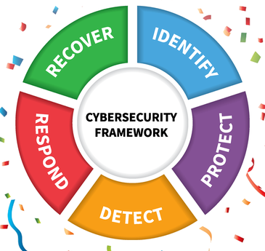
Figure 8: NIST CSF Mapping Model (Huergo, 2025)

4.2 Strategic Governance Alignment
The vision of cybersecurity governance needs to be aligned with the overall business goals to ensure that the business is resilient and stable over the long-term. Organisations can embed the NIST CSF into their enterprise governance processes, which will ensure that cybersecurity is a part of business continuity planning, and not a separate function. This alignment also fosters customer trust, which shows their dedication to data security and regulatory compliance (Yeoh et al., 2023). A risk-based governance model ensures that security investments are prioritised based on the impact of the business and the likelihood of the threat occurring which will allow resources to be allocated effectively and help to make good decisions (Barik et al., 2026).

5. RISK MANAGEMENT & ASSESSMENT

5.1 Key Risks Identified
To prevent incidents like this, it is essential that you have a proper risk management programme in place to prevent multiple unmanaged vulnerabilities from exposing huge amounts of data like in the case of Equifax (Kabanov and Madnick, 2021). The main risks listed in this cybersecurity programme are the internet exposure, lack of patch management, inappropriate network segmentation and third party exposure risks. The vulnerability in the Struts software that was exposed to the internet is a serious threat since it was publicly disclosed, but not fixed in time. Attackers actively capitalise on such vulnerabilities to be able to access the systems without authorisation. Likewise, a patch management gap raises an organisation's vulnerabilities due to the fact that critical security patches are left unapplied, which gives attackers more time to be able to breach systems (Admass et al., 2023). The second big threat is that of the weak network segmentation that lets attackers move laterally after gaining initial access. If it is not segmented, a single compromised system can result in data breaches throughout the entire system.

Risk Matrix Table
Risk Type | Likelihood | Impact | Risk Level | Description
Unpatched system vulnerability | High | Critical | Severe | Known Apache Struts flaw exploited due to delayed patching
Data breach exposure | High | Severe | Severe | Large-scale leakage of personal data (PII)
Weak network segmentation | Medium-High | High | High | Enables lateral movement across systems
Third-party risk exposure | Medium | High | High | External vendors increase attack surface

5.2 Risk Mitigation Strategy
Mitigation is done in layers to help minimise these risks. Automated patching systems guarantee critical vulnerabilities are addressed within specified timeframes, meaning that there are much smaller exposure windows (Kuppuraju, Moharir and Baniya, 2025). By implementing Zero Trust segmentation, which introduces micro-segmentation and strict identity verification throughout the network, even if an account is compromised, it cannot access anything without additional verification. With Zero Trust segmentation, there is a strict identity verification process and micro-segmentation applied across networks to prevent unauthorised lateral movement even if an account is compromised (Buck et al., 2021).
Furthermore, a continuous monitoring process with SIEM tools gives real time visibility of suspicious activities and it allows to detect suspicious activities before the escalation. By implementing an extra layer of authentication, Multi-Factor Authentication (MFA) enhances the security of your identities and helps prevent credential-related attacks and unauthorised access. The overall advantage of these combined controls is the adoption of a proactive approach to security, enhancing the resilience of organisations against sophisticated cyber-attacks (Nisamuddin, 2025).

6. COMPLIANCE, INCIDENT RESPONSE & CONTROLS

6.1 Regulatory Compliance
Regulatory compliance is a key aspect of cybersecurity governance, ensuring that organisations adhere to legal and industry regulations regarding data security and breach reporting. Organisations have to report personal data breaches under the General Data Protection Regulation (GDPR) within 72 hours of discovering an occurrence. This guarantees transparency, accountability and promptness in risk mitigation in the context of those whose data is being handled (GDPR, 2018). In Equifax's case, there was a significant delay in responding to the breach, which led to a failure in compliance, thus creating a greater number of regulations to be reviewed and a delayed notification. This indicates problems with legal compliance and internal escalation of incidents. Compliance systems must be monitored continuously, be ready for audit and have structured reporting. Organisations need to have robust governance controls to ensure that any breach is identified, evaluated and reported on in a timely fashion.

6.2 Incident Response Plan
An efficient Incident Response (IR) plan is critical to the effective management of a cybersecurity incident to minimise damage. The structured lifecycle consists of Preparation, Detection, Containment, Eradication and Recovery, providing a systematic approach to handling security incidents.
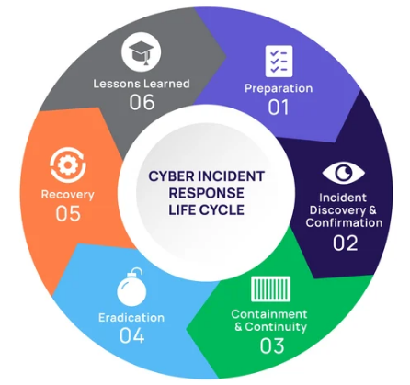
Figure 9: Incident Response Lifecycle (Inchi, 2025)
Preparation: Organisations develop policies, tools and training to prepare for any incidents that may occur. Detection is identifying malicious activity by using the monitoring systems like SIEM and EDR. If the attack is detected, containment measures are put in place to contain the attack and protect critical systems (IBM SOAR, 2023). One of the main priorities of eradication is to eliminate the source of the attack, which could be malware or a vulnerability.

6.3 Security Controls
To achieve Zero Trust principles and to minimise cyber risk exposure, a multi-layered security control framework is needed.
- SIEM (Security Information and Event Management) systems can gather real-time logs and analyse them to identify anomalies and suspicious activity early.
- SOAR (Security Orchestration, Automation and Response) automates parts of the incident response process,
- EDR (Endpoint Detection and Response) technologies constantly scan endpoint devices and are able to detect malicious activity quickly and identify advanced threats and lateral movement attempts.
- Multi-Factor Authentication (MFA) adds another layer of security to the identity, with users having to provide several authentication factors, thus making it more difficult for credentials to be compromised (Microsoft, 2026).
Last but not least, technologies for encrypting sensitive data, both at rest and in motion, will ensure that confidential data remains confidential and remains intact even in the event of a compromise of the systems. In combination these controls form a comprehensive security arena and facilitate proactive threat detection and quick response.

6.4 Impact Reduction Justification
The use of security technologies including SIEM, SOAR, and EDR have a significant role to play in helping to lessen the impact of cyberattacks and minimise damage to the organisations.
- SIEM systems can help you detect suspicious activity by aggregating and analysing security logs in real time, reducing detection time. This makes it easier to see what is going on in distributed systems and assists security teams in faster response.
- Automating the incident response workflows on SOAR platforms, they can allow immediate and automatic containment actions, such as isolating impacted systems or blocking malicious IP addresses, to be taken. This decreases the need for manual involvement and quickens the mitigation process (IBM SIEM, 2023).
- DRM solutions lower the dwell time of an attack by constantly monitoring for any malicious activity and behavioural anomalies on endpoints. This allows threats to be detected quickly that can evade traditional security measures.
- Furthermore, the successful rate of identity-based attack is lowered by MFA and even if data is accessed, it is still in scrambled form by encrypting it (Kaur et al., 2024).
In Equifax's case, the lack of automated detection and response systems meant that attackers were able to quietly access the data for more than two months, causing more data exposure and damage to the organisation. Together these tools help detect faster, respond quicker and impact the business minimally.

7. CONCLUSION
The Equifax data breach is a stark reminder of the importance of proper vulnerability management, governance controls, and timely application of patches to allow for long-standing unauthorised access and huge amounts of data exposure. This case shows how critical it is to have a structured and integrated cybersecurity programme in place to avoid similar issues in the future. A primary benefit of implementing Zero Trust Architecture and the NIST Cybersecurity Framework is the ability to continuously verify, make decisions based on risk and enhance threat detection.

References

- ‌Equifax Data breach settlement (2024). https://www.ftc.gov/enforcement/refunds/equifax-data-breach-settlement.
- Admass, W.S., Munaye, Y.Y. and Diro, A.A. (2023) 'Cyber security: State of the art, challenges and future directions,' Cyber Security and Applications, 2, p. 100031. https://doi.org/10.1016/j.csa.2023.100031.
- Barik, K., Misra, S., Fernandez-Sanz, L. and Chockalingam, S. (2026). Context-based and investment decision-making cyber resilient systems: an empirical approach. International Journal of Information Security, [online] 25(1). https://link.springer.com/article/10.1007/s10207-025-01196-9.
- Buck, C., Olenberger, C., Schweizer, A., Völter, F. and Eymann, T. (2021). Never trust, always verify: A multivocal literature review on current knowledge and research gaps of zero-trust. Computers & Security, [online] 110, p.102436. https://www.sciencedirect.com/science/article/abs/pii/S0167404821002601.
- Caluwe, L., Wilkin, C.L., Steven De Haes and Huygh, T. (2024). Board roles required for IT governance to become an integral component of corporate governance. International journal of accounting information systems, 54, pp.100694–100694. https://www.sciencedirect.com/science/article/pii/S1467089524000277.
- Gale, M., Bongiovanni, I. and Slapnicar, S. (2022) 'Governing cybersecurity from the boardroom: Challenges, drivers, and ways ahead,' Computers & Security, 121, p. 102840. https://doi.org/10.1016/j.cose.2022.102840.
- General Data Protection Regulation (GDPR). (2018). General Data Protection Regulation (GDPR) – Final text neatly arranged. [online] Available at: https://gdpr-info.eu/art-33-gdpr/ [Accessed 3 July 2026].
- Holdsworth, J. and Badman, A. (2025). Secure Software Development Life Cycle. [online] Ibm.com. Available at: https://www.ibm.com/think/topics/secure-software-development-life-cycle [Accessed 3 July 2026].
- IBM (2022). EDR. [online] Ibm.com. Available at: https://www.ibm.com/think/topics/edr [Accessed 3 July 2026].
- IBM (2023). Security Orchestration Automation Response. [online] Ibm.com. Available at: https://www.ibm.com/think/topics/security-orchestration-automation-response [Accessed 3 July 2026].
- ‌IBM (2023). SIEM. [online] Ibm.com. Available at: https://www.ibm.com/think/topics/siem [Accessed 3 July 2026].
- Kabanov, I. and Madnick, S. (2021) 'Applying the Lessons from the Equifax Cybersecurity Incident to Build a Better Defense,' MIS Quarterly Executive, pp. 109–125. https://doi.org/10.17705/2msqe.00044.
- Kaur, H. et al. (2024) 'Evolution of Endpoint Detection and Response (EDR) in Cyber Security: A Comprehensive review,' E3S Web of Conferences, 556, p. 01006. https://doi.org/10.1051/e3sconf/202455601006.
- Microsoft. (2026). What Is Multifactor Authentication (MFA)? | Microsoft Security. [online] Available at: https://www.microsoft.com/en-us/security/business/security-101/what-is-multifactor-authentication-mfa [Accessed 3 July 2026].
- ‌Monzelo, P. and Nunes, S. (2019) 'The role of the Chief Information Security Officer (CISO) in organizations,' ResearchGate [Preprint]. https://www.researchgate.net/publication/338833079_The_Role_of_the_Chief_Information_Security_Officer_CISO_in_Organizations.
- NIST. (2017). Compliance with Cybersecurity and Privacy Laws and Regulations | NIST. [online] Available at: https://www.nist.gov/mep/cybersecurity-resources-manufacturers/compliance-cybersecurity-and-privacy-laws-and-regulations [Accessed 3 July 2026].
- Njeri, G. and Kumar, A. (2019) 'A study on cyber security challenges in modern IT systems,' ResearchGate [Preprint]. https://www.researchgate.net/publication/403935965_A_Study_on_Cyber_Security_Challenges_in_Modern_IT_Systems.

