  DHL Supply chain Blogs | Student: Diana Stoyanova  Student number: 2007366  Module: Marketing Fundamentals  Module code: LCBB4004  Tutor’s name: Efua Adams

DHL Supply Chain is a company that offers multiple logistic services to make our customers satisfied. DHL Supply Chain is primarily competing in the strategic Life Sciences and Healthcare, Automotive and Technology. Our company has a strong market leader in the regions of North Amerika, Europe, Asia Pacific, Greater China, and the UK&I. DHL pays excellent attention to prices and tries to make its customers satisfied. In our products, the customer may take advantage of the standardized or specially designed option. The characteristics of good shipped and delivery lead time, are the most essential.

Why DHL is the Perfect Fit as Your Lead Logistics Partner?

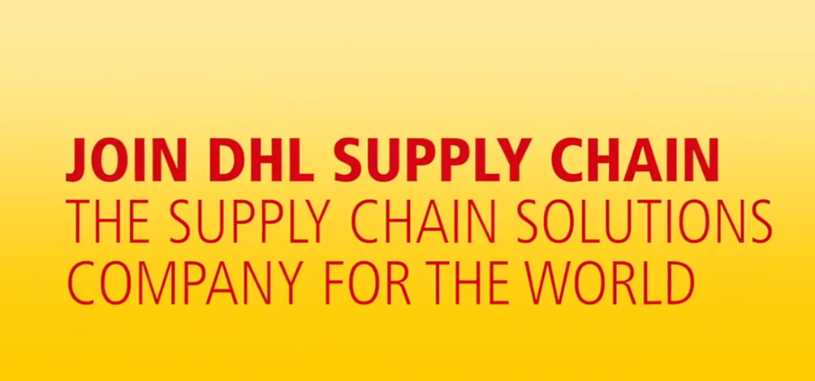

DHL Supply Chain is a branch of the DHL Group. It combines management and distribution services to provide an integrated logistics solution. The supply chain offers services in different sectors such as energy, manufacturing, engineering, healthcare, technology, and retail sectors.
We commit to our customers to provide sustainable solutions promptly without compromising results. As the leading logistics contract provider globally, we have the expertise to provide innovative logistics solutions to existing and emerging markets since we have a global reach. Wherever your business operates, DHL will be there to offer cost-efficient, innovative and high-quality solutions.
Partnering with DHL as a logistics partner will offer immense benefits because it has over 60 countries and territories, having 2,400 warehouses and offices worldwide. Our company is large, stable and it is dedicated to delivering solutions to all our customers globally. (DHL Supply Chain at a Glance, n.d.)
For more than 20 years, we have developed result driven partnerships in various sectors delivering value to our customers whether in Europe, the United States, China, Middle East, or Africa. Past experiences have made it possible to avoid mistakes, and we can steer businesses on a safe path towards a successful partnership.
As a leading logistics company, we operate, design, manage, and continuously deliver supply chain transformation and cover the business’s real needs in the supply chain. Through Total Logistics Cost Management (TLCM), we offer complete visibility of all supply chain costs, which gives transparency and improves budget planning. (DHL Supply Chain at a Glance, n.d.)

DO you have questions on how you can achieve your supply chain efficiency? Ask us on our website at www.dhl.com.

Our Service Gives us a Competitive Advantage
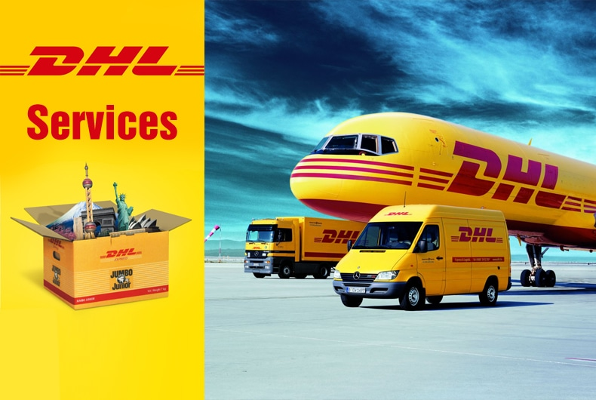
There is a strong connection between customer service and brand image. For businesses and organisations to achieve superior customer experience, they need to have the two elements aligned. The customer support you offer your clients at any point of their journey with your business points out your company values, mission, and objectives. ("Role changes: Marketing, sales, and customer service," 2015)
At DHL, we have established strong relationships with our customers because we share the same risks, rewards, vision, and goals. We offer tailored solutions to all our customers no matter their location on the globe or their size. We are committed to delivering exceptional service globally and being our customer's number one choice.
DHL is committed to delivering value to all our customers across the supply chain. Our main objective is to ensure that our customers are successful. Our solutions help our customers provide their products to the market quickly at an optimal cost; we also support businesses to enter into new markets with minimum risk exposure. This has made us the number one choice for leading companies that outsource supply chain management and logistics.
Being a leader in the logistics industry, we are aware that we significantly impact customer experiences worldwide. We ensure that all our employees are sufficiently trained in customer service to impact the lives of customers positively. ("How DHL became more customer-focused, with CCO Scott Allison," 2019)

Do you have questions about which of your services are most suitable for you and your business? Ask us on our website https://parcel.dhl.co.uk/.

Our Social Responsibilities
All forward-thinking companies have put the environment and sustainability as a priority in their agenda. There are growing concerns about global warming and increasing demand for companies to adopt sustainable processes.
At DHL, we have started Go green initiatives to ensure that we work responsibly to protect the environment. We have put in place measures to reduce logistics-related carbon emissions in our supply chain. Additionally, we have a comprehensive program at DHL involving our people. We aim to certify 80% of our employees to go to green specialists and plant one million trees per year by 2025. (Moodie, 2015)
The Go Green program also focuses on measuring our carbon impact on the environment and managing our carbon impact through critical environmental programs in transport, waste management, energy efficiency, and employee engagement.
As we expand our operations across the world, we understand the environmental impact our expansion could have on the environment; hence we align our operations with environmental sustainability. It is critical to ensure that suppliers and shipping partners along the supply chain have the same commitment to the sustainability agenda. DHL has placed climate protection projects for all its customers internationally to eliminate emissions in their logistics chain and have sustainable solutions.
Contact us for more information? Ask us questions to find out more about our mission and how you can get involved and help the environment together! Visit our website www.dhl.com- DHL Go Green Solution.
Finding the Right Transport Solution for your Business
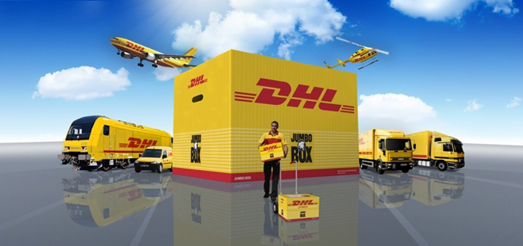
Transport is a critical element of logistics and contributes a considerable amount to logistics costs. Transportation is critical, because it enables the product’s movement to the next phase in the production process or the end customer, whether the product works in progress, materials, assemblies, or finished goods. When transporting goods, the main objective is to move products with minimal environmental and transport costs from the origin location to the end destination.
Transport operations are increasingly becoming complex, and they require businesses to balance operations, compliance, cost, and health and safety requirements. Businesses need to ensure their fleets are compliant with all these requirements. DHL will manage your business transport and ensure operational compliance at a low cost.
Partnering with DHL allows your business to venture into new markets because we will manage your transport logistics no matter the country you operate in, leaving you free to focus on your core business. DHL provides real-time end-to-end visibility of shipments by integrating their IT systems with yours.
At DHL, we use different transport modes for our logistics, including air transport, Road transport, water transport, and rail networks. We use an individual mode of transport or combine several depending on the shipment destination or how quickly the shipment needs to be conveyed.
(Transport Asset Management: Extract maximum value from your transport assets, 2020)

Solutions we Provide across the Supply Chain
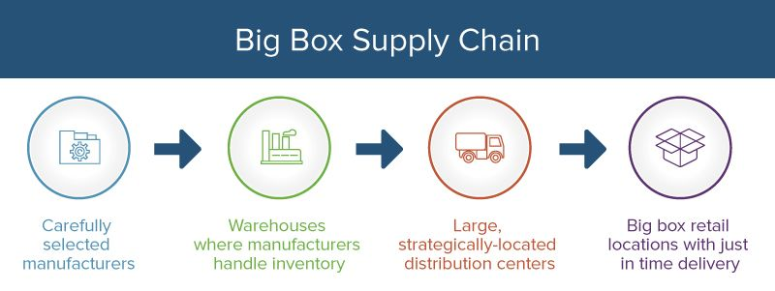
DHL offers a wide range of sourcing, storage, transport, returns, and after-sales. These solutions are provided in all the industries we work with, no matter their location. We are equipped with the necessary resources and skills to take on transportation, warehousing, and other solutions that our customers may require in the supply chain.
Our perspective is to understand customers’ needs, such as profitability goals, their growth objectives, their key customers, and competitors, to advise them appropriately on solutions for the supply chain management. We offer tailored solutions at a reduced risk and cost. These solutions include:
Planning lays the foundation of your supply chain. It incorporates the lead logistic provider services and supplies chain design.
Sourcing involves procurement services of raw materials. It also includes transportation, warehousing, and supplying these materials locally and internationally.
Manufacturing this solution includes plant logistics and manufacturing of products.
Storage and customisation - After the products have been manufactured, they are now ready to sell. This solution involves warehousing, assembly, and packing.
Delivery includes transportation and distribution management, ensuring products reach where they need to be.
Return is the last solution in supply chain management wherein case the product reaches its destination, and it’s not needed, it is returned. This solution includes reverse logistics and environmental compliance. (INTEGRATED SOLUTIONS: Simplifying Your Operations and Optimizing Your Business, n.d.)
These different solutions offer comprehensive support to our customers throughout the supply chain, and DHL manages the whole process.
What does this mean for you? What kind of service do you need for your business? Find more information – www.dhl.com.

Advanced Logistics through Automation
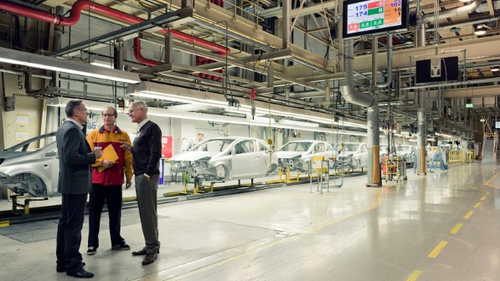

The only thing predictable in today’s business environment is constant change. There has been advancement in smart technology such as Machine Learning (ML) and artificial intelligence (AI) in recent years. Logistics companies that have invested in these technologies have seen significant improvement in their storage, transportation, and tracking of goods worldwide.
DHL has integrated AI and ML solutions in its software to improve logistics efficiency. This software is used to select ideal routes for shipment; monitor shipment along the route to ensure deliveries are done quickly.
We have also introduced wrapping robots to reduce physical work, automated forklifts for moving pallets in warehouses, cleaning robots to reduce repetitive tasks, and robotic arms to reduce repetitive packing jobs. These innovations have been developed to drive efficiency to reduce repetitive tasks that add limited value to the company’s productivity and add customer satisfaction because flow within warehouses will improve. ("Automation and digitalization will re-shape the logistics industry, says DHL," 2019)
With the innovation of robotics and automation, physical operations have been standardized within warehousing and logistics, and it is now possible to drive innovation in operations and achieve optimum standardization.
Have you incorporated automation technology in your supply chain solutions?

Find Out more of everything in our Website – www.dhl.com

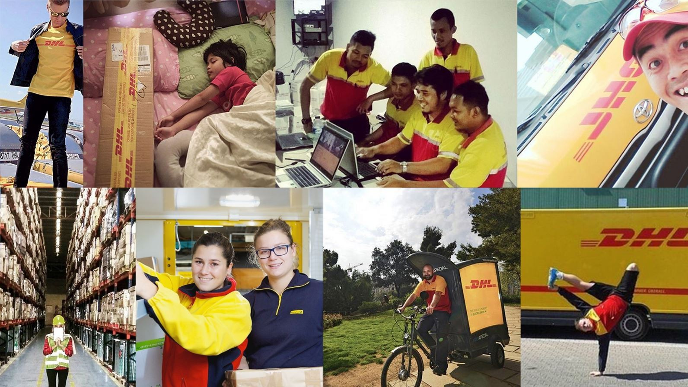
References

Automation and digitalization will re-shape the logistics industry, says DHL. (2019, December 4). Robotics & Automation News. https://roboticsandautomationnews.com/2019/12/04/automation-and-digitalization-will-re-shape-the-logistics-industry-says-dhl/27175/
DHL Supply Chain at a Glance. (n.d.). DHL Supply Chain. https://www.dhl.com/content/dam/dhl/global/dhl-supply-chain/documents/pdf/dhl-glo-supply-chain-fact-sheet-din-a4-screen-updated.pdf
Gibson, H. (2021, January 26). How “Smart” Tech Will Advance Logistics. https://goglobal.dhl.com/blog/international-business-trends/how-smart-tech-will-advance-logistics/.
How DHL became more customer-focused, with CCO Scott Allison. (2019, May 13). CustomerThink | Customer-Centric Business. https://customerthink.com/how-dhl-became-more-customer-focused-with-cco-scott-allison/
INTEGRATED SOLUTIONS Simplifying Your Operations and Optimizing Your Business. (n.d.). DHL Supply Chain. https://www.dhl.com/home/our-divisions/supply-chain/solutions/integrated-solutions
Moodie, C. (2015, September 22). How Green is Your Supply Chain? https://goglobal.dhl-usa.com/blog/small-business-insights/how-green-is-your-supply-chain/.
Role changes: Marketing, sales, and customer service. 2015. Encyclopedia of Supply Chain Management, 1075-1076. https://doi.org/10.1081/e-escm-120048221
Transport Asset Management: Extract maximum value from your transport assets., 2020. DHL Supply Chain. https://www.dhl.com/home/our-divisions/supply-chain/thought-leadership/fact-sheet/transport-asset-management.html

