Richard Davies
1701574
Introduction to Web Development
ACCA4003
Kemi Ademoye

Contents
Introduction 3
Requirements 3
Site Map 3
Wireframe Diagram 4
Implementation 4
Screen Shots 4
Validation 4
HTML 4
CSS 4
Evaluation 4
Accessibility 4
Evaluation 4
Recommendations 4

Introduction
This report is going to outline the requirements for a given website then acts as the design document for that site. At the end of this report there will be an evaluation to compare if the finished site meets the requirements.

Requirements
The proposed website is going to be about the hobbies of the author, its purpose is to inform the reader of the history and reason behind each hobby. The target audience is anyone who would like to know more about these hobbies and how they impact the life of the author.

Site Map

Wireframe Diagram
- The logo is part of the main header and is always to the left.
- The main background image is the full 12 columns wide.
- Each card link is 4 columns wide.
- The footer is centred.
Images used – siteLoge.jpg, myHobbiesBackground.jpg.
Links – index.html, modelTrains.html, legoTechnic.html, boardGames.html, videoGames.html.

Implementation

Screen Shots

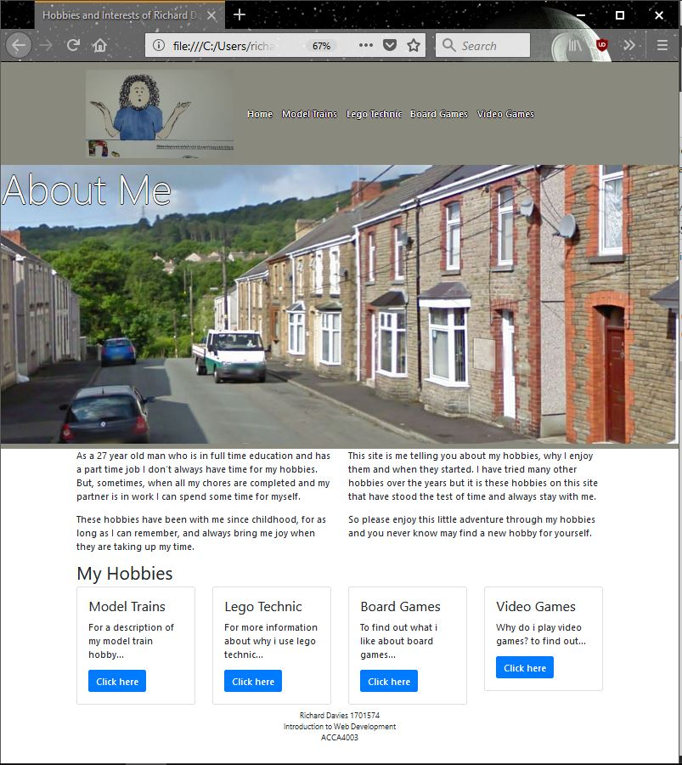
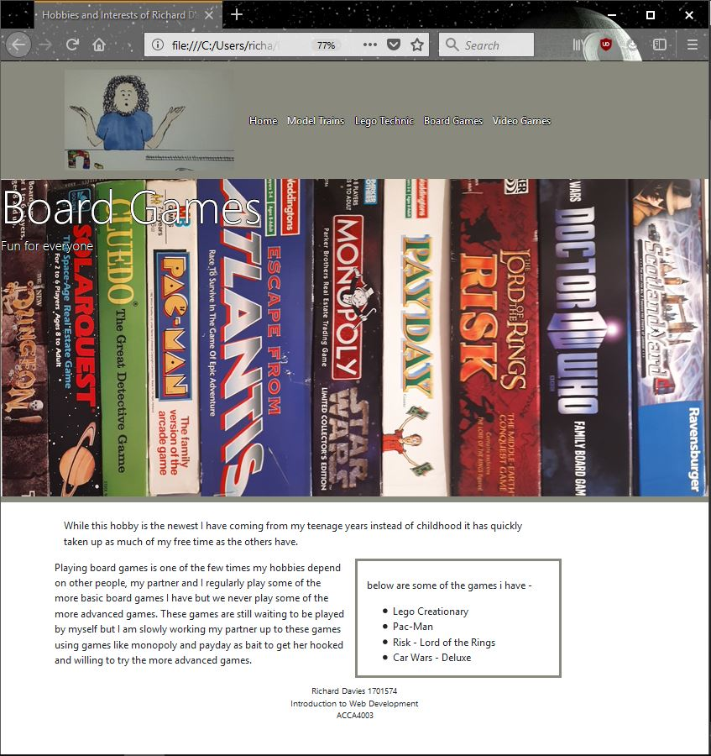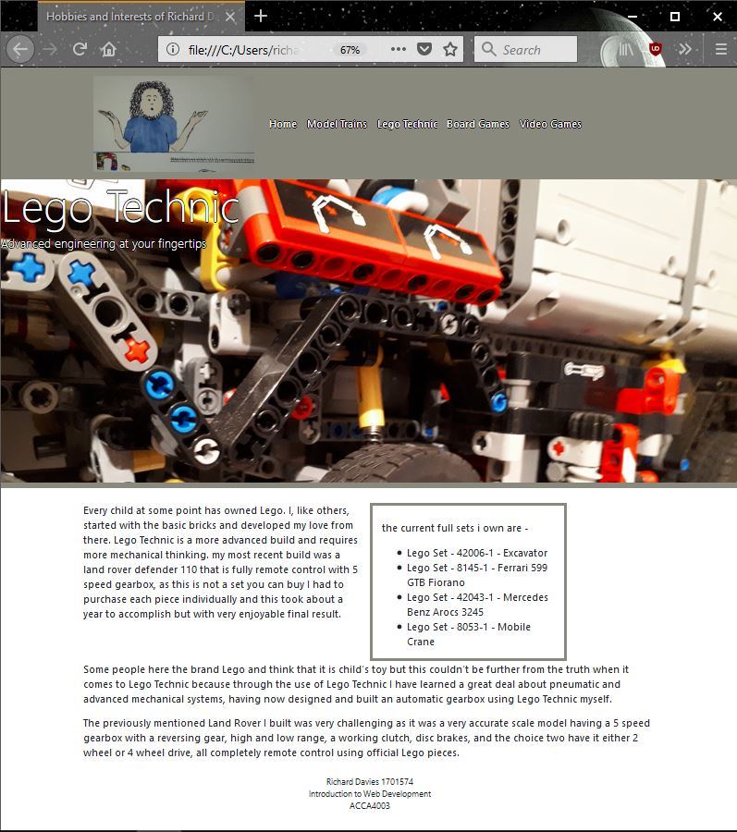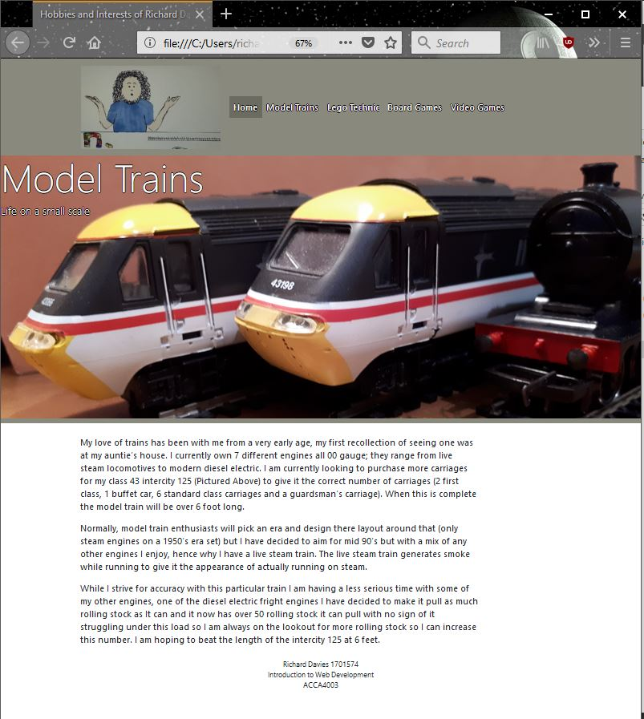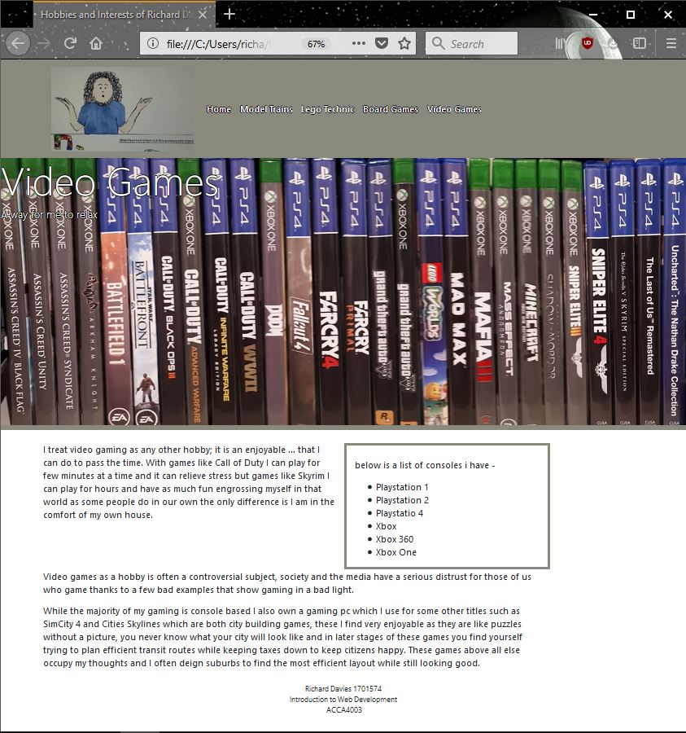

Validation

HTML [1]
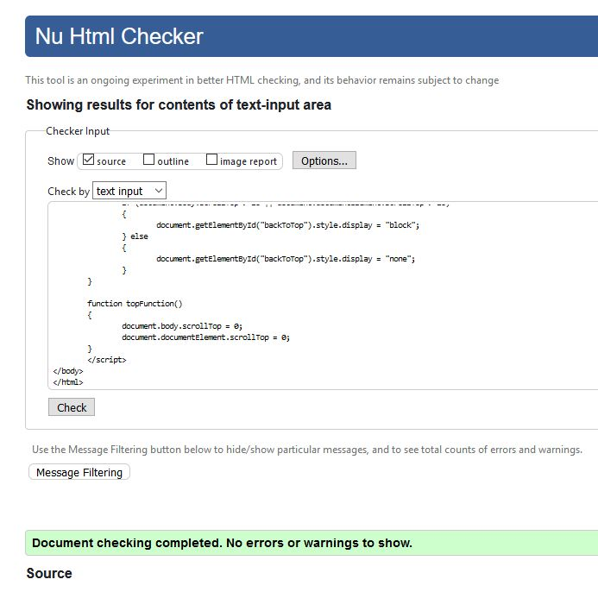

CSS [2]
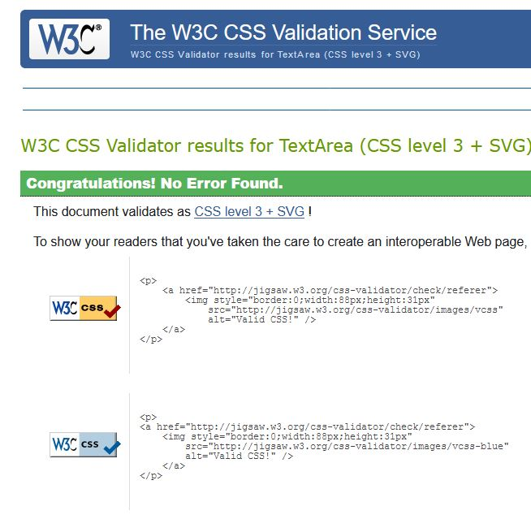

Evaluation

Accessibility
- For the main body of text the luminosity contrast ration is good [3] which follows the WCAG 2.0 guideline
- As the images on the site are decorative the use of the alt tag is not necessary [4] but all images have accompanying text in the event the images fail to load.
- As the main navigation form is only ever at the top the user always knows where it is and even though it is hidden when the user scrolls down there is a back to top button to aid in the easy location of the main navigation form.

Evaluation
It is felt that the website has met the requirements and follows the known guidelines.
The website has an overall professional feel achieved by a uniform design and colour palette and this has also helped with the functionality of the site by allowing the user to easily use every page by keeping all navigation links in the same place.
As the information on this site is personal hobbies of Richard Davies the content may not be liked by everyone and while the author could have added more content it was felt that the level of content was enough for a brief introduction into each area.

Recommendations
For any future improvements it is felt that the only major change would be the addition of more information on each subject –
- Model Trains Page – list of every engine and rolling stock.
- Lego Technic Page – external link to Lego Technic site.
- Board Games Page – image of each playable board with an upload of the instructions.
- Video Games Page – list of each game with a short review.
The colour palette could be updated depending on an external questionnaire to check how other users react to the site and to check if the colours impact on the usability.

References

[1] | “Markup Validation Service,” W3C, [Online]. Available: https://validator.w3.org/. [Accessed 09 Janurary 2018].
[2] | “CSS Validation Cervice,” W3C, [Online]. Available: http://jigsaw.w3.org/css-validator/. [Accessed 09 Janurary 2018].
[3] | “Luminosity Colour Contrast Ratio Analyser,” [Online]. Available: http://juicystudio.com/services/luminositycontrastratio.php#navigation. [Accessed 09 janurary 2018].
[4] | “Decorative Images,” W3C Web Accessibility Initiative, 23 April 2017. [Online]. Available: https://www.w3.org/WAI/tutorials/images/decorative/. [Accessed 09 Janurary 2018].

marking criteria and Student FEEDBACK

This section details the assessment criteria. The extent to which these are demonstrated by you determines your mark. The marks available for each criterion are shown. Lecturers will use the space provided to comment on the achievement of the task(s), including those areas in which you have performed well and areas that would benefit from development/improvement.

Common Assessment Criteria Applied (Assignment 1) | Marks available | Marks  awarded
1. Research-informed Literature
Extent of research and/or own reading, selection of credible sources, application of appropriate referencing conventions.
Demonstrates an average level of research. (Grade mark: 50.00%) | 5 | 2.5
2. Knowledge and Understanding of Subject
Extent of knowledge and understanding of concepts and underlying principles associated with the discipline.
Demonstrates a good understanding of the standards to design and implement a website. There is, however, room for improvement with respect to the layout and content and knowing when to use the class and id attributes as selectors for your CSS styles. (Grade mark: 60.00%) | 20 | 12
3. Analysis
Analysis, evaluation and synthesis; logic, argument and judgement; analytical reflection; organisation of ideas and evidence
The evaluation of the website is weak and too brief. However, some good recommendations for future improvements have been suggested. (Grade mark: 40.00%) | 20 | 8
4. Practical Application and Deployment
Deployment of methods, materials, tools and techniques; application of concepts; formulation of innovative and creative solutions to solve problems.
A good attempt featuring a simple website. Well done. See additional comments in your report. (Grade mark: 56.00%) | 50 | 28
5. Skills for Professional Practice
Attributes in professional practice: individual and collaborative working; deployment of appropriate media; presentation and organisation.
The report is satisfactory, but it generally lacks content and detail. (Grade mark: 40.00%) | 5 | 2

Assignment Mark (Assessment marks are subject to ratification at the Exam Board. These comments and marks are to give feedback on module work and are for guidance only until they are confirmed. ) | Late Submission Penalties (tick if appropriate) |  | 52.5%
 | Up to one week late |  | 52.5%
 | 1st/2nd/3rd attempt? |  | 52.5%

