Francis Barcelo (2401983)
2401983@stu.uwtsd.ac.uk
28/03/2025
University of Wales Trinity Saint David’s
Construction Material
ACBA4016

Table of Contents
2 Introduction 2
3 Concrete Frame structure: Burj Khalifa 2
3.1 Material 3
3.2 Environmental and Community Impact 6
3.3 Life Cycle 7
4 Steel Frame structure: 875 Michigan Avenue (The John Hancock Center) 8
4.1 3.1 Material 9
4.2 3.2 Environmental and Community Impact 12
4.3 3.3 Life Cycle 13
5 Comparison 14
6 Conclusion 16
7 Reference 17

Introduction
This report is about the various materials that are used in the construction industry, and which ones are the main building blocks in ensuring the success of a project. The report consists of a case study of 2 buildings built with a different material being compared to the other, highlighting the various properties that each material contains. Analysis of the properties is shown explaining why the particular material was used for each building, and what procedures and factors were needed to ensure the completion of the project.

Concrete Frame structure: Burj Khalifa
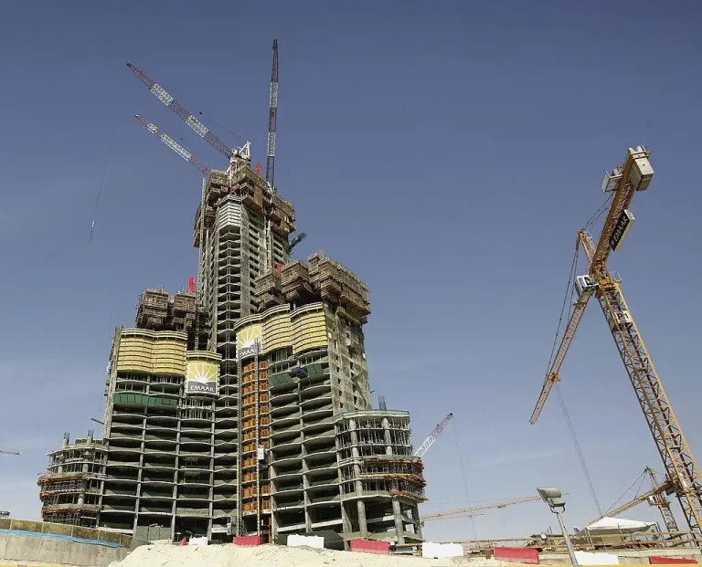
(Hafza. Y, 2024 figure 1)
The Burj Khalifa known as the world’s tallest building provides over 900 residential apartments and is made of a concrete frame structure. The construction used 330,000 cubic metres of concrete to ensure stability at great heights (Emarr, no date a).

Material
The structural design of the Burj Khalifa described as a “buttressed core” is surrounded by three wings containing setbacks along each wing. With the shape and the use of a Y-shaped floor plan it provides the stability to reduce the wind forces acting, as well as helping keep the structure design simple and “foster constructability” (Emaar, no date A and B).
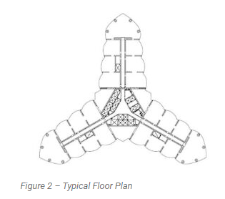
(Novak. L, 2023 figure 2)
The concrete used for the Burj Khalifa was designed to be self-consolidating (SCC) to help reduce construction time. The use of this high-performance concrete means only a small or no amount of vibration was needed to level the concrete. Careful consideration was taken due to the climate and the region Dubai was located. Because of this most pumping took place at night with temperatures still reaching 50°C degrees. The water content was composed of flake ice to achieve a common limit of 32°C. Throughout the timeline, 3 high-pressure pumps were used to carry the concrete up as construction got to greater heights (Instron, ND). BASF was tasked with developing the mix of the concrete, where they achieved a mix that maintained a workability for over three hours before it hardened. This innovative work ensured that there was a smooth application as construction continued at high altitudes, this helped speed up construction and extended the lifespan making the tower more durable (Hafza. Y, 2024)
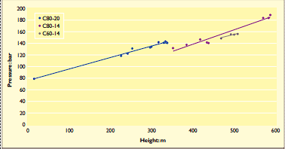
(Aldred. J, 2010 figure 3)
The Graph above shows the increase in pressure during pumping as height increases. Size of the aggregates changed from 20mm to 14mm above 346 (Aldred. J, 2010)
Each wing contains its own high-performance concrete corridor wall helping achieve stiffness both laterally and torsionally. All vertical concrete is used to support gravity and lateral loads by making outriggers on the columns participate in the lateral load resistance of the structure.
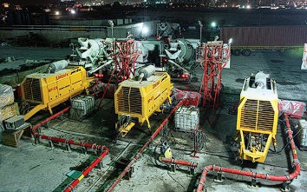
(Aldred. J, 2010 figure 4)
Figure 4 showing the 3 main pumps used to transport the cement.
The concrete used to construct the tower is made up of C50, C60, and C80 (cube strength) which is mixed with Portland cement, fly ash, and various local aggregates for the mix design. The use of C60 and C80 concrete helped ensure that it had low permeability and high durability against the harsh climate Dubai offers. Crushed aggregate such as gabbro and dolomitic limestone was used for both fine and coarse aggregate. Gabbro mixed with crushed limestone and dune sand was used to increase “finer fraction” and improve the bind of the mixture. (Aldred. J, 2010). For the coarse aggregate, the use of dolomitic limestone was used. The sizes of the aggregates were carefully considered to prevent any blockages when being pumped, a strategy they used was to reduce the sizes of these aggregates at certain altitudes (Bester. N, 2013).
The C80 concrete was used towards the bottom of the structure where it has a specified Young’s Modulus of 43,800 N/mm² at 90 days showing how stiff and how the shape of the material is slightly reduced under elastic loads (Baker. W et al, 2008).
To reduce the effects of creep and shrinkage, the thickness of each wall and column size were “fine-tuned” to match the self-weight-gravity stress on the outside columns with the interior corridor walls. With the use of reinforced concrete for construction the compatibility between the rebar used and the concrete was carefully considered (Novak. L, 2023)
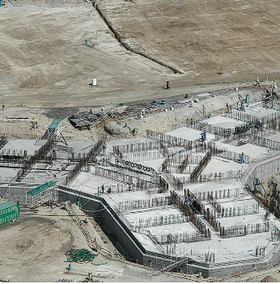
(Emaar, ND A Figure5)
C50 SSC concrete was used in the foundation of the structure. Due to the region being close to the Persian Gulf and Dubai sandy terrain concrete with low permeability and high strength such as C50 was needed. The foundation consists of a pile-supported raft, where 194 bored cast-in-place piles were used. Each pile is 43 meters long and has a design capacity of 3,000 tones (Baker. W et al, 2008).

Environmental and Community Impact
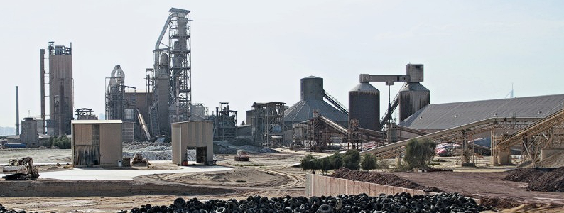(ZKG, 2013 Figure 6)
Figure 6 showing the NNC plant in Dubai.
A contract was signed with the National Cement Co in the UAE where the production of cement used in the Burj Khalifa came from. The company produced the Portland Cement that adhered to BS 12/1996 and ASTM C-150. The Limestone found in the region is brought in from two quarries the Rawda Hatta Quarry around 90km away and Al Habab that supplied inland sand about 45km away from the plant (ZKG, 2013).
Considering the size and height of the structure, the use of an extent amount of concrete for the project ensured that an increase in greenhouse gas emissions was emitted during production of the material. Gases such as C02 from production can influence both the environment and the community it’s located in. The use of quarries means that large chunks of land were used destroying habitats and the nature around them. Air quality and long exposure to noise and vibration around these sites would badly affect people leading to long-term health problems as gases such as sulphur dioxide are released into the air (Helal. J and Trabucco. D, 2024).

Life Cycle
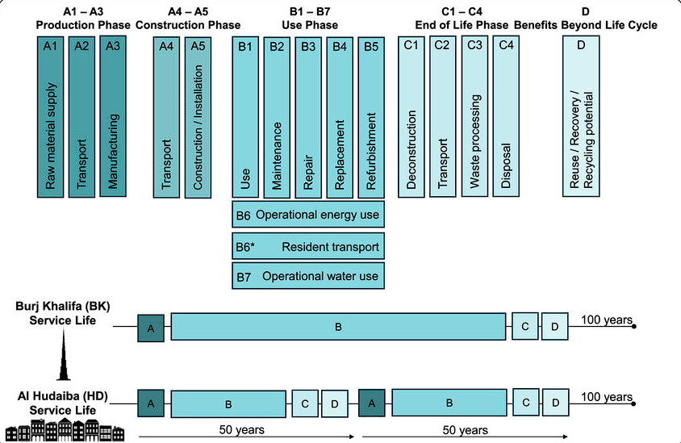(Thaneya. A et al, 2025 figure 7)
Figure 7 shows a typical life cycle of a high rise building such as the Burj Khalifa compared to a low-rise structure.
A concrete structure such as the Burj Khalifa is designed to have a life span of 50 years but with various plans to keep it maintained and in constant care, the structure can last up to 100 years. At the end of its life, a concrete structure can be demolished and recycled to be used again to prevent any waste, although for the case of the Burj Khalifa reusing the building for a different purpose is the more suitable option. Due to its extreme height, it provides a huge number of spaces that can be easily repurposed (Kelly. J, 2012).
Though a typical concrete structure provides great flexibility when being constructed the Burj Khalifa faced many challenges that made assembling the structure complicated. Due to its extreme height and the region, it located in, innovative solutions had to be created (Hafza. Y, 2024). With this factor to consider it makes changing the structural shape and design to help repurposed the building in the future more unlikely.

Steel Frame structure: 875 Michigan Avenue (The John Hancock Center)
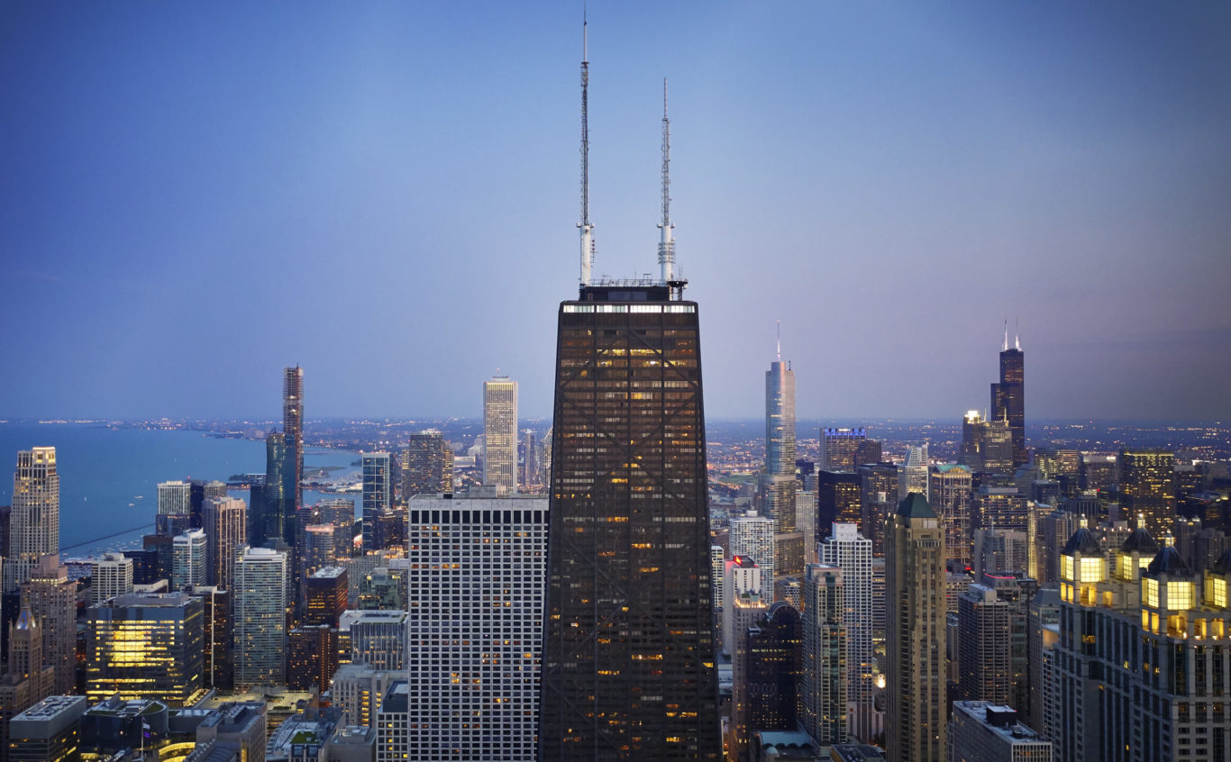(SOM, no date figure 9)
875 Michigan Avenue a mix used building constructed out of a steel frame structure is one of Chicago’s iconic skyscrapers. Containing various residential and office spaces, the structure influenced a “new era of high-rise construction” (SOM, no date).

3.1 Material
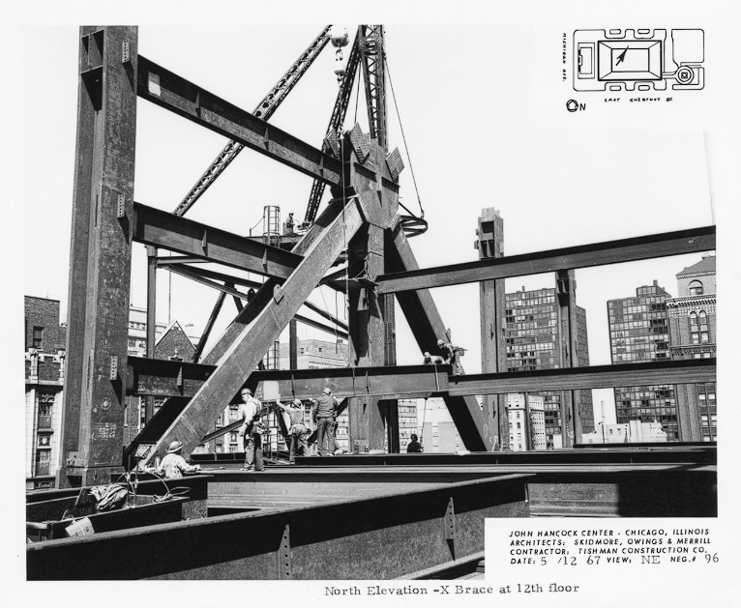
(SOM, no date figure 10)
The Structural design uses a “diagonally braced system” which was the first use of this design at its time. Each exterior frames of the structure act as a bearing wall, where loads such as gravity are evenly distributed among columns. Lateral loads that produce forces act on the windward and leeward columns. The X-bracing design on the structure is 20 stories where a secondary spandrel beam infills the bracing panels (SOM, no date). With the structure having a tapered design it allowed to maximise usable floor spaces while ensuring that the structure was suitable for the now-known X-bracing design (IABSE, 1982).
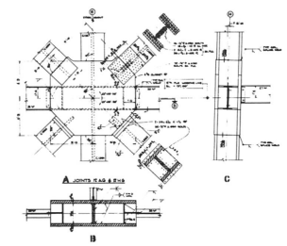
(IABSE, 1982 figure 11)
Figure 11 shows a joint detail of the 12th floor
3 independent plates were used to fabricate the columns, diagonals, and ties to an I-section where they were welded together. This allowed the joint detail to be simplified making construction easier (Namli. O, 2015). The floor framing and the interior column of the structure are made only for gravity load, where the interior columns are made up of rolled and built-up sections. The structure is mostly made up of A-36 steel, and A-441 steel was used for the gusset plates at diagonals to column joints. The bolts used to connect the diagonal members are high-strength A490 bolts which can be seen in figure 11. A-36 steel has a young modulus ofc 200 GPa making it suitable for all the load bearing of the structure (IABSE, 1982)
Due to the building located at the lakeside of Chicago problems occurred when the foundation was being constructed as the building kept sinking. Due to this design changes in the foundation were made and, in the end, the structure had the deepest foundation in Chicago at the time (Beck Tech, No date).

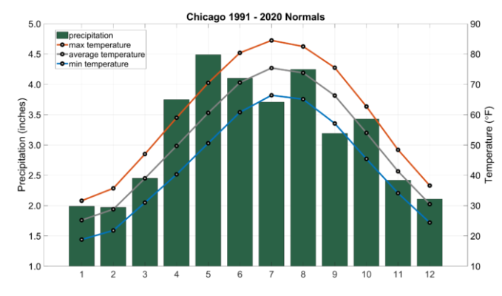
(Illinois State climatologist, no date figure 12)
Chicago has a continental climate where it has hot humid summers and cold winters with snow. Throughout the year there is a frequent short fluctuation in temperature, wind direction, and humidity, influencing the construction consideration of the structure (Angel. J, no date). The exterior facade of the building is made up of anodized aluminium clad steel columns and the famous X-bracing design. With the steel having an aluminium surface it makes it resistant to corrosion and increases durability which is key to Chicago’s humid climates (WJE, no date). With the X-bracing helping resist the wind loads while also reducing the amount of internal support columns needed (Osmond. L, 2025).

3.2 Environmental and Community Impact
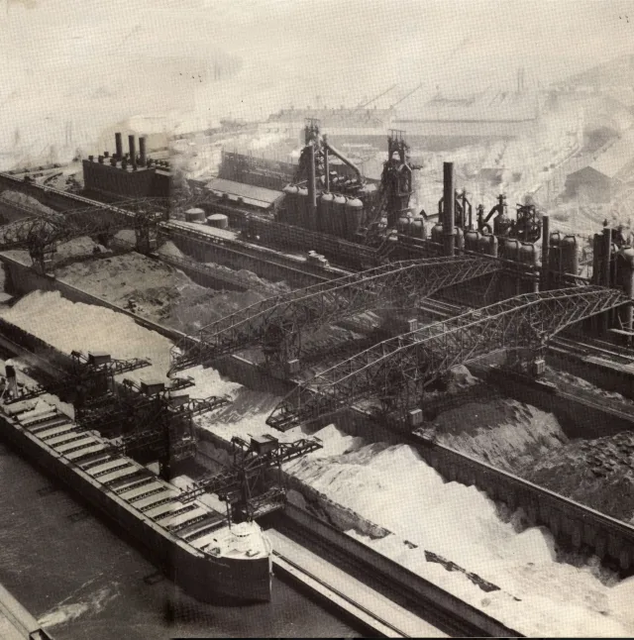
(McNeill. J, 2022 figure 13)
Chicago is known for its steel production and the contribution it has on the American steel industry (Encyclopaedia of Chicago, no date). During the construction of the 875 Michigan Avenue, quarries and mines would have been essential in the production of steel. The use of these land would mean the destruction of habitats, having a massive effect on the ecology and the surrounding environment (UKGBC, no date).
The steel industry is a major contributor to carbon dioxide emissions while also having a huge issue with water consumption leading to a negative impact on the environment (Conejo. A et al, 2020). Other harmful gases like sulphur dioxide can have a harmful effect on the people exposed. With pollutants being released air quality of the area would continue to worsen, and this can have a massive effect on people with existing health conditions such as asthma. Heavy metals such as lead have been shown to cause long-term health problems in the community nearby (Kunak, 2024). The waste products from the process can pollute nearby water sources with heavy metals harming wildlife and contaminating drinking sources (Nantel. A 2024).

3.3 Life Cycle
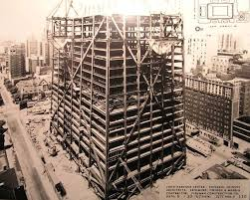
(Maddox. M et al, 2023 figure 14)
Assembling a steel frame structure such as the 875 Michigan Avenue can be quick and easy without any complications, where the structure took 4 years to complete. At the end of the life of the building, the structure can easily be taken down and dissembled (Jade-Aden, 2022). The tapered design along with the use of steel as the framing material allowed more flexibility when it came to needing more spaces. The tapered design allowed bigger office space at the bottom and residential rooms towards the top of the structure (IABSE, 1982). With this design, the building can be easily repurposed for other uses if needed in the future.
A steel frame structure can have a life span of 50 to 100 years, at the end of its life the John Hancock Center can be easily disassembled and demolished. With steel being 100% recyclable, it ensures that there is a low amount of waste material and reduces the demand for new raw materials (Nantel. A, 2024). Steel frame structures are highly adaptable allowing it to be modified or expanded providing long-term flexibility for the owner of the building (SafetechBlogs, 2024).

Comparison
Material | Advantages | Disadvantages
Concrete Frame | - Concrete frame is highly fire resistance compared to steel frames (concrete captain, no date).  - Unlike steel Concrete is not prone to corrosion leading to less Maintenace needed (Cemex, no date)  - Like steel concrete has high strength and durability allowing it to be used to build tall and larger buildings (LGW Group, 2019).  - Concrete has a long-life span with proper maintenance a concrete frame structure can last over 100 years (LGW Group, 2019).  - Concrete is a common material used in construction which means that there are plenty available at any time for a project (county materials corporation, 2022). | - Compared to steel Concrete frame structures tend to be bulkier and has more weight associated (SafetechBlogs, 2024).  - Like steel production of concrete have a massive effect on the environment from the release of C02 to removing land for quarries (Helal.J and Trabucco.D, 2024).  - Without the right mix and without proper care concrete has the potential to crack and shrink (concrete captain, no date).  - In contrast to steel, concrete frame structure cannot be modified due to it not being joined together section by section. It is a Homogeneous structure (Nantel.A, 2024)  - Concrete often needs to be reinforced where the common type used are steel rods. This helps improve the materials tensile strength (LGW Group, 2019)
Steel Frame | - Steel has a high strength to weight ratio allowing the construction for more taller and expansive building (SafetechBlogs, 2024).  - Steel frames can be manufactured offsite, and the structure can be assembled on site making it easier and efficient to build (SafetechBlogs, 2024).  - Steel frame structures can be easily assembled and dissembled allowing a reduction in construction time and labour cost (Nantel. A, 2024)  - Steel frame structures offer more flexibility when it comes to spaces due to reduce number of internal supports needed to hold up the structure (Nantel. A, 2024)  - The use of steel allows made for order ensuring the right amount material needed is acquired at a certain time (Nantel.A, 2024)  - Steel frames structures are highly adaptable allowing for expansion and modification to be possible in the building design. This help increase the life of the building and offer flexibility to the owners (SafetechBlogs, 2024).  - Steel is 100% recyclable reducing the demand for raw material. Steel can be melted and reused without any loss of its key properties (SafetechBlogs, 2024). | - Without any protective coating steel frame structures are prone to corrosion, which leads to the material gradually deteriorating until structural failure (Nantel.A 2024)  - When compared to concrete steel is more expensive to purchase and produce  - Steel frame's structure would need fire protection. High temperatures can cause the steel members to failure. The use of concrete as a protective barrier is commonly used (Patel.H, 2024).  - Steel has a high thermal conductivity leading to huge amount of energy loss in the building. Due to this necessary coating and treatment on the steel members are needed to protect it from external and internal conditions (Patel.H 2024).  - Like concrete to ensure and maximise the life span of steel it needs to have frequent appropriate maintenance.

Conclusion
To conclude, both concrete and steel frame structures play a pivotal role in the modern construction industry. Both materials are important building blocks to ensure the completion of the project. Each material contains its own properties such as strength and durability that can be utilised depending on the type of building being constructed. Both case studies have made a significant contribution to how structures are designed and made today when it comes to the materials that are being used.

Reference
Burj Khalifa Emaar (no date, A) Architecture and Design. [online] Available at: https://www.burjkhalifa.ae/the-tower/architecture-design/ (Accessed on 26 February 2025)
Burj Khalifa Emaar (no date, B) Structures. [online] Available at: https://www.burjkhalifa.ae/the-tower/structures/ (Accessed on 26 February 2025)
Fu. F (2018) Design and Analysis of Tall and Complex Structures. [Book/PDF}. Available at the University learning platform CIS. (Accessed on 3 March 2025)
Hafza.Y (2024) How was the Burj Khalifa Built? [online] Available at https://parametric-architecture.com/how-was-burj-khalifa-built/?srsltid=AfmBOorUAoW1Rx1P3TVrSPfcE2gGsD69Fr7ik9fQU3ELLUYiy36DAIKU (Accessed on 3 March 2025)
Aldred. J (2010) Burj Khalifa – A new high for high-performance concrete. [online]. Available at https://www.researchgate.net/publication/245407762_Burj_Khalifa_-_A_new_high_for_high-_Performance_concretej. (Accessed on 12 March 2025)
Baker. W, et al (2008) Engineering the World’s Tallest – Burj Dubai. [online]. Available at https://global.ctbuh.org/resources/papers/download/1326-engineering-the-worlds-tallest-burj-bubai.pdf (Accessed on 10 March 2025)
Novak. L (2023) Lead Structural Engineer Share Insights on the Burj Khalifa, World’s Tallest Structure. [online] Available at https://www.iccsafe.org/building-safety-journal/bsj-technical/a-tall-adventure-the-burj-khalifa-the-worlds-tallest-structure/ (Accessed on 10 March 2025)
Instron (no date) The Burj Khalifa – Cast in Concrete. [online]. Available at https://www.instron.com/en/-/media/literature-library/newsletter/2011/03/technotes-issue-44.pdf (Accessed on 4 March 2025)
Bester. N (2013) Concrete for high-rise buildings: Performance requirements, mix design and construction considerations. [online]. Available at https://www.researchgate.net/publication/263889511_Concrete_for_high-rise_buildings_Performance_requirements_mix_design_and_construction_considerations (Accessed on 4 March 2025)
ZKG (2013) High quality cement for Burj Khalifa and other projects. [online] Available at https://www.zkg.de/en/artikel/zkg_High_quality_cement_for_Burj_Khalifa_and_other_projects-1724465.html (Accessed on 10 March 2025)
Helal.J and Trabucco.D (2024) Sky vanity: constructing the world’s tallest buildings creates high emissions. [online] Available at https://theconversation.com/sky-high-vanity-constructing-the-worlds-tallest-buildings-creates-high-emissions-229183 (Accessed on 10 March 2025)
Kelly.J (2012) How do you demolish a skyscraper. [online] Available at https://www.bbc.co.uk/news/magazine-20535821 (Accessed on 10 March 2025)
Thaneya.A et al (2025) Can agglomerated tall buildings reduce carbon emissions compared to a low-rise urban sprawl? [online] Available at https://www.researchgate.net/publication/389382666_Can_agglomerated_tall_buildings_reduce_carbon_emissions_compared_to_a_low-rise_urban_sprawl (Accessed on 10 March 2025)
SOM (no date) 875 North Michigan Avenue. [online] Available at https://www.som.com/projects/875-north-michigan-avenue-formerly-john-hancock-center/ (Accessed on 6 March 2025)
IABSE Structure (1982) Selected Works of Fazlur R.Khan. [online] Available at https://www.e-periodica.ch/cntmng?pid=bse-pe-002:1982:6::55#:~:text=The%20interior%20columns%20weredesigned%20for,opportunities%20for%20different%20architectural%20expressions (Accessed on 6 March 2025)
Namji.O (no date) Studies on Tall Buildings: Design Considerations. [online] Available athttps://users.metu.edu.tr/archstr/BS536/documents/Projects/John%20Hancock%20Center%20-%20Olkan%20Namli.pdf (Accessed on March 6 2025)
Beck Tech (no date) How Did They Build That? John Hancock Center, Chicago. [online] https://www.beck-technology.com/blog/how-did-they-build-that-john-hancock-center-chicago (Accessed on March 7 2025)
Iyengar.H (2000) Reflections on the Hancock Concept. [online] Available at https://global.ctbuh.org/resources/papers/download/1231-reflections-on-the-hancock-concept.pdf (Accessed on March 7 2025)
WJE (no date) John Hancock Center. [online] Available at https://www.wje.com/projects/detail/john-hancock-center#:~:text=The%20exterior%20facade%20consists%20of,-bracing%2C%20and%20spandrel%20beams (Accessed on 7 March 2025)
Illinois State Climatologist (no date) Climate of Chicago. [online] Available at https://stateclimatologist.web.illinois.edu/climate-of-illinois/climate-of-chicago/ (Accessed on March 8 2025)
Angel.J (no date) Climate of Chicago – Description and Normals. [online] Available at https://www.isws.illinois.edu/statecli/general/chicago-climate-narrative.htm (Accessed on March 8 2025)
Conejo.A et al, (2020) A review of the current environmental challenges of the steel industry and its value chain. [online] Available at https://www.sciencedirect.com/science/article/abs/pii/S0301479719315002 (Accessed on 9 March 2025)
Encyclopedia of Chicago (no date) Iron and Steel. [online] Available at http://www.encyclopedia.chicagohistory.org/pages/653.html#:~:text=Iron%20and%20steel%20mills%20have,lay%20off%20thousands%20of%20workers (Accessed on 9 March 2025)
McNeill.J (2022) Chicago’s Temple of Steel: South Works since 1882. [online] Available at https://springs-rcc.org/chicagos-temple-of-steel-south-works-since-1882/ (Accessed on 9 March 2025)
UKGBC (no date) Iron Ore. [online] Available at https://ukgbc.org/our-work/topics/embodied-ecological-impacts/iron-ore/#:~:text=Land%20use%20change%20driven%20by,to%20opaque%20global%20supply%20chains (Accessed on 9 March 2025)
Nantel. A (2024) Concrete in construction 2. [online] Available at by the University Learning Platform (Accessed on 9 March 2025)
Osmond. L (2025) John Hancock Center. [online] Available at https://www.britannica.com/topic/John-Hancock-Center (Accessed on 9 March 2025)
Kunak (2024) Environmental impact of steel on air quality, deteriorating atmospheric conditions. [online] Available at https://kunakair.com/environmental-impact-of-steel-on-air-quality/#:~:text=Respiratory%20problems,main%20drivers%20of%20climate%20change. (Accessed on 9 March 2025)
Jade-Aden (2022) Structural Steel Frames: A Guide. [online] Available at https://www.jade-aden.co.uk/blog/structural-steel-frames-a-guide#:~:text=They%20are%20quick%20and%20easy,fire%20resistance%20when%20appropriately%20treated. (Accessed on 15 March 2025)
Maddox.M et al (2013) Case study of John Hancock Center structural Design. [online] Available at https://faculty.arch.tamu.edu/anichols/courses/applied-architectural-structures/projects-631/Files/JohnHancockCenter.pdf (Accessed on 15 March 2025)
SafetechBlogs (2024) Our Guide to Steel Frame Buildings. [online] Available at https://steelframebuildingsltd.co.uk/our-guide-to-steel-frame-buildings/ (Accessed on 15 March 2025)
Patel.H (2024) Steel Frame Construction: Unveiling the strengths and Weaknesses. [online] Available at https://www.bricknbolt.com/blogs-and-articles/construction-guide/steel-frame-construction-advantages-and-disadvantages#susceptible-to-fire (Accessed on 16 March 2025)
ConcreteCaptain (no date) Which is Better: Steel Structure or Concrete structure? A Comprehensive Comparison. [online] Available at https://concretecaptain.com/which-is-better-steel-structure-or-concrete-structure/ (Accessed on 16 March 2025)
Cemex (no date) Concrete vs Steel and Timber. [online] Available at https://www.cemex.co.uk/concrete-vs-steel-timber (Accessed on 16 March 2025)
LGW Group (2019) Pros & cons of concrete construction. [online] Available at https://www.lgwgroup.co.uk/news/the-pros-and-cons-of-concrete-construction#cookieagree (Accessed on 16 March 2025)
County Materials Corporation (2022) Structural Concrete Framing Proves Advantages Over Steel. [online] Available at https://hub.countymaterials.com/news/structural-concrete-framing-proves-advantages-over-steel-2 (Accessed on 16 March 2025)

