Student Name: Mustafa AY
Student ID: 2513629
Submission Date: 24/04/2026

Module: Introduction to Web and Database Concepts (ACCA4023)
Assignment: HTML & CSS Web Development
Module Lecturer: Abida Perveen

Table of Contents

Introduction (Abstract) 2
Requirements 2
Implementation 3
Errors and Fixes 7
Evaluation 8
Research (Usability, Accessibility, SEO) 8
Website Evaluation 8
Website Comparison 9
Conclusion 9
References 10
Appendices 10
Appendix A 10
Appendix B 12
Appendix C 15
Appendix D 17
Appendix E 19

Introduction (Abstract)
This document describes how to design and develop a responsive multi-page website (HTML & CSS) for Synergy Massage Therapy which is a mobile massage service that operates in London and surrounding areas.
The goal of the site is to communicate service offerings, increase potential client access to the service provided and provide evidence of basic web development skills such as layout design, responsive style and consideration for usability.
There are four pages on the website (home, services, about & contact) that are connected. The layout has a structured navigation system with images, is mobile responsive and has accessibility features like an alt tag associated with images.
This document provides an overview of the requirements; how the site was implemented; usability considerations; improvements made for accessibility; and methods for using search engine optimisation (SEO) during the implementation of the website.

Requirements

Synergy Massage Therapy's aim in this project was to create a responsive multi-page website using HTML and CSS that would enable potential customers access to therapy information as well as assist users in understanding the types of therapies and services available via Synergy Massage Therapy. This site is primarily for individuals located in London and neighbouring areas who are looking to book mobile massage therapy appointments. The intended user demographic consists of Individuals seeking sports massage therapy, deep tissue massage therapy, reflexology or relaxation therapy that deliver services through home visits.
The website consists of four pages, namely; Home, Services, About and Contact which can be accessed via a navigation menu throughout all four pages. All four pages are fully interlinked together.
HTML was selected to provide structure of content to the site while CSS was selected to provide improvement in page layout, colour schemes of site pages and add visual appeal to the finished product.
In addition to using CSS and HTML to achieve the above objectives; images were added to both the Home page and the Services page in order to enhance the useability and to create a more user friendly experience.
Another important design component was to create a responsive environment for all users accessing this website regardless of their device (desktop or mobile).

Implementation

Synergy Massage Therapy has developed their website with an HTML5 content structure and CSS3 layout and visual appeal. Each page contains a consistent navigation bar to allow for easy movement throughout the website when browsing through the different sections.
There are four pages that connect throughout the website which are Home, Services, About and Contact. The pages format has been developed to display clear and user-friendly content about the service offerings and assist the user to navigate through the four pages easily.
The Home and Services pages also include images to enhance the visual engagement and usability. Consistent CSS styles have been created to provide the pages with similar layouts, colours and spacing.
Responsive design techniques using CSS media queries have been utilized so that the pages will display properly on mobile devices and smaller displays.
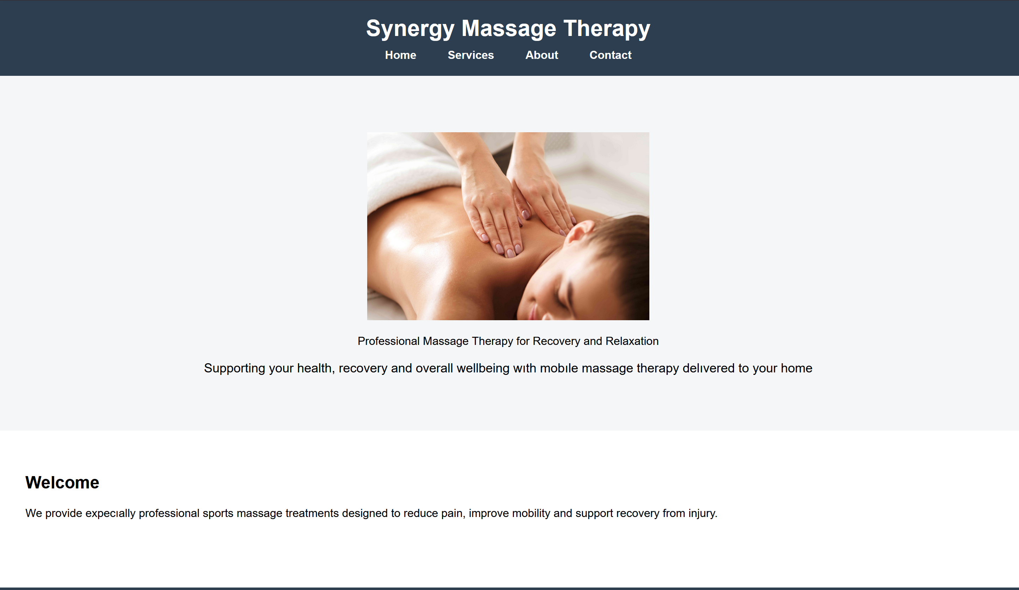
Figure 1: Home Page Layout of Synergy Massage Therapy Website

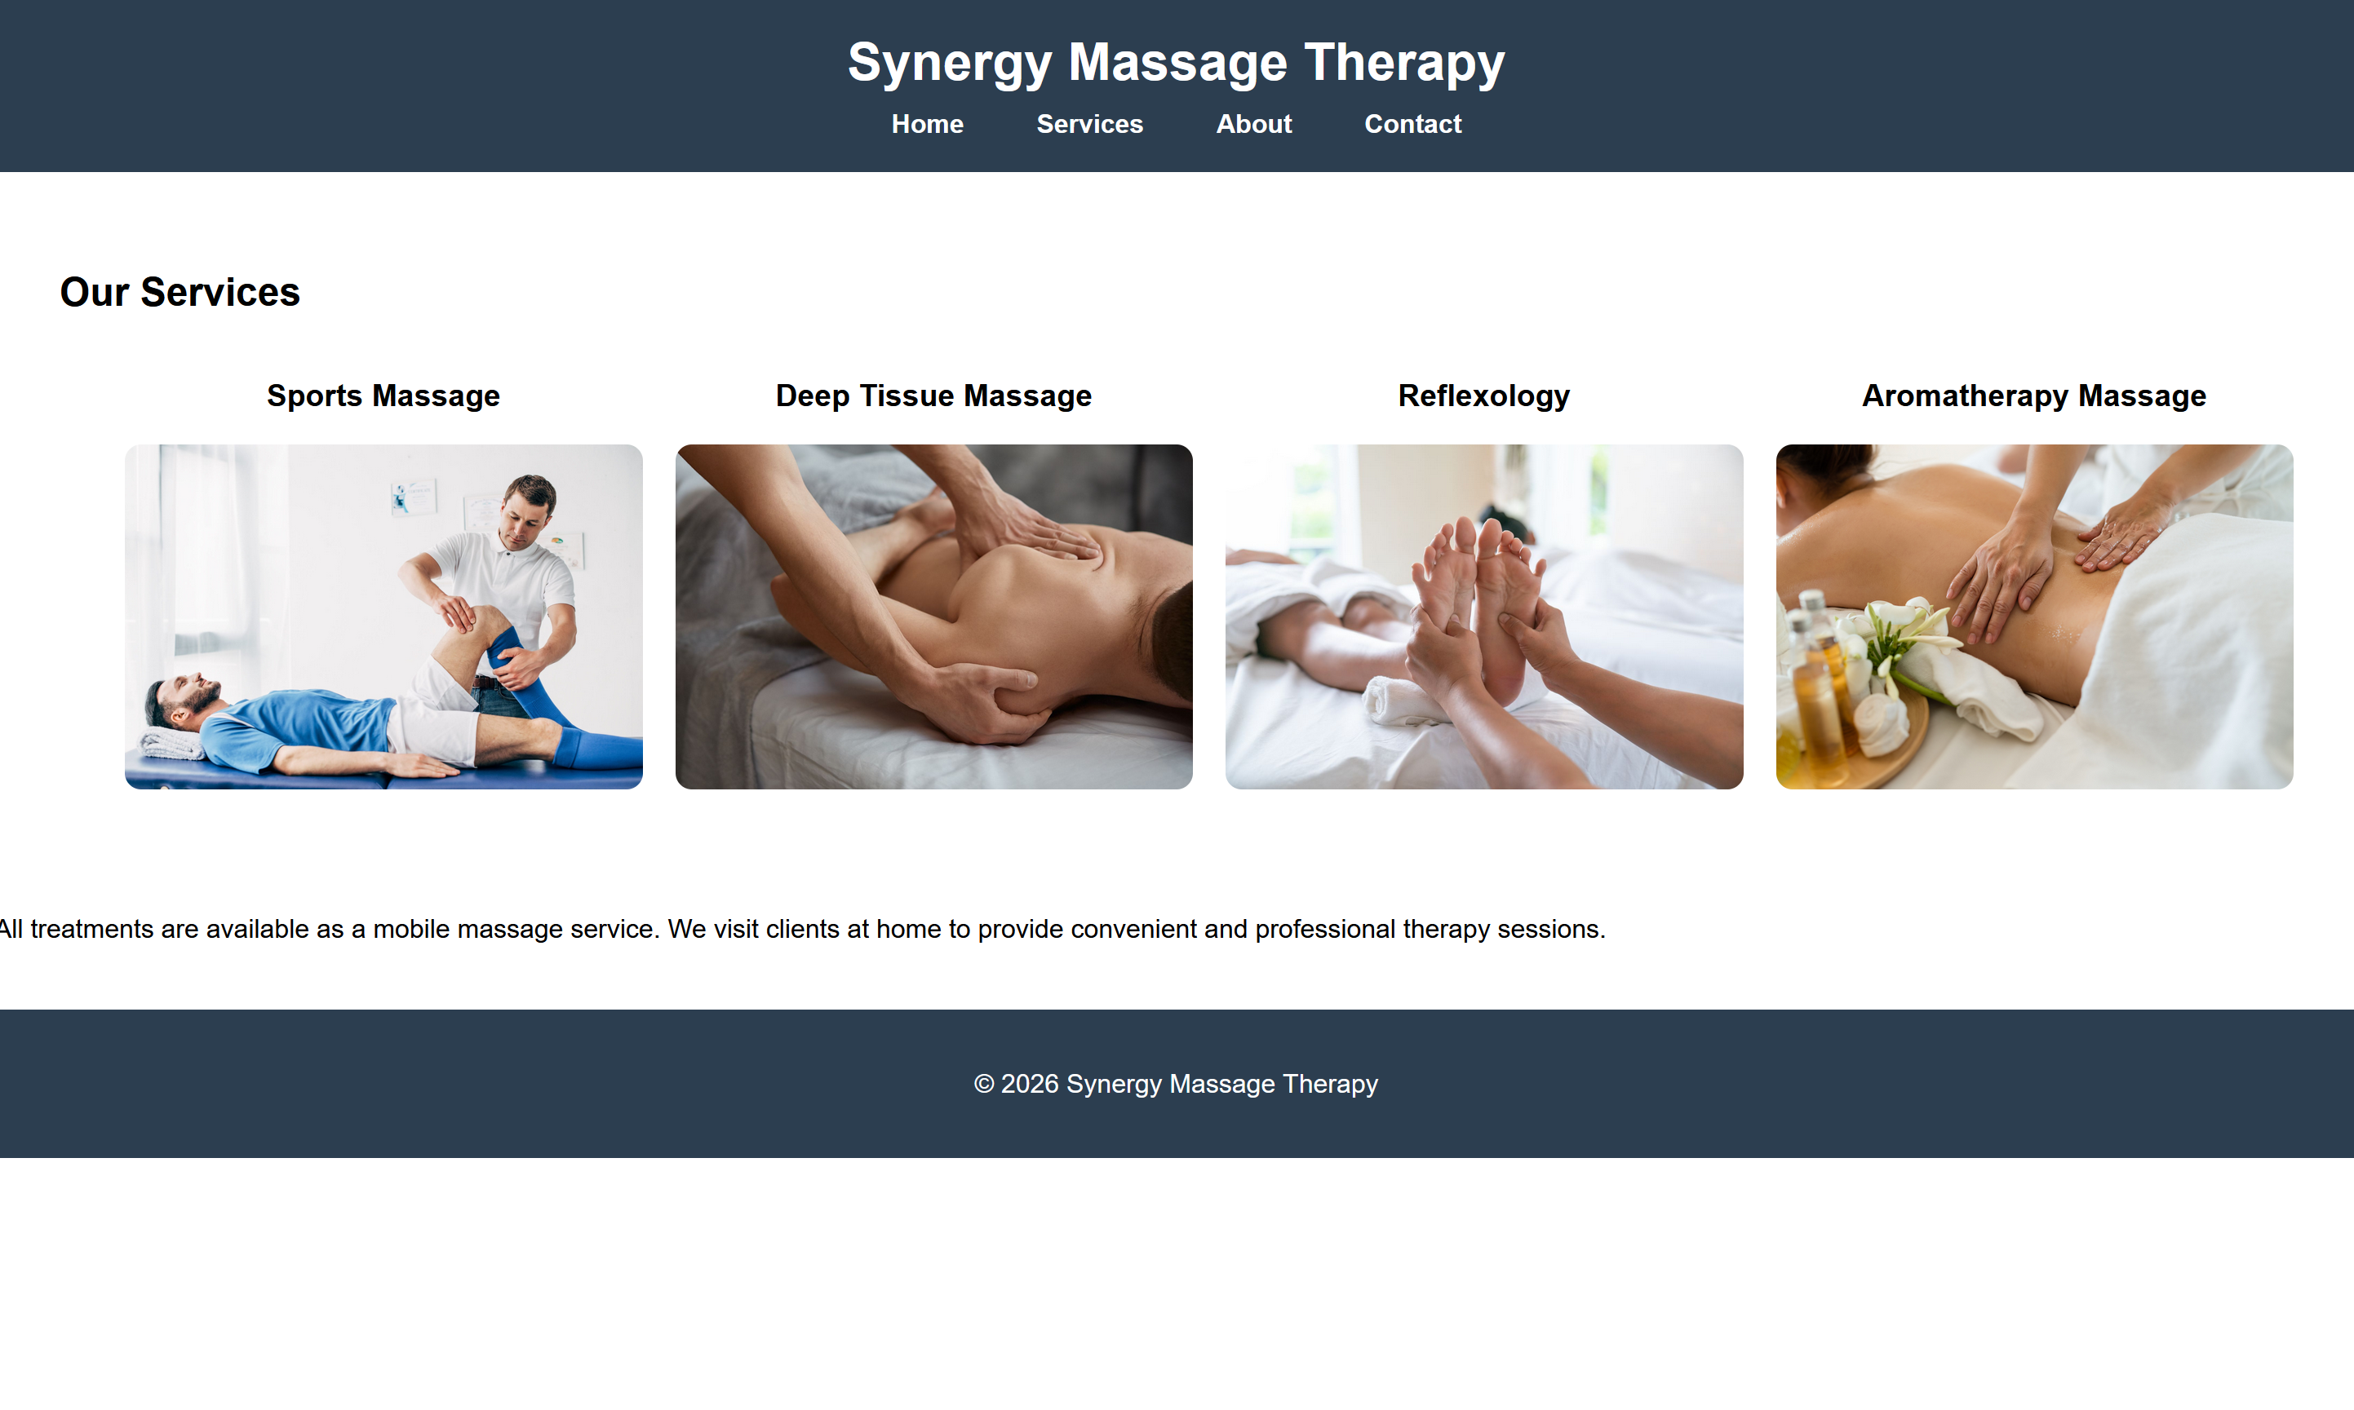
Figure 2 : Services Page Layout of Synergy Massage Therapy Website

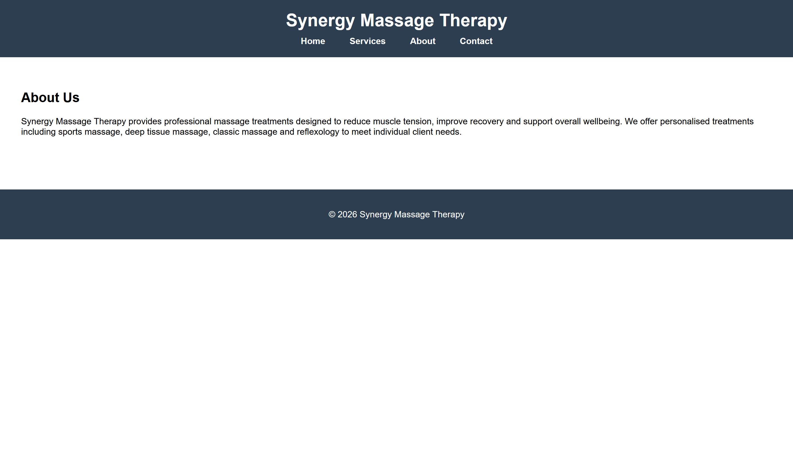
Figure 3: About Page Layout of Synergy Massage Therapy Website

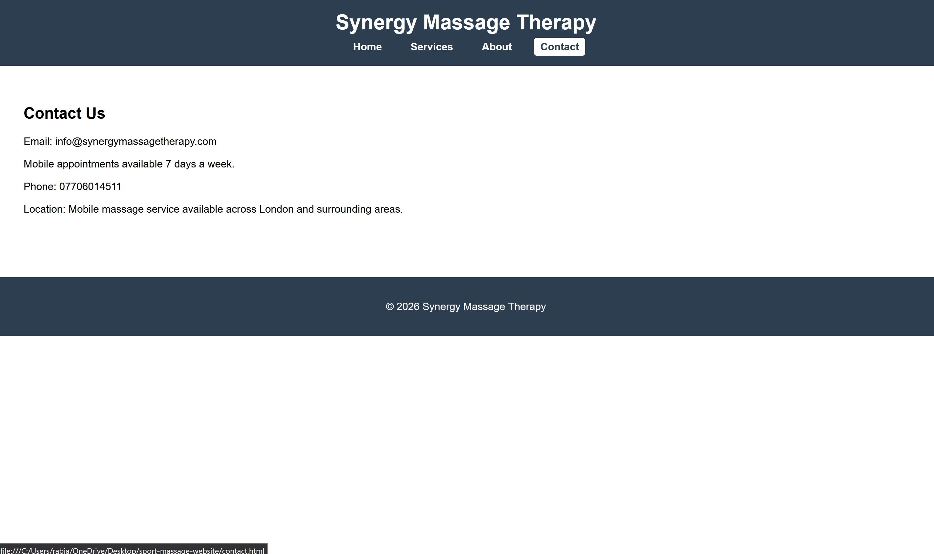
Figure 4: Contact Page Layout of Synergy Massage Therapy Website

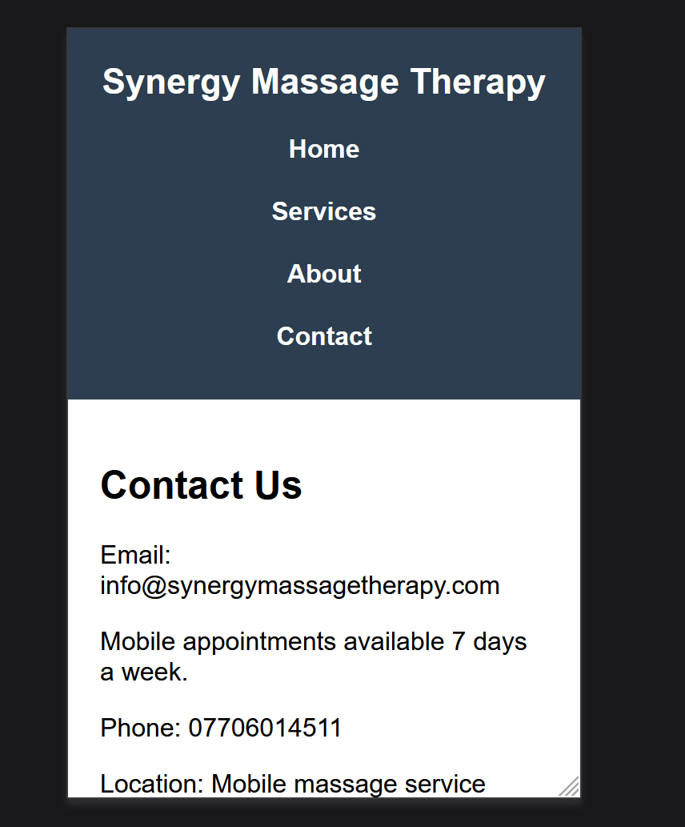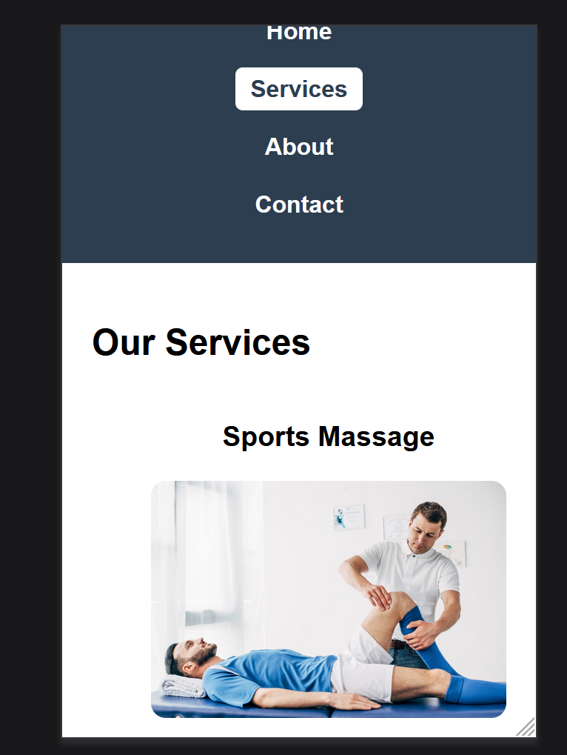
Figure 5: Mobile Responsive View Layout of Synergy Massage Therapy Website

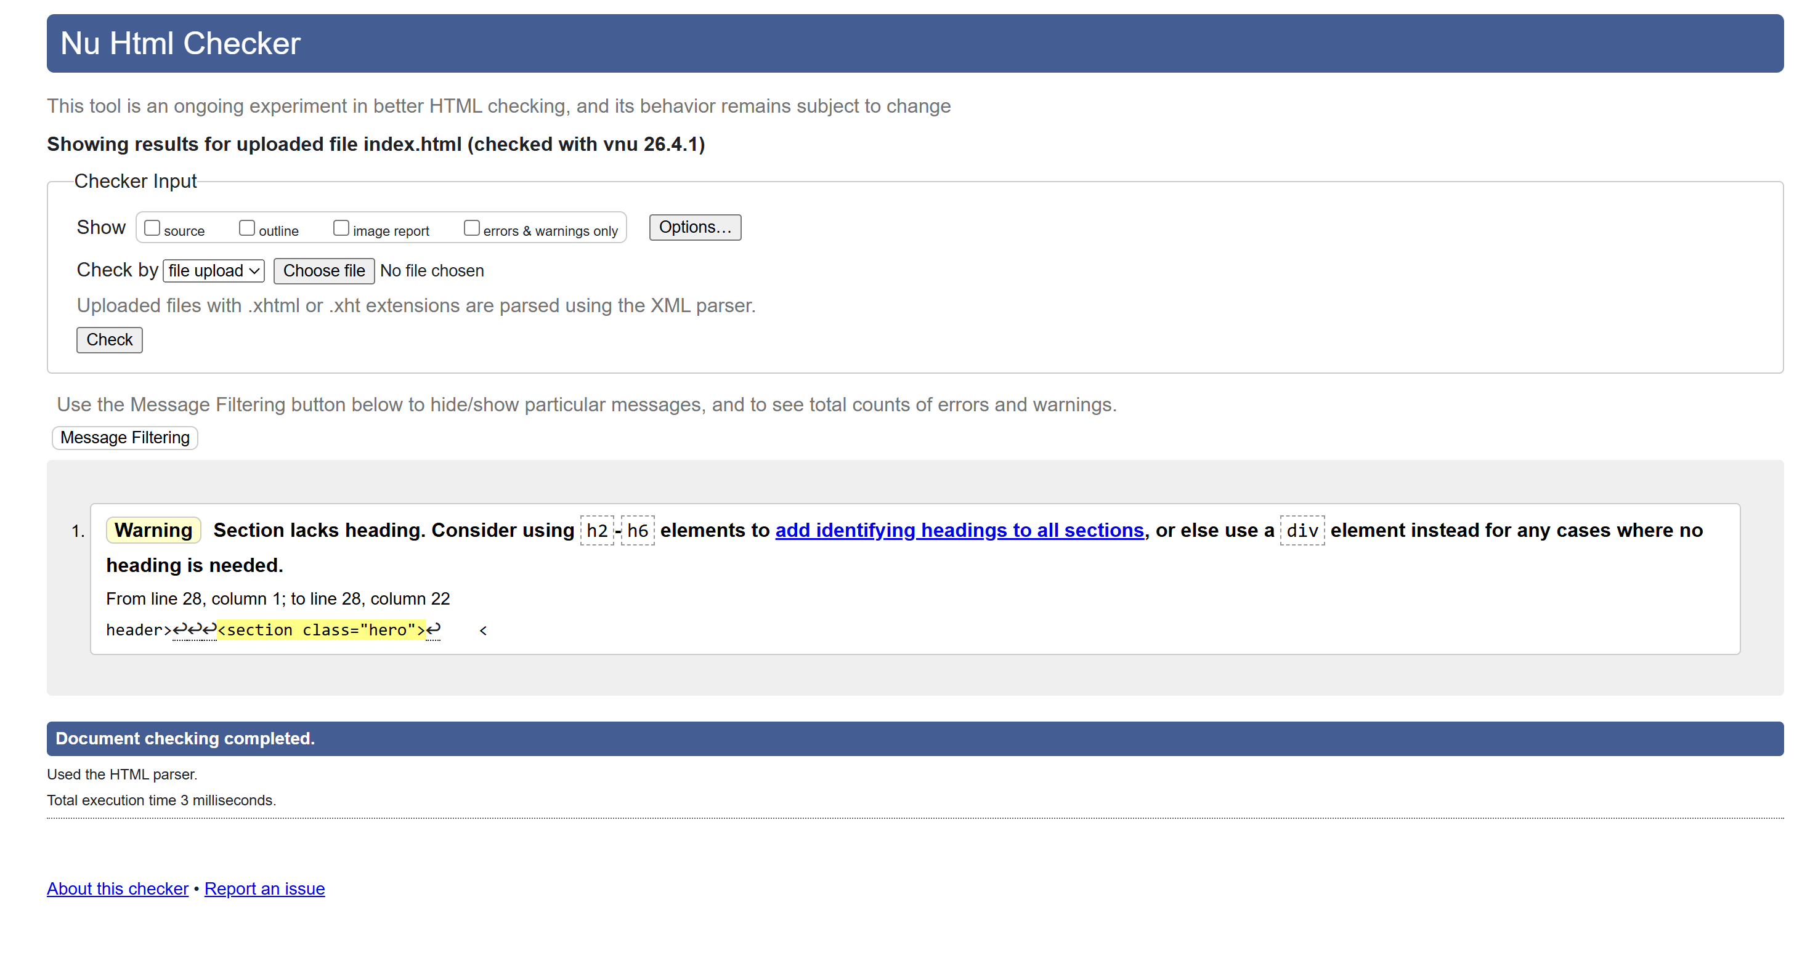
Figure 6: HTML validation results for the home page [1]
Figure 6 shows the validation results of the HTML code using the W3C HTML Validator. The validation identified one warning related to a section element lacking a heading. However, this warning did not affect the structure or functionality of the webpage. No critical errors were detected during the validation process.
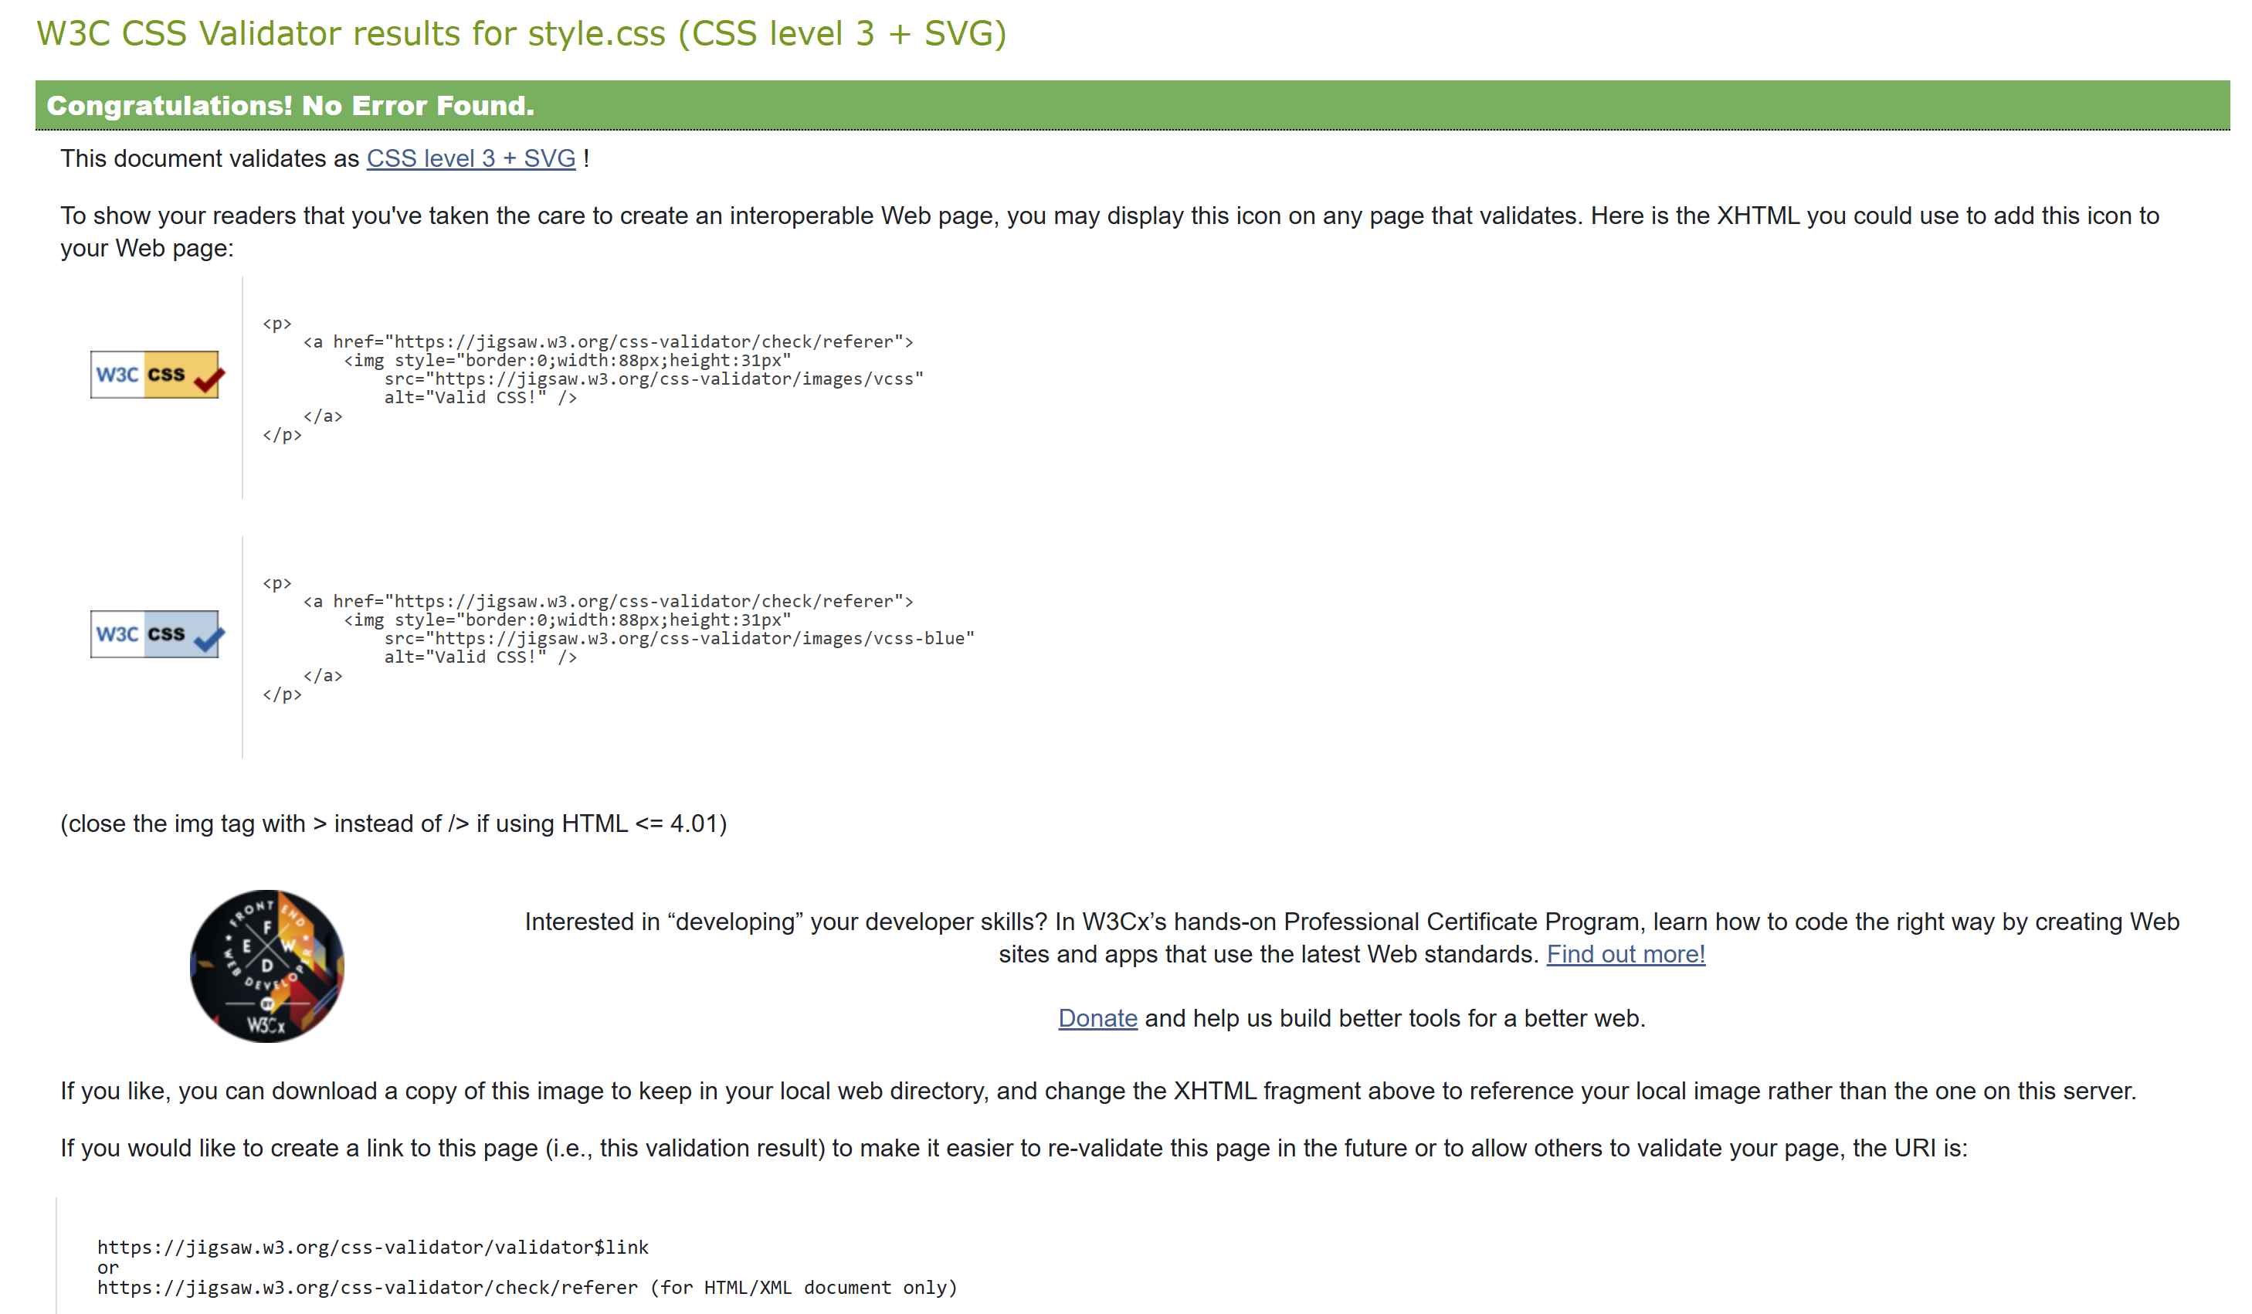
Figure 7: CSS validation results for the stylesheet [2]
Figure 7 shows the validation results of the stylesheet using the W3C CSS Validator. The validation confirmed that the CSS code followed correct syntax and styling rules, and no errors were identified during the validation process.
This result demonstrates that the layout, styling structure and responsive design features were implemented correctly and follow recognised web development standards. [3]

Errors and Fixes

W3C HTML Validator was used during validation process to test HTML code on the home page. The validator found one warning on the section element without a heading; however, the heading element is present on the section element, so the warning does not cause any functionality or layout issues on the home page. No structural changes were made as a result of the warning.

The W3C CSS Validator was used for validation of the CSS styles for validating that the styles did not contain any syntax errors. Therefore, it can be concluded that the layout styles, grid layouts, and responsive design features were implemented correctly.

A few of the layout adjustments made earlier in the development process were made to align with the devices appropriately and fix images correctly, including bringing images into alignment and fixing the layout of the mobile device using media queries for CSS.

Overall, the validation process showed that the website complied with recognised web development standards, and worked correctly across multiple devices.

Evaluation

Research (Usability, Accessibility, SEO)
Usability is an important aspect of website design because it ensures that users can easily navigate a website and find the information they are looking for without confusion. A clear navigation structure, readable layout and consistent page design all help improve the overall user experience.
Accessibility refers to how easily different users, including those with disabilities, are able to access and use a website. Accessibility can be improved by adding alternative text to images, using structured headings and ensuring the website works correctly across different devices and screen sizes. These features help users who rely on assistive technologies such as screen readers.
Search Engine Optimisation (SEO) is used to improve the visibility of websites in search engine results. SEO techniques include the use of meaningful page titles, structured headings, relevant keywords and mobile-friendly layouts. These techniques help users find websites more easily through search engines.

Website Evaluation

The Synergy Massage Therapy website was designed with usability as a key priority. A clear navigation menu is available on every page, allowing users to move easily between the Home, Services, About and Contact sections. This improves user experience by helping visitors quickly find the information they need.
Images were included on the Home and Services pages to improve visual engagement and help users better understand the types of massage treatments available. The layout uses consistent colours, spacing and structure across all pages to create a professional appearance.
Accessibility was considered during the development process by adding alternative text to images and ensuring that the website layout works correctly on both desktop and mobile devices. Responsive CSS media queries were used to adapt the layout for smaller screens.
Several SEO techniques were also applied, including meaningful page titles, structured headings and relevant keywords related to massage therapy services. These techniques help improve search engine visibility and make the website easier for potential users to find online.

Website Comparison

Comparison Website : https://www.londonmassagetherapy.co.uk [4]
To evaluate the effectiveness of the Synergy Massage Therapy website, it was compared with another massage therapy website based in London.
Both websites provide clear information about massage treatments and include structured navigation menus to help users move between pages easily. However, the Synergy Massage Therapy website uses a simpler layout which improves readability and makes it easier for users to focus on important service information.
In terms of accessibility, both websites include structured headings and readable content. The Synergy Massage Therapy website also includes alternative text for images and responsive layout features to support mobile users.
From an SEO perspective, both websites use relevant keywords related to massage therapy services. The Synergy Massage Therapy website includes clear page titles and structured headings which help improve search engine visibility.
In terms of mobile friendliness, the Synergy Massage Therapy website adapts effectively to smaller screen sizes using CSS media queries. This ensures that the layout remains easy to read and navigate on mobile devices.
Overall, the comparison shows that the Synergy Massage Therapy website provides a clear, accessible and mobile-friendly user experience that meets the expectations of a modern service website.

Conclusion

To sum up this project, which has been completed, Synergy Massage Therapy have an informative and user-friendly mobile view of their multi page responsive website that has been coded in HTML and CSS. Since the site was intended purely to provide a clear view of the services that they (Synergy Massage Therapy) offer, as well as make it easy for potential clients to understand what kinds of treatments they provide.

To assist with the overall look and feel of the website a series of website design principles were used throughout the development process. Examples of these principles are: structured navigation; consistent layout; responsive style, and; accessibility features such as alternative text for images. All of these elements together helped to improve usability and also ensure that both desktop and mobile devices were able to access the site.

Validation tools were used to validate that the HTML and CSS codes complied with the relevant web development standards. Overall the site meets the assignment requirements and therefore provides an appropriate image of a professional mobile massage therapy business through its online presence.

References

[1] | W. W. W. C. (W3C), “Markup Validation Service,” 2024. [Online]. Available: https://validator.w3.org.
[2] | W. W. W. C. (W3C), “CSS Validation Service,” 2024. [Online]. Available: https://jigsaw.w3.org/css-validator.
[3] | W. W. W. C. (W3C), “Web Content Accessibility Guidelines (WCAG) 2.1,” 2018. [Online]. Available: https://www.w3.org/TR/WCAG21.
[4] | L. M. Therapy, “London Massage Therapy,” 2024. [Online]. Available: https://www.londonmassagetherapy.co.uk.

Appendices

Appendix A – index.html
<!DOCTYPE html>
<html lang="en">
<head>
<meta charset="UTF-8">
<meta name="viewport" content="width=device-width, initial-scale=1.0">
<title>Synergy Massage Therapy</title>

<link rel="stylesheet" href="style.css">

</head>

<body>

<header>

<h1>Synergy Massage Therapy</h1>

<nav>
<a href="index.html">Home</a>
<a href="services.html">Services</a>
<a href="about.html">About</a>
<a href="contact.html">Contact</a>
</nav>

</header>

<section class="hero">

<img src="images/massage.jpg" alt="Mobile massage therapy treatment" width="400">
<h2>Professional Massage Therapy for Recovery and Relaxation</h2>
<p>Supporting your health, recovery and overall wellbeing wıth mobıle massage therapy delıvered to your home</p>

</section>

<section>

<h2>Welcome</h2>

<p>
We provide expecıally professional sports massage treatments designed to reduce pain,
improve mobility and support recovery from injury.
</p>

</section>

<footer>

<p>© 2026 Synergy Massages Therapy</p>

</footer>

</body>

Appendix B – services.html
<!DOCTYPE html>
<html lang="en">

<head>

<meta charset="UTF-8">
<meta name="viewport" content="width=device-width, initial-scale=1.0">

<title>Services - Synergy Massage Therapy</title>

<link rel="stylesheet" href="style.css">

</head>

<body>

<header>

<h1>Synergy Massage Therapy</h1>

<nav>

<a href="index.html">Home</a>
<a href="services.html">Services</a>
<a href="about.html">About</a>
<a href="contact.html">Contact</a>

</nav>

</header>

<section>

<h2>Our Services</h2>

<div class="services">

<div>
<h3>Sports Massage</h3>
<img src="images/sports.jpeg" alt="Sports massage treatment">
</div>

<div>
<h3>Deep Tissue Massage</h3>
<img src="images/deep.jpeg" alt="Deep tissue massage treatment">
</div>

<div>
<h3>Reflexology</h3>
<img src="images/reflexology.jpg" alt="Reflexology massage treatment">
</div>

<div>
<h3>Aromatherapy Massage</h3>
<img src="images/aromatherapy.jpg" alt="Aroma Therapy massage treatment">
</div>

</div>

</section>

<p>
All treatments are available as a mobile massage service. We visit clients at home to provide convenient and professional therapy sessions.
</p>

</ul>

</section>

<footer>

<p>© 2026 Synergy Massage Therapy</p>

</footer>

</body>

</html>

Appendix C – about.html
<!DOCTYPE html>
<html lang="en">

<head>

<meta charset="UTF-8">
<meta name="viewport" content="width=device-width, initial-scale=1.0">

<title>About - Synergy Massage Therapy</title>

<link rel="stylesheet" href="style.css">

</head>

<body>

<header>

<h1>Synergy Massage Therapy</h1>

<nav>

<a href="index.html">Home</a>
<a href="services.html">Services</a>
<a href="about.html">About</a>
<a href="contact.html">Contact</a>

</nav>

</header>

<section>

<h2>About Us</h2>

<p>

Synergy Massage Therapy provides professional massage treatments designed to reduce muscle tension, improve recovery and support overall wellbeing.

We offer personalised treatments including sports massage, deep tissue massage, classic massage and reflexology to meet individual client needs.

</p>

</section>

<footer>

<p>© 2026 Synergy Massage Therapy</p>

</footer>

</body>

</html>

Appendix D – contact.html
<!DOCTYPE html>
<html lang="en">

<head>

<meta charset="UTF-8">
<meta name="viewport" content="width=device-width, initial-scale=1.0">

<title>Contact - Synergy Massage Therapy</title>

<link rel="stylesheet" href="style.css">

</head>

<body>

<header>

<h1>Synergy Massage Therapy</h1>

<nav>

<a href="index.html">Home</a>
<a href="services.html">Services</a>
<a href="about.html">About</a>
<a href="contact.html">Contact</a>

</nav>

</header>

<section>

<h2>Contact Us</h2>

<p>Email: info@synergymassagetherapy.com</p>

<p>Mobile appointments available 7 days a week.</p>

<p>Phone: 07706014511</p>

<p>Location: Mobile massage service available across London and surrounding areas.</p>

</section>

<footer>

<p>© 2026 Synergy Massage Therapy</p>

</footer>

</body>

</html>

Appendix E – style.css
/* Global reset */

* {
box-sizing: border-box;
}

body {
margin: 0;
padding: 0;
font-family: Arial, sans-serif;
overflow-x: hidden;
}

/* Header */

header {
background-color: #2c3e50;
color: white;
padding: 20px;
text-align: center;
}

header h1 {
margin: 0;
}

/* Navigation */

nav {
margin-top: 10px;
}

nav a {
color: white;
margin: 10px;
text-decoration: none;
font-weight: bold;
padding: 5px 10px;
}

nav a:hover {
background-color: white;
color: #2c3e50;
border-radius: 5px;
}

/* Hero section */

.hero {
text-align: center;
background-color: #f4f6f7;
padding: 60px 20px;
}

.hero img {
display: block;
margin: 20px auto;
max-width: 80%;
height: auto;
}

.hero h2 {
text-align: center;
}

.hero p {
text-align: center;
font-size: 18px;
}

/* Sections */

section {
padding: 40px;
}

/* Services grid */

.services {
display: grid;
grid-template-columns: repeat(auto-fit, minmax(250px, 1fr));
gap: 20px;
text-align: center;
}

.services img {
width: 100%;
height: auto;
border-radius: 10px;
}

/* Footer */

footer {
background-color: #2c3e50;
color: white;
text-align: center;
padding: 20px;
margin-top: 40px;
}

/* MOBILE RESPONSIVE SETTINGS */

@media (max-width: 768px) {

header h1 {
font-size: 22px;
}

nav {
display: flex;
flex-direction: column;
align-items: center;
}

nav a {
margin: 5px 0;
}

.hero {
padding: 30px 10px;
}

.services {
grid-template-columns: 1fr;
}

section {
padding: 20px;
}

}

