

Introduction to Web and Database Concepts
ACCA4023

Component 1: Design and Implementation of a Relational Database System

Student ID – 2432768
Student Name – Jozef Szepesi

Lecturer Name: Sadhana Jha

Date: 05/03/2026

Table of Contents
Scenario Analysis 3
Entity Relationship Diagram (ERD) 3
List of attributes and their descriptions 3
Supplier 4
Medicine 4
Customer 4
Prescription 4
PrescriptionDetail 4
Sale 5
SalesDetail 5
List of relationships and their meaning. 5
Supplier supplies Medicine 5
Customer receives Prescription 5
Prescription has PrescriptionDetail 6
Medicine appears in PrescriptionDetail 6
Customer makes Sale 6
Sale includes SalesDetail 6
Medicine appears in SalesDetail 6
Use of Junction Tables 6
ER diagram: 7
List of Primary Keys and Foreign Keys 8
Primary Keys 8
Foreign Keys and Their References 8
Normalization 8
Relational Schema Generation 9
First Normal Form (1NF) 9
Second Normal Form (2NF) 9
Third Normal Form (3NF) 10
Sample Data Population 10
Query Development 12
Query 1: Low Stock Medicines 12
Query 2: Sales by Customer 13
Query 3: Sales Transaction Details 14
Query Development Summary 15
Testing and Validation 15
Design Decisions and Future Work 16
1. Design Decisions: 16
2. Future Work: 17
References: 18

Table of Figures
Figure 1: Diagram created using Creately 7
Figure 2: Sample data entered into Medicines table 11
Figure 3: Sample data entered into Customers table 12
Figure 4: Results of Low Stock Medicines query 13
Figure 5: Results of Sales by Customer query 14
Figure 6: Results of Sales Transaction Details query 15

Scenario Analysis
MediLink Pharmacy is a growing community pharmacy that currently manages its daily operations using manual methods. Information such as medicine stock, supplier details, customer records, prescriptions, and sales transactions are recorded by hand. This manual system can be slow and often leads to errors, missing data, and difficulties when updating or finding information.
To improve this situation, the CEO of MediLink Pharmacy wants to introduce a database system using Microsoft Access. The purpose of this database is to store and manage all important pharmacy data in one central system. This includes details about medicines, suppliers, customers, prescriptions, and sales. Using a database will help the pharmacy work more efficiently and reduce the risk of human error.
The database system will allow staff to track medicine stock levels, record prescriptions issued to customers, and store details of sales transactions. It will also make it easier to produce reports for management, such as checking low stock items, monitoring sales activity, and supporting regulatory requirements.
For this coursework, the real-world pharmacy system has been simplified. The focus is on designing and implementing a database that demonstrates good database design principles. This includes identifying entities, defining relationships, applying normalisation, and implementing the system in Microsoft Access. This system aims to improve accuracy, reduce manual errors, and support better data management within the pharmacy.

Entity Relationship Diagram (ERD)

List of attributes and their descriptions
This section describes each entity used in the database and explains the purpose of its attributes. The entities and attributes were identified using the entity-relationship modelling approach, which provides a structured way to represent real-world data and relationships in a database system [1]. The attributes represent the information that needs to be stored for MediLink Pharmacy to operate effectively.

Supplier
The Supplier entity stores information about the companies that supply medicines to the pharmacy. Each supplier is identified using a unique SupplierID, which is used as the primary key in the table. The SupplierName stores the name of the supplier company. The ContactNumber and Email attributes are used to store the supplier’s contact details, while the Address attribute records the physical location of the supplier.

Medicine
The Medicine entity stores details about all medicines sold by the pharmacy. Each medicine is uniquely identified by the MedicineID, which acts as the primary key. The MedicineName attribute stores the name of the medicine, and the Category attribute describes the type of medicine, such as pain relief or antibiotics. The UnitPrice attribute records the price of a single unit, while StockQuantity shows how many units are currently available in stock. The ExpiryDate attribute stores the date when the medicine expires. The SupplierID is included as a foreign key to link each medicine to the supplier that provides it.

Customer
The Customer entity stores personal information about customers who use the pharmacy. Each customer is uniquely identified using the CustomerID, which is the primary key of the table. The FirstName and LastName attributes store the customer’s name. The DateOfBirth attribute records the customer’s date of birth, which can be useful for identification purposes. The PhoneNumber attribute stores the customer’s contact telephone number, and the Address attribute records the customer’s home address.

Prescription
The Prescription entity stores information about prescriptions that are issued to customers. Each prescription is uniquely identified using the PrescriptionID, which acts as the primary key. The PrescriptionDate attribute records the date on which the prescription was issued. The DoctorName attribute stores the name of the doctor who issued the prescription. The CustomerID attribute is included as a foreign key to link each prescription to the customer who received it.

PrescriptionDetail
The PrescriptionDetail entity acts as a junction table that links prescriptions and medicines together. Each prescription detail record is uniquely identified by the PrescriptionDetailID, which is used as the primary key. The PrescriptionID attribute is a foreign key that links the record to a specific prescription, while the MedicineID attribute links it to the medicine that has been prescribed. The Quantity attribute records the amount of the medicine included in the prescription.

Sale
The Sale entity stores details of sales transactions made by customers at the pharmacy. Each sale is uniquely identified using the SaleID, which is the primary key of the table. The SaleDate attribute records the date when the sale took place. The TotalAmount attribute stores the total cost of the sale. The CustomerID attribute is included as a foreign key to link each sale to the customer who made the purchase.

SalesDetail
The SalesDetail entity acts as a junction table that links sales and medicines. Each sales detail record is uniquely identified using the SalesDetailID, which serves as the primary key. The SaleID attribute is a foreign key that links the record to a specific sale, while the MedicineID attribute links it to the medicine that was sold. The Quantity attribute records the number of units sold in the transaction, and the SubTotal attribute stores the cost of the medicine multiplied by the quantity sold.

List of relationships and their meaning.
This section explains the relationships between the entities in the database and describes how they are connected. These relationships are based on the real-world operations of MediLink Pharmacy and ensure that data is stored in a structured and organised way.

Supplier supplies Medicine
There is a one-to-many relationship between Supplier and Medicine. One supplier can supply many different medicines to the pharmacy. However, each medicine is supplied by only one supplier. This relationship helps the pharmacy identify where each medicine comes from and manage supplier information effectively.

Customer receives Prescription
There is a one-to-many relationship between Customer and Prescription. A customer can receive multiple prescriptions over time, but each prescription belongs to only one customer. This allows the pharmacy to track prescription history for each customer accurately.

Prescription has PrescriptionDetail
There is a one-to-many relationship between Prescription and PrescriptionDetail. A prescription can include multiple medicines, and each medicine on a prescription is recorded as a separate prescription detail. This relationship helps manage prescriptions that contain more than one medicine.

Medicine appears in PrescriptionDetail
There is a one-to-many relationship between Medicine and PrescriptionDetail. A medicine can appear in many different prescriptions, but each prescription detail record refers to only one medicine. This relationship links medicines to prescriptions in a structured way.

Customer makes Sale
There is a one-to-many relationship between Customer and Sale. A customer can make multiple purchases at the pharmacy, but each sale is associated with only one customer. This relationship allows the pharmacy to track customer purchasing activity.

Sale includes SalesDetail
There is a one-to-many relationship between Sale and SalesDetail. A single sale can include multiple medicines, and each medicine sold is recorded as a separate sales detail. This makes it easier to record and analyse sales transactions.

Medicine appears in SalesDetail
There is a one-to-many relationship between Medicine and SalesDetail. A medicine can be sold many times in different sales, but each sales detail record refers to one medicine. This relationship helps track how often medicines are sold.

Use of Junction Tables
The relationships between Prescription and Medicine, and between Sale and Medicine, are many-to-many relationships in real life. To handle this correctly, junction tables (PrescriptionDetail and SalesDetail) are used. These tables break down the many-to-many relationships into one-to-many relationships and allow additional information, such as quantity, to be stored.

ER diagram:
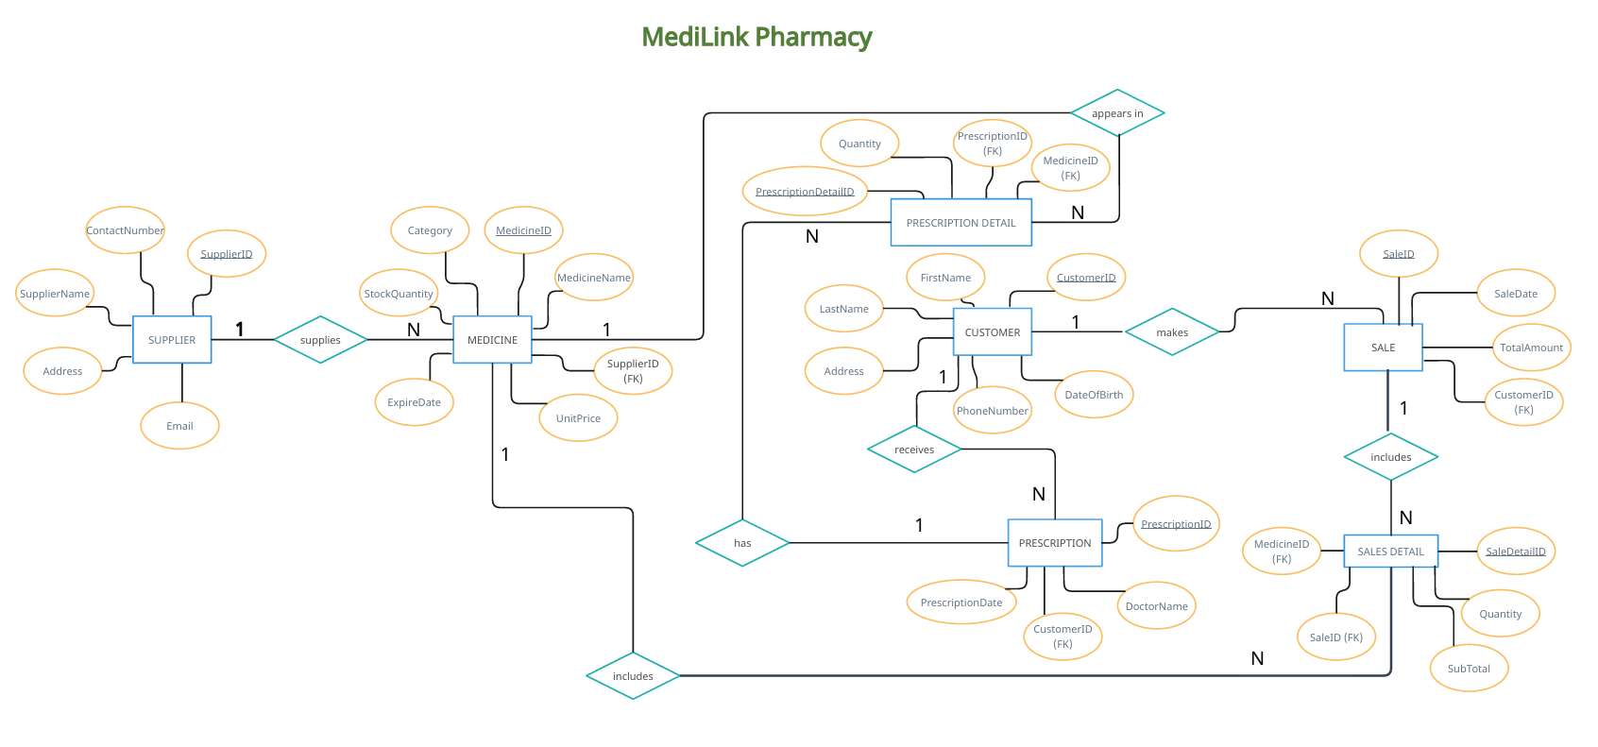
Figure 1: Diagram created using Creately

A screenshot of the Entity Relationship Diagram (ERD) created using Creately is provided in this report. The ER diagram clearly shows all entities used in the MediLink Pharmacy database, along with their attributes, relationships, cardinality, and participation constraints. The diagram was designed following a structured, step-by-step approach to entity and relationship modelling, which helps ensure clarity and correctness in database design [1].
Each entity in the ER diagram includes its attributes, with primary keys clearly identified. Foreign keys are also shown as attributes within the relevant entities to represent relationships between tables. The relationships between entities are displayed using one-to-many (1:N) cardinality, which reflects the real-life operations of the pharmacy.
Participation constraints are shown implicitly through the structure of the ER diagram. Detail entities such as PrescriptionDetail and SalesDetail have full participation, as they cannot exist without being linked to a parent entity. Other entities such as Customer, Supplier, and Medicine have partial participation, as they may exist without being involved in a prescription or sale. These constraints support data integrity and consistency and are enforced in Microsoft Access using referential integrity, following established entity-relationship modelling principles [2].

List of Primary Keys and Foreign Keys

This section explains the primary keys used in the database and how foreign keys are used to link tables together.

Primary Keys
Primary keys are used in the database to uniquely identify each record in a table. The Supplier table uses SupplierID as its primary key, while the Medicine table uses MedicineID. The Customer table is identified using CustomerID, and prescriptions are uniquely identified by PrescriptionID. The PrescriptionDetail table uses PrescriptionDetailID as its primary key. Sales transactions are identified using SaleID, and individual sales records are identified using SalesDetailID in the SalesDetail table.

Foreign Keys and Their References
Foreign keys are used to link related tables together and maintain relationships between entities. The SupplierID attribute in the Medicine table refers to the SupplierID primary key in the Supplier table, linking medicines to their suppliers. The CustomerID attribute is used as a foreign key in both the Prescription and Sale tables to connect records to customers. In the PrescriptionDetail table, PrescriptionID refers to the primary key in the Prescription table, and MedicineID refers to the primary key in the Medicine table. Similarly, the SalesDetail table uses SaleID to link to the Sale table and MedicineID to link to the Medicine table.
These primary and foreign keys ensure that relationships between entities are maintained correctly and that data integrity is preserved throughout the database.

Normalization
Normalization is the process of organising data in a database to reduce duplication and improve data integrity. It is a fundamental concept in relational database design and helps ensure consistency and reliability of stored data [3]. The process of applying normal forms step by step reduces redundancy and prevents problems such as insertion, update, and deletion anomalies [4].
In this database design, normalization was applied after converting the Entity Relationship Diagram (ERD) into relational schemas. The normalization process was carried out gradually, following First Normal Form (1NF), Second Normal Form (2NF), and Third Normal Form (3NF).

Relational Schema Generation
Based on the Entity Relationship Diagram (ERD), relational schemas were developed to represent each entity as a table. This stage converts the conceptual ER model into a logical relational structure that can be implemented in Microsoft Access [2].
The Supplier relation includes SupplierID (Primary Key), SupplierName, ContactNumber, Email, and Address. The Medicine relation includes MedicineID (Primary Key), MedicineName, Category, UnitPrice, StockQuantity, ExpiryDate, and SupplierID (Foreign Key), which links each medicine to its supplier.
The Customer relation consists of CustomerID (Primary Key), FirstName, LastName, DateOfBirth, PhoneNumber, and Address. The Prescription relation includes PrescriptionID (Primary Key), PrescriptionDate, DoctorName, and CustomerID (Foreign Key), linking prescriptions to customers.
To resolve many-to-many relationships identified in the ERD, junction tables were created. The PrescriptionDetail relation includes PrescriptionDetailID (Primary Key), PrescriptionID (Foreign Key), MedicineID (Foreign Key), and Quantity. Similarly, the SalesDetail relation includes SalesDetailID (Primary Key), SaleID (Foreign Key), MedicineID (Foreign Key), Quantity, and SubTotal. These tables allow multiple medicines to be associated with a single prescription or sale while maintaining a normalised structure.
The resulting relational schemas were then reviewed and prepared for the normalisation process to ensure the database structure was organised, efficient, and free from unnecessary data duplication.

First Normal Form (1NF)
A table is in First Normal Form if all attributes contain atomic values and there are no repeating groups. Each field must store only one value, and each record must be uniquely identifiable by a primary key [3].
In this database, all tables satisfy 1NF because there are no multi-valued attributes. For example, medicines included in a sale are not stored in a single field. Instead, each medicine is recorded separately in the SalesDetail table. This ensures that the structure remains simple and organised.

Second Normal Form (2NF)
A table is in Second Normal Form if it is already in First Normal Form and all non-key attributes depend fully on the entire primary key. This removes partial dependencies and ensures that data is logically structured [4].
In this database, tables such as Supplier, Customer, Medicine, Sale, and Prescription use a single primary key. Therefore, all non-key attributes depend entirely on that key. Junction tables such as PrescriptionDetail and SalesDetail were designed carefully so that attributes like Quantity depend on the full relationship between the linked entities. As a result, the database satisfies the requirements of 2NF.

Third Normal Form (3NF)
A table is in Third Normal Form if it is already in Second Normal Form and there are no transitive dependencies. This means that non-key attributes should not depend on other non-key attributes [3].
In this database, related information is stored only in its correct table. For example, supplier details are stored only in the Supplier table and are not duplicated in the Medicine table. Medicines are linked to suppliers using SupplierID. This design avoids redundancy and ensures that changes only need to be made in one place.
Therefore, the database structure satisfies Third Normal Form and supports efficient data management.

Sample Data Population
Sample data was added to the database to test the structure and ensure that the tables and relationships work correctly. The data entered reflects realistic examples of how MediLink Pharmacy would operate on a daily basis. At least five records were added to the main tables to meet the coursework requirements.
The Supplier table was populated with sample suppliers, including supplier names, contact numbers, email addresses, and addresses. This data represents companies that provide medicines to the pharmacy.
The Medicine table was populated with a range of medicines, including their names, categories, unit prices, stock quantities, expiry dates, and supplier references. Each medicine record is linked to a supplier using the SupplierID foreign key, which ensures referential integrity.
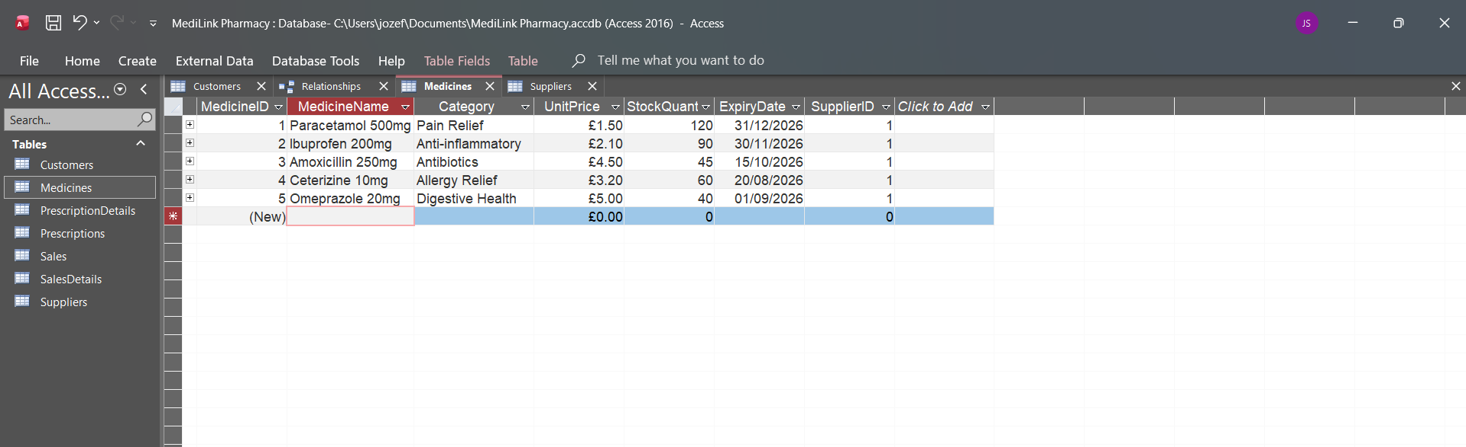
Figure 2: Sample data entered into Medicines table

The Customer table was populated with sample customer details such as first name, last name, date of birth, phone number, and address. These records represent customers who visit the pharmacy and purchase medicines or receive prescriptions.
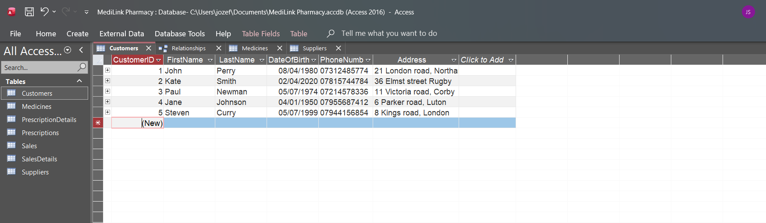
Figure 3: Sample data entered into Customers table

The Prescription table includes sample prescriptions issued to customers. Each prescription record stores the prescription date, doctor’s name, and a reference to the related customer. The PrescriptionDetail table was then populated to record which medicines were prescribed and in what quantities.
The Sale table was populated with sample sales transactions, including sale dates, total amounts, and customer references. The SalesDetail table records the medicines sold in each sale, along with quantities and subtotals. This allows each sale to include multiple medicines while maintaining a normalised structure.
Screenshots of the populated tables are included to demonstrate that the data has been successfully entered and that the relationships between tables are functioning as expected.

Query Development
Queries were created and executed in Microsoft Access to retrieve useful information from the MediLink Pharmacy database. In relational database systems, queries are used to filter, join, and analyse data stored across multiple tables [5]. These operations are based on relational principles that allow related data to be combined efficiently.
The queries developed demonstrate how the database can support daily pharmacy operations such as stock monitoring and sales tracking. Screenshots of the query results are included as evidence.

Query 1: Low Stock Medicines
This query was executed to identify medicines with low stock levels. It helps the pharmacy know which medicines may need to be reordered soon.
Query executed: Low Stock Medicines
Result shown: Medicine name, category, stock quantity, and expiry date.
A screenshot of the query results is included to show the medicines that have low stock levels.
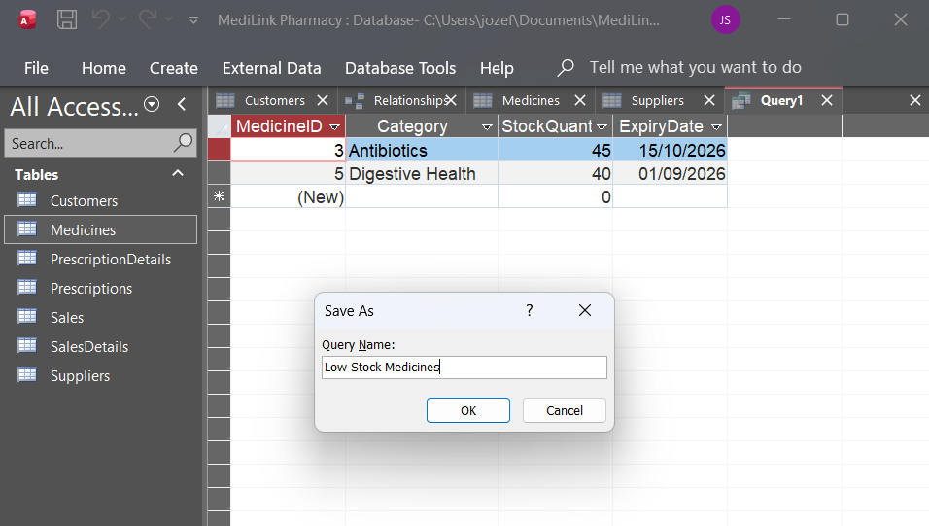
Figure 4: Results of Low Stock Medicines query

Query 2: Sales by Customer
This query was created to display sales transactions made by customers. It joins the Customer and Sale tables using the CustomerID field to show how individual purchases are linked to specific customers.
The results include customer details, the sale date, and the total amount of each transaction. This allows the pharmacy to monitor customer purchasing activity and review sales history when needed.
A screenshot of the query results is included to demonstrate that the relationship between customers and sales has been implemented correctly.
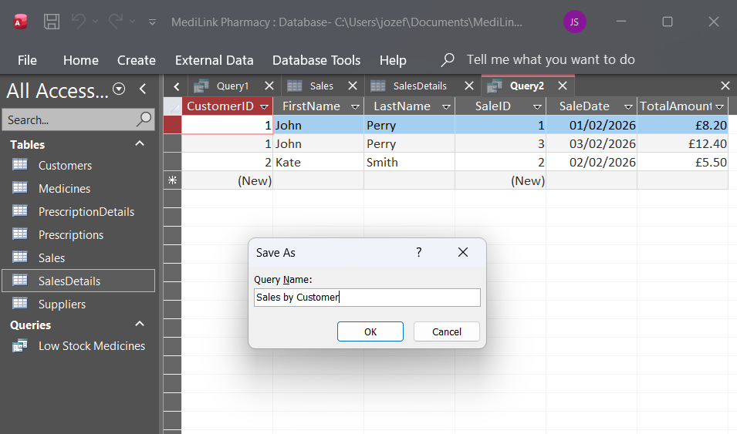
Figure 5: Results of Sales by Customer query

Query 3: Sales Transaction Details
This query was executed to show the medicines included in each sale, including quantities and subtotals.
Query executed: Sales Transaction Details
Result shown: Sale ID, medicine name, quantity sold, and subtotal.
A screenshot of the query results is included to demonstrate how individual sale items are recorded.
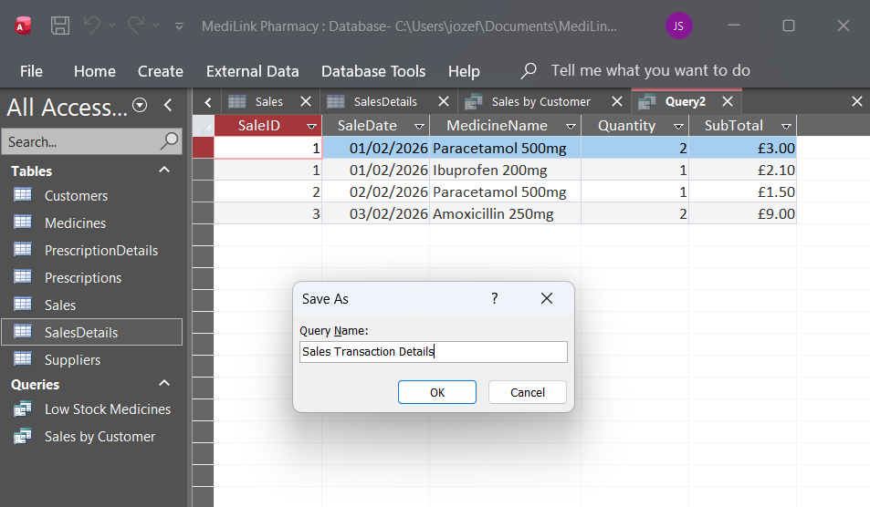
Figure 6: Results of Sales Transaction Details query

Query Development Summary
The executed queries successfully retrieve meaningful information from the database. The screenshots of the query results confirm that the queries work correctly and that the relationships between tables have been implemented properly.

Testing and Validation
Testing and validation were carried out to ensure that the MediLink Pharmacy database works correctly and meets the functional requirements of the system. The testing focused on table relationships, data entry, and query execution within Microsoft Access.
Firstly, table relationships were tested by enforcing referential integrity between related tables. For example, the system did not allow a medicine to be added unless a valid supplier existed in the Suppliers table. This confirmed that foreign key constraints were working correctly and helped prevent invalid data from being entered into the database.
Data entry testing was also performed by adding sample records to the Customers, Medicines, Sales, and SalesDetails tables. During testing, attempts to enter records with invalid foreign key values were rejected by Microsoft Access. This demonstrated that the database maintains data accuracy and consistency.
Queries were tested after sample data had been entered. Initially, some queries returned no results because the relevant tables were empty. Once appropriate data was added, the queries produced correct and meaningful results. This confirmed that the relationships between tables were correctly implemented and that the queries were functioning as intended.
Overall, the testing process confirmed that the database design is valid, the relationships are enforced correctly, and the system performs as expected when handling real-world data.

Design Decisions and Future Work

  - Design Decisions:
Several design decisions were made while developing the MediLink Pharmacy database to ensure the system is clear, structured, and easy to manage. One important decision was to use a relational database structure. Relational database design typically follows a structured approach, starting with conceptual modelling and progressing to logical schema development before implementation [2].
Before building the database in Microsoft Access, an Entity Relationship Diagram (ERD) was created. This helped identify the main entities, their attributes, and the relationships between them. The ERD was then converted into relational schemas, following established database design practices [2].
Junction tables such as PrescriptionDetail and SalesDetail were used to manage many-to-many relationships between prescriptions and medicines, and between sales and medicines. This approach ensures the database structure remains normalised and avoids unnecessary duplication of data.
Primary keys were created using AutoNumber fields to ensure each record is unique. Foreign keys were then used to link related tables together. Referential integrity was enforced in Microsoft Access to prevent invalid data entry and maintain consistency.
One challenge during development was ensuring that primary key and foreign key data types matched correctly. Errors occurred when the data types were different, but these were resolved by adjusting the field settings. This process improved understanding of how relational links function in practice.
Overall, the final database structure follows recognised database design principles and successfully manages suppliers, medicines, customers, prescriptions, and sales in a structured and reliable way [2].

  - Future Work:
Although the current database meets the assignment requirements, there are several improvements that could be made in the future. One possible improvement would be adding forms to the database. Forms would make it easier for staff to enter and view data without working directly with tables.
Another improvement could be the creation of more detailed reports, such as monthly sales reports, profit summaries, and stock usage reports. These reports would help management understand how the pharmacy is performing and support better decision-making.
Adding these features in the future would make the system more practical for real-life use in a pharmacy.

References:
[1] P. Chen, “The Entity-Relationship Model — Toward a Unified View of Data,” ACM Trans. Database Syst., vol. 1, no. 1, pp. 9–36, Mar. 1976.
[2] T. Connolly and C. Begg, *Database Systems: A Practical Approach to Design, Implementation and Management*, 6th ed., Pearson, 2014.
[3] R. Elmasri and S. B. Navathe, *Fundamentals of Database Systems*, 7th ed., Pearson, 2015.
[4] K. Kumar and S. K. Azad, “Relational Database Design: A Review,” Int. J. Comput. Appl., vol. 176, no. 6, Oct. 2017.
[5] H. F. Korth, A. Silberschatz and S. Sudarshan, *Database System Concepts*, 6th ed., McGraw-Hill, 2010.

