DIGITAL SKILLS AND RESEARCH METHODS-BMSK4003
Abdus Samad
ID:1706498
Lecturer: Anly Chandra Mohan

Executive Summary
The executive summary is based on the digital skills required by students for their development in professional career and higher studies. Today, millennials are acquiring flexible jobs, and due to their flexibility, they are achieving success in their jobs and careers. Therefore, it is necessary for every student to upgrade and develop the technical and digital skills to survive in this competitive market. The report summarizes the application of some digital models required for the development of student's career in daily lives.

Table of Contents
Introduction 4
Research-informed Literature 4
Understanding and Knowledge of the Subject 5
Analysis 6
Practical Deployment and Application 8
Professional Practice Skills 9
Conclusion 10
References 11

Introduction
The report is concerned with the efficiency of implementing modern technologies within the workplace. The implementation was done by the students who lack digital skills. Moreover, the study reconnoiters social media as a digital tool for marketing. According to Mamoulis (2011), use of modern gadgets is significant for the development of an individual’s brain. Information regarding digital skills was gathered for the improvement of student's skills and competence. The report aims to develop awareness of the significance of the dynamic analysis of information as well as its interpretation for understanding the topic. Digital literacy model is used in this report for a better understanding of the need for digital skills for student's career improvement. The impact of cloud computing technology and file transfer management in the workplace has been discussed here.

Research-informed Literature
Today, an individual can collect varieties of information regarding digital skills and competence in internet and books on digital literacy. The development and improvement of student's proficiency are significant for copping up with the modern technologies. There is a vast difference between traditional skills and digital skills. In the past, traditional peoples were unaware of the rapid growth of technologies, but today these people are getting themselves trained on digital literacy for their career development. According to Moore (2011), the organizations should introduce new technical ways of learning in the workplace for a better understanding of the topic. The companies can make use of PowerPoint presentation in meetings and seminars while making a deal with other companies. Moreover, the implementation of cloud storages in business firms increased the workplace productivity as well as employee’s quality of work. Apart from cloud technology, the use of Microsoft Word, Microsoft PowerPoint, and Microsoft Excel is widespread for most businesses. According to Rusen (2016), it is compulsory for every student to gain and learn knowledge about these advanced digital competencies. If the student wants to work for IT companies, then necessary digital skills are mandatory. For example, McLaren Technology Group is an UK-based company where it is compulsory for every employee to have necessary digital skills. The company manufacturers formula one sports cars and digital skills play an important role in the workplace. The company has to handle a lot of information which needs enormous storage and so they use cloud storage for storing their classified information. On the other perspective, virtual assistances like Cortana, "OK Google" and Siri is the primary weapon for collecting any information. The technologies of these three virtual assistance are more or less same. According to Downey (2012), a student can do freelancing jobs from home if the student has enough digital skills. For freelancers, digital skills like webpage coding (HTML5/CSS5, JavaScript, etc.), graphic designing, film and music editing, database management system and programming languages play a significant role in earning money from home. Some individuals work from home regarding data entry jobs and other home-based jobs. Social media technologies like Facebook and Instagram has improved the communication between the co-workers of a company.

Understanding and Knowledge of the Subject
The subject about digital literacy can be understood by following a digital skill theoretical framework which has been discussed in the analysis section. In the current era, it is vital for the students to understand the importance of learning digital skills. Students can learn digital skills in many ways. Today, digital skills have become more important than communication skills because a person can communicate well with the online system if the person is aware of the digital skills need to communicate in online. According to Ferrari (2010), computer literacy and digital literacy differs from each other. The main difference is that computer literacy comes before digital education. A person cannot learn a digital skill if he or she is unware of the computer education. In professional development, digital competences help a lot. The concept of this topic is related to the need for the improvement of digital skills in student's life. For better understanding, the concepts of cloud computing and file transfer management have been discussed below:
Cloud Computing Technology: It is technology by which an individual can store data virtually without storing in hard-disk or pen-drives. The information was stored in digital form. Moreover, the physical environment of the cloud storage is owned and managed by the hosting company. UK's leading companies like HSBC and Aviva are using cloud computing technology, and this technology has helped them to accomplish workplace efficiency and increment of workplace productivity. Cloud computing reduces the time and helps employees to work fast.
File Transfer Management: Sometimes it is called electronic file transfer system. An electronic file management provides benefits like easy access to files and the process is also cost-effectiveness. According to Kužnar et al. (2016), file transfer management reduces the cost of papers and hard copies. The employees of HSBC and Aviva downloads their data from cloud storage, organize them separately by employing file transfer management, process them and again upload them to cloud storage. In this way, employees of most of the companies work with cloud computing and file transfer management.

Analysis
The analysis section discusses about the impact of digital skills on the real world. It can be argued strongly that digital literacy has brought comfort in human being's lives. There are many logical shreds of evidence which can be discussed here. Today, a minimum technical skill is necessary for surviving in this world. The digital revolution has made the life of human beings easier than before. An image has been given below which shows how customers with digital literacy perform online booking.
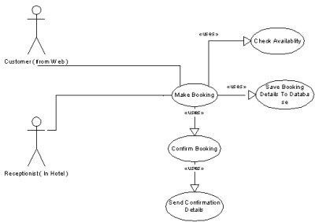
Figure: Online hotel booking system
Hotel companies of the United Kingdom like Britannia Hotel provide this kind of online booking system for their customers (Yamato, 2016). Alex Langsam who is the CEO of this hotel is responsible for proving a good online booking system to the potential customers. Online bookings can be made from computers and smartphones. Today, the emergence of applications in smartphones has changed the entire booking system. Earlier, people have to access desktop PC's for booking purpose, and now people can book anything from anywhere with the help of a smartphone and wireless internet connection. From the above figure, it can be analyzed that customer books rooms from his or her home. At first, the customer selects apartments and hotels, and after that, he or she proceeds to "Check Availability" option for checking any vacant rooms. As soon as the hotel verifies that room is vacant, then the customer moves on to "Confirm booking" option. After the confirmation, all customer details were sent to the company, and the management of the company sends the customer a room ticket through email. In the meanwhile, customer database was saved in the customer database list of the company. Apart from online booking system, the student needs to be aware of the virtual assistance by which he or she can find any information (Kužnar et al., 2016). Even, the student can book his or her preferred hotels with the help of virtual assistants. During the emergency time, people can book cabs through online booking facility. Some situation arises when a person gets lost in the city, virtual assistance like "Ok Google" and Cortana will help the person to find the place where he or she wants to go with proper direction. Google map application is connected to the virtual assistant application. As soon as the customer enter voice commands, the application changes and google map opens with directions between arrival and destination point (WU, 2017).

Practical Deployment and Application
Some real-life examples of digital skills are provided in this section. Cloud Computing Technology and Electronic File Management have brought a revolutionary change in many companies. Companies like HSBC and Aviva got affected by this extraordinary digital tool. The employees of HSBC and Aviva can drag and drop data between their cloud storage and local storage (Dufrasne et al., 2017). Cloud storage has five primary benefits such as usability, accessibility, disaster recovery, cost-saving, and bandwidth. The student can avoid emailing files to other students and instead send a link of the webpage to recipients by email. Moreover, cloud storage helps in accessing stored files from anywhere through an internet connection. This storage technology plays a significant role in backing up data, and it is highly recommended for the business to introduce an emergency backup plan to save data from deleting. Cloud storages are also beneficial for keeping business cost. The cost of cloud storage is three cents per GB. For example, HSBC purchases 100 GB cloud storage then the company have to pay 300 cents or 300 euros to the cloud storage provider (Dufrasne et al., 2017). Some of the cloud storage providers in the UK are Enterprise Compute Cloud, HPE Cloud Storage, and Amazon Cloud Drive. For students, they can use Dropbox for storing their important notes and information. In real life, the emergence of cloud storage technology has helped people to create innovative concepts and ideas relating to the digital skills and competence. Electronic File Management has helped many companies to protect their data from missing. This file management system ensures that these files will not fall easily into wrong hands if the person forgets to provide passwords to the folders. A proper file management removes messiness from the screen and helps to organize files and folders quickly.

Professional Practice Skills
Skills required for data management process impact positively on increasing the performance level of employees. In customer care departments, data management plays an essential role in retaining potential customers. Moreover, competence required for the control of data and information of customer must be present inside every employee of customer care department. The process by which data and information of customers are handled is known as data handling technique or data management process (Document management - electronic document file format for long-term preservation, 2009). The employee should be trained in skills like analysis, collection, and representation of data to solve a particular issue. The human resource department of the organizations must train the employees and new candidates with data handling technique. Consequently, the employees will be able to predict customer's behavior in future. The organization will be able to predict the future outcomes of the business and purchasing behavior of the customers. With the help of customer database, the employees need to keep track of the customers. If an individual achieves a reliable data handling process, then he or she will be able to identify the potential threats and risks in business (Mamoulis, 2011). The most significant skills that the student should have in him is to cooperate easily with the co-workers to finish a particular project within the deadline. Apart from data handling technique and cooperative nature, the student should also carry behavior of working effectively in a team. Thus, teamwork plays an important role in developing the career of the student. On the other hand, technology has helped a lot in establishing a network within and outside the workplace. So, the students should be trained technically by their mentors and tutors. The universities and colleges should introduce technical learnings needed to do basic jobs within a basic salary system. An organization implements to accomplish a stronger relationship in between their workers. Besides, it is vital for a worker to fathom their responsibilities and duties in the company. The technical support is provided by the manager of the company to the employees.

Conclusion
The paper concludes that the universities must train the students with digital skills for their future improvement. Apart from universities, the HR departments of various organizations should also train the employees with advanced and basic digital skills for increasing the workplace productivity and organizational performance. According to Greco, Molinaro, and Spezzano (2012), social media like Facebook and Instagram has helped many organizations to increase brand value. With the help of social media, these companies had developed an excellent communication system in the workplace.
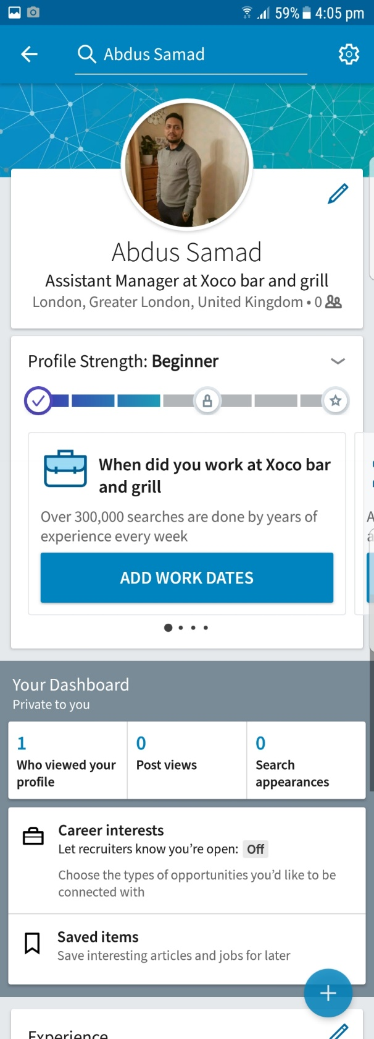

References
Document management - electronic document file format for long-term preservation. (2009). Geneva: ISO copyright Office.
Downey, K. (2012). Managing Selection for Electronic Resources: Kent State University Develops a New System to Automate Selection. Journal of Electronic Resources Librarianship, 24(2), pp.127-137.
Dufrasne, B., Burns, C., Kalabza, W., Lengyel, S., Schill, P., Schoessler, C. and Solewin, S. (2017). IBM XIV storage system architecture and implementation.
Ferrari, E. (2010). Access Control in Data Management Systems. Synthesis Lectures on Data Management, 2(1), pp.1-117.
Greco, S., Molinaro, C. and Spezzano, F. (2012). Incomplete Data and Data Dependencies in Relational Databases. Synthesis Lectures on Data Management, 4(5), pp.1-123.
Kužnar, D., Tavčar, A., Zupančič, J. and Duguleana, M. (2016). Virtual assistant platform.
Mamoulis, N. (2011). Spatial Data Management. Synthesis Lectures on Data Management, 3(6), pp.1-149.
Moore, M. (2011). Keeping Current with Electronic Resources and Libraries. Journal of Electronic Resources in Medical Libraries, 8(3), pp.263-271.
Rusen, C. (2016). Windows 10 at work For Dummies.
WU, R. (2017). Analysis on Electronic File Management of Publishers. DEStech Transactions on Social Science, Education and Human Science, (icssm).
Yamato, Y. (2016). Cloud storage application area of HDD-SSD hybrid storage, distributed storage, and HDD storage. IEEJ Transactions on Electrical and Electronic Engineering, 11(5), pp.674-675.

