

Problem Solving and Decision Making
BMSW4004
Assessment 1
Task 2

Olesia Tarytsa (2024821)
Lecturer – Mushfiqur Rahman

Contents
Introduction 3
Organisational Overview 4
Identified Complex Problem(s) 4
Applying Problem-Solving Tools and Techniques 4
SWOT Analysis 4
PESTLE Analysis 5
AKDAR Model of Change Management 7
Solutions to Complex Problem(s) 7
Alternate Solutions 8
Evaluation of Best Alternatives 8
Implementation 9
Monitoring and Controlling 9
Communicating to the Stakeholders 10
Recommendation and Conclusion 11
References 12

Introduction
The business environment and the workplace are common for employees in various business organisations, having the ability to solve problems and making important decisions is crucial (Surridge, Bushell and Gunn, 2017). Problem-solving skills and the need for decision-making are correlated because they are connected in a business setting. Leaders and managers especially need excellent decision-making skills to solve problems in the best possible ways (Griffin, 2017). Additionally, there are some methods and tools that can help in problem-solving and improving situations.

Organisational Overview
Tesco is a British retailer of groceries and general merchandise operating in many parts of the world. It is based in the UK where the company has the largest market share in the retail industry (Tesco Plc, 2018). By gross revenues alone, the company is the third-largest retailer in the world.

Figure 1: Logo of Tesco plc (Tesco Plc, 2018).
The company was founded in 1919 and expanded globally in the 1990s. John Allan has been performing the role of Chairman in the company since 2015; David Lewis has been serving as the CEO of Tesco since 2014 (Tesco Plc, 2018).

Identified Complex Problem(s)
With the sudden arrival of the coronavirus pandemic, businesses around the world were taken by a storm. Although many other businesses lost profits when that happened, Tesco’s quick decisions allowed the company to tackle the challenges and increase its sales and profits where the other businesses were struggling (Partridge and Butler, 2021). However, with the threat of the virus slowly going away, people are once again coming out of their homes for shopping, eating, and visiting pubs. Because of that, Tesco’s sales have been going down recently.
Although the company predicted that sales would slow down and profits would decrease, it must still face the consequences of its actions and make something of it. To handle the additional pressure of online orders, Tesco employed 50,000 new employees. Of them, 20,000 people joined the company in permanent jobs (Partridge and Butler, 2021). Therefore, there is an additional cost at the hands of Tesco that the company needs to do something about. Furthermore, with the slump in sales and profits, the company also needs to find a way to stabilise its online sales and increase offline sales to find balance once again.

Applying Problem-Solving Tools and Techniques

SWOT Analysis
SWOT analysis explores the internal and external environmental factors of an organisation that the organisation can wilfully control and influence. The analysis for Tesco is presented here.
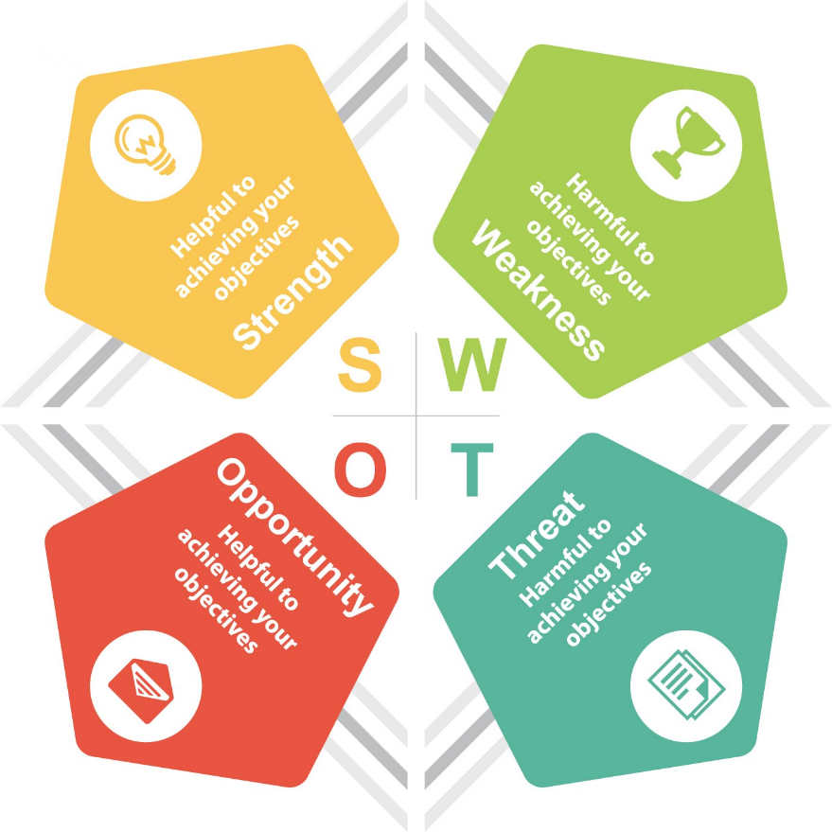
Figure 2: SWOT Analysis (Birn and Forsyth, 2012).
- Strengths: Tesco has performed very well financially over the years, which proves that it knows its market well. It also focuses on technology, as seen with its online store.
- Weaknesses: Tesco has a bad reputation for its job cuts. It is also frequently the topic of controversies, some of which are proven to be true.
- Opportunities: Bringing artificial intelligence to the retail industry could be a step for the company (Griffin, 2017). There is also the possibility of digitising the stores with augmented reality.
- Threats: Competitions have similar opportunities because of the pandemic. Customers are also swiftly changing their expectations.

PESTLE Analysis
A PESTLE analysis explores the macroenvironmental factors that a business organisation cannot directly control or influence. The analysis for Tesco is presented here.
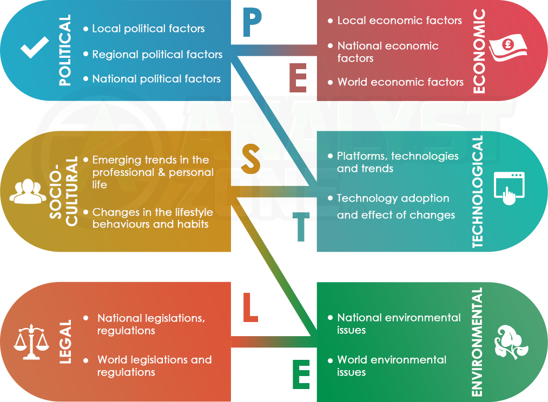
Figure 3: PESTLE Analysis (Birn and Forsyth, 2012).
- Political Factors: As a business operating in multiple countries and markets, Tesco is subjected to the political shifts of those locations as well. In the UK, Tesco faced notable difficulty because of Brexit (Surridge, Bushell and Gunn, 2017). It was also asked to return the aid it received from the government because of the pandemic, which could harm its future actions.
- Economic Factors: The global exchange rate has seen notable fluctuations because of the pandemic, and this has affected the international business of Tesco (Hellriegel, 2017). With more employees hired, Tesco is also unable to offer higher wages to its employees.
- Socio-Cultural Factors: The increasing popularity of social media has required Tesco to participate in social media marketing as well. As people have to change expectations, Tesco is struggling to adapt.
- Technological Factors: Introducing the Internet of Things (IoT) and augmented reality in the retail space could improve customer experience. These technologies are currently in popularity (Griffin, 2017).
- Legal Factors: Tesco has faced fines for false advertisement, adding horse meat in burgers, and various other lawbreaking situations. Tesco must adhere to the legal requirements of the regions where it operates.
- Environmental Factors: Tesco has been making some attempts at reducing the use of plastic to show support for the movement to protect the environment (Hellriegel, 2017). It also participates in various environmental projects through corporate social responsibility.

AKDAR Model of Change Management
The AKDAR model of change management goes through five stages to introduce and enable change in a business organisation.
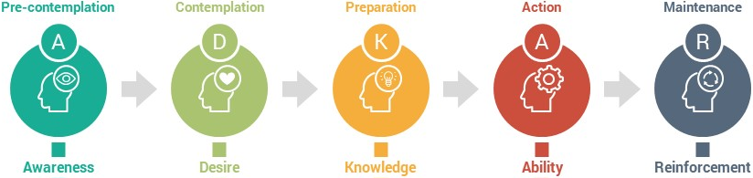
Figure 4: AKDAR Model of Change Management (Czichos, 2014).
- Awareness: Tesco is aware that they need to quickly respond to the changing times as the pandemic goes away. Hence, they are considering their options.
- Desire: As a leader in the retail industry, Tesco has a desire to stay ahead of others and quickly recover from this predicament.
- Knowledge: Tesco has a separate team that deals with market research which can identify the best course of action for the company in this situation.
- Ability: Despite suffering some setbacks, Tesco is still notably ahead of others. Hence, they have enough ability to make some changes as they see fit.
- Reinforcement: Reinforcements are needed to support and sustain change in an organisation (Czichos, 2014). Hence, Tesco requires some reinforcements for its changes to succeed.

Solutions to Complex Problem(s)
Although Tesco increased the number of staff on board to increase their deliveries and sales during the pandemic when online purchases were much higher, the situation has changed with the pandemic seemingly no longer the same kind of an issue. More and more people are getting out of their homes to eat outside at restaurants, visit pubs, and essentially trying to return to normalcy. However, this means that Tesco is in a situation where its online business is overstaffed, but not enough sales are being made.
Given the intense competition in the retail industry, Tesco could lose notable market share to a competitor if it does not get back on track and improve profitability soon (Birn and Forsyth, 2012). Tesco’s main concerns in this situation are its staffing and marketing for increasing sales. These issues could both be resolved by bringing some change into the business. There is no need to keep the temporary staff on board with the pressure from online deliveries dying down (Czichos, 2014). With clever marketing of the traditional stores, Tesco could strive for a balance between the two sales channels.

Alternate Solutions
Here are two possible alternate solutions:
- One possible solution available to Tesco is to pursue its online sales channel more aggressively. With the onslaught of the pandemic, people have been forced to adapt to a new lifestyle they are not used to. Online purchases became the norm and staying at home was mandatory. Although the situation is getting better now, many people are still habituated to the convenience of online shopping. Initiating a reward scheme for its customers for purchasing online could increase online sales once again (Kellner and Riener, 2014).
- Another possible solution in this situation is making the different stores in physical locations more accessible. Obeying the guidelines of the pandemic is a given, but it’s also crucial for the stores to increase sales. Tesco could introduce window shopping to its stores, allowing customers to buy the most popular items without even having to enter the stores. The items that are the most popular could be easily identified from the sales history of each store (Hellriegel, 2017). Because of that, a notable amount of traffic can buy the things they need while meeting health guidelines.

Evaluation of Best Alternatives
It appears that the best solution available to Tesco is to prioritise the online sales channel and market it as the next big thing. It is evaluated here using the PMI technique.
- Plus-Point: Online stores have been popular before the pandemic began, but their popularity rose to new heights during the pandemic. It is evident that the reliance on the internet and on online stores will only increase over time. Hence, prioritising the online sales channel right now could also have a lasting effect on Tesco’s business.
- Minus-Point: It would not be easy for Tesco to bring the lost traffic back to its online store. Nott only extensive, but also clever marketing is required to successfully attract customers to online stores when the pandemic is slowly going away (Czichos, 2014). Tesco may need to formulate new strategies.
- Interesting Point: It is interesting to note that Tesco can serve the customers while also serving itself at the same time. With online deliveries, customers don’t have to take the hassle of getting out of their homes. So, it is suitable for any time, not only when they’re out of the home. Similarly, it makes up for the traffic that Tesco requires.

Implementation
If Tesco wants to implement the best solution identified here, then the company must conduct some marketing research. While a general direction can be generated based on current and past metrics, it would not be a good idea to bring such an intricate change without sufficient study (Surridge, Bushell and Gunn, 2017). For starters, Tesco needs to introduce a reward scheme that will attract customers back into its online stores. Optionally, for customers interested in picking up their products personally, Tesco can offer pick-up points in the areas where its stores are located.
The reward scheme that Tesco can introduce should contain several levels of importance. For instance, the credit system could increase in value based on the importance of the customers. Hence, Silver customers can receive better benefits compared to Bronze customers for the same number of points (Kellner and Riener, 2014). At the same time, the process for levelling up one’s importance should be simple and easy to do. The points would be awarded with every purchase and remain in one’s account, but their importance ranking will be demoted if they don’t buy anything for a specified duration.

Monitoring and Controlling
Overseeing operations in a business and controlling how they happen are crucial parts of ensuring the success of business operations. Monitoring and controlling, as it is known, is significant in sales channel management as well (Vender et al., 2006). Especially with recent changes and modifications made at Tesco, the company needs to monitor these changes and see how the new features and characteristics come to fruition. For instance, Tesco must monitor how the customers react to its reward scheme. There might be people who want to exploit its reward system, and monitoring could help weed out these customers.
To help in increasing sales, monitoring and controlling could be used to determine which actions, adverts, or other means of promotion produce better sales for the company. Using these metrics, Tesco can identify what it must do to increase sales exponentially (Czichos, 2014). Furthermore, with a complicated reward scheme that works on two facets, Tesco must constantly moderate and keep track of the customers who purchase goods on their online store. These efforts should lead to better success for the company.

Communicating to the Stakeholders
Communication is an important part of business operations. The larger a business gets, the more individuals and organisations it must communicate with (O’rourke, 2015). Hence, effective communication is a necessity for many businesses, including Tesco. Communication is indispensable to produce any improvements in Tesco’s sales channels. The reward scheme suggested here depends heavily on the assumption that the customer understands the reward scheme well. Hence, Tesco must communicate how the scheme works and make it easy to understand for the customers, regardless of their age or expertise with technology (Hellriegel, 2017). Tesco’s feedback system can also help connect it with its customers. Furthermore, such a reward scheme would also be very new in the market, which means that Tesco would need to communicate how it works with stakeholders at various levels, including the managers and employees working in the various branches of the company (O’rourke, 2015). With operations management, Tesco can oversee what it communicates and who it communicates with. The company can also employ effective communication where needed and ensure that the information has been well-received.

Recommendation and Conclusion
Tesco has approached its current situation with great caution and understanding of the market. Even when it overstaffed, it knew that the situation would only be temporary, and the market would return to normal at some point. Hence, Tesco had to consider ways to deal with when that happened. Tesco should utilise social media marketing to promote the word of its reward scheme with the target consumers and have a simple and entertaining video explain how the reward system works so that it is easy to understand for anyone seeing it just once. At the same time, there should be no confusion for customers uninterested in the scheme.

References
Birn, R. and Forsyth, P. (2012) Market Research. Oxford: Capstone Pub.
Czichos, R. (2014) Change Management. London: Kogan Page.
Griffin, R. W. (2017) Management. Boston, Ma: Cengage Learning.
Hellriegel, D. (2017) Management. Cape Town ; Oxford: Oxford University Press.
Kellner, C. and Riener, G. (2014) “The Effect of Ambiguity Aversion on Reward Scheme Choice,” Economics Letters, 125(1), pp. 134–137. doi: 10.1016/j.econlet.2014.08.025.
Malhotra, N. K. (2010) Marketing Research: An Applied Orientation. Upper Saddle River, Nj: Pearson.
O’rourke, J. (2015) Effective Communication. London: Dorling Kindersley Limited.
Partridge, J. and Butler, S. (2021) Tesco Profits Fall as Covid Costs Offset Sales Surge, The Guardian. Available at: https://www.theguardian.com/business/2021/apr/14/tesco-profits-fall-as-covid-costs-offset-sales-surge (Accessed: 23 August 2021).
Surridge, M., Bushell, T. and Gunn, P. (2017) The Business Environment. London: Collinseducational.
Tesco Plc (2018) Tesco PLC, Tesco plc. Available at: https://www.tescoplc.com/ (Accessed: 23 August 2021).
Vender, J. S. et al. (2006) Monitoring. Philadelphia, Pa: Saunders, Cop.

