Computer Networks & Cybersecurity
Student Name: David James (1704050)
Module: Data Security, Governance and Compliance
Lecturer: Dr Carlene Campbell

Table of Contents
Table of Figures 3
1. Abstract 4
2. What is a Cybersecurity Framework? 4
3. Frameworks 4
4. Literature Review 5
4.1. NIST 6
4.2. PCI DSS 8
4.3. ISO 27001 9
4.4. Conclusion 11
5. Case Scenario (CaribbeanCoffee) 11
6. References 12

Table of Figures
Figure 1 - Three types of security frameworks 5
Figure 2 - NIST framework components 6
Figure 3 – NIST framework core functions 7
Figure 4 – NIST framework tiers 8
Figure 5 - PCI DSS compliance levels 9
Figure 6 - ISO 27001 requirements 10

Abstract
With an abundance of information available digitally, a high dependence on networking technology for storing digital records of data is now the norm. Accessing information on various devices across internal and external networks is a daily occurrence, with most companies and organizations spending millions on data infrastructures to operate their businesses. With the trend of digital information being a standard component for many businesses, security against the risks introduced by this technology has become a focal point. Research is carried out to obtain new knowledge on available security frameworks, applying a critical analysis of their usage. Further work in applying a custom security framework to a given case is conducted to demonstrate an understanding of the principles and practices of data governance and security.

What is a Cybersecurity Framework?
Networking has never been easier since the advent of the internet. Sharing photos, messages and videos is now more accessible and popular than ever with the rising amount of social platforms. The technology that makes this possible, whilst incredibly convenient, can also be extremely vulnerable to exploitation when available to the wrong groups or individuals [1], [2].
Subject to extreme exploitation are companies that possess sensitive data. With most companies now digitally storing such information, security policies and guidelines are now important factors to a company’s operations, even so, applicable measures are now enforced by law with many policies in place that companies need to conform to [3], [4].
Leaked data can cause serious legal consequences if the information consists of personal values. On a larger scale, companies are more at risk as critical information could be comprised of private data such as financial, personal, and operational information, that if threatened, could damage the sustainability and integrity of a company’s business. Having rules and guidelines in place that enforce protective measures as well as options for dealing with potential risks provides an effective plan in handling security threats and also provides alternatives for recovery when in the situation of a data breach.
Cybersecurity is a growing sector that aims at fighting against digital attacks. Whilst cybersecurity is a broad topic that branches out to many areas both technical and non-technical, the underlying goal is to achieve a security framework best suited to a company’s requirements. Cybersecurity frameworks primarily target risk management at multiple levels of an organization, enforcing rules and guidelines on the management and action required to dealing with potential risks and threats to business [5].
The most crucial part of a cybersecurity framework is to introduce an effective structure and methodology to safeguard critical, sensitive, and valuable data. Frameworks provide a systematic way to reduce cyber risks irrespective of how complex a business environment is.

Frameworks
According to Frank Kim at the RSA Conference 2018 [6] cybersecurity frameworks can be somewhat difficult to digest. The conference proceedings advise breaking down frameworks into 3 categories:
- Control frameworks.
- Program frameworks.
- Risk frameworks.
Furthermore, each category consists of a collection of well-known cybersecurity frameworks best suited by each group (see Figure 1).
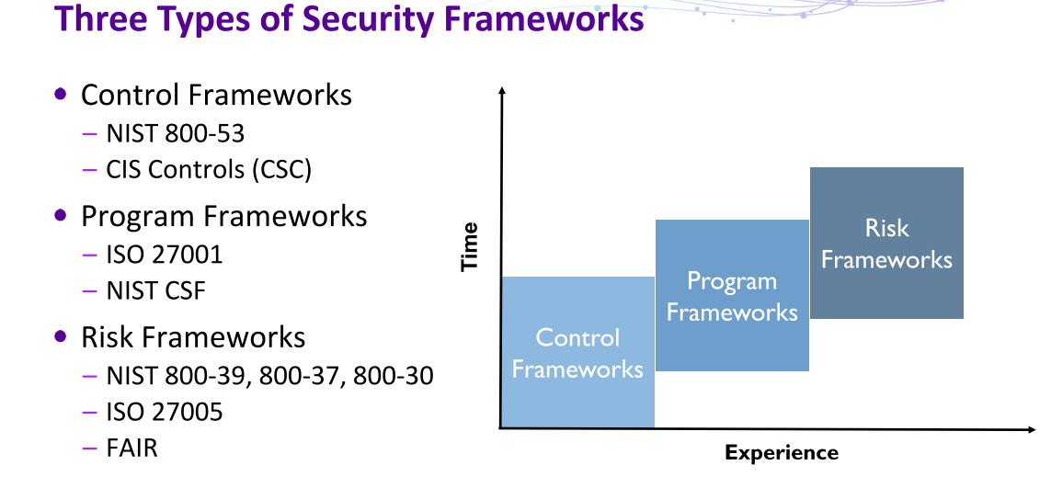
Figure 1 - Three types of security frameworks
Adapted from [6]
Subject to certain circumstances, this perspective of understanding cybersecurity frameworks provides general insight into the wealth of security structures available. Various requirements come into play when deciding on a framework as organizations differ in many ways. Where some companies may require a framework that caters to the security of sensitive financial data such as credit card information, other companies may need a framework that can conform to protecting more abstract goods such as concepts and schematics of emerging products or technologies. It is fair to say that there may not be a “one size fits all” solution to every cybersecurity framework where their generalisation may not spread to meet needed measures and requirements.
With this in mind, cybersecurity frameworks can be modularized to fit certain requirements, taking parts of one framework, and merging them with another to create a more tailored and custom solution. Other existing frameworks compensate for this issue and offer a more robust structure, although more complex, allowing for complete customizability to conform with business needs.

Literature Review
Reviewing well-known frameworks popular among the cybersecurity community, critical analysis of available literature pertinent to each framework seeks to provide fundamental understanding of the structure, usage, and flexibility of each selected cybersecurity framework.
Investigation towards finding common approaches, disadvantages and fragility is conducted for documentation alongside observations where conducive benefits are applicable. A reproving examination noting a clear weight and contrast between the selected frameworks is the desired outcome to demonstrate a moderately concise understanding of data governance and security.
The selected frameworks offer a diverse amount of usability which could cater for big or small companies, providing an acceptable enough distinction to examine.

NIST
Created in collaboration with industry professionals and the US Government [7], NIST CSF, an incredibly popular cybersecurity framework used by many companies across the world [8] aims at achieving a security framework for organizations that is cost-effective and maintains security for critical infrastructures [9]. NIST consists of a flexible framework to suit small and large companies and organizations where security is a concern.
The anatomy of the NIST framework is fairly expansive. As recorded in the documentation of the first iteration version 1.0, there are three main components which provide high-level insight to understanding how the framework operates [9], each of these components are described as the
- Framework Core
- Framework Implementation Tiers
- Framework Profiles
Explicitly, NIST provides a structure for organizations and companies to recognize their current cybersecurity approach, identify their desired position for security, recognize opportunities for improvement and also assess progress towards their target position for cybersecurity [10]. NIST also serves as formal guidelines for following best practices for companies and organizations that do not have a current cybersecurity solution in place.
Each of the three components from the NIST framework divides specific approaches that achieves deliverables for accomplishing a cybersecurity solution that fits a company or organization’s needs (see Figure 2 - NIST Framework parts). The framework core is comprised of components tailored towards frequent activities and outcomes that are common to sectors with critical infrastructures. Framework profiles aid in providing support for aligning cybersecurity requirements to a company’s risks and resources. The framework tiers are designed to provide understanding of the characteristics of a company’s approach towards managing and maintaining cybersecurity risk [11].
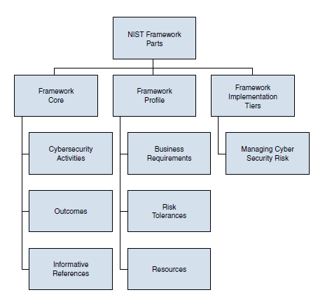
Figure 2 - NIST framework components
Source: Adapted from [11]
At the top-level NIST CSF describes a format which provides a systematic approach to implementing a cybersecurity framework. Whilst the schema of the NIST CSF is documented in a linear and concise fashion providing appropriate measures to follow for meeting best practices, surveys show that a considerable amount of companies suffer from a gap in cybersecurity expertise. Results from 2018 show that 46% of companies who had taken part in a global survey required additional skill within their organization to identify all areas of cybersecurity requirements [12].
Breaking into each component, the core consists of five functions which aim to achieve successful recognition of common cybersecurity activities, as described above. Each function covers particular goals that need to be addressed in-line with business requirements:
- Identify
- Protect
- Detect
- Respond
- Recover
Furthermore, each function holds categories, subcategories and informative references that link directly to a collection that correlates to each function of the core (see Figure 3 - Core functions).
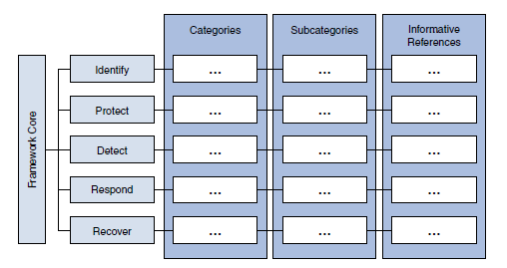
Figure 3 – NIST framework core functions
Source: Adapted from [11]
Stepping into the next top-level component of the NIST CSF introduces tiers. Framework tiers govern the guidance needed for organizations to analyse cybersecurity risks and refine the processes implemented to avoid each risk. Each tier serves as a description of how risk management procedures align with the attributes outlined in the framework. Each tier consists of four more categories which have appropriately defined characteristics of how best practices should be managed.
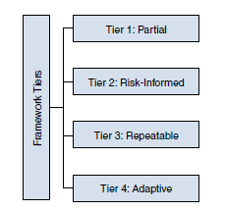
Figure 4 – NIST framework tiers
Source: Adapted from [11]
NIST outlines how each tier should be implemented and has documented a well-defined and concise explanation for each definition.
Reflection on the research of NIST CSF shows an established and professional framework with a clear and incisive schematic that offers a high degree of adaptability. Although highly popular within the cybersecurity community, contributors and researchers claim that NIST has one slight fall back in terms of measuring an organizations maturity level [13][14][15]. Maturity level, or maturity models outline how well an organizations competency skills scale to assessing effectiveness when reaching goals [16]. NIST CSF provides no guidelines for measuring maturity, leaving many cybersecurity professionals integrating maturity models into the NIST framework to accommodate [17][18][19].

PCI DSS
PCI DSS (Payment Card Industry Data Security Standard) formed in 2004 in collaboration with multiple credit card vendors [20]. Administered by PCI SSC (PCI Security Standards Council), PCI DSS defines a set of requirements for any companies that process, transmit and store credit card details. Companies are advised to follow PCI DSS, but compliance isn’t law [21].
PCI DSS aims at enhancing payment security data through 12 compliance requirements:
- Effective password protection
- Use and maintenance of firewall systems
- Encryption of card details
- Encryption of transmitted data
- Use and maintenance of anti-virus software
- Keep all software up to date
- Restrict access to all data
- Individual credentials for data access
- Restrict physical access to all data
- Create and conserve access records
- Scan and test for vulnerabilities
- Document all policies
Overall, compliance requirements can be thought to fit into both technical [21] and operational [20] domains with various cybersecurity specialists claiming some degree of complexity in ensuring compliance in both areas [22][23][24].
Compliance is regulated on an annual basis where companies enforcing PCI DSS must follow testing procedures to ensure integrity of compliance and that each of the requirements defined by PCI DSS are maintained [21].
The standard breaks compliance into four levels based on the annual amount of credit card transactions a payment branch processes.
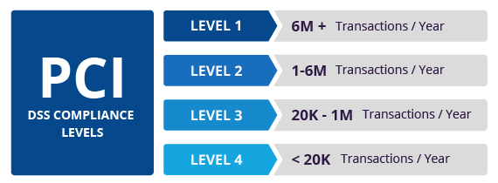
Figure 5 - PCI DSS compliance levels
Source: Adapted from [25]
Companies that do not enforce PCI DSS aren’t in breach of any laws, the framework clearly states itself as a standard that provides guidelines and best practices for protecting and securing credit card payment data. Penalties still apply to acquirers if false or fraudulent transactions occur through payment brands. Furthermore, such circumstances also invoke breach of GDPR regulations where fines are dealt for processing such transactions [26].
Annual audits are carried out to ensure compliance is met by companies following PCI DSS guidelines. A 2018 survey conducted by Verizon showed that at least 29% of companies were compliant after validation, articles document that some companies may consider themselves compliant but in actual fact aren’t [27].
In comparison to NIST CSF, PCI DSS is a more compact framework that focuses on the security of credit card payment data. Many companies utilize both frameworks to align with business needs as PCI DSS requirements are targeted towards specifications tailored for the security of financial data whereas NIST offers a security framework on a much broader scale.

ISO 27001
Similar to the NIST CSF, ISO 27001 is a framework that provides guidelines for implementing security within operational processes, information technology and communications, physical security within an organization and compliance with laws and regulations [28].
ISO 20071 can be implemented within small or large organizations within various sectors. Whilst NIST can also be utilized within companies of various sizes, NIST leans towards providing security measures for federal organizations (see NIST). ISO 20071 targets risk management through a less technical approach aimed at companies in any sector. Both frameworks can still be used together to be combined into a single and robust security framework that meets organizational needs [29].
According to most literature ISO 27001 is an accepted industry-standard in ISMS’s (Information Security Management Systems) [30][31][32][33]. In order for a company to be ISO 27001 compliant there are mandatory requirements that must be implemented. These requirements are described through clauses 4-10 within the ISO 27001 documentation [28]:
- Clause 4 – Context of the organization
- Clause 5 – Leadership
- Clause 6 – Planning
- Clause 7 – Support
- Clause 8 – Operation
- Clause 9 – Performance evaluation
- Clause 10 – Improvement
Each requirement outlines the steps that need to be performed to be ISO 27001 compliant and describes objectives that provide a professional approach to recognizing the measures that need to be met to implement an ISMS.
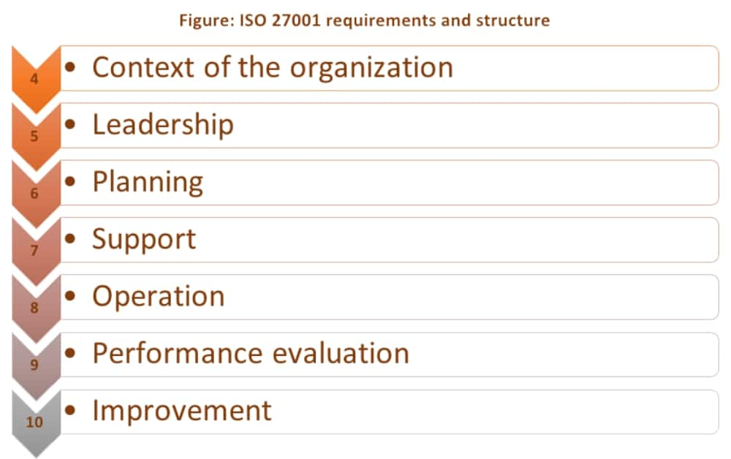
Figure 6 - ISO 27001 requirements
Source: Adapted from [34]
Compared to NIST which has a primary goal of implementing security in a cost-effective way, ISO 27001 may incur certain expenses such as training, external support and refactoring of technology to remain up to date [35].
Following from the mandatory requirements, ISO 27001 features a further section of the framework Annex A compiling a collection of reference control objectives and over 130 controls. Annex A is organized into 14 sections known as domains labelled A.5 to A.18 [36].
Many cybersecurity professionals using ISO 27001 believe it to easily deliver business objectives effectively when implemented correctly, and also state that implementation can be successful with the correct understanding of the framework and appropriate planning [37].

Conclusion
With the variety of available frameworks, research shows that ISO 27001 is a widely accepted solution for approaching a successful ISMS. Organizations looking to implement security in a cost-effective way can rely on NIST CSF which also handles management and mitigation of risks. With both NIST and ISO 27001 producing flexible and adaptable solutions for implementing security measures and handling risks this also permits integration and compatibility for organizations looking to mix both frameworks and extract their advantages for a more robust and comprehensive security solution.

Case Scenario (CaribbeanCoffee)
CaribbeanCoffee operates through a cloud-based network for reaching its staff and clients and is looking to extend its IT services to personal devices. Research findings revealing the risks involved with cloud computing show not only security risks but operational and regulatory risks [38].
A security framework that not only manages risks for mitigation but can also be extendable to conform with new technology in cloud computing and regulatory laws would keep CaribbeanCoffee’s digital assets secure with minimal threat to the company’s operations and business.
The approach taken to designing a security framework applicable to CaribbeanCoffee’s requirements follows similar constructs to the highly popular NIST and ISO 27001 frameworks.
The R4 Cybersecurity Framework provides 4 functions (see Figure 7 - R4 CSF functions) that produce deliverables to implementing a successful security framework that aligns to organisations utilizing a cloud computing network infrastructure. With CaribbeanCoffee’s staff and clients permitted to access the company’s network on personal devices, assumptions have been made on which CSP (cloud service provider) and SPI framework [39] is in use. R4 cybersecurity framework targets IaaS (infrastructure as a service) as a delivery mode for CaribbeanCoffee’s operational purposes and also assumes that CaribbeanCoffee has invested in a CSP within the EU.
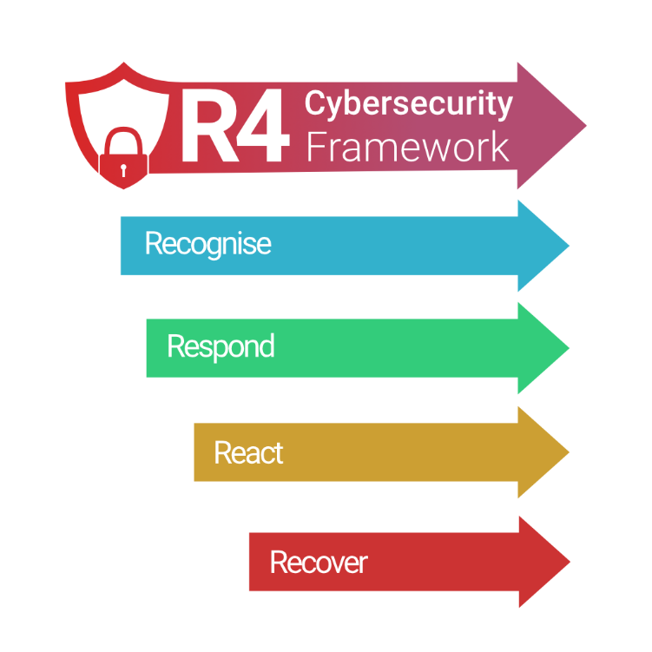
Figure 7 - R4 CSF functions
Each function within the R4 cybersecurity framework provides guidance on the fundamental actions required for discovering and tackling risks in a non-retrospective way. Although, in the event of a security breach traversing backwards through the framework produces an iterative approach to uncovering flaws in the organisational policies produced by following the framework.
This ensures that R4 provides fallback measures for organisations to not only recover but recognise which security outcomes generated by the respond function have failed. In the event of a security breach the recover function enforces a review of organisational policies for further improvement, mitigating the risk of a breach from occurring again.
The react function places requirements for monitoring and recording the developed safeguards that are derived from the respond function. Exploration of business assets that depend on being secured are discovered within the recognise function, this extends to all areas of the organization to develop a firm and concise understanding of assets that need protection from potential cybersecurity risks.
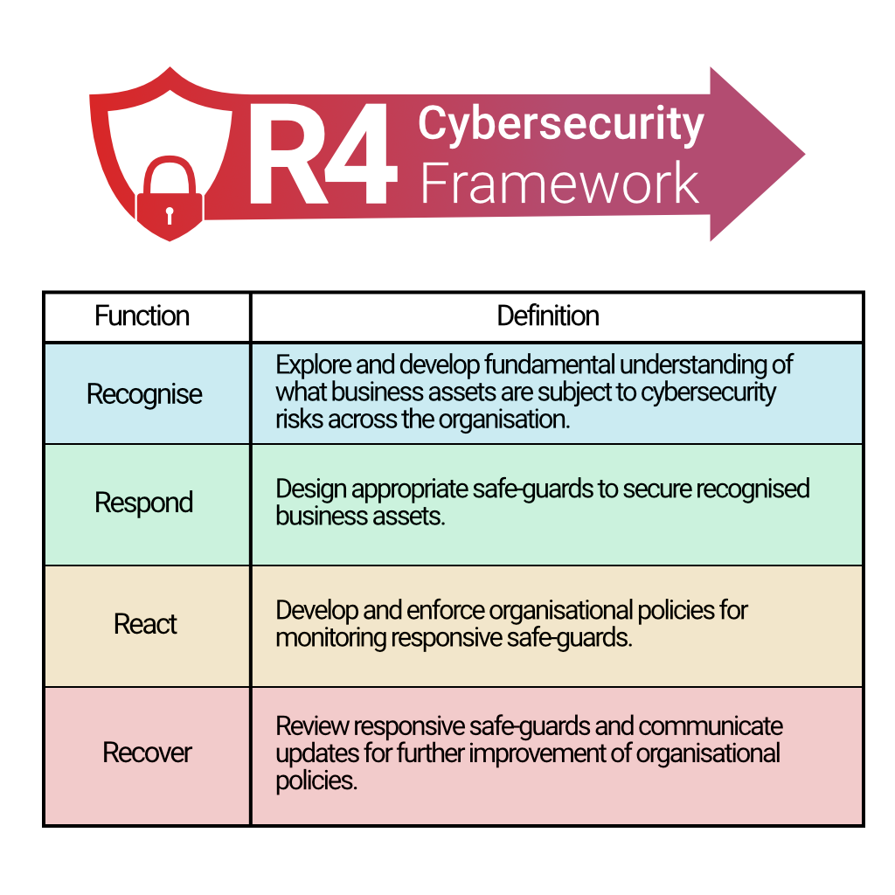
Figure 8 - R4 CSF function definitions
Whilst the R4 CSF function definitions describe the guidelines for successfully implementing the framework, the respond and react functions enforce mandatory requirements that produce effective security and monitoring measures.
Regulations for privacy of data are described in Directive 95/46/EC which outlines that the cloud service provider is responsible for ensuring compliance for privacy of data [40] in accordance to regulatory standards. The advantages of this allows CaribbeanCoffee to avoid meeting regulations which would incur further investment proving R4 to be a cost-effective security framework which takes benefits of shifting regulations in the hands of the CSP.
With this benefit, mandatory requirements outlined in the R4 core checklist provide guidance for reaching compliance in a cost-effective way, with all objectives in the core checklist being within complete attainability for the company. Scope of all objectives listed within the core checklist ensures compliance in terms of implementing security throughout each organisation level to verify concrete security measures and confirm genuine operation of the R4 CSF.
The core checklist is comprised of requirements to obtain legitimate security measures and should be enforced by the entirety of CaribbeanCoffee. Failure to implement the requirements leaves security vulnerabilities. The R4 core checklist offers stringent security requirements, this is due to staff and clients having complete accessibility to the cloud network through personal devices.
Respond:
- Strong configuration of device passwords
- Device and system protection through utilization of firewall software
- Use and maintenance of anti-virus software
- Secure personal devices from public locations and unauthorised persons
React:
- Unique ID’s for each user’s device
- Regular system scans for vulnerabilities
- Document and store logins of all users
Implementation of all requirements via the respond function provides a checklist of security measures and guidance for maintaining and securing digital assets. With privacy of data passed to the CSP this relieves CaribbeanCoffee from getting involved in regulatory measures and simplifies R4 CSF integration.

References
[1] S. Alder, “FBI Issues Warning About Increasing Ragnar Locker Ransomware Activity,” HIPPA J., 2020.
[2] S. Ghafur, E. Grass, N. R. Jennings, and A. Darzi, “The challenges of cybersecurity in health care: the UK National Health Service as a case study,” Lancet Digit. Heal., vol. 1, no. 1, pp. e10–e12, May 2019.
[3] E. S. Dove, “The EU General Data Protection Regulation: Implications for International Scientific Research in the Digital Era,” J. Law, Med. Ethics, vol. 46, no. 4, pp. 1013–1030, Dec. 2018.
[4] B. N. Walters, “Privacy Law Issues in Blockchains : An Analysis of PIPEDA , the GDPR , and Proposals for Compliance,” 17 Can. J. Law Technol. 276, p. 44, Apr. 2019.
[5] S. P.S, N. S, and S. M, “Overview of Cyber Security,” IJARCCE, vol. 7, no. 11, pp. 125–128, Nov. 2018.
[6] F. Kim, “RSA Conference 2018,” in How to Make Sense of Cybersecurity Frameworks, 2018, pp. 47–51.
[7] B. Obama, “Foreign Policy Cyber Security | The White House.” [Online]. Available: https://obamawhitehouse.archives.gov/issues/foreign-policy/cybersecurity/eo-13636. [Accessed: 31-Dec-2020].
[8] F. P. Landes, “General Perspectives,” 2016, pp. 191–192.
[9] M. Barrett, “Framework for improving critical infrastructure cybersecurity,” in Proceedings of the Annual ISA Analysis Division Symposium, 2018, vol. 535, pp. 9–25.
[10] L. A. Gordon, M. P. Loeb, and L. Zhou, “Integrating cost–benefit analysis into the NIST Cybersecurity Framework via the Gordon–Loeb Model,” J. Cybersecurity, vol. 6, no. 1, Jan. 2020.
[11] O. Santos, Developing Cybersecurity Programs & Policies. Pearsons Education, 2019.
[12] “New 2019 Global Survey: IoT-Focused Cyberattacks are the New Normal.” [Online]. Available: https://resources.irdeto.com/global-connected-industries-cybersecurity-survey/new-2019-global-survey-iot-focused-cyberattacks-are-the-new-normal. [Accessed: 03-Jan-2021].
[13] N. Tissir, S. El Kafhali, and N. Aboutabit, “Cybersecurity management in cloud computing: semantic literature review and conceptual framework proposal,” J. Reliab. Intell. Environ., pp. 1–16, Oct. 2020.
[14] I. Lee, “Internet of Things (IoT) Cybersecurity: Literature Review and IoT Cyber Risk Management,” Futur. Internet, vol. 12, no. 9, p. 157, Sep. 2020.
[15] H. Iguer, H. Medromi, A. Sayouti, S. Elhasnaoui, and S. Faris, “The impact of cyber security issues on businesses and governments: A framework for implementing a cyber security plan,” in Proceedings - 2014 International Conference on Future Internet of Things and Cloud, FiCloud 2014, 2014, pp. 316–321.
[16] W. Miron and K. Muita, “Cybersecurity Capability Maturity Models for Providers of Critical Infrastructure,” Technol. Innov. Manag. Rev., vol. 4, no. 10, pp. 33–39, Oct. 2014.
[17] S. Almuhammadi and M. Alsaleh, “Information Security Maturity Model for Nist Cyber Security Framework,” 2017, pp. 51–62.
[18] R. Kour, R. Karim, and A. Thaduri, “Cybersecurity for railways – A maturity model,” Proc. Inst. Mech. Eng. Part F J. Rail Rapid Transit, vol. 234, no. 10, pp. 1129–1148, Nov. 2020.
[19] A. Rabii, S. Assoul, K. Ouazzani Touhami, and O. Roudies, “Information and cyber security maturity models: a systematic literature review,” Inf. Comput. Secur., vol. 28, no. 4, pp. 627–644, Jun. 2020.
[20] D. Wilson, E. Roman, and I. Beierly, “PCI DSS and card brands: Standards, compliance and enforcement,” Cyber Secur. A Peer-Reviewed J., vol. 2, no. 1, pp. 73–82, 2018.
[21] E. Bonner, J. O’ Raw, and K. Curran, “Implementing the payment card industry (PCI) data security standard (DSS),” Telkomnika, vol. 9, no. 2, pp. 365–376, Aug. 2011.
[22] D. Kenga, “A Survey of Challenges Facing PCI DSS Compliance in Cloud Environments,” 2016.
[23] K. Berezina, “Top issues in PCI DSS compliance in hotels: An exploratory study,” J. Hosp. Tour. Technol., vol. 1, no. 3, pp. 218–233, Oct. 2010.
[24] J. Liu, Y. Xiao, H. Chen, S. Ozdemir, S. Dodle, and V. Singh, “A survey of payment card industry data security standard,” IEEE Commun. Surv. Tutorials, vol. 12, no. 3, pp. 287–303, Sep. 2010.
[25] “What is PCI DSS | Compliance Levels, Certification & Requirements | Imperva.” [Online]. Available: https://www.imperva.com/learn/data-security/pci-dss-certification/. [Accessed: 05-Jan-2021].
[26] L. Elluri, A. Nagar, and K. P. Joshi, “An Integrated Knowledge Graph to Automate GDPR and PCI DSS Compliance,” in Proceedings - 2018 IEEE International Conference on Big Data, Big Data 2018, 2019, pp. 1266–1271.
[27] C. Moldes, “Compliant but not Secure: Why PCI-Certified Companies Are Being Breached,” 2015.
[28] I. M. Lopes, T. Guarda, and P. Oliveira, “Implementation of ISO 27001 Standards as GDPR Compliance Facilitator,” J. Inf. Syst. Eng. Manag., vol. 4, no. 2, pp. 1–8, 2019.
[29] P. P. Roy, “A High-Level Comparison between the NIST Cyber Security Framework and the ISO 27001 Information Security Standard,” in 2020 National Conference on Emerging Trends on Sustainable Technology and Engineering Applications, NCETSTEA 2020, 2020.
[30] A. Nasser and A. A. Nasser, “Information security gap analysis based on ISO 27001: 2013 standard: A case study of the Yemeni Academy for Graduate Studies, Sana’a, Yemen,” Int. J. Sci. Res. Multidiscip. Stud., vol. 3, no. 11, pp. 4–13, 2017.
[31] E. H. Freeman, “Holistic information security: ISO 27001 and due care,” Inf. Syst. Secur., vol. 16, no. 5, pp. 291–294, 2007.
[32] G. Disterer, “ISO/IEC 27000, 27001 and 27002 for Information Security Management,” J. Inf. Secur., vol. 04, no. 02, pp. 92–100, Apr. 2013.
[33] I. Al-Mayahi and ad P. Mansoor, “ISO 27001 Gap Analysis-Case Study.”
[34] A. Giesler, “ISO 27001 requirements and structure,” Advisera Expert Solutions, 2019. [Online]. Available: https://advisera.com/27001academy/blog/2019/06/03/iso-27001-requirements-and-structure/. [Accessed: 06-Jan-2021].
[35] W. Boehmer, “Cost-benefit trade-off analysis of an ISMS based on ISO 27001,” in Proceedings - International Conference on Availability, Reliability and Security, ARES 2009, 2009, pp. 392–399.
[36] V. Diamantopoulou, A. Tsohou, and M. Karyda, “From ISO/IEC27001:2013 and ISO/IEC27002:2013 to GDPR compliance controls,” Inf. Comput. Secur., vol. 28, no. 4, pp. 645–662, Jun. 2020.
[37] C. Pelnekar, “Planning for and Implementing ISO 27001,” ISACA J., 2011.
[38] M. Ahmed and M. Ashraf Hossain, “Cloud Computing and Security Issues in the Cloud,” Int. J. Netw. Secur. Its Appl., vol. 6, no. 1, pp. 25–36, Jan. 2014.
[39] K. Hashizume, D. G. Rosado, E. Fernández-Medina, and E. B. Fernandez, “An analysis of security issues for cloud computing,” J. Internet Serv. Appl., vol. 4, no. 1, pp. 1–13, Feb. 2013.
[40] Council Directive 95/46/EC, EUR-Lex - 31995L0046 - EN - EUR-Lex. 1995.

