

Postgraduate/Distance Learning
Assignment coversheet & feedback form

THIS SHEET MUST BE THE FIRST PAGE OF THE ASSIGNMENT YOU ARE SUBMITTING (DO NOT SEND AS A SEPARATE FILE)

For completion by the student:
Student Name: Imogen O’Connor

Student University Email: 2204717@student.uwtsd.ac.uk
Module code: HPCA7014  Module title: Sacred Geography | Student ID number:  2204717 |  |  | Educational support needs:  No
Assignment title:
Is sacred space a human construct or a natural phenomenon? Discuss this question through a research project with reference to the work of at least three theorists.
Research project:
Is sacred space a human construct or a natural phenomenon? Discuss this question through a research project with reference to the work of at least three theorists.
The Place speaks: What happened when the stones told me to plant trees? Exploring the sacred, in dialogue with an acre of land in North County Sligo.
Assignment due date:
This assignment is for the 1st 2nd 3rd 4th 5th 6th module of the degree
I confirm that this is my original work and that I have adhered to the University policy on plagiarism.
Signed 
Email submission: if you are submitting this form via email, please tick this box □
(as a substitute for your signature) to confirm that you agree to the above declaration.
Assignment Mark
1st Marker’s Provisional mark
2nd Marker’s/Moderator’s provisional mark
External Examiner’s mark (if relevant)
Final Mark

NB. All marks are provisional until confirmed by the Final Examination Board.

For completion by Marker 1 :
Comments:

Marker’s signature: |  |  | Date:
For completion by Marker 2/Moderator:

Comments:

Marker’s Signature: |  | Date:
External Examiner’s comments (if relevant)

External Examiner’s Signature: |  | Date:

Research question: Is sacred space a human construct or a natural phenomenon? Discuss this question through a research project with reference to the work of at least three theorists.
Research project: The Place speaks: What happened when the stones told me to plant trees? Exploring the sacred, in dialogue with an acre of land in north county Sligo.
Introduction
This research is a case study exploring my relationship with an acre of land named Carrigeens, where I live in north country Sligo, Ireland. It aims to explore from a phenomenological perspective how relationship with place shapes both person and place, paying attention to how sacredness can be experienced in this intersubjective relational process. The research is conducted through the exploration of two questions: what does Carrigeens want known, and how is this to be discovered? In my role as co-researcher, I act as medium through which something might be articulated by this place. The methodology seeks to allow me to engage with Carrigeens, through the lens of new animism, rather than conduct research about ‘it’. I articulate the process by which I receive and translate this dialogue through my experience. The research is situated in a theoretical framework and methodology which attempts to offer ‘place’ a credible voice in this academic discourse. It draws on my daily engagement with Carrigeens from 06.10.2023 to 11.11.2023 with the resulting experiences typed up or handwritten in an outside shelter, along with personal recollections arising from my ongoing association with Carrigeens since 2001.
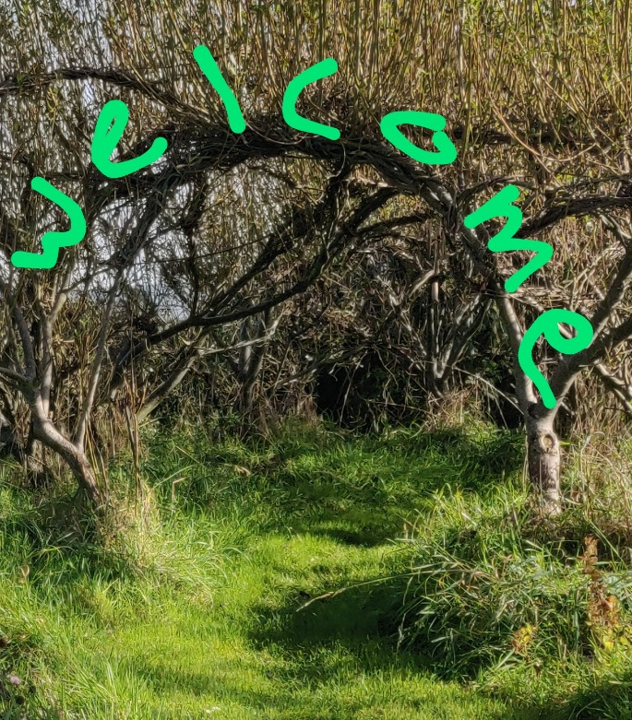
Figure 1. Carrigeens introduces the research.

Methodology.
Theoretical framework: I locate the project within a theoretical and methodological framework employing a combination of collaborative autoethnography (CAE) and more-than-human participatory research (MtHR), situated in a phenomenological approach. Hackett et al describe Autoethnography as ‘a research method, which connects a researcher’s personal story, including broader cultural meanings and political and social understandings, with the researcher’s first-hand experiences through a process of self-reflection and writing’ Following from this, Chang, Ngunjiri and Hernadez describe CAE as a qualitative research method in which researchers work as a community to collect their autobiographical materials and to analyse and interpret their data collectively…’ However, in this case study, one of the participants is not human. Abram refers to this as a ‘many-voiced landscape’ which he describes as ‘more-than-human’. Bastian explores the question of whether traditional participatory research methods can be applied to MtHR, which would involve working in partnership with non-human subjects to identify and respond to issues that matter to nonhumans.

Tilley’s phenomenological approach is applicable to this enquiry with its focus on embodied contact with natural artifacts in landscape. Valle and Mohs suggest that ‘[t]he prereflective level of awareness is central to understanding the nature of phenomenological research methodology,’ and occurs prior to any conscious cognitive manifestation. Part of my role in the research process is to attempt to verbalise these often prereflective communications, and present them through the use of different writing styles and photographs (all taken by me on the land unless otherwise stated). Three writing styles are presented to differentiate between my experience of Carrigeens speaking with me (green italics), the diary entries of my engagement with place, (italicised within speech marks) and finally the academic voice, (standard text).
Drawing on Bruhl’s concept of participation, and the new animism approach, I perceive Carrigeens, as an animate subject and collaborative autoethnographic co-researcher having personhood and agency which affords varying possibilities for being engaged with. They/them will be used throughout when referring to Carrigeens.
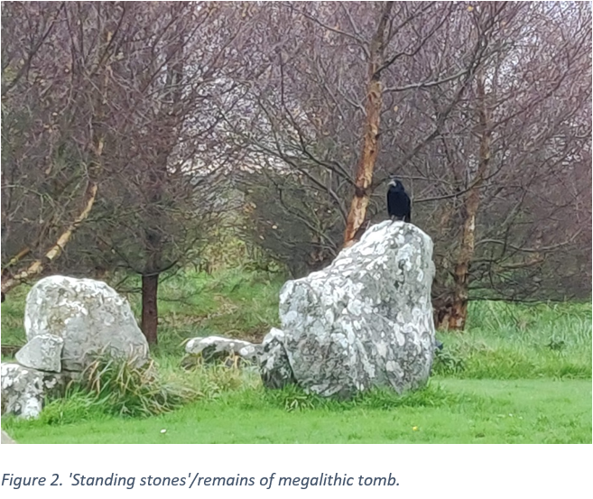
My association with Carrigeens dates from 2001 when they were purchased by my family. I have lived there since 2017. The land enfolds the remains of a megalithic tomb and ring barrow, (Figures 2 and 3) with a small woodland, ponds, wildflower meadow and sitting spaces, planted and co-created with Carrigeens since 2001.
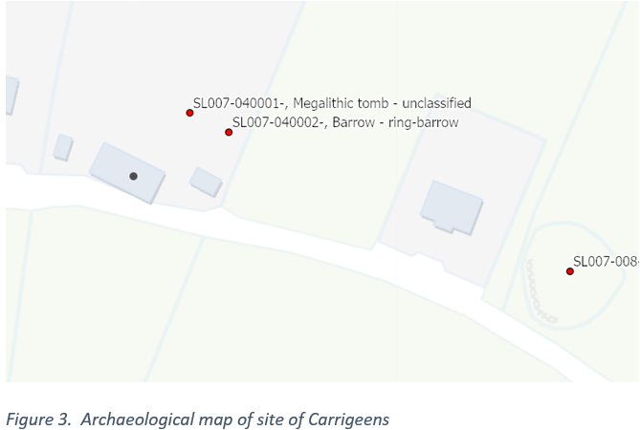
The method: Carrigeens might also be understood as a holon, in this case, an acre of land, that is ‘simultaneously part of a greater whole, of a particular biosphere, and a whole made of up lesser (or constituent) parts’, in this case, for example pond, meadow, bird, tree and myself (as an interconnected part of this acre) which are themselves holons consisting of lesser parts(Figure 4). The interactions, during the research took place at various locations in
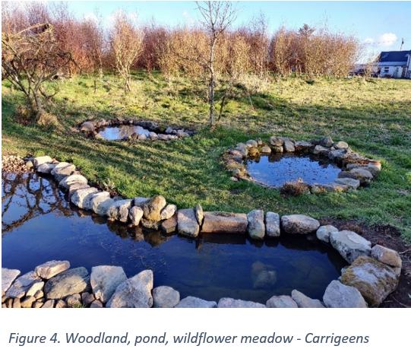
the space, and involved sitting, standing, walking/jogging, occurring predominately in the mornings, but also at different times of the day and night. The question: what do you want? was asked of Carrigeens at the beginning of most encounters. Diary entries were completed outside undercover in a geodome(Figure 5). An analysis of the emergent themes was undertaken to uncover what Carrigeens would like known through this enquiry. Given that Carrigeens is engaged with as a more-than-human person, and more vulnerable to misinterpretation and objectification, an ethics form was submitted with the research proposal.
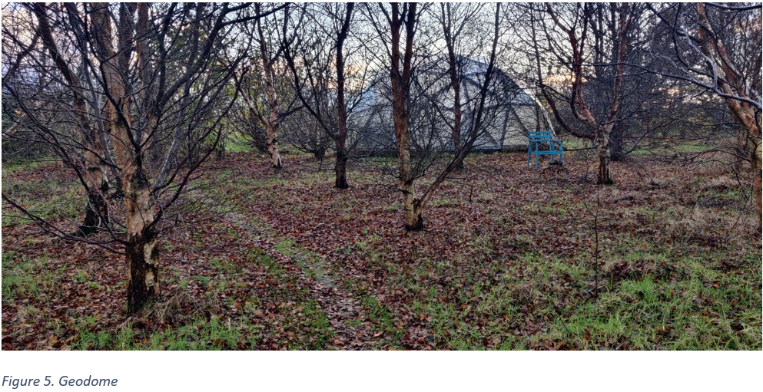
Finally, it is important to note that what has been presented in this section as a prior methodological framework, in practice evolved as the research progressed. This was part of the challenge of working with more-than-human persons which is further illustrated in the results section.
Reflexive considerations
Reflexivity is a key component of qualitative interpretative research and it ‘acknowledges that researchers…bring their subjective influences to the research process, particularly during data collection and interpretation’ While aware of my separation from the subtle communications of place, I am an insider, having helped initiate increased biodiversity through planting, digging and tending, for twenty-three years. I acknowledge my own dark green cosmology, involving a sense of kinship with life and an ontology which views matter as having its own life force and consciousness. I am also aware of my own negative associations with religious dichotomies around the sacred and profane and my leaning as a psychotherapist towards the psychological. I acknowledge the cultural biases integral to my being a white, middle-class, older Irish woman enjoying a privileged lifestyle as a property owner, which affords a security of rootedness in place. Finally of relevance to this discussion, is the concept of disciplinary reflexivity, which involves having a critical stance towards academic discourse itself. In this regard, I acknowledge the value of academic rigour but also the challenges that adhering to it presents when engaging with a non-human subject with its own ways of expressing itself. This will be explored further in the results section.
Literature Review
Place and the sacred: Evans suggests the ‘[t]he term "sacred" is used in a variety of ways and has remained a poorly developed concept in the social sciences. In their review of the concept of sacred in relation to natural sites, Tatay and Meriho point to the contested nature of this concept, noting that ‘the sacred-profane distinction, presupposes a western religious worldview that does not always make sense in other cultures and spiritual traditions’ and is even absent from some cultures.
Lane suggests that the study of sacred place in the American context, has developed in three different directions: the ontological, the cultural and the phenomenological. The first two approaches acknowledge a sacred/profane dichotomy. The ontological is associated with the work of Eliade who saw a sacred in place as something to be discovered ‘manifesting its own clithonic power and numinosity.’ The cultural approach associated with Emile Durkheim views sacredness of place, as culturally bestowed and contested rather than discovered. Finally, according to Lane, the phenomenological approach allows one to look beyond the dichotomy of sacredness in place, as either discovered or bestowed by focusing on the dynamics of the experience encountered in relationship between human and place. For Tilley and Abram, this relationship is first experienced through the body which is ‘…the very means of entering into relation with all things’ For Tilley, ‘the meaning of place is grounded in the existential of lived consciousness of it’ with Robertson suggesting that it is ‘…the basic art of attention that creates a place out of a location’
Shaping, movement and paths: Tilley views place and person as intrinsically interconnected , involved in a dialectical relationship wherein the human shapes place as place in turn shapes and influences human. Tilly and Ingold see human movement and walking as activities that both shape place and connect humans with place. For Ingold, the landscape is forged in movement: ‘the [human] traveller inscribes the surface of the earth with his feet’.and the wayfarer ‘is his movement.’ He describes handwriting as a way of inscribing movement on paper.
Place and more-than-human: Thorley and Gunn suggest that:
For many indigenous and traditional peoples who are living close to the land in the Earth Community, the relationship between humans, animals and plants and the physical landscape…is truly seamless and without boundaries. There is no concept of special-ness or profound otherness because it is recognised that all the subjects of the Earth Community are interconnected and, as science would say, ecologically interdependent.
This monistic ontology where sacred is secular, sacred is experienced as ‘as totally normal and so unremarkable that often it does not require any special terminology. In the deep ecology movement, Naess introduced the concept of the ecological self, where self is identified as embracing all living things. The field of new animism described in Hallowell and Bird-David’s ethnographic research, encompasses the concepts of relationality and personhood in relation to the more-than-human. Whitehead describes this in relation to statues as ‘…moments of active relating contain the possibility of bringing ‘persons’ …. into ‘liveliness’ or being insofar as we are relating with them, not before, not after…’ These ontologies are fundamentally relational involving an animistic view of the world where everything in the universe is alive and imbued with a life spirit, and as such are relations. Ritual and practices of gratitude are woven into the daily life of those holding such world views.
State of consciousness: Lane’s axiom that sacred place can be stepped into or over implies the presence of particular state of consciousness and intentionality in the human involved. He suggests that the experience of sacred should also allow for more mundane encounters as well as extraordinary liminal encounters of awe or fear as described by Eliade. Intersubjective reciprocal communication with the more-than-human can be accessed through deep trance states induced through the use of psychedelics or by fasting as described by Monica Gagliano. However, this is not a requirement and more ‘ordinary’ states of awareness, such as the right-brained awareness described by Kimmerer can also offer gateways to connection with place. The non-linear nature of time in sacred place in indigenous cultures is also a recurrent theme with Lane and Smith distinguishing between measurable Chronos time and Kairos which denotes a sense of the right moment for action.

Place: connection, belonging, identity. Indigenous wisdom is by definition, derived from attachment and rootedness to dwelling-in-place over a considerable length of time and the landscape becomes a reflection of the dweller’s soul, so that ‘I am the land and the land is me’. In relation to gardens and gardening, Stuart-Smith, referring to attachment theory, suggests that attachments to people and place share similarities and can be both foster and challenge sense of security. In the Irish indigenous tradition, looking through the lens of the thirty-two words for field in the Irish language, ‘A gort was a priceless, almost sacred thing handed down through the generations, having first been built up over the centuries…by hauling seaweed… [or]…sending pigs in to root it up…..[and] like a forest, was something begun by one generation and nurtured by the next in the hopes that in time, it would develop its true potential’.

Findings.

I identified two significant themes with regard to what Carrigeens wanted known in relation to the exploration of the sacred and place: the first involved a practical description of the experience of co-creating a working methodology with place as more-than human person, and the second, an exploration of the intersubjective experience of the sacred between human and place, which Carrigeens articulated though me as ‘Beloveding’.
Co-creating a practical methodology.
Several conditions emerged as themes for co-creating of a research methodology with Carrigeens: time, state of consciousness, the ability to tolerate not knowing, and identifying and applying experiential and expressive modalities. These do not designate linear steps in a process but suggest conditions favourable for conducting this research with a more-than-human person.

The tendencies for communications from Carrigeens to emerge in their own way at their own pace required a commitment to allocate adequate, unrushed time to the project I found that at least twenty minutes were required to allow mind and body to quieten. Often this took the form of a slow daily rhythmic jog around the paths winding through the woodland. In this right-brained state, described by neuroscientist, Bolt Taylor time became more expansive and I more present-moment orientated, In this state I received many internal ‘Kairos’ nudges about when and where to write, walk, gaze or ruminate.

It was necessary for me to approach engagement with Carrigeens with a focused, self-aware, intentional conscious state. At the beginning of most engagements, I stated to Carrigeens the research question: ‘what do you want revealed and how do we conduct this research’. For those times when I didn’t ask, I found that my mind took over and wandered away from connection with more-than-humans, drawing me into a dualistic subject-object mindset. This concurred with Lane’s axiom: ‘…sacred place can be trod upon without being entered.’ Early in the research, a branch caught in my hair, and I was about to snap if off in annoyance. I wrote in the diary: ‘…[Then]I remember this is birch branch – living-being, and my attitude changed to humour within a second. I experienced it as if it had tousled my hair in a teasing way. I notice how my beliefs influence my experience…’ This points the intersubjective nature of my experience of sacred – one could say that Carrigeens extended its arm to me and in this reaching out, I recognised its personhood.

The conscious cultivation of a state of curiosity, coupled along with an acceptance of experiencing a condition of ‘not-knowing’ emerged as a prominent theme in the research with my wondering about what Carrigeens might be communicating and what was ‘going on’ mentioned over 30 times in the diary. During most engagements with Carrigeens, I did not know what I was being asked to look out for. Often, I experienced a too-muchness of incoming aliveness flooding me; for example, ‘in a sky-tree-woodland-raindrop-puddle-weather-wind-cat-fur-feathered-crow-caw-beak-broken-buckted torrent’. Neither was I sure of what modality or modalities were best to process this information. The diamond raindrops
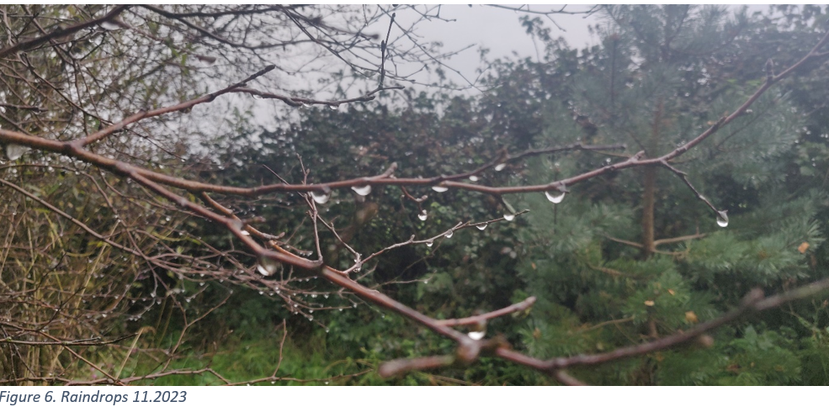

I encountered one morning invited me to engage with them not through vision but via a medley of tongue-touch-taste.(Figure 6). These wide-open-minded engagements were sometimes uncomfortable and confusing for the researcher in me. ‘To allow for the unexpected to happen with no preconception about what one is even looking for,’ Gagliano suggests, can be viewed as ‘an infringement of the conventional touchstone for scientific legitimacy’

Given that I was the medium through which this conversation with Carrigeens was taking place, I found myself, in a sense-making activity attempting to clarity the various ways I perceived and related to place as Carrigeens. I called these modalities. The experiential modality pertained to the ways I experienced input, connection and contact from environment and the expressive, how I responded to these experiences. In combination, they help describe the intersubjective engagement between place and person.

I identified four aspects of the experiential modality experience: body, emotions, thoughts and the transpersonal realm which Biddulph refers to as four components of the human psyche. Body sensations including the five senses, and others, such as temperature and gut feelings. were generally the first entry point for my experience of Carrigeens. Abrams, referring to Merleau-Ponty, reminds us that ‘at the heart of even our most abstract cogitations, [is] the sensuous and sentient life of the body itself’. I was also aware that my culturally biased focus on the five separate senses restricts what can be experienced, including synaesthesia, and that other cultures have different sensory experiences, This allowed me to experiment with sensuality as in for example, the tongue-touch-taste of raindrop already mentioned.

Sometimes emotions would arise through the senses, particularly the visual which triggered in me a sense of beholding beauty, accompanied by feelings of awe and gratitude. At other times, an idea forged when writing the diary would bring with it a flood of emotion, most associated with the experience of love: I wrote, “…beauty is the gateway to the sacred: I think with emotion that this place is my church – and as a write, I realise with surprise that living willow structure I wove three years ago near the pond resembles the nave of a chapel” (figure 7).

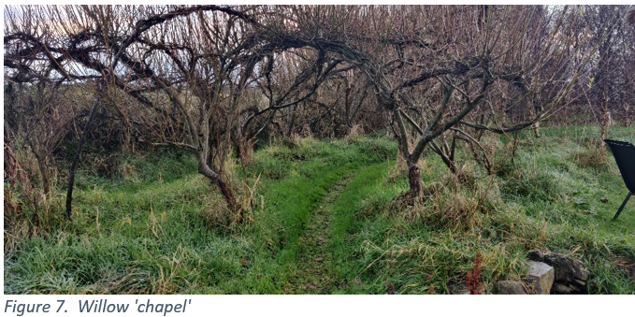

Finally, for the purposes of this research, I refer to the transpersonal realm in relation to imagery and dreaming and other non-ordinary states of consciousness. Gagliano, for example, describes the process in her shamanic engagement with the Socoba tree which resulted in the creation of a series of experiments on plant behavioural ecology. Two images, accessed respectively through trance and meditation, were key drivers for me in co-creating and shaping the landscape of Carrigeens – one is described later in this paper in a story of a forested prehistoric landscape, and the other, the image of a pattern for a path that arose spontaneously from a meditation eleven years ago. I saw a labyrinthine image, which I went on to draw and redraw several times. This inspired me to mow a path through the young saplings I had planted in the meadow, amending the original design as I went to accommodate the trees. I experienced this as a co-creation of a path with the place of Carrigeens. It was along this path that future daily engagements with Carrigeens were conducted.(Figure 8).

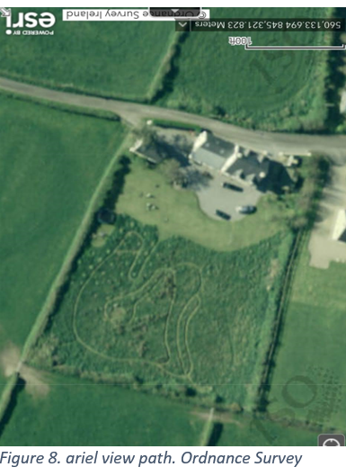

In my research, three aspects of the expressive modality emerged as themes – movement, writing and ritual. For Tilley, ‘human activities become inscribed within a landscape…’ and Ingold suggests that it is by wayfaring along paths …’that people grow into a knowing of the world around them’, The activities of reaching out, responding to touch, walking towards and away, uncovering – were at the forefront of my engagement with Carrigeens. Thoughts and ideas about this project would often come in my daily perambulations along the path, which I was remaking with every footstep. I experienced movement as a dialectical process with the affordances that Carrigeens offered– “As I run, I notice that if I let go of my habitual knowing about forward projection, the trees are definitely moving towards me as I move towards them”. On another occasion, while using divining rods to trace in my walking the energy lines around the standing stones, I felt a sense of wonder at the mystery this en-lined universe that Ingold explores in his book, Lines, and which in this moment was expressing itself in invisible traces of an energetic circle wrapping itself around the standing stones.

Kimmerer sees writing as ‘…an act of reciprocity with the living land’. In this research, the writing up of the experiential communications with Carrigeens was itself part of the unfolding communication, with most of the diary entries written in the geodome. A common phrase in the diary was, ‘as I write this…I notice/wonder/think.’ It was in the process of writing that the felt experience of Carrigeens’ communications were translated into human language, often in a poetic style. It was as if the writing were inscribing within me the mark of place. Gagliano alludes to plant-writing, and Kimmerer to developing a language of animacy, a verbing of this shapeshifting world. Encouraged by Ingold who points to the challenge to find a different way of writing: ‘…to experiment: to try things out and see what happens,’ I paid careful attention to how the research was presented in an attempt to facilitate the personhood of Carrigeens to collaborate in this final state of the process. My experience of the writing up was one of tension between opposite allegiances: a desire to stay faithful to the often creative and unorthodox way Carrigeens expresses them-selves while at the same time, producing a paper acceptable to western academia. I tried to incorporate Carrigeens’ communication style using images, and sequencing of material in a way that reflected the cyclical nature of the communication process with place. I have woven into the text three ‘voices’ already alluded to in the methodology section and the use of hyphens in order to illustrate the nuances of my experience as self-embedded-in-place, voice-of-Carrigeens and my academic scribe-self.

Lane observes that ‘…sacred place is very often ordinary place, ritually set apart to become extraordinary’ The term ritual is often used with reference to the supernatural and having some form of symbolic communication. What emerged in relation to this research was the centrality of my habitual ritual of the daily/walk run through the winding paths. My experience was of a repeated practical activity to keep fit, in the presence of a most beloved other, where the path making and following allowed to a variety of encounters with the persons-of-the-place. This was an encounter with the ordinary, not to set apart but practised to include the whole of Carrigeens in a mutual process of engagement. Other ritual activities did arise however which held symbolic value and were co-created with Carrigeens. For example, the creation of a fire ceremony at the conclusion of the research.(figure 9) and my taking in of what felt like a sacred ‘holy communion’ of a raindrop. This involved an experience of altered perception: ‘This moment opens me up to the sanctity of the water – it feels much more voluminous on my tongue than its density and volume would suggest.’
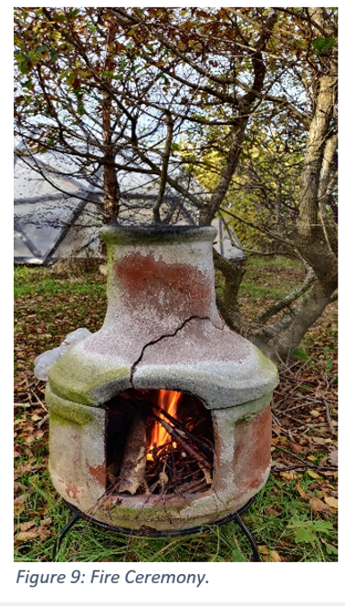

I applied the term intersubjective experimentation to refer to the active engagement of co-researchers in the testing out of hypotheses and exploring questions and hunches. For example, I had wondered about how engagements at different times of the day and night might contribute to the research. Responding to a Kairos nudge from Carrigeens, on one exceptionally balmy night, I set out (reluctantly in my nightclothes) to explore this. The contemporaneous diary entry reads: “…the darkness fools me and leads me off path. I feel a little afraid inside this new animal of the night”. My curiosity was being met by Carrigeens who presented a facet of their personality that was unfamiliar and strange to me. This elicited a fleeting sense of fear followed by a feeling akin to admiration which was “…not so much awe as a deep appreciation”.

While placed last in this section, the exploration of the process by which I interpreted communications from Carrigeens was a core activity in the application of this methodology. During the research, I identified two types of experience through which I understood that I was receiving direct communications from Carrigeens. It is important to state that the identification of these was gleaned over a long period, since 2001.

In the first instance, identifying gut feelings were paramount in discerning communications from Carrigeens. Biddulph describes, ‘supersense’ as a precognitive awareness, known in the body before it is known in the mind. It is visceral not verbal and for me this was identified through the inner kinaesthetic muscular experience of expansion and contraction, corresponding respectively to intuitive/emotional states of ‘yes, that feels right’ (expansion/relaxation), and ‘no, that’s not quite right,’ (contraction/clenching). It was my primary method of dealing with the sensory flooding described in a previous section, operating like an inner-embodied divination tool. By continually asking Carrigeens the question – ‘is this what you what me to pay attention to?’ and checking gut-feelings, I was able to ascertain where and how to place my focus. It also acted as a proofreader for my writing when transcribing Carrigeens’ communications into words.

I learnt that there are also subtle nuances in the interpretation of gut feelings with an initial ‘no’ response not always coinciding with my experience of what Carrigeens was communicating. Over my apprenticeship with Carrigeens, I have learnt that they often ask for more than I am initially willing to give, so that the request at first, is received in me with a contraction and reluctance, followed almost always by a knowing that the request is ‘right’, culminating in muscular relaxation. This occurred during this research when I felt compelled by Carrigeens to ‘…do my writing here outside in the place which is speaking [to me]. I hear the command from the land, and I know this feeling – it’s a slight resistance, because it’s going to be a little more troublesome to do, requiring more accommodations by me.’ It was also important to pay attention to hunches, perceptual shifts, mental surprises and synchronicities (synchronicities are referred to 20 times in the diary). For example, when I was writing up the diary in the geodome midway through the research, I had a thought accompanied with a feeling of dismay about having forgotten to include in the research, another piece of land I own which is separated from Carrigeens by a road. I felt disconnected from it. Three weeks later, when investigating material for a presentation on belonging, I was surprised to discover from survey maps, that in the 1836 version, a road is not marked – Carrigeens and the land over the road had once been joined and later divided.(Figure 10). Perhaps I was experiencing a ‘memory’ held by place in much the same way as the findings in human neuroscience show that the human body ‘keeps the score’ storing trauma at a precognitive level.

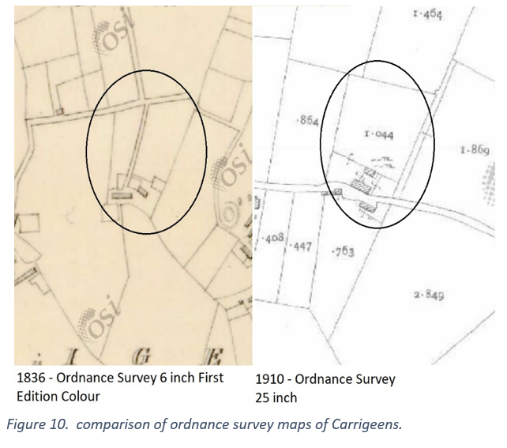

Experiencing the sacred in place as a cocreation of beloveding.

Hislop et al identify storytelling as part of the methodology in collaborative autoethnography. The inspiration for this research arose out of my attachment relationship with Carrigeens for over twenty-two years, and the origins of this can be told as a story.

What happened when the stones told me to plant trees?

It is 2002, I have come from Dublin with my family to spend our first summer holiday in Carrigeens. The children are at the beach, and I stand facing north with my hands on the shoulder of the tallest standing stone. As I look out onto the mown meadow, I ask the stones – “what is my purpose here with you”? I sink into a familiar light trance - the state I enter in my shamanic journeys. I see an image of woodland as far as the eye can see, sweeping down to a lake or sea inlet in the valley below, which is now boggy meadow. A thought shoots into my mind, clear and insistent, from what I imagine to be the ancestors who constructed the tomb – put back the trees that we felled to make way for the stones . Eight years later, just after the winter solstice, I plant one hundred-and-eighty, two-year old native saplings, and the love affair with Carrigeens unfolds.

Howe identifies aspects of secure attachment relationships which include offering a haven and secure base through the development of affectional bonds, caregiving and receiving and regulation of emotional states all of which offer a mirror for the development of a sense of self. Regulation of my emotional state and being calmed through engagement with Carrigeens is mentioned at least fourteen times in the diary and was a regular experience for me over the years. This is supported by research on the positive impact of the natural environment on human wellbeing. My attachment relationship, is expressed through my commitment to spend more than thirty-three hours of direct contact with Carrigeens as part of this project. I experienced this as a delightful daily contact with an old friend, and the increased contact over the course of the research, has deepened this connection further. Tilley points out that ‘the place acts dialectically so as to create the people who are of that place….[giving[ rise to a feeling of belonging and rootedness [and] concern that provides ontological security’

Reciprocal caregiving and care-receiving over the years with Carrigeens resembles the changing relationship between parent and child. My tending of Carrigeens by planting saplings, and encouraging biodiversity in many ways, has deepened and broadened the extent of their personhood and presence. I recall the first time I stepped into the growing woodland and felt with awe, the hush of their palpable presence as consciously-evolving-woodland, and many years later, being moved to tears of gratitude when I was able to lie in a hammock supported by two now sturdy birches I had planted all those years ago, as I was rocked like a baby by the movement of the trunks in the wind. The reciprocity had come full circle.

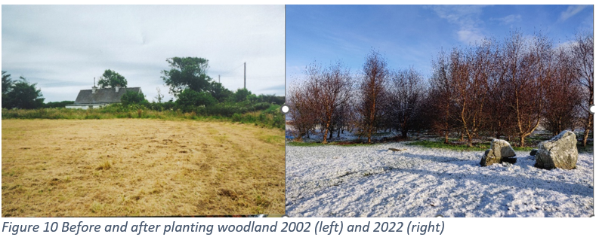

As Lane suggests, like others, my experience of Carrigeens as ‘sacred’ is one which …honor[s] the participation of the whole environment’. This arose neither out of a sense of sacred being intrinsically present and discovered in various fixed locations or bestowed by me or the ancestors who placed the tomb. In fact, I rarely engaged with the tomb over the years after that first shamanic encounter. Instead, the experience of sacred arose out of relational intersubjective participation which Carrigeens seems to call beloveding. The concept sacred becomes a noun – a act of beloveding - akin to the verbing grammar of animacy described by Kimmerer. I experienced this during the fire ritual at the conclusion of the research, when reaching out in gratitude to an oak which I had planted as acorn, a robin simultaneously and surprisingly appeared, engaging with me-touching-oak in what felt like playful curiosity. It was a moment of wonder that this bird-person was curious about and willing to engage with me as I was engaging consciously with place. (This can be viewed at VID_20231111_115912~2.mp4 )

This research illustrates my experience of the sacred as erupting in moments of often spontaneous intersubjective relating, at various locations, where sacred was neither intrinsic to particular spaces nor bestowed by me onto place. This process was rooted in attachment, reciprocity and kinship and ‘sacredised’ by the simple ‘art of attention’ where Carrigeens was beheld as a precious more-than-human other identified as part of my wider ‘ecological’ self: “I witness myself being witnessed by myself as this place”. “The place is not out there, but in me seeking consciousness”. It could be said that the execution of this research project was itself an activity of beloveding. I leave Carrigeens to conclude this section.

Don’t you know, my dear, that you are this place, you are in path, tree, seat, mound, water and air, you have drawn out our unfolding and [our] ever-complex being, and we have drawn out through our teachings and tendings, your own essential nature and awareness. (see figure 11).

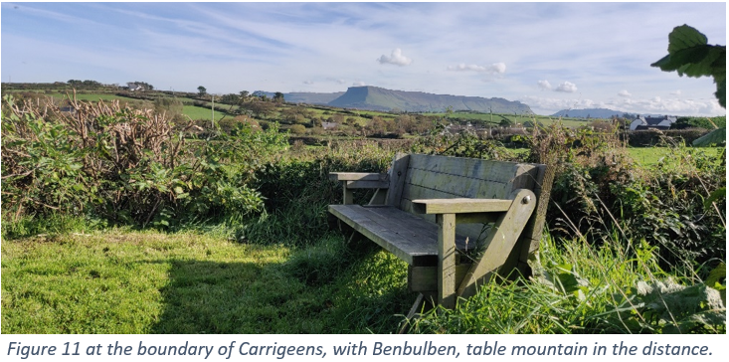

Further thoughts.

In this research, I discovered that working with more-than-human personhood of place creates a meandering practical methodology requiring patience, discernment and a construction that did not follow a linear progression, with communications received often at a precognitive level This presented challenges in translating these accurately through text and image, and in discerning what might be considered correct or admissible within an academic framework. My research position which took seriously my experience of place-as-person, created ethical obligations and tensions between loyalties to the academy, and adherence to the research question posed, and what ‘place’ might want known that diverged from this.

Conclusion
This case study presents research undertaken with a particular place named Carrigeens, conceptualised as a more-than-human person, who actively participated in the research as both subject and co-researcher. I located the research within an existing theoretical and methodological framework using a hybrid combination of CAE and MtHR. It was conducted within a phenomenological perspective which circumvented the need to attend to ontological issues associated with engaging with more-than-human persons, and western dualistic concepts of the sacred. The enquiry focused on the embodied, intersubjective experience of place and how the sacred might be encountered and co-created in relationship with place. The concept of new animism, established in anthropology gave an explanatory context in which to situate the dialogical research process. Tensions between commitment to working with more-than-human persons and adhering to the rigour of an academic enquiry were acknowledged.

The research offered insights in two specific areas: The first explored the operational practicalities of how a methodology might be co-created with a more than human subject/co-researcher. This involved identifying factors which facilitated conditions favourable to the research process. Given that the human co-researcher was the medium through which place communicated, particular attention was paid to identifying the personal and expressive modalities, through which place was experienced and the methods employed to interpret this experience. The second theme involved the encounter of sacred in relation to place. This was articulated as a relational and intersubjective process arising within the context of an attachment bond. It involved a dialogical relationship developed over time, between the personhood of place and human person, each influencing and enriching the growth of the other in an activity described as Beloveding. Sacred was not attributed to features of place to be discovered or bestowed. It described rather, activities of intersubjective witnessing ‘sacredised’ through the conscious act of attention by researcher-as-human to behold place and its constituents as more-than-human persons.

Collaborating with more-than-human colleagues offered practical and ethical challenges within the conventions demanded by western academia. It is hoped however, that this study might invite further investigations both into practical applications of a CAE/MtHR hybrid approach, and in exploring the sacred in western settings.

Bibliography

Abram, David. The spell of the sensuous: Perception and language in a more-than-human world. (Vintage, 2012).
Abram, D. "Becoming Animal: An Earthly Cosmology, (Vintage books, New York, 2011).
Bastian, Michelle. "Towards a more-than-human participatory research." Participatory research in more-than-human worlds. Routledge, 2016. pp 19-37.
Biddulph, Steve, Fully human: a new way of using your mind, (Macmillan Publishers Ireland, 2021).
Bird-David, Nurit. "“Animism” revisited: personhood, environment, and relational epistemology." Current anthropology 40.S1 (1999), S67-S91.
Braud, William, and Rosemarie Anderson. Transpersonal research methods for the social sciences: Honoring human experience, (Sage, 1998).
Chang, Heewon, Faith Ngunjiri, and Kathy-Ann C. Hernandez. Collaborative autoethnography. Vol. 8. (Routledge, 2016). This can be previewed at https://www.taylorfrancis.com/books/mono/10.4324/9781315432137/collaborative-autoethnography-kathy-ann-hernandez-heewon-chang-faith-ngunjiri.
Classen, Constance. “Sweet Colors, Fragrant Songs: Sensory Models of the Andes and the Amazon.” American Ethnologist, vol. 17, no. 4, 1990, pp. 722–35. JSTOR, http://www.jstor.org/stable/645710. [Accessed 7 Dec. 2023].
Cusick, Christine, and Derek Gladwin ed, ‘Unfolding Irish landscapes: Tim Robinson, culture and environment.’ Unfolding Irish landscapes (2016).
Drawson, Alexandra S., Elaine Toombs, and Christopher J. Mushquash. "Indigenous research methods: A systematic review." The International Indigenous Policy Journal 8.2 (2017).
Durkheim, Emile, The Elementary Forms of Religious Life, Translated, Fields, Karen E., (The free press, New York, 1995).
Gagliano, Monica. Thus spoke the plant: A remarkable journey of groundbreaking scientific discoveries and personal encounters with plants, (North Atlantic Books, 2018).
Hackett, Paul M. W., et al., ‘Autoethnography.’ Chapter 13, Consumer Psychology: A Study Guide to Qualitative Research Methods, 1st ed., Verlag Barbara Budrich, (2016) pp. 87–90. JSTOR, https://doi.org/10.2307/j.ctvddzsrf.19. Accessed 12 Dec. 2023.
Harvey, Graham. "Animism and ecology: Participating in the world community." The Ecological Citizen 3.1 (2019): 79-84.
Hennink, Monique, Inge Hutter, and Ajay Bailey. Qualitative research methods. (Sage, 2020).
Hislop, Lauren, Kate Davies and Shaylie Pryer, ‘Taking Power, Telling Stories: Using Collaborative Autoethnography to Explore Transitions to Adulthood with and without Disability Identities, ’Scandinavian Journal of Disability Research 25(1), (2023), pp 78-91, DOI: https://doi. org/10.16993/sjdr.915 .
Howe, David. Attachment Across the Lifecourse: A Brief Introduction. (Bloomsbury Publishing, 2011), pp 3-28.
Hunter, Jack. "Ontological flooding and continuing bonds." Contin. Bonds Bereave (2017), pp 191-200.
Ingold, Tim. Lines: A brief history. (Routledge, 2016).
Ingold, Tim. Correspondences. John Wiley & Sons, 2020.
Jimenez, Marcia P., et al. "Associations between nature exposure and health: a review of the evidence." International Journal of Environmental Research and Public Health 18.9 (2021): 4790.
Kimmerer, Robin. Braiding sweetgrass: Indigenous wisdom, scientific knowledge and the teachings of plants, (Penguin, Random House, UK, 2013).
Kimmerer, Robin Wall. The Democracy of Species. (Penguin UK, 2021).
Koechlin, Florianne, Plant Signal Behav. 2009 Jan; 4(1): 78–79. doi: 10.4161/psb.4.1.7315.
Lane, Belden C. Landscapes of the sacred: Geography and narrative in American spirituality, (JHU Press, 2002).
Langdridge, Darren. Phenomenological psychology: Theory, research and method, (Pearson education, 2007).
Magan, Manchán. Thirty-two words for field: Lost words of the Irish landscape. (Gill & Macmillan Ltd, 2020).
Magallanes, Catherine Iorns. "From rights to responsibilities using legal personhood and guardianship for rivers." ResponsAbility (2018): 216-239.
Naess, Arne, et al. Thinking like a mountain: towards a council of all beings, (New Catalyst Books, 2007),
Patten, Bernard C., and Gregor T. Auble. “System Theory of the Ecological Niche.” The American Naturalist, vol. 117, no. 6, 1981, pp. 893–922. JSTOR, http://www.jstor.org/stable/2460571. Accessed 2 Dec. 2023.
Rappaport, Joanne. ‘Beyond participant observation: Collaborative ethnography as theoretical innovation.’ Collaborative anthropologies 1.1 (2008): 1-31.
Simard, Suzanne. Finding the mother tree: Uncovering the wisdom and intelligence of the forest. Penguin UK, 2021.
Smith, John E. “Time and Qualitative Time.” The Review of Metaphysics, vol. 40, no. 1, 1986, pp. 3–16. JSTOR, http://www.jstor.org/stable/20128415. Accessed 19 Dec. 2023.
Studstill, Randall, ‘Eliade, phenomenology, and the sacred’, (Religious Studies 36.2 2000), pp 177-194.
Tatay, Jaime, and Amparo Merino. "What is sacred in sacred natural sites? A literature review from a conservation lens." Ecology and Society 28.1 (2023), https://doi.org/10.5751/ES-13823-280112 .
Taylor, Bron Raymond. Dark green religion: Nature spirituality and the planetary future. (University of California Press, 2010).
Taylor, Jill Bolte. My stroke of insight. (Hachette UK, 2009).
Thorley, Anthony, and Celia M. Gunn. Sacred Sites: an overview, (Bath: The Gaia Foundation, 2008).
Tilly, Christopher, Space, Place, Landscape and Perception: Phenomenological Perspectives, A phenomenology of landscape: places, paths, and monuments, (Vol. 10. Oxford: Berg, 1994).
Van der Kolk, Bessel. The body keeps the score: Mind, brain and body in the transformation of trauma, (Penguin UK, 2014).
Verhoeven, Marc. ‘The many dimensions of ritual,’ The Oxford handbook of the archaeology of ritual and religion (2011), pp.115-132.
Whitehead, Amy R. Religious statues and personhood: testing the role of materiality, (A&C Black, 2013).
Żerkowski, Michał. "A. Irving Hallowell’s research on the Ojibwe animism." Etnografia. Praktyki, Teorie, Doświadczenia 6 (2020): 21-48.

Appendix 1

historic environment viewer

SL007-040001- : Megalithic tomb - unclassified : CARRIGEENS (Carbury By.)
Description: Situated on a lawn in the rear garden of a dwelling. Four upright and three prostrate stones appear to represent the last vestiges of a megalithic tomb. The stone to the S is 0.7m long, 0.5m thick and 1.15m high. A pair of stones, probably originally one stone, stand 2.2m to the N of this. The taller stone is 0.95m long, 0.25m thick and 0.90m high and at its N base is a smaller piece, 0.3m long by 0.18m thick and 0.45m high. Beside these to the N is a prostrate stone, 1.25m long by 0.9m wide and 0.4m thick. It is possible that this represents part of the previous stone that has been broken off. Some 0.4m W of this slab is another upright, 1.05m long, 0.55m thick and 0.8m high. A prostrate slab (0.95m by 0.80m and 0.2m thick) lies c. 3.8m to the NNW. Another prostrate slab (1.5m by 0.85m and at least 0.22m thick) lies 1.2m E of the S upright. The relationship of these to the structure is unclear and they clearly are displaced. Inasmuch as the garden has been landscaped there is no evidence of any surviving mound around the structure. The monument appears to be the last vestiges of a megalithic tomb, though in view of the scantiness of the remains some caution is necessary. The orientation of the three principal uprights would support interpretation as the remains of a gallery aligned E-W with possible affinities to those of the wedge-tomb class. However, elucidation of the full design of the monument must await excavation. Immediately E of the monument is a ring-barrow (SL007-040002-) the outline of which is visible as slight circular undulations (diam. 6.5-7m) in the ground surface.Attached images:SL007-040001-_01.pdf plan of the monumentSL007-040001-_01.JPG Viewed from WSL007-040001-_02.JPG Viewed from NWSL007-040001-_02.JPG Viewed from SECompiled by: Paul WalshDate of upload: 20 April 2012

Six-Inch First edition: Not indicated
Six-Inch Latest edition: Not indicated

ITM Coordinates: 560136 , 845297
Latitude and Longitude: 54.354786 , -8.613247

SL007-040002- : Barrow - ring-barrow : CARRIGEENS (Carbury By.)
Description: Situated on a lawn in the rear garden of a dwelling. The ring-barrow stands immediately E of the remains of a megalithic tomb (SL007-040001-). It measures c. 6.5-7m in diameter. The central mound (diam. c. 3m) and outer-bank (Wth 1-1.2m) are visible as a slight rise (0.1-0.15m) above the surface of the lawn. The outer element of the bank at W fades into a slight rise in ground surface where it borders the remains of the megalithic tomb.SL007-040002-_01.pdf Plan of ringbarrowSL007-040002-_01.JPG Ringbarrow viewed from WSL007-040002-_01.JPG Ringbarrow viewed from SE, outer bank visible as yellowish grass, with possible megalithic tomb (SL007-040001-) on W edge.Compiled by: Paul WalshDate of upload: 20 April 2012

Hackett, Paul M. W., et al., ‘Autoethnography.’ Chapter 13, Consumer Psychology: A Study Guide to Qualitative Research Methods, 1st ed., Verlag Barbara Budrich, (2016) p 90, JSTOR, https://doi.org/10.2307/j.ctvddzsrf.19. Accessed 12 Dec. 2023.
Chang, Heewon, Faith Ngunjiri, and Kathy-Ann C. Hernandez. Collaborative autoethnography. Vol. 8. Routledge, 2016, pp. 23-24.
Abram, David. The spell of the sensuous: Perception and language in a more-than-human world, (Vintage, 2012), p. ix
Ibid, p.22.
Bastian, Michelle. "Towards a more-than-human participatory research." Participatory research in more-than-human worlds. (Routledge, 2016). pp 19-37.
Tilly, Christopher, Chapter 1 Space, Place, Landscape and Perception: Phenomenological Perspectives, A phenomenology of landscape: places, paths, and monuments, (Vol. 10. Oxford: Berg, 1994).
Valle, R, and Mohs, Mary, ‘Transpersonal awareness in phenomenological inquiry: philosophy, reflections and recent research’, in Braud, William, and Rosemarie Anderson. Transpersonal research methods for the social sciences: Honoring human experience,( Sage, 1998), p.98.
Abram, David. The spell of the sensuous: Perception and language in a more-than-human world. (Vintage, 2012), p57.
Harvey, Graham. "Animism and ecology: Participating in the world community." The Ecological Citizen 3.1 (2019), p.80.
This can be viewed at https://www.archaeology.ie/archaeological-survey-ireland/historic-environment-viewer-application by inputting Carrigeens, Carrigeens (Ballinfull), Sligo, IRL. The reference, SL007-040002- is visible on the map. See also appendix 1 which gives a description of the archaeological remains extracted from the viewer.
Patten, Bernard C., and Gregor T. Auble. “System Theory of the Ecological Niche.” The American Naturalist, vol. 117, no. 6, 1981, pp. 893–922. JSTOR, http://www.jstor.org/stable/2460571. Accessed 2 Dec. 2023. P.897.
Langdridge, Darren. Phenomenological psychology: Theory, research and method, (Pearson education, 2007), pp58-61.
Hennink, Monique, Inge Hutter, and Ajay Bailey, (2020), P.19.
See Taylor, Bron Raymond. Dark green religion: Nature spirituality and the planetary future, (Univ of California Press, 2010, p.13.
Wilkinson, Sue. ‘The role of reflexivity in feminist psychology.’ Women's Studies International Forum. Vol. 11. No. 5. Pergamon, (1988) Cited in Langdridge, Darren (2007), p. 60.
Evans, Matthew T. “The Sacred: Differentiating, Clarifying and Extending Concepts.” Review of Religious Research, vol. 45, no. 1, (2003), pp. 32–47. JSTOR, https://doi.org/10.2307/3512498. Accessed 19 Dec. 2023, p.44
Tatay, Jaime, and Amparo Merino. "What is sacred in sacred natural sites? A literature review from a conservation lens." Ecology and Society 28.1 (2023), p.12.
Lane, Belden C. Landscapes of the sacred: Geography and narrative in American spirituality, (JHU Press, 2002), pp 42-46.
Lane, (2002), op cit, p 43.
Ibid, pp 44-45.
Tilley, op cit (1994). P 15.
Abram, David, op cit, (2012). p.47.
Tilley, Christopher op cit, (1994) op cit, p.15.
Robinson, Tim. "A Land without Shortcuts,’." The Dublin Review 46 (2012), p.43, cited in Cusick, Christine, and Derek Gladwin ed, ‘Unfolding Irish landscapes: Tim Robinson, culture and environment.’ Unfolding Irish landscapes (2016), p. xix.
Tilley, Christopher, (1994), op cit, p.26.
Tilley, Christopher, (1994), op cit, p.27.
Ingold, Tim, Lines, Routledge, 2016 pp 16-17.
Ibid, p78.
Ibid p 26.
Thorley, Anthony, and Celia M. Gunn. Sacred Sites: an overview, (Bath: The Gaia Foundation, 2008), p.9.
Ibid, p. 9.
Naess, Arne, ‘Self realization: an ecological approach to being in the world’ in Naess, Arne, et al. Thinking like a mountain: towards a council of all beings, (New Catalyst Books, 2007), P.20.
Żerkowski, Michał. "A. Irving Hallowell’s research on the Ojibwe animism." Etnografia. Praktyki, Teorie, Doświadczenia 6 (2020): pp 21-48.
Bird-David, Nurit. "“Animism” revisited: personhood, environment, and relational epistemology." Current anthropology 40.S1 (1999): S67-S91.
Whitehead, Amy R. Religious statues and personhood: testing the role of materiality, (A&C Black, 2013), p.100.
Drawson, Alexandra S., Elaine Toombs, and Christopher J. Mushquash.’Indigenous research methods: A systematic review.’ The International Indigenous Policy Journal 8.2 (2017), pp.557-558.
Naess, Arne, et al. Thinking like a mountain: towards a council of all beings, (New Catalyst Books, 2007), pp 10-12.
Lane, Belden, op cit, (2002), p.19.
ibid, p.24.
Gagliano, Monica. Thus spoke the plant: A remarkable journey of groundbreaking scientific discoveries and personal encounters with plants, (North Atlantic Books, 2018), pp 10-22.
Kimmerer, Robin Wall. The Democracy of Species. (Penguin UK, 2021).
Tilley, Christopher, op cit (1994), p.21. Drawson, Alexandra, et al., (2017), pp.562.
See Lane, p. 41. and Smith, John E. “Time and Qualitative Time.” The Review of Metaphysics, vol. 40, no. 1, 1986, pp. 3–16. JSTOR, http://www.jstor.org/stable/20128415. Accessed 19 Dec. 2023, p.4.
Drawson, et al (2017), p.558.
Thorley and Gunn op cit, (2008) p. 10.
Stuart-Smith, Sue. The well-gardened mind: The restorative power of nature. Simon and Schuster, 2021, p18
Magan, Manchán. Thirty-two words for field: Lost words of the Irish landscape. (Gill & Macmillan Ltd, 2020), pp 131-132.
Taylor, Jill Bolte. My stroke of insight. (Hachette UK, 2009), pp 42-55.
Lane, op cit, (2001), p.19.
Research diary, p.8.
Gagliano, Monica (), p.31.
Biddulph, Steve, Fully human: a new way of using your mind, (Macmillan Publishers Ireland, 2021), pp 32-36.
Classen, Constance. “Sweet Colors, Fragrant Songs: Sensory Models of the Andes and the Amazon.” American Ethnologist, vol. 17, no. 4, 1990, pp. 722–35. JSTOR, http://www.jstor.org/stable/645710. [Accessed 7 Dec. 2023].
Research diary, p.10
Gagliano, Maria pp10-22.
Tilley, Christopher, op cit(1994), p.27.
Ingold, Tim, op cit (2016), p.3.
Research diary, pp22-23.
Ingold, op cit (2016).
Kimmerer, op cit, (2021), p.88.
Gagliano op cit, 0.16.
Kimmerer, (2021pp. 1-23
Ingold, Tim, op cit., (2021), p.201.
Lane, Belden, op cit (2001), p. 25.
Verhoeven, Marc. "The many dimensions of ritual." The Oxford handbook of the archaeology of ritual and religion (2011), p. 116. 115-132.
Diary entry, p.11
Research diary, p.5.
Ibid, p.5.
Biddulph, Steve. Fully human: a new way of using your mind. Macmillan Publishers Ireland, 2021.pp 3-18.
Ibid, p. 12.
Ibid, p.11-12.
Research diary, p.12
Van der Kolk, Bessel. The body keeps the score: Mind, brain and body in the transformation of trauma, (Penguin UK, 2014).
Hislop et al, op cit, p.82.
Howe, David. Attachment Across the Lifecourse: A Brief Introduction. (Bloomsbury Publishing, 2011), pp 3-28.
See Jimenez, Marcia P., et al. "Associations between nature exposure and health: a review of the evidence." International Journal of Environmental Research and Public Health 18.9 (2021): 4790. Stuart-smith, Sue op cit (2021), pp72-86, and
Tilley, Chrisopher, op cit, (1994) p.26.
Kimmerer, Robin-wall op cit (2021), pp
UWSTD, student OneDrive account.
Robinson, tim,op cit, (2016), p.xix.
Naess, Arne, op cit, (2007), p.20.
Research diary, op cit, p.25.
Ibid, p.21.
Research diary, op cit p.15.

