

Module: Creativity and Value Creation
Module Code: BMHP5014
Assignment Title: Component 2 – Written Assignment (Poster and Pitch)
Student Name: Elena Bianca Coroeanu
Student Number: 2325653
Teacher name: Alice Clayton

Table of Contents
Poster 3
Innovation Overview: 3
The Issue/Gaps in Health & Social Care: 3
Target Audience and Impact: 3
Implementation: 3
Timeline: 4
Development and Regulations: 4
Technology Integration: 4
Dissemination: How the Innovation Will Be Promoted: 4
Conclusion: 5
Pitch 7
Introduction 7
The Health and Social Care Challenge 7
Target Population and Expected Impact 7
Target Population and Expected Impact 8
Policy and Legislative Context 8
Innovation and Creativity 9
Public Involvement and Awareness 10
Evaluation and Sustainability 10
Conclusion 11
References 12

Poster
Title: BrightSmiles: Empowering Children and Families for Lifelong Oral Health

Innovation Overview:
UK children aged five to eleven are targeted by BrightSmiles to enhance oral health. It uses a mobile app, school workshops, and family education to make daily brushing and healthy eating a habit for kids. Games, little prizes, and visual learning encourage children and help parents maintain home routines. BrightSmiles promotes early prevention and the government's goal of reducing health inequities and improving community wellbeing (Public Health England, 2023; Department of Health and Social Care, 2025; NHS Digital, 2024).

The Issue/Gaps in Health & Social Care:
Tooth decay is still a common health problem for young children in England and is still one of the main reasons people go to the hospital. Despite improvements in dental care, many families still have trouble getting regular check-ups, especially in poor areas (Public Health England, 2023).
Poor dental health is linked to lack of oral health information and poverty (George et al., 2018; Richard et al., 2016). These discrepancies demonstrate the need for new, inclusive strategies to make dental care more entertaining and accessible to all youngsters, regardless of background or income.

Target Audience and Impact:
BrightSmiles targets children aged five to eleven, their parents or guardians, as well as the educational institutions and professionals assisting them. The initiative promotes familial engagement in the preservation of optimal oral health and fosters confidence through collaborative education.
Digital technology in community education help parents build healthy home habits and give schools realistic teaching materials. Improved regular brushing, dietary knowledge, and dental caries reduction are expected. NHS England (2017) and Bate and Robert (2006) believe the approach promotes community health equity.

Implementation:
Ten elementary schools in Greater Manchester will pilot the BrightSmiles program. School nurses, dental practitioners, and community educators will conduct workshops and family support sessions. The smartphone application will enable parents and children to monitor progress and receive notifications regarding dental hygiene and check-ups. Before extensive implementation, educational institutions and families will assess its effectiveness. The pilot phase will guide enhancements and nationwide implementation in subsequent years (Usher, 2025; Durham University, 2024).

Timeline:
BrightSmiles will be developed in phases over three years. Schools and health experts will help design the app and educational materials in the first three months. Second, from month four to nine, 10 elementary schools will pilot the concept. In months 10-12, engagement and early results will be assessed. BrightSmiles will expand regionally in the second year and premiere nationwide as a sustainable public health initiative in the third (Department of Health and Social Care, 2025).

Development and Regulations:
BrightSmiles will be produced in accordance with all pertinent health and data protection regulations in the United Kingdom. The program adheres to the UK Data Protection Act (2025) and the General Data Protection Regulation (UK GDPR) to guarantee the secure management of all information gathered via the mobile application. Ethical permission will be secured from the NHS Health Research Authority prior to the commencement of the pilot. The initiative adheres to national directives from NHS Digital and Public Health England to guarantee accessibility, inclusion, and superior health promotion materials (UK Government, 2025; NHS Health Research Authority, 2017).

Technology Integration:
BrightSmiles uses technology to make oral health education fun and engaging for kids. Brushing activities, prizes, and subtle reminders on the smartphone app encourage frequent use and good behaviours. Parents may follow their child's progress on a dashboard that provides advises on good habits and dental checkups. Artificial intelligence is employed to customise reminders and monitor participation over time. The secure NHS-supported cloud infrastructure guarantees that all data is safeguarded and utilised solely for enhancing health outcomes (Runco, 2014; NHS Digital, 2024).

Dissemination: How the Innovation Will Be Promoted:
BrightSmiles will be marketed through a mix of school, community, and online outlets to reach as many people as possible. Local school assemblies and newsletters will tell kids and parents about the campaign. Social media sites will also use the hashtag #BrightSmilesUK to spread the word. Posters and demonstrations at NHS dental clinics and community fairs will also encourage people to take part. Working with local governments and the media will assist get the word out and gain people's trust. BrightSmiles wants to make everyone responsible for improving children's oral health by getting teachers, health professionals, and families involved (Bate and Robert, 2006; Usher, 2025).

Conclusion:
UK children aged five to eleven are targeted by BrightSmiles to enhance oral health. It uses a mobile app, school workshops, and family education to make daily brushing and healthy eating a habit for kids. Games, little prizes, and visual learning encourage children and help parents maintain home routines. BrightSmiles supports the government's goal of eliminating health inequities and boosting community wellness through early prevention.

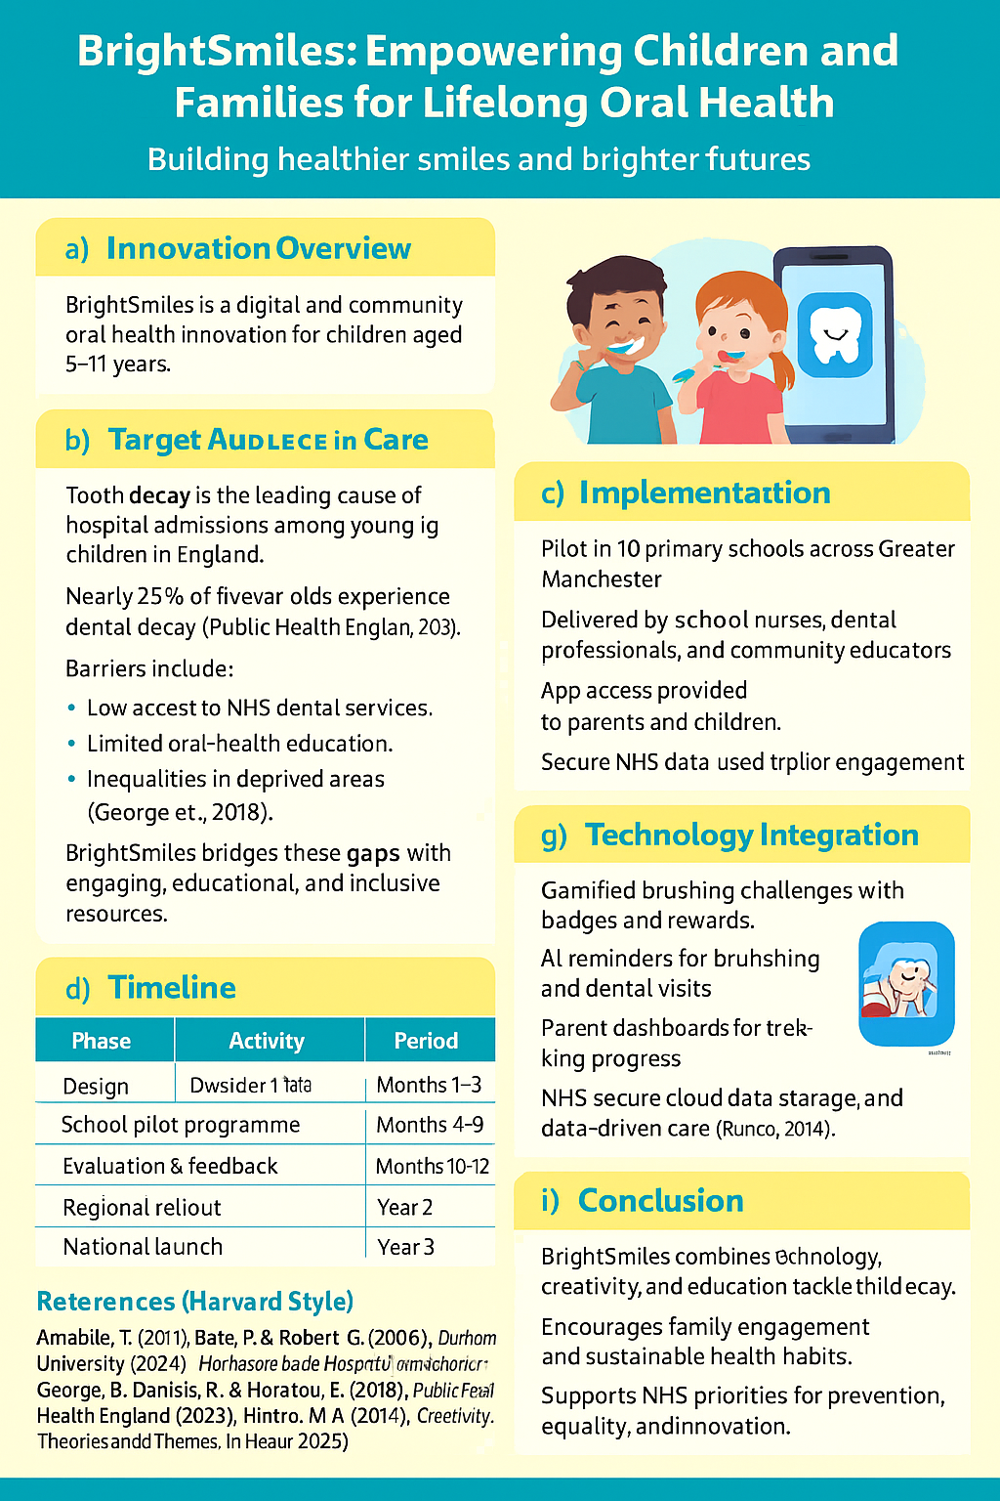

Pitch

Introduction
Oral health is an important part of a child's general health that is often overlooked. Even though schooling and health care have improved, dental caries is still the most common noncommunicable disease in children in the UK. The fact that children from poor families have much higher rates of oral cavities and hospital stays for tooth extractions (Public Health England, 2023) shows how this preventable illness reflects larger social problems. These differences show that health education, prevention, and promotion are not working as well as they should be across the board.
The BrightSmiles initiative addresses this ongoing dilemma by creatively integrating digital technology, community involvement, and health education. It seeks to enable children aged five to eleven, as well as their families and schools, to cultivate enduring healthy oral health practices. The innovation is consistent with the NHS Long Term Plan and the Fit for the Future: 10-Year Health Plan for England (Department of Health and Social Care, 2025), embodying national priorities in prevention, equity, and public health innovation. BrightSmiles exemplifies a novel paradigm for sustainable, community-driven health enhancement by fostering collaboration among families, professionals, and politicians.

The Health and Social Care Challenge
Although oral health is widely recognized as a fundamental component of general wellbeing, it continues to reveal stark inequalities within the United Kingdom. Dental decay among young children is not simply a clinical issue but a reflection of broader social, economic, and educational factors. According to Public Health England (2023), nearly a quarter of five-year-olds experience tooth decay, with prevalence significantly higher in lower-income communities. These patterns illustrate the persistent link between health outcomes and the wider determinants of health, such as income, parental education, and access to services (George, Daniels and Fioratou, 2018).

Target Population and Expected Impact
The ramifications beyond mere bodily suffering. Subpar oral health has been linked to school absenteeism, diminished self-esteem, and a lower quality of life. Simultaneously, avoidable hospital admissions for dental extractions impose unnecessary strain on NHS resources. Notwithstanding numerous national campaigns, advancement has been sluggish, mainly because to the inability of current initiatives to maintain family involvement or adjust to the digital habits of contemporary homes. Confronting this dilemma necessitates unique, creative solutions that empower families instead of simply instructing them, thereby bridging the divide between healthcare policy and practical application.

Target Population and Expected Impact
The BrightSmiles campaign primarily focusses on children aged five to eleven, a developmental stage when daily routines and health attitudes are most readily established. At this juncture, children are amenable to imaginative, play-oriented education and can impact their families' conduct through collaborative engagement. Concentrating on this demographic targets a crucial prevention period recognised in the National Dental Epidemiology Programme (Public Health England, 2023), during which early intervention can markedly diminish the probability of subsequent dental disease.
BrightSmiles acknowledges that children's family and community surroundings impact dental health. Therefore, parents, carers, and teachers are key project partners. The concept fosters collaborative learning and accountability for wellbeing through digital technologies, school-based workshops, and parental education. Brushing frequency, dental checkup attendance, and oral health literacy should improve. Beyond individual gains, the plan aims to minimise regional inequities, relieve NHS dental service burden, and promote preventative health knowledge for the greater good.

Policy and Legislative Context
The BrightSmiles project is entirely consistent with national health aims and existing UK legislation. The Fit for the Future: 10-Year Health Plan for England (Department of Health and Social Care, 2025) and the NHS Long Term Plan underscore the significance of prevention, early intervention, and the mitigation of health disparities via community collaboration. These strategies recognise that significant enhancement in population health cannot depend exclusively on clinical treatment but must incorporate education, digital innovation, and community empowerment. BrightSmiles actualises this policy aim by incorporating preventative practices into everyday life and advancing health equity through collaborative efforts among families, schools, and healthcare professionals.
The program adheres to the Data Protection Act (UK Government, 2025) and the UK General Data Protection Regulation (GDPR), guaranteeing that any personal data gathered via the app is managed responsibly and securely. Ethical approval will be obtained by the NHS Health Research Authority (2017), ensuring participant welfare and upholding professional accountability. Furthermore, BrightSmiles endorses the Health and Social Care Act 2012 by promoting collaborative efforts among local authorities and NHS services. This policy consistency guarantees the initiative's legitimacy, viability, and potential for long-term national implementation.

Innovation and Creativity
The BrightSmiles initiative exemplifies an innovative and evidence-based approach to a longstanding public health issue. The design is based on Amabile’s Componential Theory of Creativity (2011), which emphasises the interplay of knowledge, creative thinking abilities, and intrinsic motivation as the cornerstone of creativity. BrightSmiles converts oral health education from a passive, instructional approach into an interactive, participatory experience by integrating these features. Gamification in the mobile application promotes a joyful perception of toothbrushing among youngsters, while rewards and feedback maintain motivation and behavioural consistency.
Creativity at BrightSmiles transcends digital instruments. School-based workshops incorporate art, storytelling, and group discussions to help children articulate their understanding of healthy habits in personal and meaningful ways. This interactive method bolsters Runco’s (2014) assertion that creativity improves problem-solving and long-term learning by prompting individuals to link ideas across many contexts. The initiative exemplifies design thinking by employing empathy, prototyping, and iteration to enhance solutions informed by community feedback. BrightSmiles demonstrates how the integration of innovative approaches with public health objectives may provide social benefit and mitigate inequities through inclusive, human-centered design.
Implementation Plan
The execution of BrightSmiles adheres to a systematic, evidence-driven framework aimed at guaranteeing both efficacy and sustainability. The initial phase entails a twelve-month pilot program in ten primary schools throughout the city of Manchester, chosen for their different demographics and differing dental health requirements. The initiative will be jointly directed by school nurses, dental professionals, and health promotion experts, with assistance from trained educators and volunteers. They will conduct classroom seminars, parental engagement sessions, and community events to introduce the digital application and educational materials.
An essential aspect of implementation is the incorporation of digital monitoring and feedback mechanisms. Data on app engagement, brushing frequency, and parental involvement will be securely collected and examined to discern trends and obstacles to participation. Consistent assessment meetings with local stakeholders will provide transparency and flexibility during the trial phase. At year-end, results will be evaluated against national standards, and conclusions will guide an improved implementation approach. According to the NHS’s Improvement Leaders’ Guide (NHS England, 2017), this methodology facilitates the project's development through co-production and collaborative learning, enhancing its preparedness for regional and national scaling.

Public Involvement and Awareness
Public interaction is key to BrightSmiles' success and longevity. The initiative recognises that oral health improvement requires professional skill and family and community participation. The initiative's co-design strategy makes parents, children, and educators true collaborators in project development. Community centres and NHS dental clinics will promote BrightSmiles and provide oral hygiene advice, while school assemblies, newsletters, and family activities will allow for sharing.
Digital monitoring and feedback are crucial to deployment. Securely collecting and processing application engagement, brushing frequency, and parental involvement data will reveal trends and barriers to participation. Regular assessment meetings with local stakeholders will ensure trial transparency and flexibility. Results will be compared to national standards at year's end to improve implementation. The NHS Improvement Leaders' Guide (NHS England, 2017) states that co-production and collaborative learning help the project's development, ready it for regional and national scaling.

Evaluation and Sustainability
Evaluation is an important part of the BrightSmiles initiative because it makes sure that everything is clear, that people are always learning, and that there is measurable growth. To figure out what effect the project had, it will use both personal and quantitative data. Key success indicators include better knowledge about oral health, more frequent brushing, and going to dental checkups. Also, kids, parents, and teachers will be asked for feedback so that we can learn from their experiences and find ways to make things better. Durham University found in 2024 that user feedback and iterative design are important for digital health innovations to work.

Conclusion
BrightSmiles illustrates the potential of creativity, technology, and teamwork to enhance children's oral health throughout the United Kingdom. By integrating families, educational institutions, and professionals in a common objective, the program transcends conventional health education to foster authentic, enduring behavioural transformation. It fosters equity, prevention, and empowerment via accessible and engaging educational experiences. The project's emphasis on innovation and community collaboration guarantees its ability to adapt, expand, and maintain its influence for the foreseeable future. BrightSmiles presents an innovative framework for cultivating healthier and more fulfilling futures for children globally.

References
Amabile, T. (2011). Componential theory of creativity (pp. 538-559). Boston, MA: Harvard Business School.
Bate, P., & Robert, G. (2006). Experience-based design: from redesigning the system around the patient to co-designing services with the patient. Quality and Safety in Health Care, 15(5), 307–310. Available at: https://doi.org/10.1136/qshc.2005.016527 (Accessed on 01 November 2025).
Department of Health and Social Care. (2025). Fit for the future: 10 Year Health Plan for England - Executive Summary. GOV.UK. https://www.gov.uk/government/publications/10-year-health-plan-for-england-fit-for-the-future/fit-for-the-future-10-year-health-plan-for-england-executive-summary (Accessed on 01 November 2025).
Durham University, & Durham University. (2024, February 14). Healthcare app reduces hospital admissions from care homes - Durham University. Durham.ac.uk. . Available at: https://www.durham.ac.uk/news-events/latest-news/2024/02/healthcare-app-reduces-hospital-admissions-from-care-homes/ (Accessed on 01 November 2025).
George, S., Daniels, K., & Fioratou, E. (2018). A qualitative study into the perceived barriers of accessing healthcare among a vulnerable population involved with a community centre in Romania. International journal for equity in health, 17(1), 41.
Public Health England. (2023, October 11). National Dental Epidemiology Programme (NDEP) for England: oral health survey of 5 year old children 2022. GOV.UK. https://www.gov.uk/government/statistics/oral-health-survey-of-5-year-old-children-2022/national-dental-epidemiology-programme-ndep-for-england-oral-health-survey-of-5-year-old-children-2022 (Accessed on 01 November 2025).
NHS digital. (2024, April 4). Home - NHS Digital. NHS Digital. https://digital.nhs.uk/ (Accessed on 01 November 2025).
NHS England. (2017). Improvement Leaders’ Guide Involving patients and carers General improvement skills. https://www.england.nhs.uk/improvement-hub/wp-content/uploads/sites/44/2017/11/ILG-1.4-Involving-Patients-and-Carers.pdf (Accessed on 05 November 2025).
NHS Health Research Authority. (2017). NHS Health Research Authority. Health Research Authority. https://www.hra.nhs.uk/ (Accessed on 05 November 2025).
Richard, L., Furler, J., Densley, K., Haggerty, J., Russell, G., Levesque, J. F., & Gunn, J. (2016). Equity of access to primary healthcare for vulnerable populations: the IMPACT international online survey of innovations. International journal for equity in health, 15(1), 64.
Runco, M. A. (2014) Creativity: Theories and Themes. Academic Press.
UK Government. (2025). Data Protection Act. Gov.uk; www.gov.uk. https://www.gov.uk/data-protection (Accessed on 06 November 2025).
Usher, A. (2025, July 22). Insight – July 2025 - Transformation Partners in Health and Care. Transformation Partners in Health and Care. https://www.transformationpartners.nhs.uk/insight-july-2025/ ‌(Accessed on 06 November 2025).

