Appendices

Appendix A.

Observation Schedule

Date: Student Teacher: Observer: Year:
 | Child A |  |  | Child B |  |  | Child C
Body language
(Comment)
Work Ethic  (1-5 rating) | AM | BW |  | AM | BW |  | AM | BW
Collaboration
(Comment)
Quality of work  (1-5 rating) | AM | BW |  | AM | BW |  | AM | BW
Additional Notes:

*1-5 scale: 1 = ​low​, 2 = moderately low​ ​, 3 = ​moderate/usual​, 4 = ​moderately high​, 5 = ​high​.

Body Language
Primary assessment tool. Observer only.

Work Ethic
Assessed in action - effort and reliance on HA partner. To be observed by the student teacher and observer to increase validity.

Collaboration
Assessed in action - number of meaningful conversations with partner. Observer only.

Quality of Work
Assessed post-task through books and/or supporting work. To be observed by the student teacher and observer to increase validity.

Appendix B.

Focus Group Interview Questions

- How did you feel working with…?
- Would you like to work with … again? Why?
- How ​confident​ did you feel completing the task with?
- On a scale of 1-10, how ​motivated​ were you doing this task? What could’ve/would’ve motivated​ you more?
- Did you notice any differences from working with your usual partner?
- What help did you get during this task?

Alternative words:
- Confident - easy
- Motivated - excited

Appendix C.
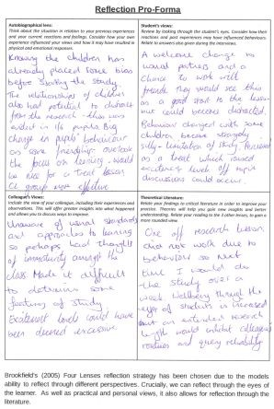
Appendix D.

 |  |  |  |  | 1B
Session Plan – Key Stage 2
Name of trainee: ​Andrew Morgan |  | Date: ​20.02.19
Session ref: ​W5 Literacy - Persuasive Writing
Personal target(s) in relation to QTS:​ ​ ​S3.2.4
They identify and support more able and talented learners, those who are working below age-related expectations, those who are failing to achieve their potential in learning, and those who experience behavioural, emotional and social difficulties. They may have guidance from an experienced teacher where appropriate.

Year group: 3 | No. of 22 learners: |  | ALN​: Child 4 - EAL Child 6 - S & L  Child 11 - EAL Child 15 - S & L  Child 13 - EAL Child 7 - BSDE  Child 17 - EAL
Additional Adults: ​1
Learning objective(s):  Writing a persuasive advert. |  |  | Success criteria:  I know what persuasive means.  I can use persuasive language.  I can apply persuasive language in an advert.  (additional success criteria for books to be printed)
Links to previous learning: ​To conclude the mini project, children are going to write a persuasive advert for their smoothies.
Curriculum coverage (range, skills):
- Literacy: Writing across the curriculum - Organising ideas and information - Meaning, purposes, readers: note down ideas to use in writing
- Literacy: Writing across the curriculum - Organising ideas and information - Writing for different purposes.
- Literacy: Writing across the curriculum - Writing accurately - Languages: use vocabulary related to the topic or subject context
- Literacy: Reading across the curriculum - Locating selecting and reading information - Reading strategies: identify different purposes of texts, e.g. to inform, instruct, explain.

Literacy (LNF):  STRAND: Reading across the curriculum. ELEMENT: Locating, selecting and using information. ASPECT: Reading strategies - skim to gain an overview of a text, e.g. topic, purpose; identify different purposes of texts, e.g. to inform, instruct, explain; use visual clues, e.g. illustration, photographs, diagrams and charts, to enhance understanding. |  | Numeracy (LNF):  STRAND: Developing numerical reasoning. ELEMENT: Identify processes and connections - identify the appropriate steps and information needed to complete the task or reach a solution.
DCF:  - IWB  - Powerpoint  - Use of IWB as a writing tool. | Thinking:  - Recalling/Retrieving previous knowledge.  - Construct plans.  - Organise ideas and information.  - Linking ideas together. | ESDGC:  - Sustainability of their product.  - Why should we use cardboard packaging not plastic?  - Recycling and impact on the environment. |  | YCC:  - Incidental Welsh to be used throughout:  - Commands  - Praise
 | - Metacognition: how can we use previous knowledge to help us with this task? | - Why drink healthy smoothies impact on our health and wellbeing.  - Choices of healthy smoothies, water and pop.
Key vocabulary (English/Welsh):
Persuasion, advert, encourage, sway.

Time | Session activities, organisation and management | Key questions & AfL opportunities
15 | Introduction  Recap the 8 features that have been heavily discussed over the last week or so.  In new pairs, can they identify all 8?  Work together on modelling an incredible opening. The opening is the hook for readers - very important to start well.  Model the 4 features that will be focussed on today. |  | ALN  EAL: Support from cooperative learning groups where needed. Check in with child 17 straight away.  S&L: Additional process time. Support from cooperative learning. Constant check ins. BSDE: Differentiated worksheet. Cooperative learning group to support. Additional sheet to support. Constant check ins. If work complete - reward.  Most of the information they need they’ve done so they need to flick back.  Children will have example on the board to help them.  Key question throughout - Would you want to buy it?  Checklist to aid independence and accurate completion of task.  AfL - peer checking, books in RAG trays & reading a good example.
35 | Main activities  Children will write ideas for the first 4 sections; Special offers, exaggerated adjectives, catchy slogan & rhetorical questions. Think where these features will best fit in the advert.  Leave the example on the board for children to take ideas from and guide them in the layout.
10 | Plenary  Read through some good examples.  Magpie ideas if necessary.  AfL >  7 mins plenary - 3 mins tidy up on counter.

Appendix E

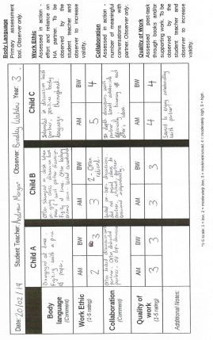
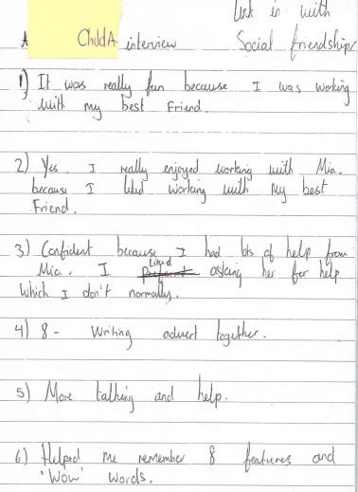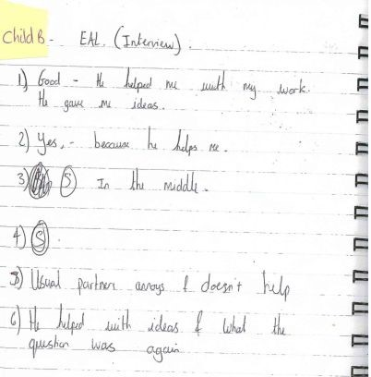
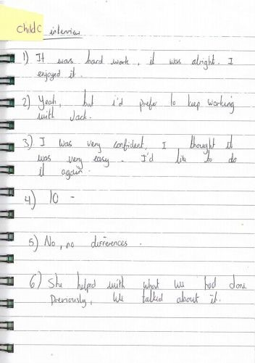

Appendix F


