

Online portfolio

Name: Mimi Alero Imo

Student ID: 2414781

Module Code: BMHP5015

Module Title: Changemakers: Building your Personal Brand for Sustainable Employment

Lecturer: Caroline Salami & Brian Mashumba

Word Count: 2000

Submission Date: 31/07/2026

Introduction
This portfolio provides a comprehensive reflective account of my learning experiences throughout Module BMHP5015, entitled "Changemakers: Building Your Personal Brand for Sustainable Employment." Drawing on my academic background as a graduate in Health and Social Care, coupled with practical experience in midwifery-related social care work, this assignment delves into how the concepts discussed across the module's four units have significantly influenced my professional identity and career trajectory within the health and social care sector.
The reflection is organized around four pivotal units: "Brand You," which investigated the principles of personal branding and employability skills; "It’s a Small World," which examined the importance of global connections and diverse perspectives in health and social care; "Opportunity Knocks," which highlighted the notion that opportunities are proactively created rather than passively encountered; and "The Pursuit of Happiness," which focused on the interplay between personal values, wellbeing, and enduring career satisfaction. Each unit is analysed sequentially, supported by relevant academic literature and evidenced through visuals of online class activities.
In conclusion, this portfolio illustrates how the knowledge and skills acquired throughout this module have enhanced my comprehension of professional identity, resilience, and the proactive pursuit of opportunities. This foundation equips me to advance confidently within the health and social care profession.

Reflection on Unit 1: Brand You
Unit 1 elucidated the concept of personal branding through the dimensions of ambition, motivation, and career mobility, all of which have fundamentally shaped my perspective regarding my future as a Health and Social Care graduate aspiring to pursue a career in midwifery social care, particularly focusing on safeguarding within maternity services and health visiting. Ambition, as articulated by Roy (2008), is defined as a desire for personal or professional advancement, reflecting my intrinsic motivation for selecting this specialisation: an unwavering commitment to safeguarding vulnerable mothers and infants at a critical juncture within the health and social care continuum. Supporting this notion, Maddux (2016) posits that ambition enhances resilience and equips individuals with the energy to navigate obstacles, a sentiment that resonates deeply with the sustained effort necessary to transition from a general health and social care degree to a specialised safeguarding-oriented role, such as health visiting.
The unit further introduced the framework of self-determination as conceptualised by Deci and Ryan, which is predicated upon the principles of competence, autonomy, and relatedness (CAR). When applied to my professional aspirations, my competence is being cultivated through academic modules that cover essential topics such as safeguarding legislation, person-centred care, and public health promotion. My autonomy is evidenced by my deliberate choice to specialise in maternal safeguarding and health visiting—a decision propelled by a strong personal conviction that early intervention during pregnancy and infancy can mitigate long-term adverse outcomes. Moreover, my relatedness is manifested in the critical interpersonal skills that are indispensable to this profession: qualities such as empathy, non-judgmental listening, and the ability to foster trust with mothers who may be hesitant to disclose challenges, attributes identified by Houston (2019) as vital for sustaining motivation toward achieving long-term goals.
Finally, the concept of the boundaryless career articulated by Arthur, Khapova, and Wilderom (2005) has prompted me to reframe my understanding of entry into health visiting and maternity safeguarding roles. Rather than perceiving a linear career trajectory, I have come to appreciate the healthcare pathway as one that encourages fluid movement among generalist health support roles, therapeutic services, and specialised safeguarding or public health nursing pathways. This perspective has empowered me to regard my experiences in generalist care and academic pursuits in health and social care not as distractions but as integral components contributing to a boundaryless pathway toward a future dedicated to the protection of mothers and infants through safeguarding practices and health visiting.
Collectively, these foundational concepts have elucidated the understanding that constructing a personal brand for a career in maternity safeguarding and health visiting extends beyond the attainment of a singular job title; it involves the intentional cultivation of a coherent professional identity—anchored in ambition, self-determined values, and a commitment to developing transferable skills that are essential within an evolving career landscape.

Reflection on Unit 2: It's a Small World
Unit 2 provided a comprehensive exploration of networking, its critical evaluation, and the significance of diversity within professional networks, all of which hold substantial implications for a future career in maternity safeguarding and health visiting. Networking is conceptualised as the establishment of relationships and the dissemination of information among individuals who share common professional interests. This process manifests itself through various platforms, including conferences, LinkedIn, and professional dialogues. Within the context of safeguarding vulnerable mothers and infants, it becomes evident that no singular practitioner can independently identify and mitigate risks; effective safeguarding necessitates a robust multi-agency network comprised of midwives, health visitors, general practitioners, social workers, and third-sector organisations that collaborate and share pertinent information appropriately.
The unit also introduced methodologies for evaluating networks, which include goal-based, process-based, and outcome-based approaches. This discussion resonated significantly with my comprehension of the Health and Care Act 2022, which mobilises partners within Integrated Care Systems (ICSs) to engage collaboratively across the NHS, social care, and local authorities (Legislation.gov.uk, 2022). Through a safeguarding lens, a goal-based evaluation might interrogate whether a local safeguarding network has successfully achieved its objectives concerning the early identification of at-risk mothers. Conversely, a process-based evaluation would seek to understand the reasons behind the breakdown of referral pathways between maternity services and health visiting, while an outcome-based evaluation would assess the broader implications for maternal and infant wellbeing, consistent with the NHS's explicit mandate to consider health, wellbeing, and service quality effects (NHS England, 2022).
The unit's analysis of "small-world networks" and the propensity to network primarily with individuals akin to oneself offered critical insights. In the sphere of safeguarding practice, confining oneself to a narrow professional comfort zone may preclude engagement with invaluable perspectives, particularly from social workers, health visitors, or practitioners from the voluntary sector, who frequently possess insights that are vital for safeguarding vulnerable families. Therefore, it is imperative to transcend these comfort zones by proactively engaging with professionals across diverse disciplines and organisations. This engagement is essential for constructing a comprehensive, multi-agency safeguarding network that is pivotal for the protection of mothers and infants.
Ultimately, this unit has reinforced my belief that networking within the contexts of maternity safeguarding and health visiting is not merely an ancillary skill but rather a fundamental professional competency. The development and periodic evaluation of a broad and diverse network of contacts across health, social care, and voluntary services will be indispensable to my future capacity for early risk identification and effective responses aimed at safeguarding mothers and infants.

Reflection on Unit 3: Opportunity Knocks
Unit 3 delved into the proactive strategies that health and social care professionals can employ to identify and cultivate opportunities, rather than relying on the serendipity of chance. A pivotal concept introduced was the distinction between blind luck and a "serendipity mindset," posited by Heinström and Sormunen (2020). This mindset emphasises the notion that valuable opportunities emerge not merely through happenstance, but as a result of deliberate preparation and an openness to new experiences. Reflecting on my career trajectory, which includes a Bachelor of Science in Health and Social Care alongside hands-on experience in midwifery-related social care, I recognise the applicability of this concept. Rather than passively awaiting opportunities, I proactively pursued placements and voluntary roles that allowed me to develop crucial clinical and interpersonal skills, thereby facilitating access to professional roles within maternity and social care settings.
Moreover, the unit highlighted the significance of communication, interpersonal skills, and networking as integral components for success within health and social care professions (Aicinena, 2013). This emphasis resonated profoundly with my experience in offering support to women and families during critical periods of pregnancy and postnatal care, wherein trust, empathy, and effective communication were not only essential for delivering quality care but also instrumental in cultivating professional relationships that subsequently opened additional avenues within the sector.
Furthermore, the introduction of "stretch goals" in this unit prompted a re-evaluation of my approach to career advancement. As articulated by Pina e Cunha et al. (2017), stretch goals represent objectives that compel individuals to transcend their comfort zones in pursuit of exceptional outcomes. In my context, the pursuit of further academic qualifications and the aspiration for more advanced roles within maternity and social care services can be framed as intentional stretch goals; they necessitate sustained effort and commitment, offering substantial potential for professional development.
Finally, the discourse on traditional versus contemporary recruitment methodologies underscored the transformative impact of digital platforms on access to job opportunities (Kaharuddin, Pangemanan, and Rumokoy, 2018). This insight has inspired me to enhance my online professional presence in order to broaden my visibility to prospective employers in the health and social care sector—a theme that I intend to explore further in Unit 4.
In summary, this unit has reinforced the idea that opportunity is not a fortuitous occurrence but rather a construct that can be actively shaped through strategic preparation, effective communication, and sustained ambition.

Reflection on Unit 4: The Pursuit of Happiness
Unit 4, titled "The Pursuit of Happiness," resonated profoundly with me as a graduate in health and social care aspiring to a career in midwifery. This unit intricately progressed from examining personal mindset factors—such as limiting beliefs, grit, and resilience—to the empirical challenges associated with change within health and social care settings, including technological advancements and antifragile thinking. It concluded with an exploration of the significance of mentoring and role models, all of which are directly pertinent to the challenges faced in qualifying and integrating into a demanding clinical profession.
One salient concept that emerged is that of limiting beliefs. Meadows (2015) characterises these as subconscious convictions that restrict individuals' perceptions of their capabilities. Bermingham (2010) further identifies common manifestations of these beliefs, including self-doubt, defensiveness, and various forms of rationalisation. As an individual entering the field of midwifery, I have recognised thoughts akin to "I don't have enough experience yet" as limiting beliefs rather than objective barriers. The practice of "pausing, stopping, and reflecting" (Meadows, 2015) has proven to be a valuable strategy for critically interrogating these assumptions instead of allowing them to dictate my professional decisions.
The concept of grit, defined by Duckworth et al. (2007) as sustained passion and determination in pursuit of long-term goals amidst adversity, also emerged as highly relevant. This perspective reframes the challenges inherent in midwifery training and early practice as part of a continuous journey rather than disjointed obstacles. Ullsperger, Nittono, and Von Cramon (2007) support this notion by outlining constructive methods for processing setbacks—encouraging the acknowledgement of emotions without succumbing to overwhelm, and framing failures, such as difficult placements or unsuccessful applications, as opportunities for learning rather than reasons for self-reproach.
The unit highlighted the need for technological change in health and social care. Sheikh et al. (2021) emphasise barriers like insufficient digital infrastructure and workforce skill gaps in maternity services, especially with the rise of electronic patient records and remote monitoring. Larsson and Tacking (2023) introduce the concept of antifragility, suggesting that systems and individuals can strengthen through instability, offering a constructive perspective on the digital transformation in clinical practice.
Lastly, the exploration of social learning theory (Pratt et al., 2010) and the dialogue surrounding mentoring (Klinge, 2015; Whiting and de Janasz, 2004) reinforced the critical importance of observation and guidance from seasoned midwives and mentors in shaping my early career. This understanding has solidified my commitment to actively seek mentorship as I embark on my professional journey in midwifery.

Conclusion
This portfolio reflects my development throughout the four units of BMHP5015, ranging from constructing an authentic personal brand to understanding my role within the global health and social care landscape. It highlights the recognition of opportunities and the importance of cultivating a mindset necessary for sustaining a long and demanding career in midwifery. Several recurring themes have emerged: the significance of self-awareness, the value of resilience in the face of setbacks, and the pivotal role that relationships through professional networks, mentors, and role models play in fostering growth.
As I apply these reflections to my own journey as a graduate entering midwifery, I have acquired practical tools for challenging limiting beliefs, building resilience, and adapting to technological advancements within maternity care and the broader health and social care services. Most notably, this module has illuminated the fact that a successful career in midwifery is rarely a linear journey; it is shaped by continuous reflection, learning from failures, and leveraging the support of others. Moving forward, I plan to apply these insights directly, particularly by actively seeking a mentor within the field of midwifery and tackling future professional challenges with the antifragile mindset that this module has helped me cultivate.

Module Screenshots
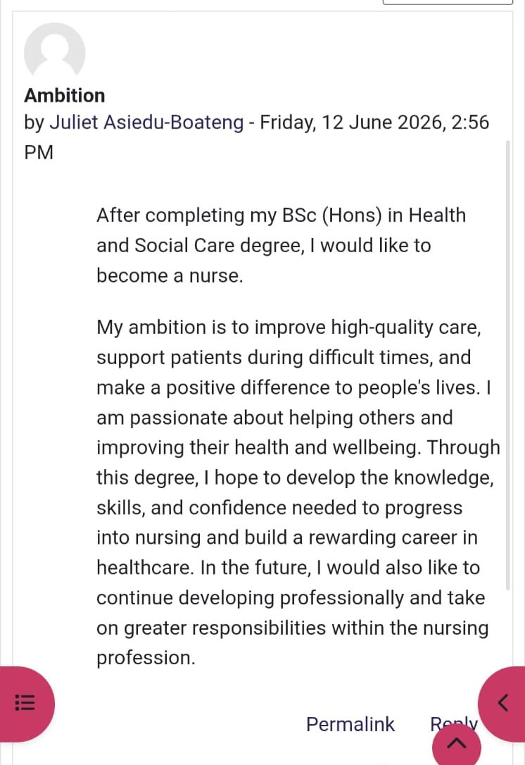
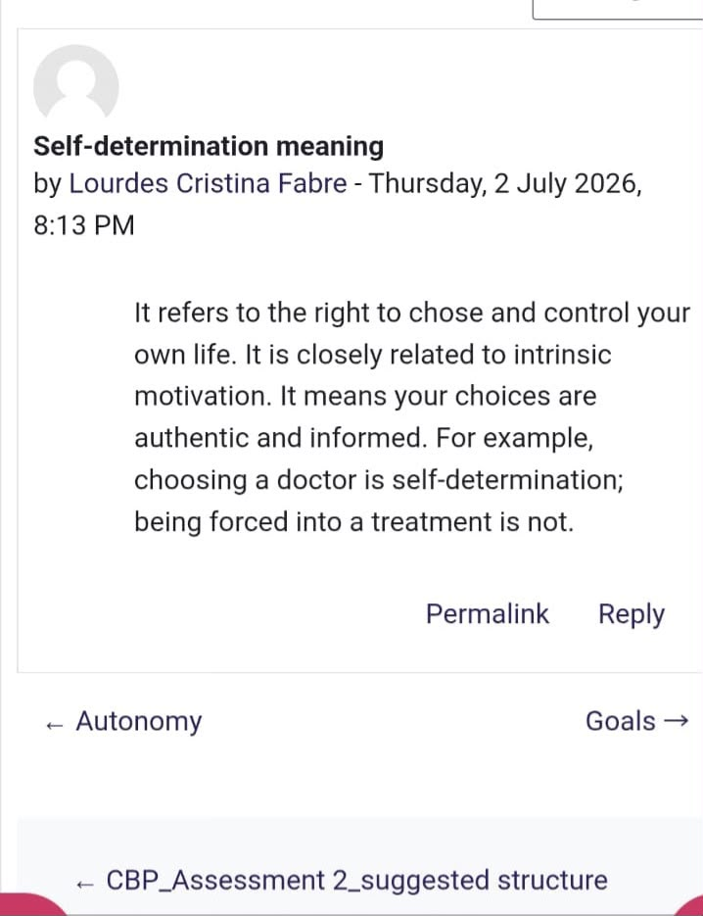

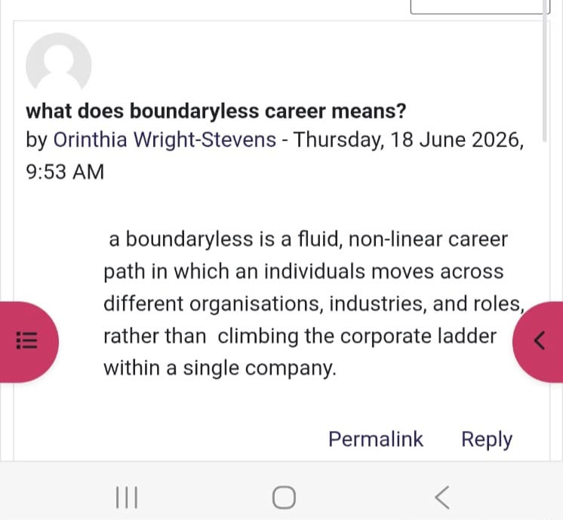
Screenshot 1 Screenshot 2
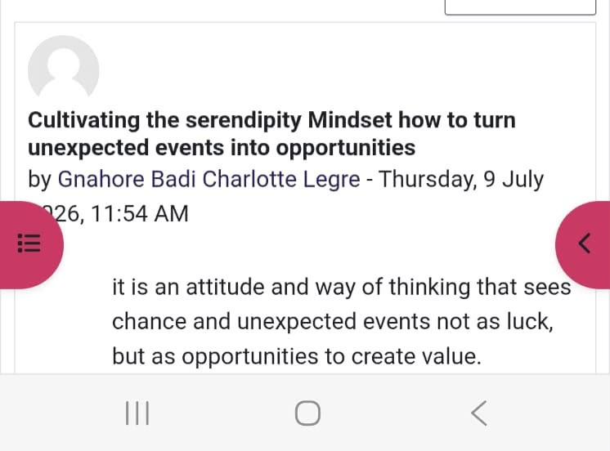
Screenshot 3 Screenshot 4

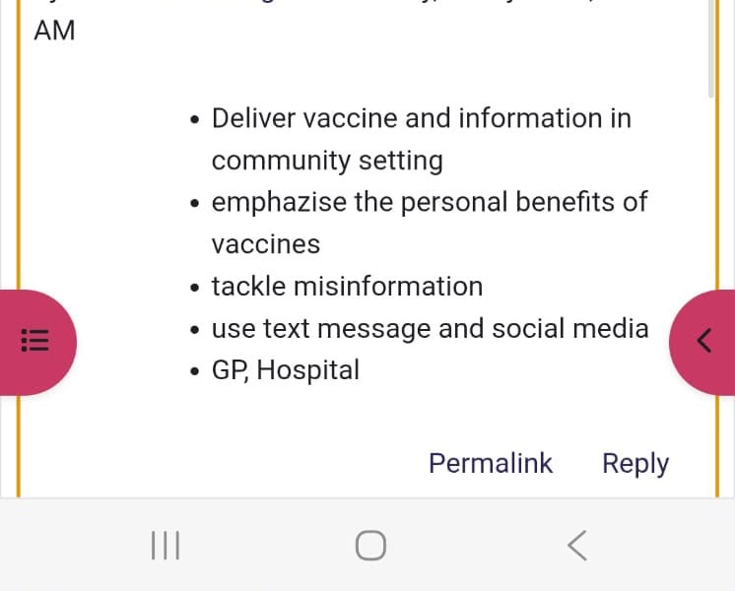

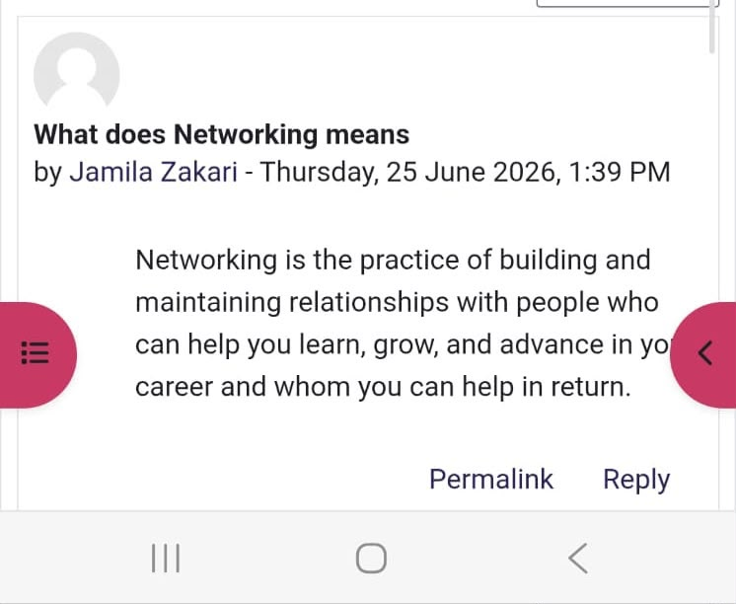
Screenshot 5

Screenshot 6

References
Addux, J.E. (2016). Self-efficacy. In Interpersonal and intrapersonal expectancies (pp. 41-46).
Arthur, M.B., Khapova, S.N., Wilderom, C.P. (2005). Career success in a boundaryless career world. Journal of Organisational Behaviour: The International Journal of Industrial, Occupational and Organisational Psychology and Behaviour. 26(2), pp.177-202.Aveyard, H. and Sharp, P. (2017) A Beginner's Guide to Evidence-Based Practice in Health and Social Care. Ebook. McGraw-Hill Education (UK).
Bermingham, K. (2010) Change Your Limiting Beliefs: Three Steps to Achieve Meaningful Goals. Lulu.com.
Bury, M. (2013) Health and Illness in a Changing Society. Routledge.
Deci, E.L. and Ryan, R.M. (2000) The "what" and "why" of goal pursuits: human needs and the self-determination of behaviour. Psychological Inquiry, 11(4), pp.227-268.
Duckworth, A.L., Peterson, C., Matthews, M.D. and Kelly, D.R. (2007) Grit: perseverance and passion for long-term goals. Journal of Personality and Social Psychology, 92(6), pp.1087-1101.
Heinström, J. and Sormunen, E. (2020). Serendipity as chaos or discovery-exploring the role of personality and sense of coherence.
Houston (2019). What is Goal Setting and How to Do it Well. URL Available at: https://positivepsychology.com/goal-setting/
https://www.legislation.gov.uk/ukpga/2022/31/contents
Jones, J.M. (2015). Blog. Screen.
Kaharuddin, I.W., Pangemanan, S.S. and Rumokoy, F.S. (2018) Analysing employees' perception of traditional and modern recruitment. Jurnal EMBA: Jurnal Riset Ekonomi, Manajemen, Bisnis dan Akuntansi, 6(4).
Klinge, C.M. (2015) A conceptual framework for mentoring in a learning organisation. Adult Learning, 26(4), pp.160-166.
Larsson, J. and Tacking, N. (2023) Antifragility in Small Industry Companies: An Exploration of Resilience and Adaptation.
Legislation.gov.uk (2022) Health and Care Act 2022. Available at:
Meadows, M. (2015) Confidence: How to Overcome Your Limiting Beliefs and Achieve Your Goals. Meadows Publishing.
Nardi, B.A., Schiano, D.J., Gumbrecht, M. and Swartz, L. (2004) Why we blog. Communications of the ACM, 47(12), pp.41-46.
NHS England (2022) Working in partnership with people and communities: Statutory guidance. Available at: https://www.england.nhs.uk/long-read/working-inpartnership-with-people-and-communities-statutoryguidance/ Pina e Cunha, M., Giustiniano, L., Rego, A. and Clegg, S. (2017) Mission impossible? The paradoxes of stretch goal setting. Management Learning, 48(2), pp.140-157.
Pratt, T.C., Cullen, F.T., Sellers, C.S., Thomas Winfree Jr, L., Madensen, T.D., Daigle, L.E., Fearn, N.E. and Gau, J.M. (2010) The empirical status of social learning theory: A meta-analysis. Justice Quarterly, 27(6), pp.765-802.
Rains, S.A. and Keating, D.M. (2011) The social dimension of blogging about health: health blogging, social support, and well-being. Communication Monographs, 78(4), pp.511-534.
Roy, S.K., (2008) Identifying the dimensions of attractiveness of an employer brand in the Indian context. South Asian Journal of Management, 15(4), pp.110-130.Sheikh, A., Anderson, M., Albala, S., Casadei, B., Franklin, B.D., Richards, M., Taylor, D., Tibble, H. and Mossialos, E. (2021) Health information technology and digital innovation for national learning health and care systems. The Lancet Digital Health, 3(6), pp.e383-e396.
Stansky, L.J. (1996) Opening doors. ABAJ, 82, p.66.
Ullsperger, M., Nittono, H. and Von Cramon, D.Y. (2007) When goals are missed: dealing with self-generated and externally induced failure. Neuroimage, 35(3), pp.1356-1364.
Whiting, V.R. and de Janasz, S.C. (2004) Mentoring in the 21st century: using the internet to build skills and networks. Journal of Management Education, 28(3), pp.275-293.

