Marie Achille Kouakou
2438126
LCHS4003_BIRM
Introduction To Health And Social Care
Aishat Bakre
Component 1
18/10/2025
Task1: AMBULANCE SERVICE

Ambulance services are an essential part of healthcare, providing help in emergencies and safe transport for patients. When someone calls 999, an ambulance is sent to give urgent care at the scene and take patients to hospital if needed. Ambulances are staffed by paramedics, technicians, and support workers who can carry out life-saving treatments such as CPR and giving medicines. They also provide non-emergency transport for people who need medical support when travelling to appointments. By connecting patients with hospital care quickly, ambulance services help save lives and support the health and wellbeing of communities.

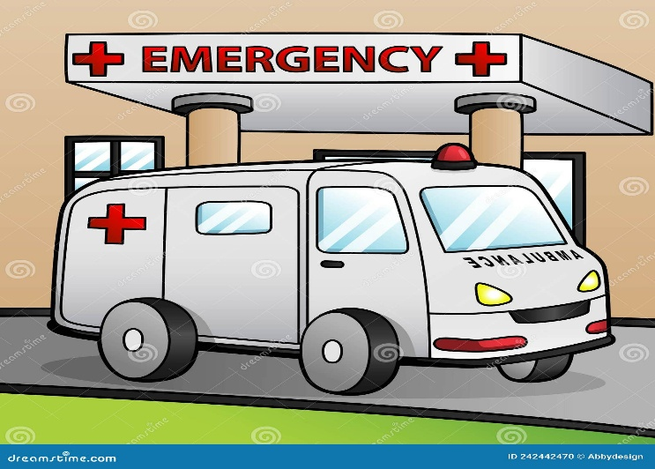
Ambulance services have a long history, starting in the late 1800s when horse-drawn carriages were first used in the UK to take sick or injured people to hospital. In the early 1900s, motor vehicles began to replace horses, which made the service faster and more reliable. During the First and Second World Wars, the need for quick medical help and transport became very clear, and this shaped how ambulance services developed. In 1948, when the National Health Service (NHS) was created, ambulance services became part of it, making them free and available to everyone. At first, ambulances were mainly used to transport patients, but over time they became more advanced. In the 1970s, paramedics were introduced, allowing treatment to start before patients reached hospital. Today, ambulance services provide expert pre-hospital care, using modern equipment and highly trained staff to save lives and support communities.
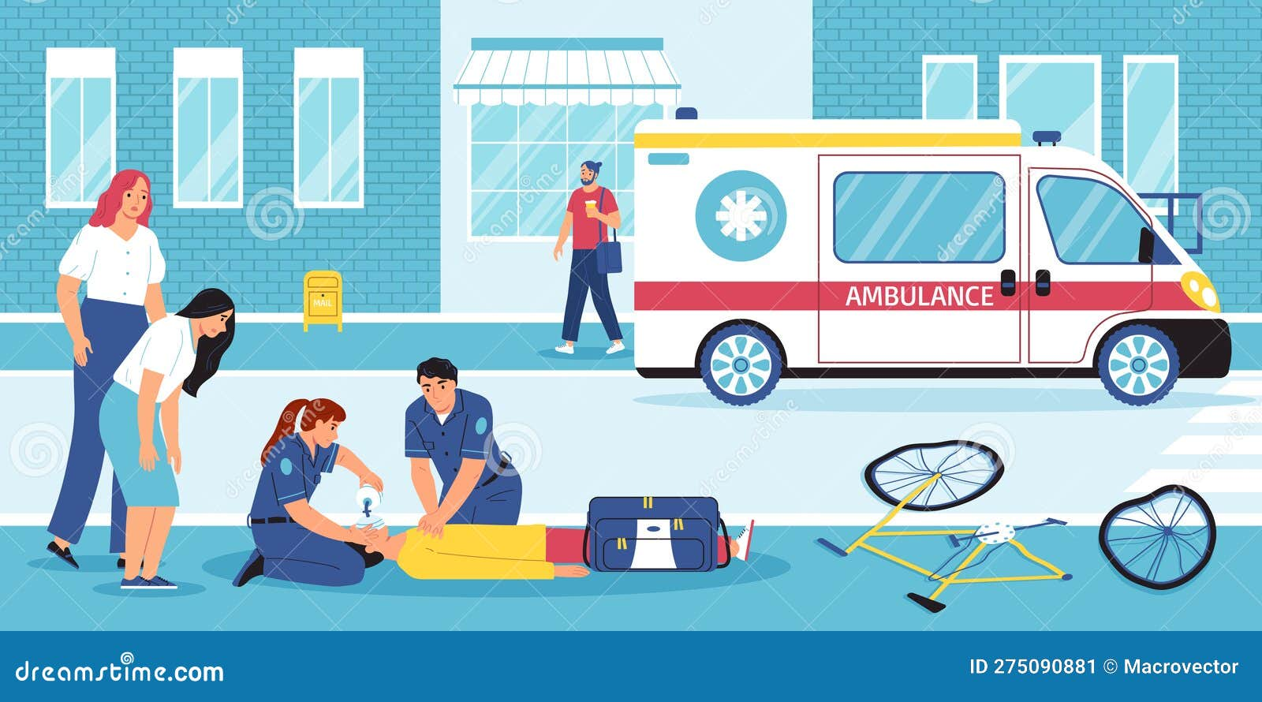

Ambulance services in the UK are part of the NHS and play an important role in helping people during emergencies and in everyday healthcare

The most urgent work they do is responding to 999 calls. When someone calls, trained staff answer the phone and decide how serious the situation is. They then send out the right ambulance team. Paramedics and technicians can give treatments such as CPR, using a defibrillator, giving medicines, and supporting breathing before the patient reaches hospital. Ambulances also provide non-emergency transport. This is for people who cannot travel alone because of illness, disability, or medical needs. These services help patients get to hospital appointments safely.
Modern ambulances are like mini hospitals. They have equipment such as heart monitors, oxygen, and medicines, so patients can get care straight away. Ambulance teams work closely with hospitals, A&E departments, and other services like the police and fire service to keep patients safe. Another important role is helping reduce pressure on hospitals. Paramedics can now assess patients at home and decide if they really need to go to hospital. In some cases, they can give treatment at the scene and avoid unnecessary admissions. Overall, ambulance services are no longer just transport.

They are a key part of healthcare, providing life-saving treatment, safe transport, and strong links between the community and hospitals.

Ambulance services face many challenges that affect how well they can respond to patients. One of the biggest problems is increased demand and long response times. Each year, the number of 999 calls continues to rise. This is due to an ageing population, more people with long-term health conditions, and greater public awareness of emergency services. As a result, ambulance crews are often under pressure, and patients may experience long waits before help arrives. Delays also happen outside hospitals, where ambulances sometimes wait hours to hand patients over to A&E staff, stopping them from attending new emergencies quickly. Another major challenge is staff shortages and stress. Working in the ambulance service is demanding, with long shifts, unpredictable situations, and exposure to trauma.

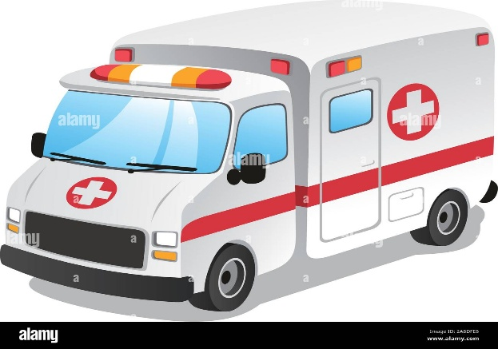

Paramedics and technicians often face emotional and physical strain, which can lead to burnout and difficulties in keeping staff. Recruiting and training new staff takes time and money, so shortages put extra pressure on existing teams. These challenges affect patient safety and the wellbeing of ambulance staff. To address them, the NHS has been working on solutions such as hiring more staff, improving working conditions, investing in new vehicles, and using technology to support quicker decision-making. However, demand continues to rise, and finding long-term answers remains difficult.

Ambulance services are a vital part of the NHS, providing emergency response, life-saving care, and safe transport for patients. Over time, they have grown from basic transport services into highly skilled medical teams able to treat patients before reaching hospital. Today, they face serious challenges such as rising demand, staff shortages, and long response times, but they continue to play a crucial role in keeping communities safe. By linking people quickly with healthcare and offering expert treatment, ambulance services remain an essential part of modern healthcare, saving lives and supporting patients every day.

Task 2 essay

The National Health Service (NHS) is one of the United Kingdom’s most important public institutions. It was founded in 1948 on the principles of being universal, free at the point of use, and funded by taxation. Today, it still provides healthcare to millions of people every year, but it faces serious pressures that affect how well it functions. This essay will look at how the NHS is currently structured, highlight some of its strengths, and then critically examine its problems such as waiting times, staff shortages, funding pressures, and integration with social care.

The NHS in England is organised by the Department of Health and Social Care. Day-to-day services are delivered by NHS trusts, primary care providers such as GPs, and community services. Since the Health and Care Act of 2022, the system has been reorganised into Integrated Care Systems (ICSs). These aim to bring hospitals, GPs, councils, and community organisations together to work more closely. The goal is to improve patient outcomes and reduce the fragmentation that sometimes happens between different services. One of the key strengths of the NHS is that it still delivers healthcare to everyone in the country, regardless of wealth. Public support remains very high, and surveys show that most people still believe in the core principles of the NHS (House of Commons Library, 2025). The NHS has also been able to adapt in some areas. For example, it played a leading role in the COVID-19 vaccination rollout and has been expanding Community Diagnostic Centres to help reduce waiting times (NHS England, 2025a).
However, the NHS is also under intense pressure. One of the biggest problems is long waiting times. By early 2025, there were about 7.43 million treatment pathways waiting in England, which represents more than six million people (NHS England, 2025b). Only 58.9% of these patients were seen or treated within 18 weeks, far below the standard of 92%. Around 190,000 patients had been waiting more than a year, which shows how difficult it has become to meet demand (NHS England, 2025c). Long waits affect not only elective operations like hip replacements, but also diagnostics and cancer treatment, where delays can be life-threatening. Another major challenge is workforce shortages. The NHS had more than 106,000 vacancies in early 2025, including over 25,000 nursing posts (NHS Support Federation, 2025). Staff often report stress, burnout, and low morale. Industrial action over pay and conditions has further highlighted the difficulties. Without enough staff, it is hard to reduce backlogs or maintain high standards of care.
Emergency and urgent care are also struggling. In March 2025, only 75% of patients were admitted, transferred, or discharged from Accident & Emergency (A&E) departments within four hours, compared to the target of 95% (NHS England, 2025d). Ambulance response times also remain worse than the 18-minute standard for category 2 calls, though there have been small improvements. These failures in urgent care show how stretched hospital resources have become.
A further problem is the weak link between the NHS and social care. Social care services, which help older and disabled people, are not fully part of the NHS and are often run by local councils. Because social care is underfunded, many patients cannot be discharged from hospital quickly, leading to bed shortages and delays for new patients. This lack of integration makes the whole system less efficient.

In conclusion, the NHS continues to provide universal healthcare and remains one of the most trusted parts of public life in Britain. However, its current functioning shows serious weaknesses, particularly in waiting times, staffing, and emergency care. Reforms like Integrated Care Systems and new diagnostic centres are positive steps, but without more staff, funding, and proper coordination with social care, the NHS will struggle to meet its targets. To protect its founding principles, the government will need to make long-term investments and tackle these structural problems directly.

REFERENCES

• NHS (2023) Ambulance services. Available at: https://www.nhs.uk/nhs-services/urgent-and-emergency-care-services/ambulance-services/ (Accessed: 20 September 2025).
• NHS England (2024) Ambulance quality indicators. Available at: https://www.england.nhs.uk/statistics/statistical-work-areas/ambulance-quality-indicators/ (Accessed: 20 September 2025).
• Association of Ambulance Chief Executives (AACE) (2023) About us. Available at: https://aace.org.uk/about-us/ (Accessed: 20 September 2025).
• Gov.uk (2023) NHS ambulance services workforce statistics. Available at: https://www.gov.uk/government/statistics/nhs-workforce-statistics (Accessed: 20 September 2025).
• College of Paramedics (2022) The role of the paramedic. Available at: https://www.collegeofparamedics.co.uk/ (Accessed: 20 September 2025).
• Turner, J., Coster, J., and Chambers, D. (2019) What evidence is there on the effectiveness of different models of delivering urgent care? Health Services and Delivery Research, 7(35), pp. 1–122.
House of Commons Library (2025) NHS key statistics: England. Available at: https://commonslibrary.parliament.uk/research-briefings/cbp-7281/ (Accessed: 21 September 2025).
NHS England (2025a) Monthly Operational Statistics – March 2025. Available at: https://www.england.nhs.uk/long-read/monthly-operational-statistics-march-2025/ (Accessed: 21 September 2025).
NHS England (2025b) Monthly Operational Statistics – February 2025. Available at: https://www.england.nhs.uk/long-read/monthly-operational-statistics-february-2025/ (Accessed: 21 September 2025).
NHS England (2025c) Monthly Operational Statistics – June 2025. Available at: https://www.england.nhs.uk/long-read/monthly-operational-statistics-june-2025/ (Accessed: 21 September 2025).
NHS England (2025d) Monthly Operational Statistics – April 2025. Available at: https://www.england.nhs.uk/long-read/monthly-operational-statistics-april-2025/ (Accessed: 21 September 2025).
NHS Support Federation (2025) Staff Shortages – NHS England. Available at: https://nhscampaign.org/issues/staff-shortages/ (Accessed: 21 September 2025).

