

Module: Computer Architecture and Operating Systems (ACCA4022)
Programme: Computing Portfolio
Assignment title: Operating Systems Assignment
Lecture: James Williams
Biniyam Memberu
2405357
Contents
Introduction 3
1. Key Functions of General-Purpose Operating Systems 3
1.1 Process Management 3
1.2 Memory Management 4
1.3 File System Management 4
1.4 Device (I/O) Management 5
1.5 Security & Access Control 6
1.6 User Interface (UI) Management 7
1.7 Networking and Communication 8
2. Use of Windows OS CLI commands 10
3. Use of Linux OS CLI commands 15
4. Use of Windows OS scripts 20
4.1 Batch Scripting in Windows 20
5. Use of Linux OS scripts 25
Conclusion 29
References 30
Appendices 31

Introduction
This assignment covers some of the critical concepts and related practical tools that an operating system offers. Firstly, this assignment explains the fundamental functions of a general operating system and highlights how two popular operating systems, Windows and Linux, utilise their Command-Line Interface (CLI) commands and argument lists to efficiently perform several critical system tasks. This assignment will also examine scripts, how scripting differs between Windows and Linux, and how using scripts in both Windows and Linux simplifies the automation of numerous tedious, repetitive operations for a system administrator, saves time, and boosts productivity.

1. Key Functions of General-Purpose Operating Systems
An operating system (OS) is the interface to your computer's underlying hardware, allowing you to efficiently leverage the resources within your system. General-purpose operating systems serve several functions, which are explored below, along with practical guidance on monitoring each and the associated tools in Windows, Linux distributions, and macOS [1].

1.1 Process Management
The OS has one main task: running programs (processes). As the Process Generator, the operating system creates new processes, schedules active processes, and terminates inactive processes to improve system performance. A single process cannot monopolise the CPU and continue running indefinitely, thereby blocking other processes. The "Processes" tab in Windows Task Manager lists active applications and background processes, including CPU and memory usage, open handles, multitasking, and whether a process can communicate with other currently running processes [2]. See Figure 1, the "Processes" tab in Windows Task Manager.
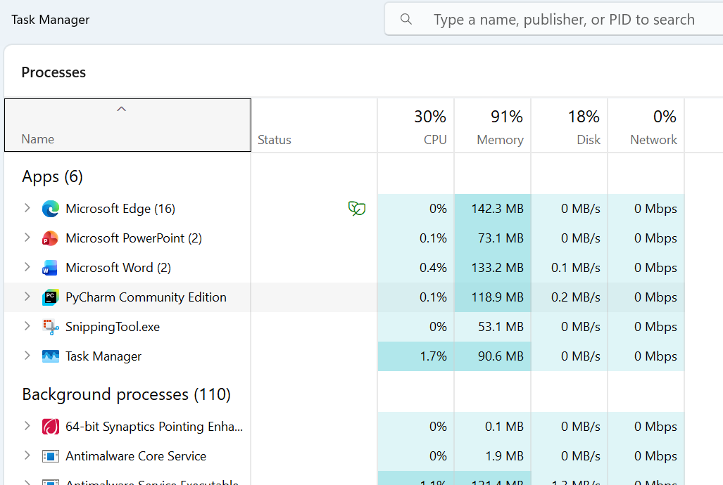
Figure 1

1.2 Memory Management
Primary memory, managed by the Operating System on a computer, consists of RAM. The Operating System is responsible for tracking which parts of memory are currently in use, allocating memory to processes when required, and deallocating memory to the computer once a process no longer requires it. The Operating System also controls which processes are allocated memory, how much memory they receive, and how memory is reclaimed once a process has completed. The Operating System also protects one process's memory from another, manages a process's virtual memory, and handles memory fragmentation [3]. Windows Task Manager shows memory utilisation in the "Performance" tab (see Figure 2) as a graph. It also displays the total amount of RAM installed in the computer, and the current amount of RAM in use.
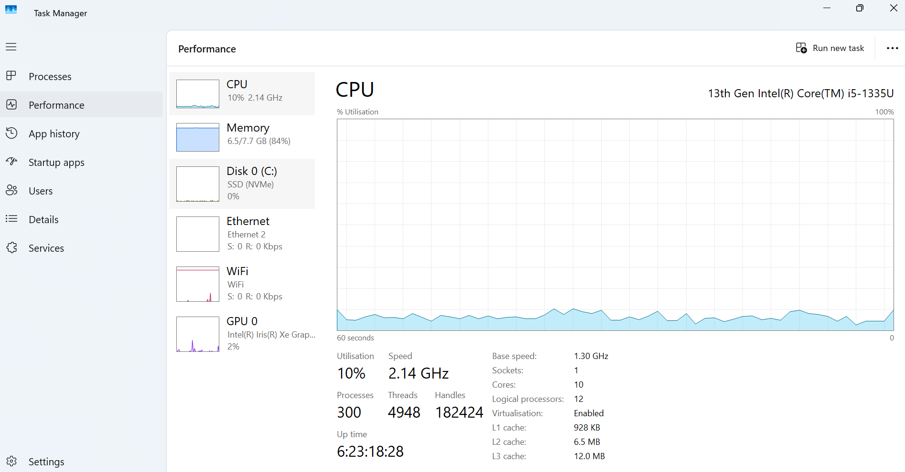
Figure 2

1.3 File System Management
Another essential way to look at computer data is as files stored on storage devices, such as hard drives and solid-state drives. The Operating System manages the file system, the folders and files that are stored on hard drives, and it also manages files and folders. The Operating System provides several capabilities, including organising files and folders, organising permissions and file attributes, and different access methods (sequential, direct, indexed) [4]. It also manages the storage devices. The most direct interface to a file system is typically a file manager, a computer program that provides a user interface for browsing and interacting with files and directories. A common file manager user interface is a graphical file explorer. The Windows File Explorer is a typical example of a file manager interface, as shown in Figure 3.
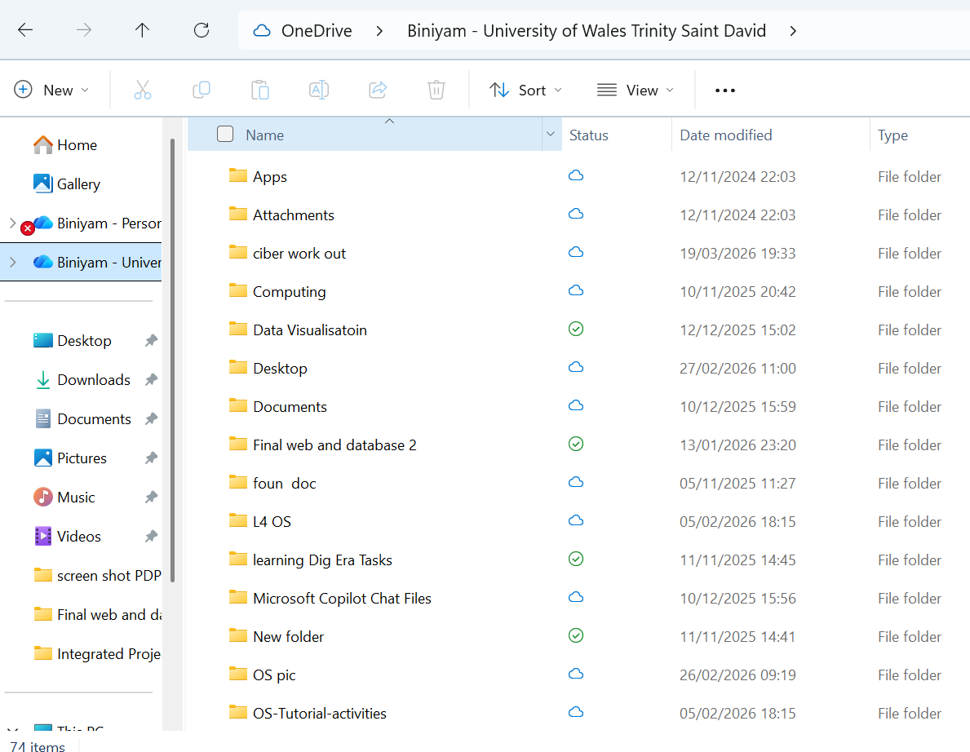
Figure 3

1.4 Device (I/O) Management
The Operating System conceals many details of hardware devices, such as keyboards, mice, printers, and graphics processing units (GPUs), from the user. It uses a device driver to translate generic operating system commands into vendor-specific commands that individual devices can support. Devices can be managed via the system settings [5]. On Windows, this is found in Device Manager, where you can see a list of installed hardware and manage and disable individual items. On macOS, this information is available in the native System Information app and in the System Settings. Figure 4 shows the device management in Windows.
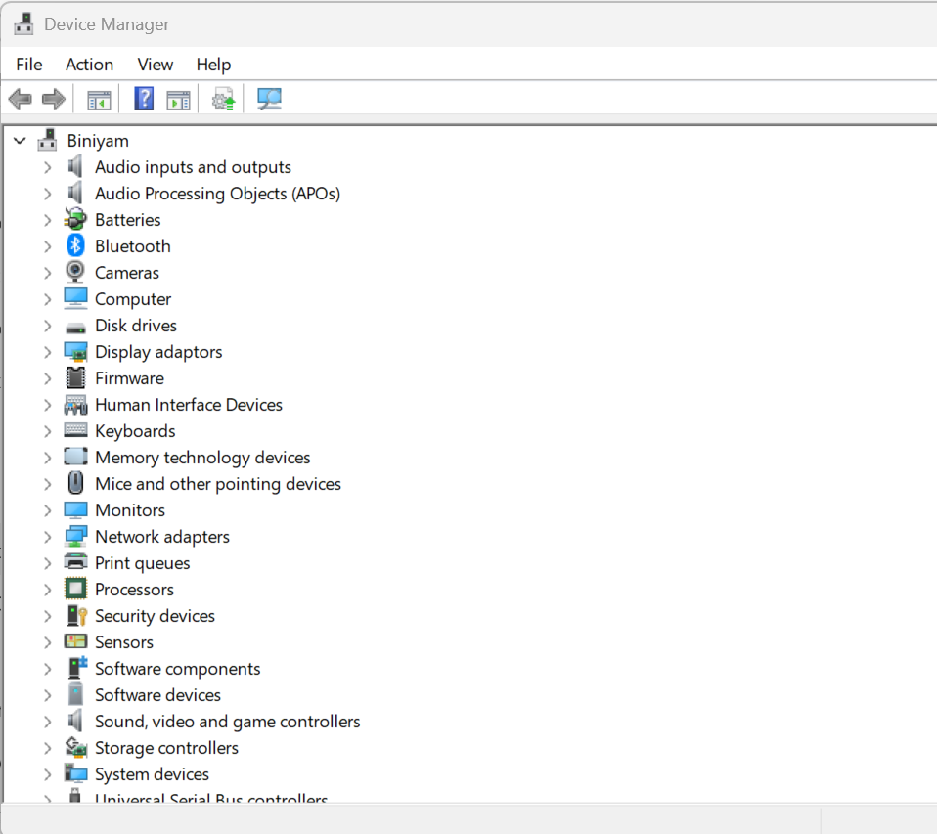
Figure 4

1.5 Security & Access Control
The Operating System (OS) plays an essential role in protecting a system and its contents from harm by ensuring all resources and information are kept secure, forming the basis of overall system security. Most critical to the role of the OS in this area are user account management, file permissions and data encryption, and ensuring that all changes are executed with the user themselves approving the action. The OS enforces user authentication, limits access to certain information through permissions, encrypts data on physical media such as storage devices, and ensures the system itself is secure [6]. All the security settings for the various Operating Systems are stored centrally within the Security and User Account Control (UAC) sections shown in Figure 5.
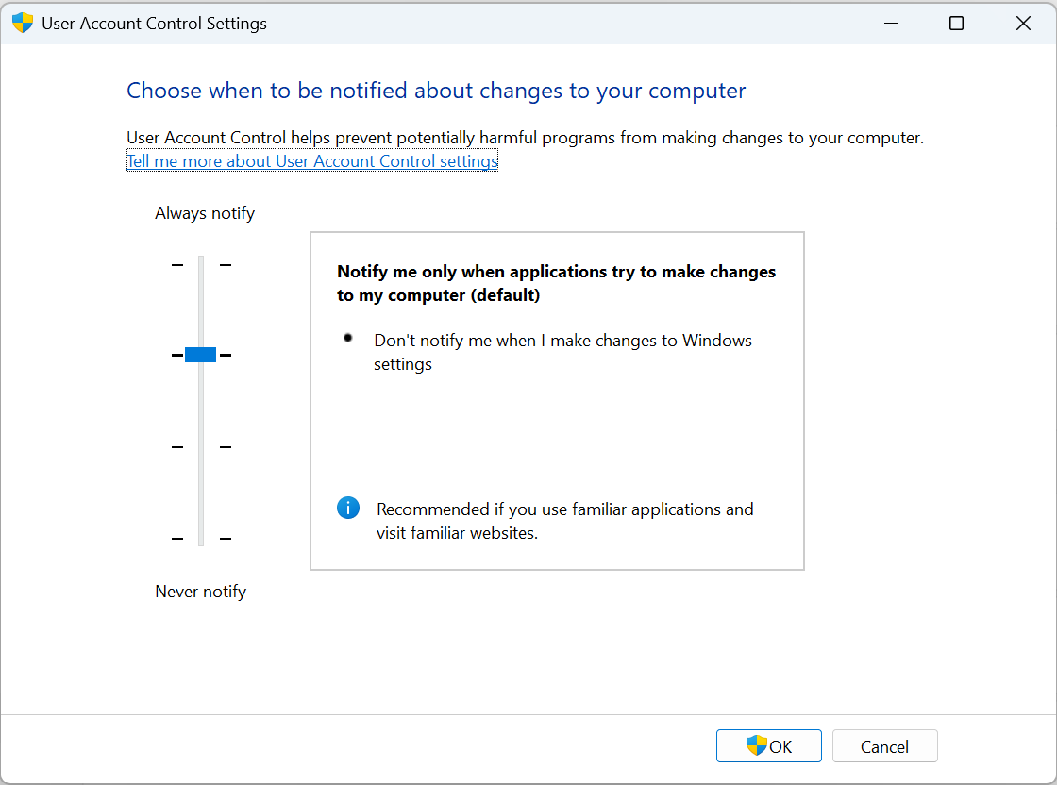
Figure 5

1.6 User Interface (UI) Management
This part of the Operating System is where you interact with the computer. Here you type commands to the Operating System. The Interface can be a Graphical User Interface (GUI) or a Command-Line Interface (CLI) [7]. The GUI has windows, icons, and menus and is easier to use. The CLI requires that you type commands and is generally more powerful. Figure 6 shows the entire desktop environment as it appears when you log in to a Windows Operating System.
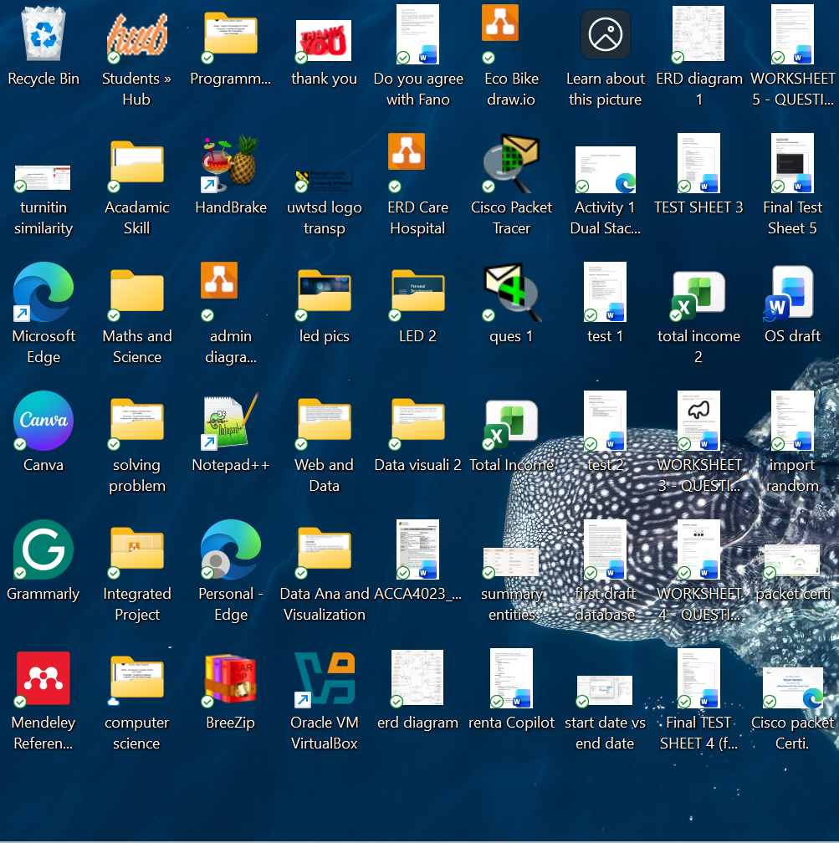
Figure 6

1.7 Networking and Communication
Operating Systems include a complete network stack, enabling computers to connect to one another over a network. The Operating System manages network connections; it can send or receive packets over a network and enforce rules that define what is allowed and what is not. Parts of the network traffic can even be monitored [7]. Figures 7 & 8 show the “Network” tab of the Windows Task Manager Monitor.
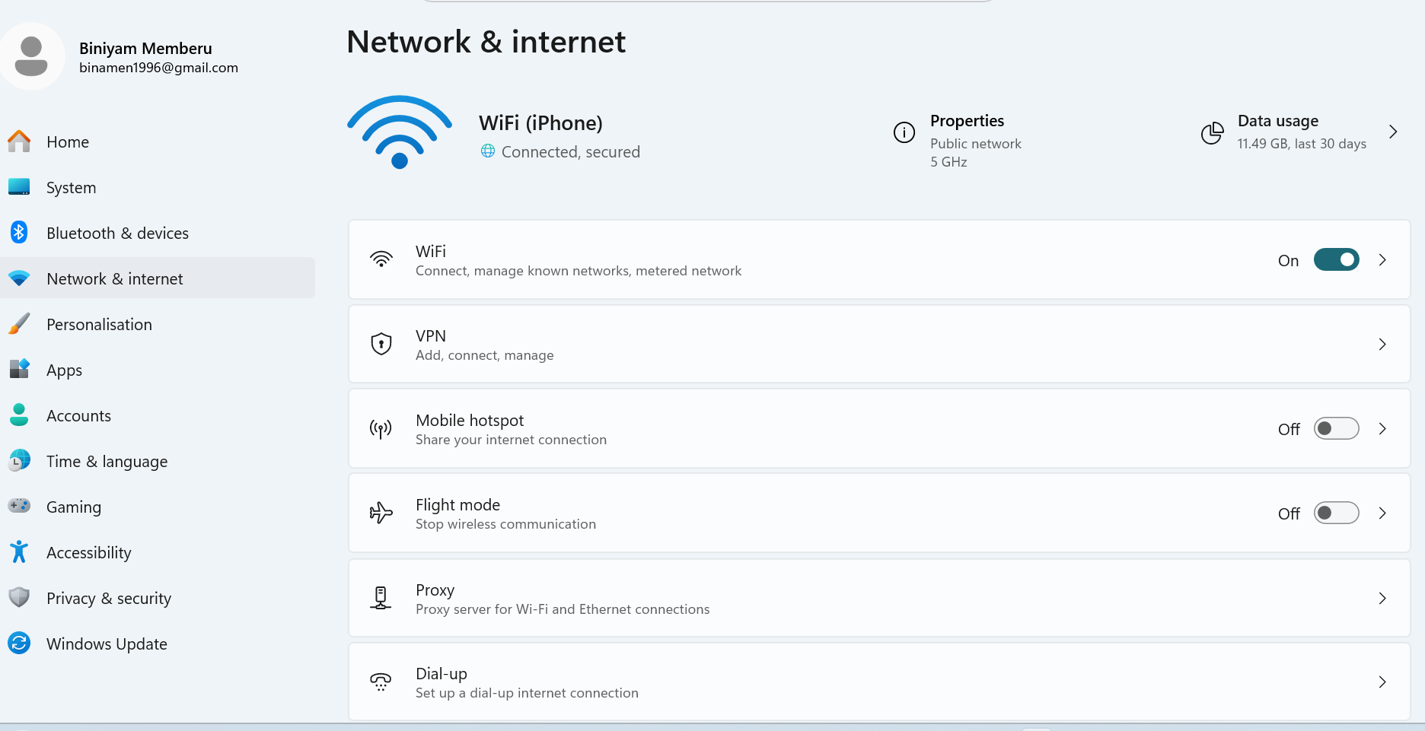
Figure 7
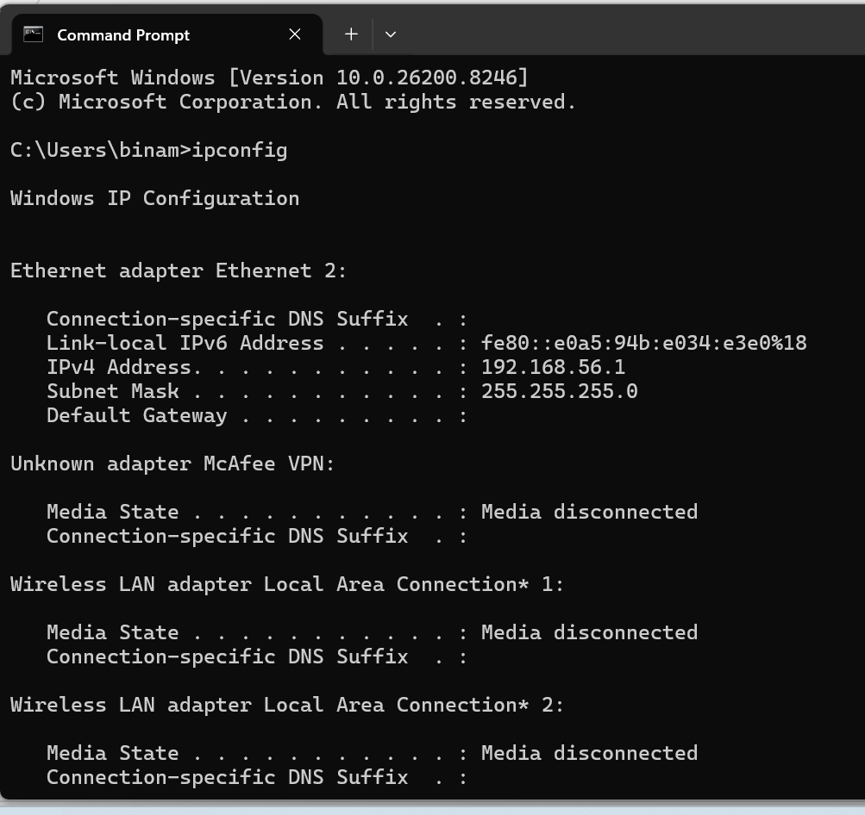
Figure 8

2. Use of Windows OS CLI commands
The Windows Operating System offers a powerful set of commands, known as Command-Line Interface (CLI) tools, to manage system processes, files, folders, networks, user and computer accounts, and scheduled tasks. Windows offers two main environments to run these commands: Command Prompt (Batch) and PowerShell [5]. Having a good grasp of Windows CLI commands is crucial for day-to-day system administration, troubleshooting, automating repetitive tasks, and creating scripts [8].

Tasklist displays all currently running processes on a Windows system, and Windows continually monitors them [9]. This command shows all processes that are currently “running,” rather than those that are “suspended” or dormant, and lets you filter your searches, accordingly, as shown in Figure 9.
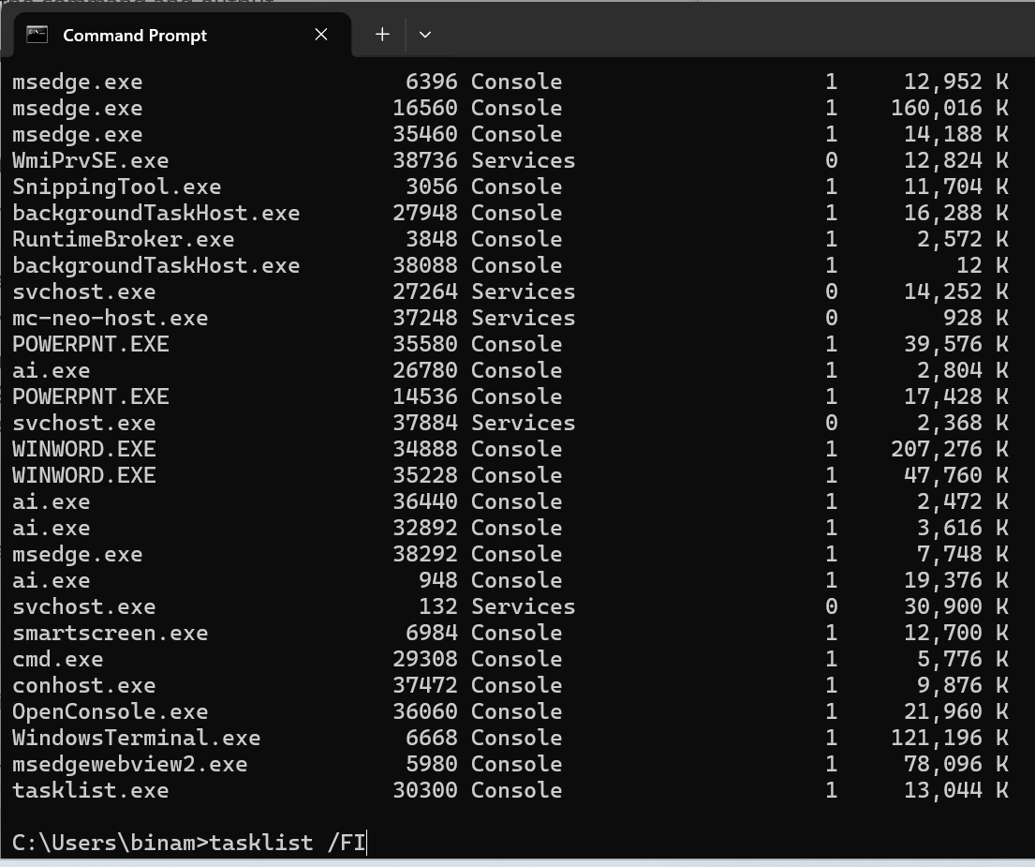
Figure 9
Get-Process is a PowerShell command used to view information about currently running processes [9]. It displays items such as CPU usage, memory usage, and each process's ID, and can be filtered, sorted, or formatted for ease of use, as shown in Figure 10.
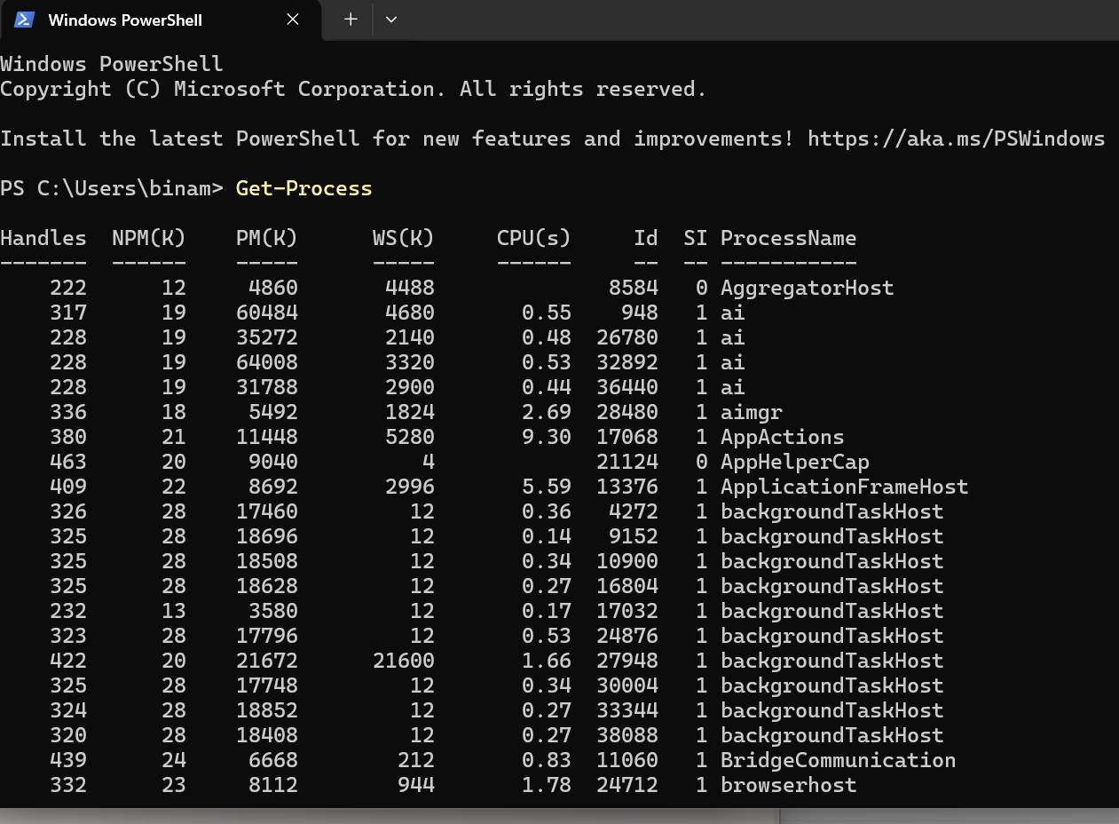
Figure 10
Dir: To list files and directories in the current working directory, Windows provides the dir command. By utilising several switches, such as /A to show hidden files, /O to arrange the results of a dir command, and /S to search through subdirectories, dir offers a very powerful command for navigating a file system from the command line [9], as shown in Figure 11.
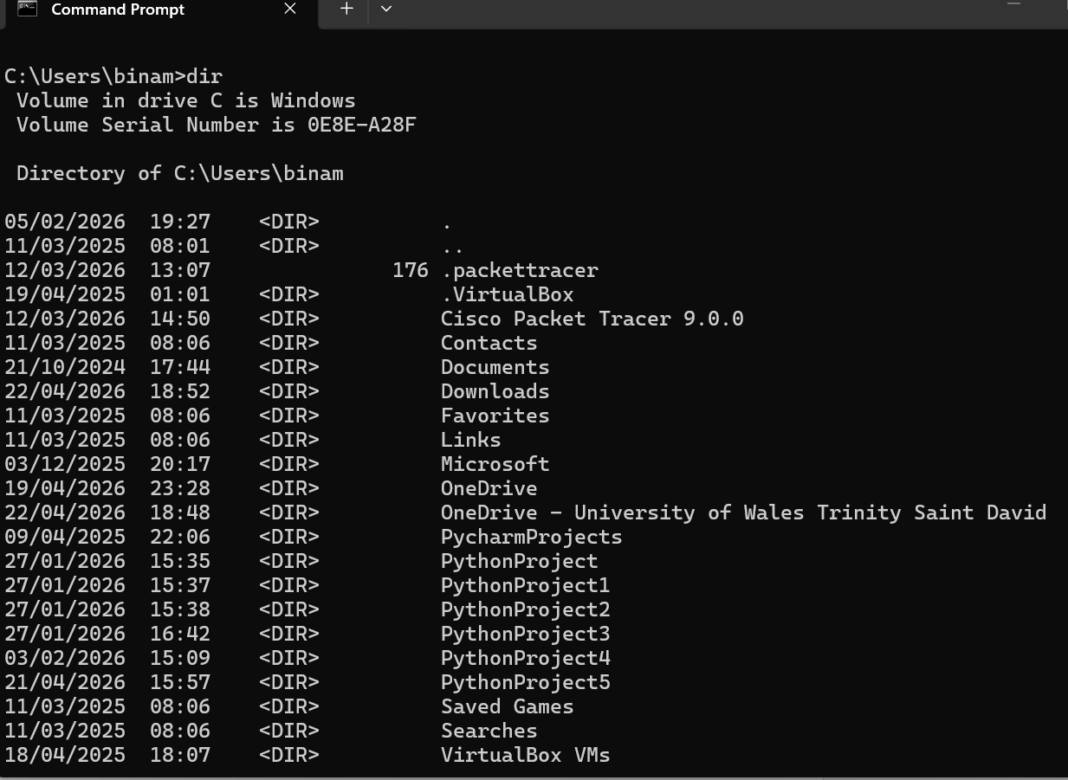
Figure 11
Get-ChildItem is a PowerShell command used to view files and directories at a given path [9]. It allows you to filter items, decide whether to search recursively, and view hidden files and directories, as shown in Figure 12.
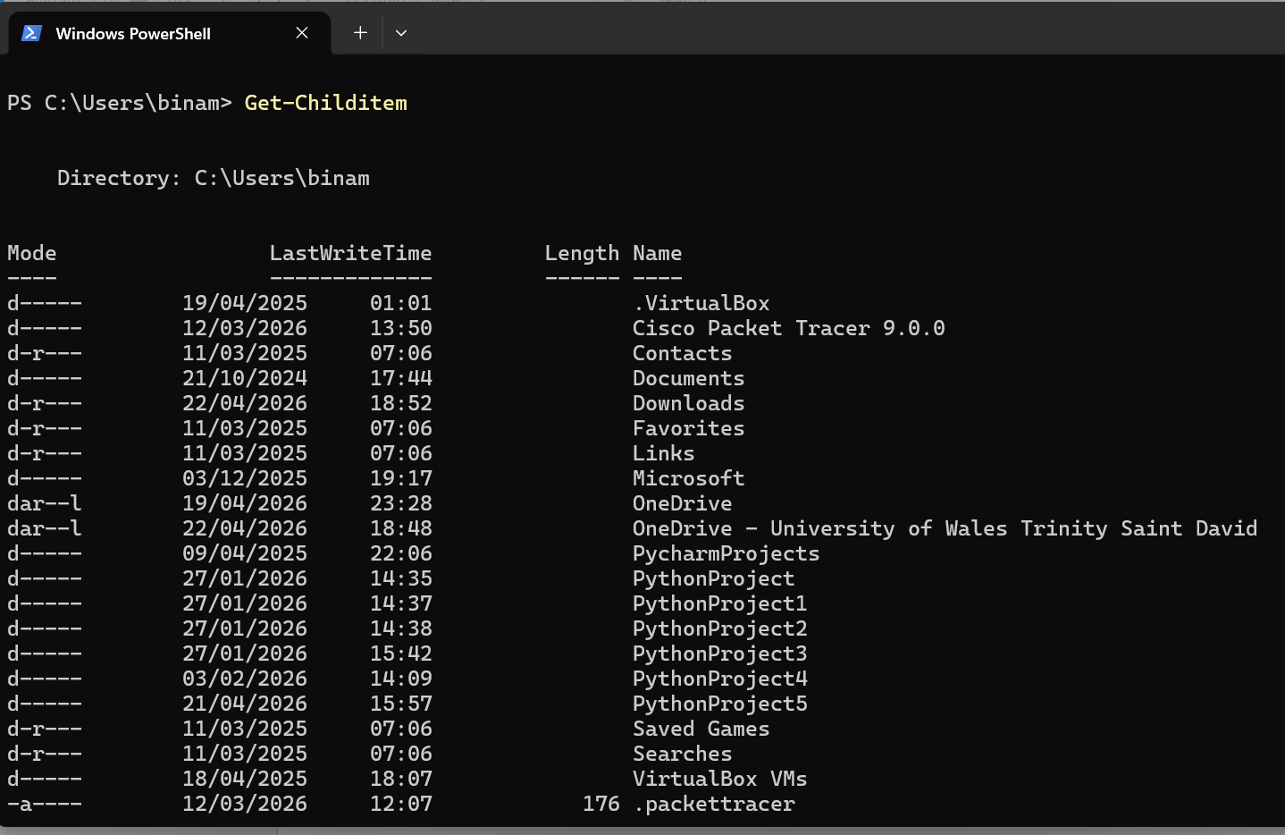
Figure 12
The ping command is used to test IP Reachability. It sends a series of request packets to a destination and then measures the time, number of replies, and loss rate it receives. In Windows, ping supports additional switches such as /n to specify the number of requests, /t to send requests continuously, and /l to change the packet size [9]. Ping is a simple yet powerful network troubleshooting tool that determines whether a system is reachable on a network, as shown in Figure 13.
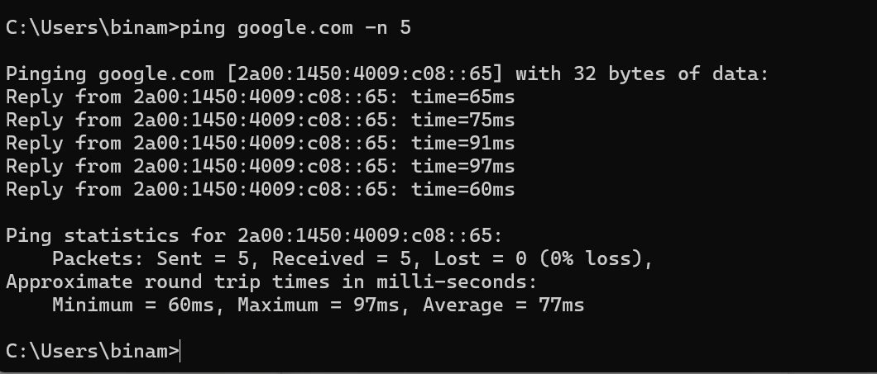
Figure 13
ipconfig is a basic command for those using Windows Operating Systems. The purpose of the ipconfig command is to view and manage IP Address Info, including the subnet mask, default gateway and DNS Server Addresses [9], as shown in Figure 14. The basic switches that you can add to perform additional functions like displaying all the IP addresses of IP address configuration with /all, releasing your current DHCP IP Address with /release, renewing your DHCP IP with /renew and finally displaying the current DNS Cache with /displaydns.
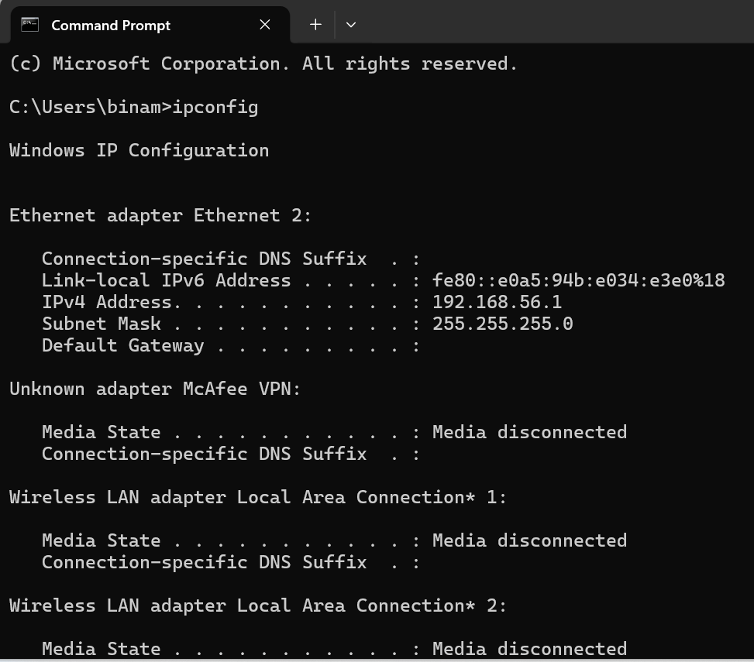
Figure 14
The Test-NetConnection cmdlet assesses whether a host is reachable over the network. It can test connectivity to a specific TCP port and display detailed information about how the command works [9], as shown in Figure 15. PowerShell’s Test-NetConnection is more powerful than the traditional ping and traceroute commands because it can run multiple network tests and return information for each in a single command.
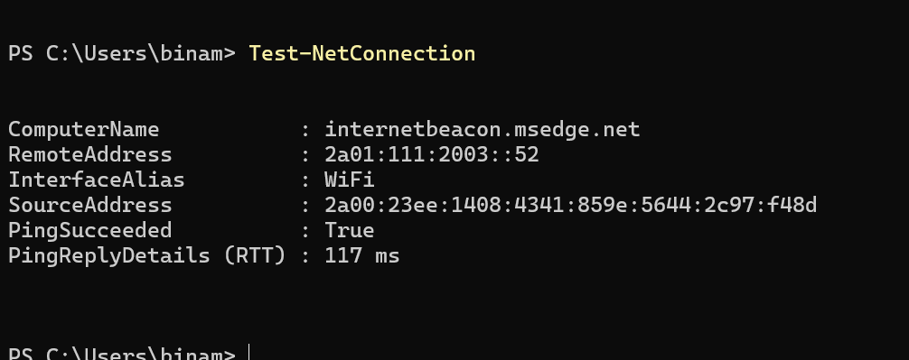
Figure 15
The net user command is used to manage local users and groups on a Windows machine, as shown in Figure 16. It can be used to add, change, enable or disable, and remove users, as well as change their passwords and display information about them.
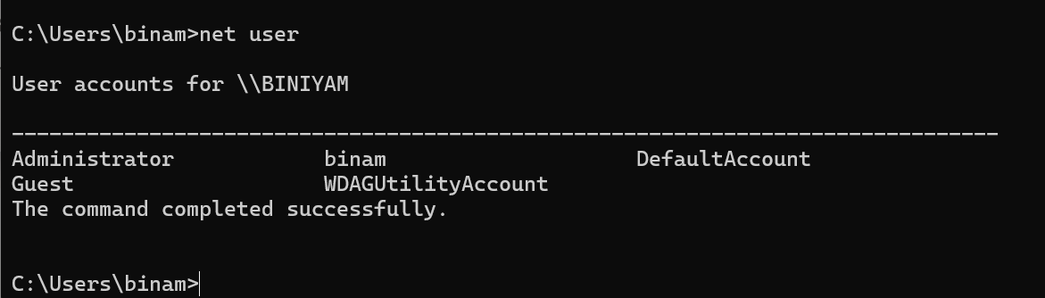
Figure 16
LocalUser PowerShell can be used to retrieve local user accounts on a Windows machine with the cmdlet [9]. A filter can be applied by name or SID, and all local user accounts can be shown. All user details are also shown. Below are the local user accounts on this machine, including Enabled status and Description as shown in Figure 17.
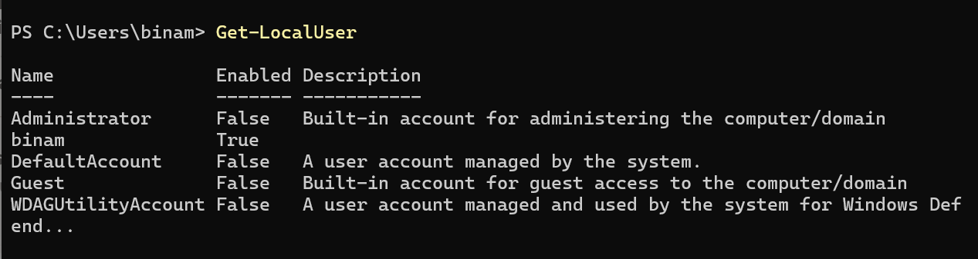
Figure 17
The schtasks command is used to create, edit, delete, run and display Windows scheduled tasks as shown in Figure 18. 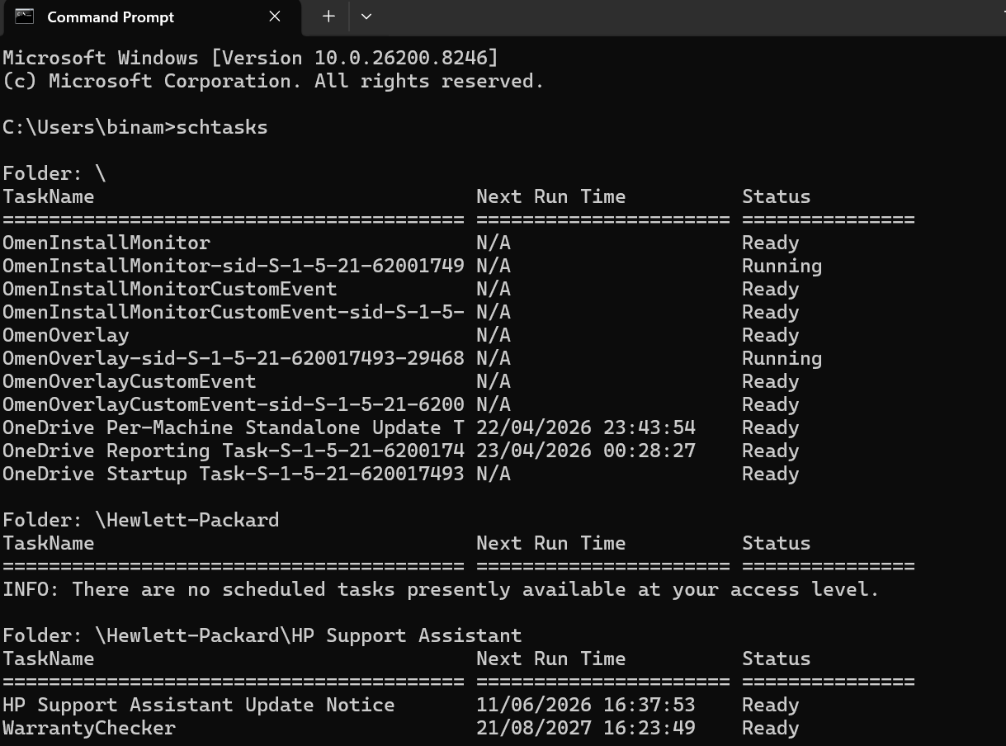
Figure 18
PowerShell scheduled tasks are created using the Register-ScheduledTask cmdlet. Define a trigger (when the task runs) and an action (what the task does), and then register the task. While the schtasks command can perform the same function, PowerShell scheduled tasks are more flexible and more powerful and are often used to automate scripts and other system maintenance and upkeep [10].

3. Use of Linux OS CLI commands
The Linux Operating System comes with a powerful Command Line Interface (CLI) [8]. All Linux distributions provide a powerful Command Line Interface (CLI) that lets users interact with the Linux Operating System via commands, offering greater control, flexibility, and automation than a graphical interface [11].
Ps: is the Linux command for finding and viewing running processes [5], as shown in Figure 19. It can be used with several options, including aux, which stands for all user extended. This command is used in Linux to monitor and troubleshoot processes.

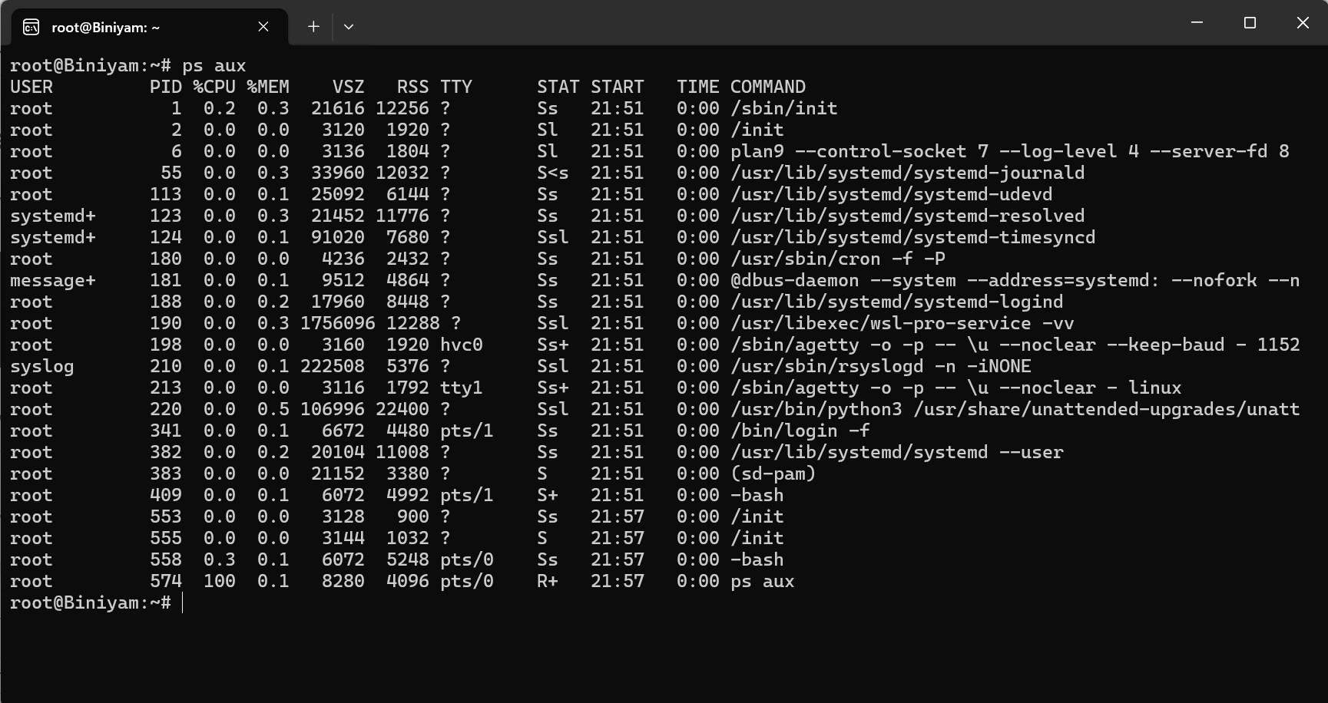
Figure 19
Top: Interactively monitor Linux system performance. Shows CPU, memory and disk usage, as well as running processes, as shown in Figure 20. Processes can be sorted, killed, and filtered by user usage, and the refresh rate can be changed within the program.
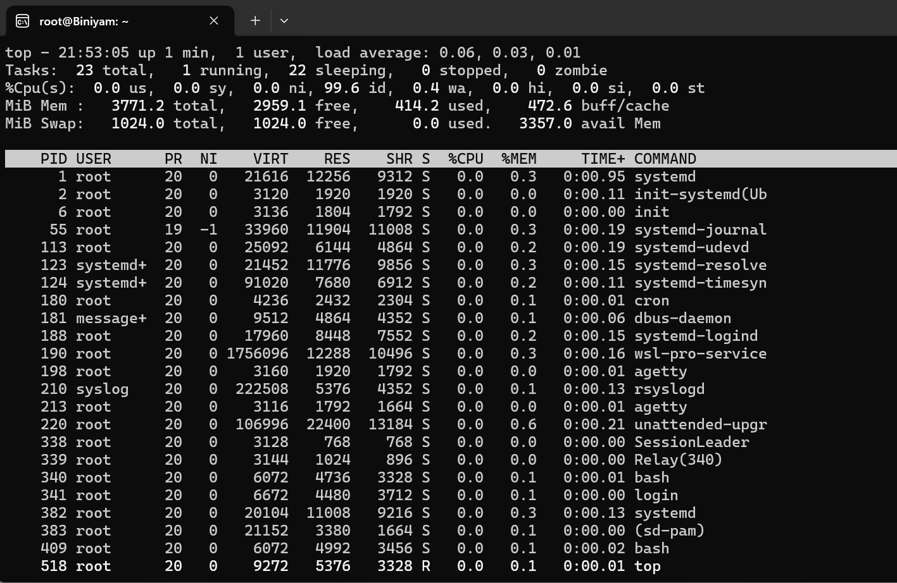
Figure 20
The ls command lists files and directories for the user. This command can be modified by adding options such as -l to view detailed information about files, -a to view hidden files and directories, and -h to list file sizes in a human-readable format [5]. The ls command is a fundamental Linux command for working with the file system, as shown in Figure 21.
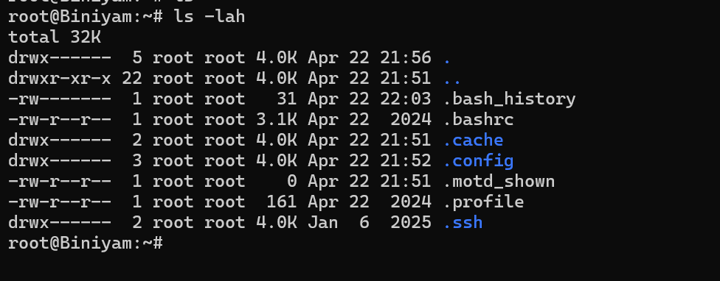
Figure 21
ip a and ifconfig show information about network interfaces, including IP addresses, MAC addresses, interface details, and any connections associated with the interface shown in Figure 22. While both commands accomplish the same goal, ifconfig is legacy and has been largely replaced by the newer, more feature-rich “ip a” command. Both commands are available by default on most Linux distributions [5].
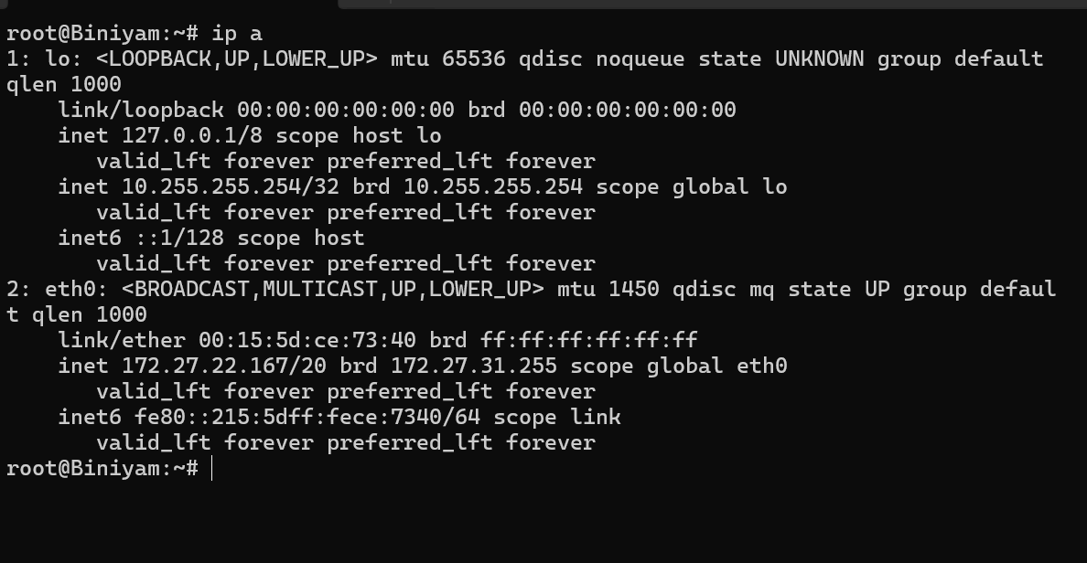
Figure 22
The useradd command is used to add a new user account and login capability. The passwd command is then used to assign a password to the newly created user [11]. The useradd command is shown in Figure 23 below.
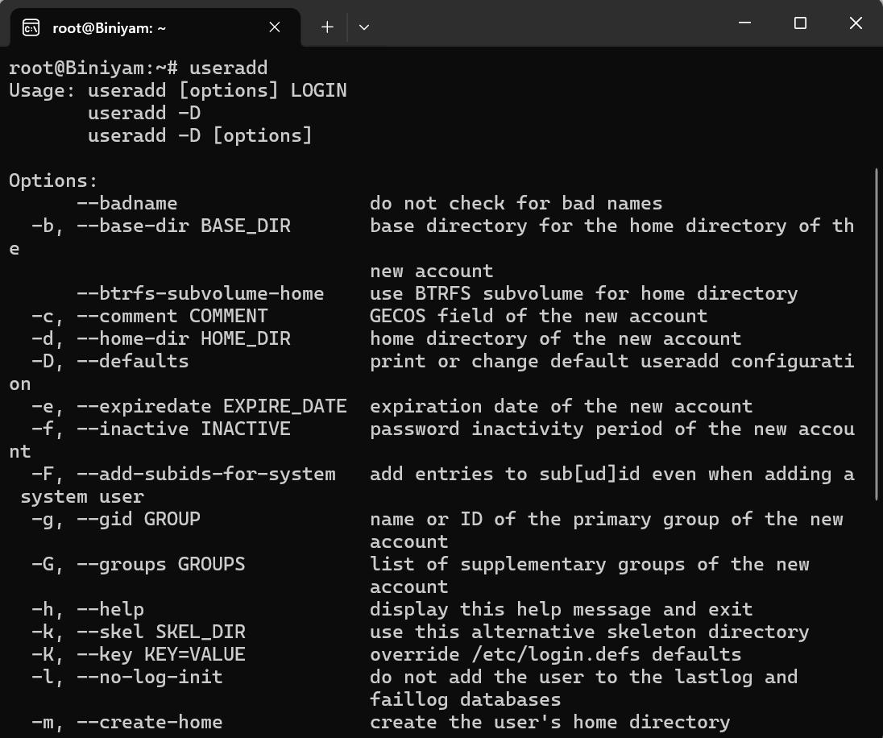
Figure 23
passwd is a Linux command that is used to change a user's password. Users can change their own passwords, and administrators can set, lock, unlock, or expire another user's password [12], as shown in Figure 24. It is a basic but important tool for Linux user administration and system security.
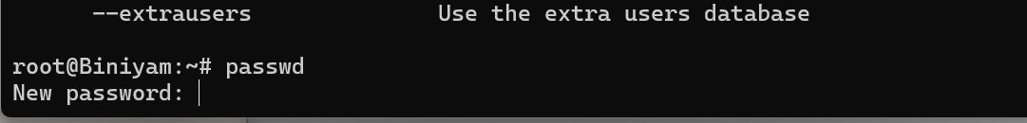
Figure 24
df -h command in Linux to find the amount of available and used disk space on filesystems where the file system is mounted [12]. The ‘-h’ option, short for human-readable, is used with the df command in Linux to display filesystem sizes in GB/MB, etc., in a human-readable format, as shown in Figure 25. The main intention of df command is to report file system disk space usage statistics. It is used to check disk space on a Linux system and identify how much space is available on the running disk to avoid “out of disk space error”.
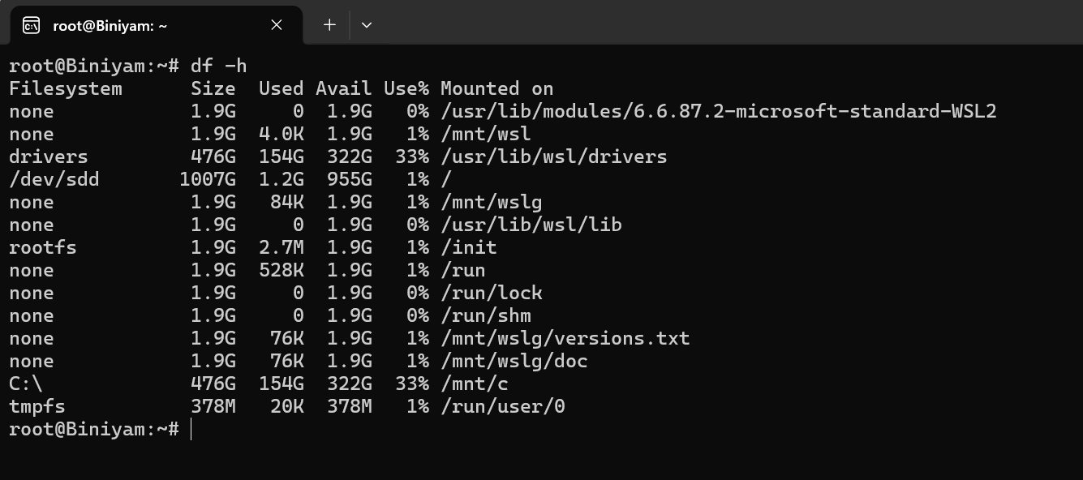
Figure 25
The history command displays all commands from your previous Linux sessions that you can reuse. This command can be useful for auditing and verifying, as shown in Figure 26.
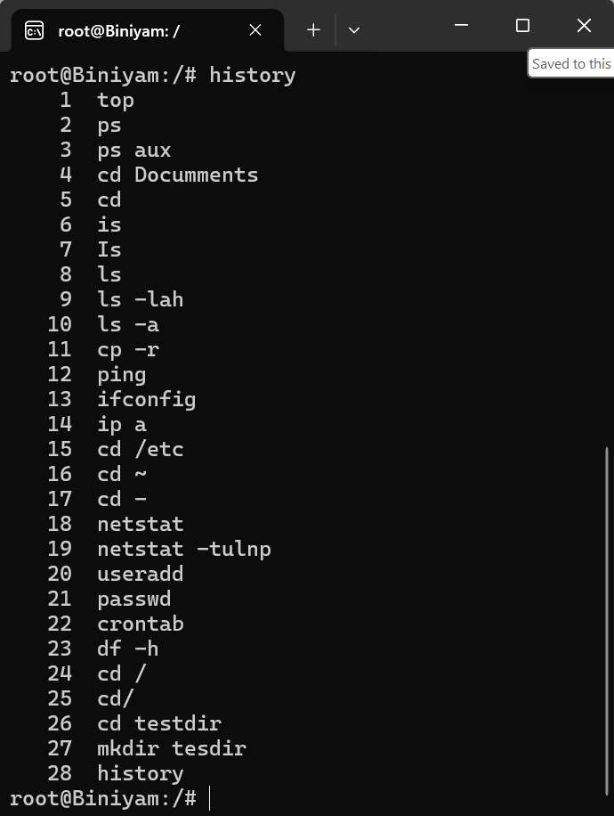
Figure 26
The top command displays its manual page, as shown in Figure 27. The manual page for the top command explains how to use it, lists the available options, shows the keys you can press to interact with it, and describes the fields displayed on the top screen [5]. The manual page is navigated using the keyboard.
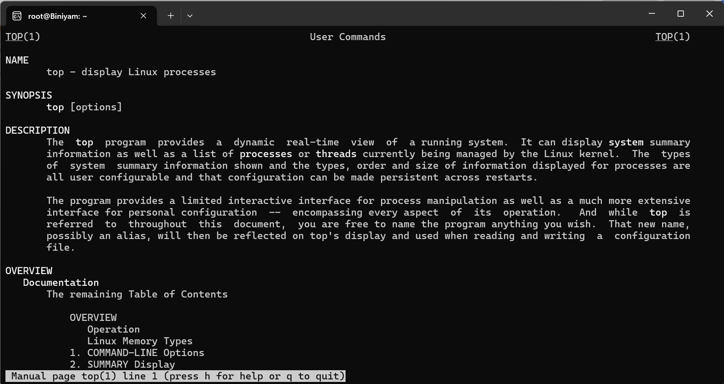
Figure 27
The vmstat 1 2 command gives information about virtual memory, as is shown in Figure 28. The first report shows the average since the computer turned on. The second report shows real-time data after one second. This tool tracks what each process does.
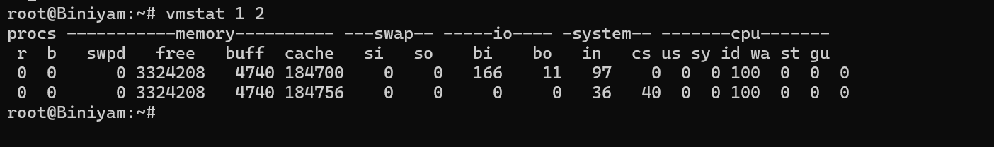
Figure 28

4. Use of Windows OS scripts
In Windows operating systems, there are two primary ways to do system scripting. Both the Batch (CMD) environment and the PowerShell environment have their own specific uses and advantages. Manage running system processes and services without navigating menus. Carry out administrative tasks like user management, network configuration and testing, and system monitoring. Because of cross-system compatibility, commands can be used on many different computers, especially in enterprise settings [9]. By creating a script, users can save time and reduce the risk of errors when executing repetitive tasks.

4.1 Batch Scripting in Windows
Batch files are created using the Windows Command Prompt scripting environment. They are pre-programmed files that are straightforward to create and serve simple automation needs [9]. Batch files are executed in the Command Prompt, and commands are processed line by line to achieve a desired end state.
The figures below show how Batch files can store and reuse data, forming the foundation for more advanced scripting tasks. Figures 29 &30 show the input and the output of a variable.
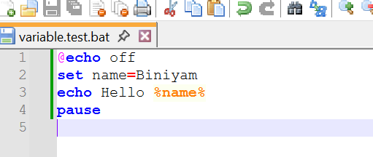
Figure 29
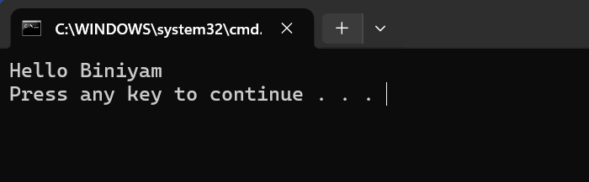
Figure 30
This figure shows how Batch scripts can control a program's flow, skip unnecessary steps, and organise code into sections. Figures 31 & 32 show the input and the output.

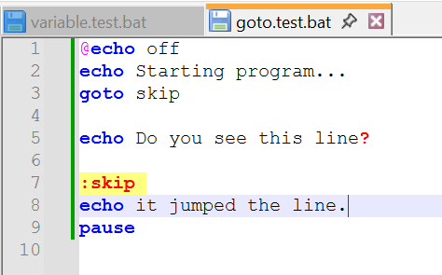
Figure 31
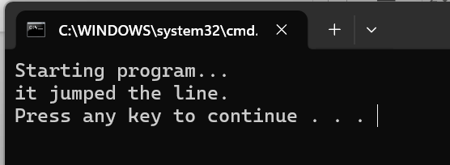
Figure 32
Figures 33, 34, and 35 illustrate how Batch scripts can communicate with the user, making programs more dynamic and interactive.
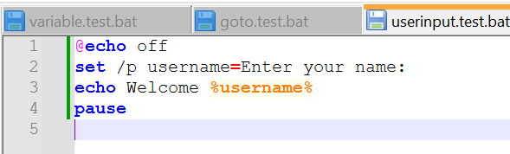
Figure 33
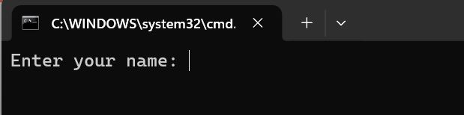
Figure 34
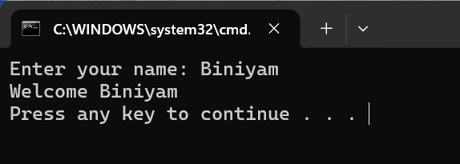
Figure 35
The IF statement allows your program to make decisions based on user input [9]. Figures 36, 37, & 38shows how Batch files can respond to different circumstances and guide your program through different parts of the script, using user input as a guide.
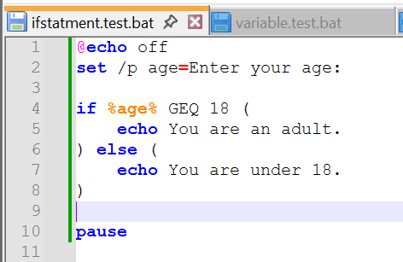
Figure 36
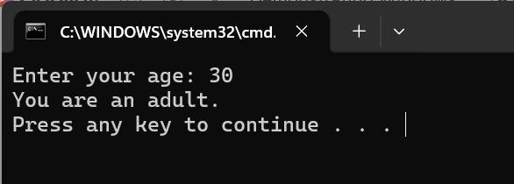
Figure 37
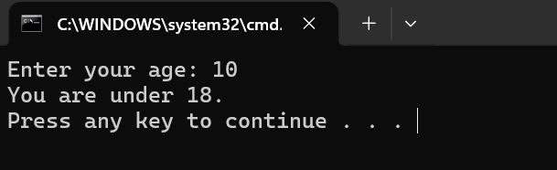
Figure 38
The FOR loop script finds all PDF files in the current directory and processes each file. The filename of the currently processed PDF is stored in the variable [9], as shown in Figures 39 & 40. It is possible to process several files at once using Batch scripts. Such scripts can be useful for organisation, verification, or automation.
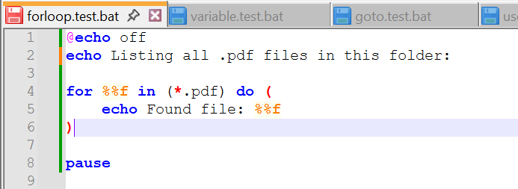
Figure 39
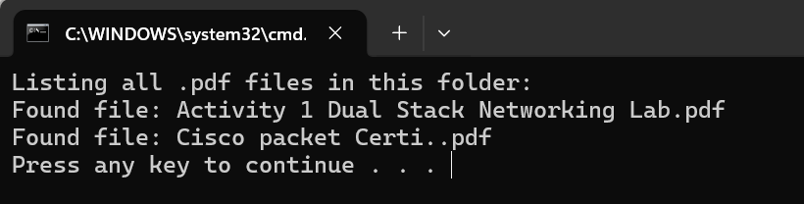
Figure 40
The following figures 41 & 42 show how an array of batch scripts can store multiple values using numbered variables, which is useful for lists, menus, and simple data storage.

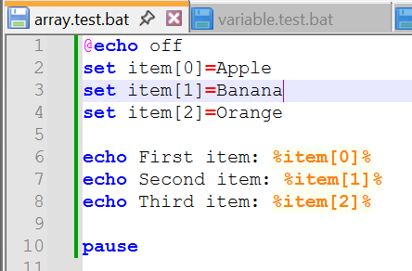
Figure 41
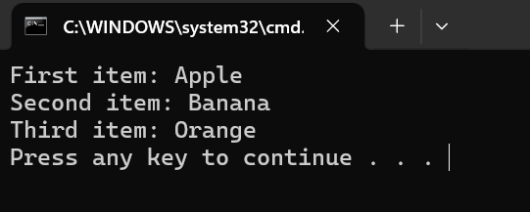
Figure 42
A function script in Batch allows you to run chunks of code as needed, to avoid repeating yourself. This helps keep your output clear and readable. See the following figures 43 & 44.
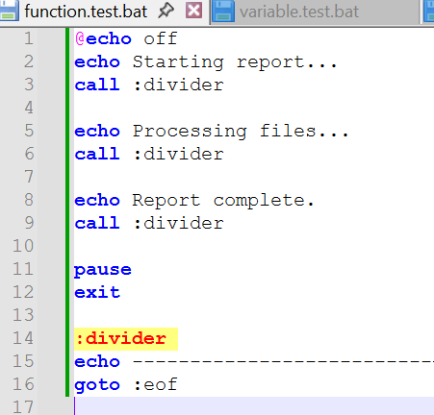
Figure 43
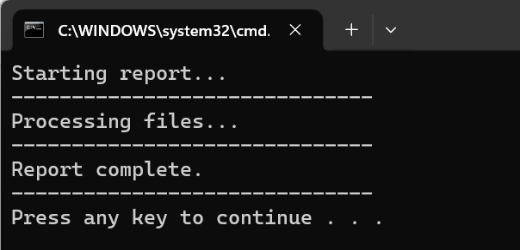
Figure 44

5. Use of Linux OS scripts
Linux OS scripts are very useful for making the Linux operating system much more efficient and easier to use [13]. Linux OS scripts are collections of Linux commands written in a single file. Script file can be used to work with files, read user input, make decisions, loop through a series of commands, and sort data.
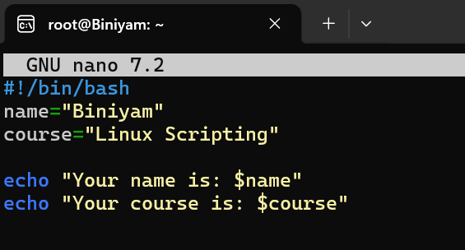
Figure 45
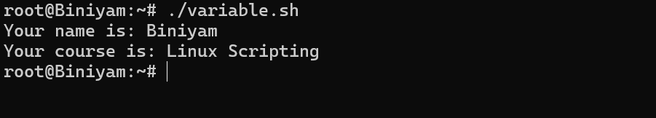
Figure 46
In this script, variables are assigned values and displayed with echo, prefixing the variable name with a dollar sign, such as $name. When the script runs, Bash reads each variable, retrieves the stored value, and prints it to the terminal. Figures 45 & 46 demonstrate how Linux scripts can hold data, reuse it later in the program, and make the script more flexible and readable.

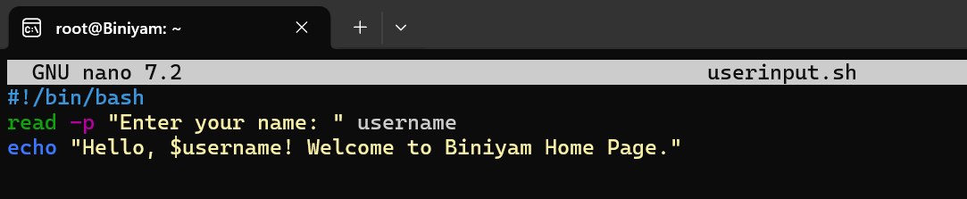
Figure 47
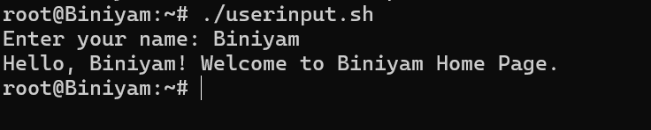
Figure 48
The user input script shows how Bash can interact with the user by prompting for information and storing it in a variable. In this script, the read -p command displays a prompt on the screen and waits for the user to type a response [5]. When the script prints a message using echo, it includes the stored value by referencing it with $username. Figures 47 & 48 demonstrate how Bash scripts can collect input, store it, and use it to produce dynamic output.
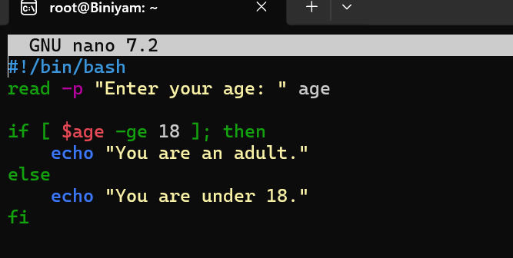
Figure 49
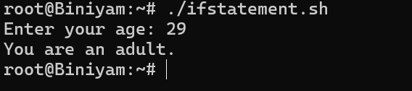
Figure 50
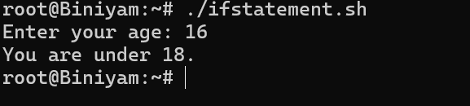
Figure 51
In this script, the user is prompted for their age and the value is stored. Then compare the value to 18 and print whether the user is an adult. Figures 49, 50 &51 show an if statement based on conditions.
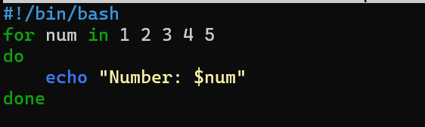
Figure 52
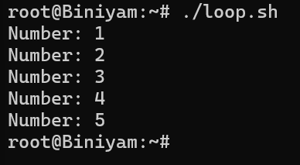
Figure 53
The figure above shows how Bash can automatically repeat a set of commands without typing them one by one. The script uses echo to print the current value of num, and this repeats for each item in the list shown in Figure 52. This demonstrates how Bash can automate repetitive tasks, making scripts more efficient, as shown in Figure 53.

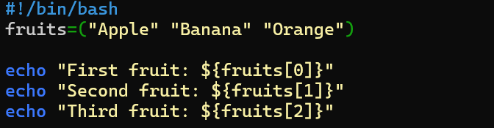
Figure 54
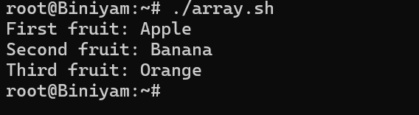
Figure 55
Figures 54 & 55 above show how Bash can store multiple values in a single variable and access them by index. Arrays are useful for processing lists of items and for looking up specific elements.
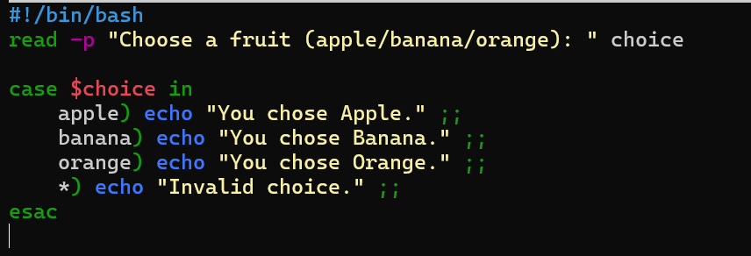
Figure 56
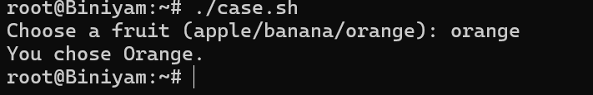
Figure 57
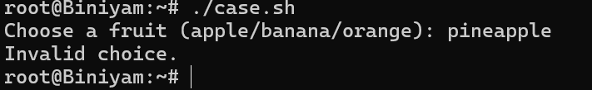
Figure 58
Figures 56, 57 & 58 demonstrate how Bash can compare one piece of user input against several possible options and run different commands depending on the match. The case statement is useful for menu systems and option selection.

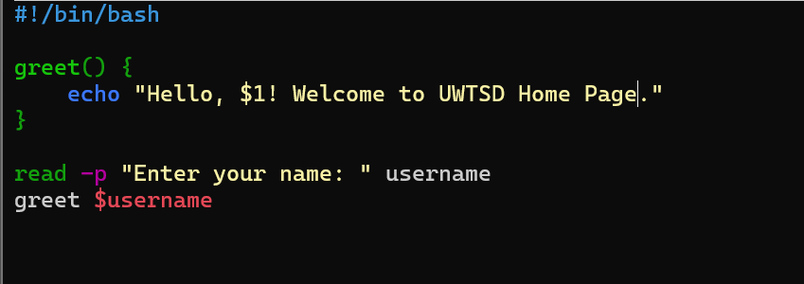
Figure 59
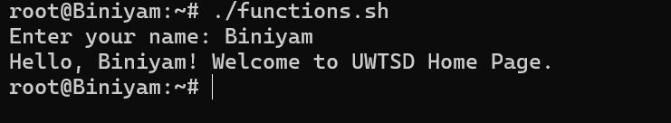
Figure 60
The figures 59 & 60 above show how Bash can group a set of commands into a reusable block of code. The script defines a function, represented by $. When the user enters their name, the script stores it in a variable and prints a personalised greeting. This demonstrates how functions help organise code and avoid repetition.

Conclusion
In conclusion to the assignment, I gained insight into how operating systems work, the utilisation of the CLI on both Windows and Linux platforms, and the use of scripts to automate tasks. Developing the skills to use these tools was challenging, and at times it was hard to understand how to use several commands. Additionally, I encountered difficulties, including insufficient permissions and scripts that crashed and failed to run. Studying the various features of Operating Systems and the tools available in both Windows and Linux also highlighted their power and flexibility and provided a basis for evaluating the skills a system administrator needs to efficiently manage and automate tasks.

References

[1] | W. Stallings, Operating System Internal and Design principles 9th Edition, Edinburgh: Pearson Education Limited , 2018.
[2] | V. R. &. R. C. Gary Johnstone, “Process Management,” Process Management and exceptional handling in multiprocesser Operating System, no. Multimedia, pp. 248-258, 1988.
[3] | S. S. &. A. Dwivedi, “Memory Management Techniques,” Memory Management Techniques in Modern operating system, vol. Vol 1, no. International Journal of Emerging Research in Computer Science , 15 December 2025 .
[4] | F. H., “Role of File System,” Role of File System in Operating System, vol. vol 3, no. Infinity Sciences , pp. 117-127, 2016.
[5] | UWTSD, “Computer Arc. and Operating System,” UWTSD, 2026. [Online]. Available: https://moodle.uwtsd.ac.uk/. [Accessed 04 04 2026].
[6] | T. Jaeger, Operating System Security, Springer Natural, 2022.
[7] | G. G. ABRAHAM SILBERSCHATZ, Operating System Concept, Wiley Publishing, 2018.
[8] | C. N. Acadamy, “Cisco Networking Acadamy : Operating System Basics,” Cisco Networking Acadamy, [Online]. Available: https://www.netacad.com/courses/operating-systems-basics. [Accessed 28 04 2026].
[9] | Microsoft, “Microsoft Build 2026,” Microsoft , 2 june 2026. [Online]. Available: https://learn.microsoft.com/en-us/windows-server/administration/windows-commands. [Accessed 04 04 2026].
[10] | Linkedin, “learning power shell,” Linkedin, [Online]. Available: https://www.linkedin.com/learning/learning-powershell. [Accessed 02 04 2026].
[11] | “The Linux command line for beginners,” Ubuntu and Canonical , [Online]. Available: https://ubuntu.com/tutorials/command-line-for-beginners. [Accessed 03 04 2025].
[12] | C. Networking, “Cisco Networking Acadamy linux unhacted,” Cisco Networking, 2026. [Online]. Available: https://www.netacad.com/courses/linux-unhatched. [Accessed 03 04 2026].
[13] | D. P. B. &. M. Cesati, “Understanding the Linux,” Understanding the Linux Kernel, vol. Vol 10, no. O'Relly Association, p. 705, 2000.

Appendices
This appendix contains work from the Tutorial 1 activity on Operating System types, which provides evidence of participation in lecture activities and engagement with an online, certified course (Cisco Networking Academy – Operating Systems Basics). The following screenshots show engagement with tutorial, lecture, and online course activities.
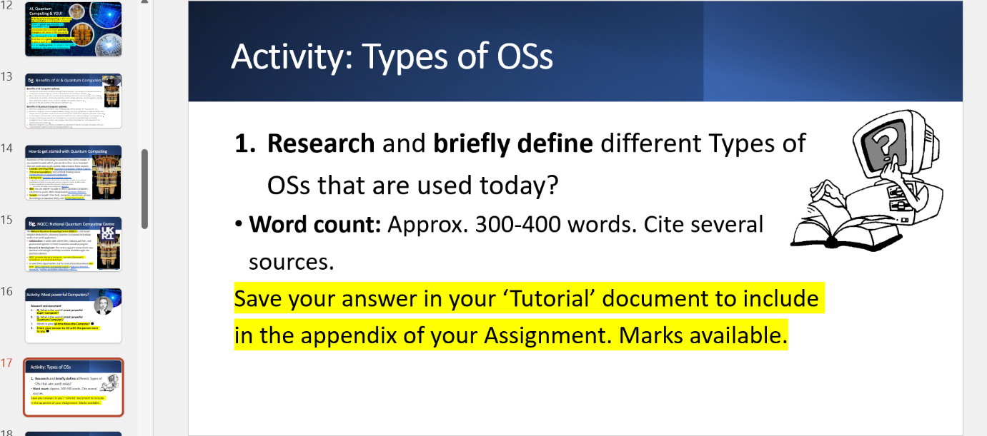
Screenshot 1: Tutorial Activities.
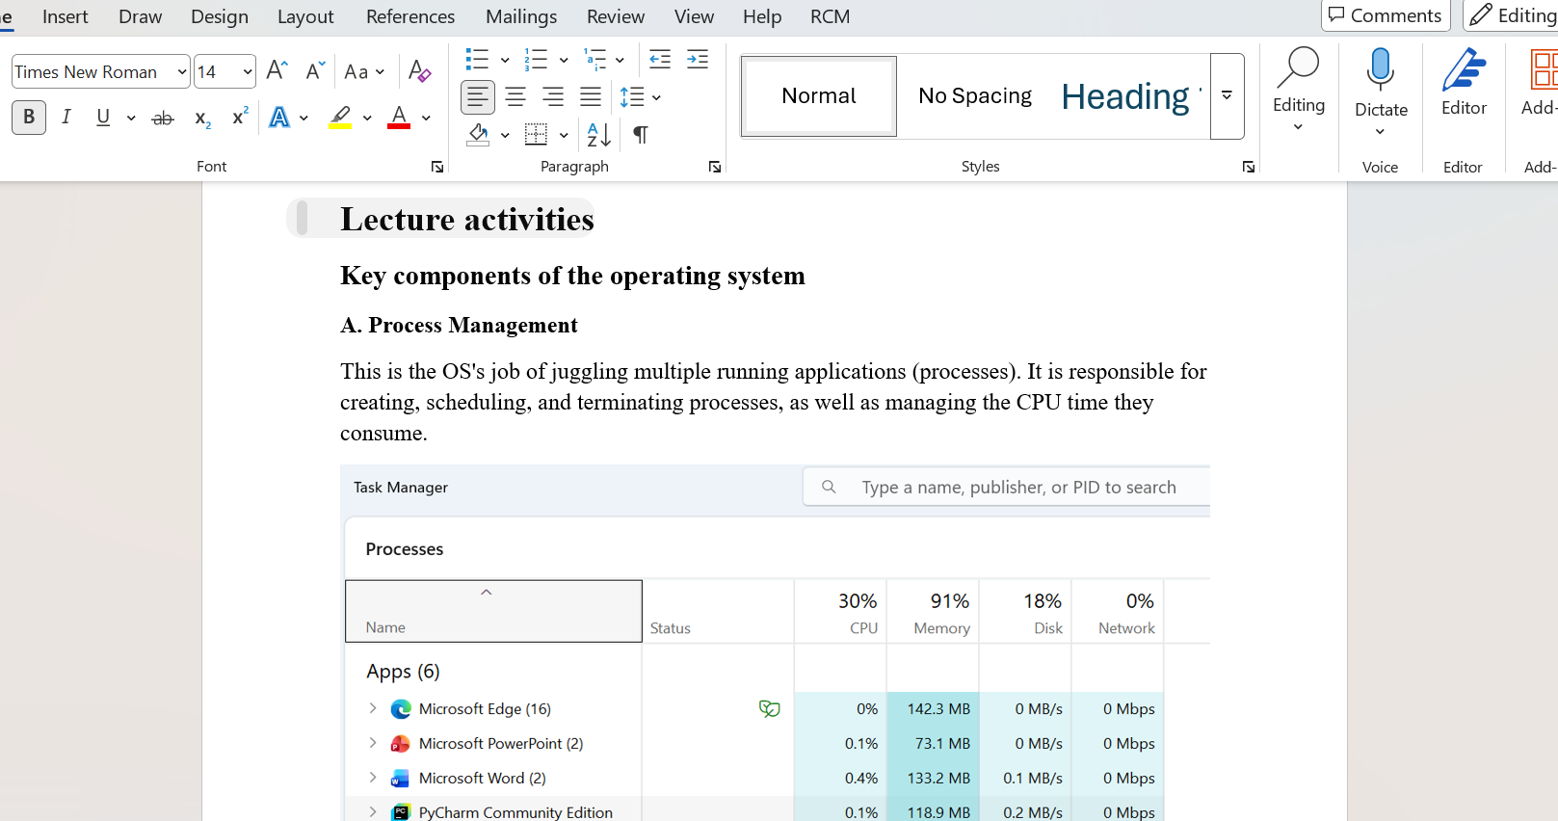
Screenshot 2: Lecture Activities.

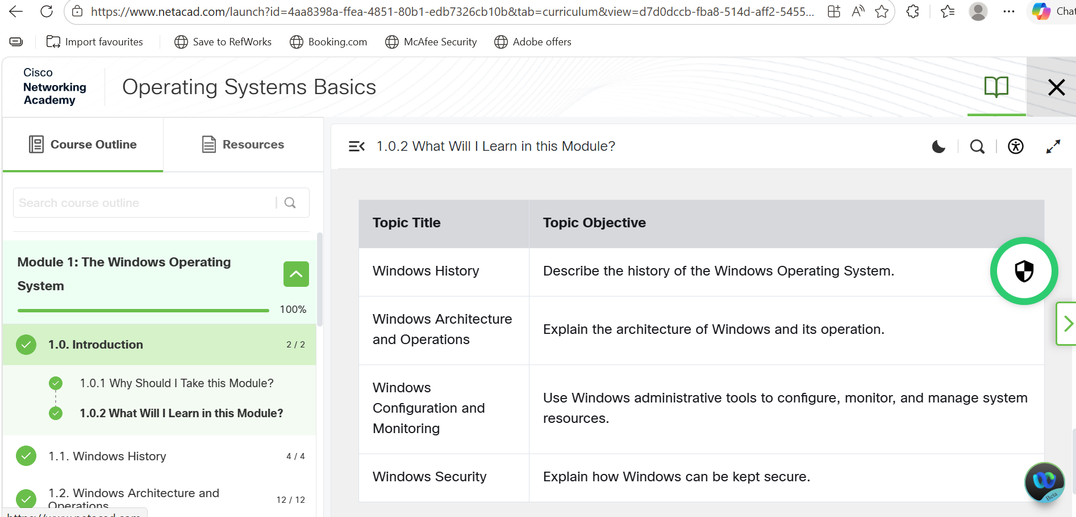
Screenshot 3: online course activities

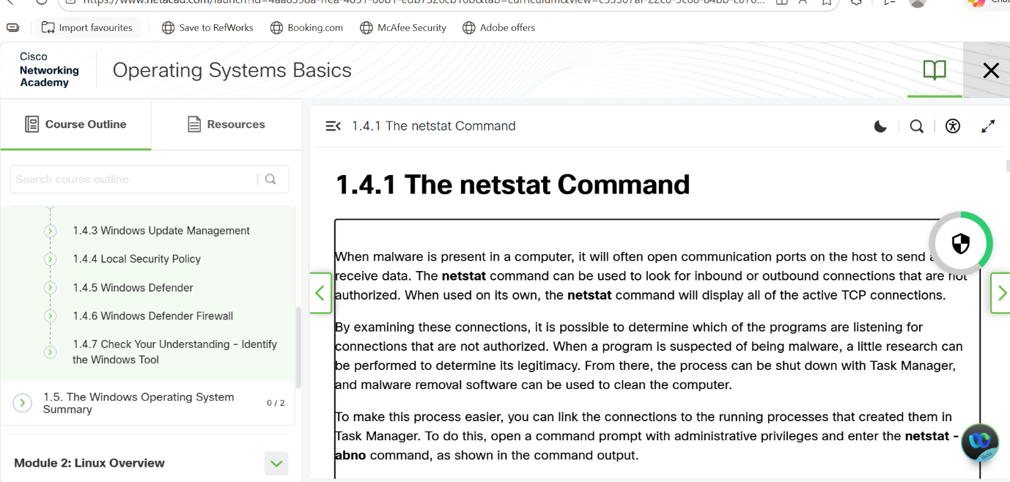
Screenshot 4: online course activities

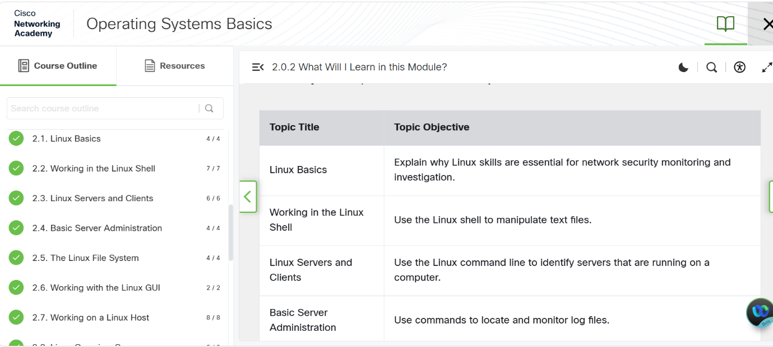
Screenshot 5: online course activities

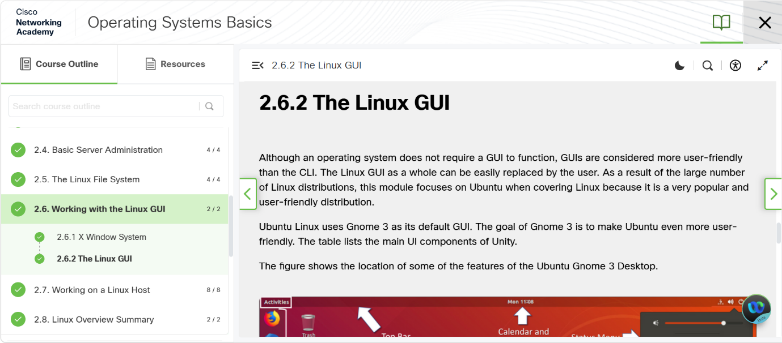
Screenshot 6: online course activities

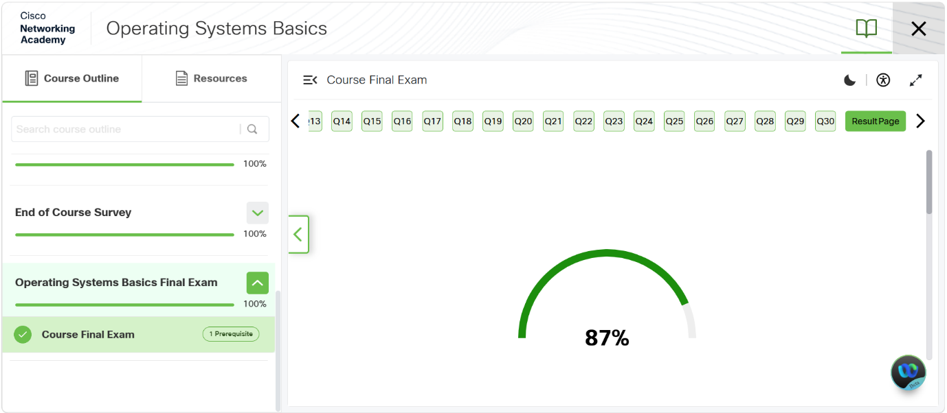
Screenshot 7: Final exam online course activities

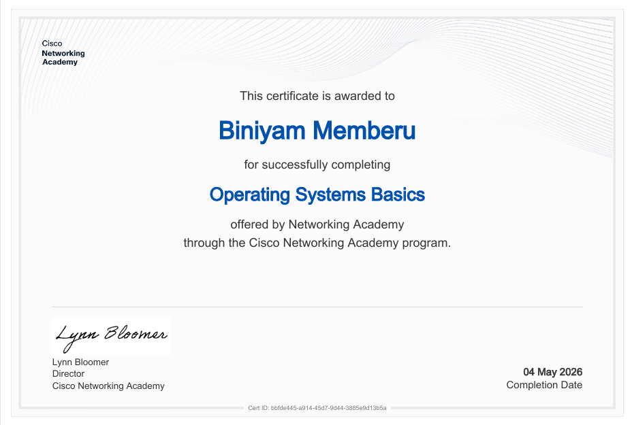
Screenshot 8: Certificate online course activities.
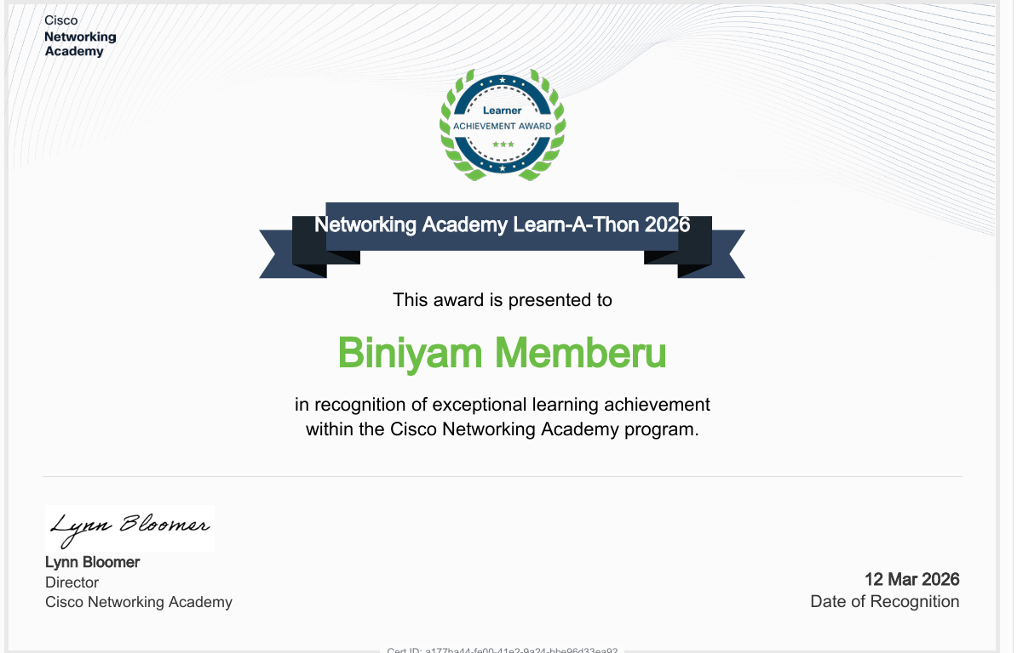
Screenshot 9: Award in an online course.

