DS 1 Template

My Screenshots/Photos
- Please add 4–6 screenshots or photos of your digital life.
- You can use your phone or laptop.
- For each screenshot, write one or two sentences explaining what it shows.

Screenshot/Photo 1
[Insert Photo/Screenshot below]

[Write what this shows of your digital life] I use the laptop for many purpose

Screenshot/Photo 2
[Insert Photo/Screenshot below]
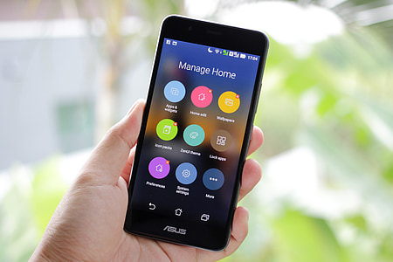
I use the phone to make call family and friend

Screenshot/Photo 3
[Insert Photo/Screenshot below]
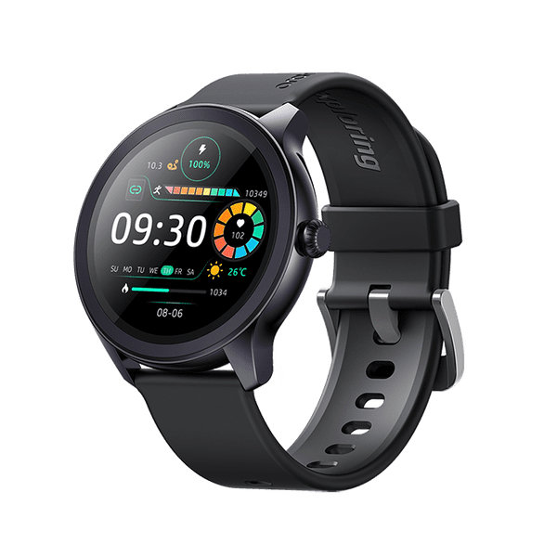 Smart watch for exercise counting , payment and weather report
[Write what this shows of your digital life] I use the watch for time, its very important

Screenshot/Photo 4
[Insert Photo/Screenshot below]
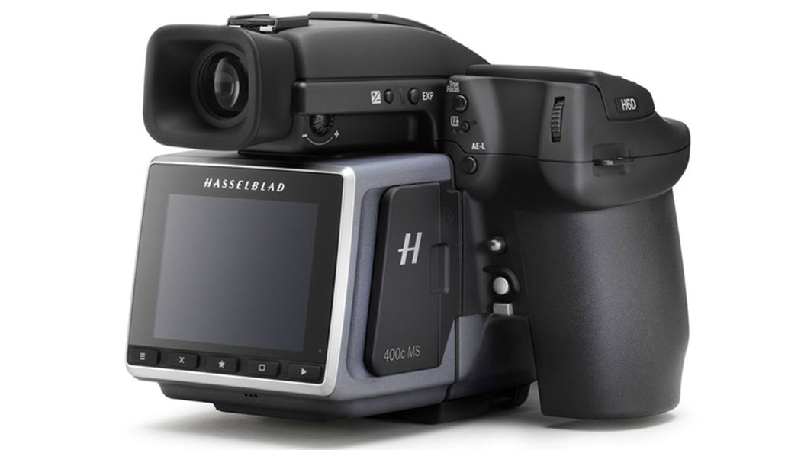
Digital camera for photo

Screenshot/Photo 5
[Insert Photo/Screenshot below]
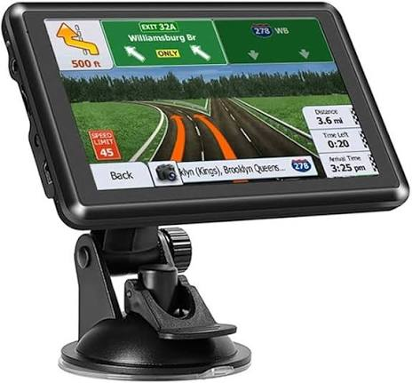

I use for map and driving

Screenshot/Photo 6
Door camera and home security

My Short Reflection
- Write 5–8 simple sentences about your digital life.
- You can use the sentence starters below if helpful.
I use the devices for everyday my daily life. I feel confident to use all the devices . all the digital device is important for me to make my daily life easy.

Sentence starters
- I use digital tools to …
- I feel confident when I …
- I want to improve …
- I often use these tools: …
- I sometimes feel nervous about …
- I hope this module will help me …
- Digital skills are important for me because …
You can write more if you want.

Submission Checklist
Before you submit, please check:
​​​ ☐ I added 4–6 screenshots
☐ I wrote short sentences for each screenshot
☐ I wrote my short reflection
☐ My work is my own
☐ My file opens correctly
​​☐ My file opens correctly

