

Student Name: Vishal Pareshbhai Kathiriya

Student ID: 2528421

Module Name: Marketing Management

Module Code: LCMB7024

Assessment Title: Marketing Strategies Portfolio
(Brand Development: Apple Smart Ring)

Lecturer’s Name: Laila Maazouz

Term 1

Table of Contents
ELEMENT 1: POSTER 3
ELEMENT 2: STDP ANALYSIS 4
Introduction 4
Market Segmentation 4
Target Market 5
Differentiation Strategy 5
Positioning Strategy 6
ELEMENT 3: MARKETING MIX 6
Introduction 6
Product Strategy 7
Pricing Strategy 7
Place Strategy 8
Promotion Strategy 8
Integration with Overall Strategy 9
ELEMENT 4: REFLECTION (Gibbs Reflective Cycle) 9
Description 9
Feelings 10
Evaluation 10
Analysis 10
Conclusion 10
Action Plan 10
References 12

ELEMENT 1: POSTER
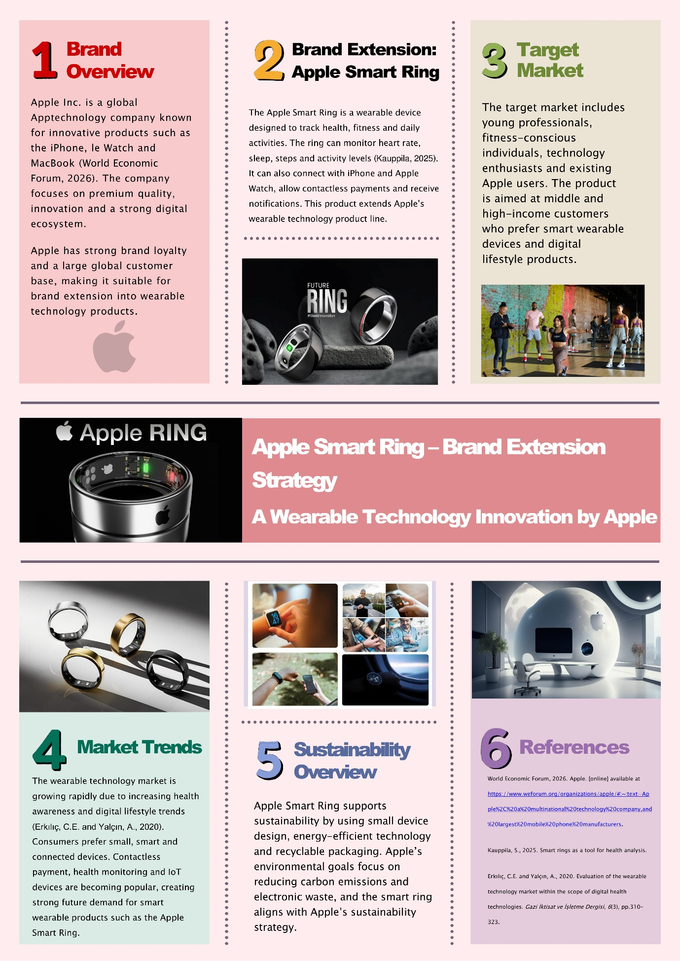

ELEMENT 2: STDP ANALYSIS

Introduction
Apple Inc. has recently launched the Apple Smart Ring, a new product extension, which is a small wearable device that combines health, fitness and smart technologies (Yan, 2024). The smart ring, as a wearable device, fits into the expanding market for wearable technologies and supplements Apple's product range by being compatible with other Apple devices, including the iPhone and Apple Watch. The product represents the trend towards smaller, lightweight and multi-function devices. This section aims to examine the Segmentation, Targeting, Differentiation, and Positioning (STDP) of the Apple Smart Ring, and how it successfully addresses market demands and drives business development.

Market Segmentation
Market segmentation for the Apple Smart Ring is critical to target a specific market segment and develop effective marketing plans. The market segmentation is done through demographics, geography, psychographic and behaviour factors.
Demographic segmentation targets people aged 20-45 years, since this segment is more likely to embrace new technologies and wearables. The consumers are generally from middle- to high-income households, as Apple products are positioned as premium brands. Professionals are also a significant target, as they seek convenience, efficiency and health tracking in their lifestyles.
Geographic segmentation involves consumers in high-income markets like the United Kingdom, the United States, and Europe, with high usage of wearable devices. Cities are crucial as urban consumers are more exposed to digital lifestyles and have access to Apple's retail and online stores (Dong, 2024).
Psychographic segmentation involves health-conscious, tech-savvy individuals, as well as those who are interested in lifestyle (Hazan, 2025). These consumers are looking for products that promote health, monitor fitness and fit into a digital world. They are also interested in innovation, design, and brand equity, all of which reflect Apple's image.
Behavioural segmentation targets Apple loyal consumers who are already in the Apple ecosystem and open to purchasing new Apple products (Aghabi and Nouri Qurjanaki, 2024). This includes health and fitness monitor users who track their fitness and health, and also early adopters who are keen to explore and adopt new and innovative products. This approach maximises the potential of the Apple Smart Ring to reach and appeal to its target audience.

Target Market
The primary target audience for the Apple Smart Ring is current Apple users and young to middle-aged professionals who are part of the Apple ecosystem. They are typically middle- and high-income groups, who can afford to pay for premium-priced products. They appreciate convenience, innovation, and integration of various devices, including iPhone, Apple Watch and MacBook. This market segment is attracted by the Smart Ring's compact, efficient, and fashionable design, which adds to their digital experiences and helps them improve productivity and health (Cusack et al., 2024).
Another potential market segment is health-conscious consumers who monitor their activity levels, sleep quality, and other health indicators. They are health-oriented and seek smart devices that offer reliable and timely health information. The Apple Smart Ring caters to these users with cutting-edge health tracking capabilities in a convenient, comfortable form. The Apple Smart Ring resonates with the lifestyle, income and technology needs of both market segments and is highly relevant in the emerging wearable technology market (Ferreira et al., 2021).

Differentiation Strategy
The Apple Smart Ring differentiates itself in the wearable technology market with its seamless integration with the Apple ecosystem, its upscale branding, its features and its aesthetics. The Smart Ring offers greater integration with devices such as iPhone and Apple Watch than its competitors, enabling notifications, health monitoring and payments from a connected ecosystem (Tong, 2023). This integration provides convenience and a seamless digital experience, which could be difficult for competitors to match.
Apple's brand positioning is a key differentiator. Apple is known for its high quality, innovation, and reliability, which builds consumer trust and loyalty. In contrast, competitors such as Fitbit emphasise fitness monitoring, and Samsung wearables provide more versatile functions, but with less integration. The Smart Ring further distinguishes itself with its health tracking features (such as heart rate and sleep monitoring) and its small, sleek design (Yin and Flores, 2025). Its user-friendly and subtler design makes it more wearable, providing both convenience and comfort. This innovation, design and brand positioning make it a competitive edge.

Positioning Strategy
The Apple Smart Ring is a high-end, innovative and small wearable product marketed to consumers who are looking for convenience, connectivity and health-related technologies in their everyday lives. The target market for the Apple Smart Ring is tech enthusiasts and current Apple product users who appreciate product integration and superior user experience (Bryła and Abdusattarov, 2025). It offers health-monitoring capabilities with a sleek and fashionable design, which can be used both at work and in everyday life.
The value proposition of the Apple Smart Ring lies in its ability to deliver powerful functionality within a small and discreet device, while maintaining strong connectivity with the Apple ecosystem. This enhances user efficiency, supports health management, and strengthens customer loyalty. From a customer perception perspective, the Smart Ring is viewed as an advanced and reliable product that reflects Apple’s core values of innovation, simplicity, and premium quality. The positioning strategy reinforces Apple’s competitive advantage by offering a combination of technology, lifestyle benefits s, and status, making the Smart Ring a desirable choice in the wearable technology market (Filip, 2025).

ELEMENT 3: MARKETING MIX

Introduction
The marketing mix is a core concept used to create marketing strategies that integrate the elements of product, price, place and promotion. The marketing mix is essential in positioning the Apple Smart Ring in line with Apple's brand strategy of high-quality and innovative products. The Smart Ring is a wearable device that combines health, communication and utility in a small package (Yin and Flores, 2025). This section assesses the role of each of the marketing mix elements in ensuring the product's success in the crowded wearable technology sector while being consistent with Apple's brand positioning and consumer expectations.

Product Strategy
The Apple Smart Ring is a premium, cutting-edge wearable device that complements Apple's ecosystem. The product offers advanced features such as heart rate monitoring, sleep tracking, step counting, and activity analysis, enabling users to manage their health effectively. The Smart Ring is capable of contactless payments and can display notifications, allowing it to be used for a variety of tasks (Manimuthu et al., 2021). The Smart Ring's design is centred on simplicity, wearability and fashion. The small and light design ensures that it is less visible than other wearables like smartwatches. Apple's focus on design guarantees that the device is suitable for both work and personal use.
Apple's commitment to quality is evident in the use of high-quality materials, durability and ease of use. Connectivity with other Apple products, such as the iPhone and Apple Watch, provides added value and a user-friendly experience (Siahaan, 2023). The Smart Ring is a product innovation within the wearable product category, helping with the product lifecycle and growth strategies. It will probably be launched at the growth stage of the product lifecycle, aiming to target early adopters and loyal customers. The product strategy is in line with Apple's emphasis on innovation, design, and integration.

Pricing Strategy
Apple employs a high-end pricing strategy for the Smart Ring, in line with its brand strategy. It will likely be more expensive than other wearable devices because of its high-end features, quality, and brand reputation. A higher price supports Apple's branding as a premium and cutting-edge technology company, which appeals to consumers who perceive value and quality in the higher price (Eriksson, 2025).
The Smart Ring is aimed at middle- to high-income customers who are prepared to pay for innovative and high-quality technology products (Arunachalam et al., 2020). This market segment is more interested in quality, brand status and compatibility than price. Apple might adopt a price skimming approach in the initial product launch. This strategy helps it capture the most revenue from early customers willing to pay a premium for innovative new products. Prices may later be lowered to reach a wider audience.
In contrast to other companies like Fitbit and Samsung, Apple's pricing strategy focuses on value in terms of ecosystem compatibility and superior user experience, rather than just price.

Place Strategy
The Apple Smart Ring distribution strategy prioritises availability, convenience and global distribution. Apple employs a multi-channel strategy of both offline and online distribution to maximise product availability to its customers (Al-Sakaf, 2025). The Smart Ring will be sold at Apple's official stores, which offer customers a high-end shopping experience, expert advice, and demonstrations. These outlets play a crucial role in brand building and customer engagement.
The product will also be sold through Apple's website, enabling customers to buy the Smart Ring online. The website also facilitates international distribution, allowing Apple to effectively penetrate global markets (Bryła and Abdusattarov, 2025). The Smart Ring is also available through authorised retailers and technology partners, especially in markets where Apple retail stores may not be prevalent. This omnichannel sales strategy makes the Smart Ring more accessible to customers while allowing Apple to control the brand and customer experience. The place strategy supports Apple's global reach and convenience.

Promotion Strategy
The Apple Smart Ring's promotion strategy aims to build brand awareness, customer engagement, and showcase the product's innovative technologies. Apple has a strong reputation for its comprehensive marketing strategies, leveraging digital marketing, social media, events, and influencer partnerships (Ozioko, 2025). Online marketing is a crucial component of the Smart Ring promotion strategy, including marketing through Apple's website, digital ads, and email marketing. Apple leverages social media channels like Instagram, YouTube, and Twitter to demonstrate the Smart Ring’s features, design, and use cases. This enables Apple to engage with a worldwide audience and directly engage with consumers.
Another marketing strategy is influencer marketing, where fitness, tech, and lifestyle bloggers showcase the features of the Smart Ring (Pekkanen, 2024). This approach builds credibility and influences consumer purchasing decisions. Apple also uses product launch events to generate excitement and media attention. These showcase product features, innovation and design, resonating with consumers on an emotional level.
Apple's marketing strategy includes storytelling that highlights the benefits of the Smart Ring in enhancing health, productivity and overall lifestyle. This emotional connection enhances customer engagement and brand loyalty. The promotion strategy will ensure that the Smart Ring is marketed as an innovative, desirable and must-have wearable.

Integration with Overall Strategy
The Apple Smart Ring's marketing mix is integrated with the brand extension strategy. The features and design of the product enhance Apple's image of quality and innovation. The high price point emphasises the brand's exclusivity, and the international distribution channels provide a wide reach while maintaining brand control (Grey, 2024). The promotion strategy effectively communicates the product's value and enhances customer loyalty. These factors contribute to a coherent and unified marketing strategy that strengthens brand loyalty, satisfies customers, and drives Apple's expansion in the wearable device sector.

ELEMENT 4: REFLECTION (Gibbs Reflective Cycle)
This is a reflection of my learning journey in creating a brand extension strategy for the Apple Smart Ring. I developed a poster, STDP analysis and a marketing mix. This reflection aims to critically assess the knowledge, skills and experience I have taken from the project, and how this has benefitted my learning in the field of marketing (Adeani et al., 2020).

Description
In this project, I created a brand extension for Apple, the Smart Ring. I began by designing a poster for the product concept, market research and sustainability. Next, I conducted an STDP analysis to determine the target market and positioning (Jewel and Kalam, 2020). Next, I created a marketing mix strategy for product, price, place and promotion. Each stage required research, application of marketing theories, and critical thinking.

Feelings
I initially found the assignment difficult as it required me to be creative with theory. I was not confident about choosing the most suitable brand extension and developing an appropriate analysis. However, as I progressed, particularly in STDP and marketing mix (Ocampo et al., 2025). I was interested in the topic as it is linked with new wearable devices, which boosted my interest and enthusiasm.

Evaluation
I was successful in creating a simple and creative product idea that is a good fit with Apple's branding. I managed to construct the analysis in a coherent manner and apply marketing principles. But I think I could have done more research into real data and competitive analysis. I also experienced time management issues, particularly with creative work and writing.

Analysis
This project helped me understand the significance of brand extension for business development. I understood how market segmentation, targeting and positioning help to target the right consumers and build value. The use of the marketing mix made me realise the need for product, price, place and promotion to complement brand strategy (Abedian et al., 2022). I also learned the value of connecting theory to practice, particularly with regard to consumer behaviour and competitive strategies. It also helped me enhance my strategic skills and apply marketing theories to practice.

Conclusion
This project improved my understanding and skills in marketing and analysis. It improved my understanding of strategy and innovation based on customer needs. It also gave me more self-assurance to apply theoretical concepts to real-world scenarios, which will be beneficial in my academic and career journey.

Action Plan
Area for Improvement | Action Steps | Expected Outcome
Research skills | Use more academic journals and current industry reports | Improved depth and credibility of analysis
Critical analysis | Focus on comparing competitors and evaluating strategies | Stronger arguments and higher academic quality
Time management | Create a structured timeline and follow deadlines | Better organisation and reduced last-minute pressure
Data usage | Include real-world statistics and market data | More evidence-based conclusions
Presentation skills | Practice visual and written communication techniques | More professional and impactful work

References
Abedian, M., Amindoust, A., Maddahi, R. and Jouzdani, J., 2022. A game theory approach to selecting marketing-mix strategies. Journal of Advances in Management Research, 19(1), pp.139-158.
Adeani, I.S., Febriani, R.B. and Syafryadin, S., 2020. Using GIBBS’reflective cycle in making reflections of literary analysis. Indonesian EFL Journal, 6(2), pp.139-148.
Aghabi, S. and Nouri Qurjanaki, P., 2024. Exploring Apple's Marketing Strategies Through the Lens of Maslow's Hierarchy of Needs: A Qualitative Study on Apple's Marketing Strategies and Consumer Needs.
Al-Sakaf, H.F.T.A., 2025. International marketing strategy of the enterprise (based on the materials company «Apple Inc.».
Arunachalam, S., Bahadir, S.C., Bharadwaj, S.G. and Guesalaga, R., 2020. New product introductions for low-income consumers in emerging markets. Journal of the Academy of Marketing Science, 48(5), pp.914-940.
Bryła, P. and Abdusattarov, S., 2025. Apple’s Strategy Success Factors and Challenges in Europe: A Case Study of Apple’s Business Model and International Marketing. Annales Universitatis Mariae Curie-Skłodowska, sectio H–Oeconomia, 59(5), pp.7-30.
Cusack, N.M., Venkatraman, P.D., Raza, U. and Faisal, A., 2024. Smart wearable sensors for health and lifestyle monitoring: commercial and emerging solutions. ECS sensors plus, 3(1), p.017001.
Dong, X., 2024. Digital Payment Systems in Urban Media Landscapes: The Evolution and Impact of Apple Pay on Urban Life and Consumer Behavior. Journalism, 14(6), pp.325-329.
Eriksson, K.B., 2025. Impact Of Apple's Branding on Financial Performance: To What Extent Has Apple's Branding Affected Their Financial Performance in the Smartphone Market?.
Ferreira, J.J., Fernandes, C.I., Rammal, H.G. and Veiga, P.M., 2021. Wearable technology and consumer interaction: A systematic review and research agenda. Computers in human behavior, 118, p.106710.
Filip, C., 2025. Strategic positioning in wearable health technology: leveraging consumer centric analytical approaches for market leadership–perceptual map analysis.
Grey, F., 2024. Channel Control Mechanisms: Exclusivity and Minimum Advertised Price Policies (Doctoral dissertation, The University of North Carolina at Chapel Hill).
Hazan, M., 2025. Strategic Positioning in Wearable Health Technology: Leveraging Consumer Centric Analytical Approaches for Market Leadership A Literature Review on Advanced Applications, Addressing Adoption Challenges, and Innovative Solutions for Healthcare Technology (Master's thesis, Universidade NOVA de Lisboa (Portugal)).
Jewel, M.M.H. and Kalam, K.K., 2020. The importance and level of adaptation of STP strategies for growth in foreign markets: In the case of soft drinks company. Asian Journal of Economics, Business and Accounting, 19(2), pp.13-23.
Manimuthu, A., Dharshini, V., Zografopoulos, I., Priyan, M.K. and Konstantinou, C., 2021. Contactless technologies for smart cities: big data, IoT, and cloud infrastructures. SN computer science, 2(4), p.334.SSSSS
Ocampo, F.A., McIntyre, B.G., Massey, D. and Saunders, R., 2025. Nursing student reflections on a research internship: A reflective discussion following the Gibbs' reflective cycle. Nurse education today, 145, p.106481.
Ozioko, E.A., 2025. Content Marketing as an Advertising Strategy: An Analysis of Brand Awareness and Audience Relationships at Apple. Mdooter Journal of Communication and Digital Technologies, 2(2), pp.44-55.
Pekkanen, E., 2024. The effect of influencer marketing on consumer behavior: An analysis of fitness influencers on Instagram.
Siahaan, M., 2023. Analysis and Evaluation of the Business Innovation Strategy: A Case Study of Apple Inc. Enigma in Economics, 1(2), pp.42-48.
Tong, Y., 2023. An architecture for seamless communication between wearables and connected vehicles (Doctoral dissertation, University of Stuttgart).
Yan, B., 2024. Design research on smart wearable devices: A case study of apple watch. Applied and Computational Engineering, 97, pp.37-42.
Yin, Z. and Flores, H., 2025. The Evolution of Wearables: A Survey on Trends, Challenges, and the Emerging Impact of Smart Rings. Authorea Preprints.

